Supplementary Information
Post-Polymerization Modification of Polystyrene through Mn-Catalyzed Phosphorylation of Aromatic C(sp²)-H Bonds
Ruixing Liu, ª Cong Lin, ^{*, a} Yubai Zou, ª Yaqi Zhang, ª Wenhai Sun, ª Yuping Yang, ª Jiang Zhong, ^{*, a} Liang Shen ^{*, a}
ª Jiangxi Provincial Engineering Research Center for Waterborne Coatings, College of Chemistry and Chemical Engineering, Jiangxi Science & Technology Normal University, Nanchang 330013, China.

- Characterization of Polymer Starting Materials
Polystyrene(PS):
Appearance: granular solid. GPC analysis (35 °C, THF): M_{n} = 151.0 kg mol^{–1} and Ð = 1.97.
¹H NMR ( CDCl₃, 400 MHz): δ 7.34-6.92 (br, 3H, C₆H₅), 6.90-6.25 (br, 2H, C₆H₅), 2.24-1.77 (br, 1H CHCH₂), 1.76-1.39 (br, 2H, CHCH₂).
¹³C NMR ( CDCl₃, 100 MHz): δ 146.123, 145.696, 145.370, 145.265, 145.166, 127.996, 127.696, 127.471, 127.346, 125.676, 125.518, 77.354, 77.037, 76.718, 44.272, 43.934, 43.553, 42.521, 40.419, 29.718.
FT-IR (film) ν_{max} (cm^{–1} ): 3104, 3083, 3060, 3025, 3002, 2921, 2850, 1942, 1867, 1800, 1749, 1601, 1583, 1539, 1492, 1452, 1372, 1330, 1312, 1182, 1155, 1068, 1028, 1003, 980, 964, 942, 906, 841, 755, 748, 695, 621, 538.
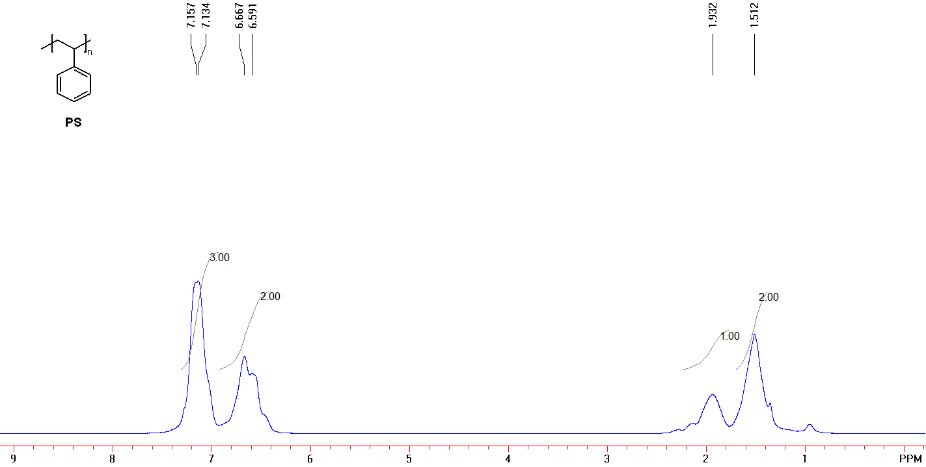
Figure S1. ¹H NMR (400 MHz, CDCl₃) spectrum of PS.
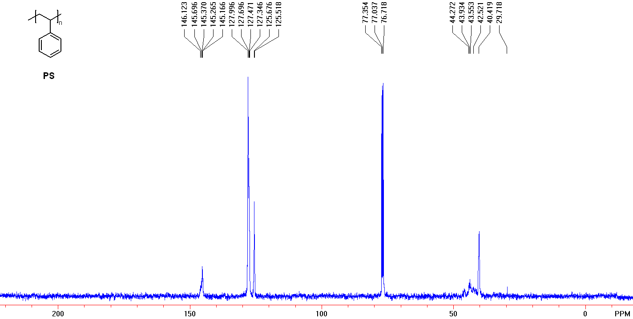
Figure S2. ¹³C NMR (100 MHz, CDCl₃) spectrum of PS.
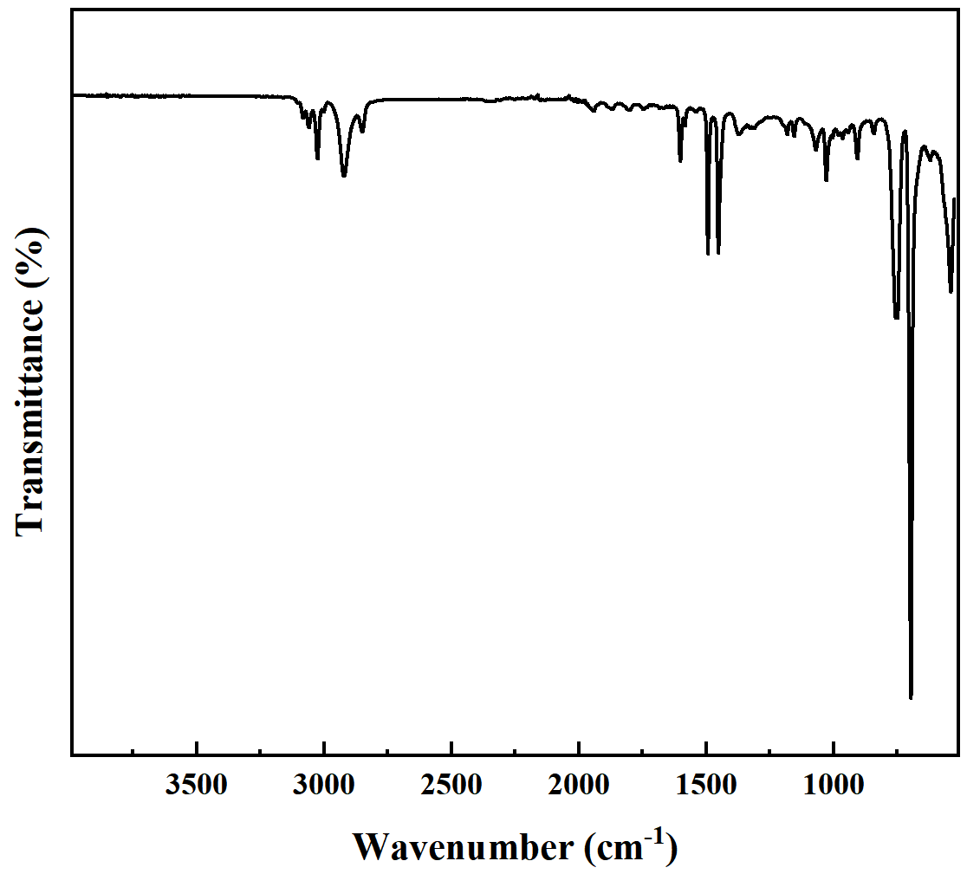
Figure S3. FT-IR spectra of PS.

- Calculation of Percent Functionalization
The functionalization (i.e., % functionalization) were calculated from ¹H NMR using Equation S1：

Where I₁, I₂, N₁, and N₂ represent the integration of the -OCH₂- proton signal, the integration of the reference peak (consistent number of protons between product and scaffold), number of protons represented by the reference peak, and integration of the α-carbonyl alkene proton, respectively. The application of this equation is illustrated as an inset in the ¹H NMR of Figure S4.

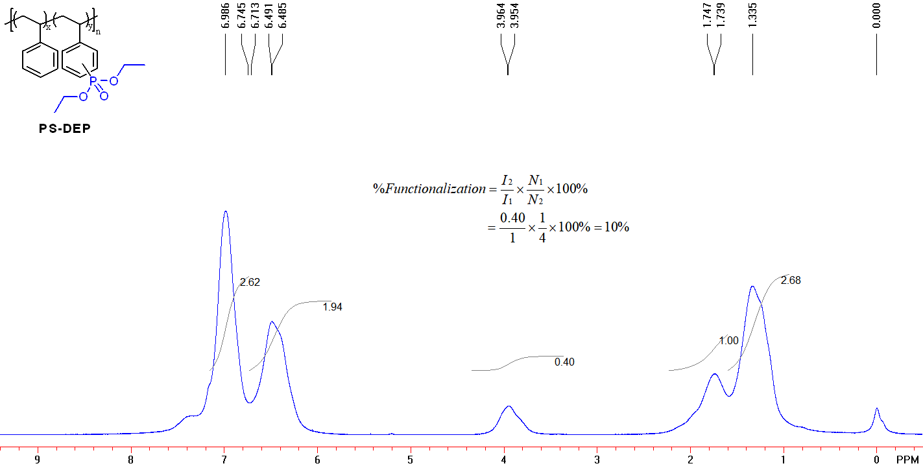
Figure S4. Calculation of the functionalization degree.
The functionalization (i.e., % functionalization) were calculated from ¹H NMR using equation S2：
Where H₂, H₁, H_{ref}, N₁, N₂ represents the integral of the proton signal of the benzene ring on the modified polymer, the integral of the proton signal of the benzene ring on the polystyrene, the integral of the reference peak (with the same number of protons between the product and the scaffold), the number of protons represented by the reference peak and the integral of the protons of the benzene ring on the modified polymer. The application of this equation is illustrated as an inset in the ¹H NMR of Figure S5.
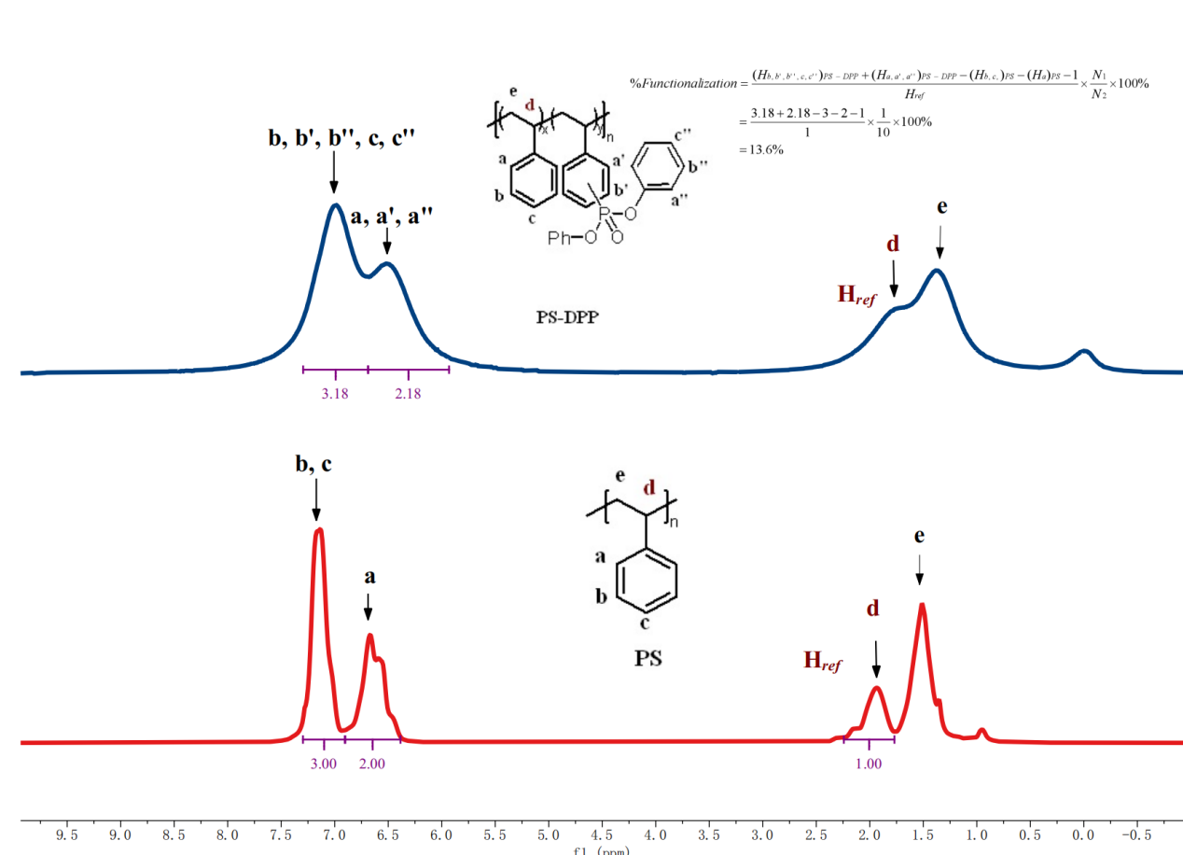
Figure S5. Calculation of the functionalization degree.

- Experimental Procedures for the Phosphorylation of PS
4.1 Screening the optimal reaction conditions
Table S1: Screening the optimal reaction conditions with Diethyl phosphite (DEP) under Mn(OAc)₃·2H₂O catalysis.
Entry | Solvent | [DEP]/[PS] | [Mn(OAc)₃·2H₂O] | T  (℃) | t  (h) | Functionalization ^{b}  (%)
1 | DMF | 2 | 3 | 80 | 12 | 0
2 | DMF | 2 | 2 | 80 | 12 | 1.25
3 | DMF | 2 | 1 | 80 | 12 | 5
4 | DMF | 2 | 0.2 | 80 | 12 | 2
5 | DMF | 1 | 3 | 80 | 12 | 0
6 | DMF | 1 | 2 | 80 | 12 | 0
7 | DMF | 1 | 1 | 80 | 12 | 1.75
8 | DMF | 1 | 0.2 | 80 | 12 | 6
9 | DMF | 2 | 1 | 60 | 12 | 5
10 | DMF | 2 | 1 | 100 | 12 | 2.25
11 | DMF | 2 | 1 | 120 | 12 | 0.75
12 | DCE | 2 | 1 | 80 | 12 | 4.5
13 | DCM | 2 | 1 | 80 | 12 | 4.5
14 | CHCl₃ | 2 | 1 | 80 | 12 | 2
15 | DMF: HOAc = 10: 1 | 2 | 1 | 80 | 12 | n.d
16 | DMF: HOAc = 20: 1 | 2 | 1 | 80 | 12 | 5
ªConditions: PS, DEP, solvent (1.0 mL). ^{b}The functionalization of PS was determined by the ¹H NMR analysis.
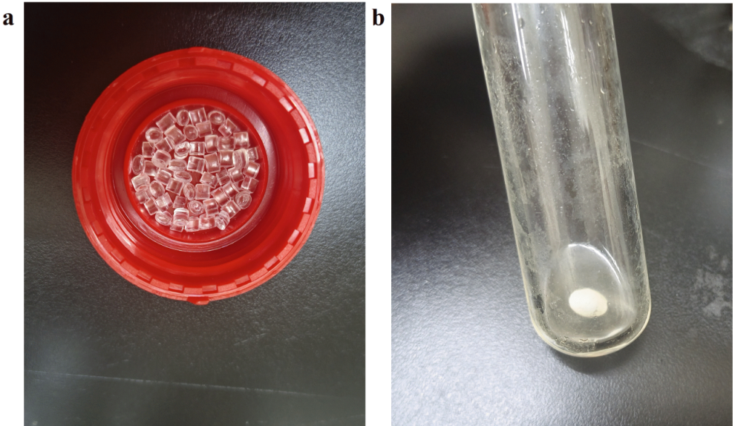
Figure S6. (a) Picture of Polystyrene (PS). (b) Picture of the reaction fluid in the reaction tube.

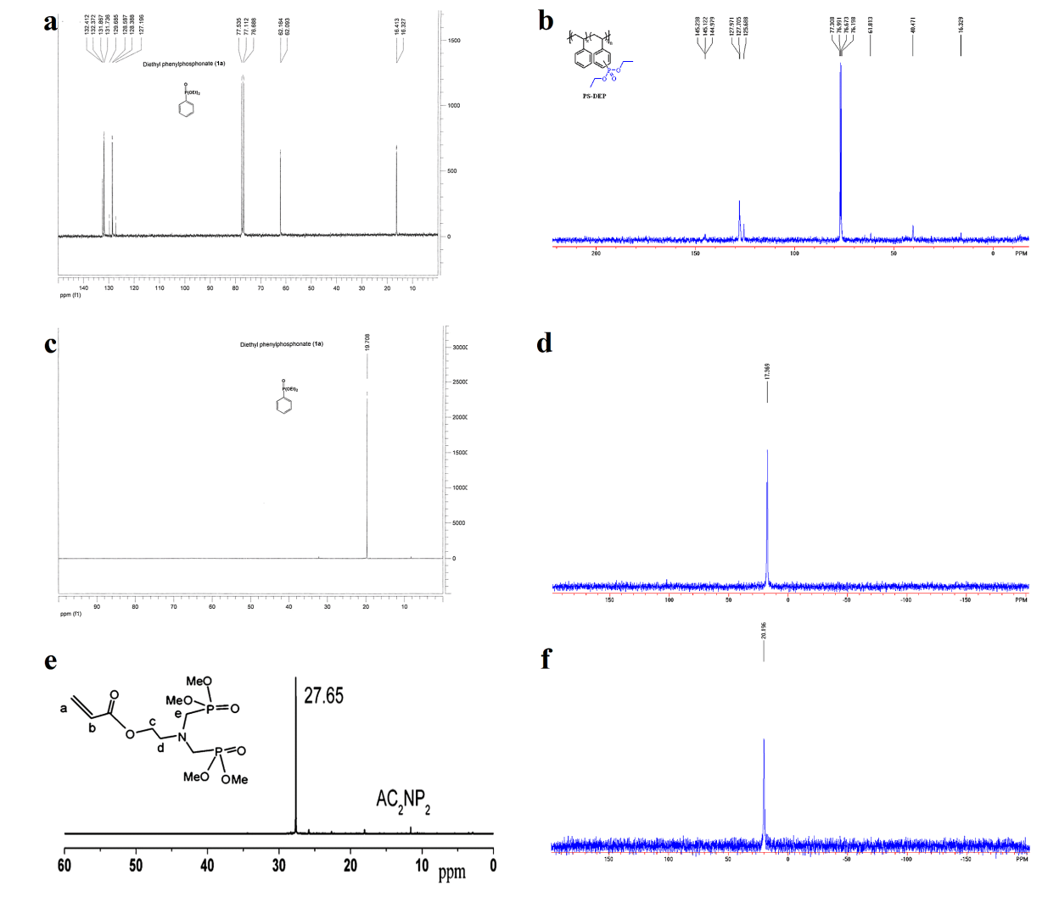
Figure S7. (a) ¹³C NMR (125.7 MHz, CDCl₃) spectrum¹ of Diethyl phenylphosnate. (b) ¹³C NMR (100 MHz, CDCl₃) spectrum of PS-DEP. (c) ³¹P NMR (CDCl₃) spectrum¹ of Diethyl phenylphosnate. (d) ³¹P NMR (162 MHz, CDCl₃) spectrum of PS-DEP. (e) ³¹P NMR (CDCl₃) spectrum² of AC₂NP₂. (f) ³¹P NMR (162 MHz, CDCl₃) spectrum of PS-DMP.
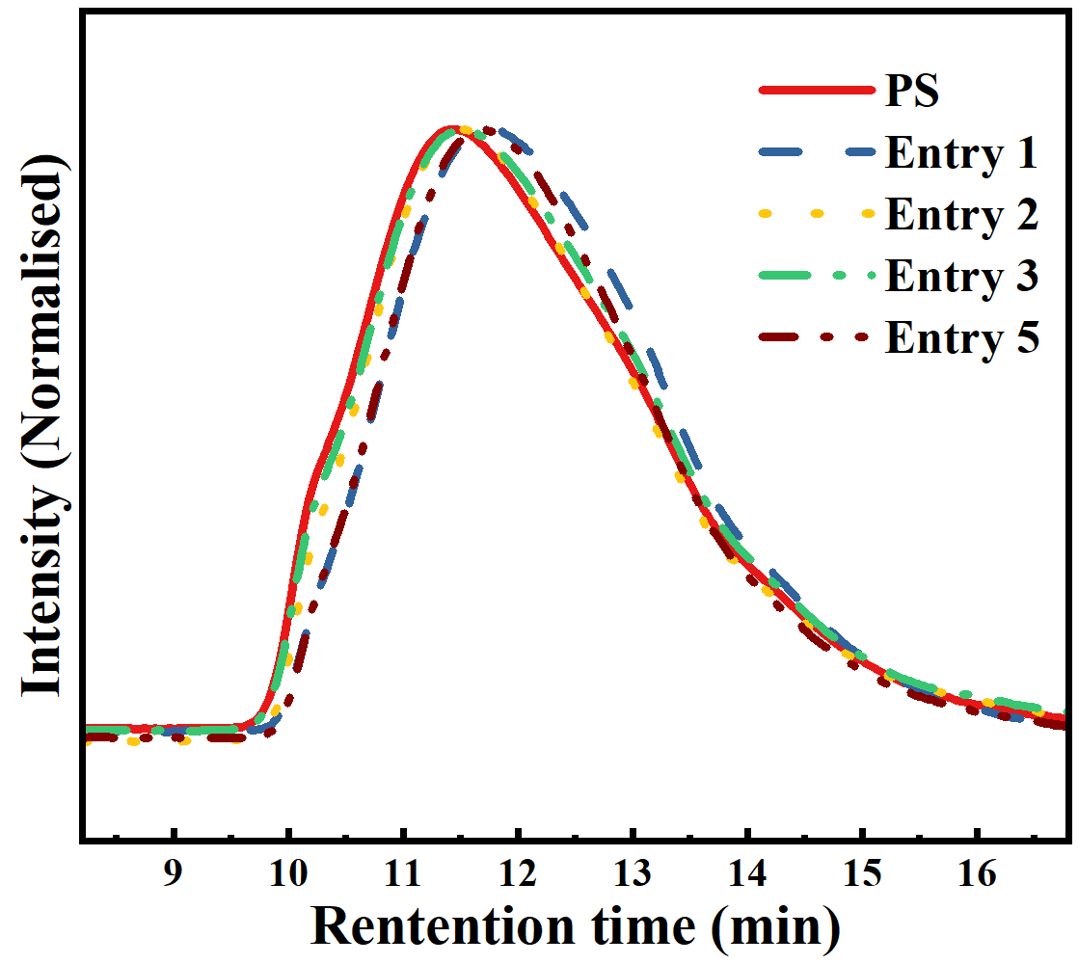
Figure S8. GPC traces for PS, entries 1, 2, 3 and 5 of Table1.
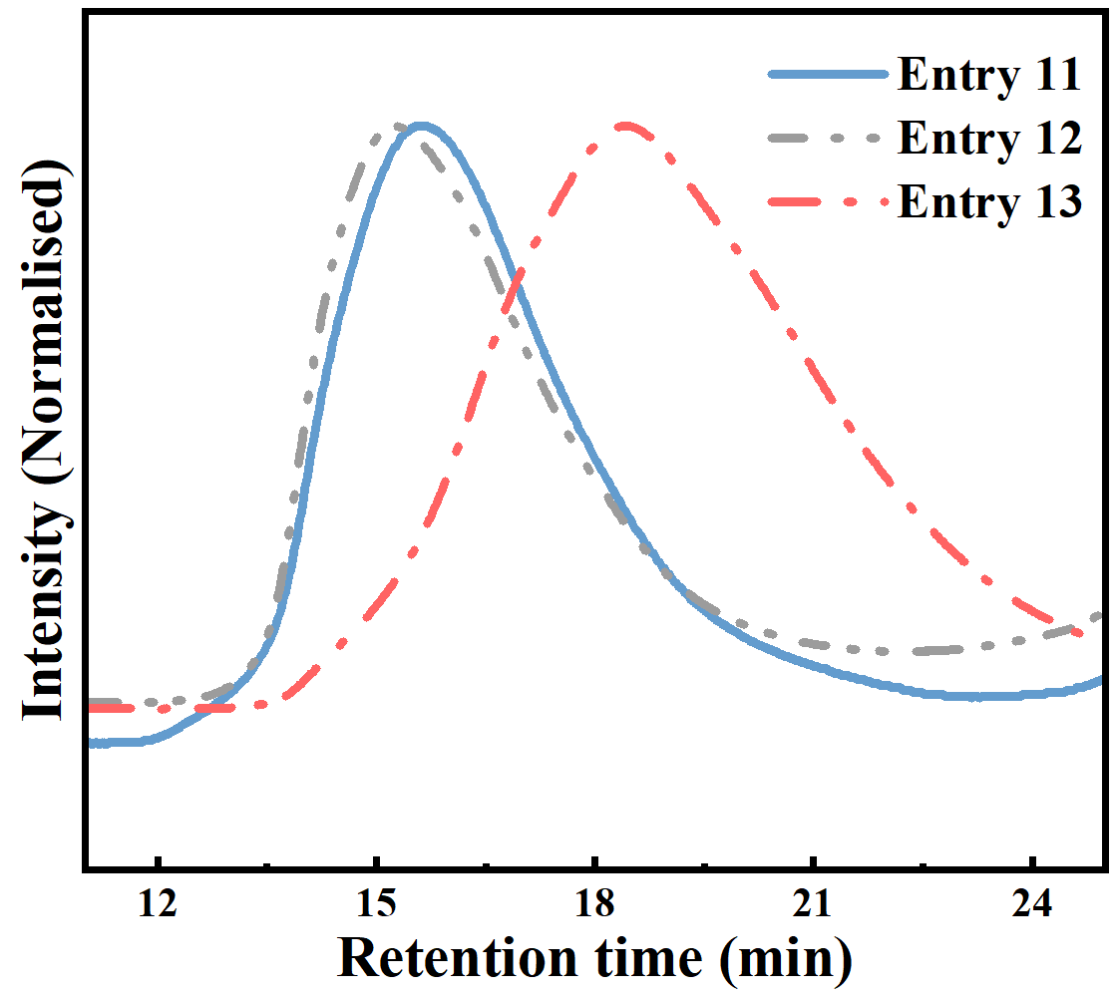
Figure S9. GPC traces for entries 11, 12 and 13 of Table1.

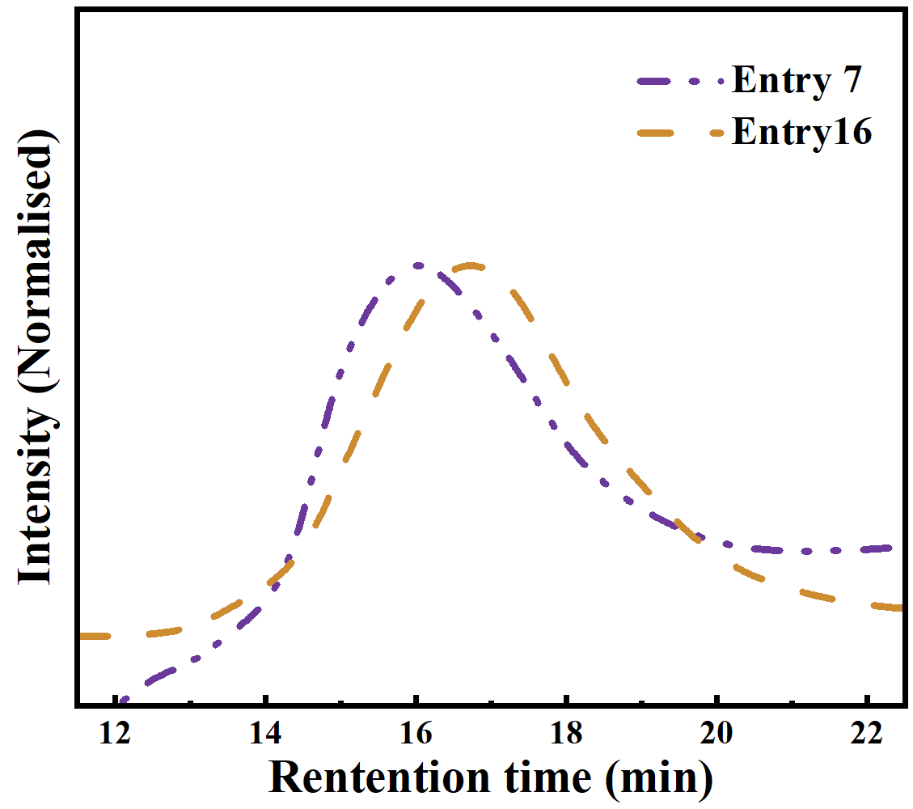
Figure S10. GPC traces for entries 7 and 16 of Table1.

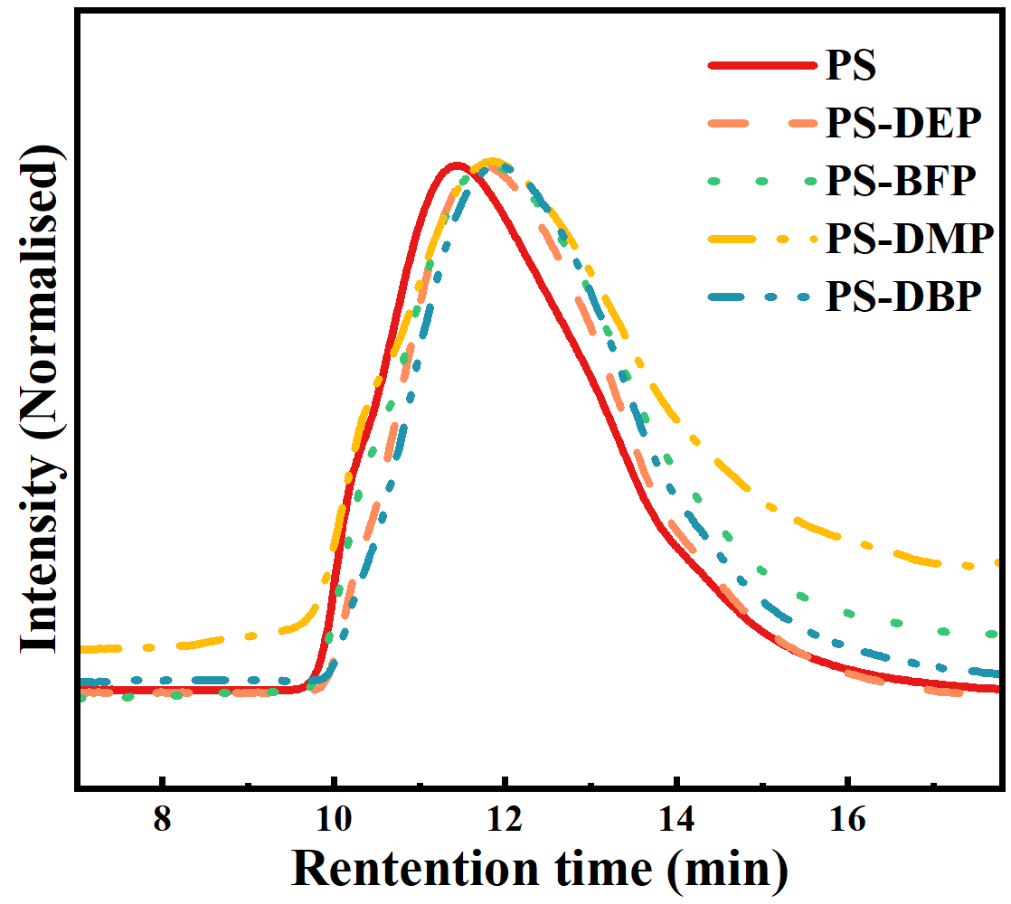
Figure S11. GPC traces of PS, PS-DEP, PS-BFP, PS-DMP and PS-DBP of Table2.
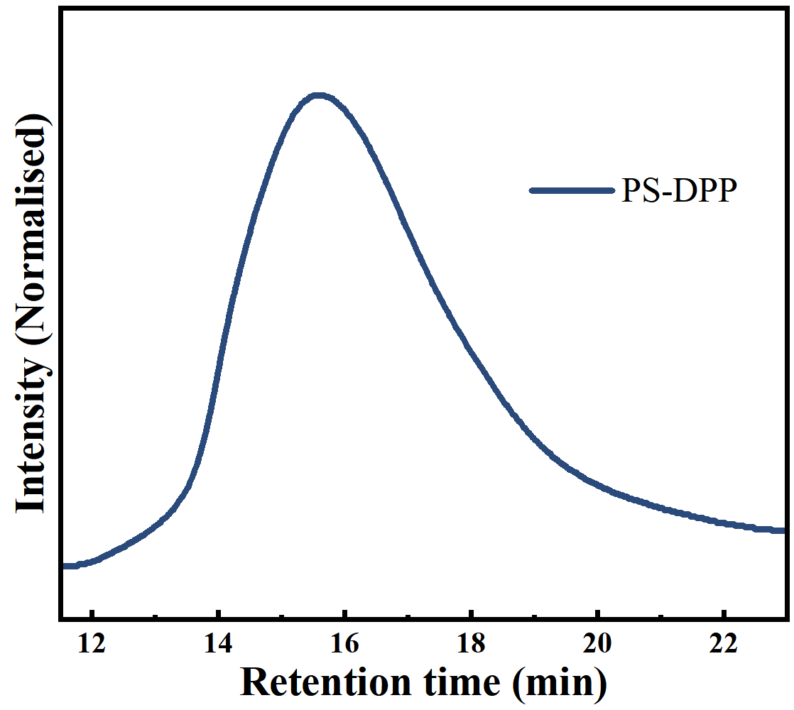
Figure S12. GPC trace of PS-DPP of Table2.

4.2 General procedure for the phosphorylation

Diethyl Phosphite Phosphorylation of polystyrene: polystyrene (PS) (50.3 mg, 0.4830 mmol), Diethyl phosphite (DEP) (66.7 mg, 0.4830 mmol), Manganous acetate (16.7 mg, 20 mol%) and DMF: HOAc = 10: 1 (1.0 mL) were added to a Schlenk reaction tube. The solution was reacted at 80 ℃ for 12 hours. After cooling to room temperature, the solution was dissolved with dichloromethane and transferred to the pear-shaped liquid funnel. The organic phase purified by washing the water three to five times, dried with anhydrous sodium sulfate, concentrated and precipitated into methanol, filtered to obtain solid sediment and dried under vacuum. If necessary, the precipitation process was repeated one more time to ensure complete removal of any small molecules trapped in the polymer. The product was isolated white solid. (25.9 mg, 51.5 %).
¹H NMR (CDCl₃, 400 MHz): δ 7.18-6.76 (br, 3H, C₆H₅), 6.76-5.98 (br, 2H, C₆H₅), 4.3-3.5 (br, 2H, OCH₂CH₃), 2.25-1.60 (br, 1H CHCH₂), 1.60-1.05 (br).
¹³C NMR (CDCl₃, 100MHz): δ 145.238, 145.122, 144.979, 127.971, 127.705, 125.688, 77.308, 76.991, 76.673, 61.813, 40.471, 16.329.
³¹P NMR (CDCl₃, 162 MHZ): δ 17.369.
IR (neat, ATR, cm⁻¹): 3082, 3060, 3026, 3000, 2979, 2923, 2850, 1682, 1602, 1583, 1493, 1452, 1390, 1367, 1251, 1181, 1162, 1155, 1129, 1096, 1052, 1022, 962, 907, 831, 811, 790, 757, 750, 696, 620, 561, 539.
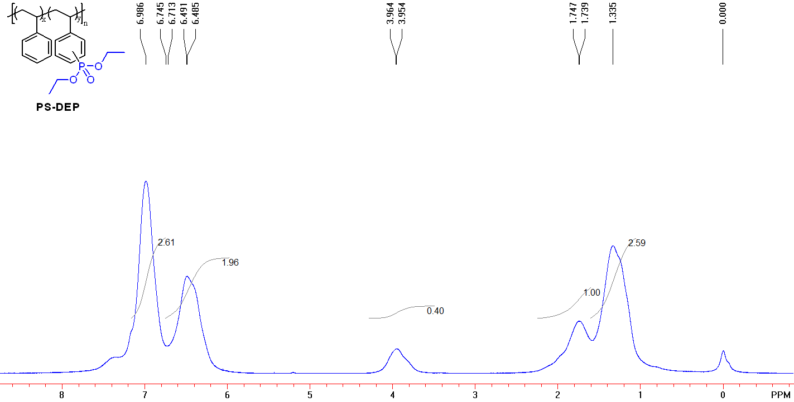
Figure S13. ¹H NMR (400 MHz, CDCl₃) spectrum of PS-DEP.
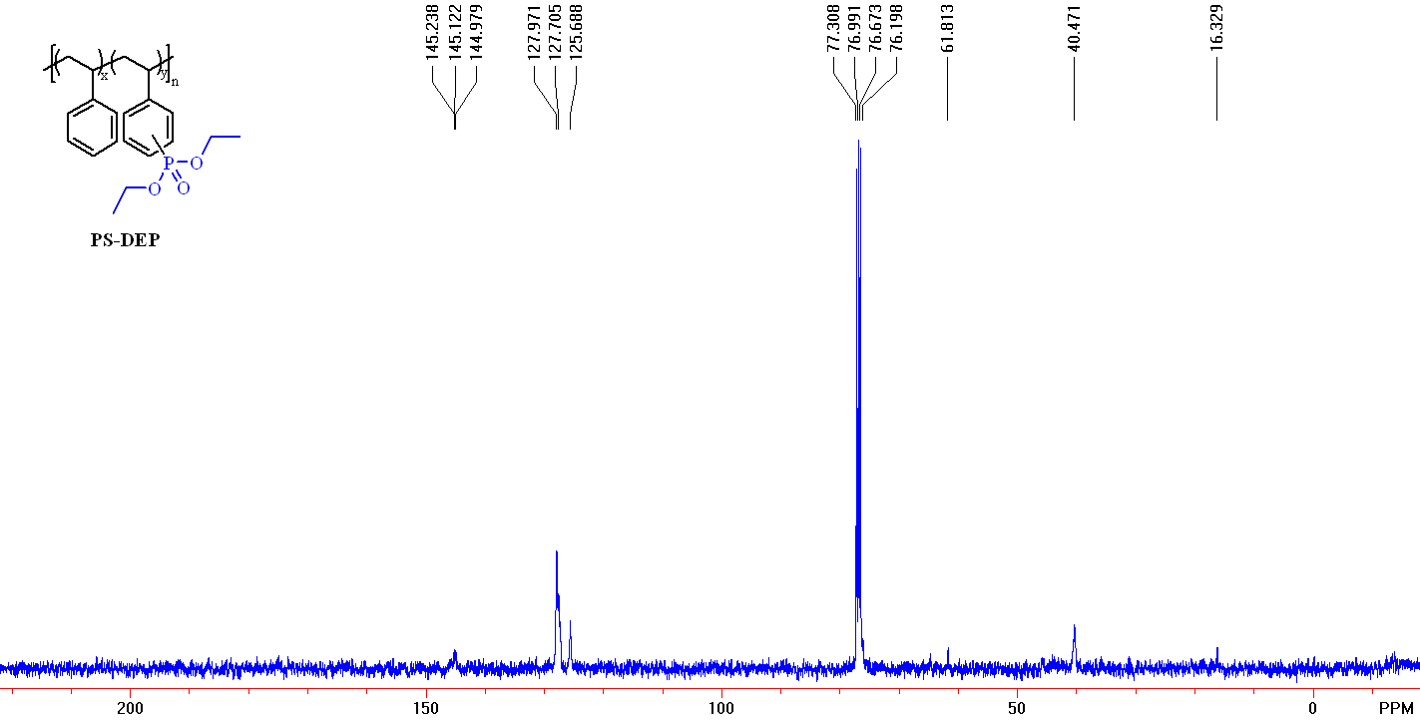
Figure S14. ¹³C NMR (100 MHz, CDCl₃) spectrum of PS-DEP.
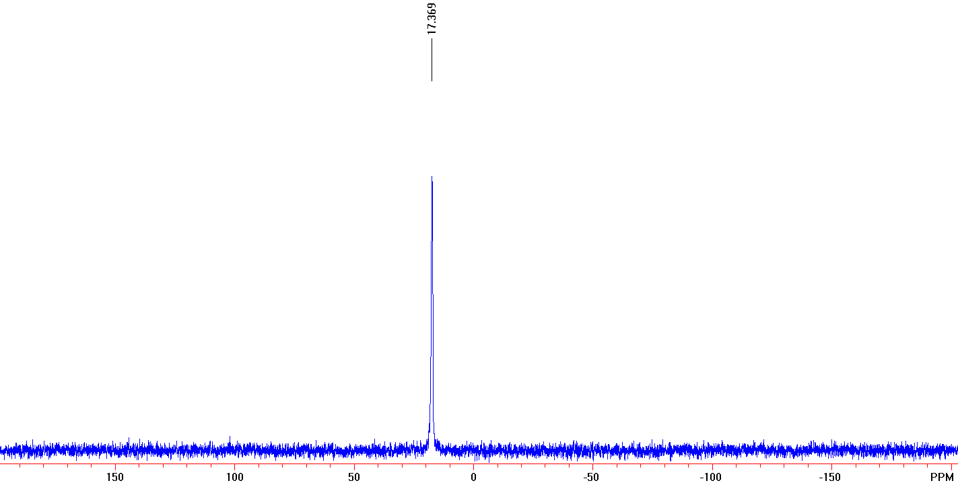
Figure S15. ³¹P NMR (162 MHz, CDCl₃) spectrum of PS-DEP.
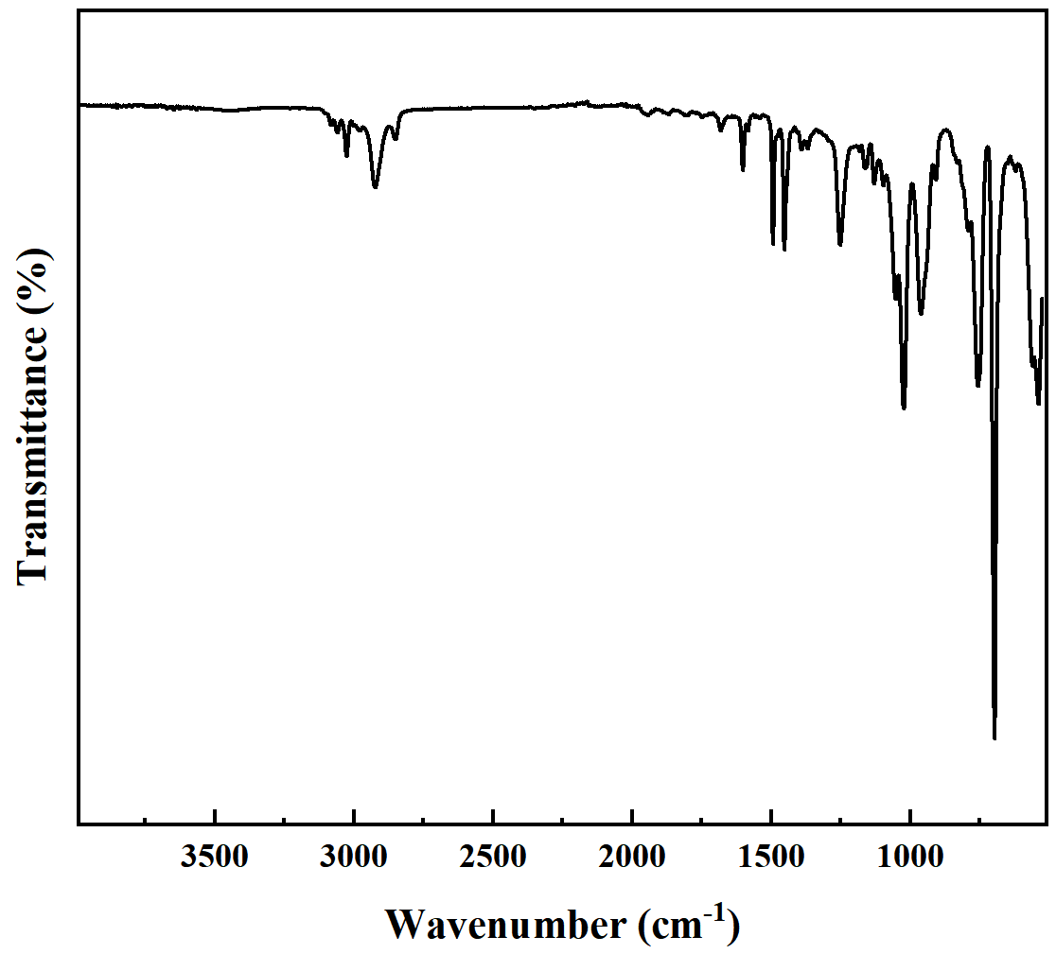
Figure S16. FT-IR spectra of PS-DEP.

Bis (2, 2, 2-trifluoroethyl) Phosphite Phosphorylation of polystyrene (PS-BFP):
PS-BFP: polystyrene (PS) (52.8 mg, 0.507 mmol), Bis (2, 2, 2-trifluoroethyl) Phosphite (BFP) (131 mg, 0.507 mmol), Manganous acetate (17.8 mg, 20 mol%) and DMF (1.0 mL) were added to a Schlenk reaction tube. The solution was reacted at 80 ℃ for 12 hours. After cooling to room temperature, the solution was dissolved with dichloromethane and transferred to the pear-shaped liquid funnel. The organic phase purified by washing the water three to five times, dried with anhydrous sodium sulfate, concentrated and precipitated into methanol, filtered to obtain solid sediment and dried under vacuum. If necessary, the precipitation process was repeated one more time to ensure complete removal of any small molecules trapped in the polymer. The product was isolated white solid (33 mg, 62.5 %).
¹H NMR (CDCl₃, 400 MHz): δ 7.16-6.78 (br, 3H, C₆H₅), 6.78-6.18 (br, 2H, C₆H₅), 4.57-3.94 (br, 2H, OCH₂CF₃), 2.11-1.59 (br, 1H CHCH₂), 1.59-1.23 (br, 2H CHCH₂).
³¹P NMR (CDCl₃, 162 MHZ): δ 19.908, 19.610, 16.942.
IR (neat, ATR, cm⁻¹): 3103, 3083, 3060, 3026, 3001, 2923, 2851, 1601, 1583, 1493, 1452, 1419, 1373, 1287, 1260, 1170, 1132, 1070, 1027, 1003, 962, 906, 874, 841, 755, 748, 695, 660, 537.
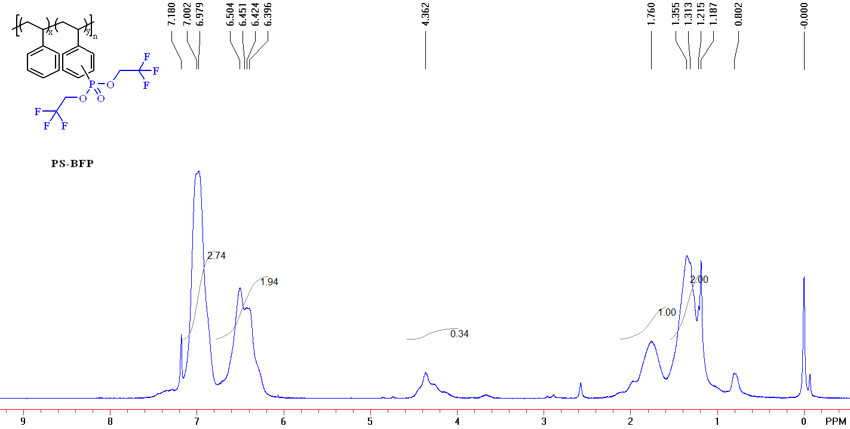
Figure S17. ¹H NMR (400 MHz, CDCl₃) spectrum of PS-BFP.
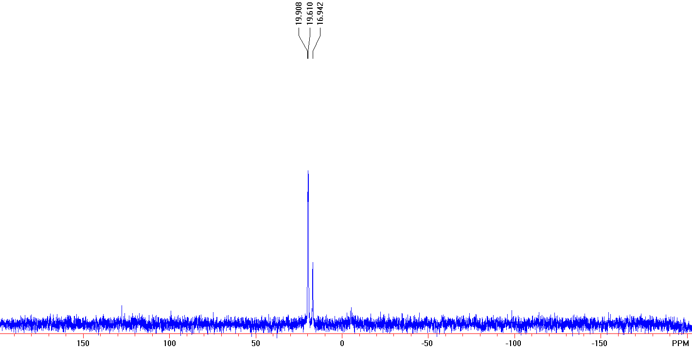
Figure S18. ³¹P NMR (162 MHz, CDCl₃) spectrum of PS-BFP.
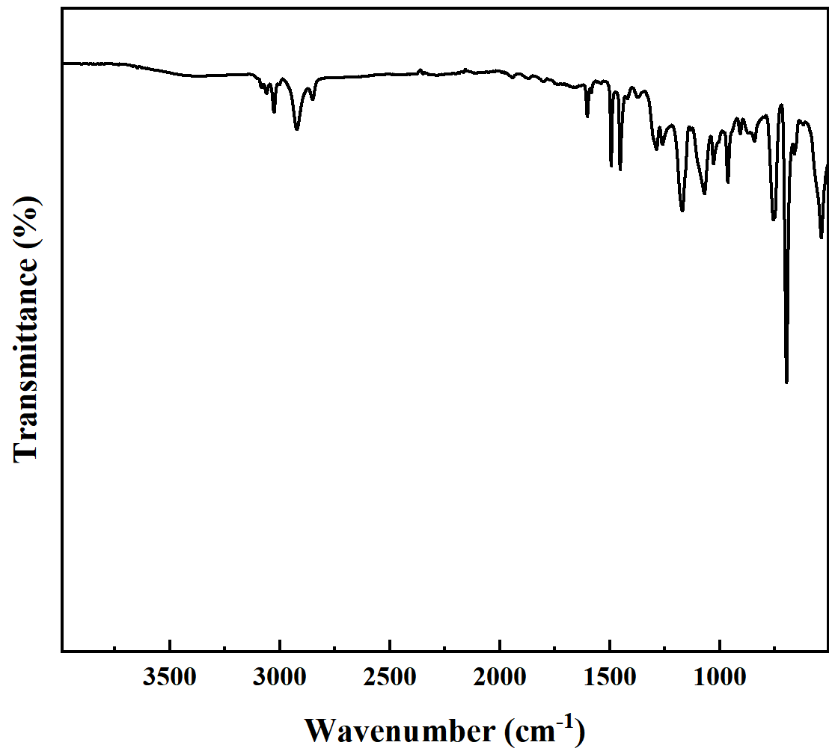
Figure S19. FT-IR spectra of PS-BFP.

Dimethyl Phosphonate Phosphorylation of polystyrene (PS-DMP):
PS-DMP: polystyrene (PS) (46.2 mg, 0.444 mmol), Dimethyl Phosphonate (DMP) (49 mg, 0.444 mmol), Manganous acetate (15.8 mg, 20 mol%) and DMF (1.0 mL) were added to a Schlenk reaction tube. The solution was reacted at 80 ℃ for 12 hours. After cooling to room temperature, the solution was dissolved with dichloromethane and transferred to the pear-shaped liquid funnel. The organic phase purified by washing the water three to five times, dried with anhydrous sodium sulfate, concentrated and precipitated into methanol, filtered to obtain solid sediment and dried under vacuum. If necessary, the precipitation process was repeated one more time to ensure complete removal of any small molecules trapped in the polymer. The product was isolated white solid (33.2 mg, 71.8 %).
¹H NMR (CDCl₃, 400 MHz): δ 7.8-6.78 (br, 3H, C₆H₅), 6.78-5.95 (br, 2H, C₆H₅), 4.07-3.29 (br, 2H, OCH₃), 2.28-1.69 (br, 1H CHCH₂), 1.69-1.18 (br, 2H CHCH₂).
³¹P NMR (CDCl₃, 162 MHZ): δ 20.305.
IR (neat, ATR, cm⁻¹): 3103, 3083, 3059, 3026, 3000, 2922, 2850, 1601, 1582, 1493, 1451, 1375, 1259, 1183, 1154, 1127, 1050, 1028, 907, 823, 800, 755, 697, 539.
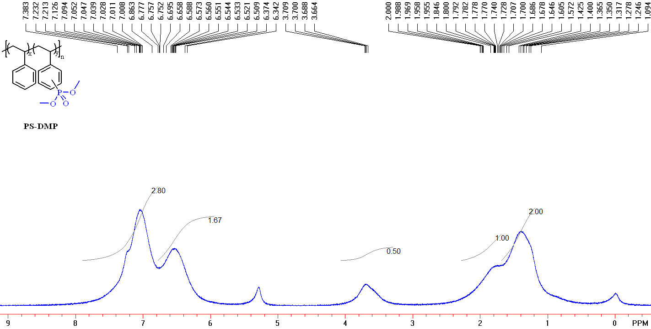
Figure S20. ¹H NMR (400 MHz, CDCl₃) spectrum of PS-DMP.
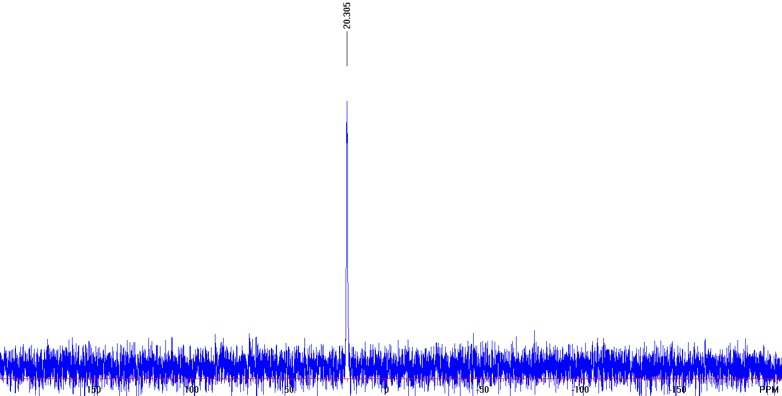
Figure S21. ³¹P NMR (162 MHz, CDCl₃) spectrum of PS-DMP.
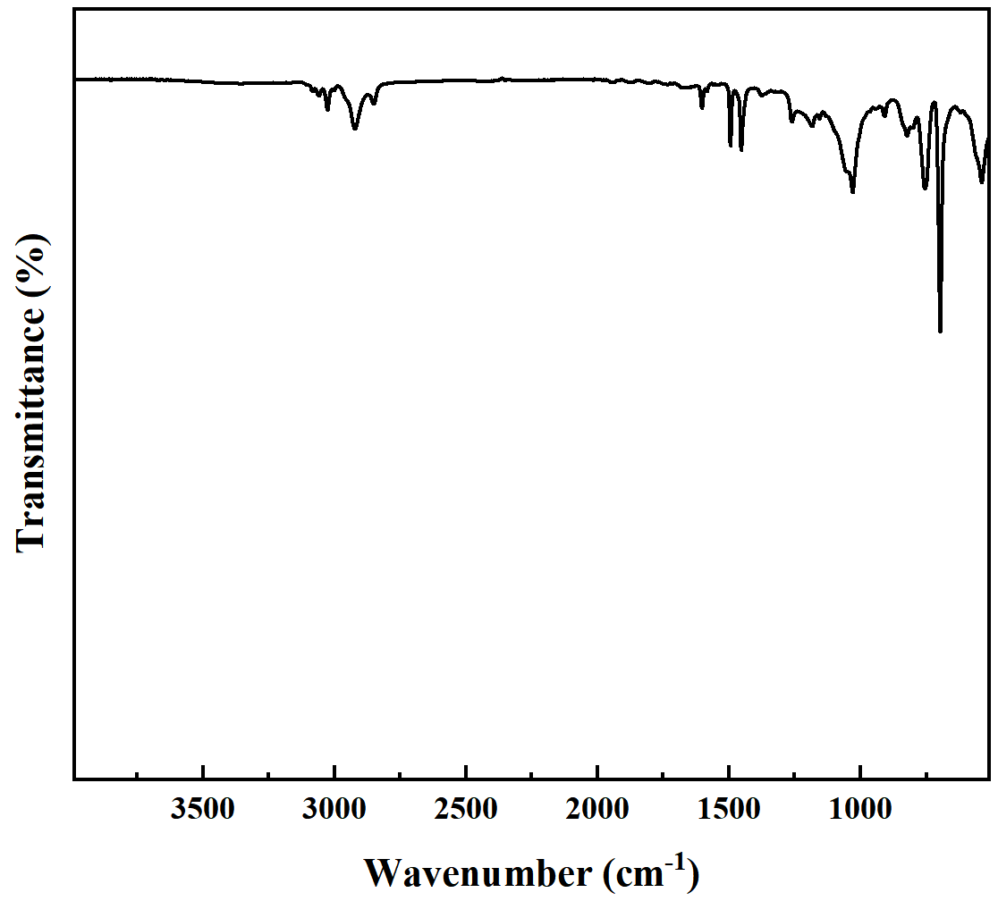
Figure S22. FT-IR spectra of PS-DMP.

Dibutyl Phosphonate Phosphorylation of polystyrene (PS-DBP):
PS-DBP: polystyrene (PS) (50.3 mg, 0.4830 mmol), Dibutyl Phosphonate (DBP) (93.8 mg, 0.4830 mmol), Manganous acetate (16.7 mg, 20 mol%) and DMF (1.0 mL) were added to a Schlenk reaction tube. The solution was reacted at 80 ℃ for 12 hours. After cooling to room temperature, the solution was dissolved with dichloromethane and transferred to the pear-shaped liquid funnel. The organic phase purified by washing the water three to five times, dried with anhydrous sodium sulfate, concentrated and precipitated into methanol, filtered to obtain solid sediment and dried under vacuum. If necessary, the precipitation process was repeated one more time to ensure complete removal of any small molecules trapped in the polymer. The product was isolated white solid (40.5 mg, 80.5 %).
¹H NMR (CDCl₃, 400 MHz): δ 7.16-6.78(br, 3H, C₆H₅), 6.78-6.22 (br, 2H, C₆H₅), 4.30-3.54 (br, 2H, OCH₂CH₂CH₂CH₃), 2.16-1.67 (br, 1H CHCH₂), 1.67-0.96 (br), 0.96-0.72 (br).
³¹P NMR (CDCl₃, 162 MHZ): δ 17.110.
IR (neat, ATR, cm⁻¹): 3103, 3082, 3059, 3026, 3001, 2957, 2924, 2870, 2851, 1601, 1583, 1542, 1492, 1452, 1409, 1377, 1328, 1312, 1256, 1233, 1182, 1154, 1128, 1065, 1025, 976, 906, 843, 800, 756, 749, 696, 649, 620, 560, 539.
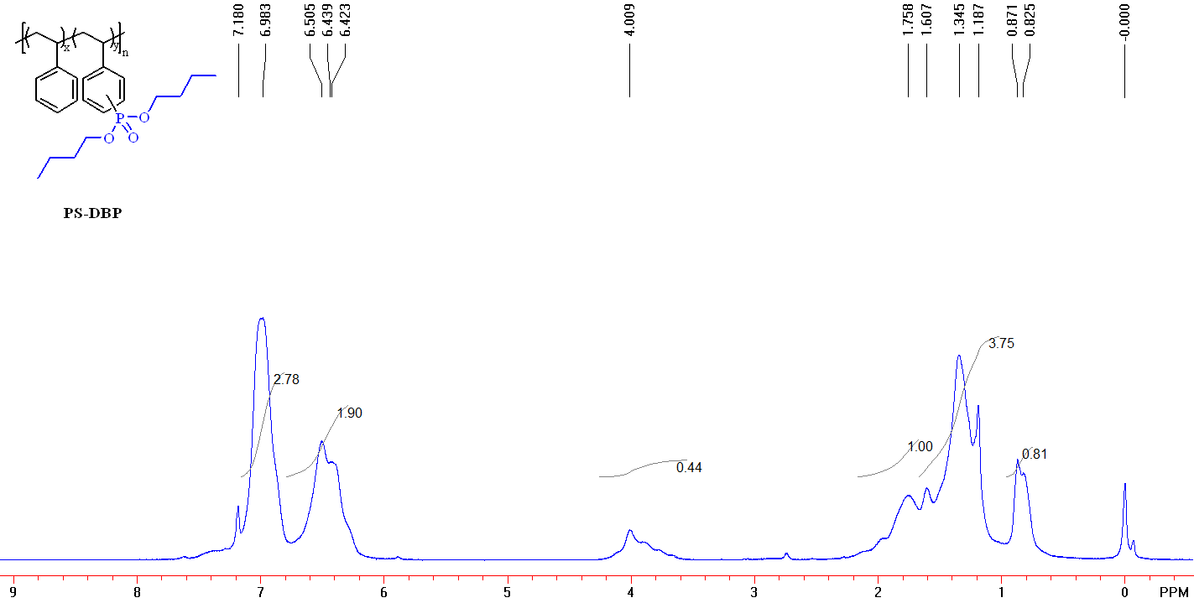
Figure S23. ¹H NMR (400 MHz, CDCl₃) spectrum of PS-DBP.
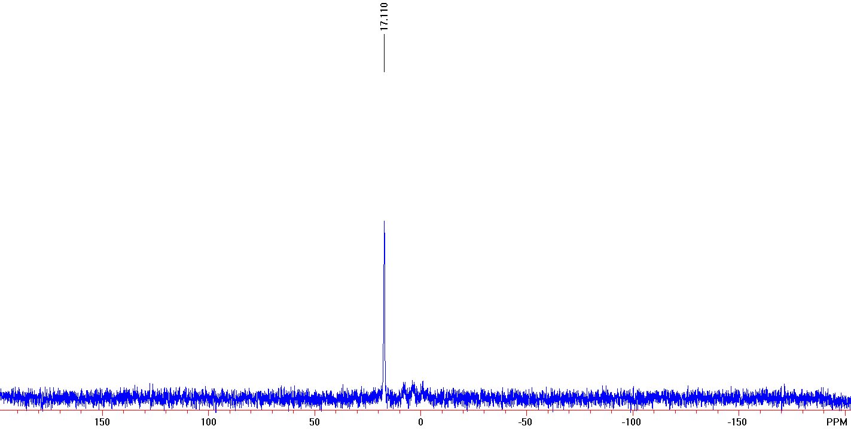
Figure S24. ³¹P NMR (162 MHz, CDCl₃) spectrum of PS-DBP.

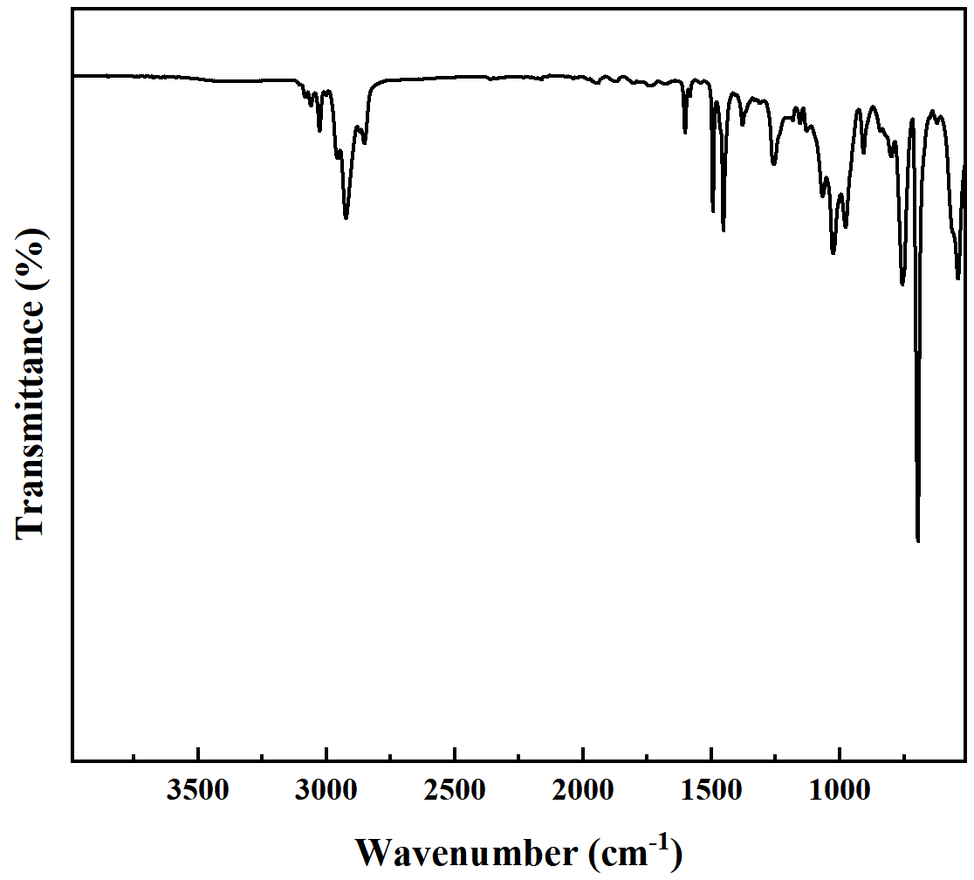
Figure S25. FT-IR spectra of PS-DBP.

Diphenyl Phosphite Phosphorylation of polystyrene (PS-DPP):
PS-DPP: polystyrene (PS) (52.6 mg, 0.505 mmol), Diphenyl Phosphite (DPP) (126.4 mg, 0.505 mmol), Manganous acetate (17.5 mg, 20 mol%) and DMF (1.0 mL) were added to a Schlenk reaction tube. The solution was reacted at 80 ℃ for 12 hours. After cooling to room temperature, the solution was dissolved with dichloromethane and transferred to the pear-shaped liquid funnel. The organic phase purified by washing the water three to five times, dried with anhydrous sodium sulfate, concentrated and precipitated into methanol, filtered to obtain solid sediment and dried under vacuum. If necessary, the precipitation process was repeated one more time to ensure complete removal of any small molecules trapped in the polymer. The product was isolated white solid (49.5 mg, 94.1 %).
¹H NMR (CDCl₃, 400 MHz): δ 7.25-6.76 (br), 6.75-6.00 (br), 2.04-1.61 (br, 1H CHCH₂), 1.58-1.16 (br, 2H CHCH₂).
³¹P NMR (CDCl₃, 162 MHZ): δ 10.537.
IR (neat, ATR, cm⁻¹): 3102, 3083, 3060, 3025, 3000, 2922, 2851, 1943, 1869, 1801, 1749, 1601, 1584, 1540, 1492, 1451, 1375, 1262, 1213, 1190, 1154, 1070, 1027, 980, 964, 933, 927, 906, 841, 802, 753, 748, 695, 619, 539.
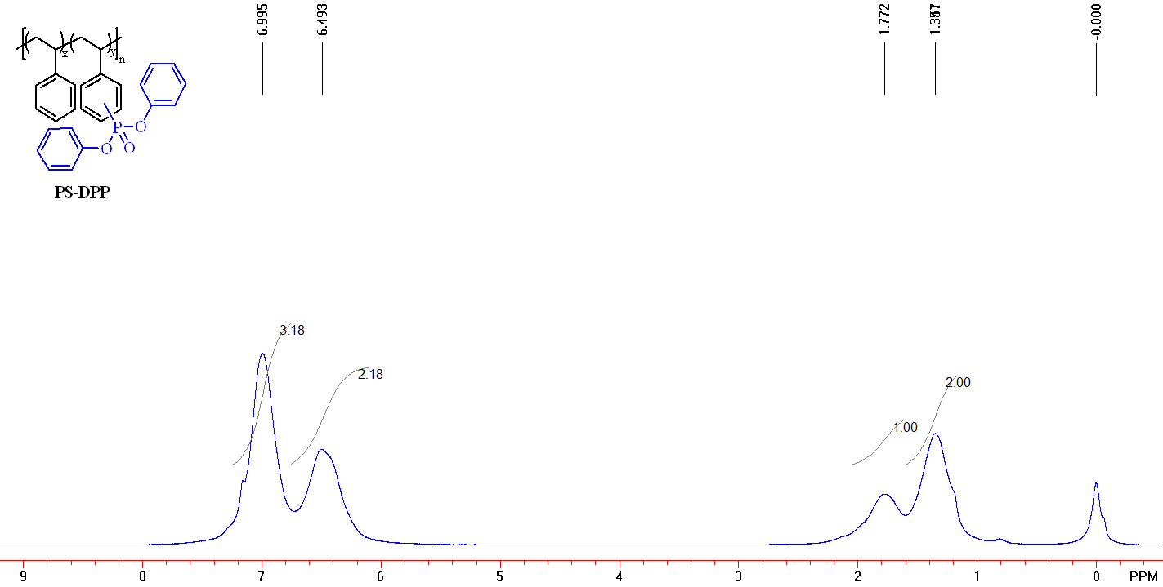
Figure S26. ¹H NMR (400 MHz, CDCl₃) spectrum of PS-DPP.
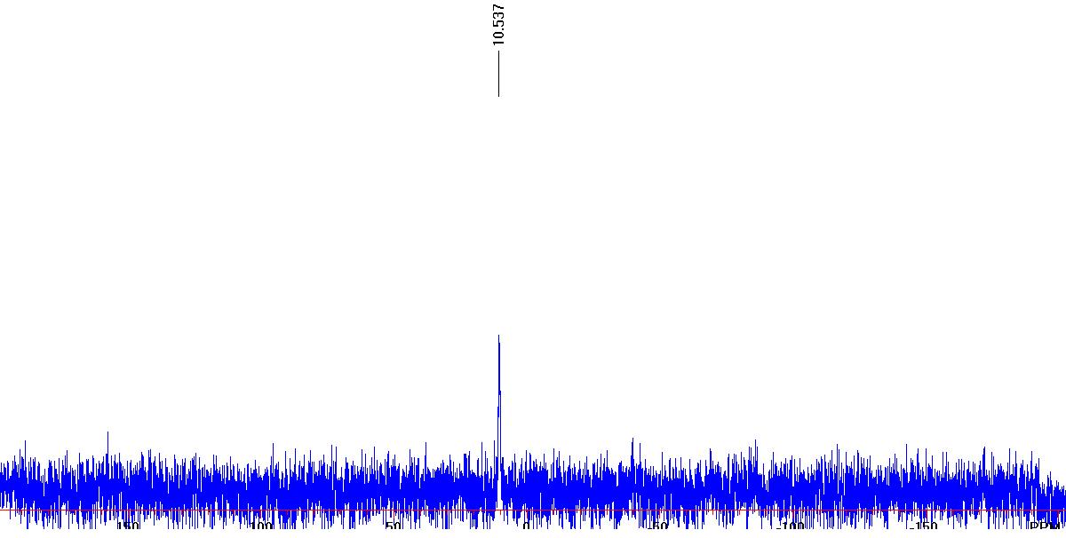
Figure S27. ³¹P NMR (162 MHz, CDCl₃) spectrum of PS-DPP.
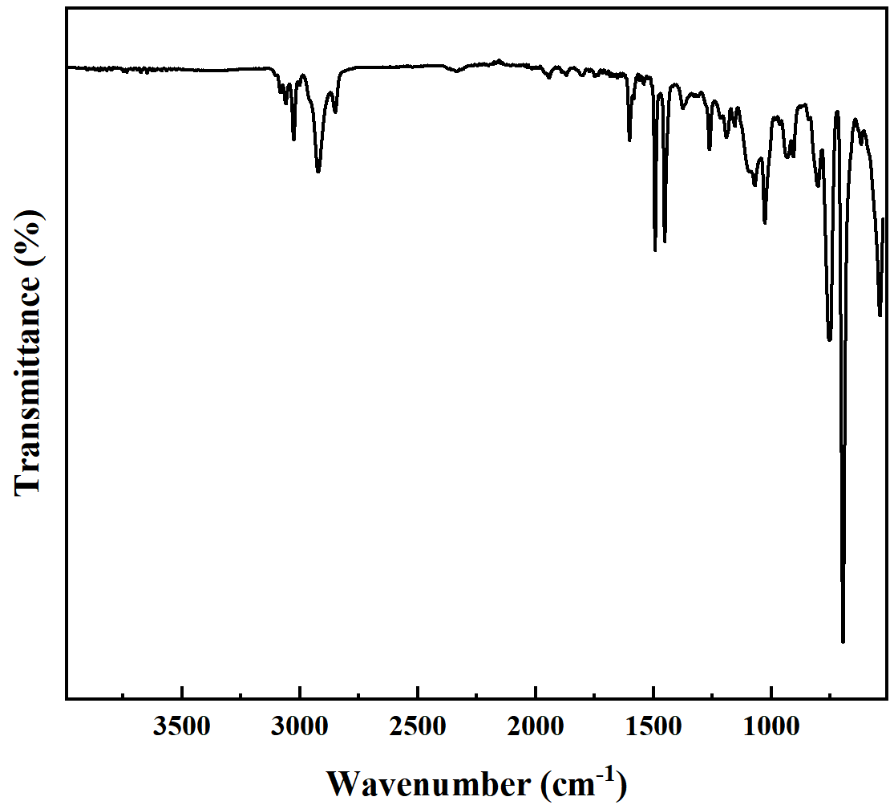
Figure S28. FT-IR spectra of PS-DPP.

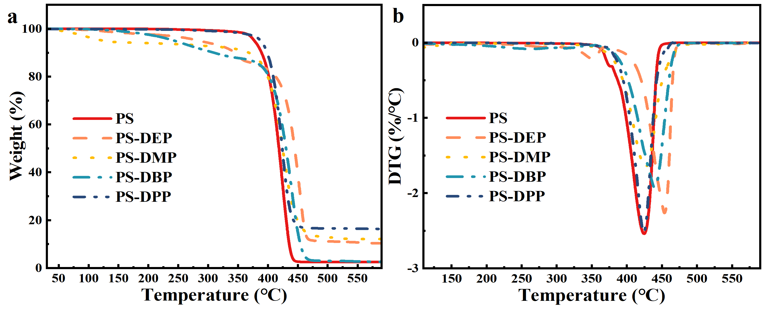
Figure S29. TGA(a) and DTG(b) curves of PS, PS-DEP, PS-DMP, PS-DBP and PS-DPP under nitrogen atmosphere.
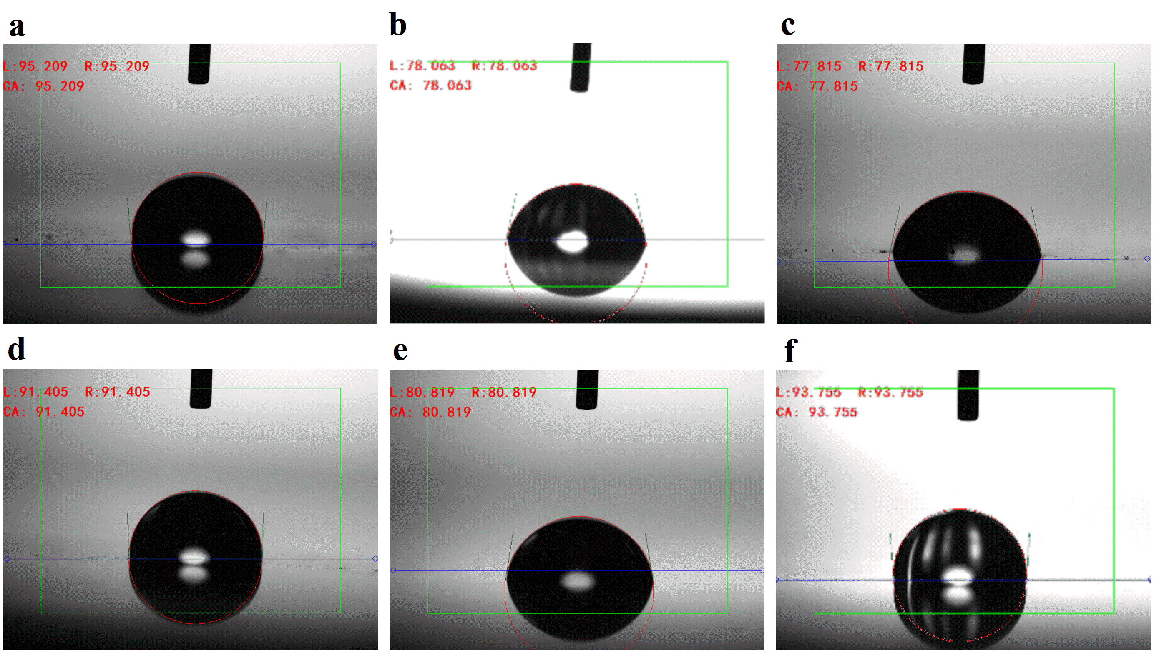
Figure S30. Selected images of water droplets on (a) PS. (b) PS-DEP (10.0 % functionality). (c) PS-BFP (8.5 % functionality). (d) PS-DMP (8.3 % functionality). (e) PS-DBP (11.0 % functionality) and (f) PS-DPP (13.6 % functionality).

Table S2. TGA data of reference polymers.
Sample | Wt% | T_{5%}  (℃) | T_{50%}  (℃) | T_{max}  (℃) | Residue^{b}  (%)
PS | 100 | 377.5 | 418.5 | 424 | 2.48
PS-DPP | 95:5 | 384 | 419 | 423.5 | 2.4
 | 90:10 | 389 | 421 | 424 | 4.24
ªTGA tests were performed between 30-600 ℃ under nitrogen atmospheres with a heating rate of 10 ℃·min⁻¹. ^{b}Residue at 600 ℃.

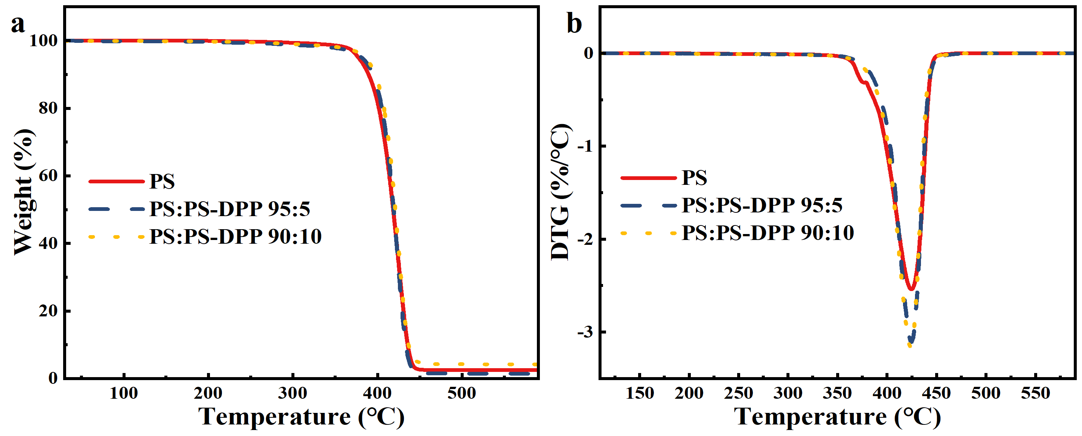
Figure S31. TGA (a) and DTG (b) curves of PS and blended PS with PS-DPP polymers under nitrogen atmosphere.

4.3 Functionalized commercial PS products
Foamed Polystyrene (FPS):
Appearance: white soild. GPC analysis (35 °C, THF): M_{n} = 163.5 kg/mol and Ð = 1.82.
¹H NMR ( CDCl₃, 400 MHz): δ 7.22-6.83 (br, 3H, C₆H₅), 6.83-6.30 (br, 2H, C₆H₅), 2.19-1.68 (br, 1H CHCH₂), 1.68-1.25 (br, 2H, CHCH₂).
¹³C NMR ( CDCl₃, 100 MHz): δ 146.090, 145.877, 145.764, 145.363, 128.000, 127.696, 127.469, 127.350, 125.675, 125.521, 77.342, 77.024, 76.708, 45.934, 45.688, 44.276, 43.959, 43.598, 43.240, 42.392, 41.849, 40.462.
FT-IR (film) ν_{max} (cm^{–1} ): 3105, 3082, 3060, 3026, 3002, 2922, 2850, 1942, 1871, 1802, 1746, 1601, 1583, 1492, 1452, 1371, 1328, 1312, 1182, 1155, 1069, 1028, 1003, 981, 966, 943, 907, 842, 755, 747, 695, 620, 538.
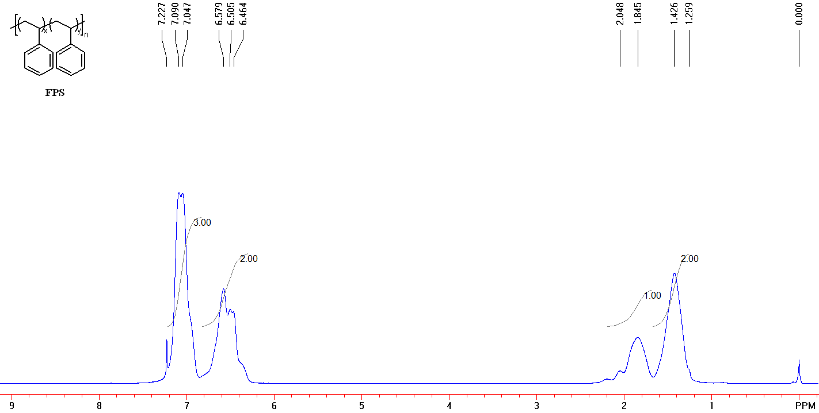
Figure S32. ¹H NMR (400 MHz, CDCl₃) spectrum of waste expandable FPS.

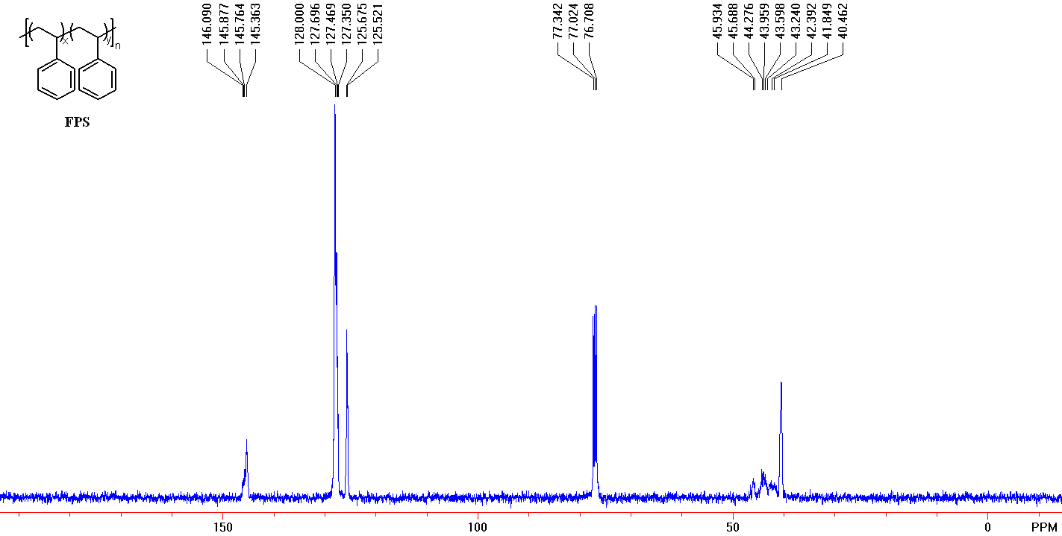
Figure S33. ¹³C NMR (100 MHz, CDCl₃) spectrum of waste expandable FPS.

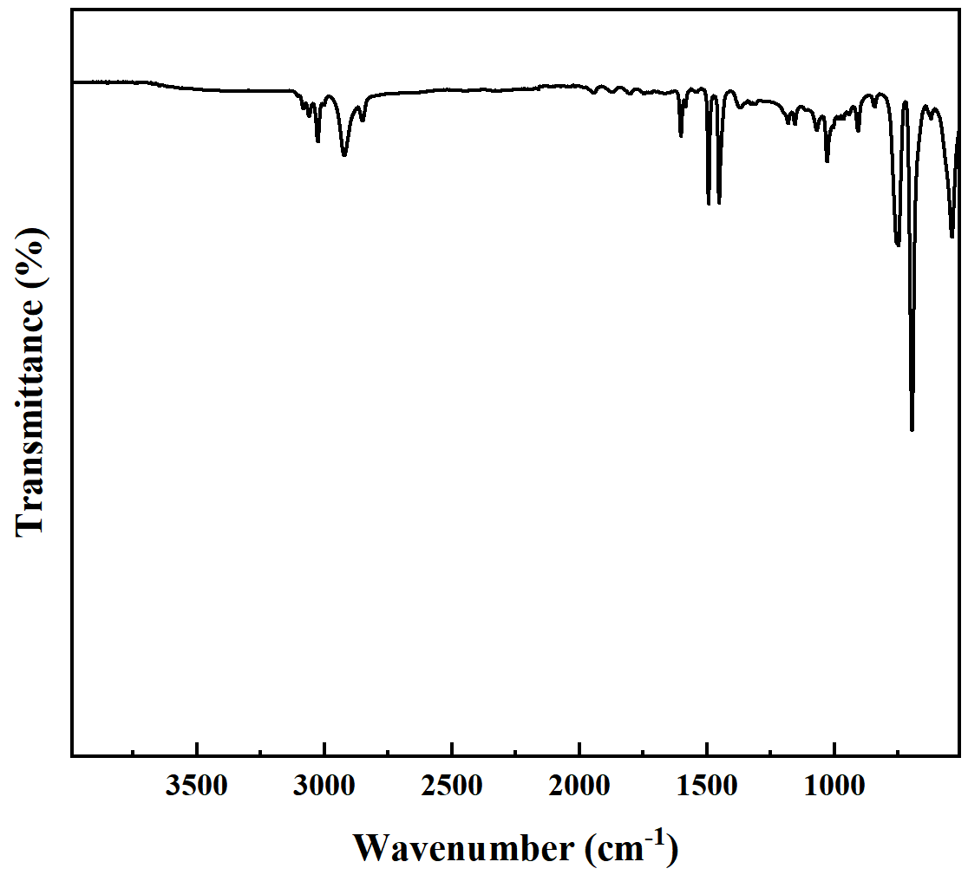
Figure S34. FT-IR spectra of FPS.

Diphenyl Phosphite Phosphorylation of foamed polystyrene (FPS-DPP):
FPS-DPP: foamed polystyrene (FPS) (258.7 mg, 2.484 mmol), Diphenyl Phosphite (DPP) (581.7 mg, 2.484 mmol), Manganous acetate (86.3 mg, 20 mol%) and DMF (2.0 mL) were added to a Schlenk reaction tube. The solution was reacted at 80 ℃ for 12 hours. After cooling to room temperature, the solution was dissolved with dichloromethane and transferred to the pear-shaped liquid funnel. The organic phase purified by washing the water three to five times, dried with anhydrous sodium sulfate, concentrated and precipitated into methanol, filtered to obtain solid sediment and dried under vacuum. If necessary, the precipitation process was repeated one more time to ensure complete removal of any small molecules trapped in the polymer. The product was isolated white solid (224.9 mg, 86.9 %).
¹H NMR (CDCl₃, 400 MHz) δ 7.17-6.73 (br), 6.73-6.00 (br), 2.04-1.61 (br, 1H CHCH₂), 1.60-1.12 (br, 2H CHCH₂).
IR (neat, ATR, cm⁻¹) 3104, 3083, 3060, 3062, 3002, 2921, 2849, 1601, 1492, 1452, 1373, 1277, 1262, 1180, 1133, 1106, 1027, 928, 905, 843, 801, 755, 696, 636, 617, 537.
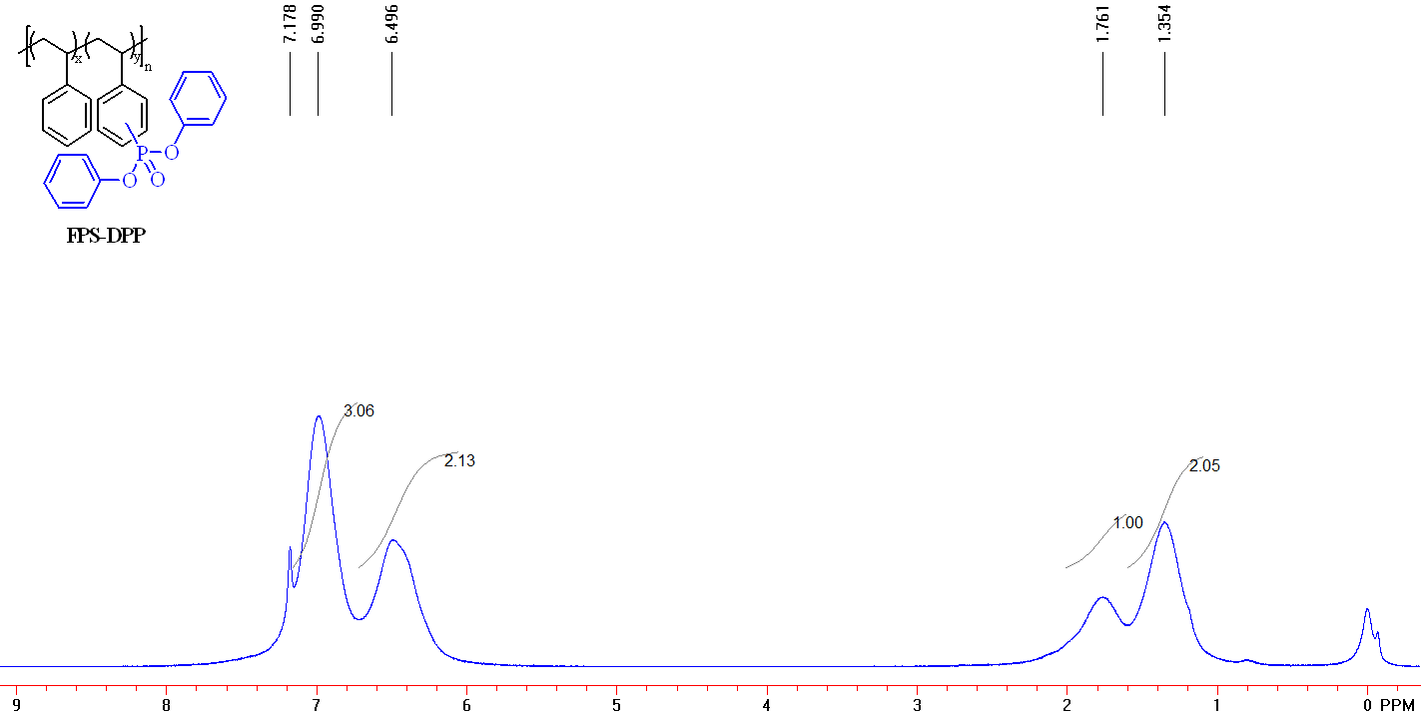
Figure S35. ¹H NMR (400 MHz, CDCl₃) spectrum of FPS-DPP.
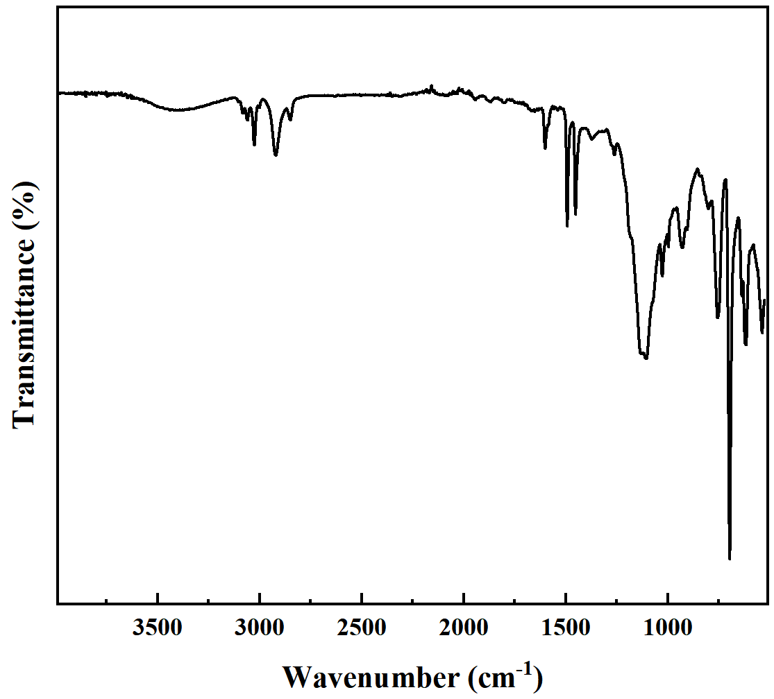
Figure S36. FT-IR spectra of FPS-DPP.

Poly(styrene-co-acrylonitrile) (SAN):
Appearance: white pellets. GPC analysis (35 °C, THF): M_{n} = 96.6 kg/mol and Ð = 1.38.
¹H NMR ( CDCl₃, 400 MHz): δ 7.24-6.94 (br, 3H, C₆H₅), 6.94-6.49 (br, 2H, C₆H₅), 2.93-2.40 (br), 2.40-1.96 (br), 1.95-1.02 (br).
¹³C NMR ( CDCl₃, 100 MHz): δ 142.086, 141.784, 128.802, 128.578, 127.332, 127.176, 126.595, 121.205, 77.379, 77.062, 76.744, 41.734, 41.250, 40.678, 40.333, 40.194, 39.006, 38.694, 37.920, 37.475, 37.071, 27.739, 27.623, 27.550, 26.721, 26.355.
FT-IR (film) ν_{max} (cm^{–1} ): 3104, 3084, 3061, 3027, 3003, 2925, 2858, 2237, 1953, 1882, 1809, 1726, 1602, 1583, 1493, 1452, 1365, 1274, 1251, 1202, 1183, 1155, 1117, 1101, 1069, 1028, 1005, 986, 966, 910, 844, 759, 698, 620, 545.
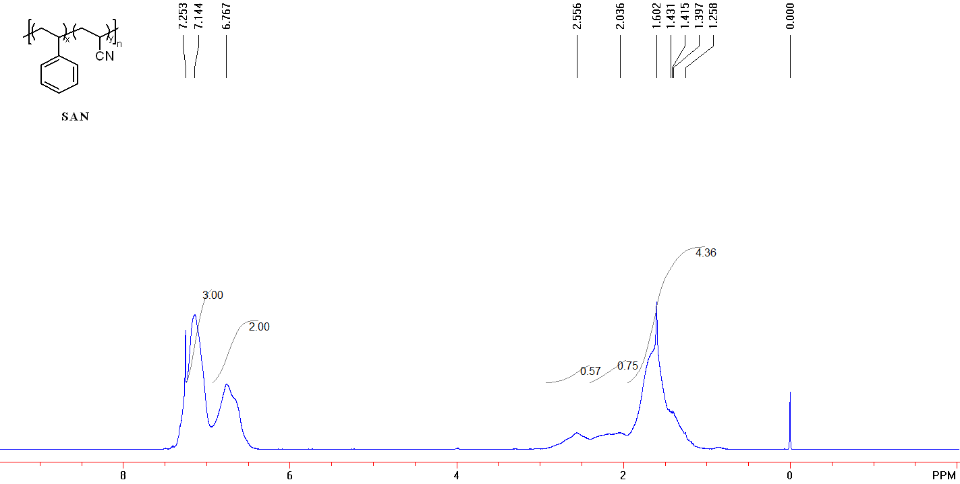
Figure S37. ¹H NMR (400 MHz, CDCl₃) spectrum of SAN.
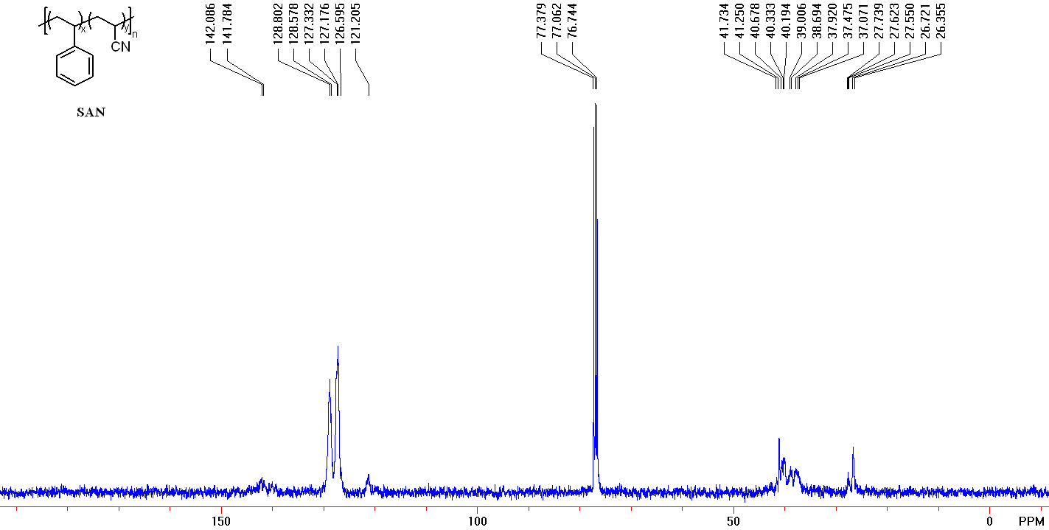
Figure S38. ¹³C NMR (100 MHz, CDCl₃) spectrum of SAN.
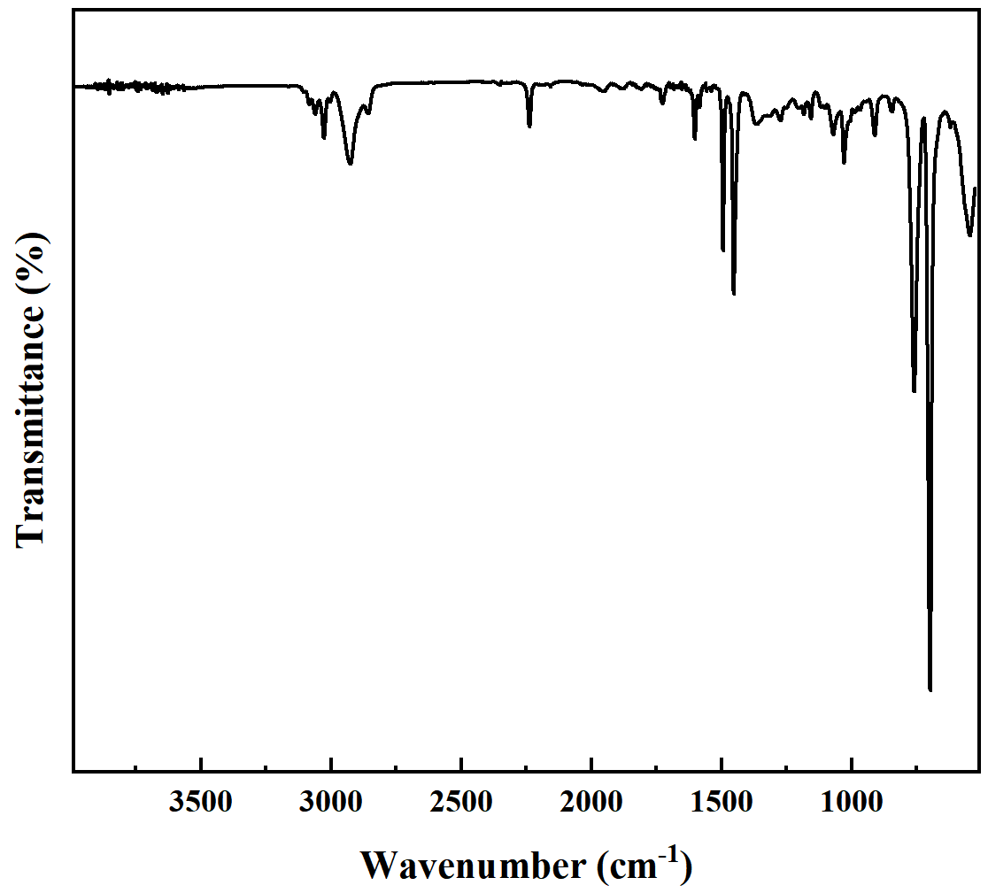
Figure S39. FT-IR spectra of SAN.

Ditertbutyl Phosphite phosphorylation of Poly(styrene-co-acrylonitrile) (SAN-DEP):
SAN-DEP: Poly(styrene-co-acrylonitrile) (SAN) (39.4 mg, 0.251 mmol), Diethyl phosphite (DEP) (34.8 mg, 0.251 mmol), Manganous acetate (8.8 mg, 20 mol%) and DMF (1.0 mL) were added to a Schlenk reaction tube. The solution was reacted at 80 ℃ for 12 hours. After cooling to room temperature, the solution was dissolved with dichloromethane and transferred to the pear-shaped liquid funnel. The organic phase purified by washing the water three to five times, dried with anhydrous sodium sulfate, concentrated and precipitated into methanol, filtered to obtain solid sediment and dried under vacuum. If necessary, the precipitation process was repeated one more time to ensure complete removal of any small molecules trapped in the polymer. The product was isolated white solid (29.6 mg, 75.1 %).
¹H NMR (CDCl₃, 400 MHz): δ 7.19-6.90 (br, 3H, C₆H₅), 6.88-6.3 (br, 2H, C₆H₅), 4.31-3.77 (br), 2.71-2.31 (br), 2.31-1.88 (br), 1.88-1.11 (br)。
IR (neat, ATR, cm⁻¹): 3083, 3060, 3028, 2925, 2857, 2237, 2181, 2160, 2030, 2009, 1973, 1602, 1583, 1494, 1453, 1392, 1366, 1260, 1203, 1183, 1157, 1128, 1097, 1052, 1026, 968, 912, 799, 759, 699, 620, 547.
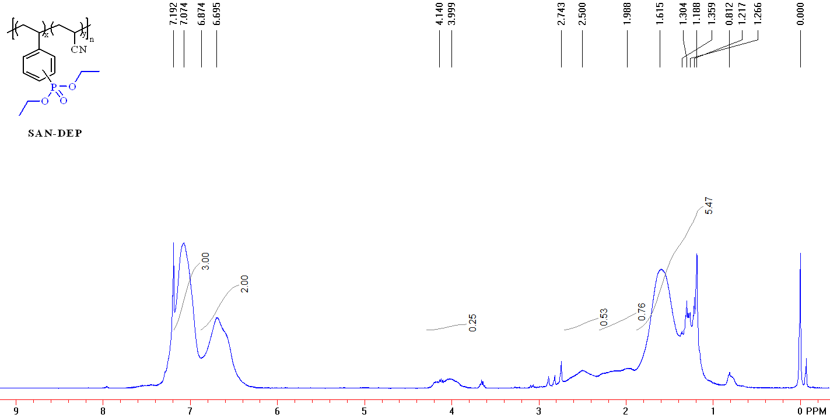
Figure S40. ¹H NMR (400 MHz, CDCl₃) spectrum of SAN-DEP.

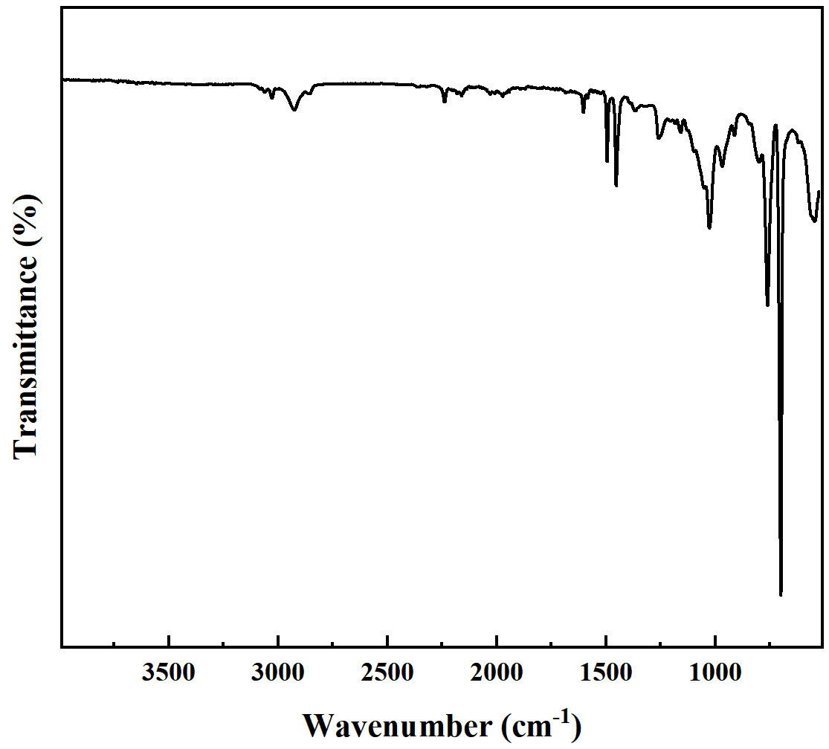
Figure S41. FT-IR spectra of SAN-DEP.

- References
- G. Keglevich, E. Jablonkai and L. B. Bal’azs, A “green” variation of the Hirao reaction: the P–C coupling of diethyl phosphite, alkyl phenyl-Hphosphinates and secondary phosphine oxides with bromoarenes using a P-ligand-free Pd(OAc)₂ catalyst under microwave and solvent-free conditions RSC Adv. 2014, 4, 22808-22816.
- Q. Tai, L. Songa, Y. Hua, R. K.K. Yuen, H. Feng and Y. Tao, Novel styrene polymers functionalized with phosphorus–nitrogen containing molecules: Synthesis and properties: Mater. Chem. Phys. 2012, 134, 163-169.

