Supplementary Information for

Abiotic hydrocarbons discharge from a felsic rock-hosted hydrothermal system

Xue-Gang Chen *, Ming-Zhen Yu, Mark Schmidt, Pei Sun Loh, Shuhei Ono, Chen-Tung Arthur Chen, Ying Ye

To whom correspondence should be addressed: Xue-Gang Chen, Email: chenxg83@zju.edu.cn. Tel: +86-580-2092326; Fax: +86-580-2092891; ORCID: 0000-0002-9148-8309

This file includes:

Supplementary Text
Figs. S1 to S8
Tables S1 to S3
References for supplementary information reference citations

Supplementary Text
T1. Geological setting
The volcanic island Lutao (or Green Island) (22.63°-22.70°N, 121.45°-121.55°E), covering an area of about 17 km², is located at the northern end of the Luzon arc, 34 km to the southeast of Taiwan island. It is formed by the volcanic activity driven by the subduction of the South China Sea plate beneath the Philippine plate (Fig. S1a) ¹. The volcanism occurred in Pleistocene, followed by crustal uplift and seawater erosion of the accumulated stack ². The volcanic rocks constituting the island range from basalt to dacite but are dominated by andesite with primary mineralogy of plagioclase and amphibole ^{3,4}. Only a few rock samples showed the occurrence of olivine (<5%) and pyroxene (<10%) ⁵. The MgO and ΣFeO contents of Lutao andesite fall in a range of 2.4 – 6.8% and 4 – 9% (average 6.4%), respectively. According to the chemical compositions of Lutao rock samples ⁵, the CIPW norm calculation suggested that olivine occurred in 1/3 samples with content of 2 – 7%. The average contents of olivine and pyroxene of Lutao rock was about 1.4% and 5.8%, respectively.
The outer rims of the island are covered by Holocene raised coral reefs (Fig. S1d) ⁶. The hydrothermal system, named as the Chao-Jih hot springs, situates at the southeastern corner of Lutao (Fig. S1b). There are two characteristic vents within this coral reef covered sediment-starving geothermal field, the Zhudanqu (ZDQ) brine vent and the Huwaichi (HWC) vapor spring (Fig. S1 c). The ZDQ brine vent was protected by concrete walls, forming a shape like a well, discharging vent fluids with a temperature of about 90 ºC, pH of about 7.8, and salinity of 36‰. The HWC vapor spring that about 80 m distance from the ZDQ vent, on the contrary, showed vent fluids with a temperature of about 65 ºC and pH of about 7.5, and salinity of 29-31‰. Because the gases discharged from the HWC vapor spring may have experienced anaerobic oxidation (see section T4), we will focus on the origin of short-chain alkanes released from the ZDQ brine vent in this study.

T2. Methane was not originated from the mantle/magma
CH₄ and C₂H₆ only exist in the mantle/magma with fO₂ 3 log units lower than that of Fayalite-Magnetite-Quartz (FMQ) buffer ^{7,8}. The calculated fO₂ (10⁻¹⁶ to 10⁻¹² bar) at 645 – 813 ºC of andesite, however, was 2 log units higher than that of FMQ ³. Therefore, it is impossible that the Lutao hydrocarbons were directly produced from the mantle/magma, where the C-O-H fluids would be dominated by CO₂ and H₂O. Besides, the methane isotopologue abundances also suggested that the Lutao methane was produced at a temperature of 174 – 206 ºC, rather than the high-temperature conditions of the mantle/magma.

T3. Modeling
1. Model for δ¹³C fractionation in a closed C-O-H system (Fig. 3)
(1) No matter the methane was produced from a one-step reaction or a two-step process, the overall formation mechanism is the reaction (3) in the main text, buffered by Fe(II) minerals (e.g., fayalite) and Fe(III)-bearing minerals (e.g., magnetite, hematite). The chemical equilibrium of C-O-H fluid under this environment has been studied extensively by ^{9,10}. They proposed that the chemical ratio between equilibrated CH₄ and CO₂ is a function of temperature:
log₁₀ (CH₄/CO₂) = 5280/T -11.12 = a (1)
where T (K) is the equilibrium temperature.
(2) In a confined environment like fluid inclusion, CH₄ was completely conversed from CO₂. The conversion ratio (CR) of CO₂ to CH₄ is:
CR = 10ª/(1+10ª) (2)
(3) According to Horita (2001) ¹¹, the carbon isotope exchange in the CO₂-CH₄ system is:
10³lnα(CO₂−CH₄) = 0.16+11.754∗(10⁶/T²) − 2.3655∗(10⁹/T³) + 0.2054∗(10¹²/T⁴) (3)
(T = 273 – 1573 K)
(4) Based on the isotopic mass balance:
δ¹³C(CO₂)_{t} *(1-CR) + δ¹³C(CH₄) *CR = δ¹³C(CO₂)_{i} (4)
where δ¹³C(CO₂)_{i} and δ¹³C(CO₂)_{t} are the initial δ¹³C(CO₂) and that at equilibrium, respectively.
then,
δ¹³C(CO₂)_{t} - CR *(δ¹³C(CO₂)_{t} - δ¹³C(CH₄)) = δ¹³C(CO₂)_{i} (5)
Because δ¹³C(CO₂)_{t} - δ¹³C(CH₄) ≈ 10³lnα(CO₂−CH₄), then,
δ¹³C(CH₄) ≈ δ¹³C(CO₂)_{i} - 10³lnα(CO₂−CH₄) + 10³lnα(CO₂−CH₄)*CR (6)
One disadvantage is that CO₂ in the Lutao gas samples was in trace amount, similar to many low-temperature continental gas seeps ^{12,13}. The low CO₂ content was caused by either high CO₂-CH₄ conversion ratio at low temperatures or removal by the vent fluids, or a combination of both. Therefore, we don’t know the initial δ¹³C(CO₂) values and δ¹³C(CO₂) at equilibrium. In this study, we set the initial δ¹³C value of magmatic CO₂ at a range of 0 ~ -8‰ ^{14,15}. Two temperature ranges could generate δ¹³C(CH₄) of -15.5 ~ -19‰: 180 ~ 206 ºC and > 408 ºC, where the former range fits well with the methane isotopologue results.
Numerous studies have investigated the δ¹³C(CH₄) values and their equilibration temperatures with CO₂, using the equation suggested by Horita (2001) ¹¹. However, the conversion ratio from CO₂ to CH₄ in the C-O-H system is less than 5% at temperatures of >265 ºC. The δ¹³C values of the residual CO₂ will be almost identical to the initial values at this temperature range. As a result, the equilibration temperature calculated from CO₂-CH₄ isotopic equilibrium will always fit our proposed model. Consequently, we only chose the data with temperatures calculated using other methods such as chemical equilibrium, methane isotopologue abundances, and D/H equilibrium.
2. Model for D/H fraction in a closed C-O-H system (Fig. S7)
(1) No matter the CH₄ was exclusively produced from respeciation of C-O-H fluids (equation 20) or a combination of serpentinization and Sabatier reaction (equations 22 and 24), the stoichiometric ratio between CO₂: H₂O: CH₄ is 1:2:1. A simplified expression of the reaction could be:
CO₂ + 2H₂O CH₄ (7)
The initial magmatic H₂O/CO₂ molar ratio is named as RH, which varies greatly with different systems ¹⁶, but is basically higher than 2.
(2) When the C-O-H fluid achieved chemical equilibrium buffered by typical volcanic rocks ^{9,10}, the ratio between CH₄ and CO₂ is:
log₁₀ (CH₄/CO₂) = 5280/T -11.12 = a (8)
where T (K) is the equilibrium temperature.
Because CH₄ was completely conversed from CO₂, therefore, the conversion ratio (CR) of CO₂ to CH₄ is:
CR = 10ª/(1+10ª) (9)
According to the stoichiometric ratio of the reaction (9), the conversion ratio of H₂O is 2*CR/RH.
(3) The D/H fractionation between CH₄, water vapor, and H₂ has been well studied by ^{17,18}:
CH₄(g)/H₂(g): α₁ = 0.8994 + 183540/T² (10)
H₂O(g)/H₂(g): α₂ = 0.9714 + 225230/T² (11)
Combined with equations (12) and (13), the fractionation between CH₄(g) and water vapor will be:
α = α₁ / α₂ (12)
Then, δ²H_{CH4} - δ²H_{H2O} = ε_{CH4-H2O} = (α – 1)*1000 (13)
(4) Based on the isotopic mass balance:
δ²H_{H2Oi =} δ²H_{H2Ot}* 2* (1-2*CR/RH) + δ²H_{CH4t} * 4*CR/RH (14)
therefore, δ²H_{CH4t} = [δ²H_{H2Oi}*RH + ε_{CH4-H2O} *(2RH-4CR)]/2RH (15)
the subscript i and t denote the initial δ²H value and that at equilibrium, respectively.
The modeled results (Fig. S7) indicate that at a temperature of < 250 ºC, the resulting δ²H_{CH4} values vary significantly with initial magmatic H₂O/CO₂ ratios. At higher temperatures of > 250 ºC, on the contrary, the δ²H_{CH4} values are almost identical with different initial RH ratios. The initial δ²H value of magmatic water vapor was set at 0 ~ - 50‰ ¹⁵. The relatively faster D/H exchange between CH₄, H₂, and H₂O with respect to ¹³C/¹²C exchange restricts the application of this model. Nevertheless, the methane released from Pantelleria, Chimaera, Nisyros, Zambales generally follows the estimated gray bands.

T4. Geochemistry of methane that discharged from the HWC vapor spring
In this study, the gas from the HWC vapor spring was also collected and analyzed for chemical and stable isotopic compositions (Table S3). When compared with the gas samples from the ZDQ brine vent, the HWC gas samples showed relatively higher N₂ contents but lower CH₄ concentrations (46.35 mmol/mol). Both vents showed similar concentrations of all the other chemical components. A remarkable difference between the methane discharged from both vents is that the HWC samples presented significantly heavier δ¹³C (-8.08±1.97‰) and δ²H (-2.34±43.55‰) values. Two mechanisms were applied to explain this phenomenon.
(1) Microbial oxidation: Both the ZDQ and HWC methane was originated from the same source, while the HWC methane experienced extensive microbial oxidation. The most compelling evidence for this hypothesis is that the δ¹³C(CH₄) values of Lutao gas samples increased linearly with their δ²H values (Fig. T1). The slope of ²H/¹³C fractionation (ΔH/ΔC) is 10.1, close to the reported values for aerobic oxidation of methane ^{19,20}. In addition, two HWC gas samples showed δ¹³C and δ²H values just on the oxidation curve, further suggested that the methane in these samples might originate from the ZDQ gas and subsequently underwent microbial oxidation with different degrees.
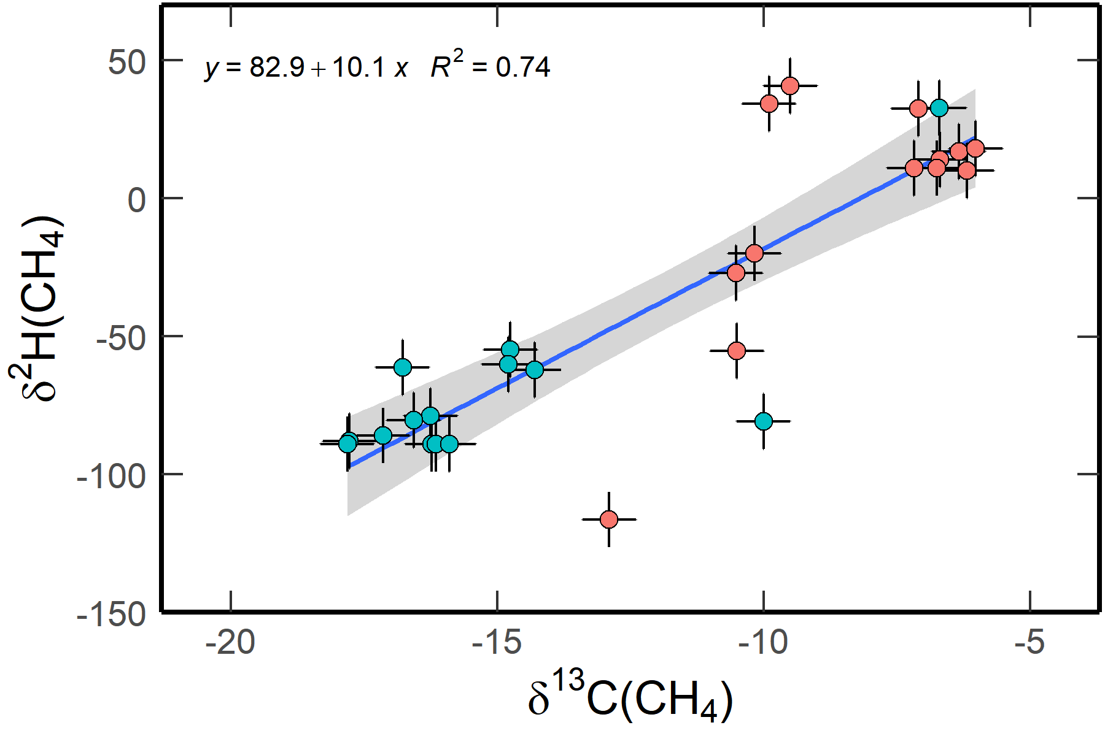
Fig. T1: δ²H - δ¹³C plot of methane discharged from ZDQ brine vent (blue circles) and HWC vapor spring (red circles), respectively. Unit: δ¹³C, ‰, vPDB; δ²H, ‰, vSMOW.

However, an (2) enhanced conversion from CO₂ to CH₄ in the C-O-H system will also result in both elevated δ²H and δ¹³C values. In a closed equilibrated C-O-H system, the conversion ratio of CO₂ to CH₄ decreases with temperature. As a result, the δ¹³C values of the remnant CO₂ become increasingly heavy with decreasing temperature. Although the fractionation factor between CO₂ and CH₄ (Δ_{CO2-CH4}) generally increases with decreasing temperature ¹¹, the δ¹³C values of the resulting CH₄ increases with declining temperatures, and eventually close to the initial δ¹³C(CO₂) values (Fig. 3). For example, at 180 and 104 ºC (the apparent formation temperatures of methane discharged from the ZDQ brine vent and HWC vapor spring, respectively. Temperatures were calculated from the Δ¹³CH₃D abundance, Table 2), the conversion ratios of CO₂ at equilibrium are 77.44% and 99.87%, respectively ¹⁰. This result is consistent with the low CO₂ contents in the Lutao gas samples, as well as the low-temperature gas seeps in Chimaera and Zambales ^{12,21–23}. Nevertheless, the δ¹³C values of CO₂ in these fields were quite negative, possibly ascribed to the fact that the residual CO₂ was in trace amount or has been massively removed by the alkaline vent fluids. The detected CO₂ was primarily a product of methane oxidation.
According to the relationship between temperature and equilibrated δ¹³C(CH₄) values (Fig. 3), the C-O-H system equilibrated at 180 and 104 ºC would eventually create ultra-heavy δ¹³C values of remnant CO₂ of 20‰ and 41‰, respectively, when the initial δ¹³C of magmatic CO₂ was -8‰. As a result, the δ¹³C values of generated CH₄ will be -16.7 and -8.1‰, respectively. Both values resemble the δ¹³C values of methane discharged from the ZDQ brine vent (-19 ~ -15.5‰) and HWC vapor spring (-10 ~ -6‰). A similar process also applies to the D/H fractionation between CH₄ and H₂O (Fig. S7), where the δ²H values of Lutao methane fit well with the modeled results.
Furthermore, the Δ¹³CH₃D abundance of the HWC methane was 3.61 – 4.02‰, significantly larger than that of ZDQ methane (2.38 - 2.74‰). This result contradicts previous studies on the aerobic oxidation of methane, where the Δ¹³CH₃D abundance decreased with enhanced oxidation ²⁰. The effect of anaerobic oxidation on the methane isotopologues, however, was less constrained. Some studies suggested that it could induce partial carbon isotope equilibration between residual methane and CO₂ ²⁴. Therefore, it is possible that the apparent temperature of HWC methane (93 - 115 ºC) reflects the temperature of anaerobic oxidation ²¹. Thermophilic anaerobic bacteria were atypical but existed. A previous study reported a hyperthermophilic methanogen could survive at 122 ºC and produce CH₄ with heavy δ¹³C values ²⁵.
The methane oxidation curve (Fig. T2) also supports that the methane in most HWC samples was not an oxidation product of the ZDQ methane. The δ¹³C(CH₄) - CO₂/CH₄ diagram of methane in the ZDQ samples and several HWC samples follows the theoretical oxidation curves with initial δ¹³C(CH₄) values of -19 ~ -15.5‰ and Δ_{CO2-CH4} of -30‰. It is suggested that the methane in some HWC samples was oxidized from the ZDQ methane. The majority of HWC samples, however, showed different oxidation curves than the ZDQ samples, indicating that they were originated from different sources or have experienced diverse processes. The endmember δ¹³C value of HWC methane could be determined as -10 ~ -8‰.
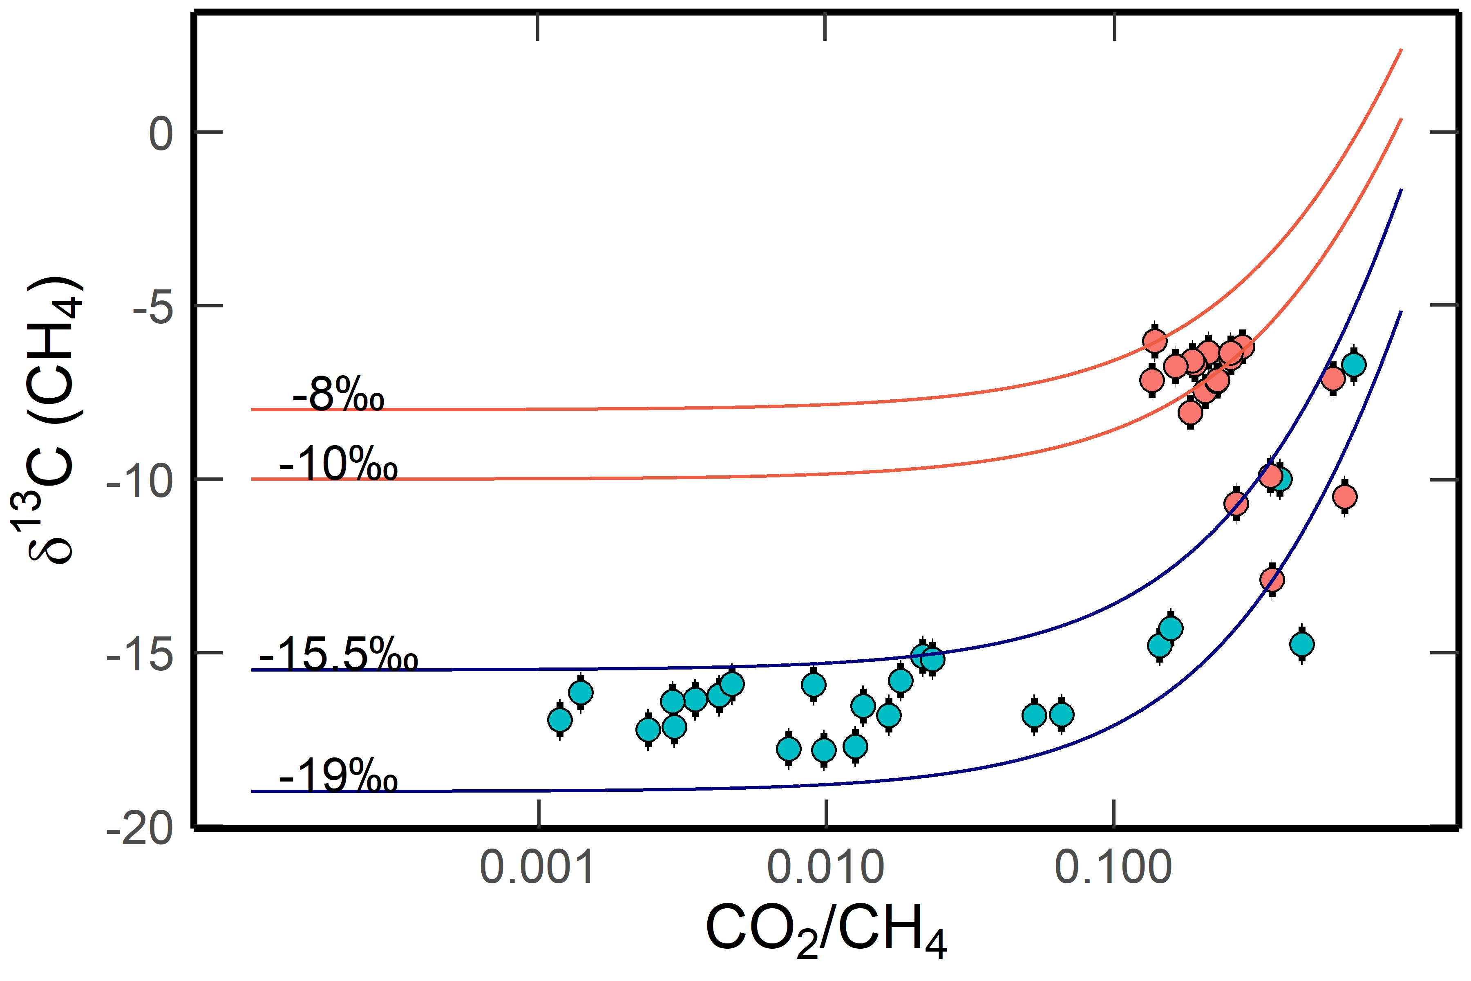
Fig. T2 Variations of δ¹³C(CH₄) values of methane discharged from the ZDQ brine vent (blue circles) and the HWC vapor spring (red circles), respectively. The initial δ¹³C(CH₄) value of each line was marked on the plot. The theoretical curves were calculated using equation (27), using a fractionation factor Δ_{CO2-CH4} of -15‰ (red lines) or -20‰ (blue lines). Partial dissolution of CO₂ has been considered, which dissolved 60% ZDQ CO₂ and 67% HWC CO₂ into the fluid phase.

Furthermore, the δ¹³C - CH₄/(C₂+C₃) plots of Lutao methane and ethane clearly distinguish the trends of microbial oxidation from the mixing between the HWC and ZDQ gases (Fig. T3). The initial CH₄/(C₂+C₃) ratio of the ZDQ gas samples was about 200 – 230. With enhanced microbial oxidation, the methane was gradually consumed, resulting in simultaneously decreased CH₄/(C₂+C₃) ratios and increased δ¹³C values. The CH₄/(C₂+C₃) ratio of the HWC samples, on the contrary, was elevated to about 700 – 800. Because the ZDQ ethane exhibited increased δ¹³C values with almost constant CH₄/(C₂+C₃) ratios, it is indicated that microbial oxidation of ethane posed minor influence on the CH₄/(C₂+C₃) ratios. Therefore, the enlarged CH₄/(C₂+C₃) ratios of the HWC gases did not result from ethane oxidation. Some HWC samples exhibited CH₄/(C₂+C₃) ratios of about 300 – 400 and δ¹³C(CH4) values of -13 ~ -8%. These samples could be explained as mixtures of the HWC and ZDQ gases, which were subsequently oxidized by microbial activities.
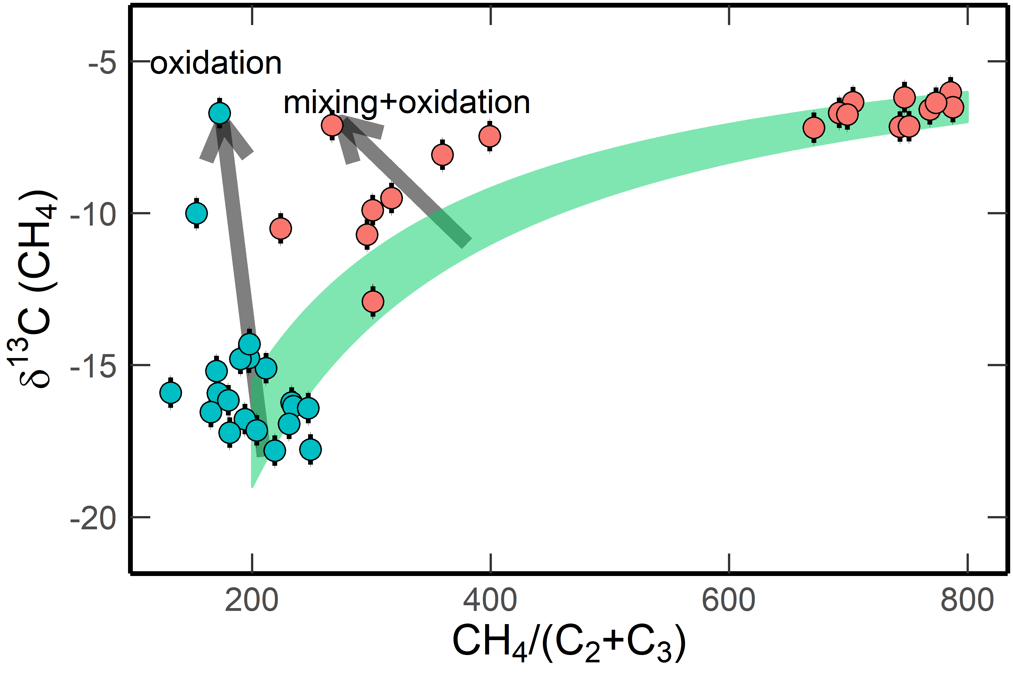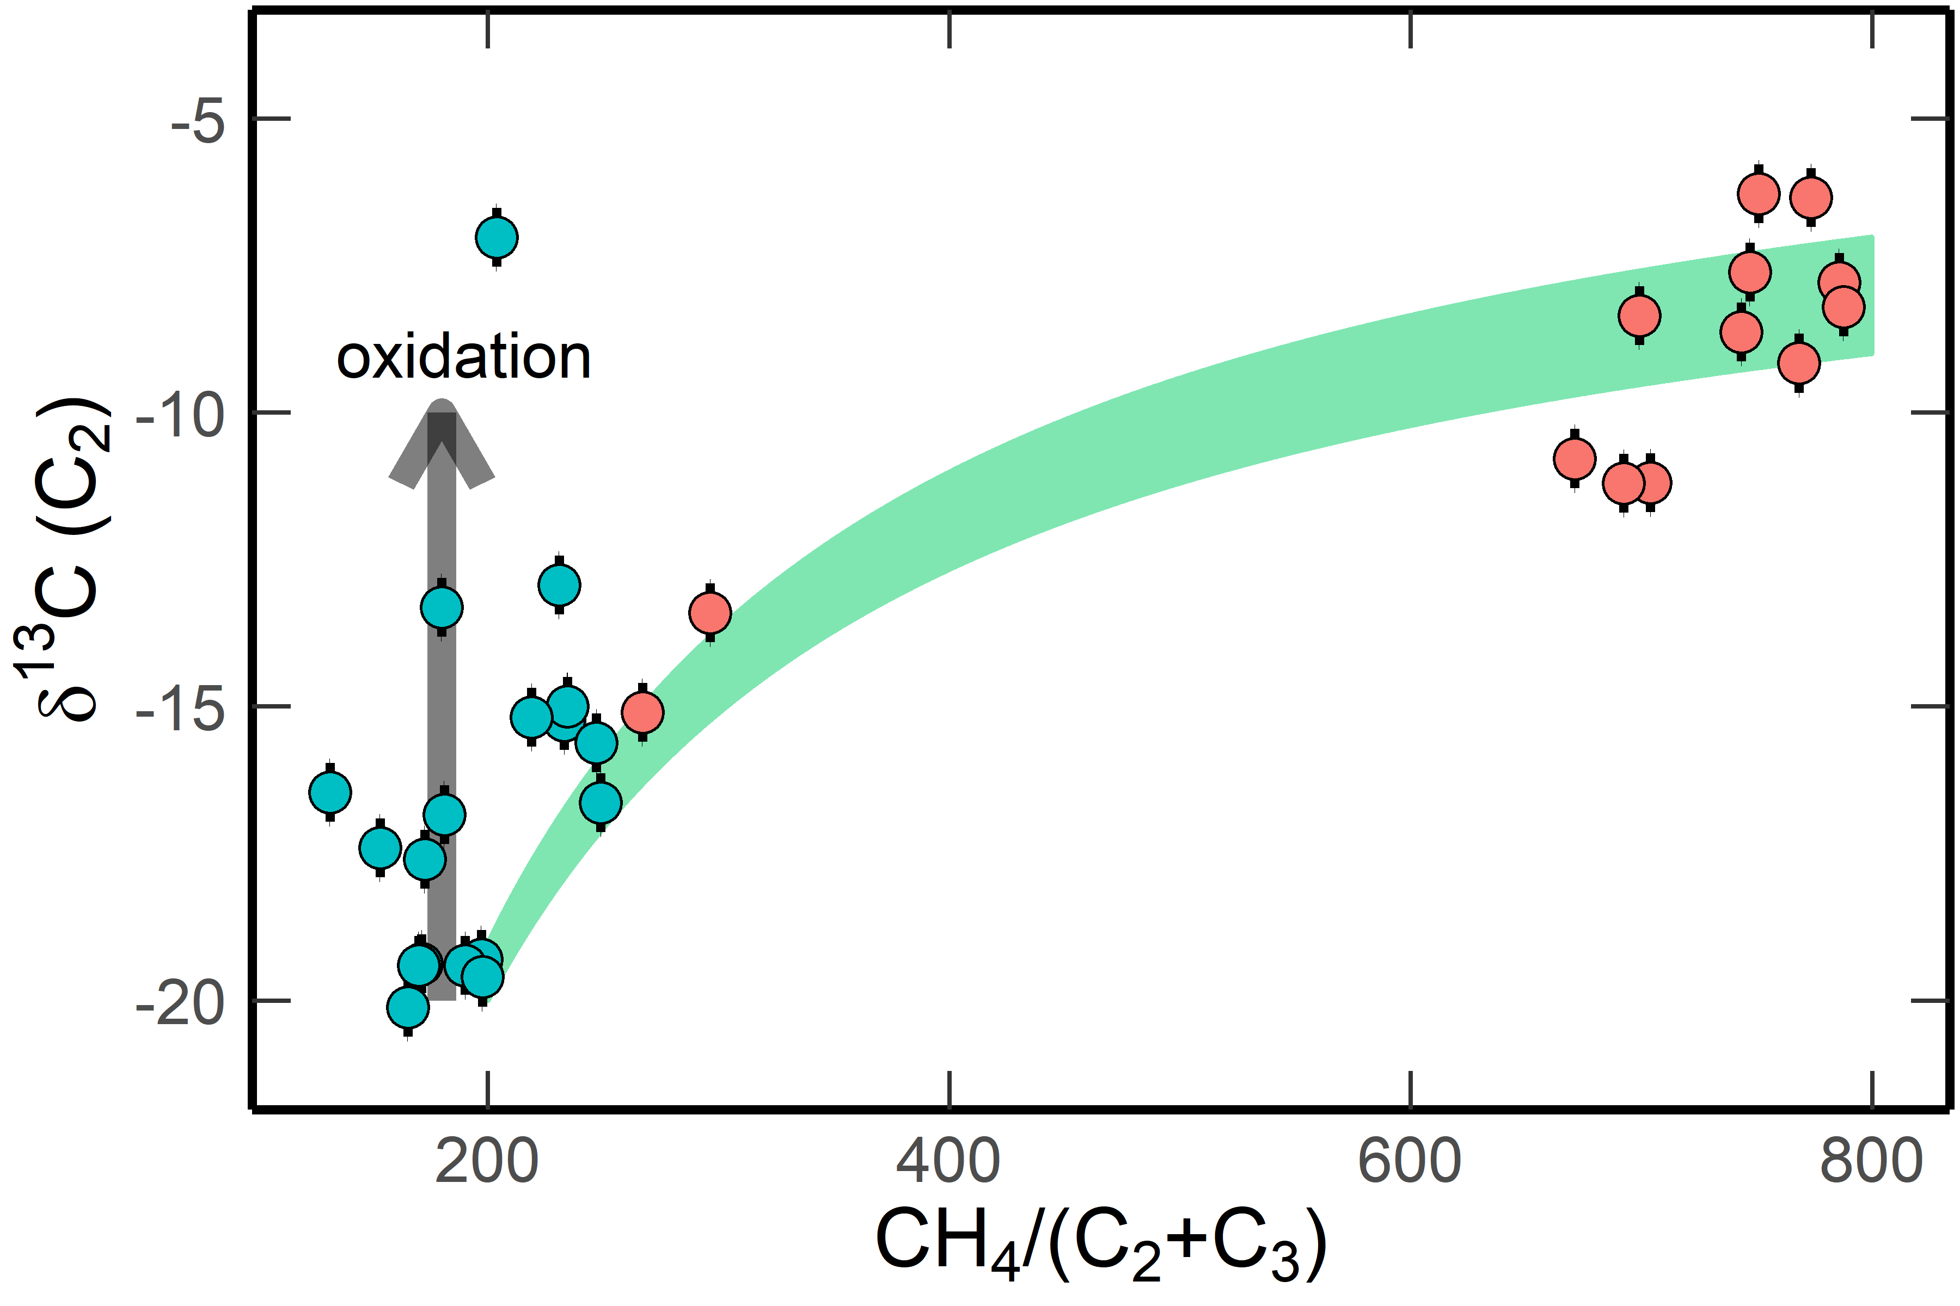
Fig. T3 δ¹³C – CH₄/(C₂+C₃) plots for (a) methane and (b) ethane discharged from the ZDQ brine vent (blue circles) and HWC vapor spring (red circles). The mixing curves (green bands) were calculated using the following endmembers: HWC, δ¹³C(CH₄) = -7 ~ -6‰, δ¹³C(C₂) = -9 ~ -7‰, CH₄/(C₂+C₃) = 800; ZDQ, δ¹³C(CH₄) = -19 ~ -15.5‰, δ¹³C(C₂) = -20 ~ -19‰, CH₄/(C₂+C₃) = 200.

In conclusion, multiple pieces of evidence suggested that the heavy δ¹³C and δ²H values of HWC methane were not created by microbial oxidation. The methane released from the HWC vapor spring was probably leached from fluid inclusions that equilibrated at about 100 ºC in the host rock. Nevertheless, potential oxidation that occurred during hydrothermal circulation was still largely unknown, and the impact of anaerobic oxidation was not constrained. Therefore, we would like to present the source of the short-chain alkanes discharged from the HWC vapor spring in the supporting information rather than in the main text.

T5. Flux estimation
In this study, we roughly estimated the flux of abiogenic methane that discharged from the Lutao geothermal system.
- During our sampling, Lutao gas filled the sampling bottle with a volume of about 100 mL within 20 s. The sampling bottle was connected to a glass funnel with a cross-sectional area of 175 cm². Because the venting area of ZDQ is about 1 m²; the total gas flux of the ZDQ vent was estimated at 285 mL s⁻¹.
- The CH₄ content of the Lutao gas was 11% ~ 17%. Therefore, the methane flux was about 31-48 mL s⁻¹. That is about 1000 – 1500 m³ a⁻¹, or 700 – 1080 kg a⁻¹.
- The vent fluids filled a volume of 0.8 m³ in about 5 s. Therefore, the fluid flux was calculated as 160 L s⁻¹. Because the density of the vent fluids closes to 1 g cm⁻³, the annual flux of Lutao vent fluid is about 5000*10⁶ kg a⁻¹.
- The W/R ratio of the Lutao system was calculated as about 2 based on the boron concentrations (1.10 -1.20 mM L⁻¹) of the vent fluids. Therefore, the annual consumption of host rock is about 2500 *10⁶ kg, corresponding to a volume of 8.1 ~ 9.6 *10⁻⁴ km³ according to the density of intermediate rock (2.6 – 3.1 kg L⁻¹). Because the Lutao island covers an area of about 17 km² and at 50 m water depth about 60 km², a 13 - 16 m thick host rock could easily sustain the release of abiogenic methane for 1000 years.
- Consequently, the mass ratio between the Lutao host rock and methane is estimated at 2.3 ~ 3.6 *10⁶. This value is comparable to the range of published data for methane-rich inclusions in the plutonic rocks of Southwest Indian Ridge (0.3 ~ 0.6 mmol methane/kg, or a mass ratio of 1 - 2*10⁵) ²⁶, Cayman ultramafic rocks (4.3 nmol/g, or a ratio of 1.5*10⁷), and Zambales ophiolite (2 ~ 37 nmol/g, or a ratio of 1.6 ~ 31*10⁶) ²⁷.

T6. Thermodynamic calculation:
According to the structure and nature of methane, a carbon source, a hydrogen source, and a reductive environment are required to form methane. Under natural hydrothermal systems, carbon source could be carbonate, CO₂, CO, C, or organic acids. The abundance of CO is below the detection limit in the Lutao system and therefore, was not considered. Etiope and Whiticar (2019) ¹³ concluded that organic acids such as formic acid and formate are intermediate products rather than carbon sources for abiotic CH₄ production. Therefore, potential carbon source for Lutao methane was CO₂, C, or carbonate. Typical hydrogen sources are H₂O and H₂. The reductive environment is usually supplied by H₂ or rock buffer (Fe²⁺-bearing minerals).
Under these statements, potential processes to abiotically produce methane include:
(1) Carbonate reduction ²⁸:
12FeO + CaCO₃ + 2H₂O = 4 Fe₃O₄ + CH₄ + CaO (16)
This process has been suggested to produce methane in the mantle at temperatures of 500 – 1500 ºC and pressures of 5 – 11 GPa.
(2) respeciation of C-O-H fluids ^{10,29}: If the carbon source was CO₂ (which is quite common in hydrothermal systems) rather than carbonate, then the equation (18) transfers to:
CO₂ + 2H₂O = CH₄ + 2O₂ (17)
However, this reaction is thermodynamically unfavorable at all temperature ranges. A reductive agent was required to overcome the thermodynamic barrier. In volcanic rocks, Fe²⁺ the most common reductive agent.
12FeO + CO₂ + 2H₂O = CH₄ +4Fe₃O₄ (18)
or, 8Fe₃O₄ + CO₂ + 2H₂O = CH₄ + 12Fe₂O₃ (19)
If CO₂ was absent, this reaction resembles the simplified form of the serpentinization process that generates H₂ ^{30,31}:
3FeO + H₂O = H₂ + Fe₃O₄ (20)
where FeO represents the ferrous components of silicate minerals such as olivine and pyroxene ^{32,33}.
(3) The most widely studied mechanism for the production of abiotic methane is Fischer-Tropsch-Type reaction (equation 23), or its one-step form (Sabatier reaction, equation 24) ^{13,29,34,35}. Both processes require H₂ as a reactant.
CO₂ + (2+m/2n)H₂ = (1/n)C_{n}H_{m} + 2H₂O (21)
CO₂ + 4H₂ = CH₄ + 2H₂O (22)
If the carbon source was C or carbonate, then the reactions will be:
C + H₂ = CH₄ (23)
MCO₃ (M = Fe, Ca, or Mg) + 4H₂ = CH₄ + MO + 2H₂O (24)
Thermodynamic calculations using R package CHNOSZ ^{36–38} suggested that the equations 19 and 21 are thermodynamically unfavorable at temperatures of 0 -1000 ºC and pressure of 1 – 500 Bar. Equation 26 could occur only at temperatures of < 25 ºC. Equation 25 is a less plausible process to generate Lutao methane because graphite is not common in andesitic volcanic rocks.
For the rest equations 18, 20, 22, and 24, Fig. T4 compiles the changes of ΔG of these equations at different temperatures and pressures. At 1 bar, equation 20 (C-O-H respeciation) exhibits the most negative ΔG values at temperatures < 380 ºC, and therefore is the most thermodynamically favorable reaction at this temperature range. Equation 24 (Sabatier reaction) is more favorable at 380 – 590 ºC. Beyond this temperature, both reactions are thermodynamically unfavorable. Equation 18 (carbonate reduction) only favorable at temperatures < 308 ºC, while equation 22 (serpentinization) shows slightly negative ΔG values at < 380 ºC. At a pressure of 10 bar that represents a shallow depth environment, C-O-H respeciation is always the most favorable reaction in case of ΔG < 0, followed by Sabatier reaction and carbonate reduction. At 500 bar that typically used in laboratory experiments to study the serpentinization and abiotic formation of methane ^{39,40}, C-O-H respeciation is still the thermodynamically most favorable reaction at < 580 ºC. Beyond this temperature, serpentinization prevails.
Based on these calculations, the abiogenic methane discharged from the Lutao field was potentially produced by two routes: (1) one-step formation: methane was exclusively generated from the respeciation of C-O-H fluids, which is the most thermodynamically favorable reaction at temperatures ranging from 0 to 580 ºC. Presumably, magmatic CO₂ and H₂O were trapped in the intrusive rocks during Lutao volcanism; these C-O-H fluid inclusions reacted with Fe²⁺ in the surrounding rock to form methane. Although the Lutao host rock is dominated by andesite, the sporadic occurrence of ultramafic minerals (olivine and pyroxene) and the absence of ferric minerals suggested that the Lutao host rock contains 4 – 9% FeO ^{3,5}. (2) Two-step reactions: Serpentinization is the most favorable reaction at high pressure (500 Bar) and high temperatures (> 580 ºC). However, olivine is stable at temperatures > 400 ºC. Therefore, it is plausible that serpentinization occurred firstly during the initial cooling of Lutao magma when temperatures colled to < 400 ºC. Although the reaction rate of serpentinization highly relies on kinetic parameters, it is suggested that serpentinization is a fast process on the geological time scale ³¹. The produced H₂, together with magmatic CO₂ and H₂O were trapped in the intrusive rocks and formed fluid inclusions. Then these CO₂-H₂-H₂O rich inclusions achieved equilibrium via Sabatier reaction (equation 24) or respeciation (equation 20), or a combination of both processes at lower temperatures and pressures. The sluggish kinetic barrier of Sabatier reaction without catalysts was overwhelmed by the geological time scale ⁴¹ since the major volcanic eruptions at Lutao occurred at 1.3 Ma. Most H₂ and CO₂ have been transferred to CH₄ when equilibrated at low temperatures, that CH₄-rich H₂-free inclusions have been suggested by previous studies ^{26,41}. In addition, both species may be additionally removed by microbial oxidation or carbonate precipitation during hydrothermal circulation ^{19,42}. Therefore, both gases were not detected or at low contents in the Lutao gas samples.
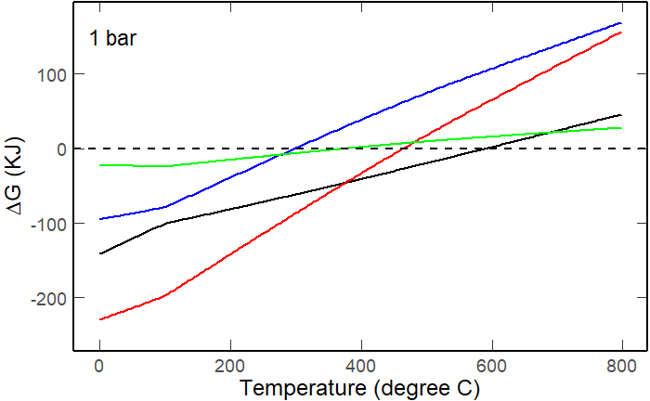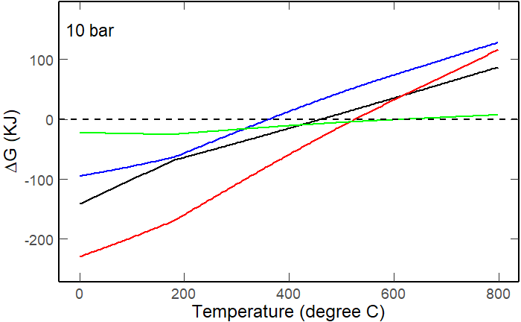
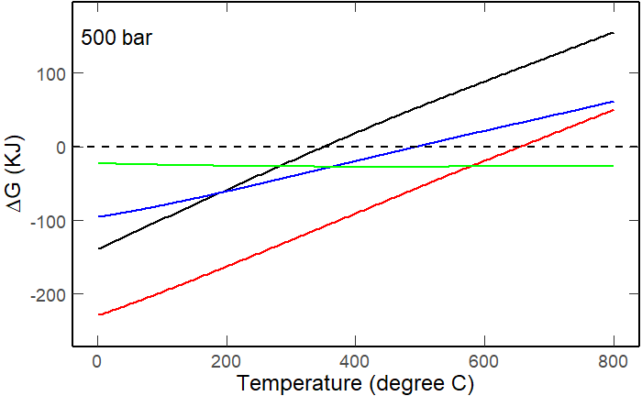
Fig. T4 Variations of Gibbs free energy changes (ΔG) as a function of temperature from 0 to 800 ºC, with pressure conditions of 1 bar, 10 bar, and 500 bar. Black line: Sabatier reaction (equation 24); blue line: carbonate reduction (equation 18); red line: respeciation of C-O-H fluids (equation 20); and green line: serpentinization (equation 22).

Fig. S1
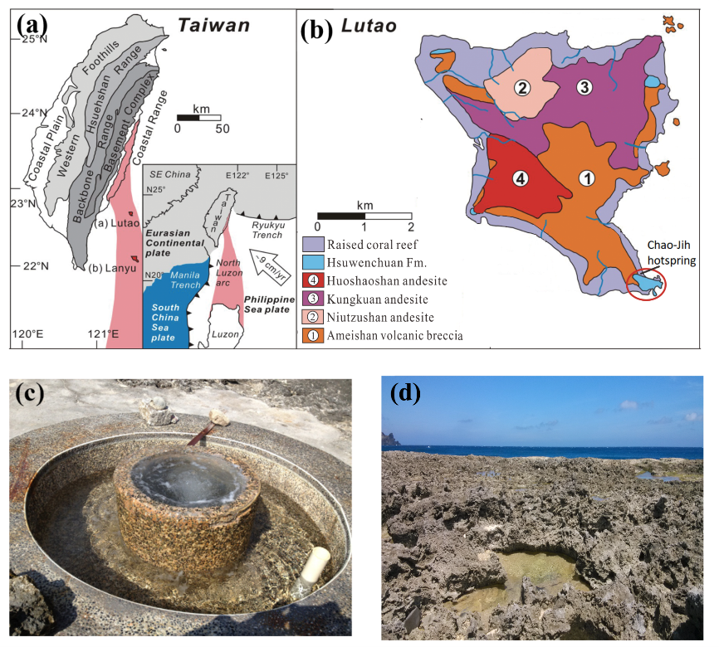
Fig. S1 The Lutao andesite-hosted geothermal system: (a) geological setting, (b) the surface lithology modified from Shao et al., (2014) ¹. The island is mostly composed of andesite agglomerate and lava with dominant mineralogy of amphibole and plagioclase. (c) the typical “Zhudanqu” spring, and (d) the modern coral reef covering the geothermal field ⁶.

Fig. S2
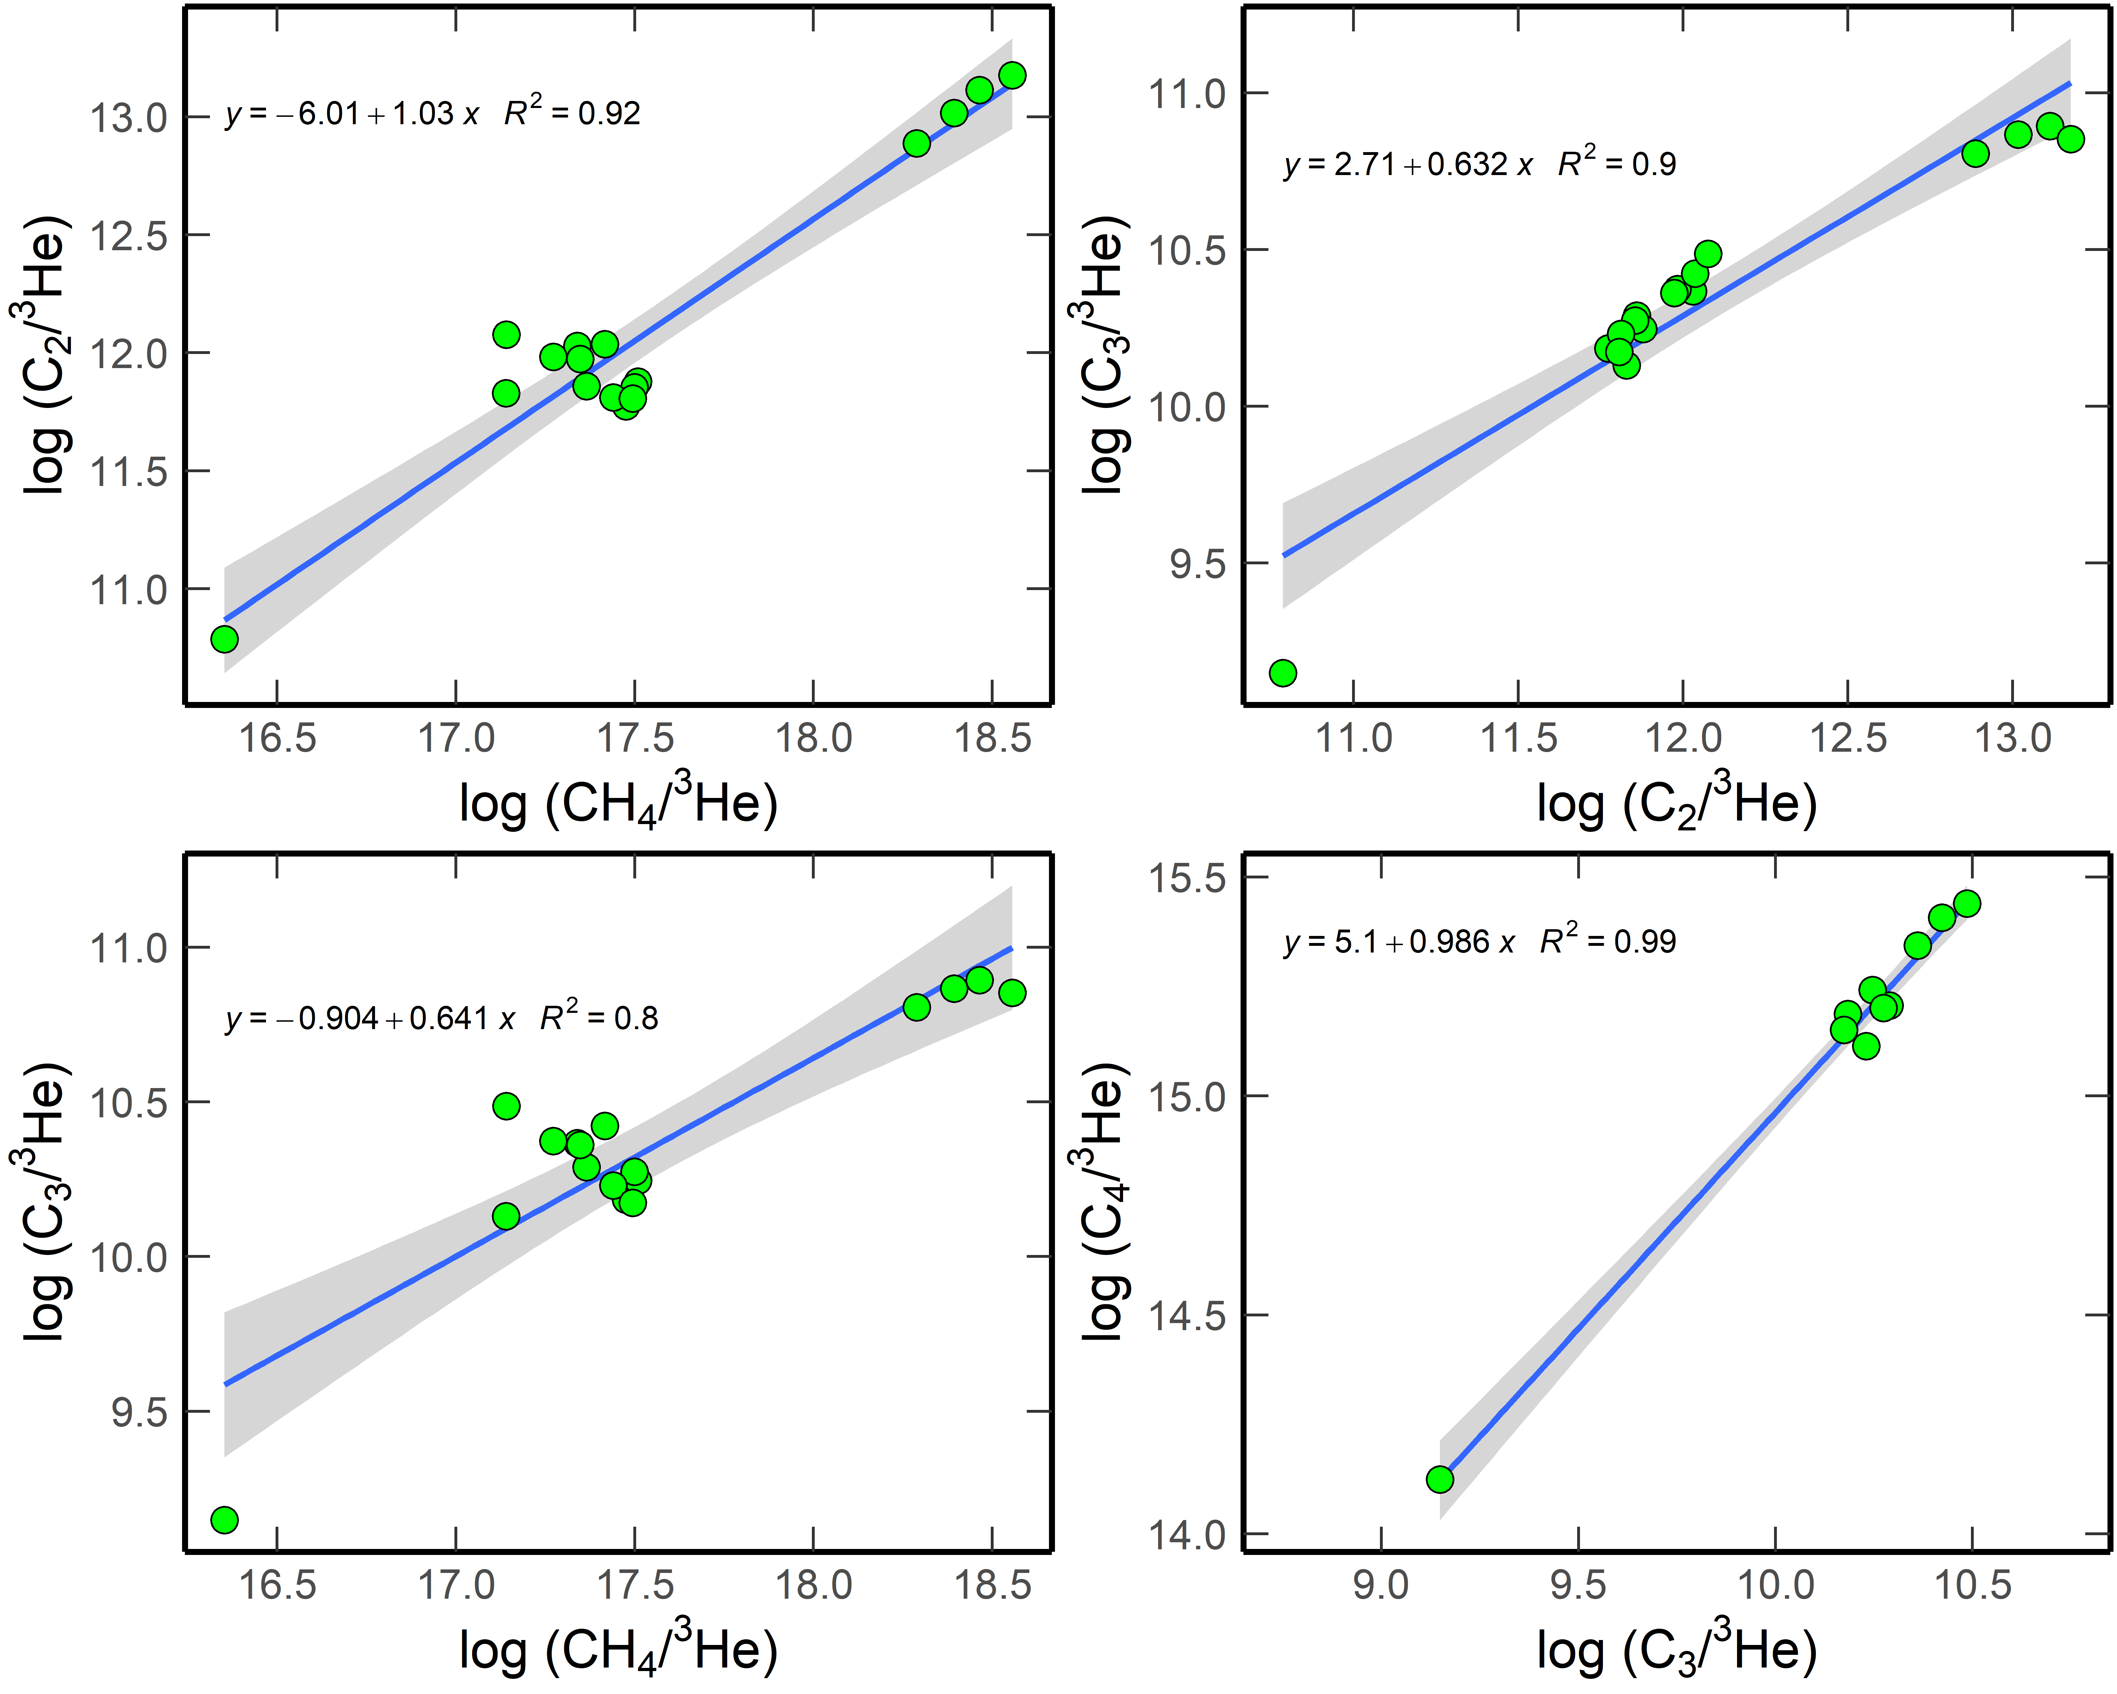
Fig. S2 The relationships between methane, ethane, propane, and butane. ³He was used as a reference to show the relative abundances of Lutao alkanes because ³He was almost exclusively originated from the mantle on account of the dramatically high ⁴He/²⁰Ne ratios of Lutao gases (Table S1) ^{43,44}.

Fig. S3
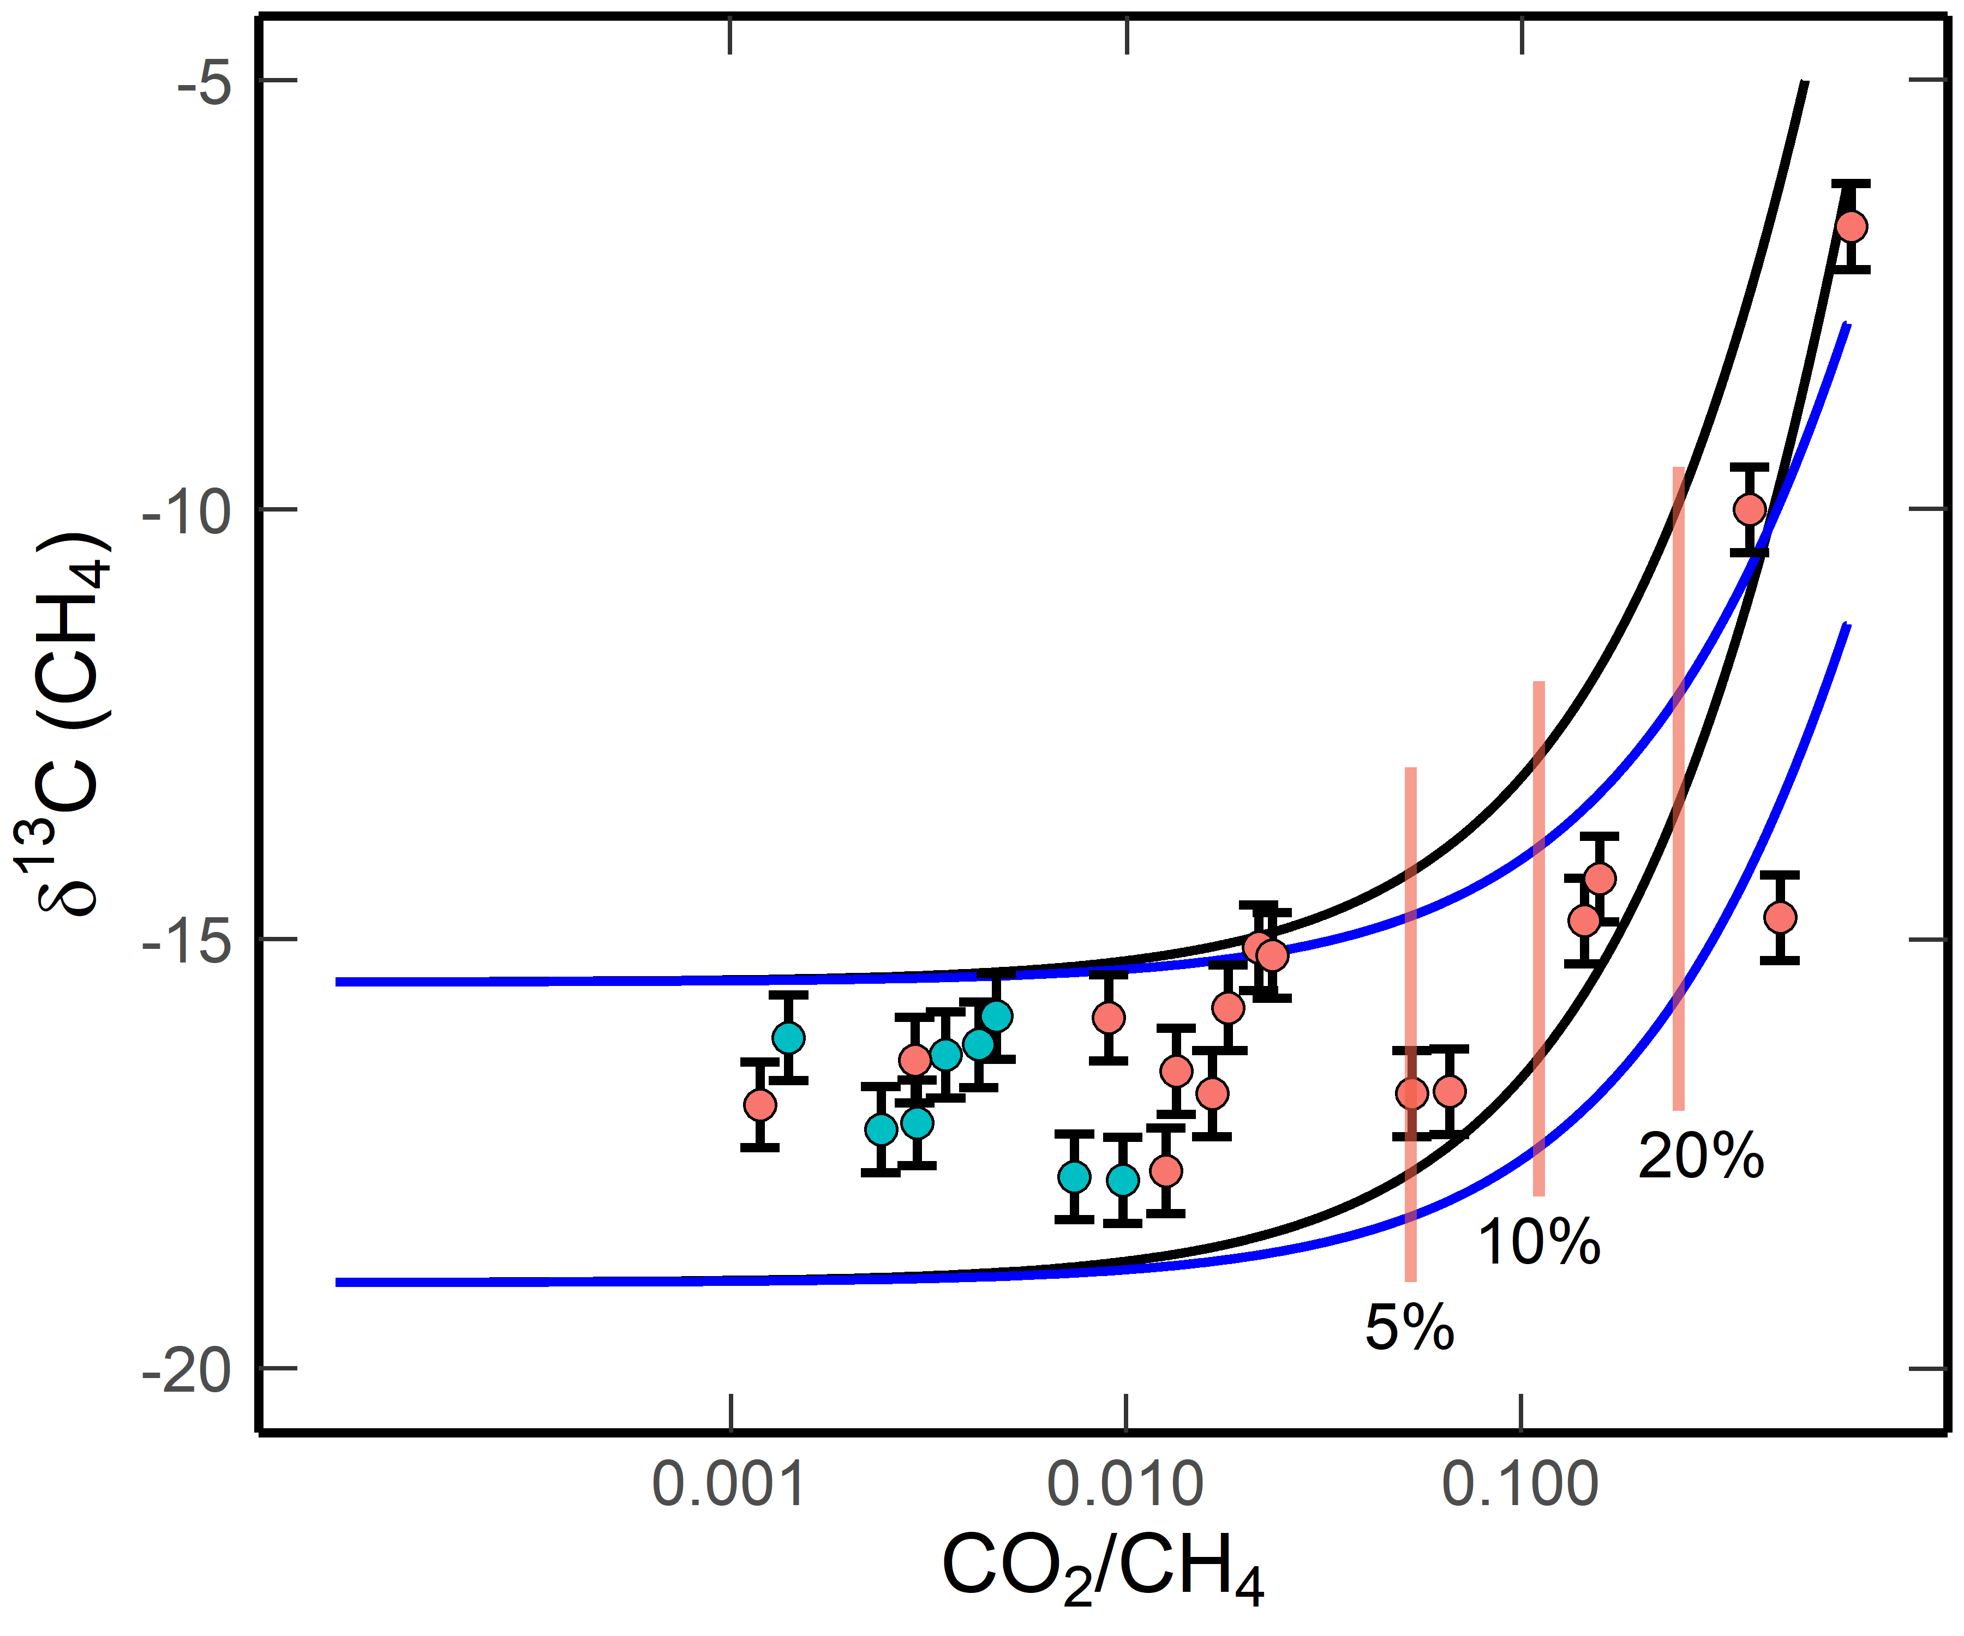
Fig. S3 The correlation between CO₂/CH₄ ratios and δ¹³C(CH₄) values (per mil, v-PDB) suggesting that methane was oxidized to produce CO₂ in the Lutao system. Blue points: HgCl₂ was added to prevent microbial oxidation. Red points: HgCl₂ was not added.
The theoretical curves were calculated according to Whiticar (1999)¹⁹ using the following equation:
δ¹³C(CH₄)_{t} = δ¹³C(CH₄)_{i} + ΔCO₂-CH₄ *ln (1-F) (25)
Where the subscripts i and t denote the initial δ¹³C(CH₄) value and at time t, respectively. ΔCO₂-CH₄ is the ¹³C isotopic fractionation factor between CO₂ and CH₄, which covered a large range from -5 to -30‰ ^{19,45,46}. In this study, this value was set at -15‰ (blue lines) or -25‰ (black lines). F is the conversion ratio from CH₄ to CO₂. The initial δ¹³C(CH₄) values were set at a range of -15.5‰ ~ -19‰, respectively. CH₄-CO₂ conversion ratios (that calculated from the CO₂/CH₄ ratios) of 5%, 10%, and 20% were marked on the figure. Most samples showed very low conversion ratios, and only the samples without adding HgCl₂ solutions experienced significant microbial oxidation. It is suggested that microbial oxidation of methane occurred after sampling/during preservation. CO₂ in the samples may have experienced partial dissolution in the vent fluids with a pH of about 7.8 and temperature of 90 ºC. Therefore, the total CO₂ content will be 2.5 times higher than the residual CO₂ in the gas phase.

Fig. S4
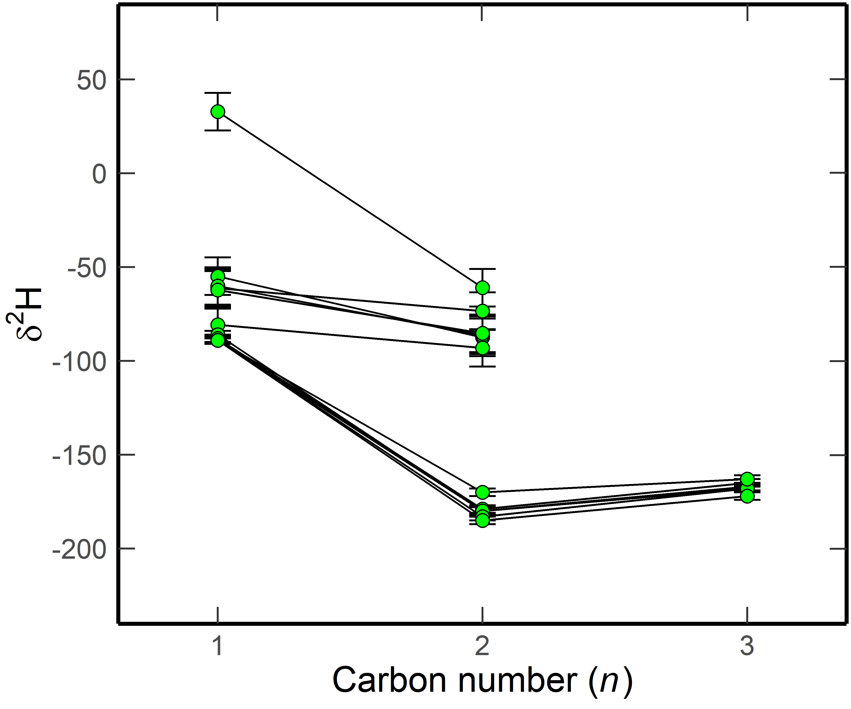
Fig. S4 Reversed trend of δ²H values (per mil, vSMOW) of Lutao alkanes with increasing carbon number (n).

Fig. S5
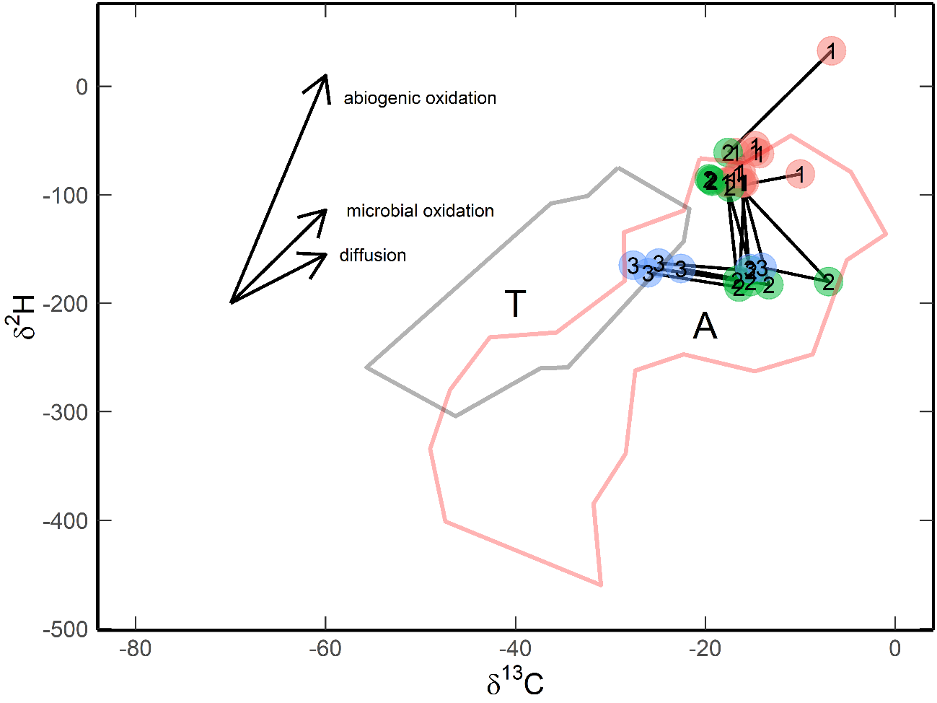
Fig. S5 δ¹³C – δ²H (CD) diagram of the Lutao alkanes. The numbers inside the dots indicate the carbon number of the alkanes. Isotopic fractionation trends of methane by abiogenic oxidation (ΔH/ΔC = 21), microbial oxidation (ΔH/ΔC = 8.6), and diffusion (ΔH/ΔC = 4.5) were calculated according to Etiope and Lollar (2013) ²⁹ and references therein. The boundaries for thermogenic (T) and abiogenic (A) methane were also suggested by Etiope and Lollar (2013) ²⁹. Units: per mil, vPDB for δ¹³C, and vSMOW for δ²H.

Fig. S6
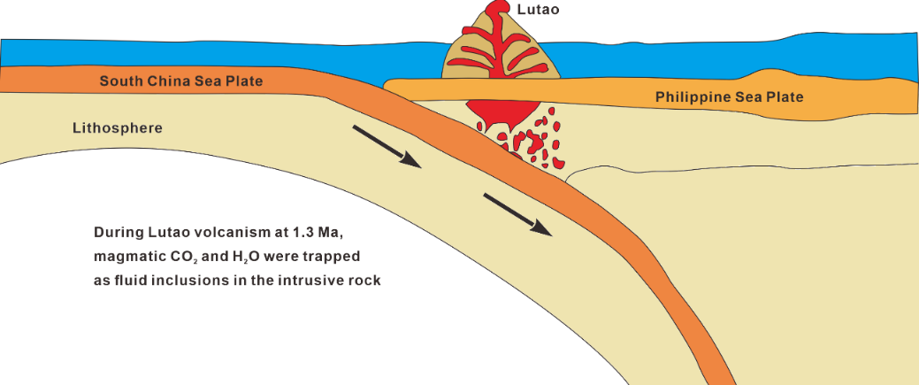
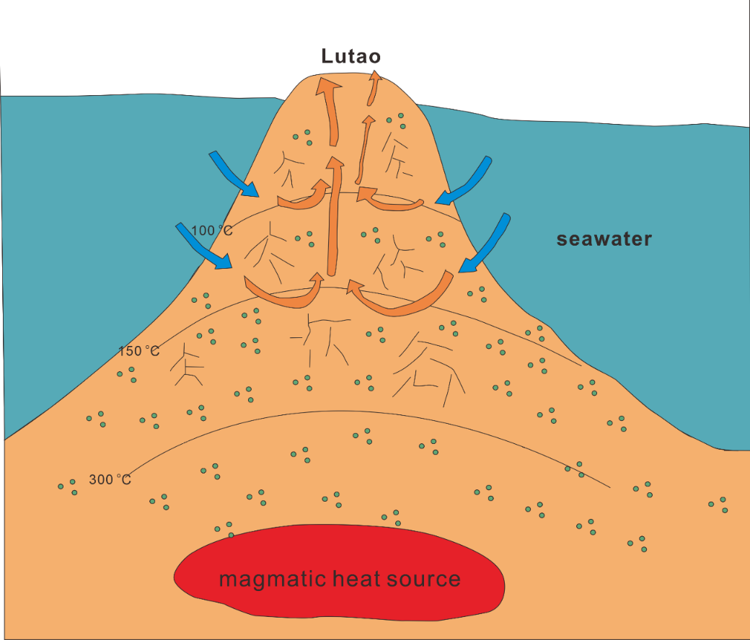
Fig. S6 Formation mechanism of Lutao methane: (upper figure) magmatic CO₂ and H₂O were trapped in the intrusive rock during Lutao volcanism at ~ 1.3 Ma. (bottom figure) These CO₂-H₂O rich inclusions achieved chemical and isotopic equilibrium with temperature gradients after long-term processing. Short-chain alkanes were formed from these inclusions via a one-step reaction (respeciation of CO₂ and H₂O buffered by Fe(II) minerals. H₂ was not formed) or a two-step mechanism that combines serpentinization and Sabatier reaction/respeciation. These alkanes were leached by vent fluids during hydrothermal circulation.

Fig. S7
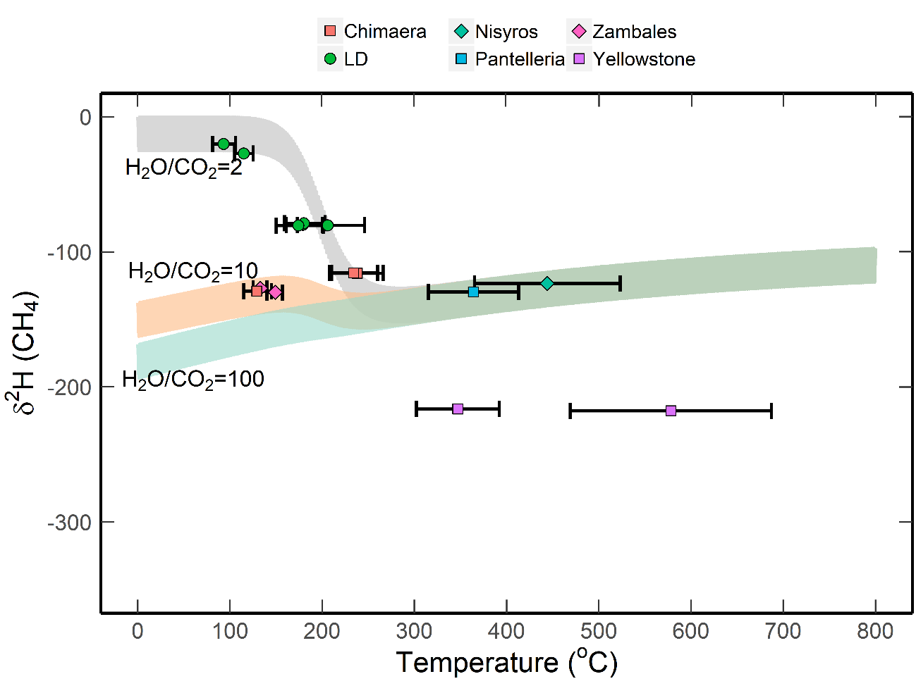
Fig. S7 Variations of δ²H values of methane (the gray area) as a function of equilibrium temperature in a closed system. The details on the D/H fractionation model are shown in the supporting information T3. Data source: Chimaera ^{22,23}; LD (this study); Nisyros, Pantelleria, and Yellowstone ²¹; Zambales ⁴⁷.

Fig. S8
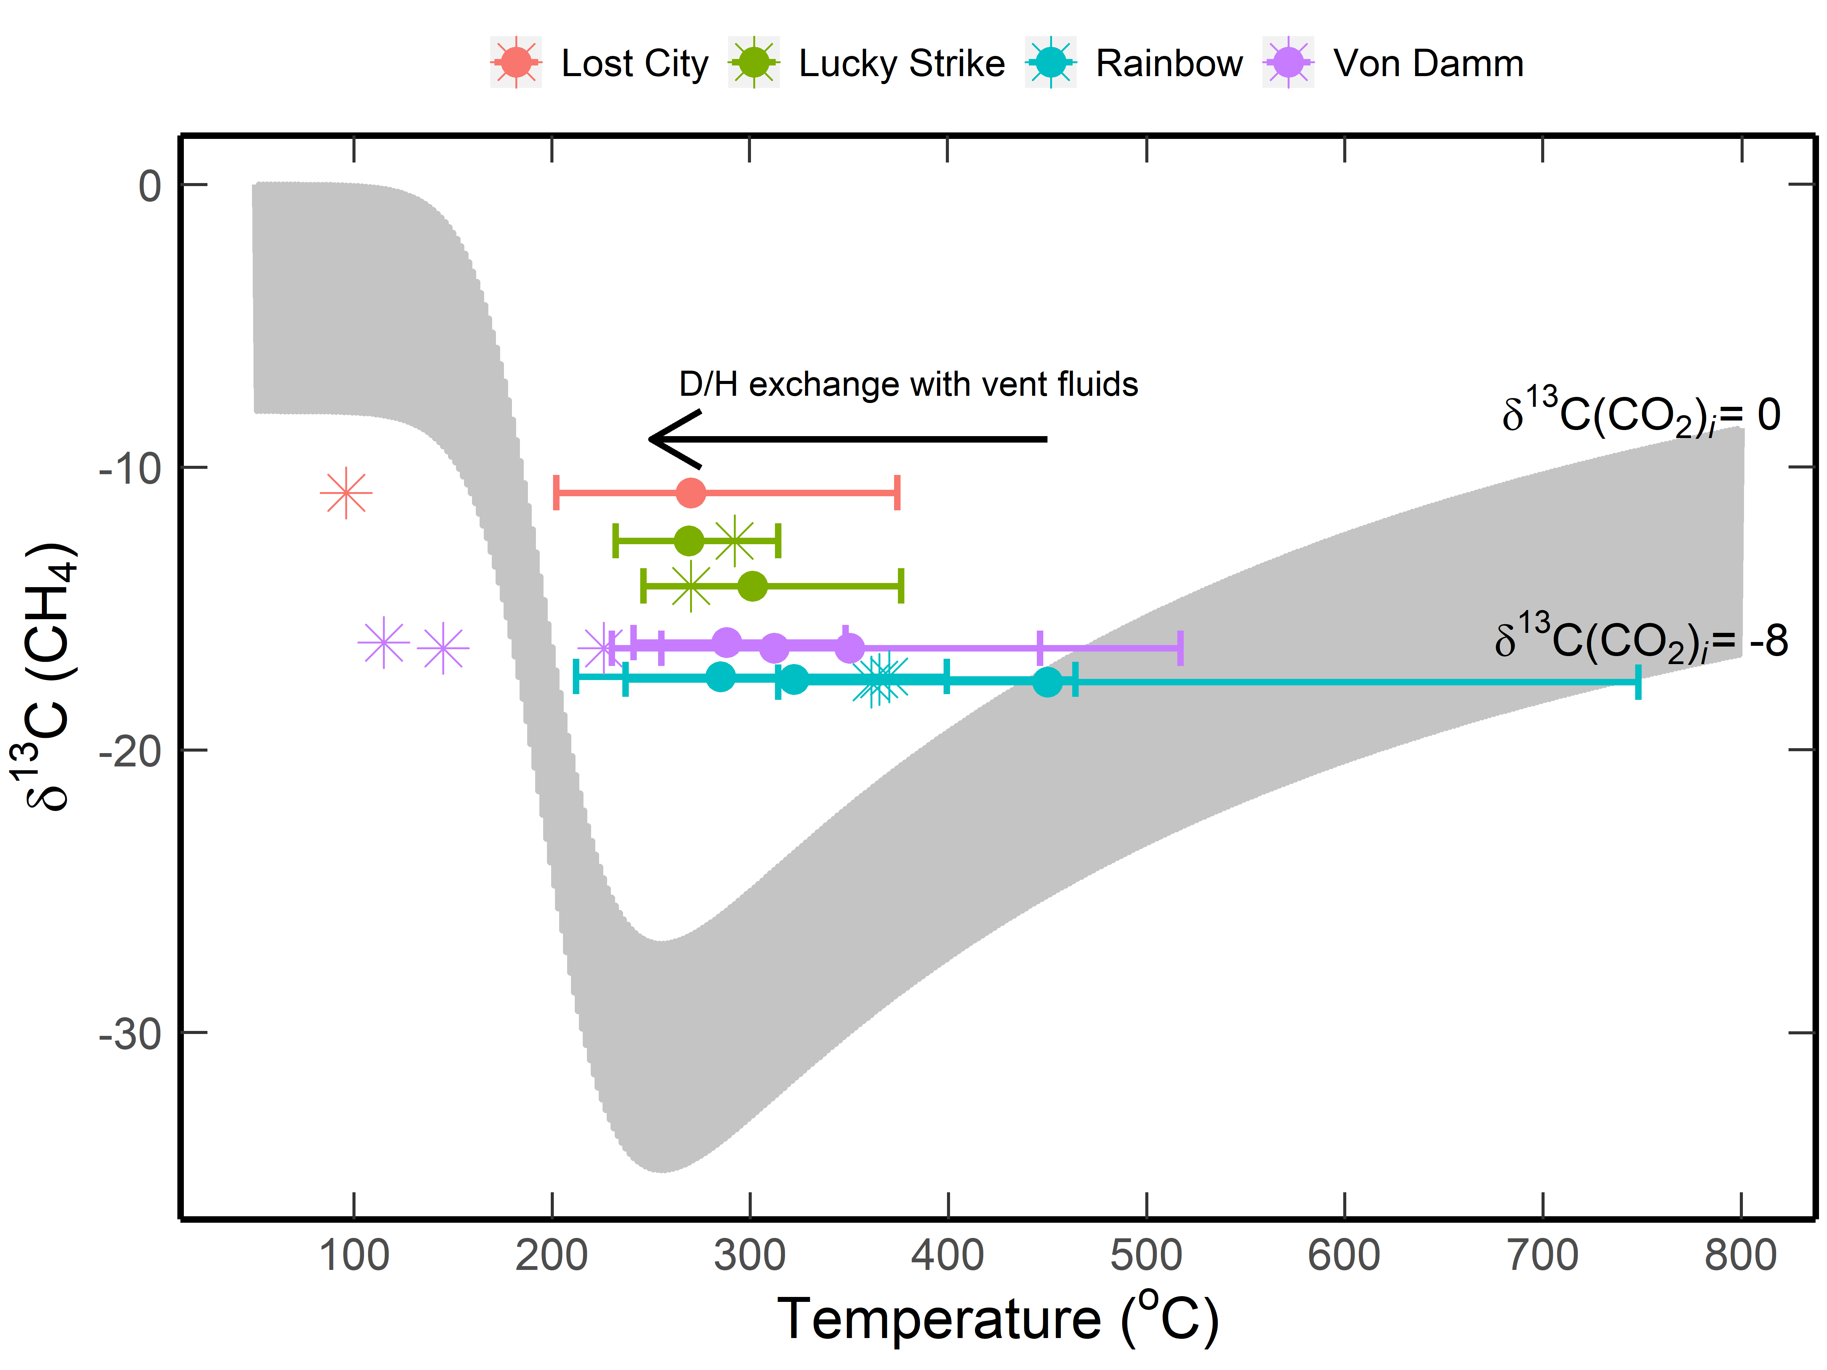
Fig. S8 Variation of equilibrium temperature and δ¹³C values of methane discharged from Mid-Ocean Ridge (MOR) hydrothermal system (Rainbow, Von Damm, Lost City, and Lucky Strike) ⁴⁸. Temperatures were calculated from methane isotopologue (∆¹³CH₃D) abundances. The gray area shows the estimated equilibrium δ¹³C(CH₄) values in closed systems (Fig. 3). The vent temperatures are shown in asterisks. The fast D/H exchange between equilibrated CH₄ and vent fluids decreased the apparent temperatures that calculated from the ∆¹³CH₃D abundances.

Table S1
Table S1. The chemical compositions of gas discharges from the Lutao ZDQ brine vent. Units: He, μmol/mol; all other components, mmol/mol.
Date | Sample | HgCl₂ added | H₂ | N₂ | O₂ | Ar | CO₂ | He | R/R_{a} | R_{c}/R_{a} | ⁴He/²⁰Ne
2012/5/5 | 012a1 | No | n.d. | 805.8 | 60.9 | 4.7 | 1.1 | 237 | n.d. |  | 32.6
2014/4/29 | 014a1 | No | n.d. | 823.7 | 5.3 | 2.6 | 0.6 | 650 | 6.57 |  | n.d.
2014/4/29 | 014a2 | No | n.d. | 816.1 | 60.3 | 4.4 | 1.1 | 370 | 6.67 |  | n.d.
2014/4/30 | 014a3 | No | n.d. | 820.7 | 15.5 | 2.9 | 0.85 | 510 | 7.00 |  | n.d.
2014/9/22 | 014b1 | No | n.d. | 823.3 | 9.9 | 3.0 | 4.2 | 234 | 4.97 | 4.99 | 76.8
2014/9/22 | 014b3 | No | n.d. | 837.2 | 27.4 | 5.4 | 19.8 | 161 | 5.56 | 5.60 | 30.6
2014/9/22 | 014b4 | No | n.d. | 815.4 | 44.8 | 4.2 | 7.4 | 170 | 5.10 | 5.14 | 34.7
2014/9/22 | 014b5 | No | n.d. | 820.4 | 20.6 | 3.5 | 9.2 | 185 | 4.90 | 4.93 | 52.7
2014/9/23 | 014b6 | No | n.d. | 828.4 | 61.7 | 6.2 | 22.2 | n.d. | 4.97 | 5.08 | 11.1
2014/9/23 | 014b7 | No | n.d. | 806.5 | 102.5 | 6.1 | 11.1 | n.d. | 4.25 | 4.39 | 7.5
2016/5/20 | 016z1 | Yes | b.d.l | 821.9 | 3.1 | 2.4 | 0.17 | 473 | 6.08 | 6.09 | 729.3
2016/5/20 | 016z3 | Yes | b.d.l | 822.1 | 3.2 | 2.4 | 0.51 | 501 | 6.26 | 6.26 | 715.7
2016/5/20 | 016z4 | Yes | b.d.l | 822.4 | 4.1 | 2.5 | 0.27 | 453 | 6.21 | 6.22 | 546.4
2016/5/21 | 016z5 | Yes | b.d.l | 822.0 | 1.8 | 2.4 | 0.22 | 473 | 5.93 | 5.94 | 151.0
2016/5/21 | 016z6 | No | b.d.l | 822.7 | 1.2 | 2.4 | 0.07 | 501 | 5.91 | 5.92 | 155.9
2016/5/21 | 016z7 | Yes | b.d.l | 820.0 | 16.1 | 2.9 | 0.14 | 465 | 5.97 | 5.99 | 66.2
2016/5/21 | 016z8 | Yes | b.d.l | 819.5 | 3.8 | 2.4 | 0.08 | 506 | 6.13 | 6.14 | 110.1
2016/5/22 | 016z9 | Yes | b.d.l | 821.2 | 7.7 | 2.6 | 0.21 | 500 | 5.76 | 5.77 | 679.6
2016/5/22 | 016z10 | No | b.d.l | 822.5 | 3.1 | 2.5 | 0.20 | 515 | 5.91 | 5.91 | 685.7
2016/5/22 | 016z11 | Yes | 0.99 | 806.8 | 90.2 | 5.3 | 0.13 | 310 | 5.94 | 5.97 | 42.5
Precision: ±3%.
R_{c}/R_{a} ratios were calculated from the R/R_{a} and ⁴He/²⁰Ne ratios assuming that all ²⁰Ne was originated from air contamination ⁴³.
n.d. = not determined. b.d.l.= below detection limit.

Table S2
Table S2. The chemical compositions of Lutao ZDQ hydrocarbons. Units: C₁-C₃, mmol/mol; C₄ and C₅, μmol/mol
Date | Sample | CH₄ | C₂H₆ | C₃H₈ | i-C₄H₁₀ | n-C₄H₁₀ | C₅H₁₂
2012/5/5 | 012a1 | 126.9 | 0.5 | 0.1 | n.d. | n.d. | n.d.
2014/4/29 | 014a1 | 166.1 | 0.82 | 0.15 | n.d. | n.d. | n.d.
2014/4/29 | 014a2 | 117.3 | 0.58 | 0.11 | n.d. | n.d. | n.d.
2014/4/30 | 014a3 | 158.6 | 0.80 | 0.16 | n.d. | n.d. | n.d.
2014/9/22 | 014b1 | 158.6 | 0.733 | 0.085 | n.d. | n.d. | n.d.
2014/9/22 | 014b3 | 109.5 | 0.494 | 0.062 | n.d. | n.d. | n.d.
2014/9/22 | 014b4 | 127.4 | 0.605 | 0.066 | n.d. | n.d. | n.d.
2014/9/22 | 014b5 | 145.4 | 0.670 | 0.066 | n.d. | n.d. | n.d.
2014/9/23 | 014b6 | 81.1 | 0.408 | 0.062 | n.d. | n.d. | n.d.
2014/9/23 | 014b7 | 73.3 | 0.414 | 0.064 | n.d. | n.d. | n.d.
2016/5/20 | 016z1 | 140.2 | 0.570 | 0.119 | 4.6 | 11.6 | 0.7
2016/5/20 | 016z3 | 170.7 | 0.569 | 0.116 | 5.4 | 11.9 | 1.6
2016/5/20 | 016z4 | 158.3 | 0.568 | 0.111 | 4.9 | 11.5 | 0.7
2016/5/21 | 016z5 | 156.4 | 0.553 | 0.114 | 4.9 | 10.8 | 1.0
2016/5/21 | 016z6 | 155.7 | 0.559 | 0.115 | 4.4 | 10.8 | 1.0
2016/5/21 | 016z7 | 142.6 | 0.658 | 0.131 | 5.9 | 13.2 | 1.4
2016/5/21 | 016z8 | 148.3 | 0.688 | 0.137 | 6.0 | 14.0 | 1.3
2016/5/22 | 016z9 | 112.4 | 0.710 | 0.145 | 6.2 | 14.3 | 1.4
2016/5/22 | 016z10 | 168.7 | 0.572 | 0.112 | 4.6 | 11.6 | 0.7
2016/5/22 | 016z11 | 32.5 | 0.124 | 0.024 | 1.2 | 2.3 | b.d.l.
n.d. = not determined. b.d.l.= below detection limit.
Measurement uncertainties: samples collected in 2012 and 2014, ±5%; 2016 samples, ±2-10%

Table S3
Table S3. The chemical and isotopic compositions of gas samples collected from the HWC vapor spring.
Date | sample | H₂ | N₂ | O₂ | Ar | CO₂ | CH₄ | C₂H₆ | C₃H₈ | δ¹³C-C₁ | δ¹³C-CO₂ | δ¹³C-C₂ | δ¹³C-C₃ | δ²H-C₁ | δ²H-C₂ | δ²H-C₃
2012/5/5 | 012a2 | n.d. | 899.5 | 0.4 | 3.0 | 7.9 | 88.9 | 0.2 | 0.1 | -10.7 | -18.5 | -13.4 | n.d. | n.d. | n.d. | n.d.
2014/4/29 | 014w1 | n.d. | 910.0 | 35.4 | 4.0 | 2.9 | 47.1 | 0.09 | 0.04 | -8.1 | -16.6 | n.d. | n.d. | n.d. | n.d. | n.d.
2014/4/30 | 014w2 | n.d. | 915.6 | 27.6 | 3.8 | 3.4 | 49.1 | 0.08 | 0.04 | -7.5 | -13.3 | n.d. | n.d. | n.d. | n.d. | n.d.
2014/9/22 | 014s2 | n.d. | 875.9 | 82.4 | 5.8 | 3.8 | 31.9 | 0.066 | 0.040 | -12.9 | -12.9 | n.d. | n.d. | -117 | n.d. | n.d.
2014/9/22 | 014s3 | n.d. | 841.4 | 132.8 | 7.9 | 3.1 | 14.6 | 0.045 | 0.020 | -10.5 | -13.2 | n.d. | n.d. | -55 | n.d. | n.d.
2014/9/22 | 014s4 | n.d. | 919.3 | 20.3 | 4.1 | 9.1 | 46.9 | 0.062 | 0.113 | -7.1 | -14.6 | -15.1 | n.d. | 33 | n.d. | n.d.
2014/9/23 | 014s6 | n.d. | 927.3 | 12.8 | 3.9 | 5.8 | 49.8 | 0.113 | 0.053 | -9.9 | -17.2 | n.d. | n.d. | 34 | n.d. | n.d.
2014/9/23 | 014s8 | n.d. | 881.5 | 63.0 | 5.5 | 16.3 | 33.4 | 0.060 | 0.045 | -9.5 | -14.3 | n.d. | n.d. | 41 | n.d. | n.d.
2016/5/20 | 016w1 | n.d. | 939.9 | 5.3 | 3.3 | 3.6 | 50.1 | 0.036 | 0.035 | -6.3 | -12.2 | -11.2 | -37.9 | 17 | -141 | -179
2016/5/20 | 016w2 | n.d. | 940.9 | 6.0 | 3.3 | 2.4 | 51.1 | 0.036 | 0.029 | -6.0 | -8.4 | -7.8 | -31.2 | 18 | -135 | -178
2016/5/20 | 016w3 | 5.88 | 931.0 | 8.6 | 3.2 | 3.1 | 49.0 | 0.042 | 0.029 | -6.7 | -10.5 | -11.2 | -27.5 | 14 | -146 | n.d.
2016/5/20 | 016w4 | 4.12 | 935.3 | 7.0 | 3.3 | 2.2 | 48.0 | 0.037 | 0.028 | -7.2 | -8.6 | -8.6 | -26.4 | n.d. | n.d. | n.d.
2016/5/21 | 016w5 | 3.75 | 936.8 | 3.8 | 3.3 | 4.0 | 46.5 | 0.033 | 0.026 | -6.5 | -11.7 | -8.2 | -21.4 | n.d. | n.d. | n.d.
2016/5/21 | 016w6 | n.d. | 942.7 | 2.7 | 3.3 | 2.9 | 47.1 | 0.034 | 0.028 | -6.6 | -12.4 | -9.2 | -21.8 | n.d. | n.d. | n.d.
2016/5/21 | 016w7 | 5.32 | 934.6 | 4.3 | 3.2 | 3.6 | 47.1 | 0.041 | 0.030 | -7.2 | -12.1 | -10.8 | -13.0 | 11 | -115 | n.d.
2016/5/21 | 016w8 | n.d. | 932.6 | 15.8 | 3.6 | 2.4 | 43.2 | 0.033 | 0.028 | -6.8 | -12.5 | -8.4 | -12.9 | 11 | -114 | n.d.
2016/5/22 | 016w9 | 1.53 | 938.8 | 2.6 | 3.3 | 4.3 | 46.5 | 0.035 | 0.027 | -6.2 | -13.3 | -7.6 | -13.0 | 10 | -130 | n.d.
2016/5/22 | 016w10 | n.d. | 932.6 | 14.3 | 3.7 | 3.7 | 43.3 | 0.030 | 0.026 | -6.4 | -14.2 | -6.3 | -13.6 | n.d. | n.d. | n.d.
2016/5/22 | 016w11 | n.d. | 939.2 | 5.6 | 3.3 | 3.6 | 47.0 | 0.035 | 0.027 | -7.1 | -14.8 | -6.3 | -13.0 | n.d. | n.d. | n.d.
2018/10/30 | 018WG3 | n.d. | n.d. | n.d. | n.d. | n.d. | n.d. | n.d. | n.d. | -10.5 | n.d. | n.d. | n.d. | -27 | n.d. | n.d.
2018/10/30 | 018WG4 | n.d. | n.d. | n.d. | n.d. | n.d. | n.d. | n.d. | n.d. | -10.2 | n.d. | n.d. | n.d. | -20 | n.d. | n.d.

* The units and measurement uncertainties are identical to those listed in Table 1, Table S1 and S2.

References
1. Shao, W.-Y., Chung, S.-L. & Chen, W.-S. Zircon U-Pb Age Determination of Volcanic Eruptions in Lutao and Lanyu in the Northern Luzon Magmatic Arc. Terr. Atmospheric Ocean. Sci. 25, 149–187 (2014).
2. Lai, Y.-M. et al. Zircon U-Pb and Hf isotopic constraints on the magmatic evolution of the Northern Luzon Arc. Terr. Atmospheric Ocean. Sci. 29, 149–186 (2018).
3. Chen, C.-H. Petrology and genesis of cognate plutonic inclusions in andesites of East Coastal Range, Lutao and Lanhsu, Taiwan. Mem Geol Soc China 7, 259–281 (1986).
4. Wang, Y. & Chung, S.-H. A preliminary mineralogical study of the Lutao andesites. Spec. Publ. Cent. Geol. Surv. 5, 77–91 (1991).
5. Chen, J. & Lin, F. Geochemistry of Lutao andesites. Acta Ocean. Taiwanica 11, 49–69 (1980).
6. Shen, C.-C., Wu, C.-C., Dai, C.-F. & Gong, S.-Y. Variable uplift rate through time: Holocene coral reef and neotectonics of Lutao, eastern Taiwan. J. Asian Earth Sci. 156, 201–206 (2018).
7. Woodland, A. B. & Koch, M. Variation in oxygen fugacity with depth in the upper mantle beneath the Kaapvaal craton, Southern Africa. Earth Planet. Sci. Lett. 214, 295–310 (2003).
8. Zhang, C. & Duan, Z. A model for C–O–H fluid in the Earth’s mantle. Geochim. Cosmochim. Acta 73, 2089–2102 (2009).
9. Taran, Y. A. & Giggenbach, W. F. Geochemistry of light hydrocarbons in subduction-related volcanic and hydrothermal fluids. Spec. Publ.-Soc. Econ. Geol. 10, 61–74 (2003).
10. Giggenbach, W. F. Relative importance of thermodynamic and kinetic processes in governing the chemical and isotopic composition of carbon gases in high-heatflow sedimentary basins. Geochim. Cosmochim. Acta 61, 3763–3785 (1997).
11. Horita, J. Carbon isotope exchange in the system CO2-CH4 at elevated temperatures. Geochim. Cosmochim. Acta 65, 1907–1919 (2001).
12. Abrajano, T. A. et al. Methane Hydrogen Gas Seeps, Zambales Ophiolite, Philippines - Deep or Shallow Origin. Chem. Geol. 71, 211–222 (1988).
13. Etiope, G. & Whiticar, M. J. Abiotic methane in continental ultramafic rock systems: Towards a genetic model. Appl. Geochem. 102, 139–152 (2019).
14. Fiebig, J. et al. Chemical and isotopic equilibrium between CO₂ and CH₄ in fumarolic gas discharges: Generation of CH₄ in arc magmatic-hydrothermal systems. Geochim. Cosmochim. Acta 68, 2321–2334 (2004).
15. Hoefs, J. Stable isotope geochemistry. (Springer, 2009).
16. Lowenstern, J. B. Carbon dioxide in magmas and implications for hydrothermal systems. Miner. Deposita 36, 490–502 (2001).
17. Suess, H. E. Das Gleichgewicht H₂+ HDO⇌ HD+ H₂ O und die weiteren Austauschgleichgewichte im System H₂, D₂ und H₂O. Z. Für Naturforschung A 4, 328–332 (1949).
18. Horibe, Y. & Craig, H. D/H fractionation in the system methane-hydrogen-water. Geochim. Cosmochim. Acta 59, 5209–5217 (1995).
19. Whiticar, M. J. Carbon and hydrogen isotope systematics of bacterial formation and oxidation of methane. Chem. Geol. 161, 291–314 (1999).
20. Wang, D. T., Welander, P. V. & Ono, S. Fractionation of the methane isotopologues ¹³CH₄, ¹²CH₃D, and ¹³CH₃D during aerobic oxidation of methane by Methylococcus capsulatus (Bath). Geochim. Cosmochim. Acta 192, 186–202 (2016).
21. Douglas, P. M. J. et al. Methane clumped isotopes: Progress and potential for a new isotopic tracer. Org. Geochem. 113, 262–282 (2017).
22. Etiope, G., Schoell, M. & Hosgörmez, H. Abiotic methane flux from the Chimaera seep and Tekirova ophiolites (Turkey): Understanding gas exhalation from low temperature serpentinization and implications for Mars. Earth Planet. Sci. Lett. 310, 96–104 (2011).
23. Young, E. D. et al. The relative abundances of resolved (CH₂D₂)-C-12 and (CH₃D)-C-13 and mechanisms controlling isotopic bond ordering in abiotic and biotic methane gases. Geochim. Cosmochim. Acta 203, 235–264 (2017).
24. Yoshinaga, M. Y. et al. Carbon isotope equilibration during sulphate-limited anaerobic oxidation of methane. Nat. Geosci. 7, 190–194 (2014).
25. Takai, K. et al. Cell proliferation at 122°C and isotopically heavy CH₄ production by a hyperthermophilic methanogen under high-pressure cultivation. Proc. Natl. Acad. Sci. 105, 10949–10954 (2008).
26. Kelley, D. S. & Fruh-Green, G. L. Abiogenic methane in deep-seated mid-ocean ridge environments: Insights from stable isotope analyses. J. Geophys. Res.-Solid Earth 104, 10439–10460 (1999).
27. Grozeva, N. G. Carbon and mineral transformations in seafloor serpentinization systems. (Massachusetts Institute of Technology, 2018).
28. Scott, H. P. et al. Generation of methane in the Earth’s mantle: In situ high pressure-temperature measurements of carbonate reduction. Proc. Natl. Acad. Sci. 101, 14023–14026 (2004).
29. Etiope, G. & Lollar, B. S. Abiotic Methane on Earth. Rev. Geophys. 51, 276–299 (2013).
30. Oze, C. & Sharma, M. Have olivine, will gas: Serpentinization and the abiogenic production of methane on Mars. Geophys. Res. Lett. 32, L10203 (2005).
31. Holm, N. G., Oze, C., Mousis, O., Waite, J. H. & Guilbert-Lepoutre, A. Serpentinization and the Formation of H-2 and CH4 on Celestial Bodies (Planets, Moons, Comets). Astrobiology 15, 587–600 (2015).
32. Schrenk, M. O., Brazelton, W. J. & Lang, S. Q. Serpentinization, carbon, and deep life. Rev. Mineral. Geochem. 75, 575–606 (2013).
33. McCollom, T. M. Abiotic methane formation during experimental serpentinization of olivine. Proc. Natl. Acad. Sci. 113, 13965–13970 (2016).
34. McCollom, T. M. Laboratory Simulations of Abiotic Hydrocarbon Formation in Earth’s Deep Subsurface. Rev. Mineral. Geochem. 75, 467–494 (2013).
35. Fiebig, J., Woodland, A. B., D’Alessandro, W. & Puttmann, W. Excess methane in continental hydrothermal emissions is abiogenic. Geology 37, 495–498 (2009).
36. Johnson, J. W., Oelkers, E. H. & Helgeson, H. C. SUPCRT92: A software package for calculating the standard molal thermodynamic properties of minerals, gases, aqueous species, and reactions from 1 to 5000 bar and 0 to 1000°C. Comput. Geosci. 18, 899–947 (1992).
37. Shock, E. L., Sassani, D. C., Willis, M. & Sverjensky, D. A. Inorganic species in geologic fluids: correlations among standard molal thermodynamic properties of aqueous ions and hydroxide complexes. Geochim. Cosmochim. Acta 61, 907–950 (1997).
38. Dick, J. M. Calculation of the relative metastabilities of proteins using the CHNOSZ software package. Geochem. Trans. 9, 10 (2008).
39. Berndt, M. E., Allen, D. E. & Seyfried, W. E. Reduction of CO₂ during serpentinization of olivine at 300 °C and 500 bar. Geology 24, 351 (1996).
40. Syverson, D. D. et al. Fe isotope fractionation between chalcopyrite and dissolved Fe during hydrothermal recrystallization: An experimental study at 350 °C and 500 bars. Geochim. Cosmochim. Acta 200, 87–109 (2017).
41. Klein, F., Grozeva, N. G. & Seewald, J. S. Abiotic methane synthesis and serpentinization in olivine-hosted fluid inclusions. Proc. Natl. Acad. Sci. 116, 17666–17672 (2019).
42. Grozeva, N. G., Klein, F., Seewald, J. S. & Sylva, S. P. Experimental study of carbonate formation in oceanic peridotite. Geochim. Cosmochim. Acta 199, 264–286 (2017).
43. Poreda, R. & Craig, H. Helium isotope ratios in circum-Pacific volcanic arcs. Nature 338, 473–478 (1989).
44. Hilton, D., McMurtry, G. & Goff, F. Large variations in vent fluid CO₂/³He ratios signal rapid changes in magma chemistry at Loihi seamount, Hawaii. Nature 396, 359–362 (1998).
45. Coleman, D. D., Risatti, J. B. & Schoell, M. Fractionation of carbon and hydrogen isotopes by methane-oxidizing bacteria. Geochim. Cosmochim. Acta 45, 1033–1037 (1981).
46. Barker, J. F. & Fritz, P. Carbon isotope fractionation during microbial methane oxidation. Nature 293, 289–291 (1981).
47. Abrajano, T. A. et al. Geochemistry of Reduced Gas Related to Serpentinization of the Zambales Ophiolite, Philippines. Appl. Geochem. 5, 625–630 (1990).
48. Wang, D. T., Reeves, E. P., McDermott, J. M., Seewald, J. S. & Ono, S. Clumped isotopologue constraints on the origin of methane at seafloor hot springs. Geochim. Cosmochim. Acta 223, 141–158 (2018).

