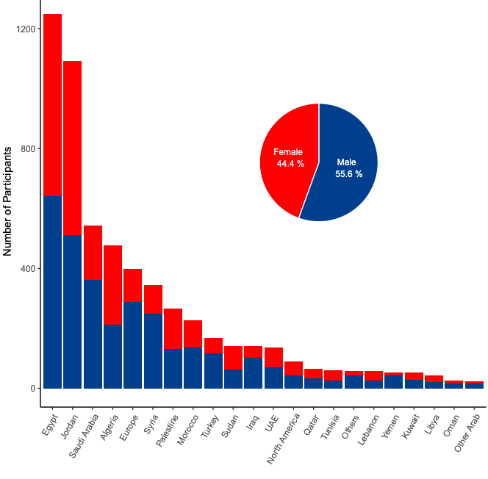
Supplementary Figure 1. A bar plot and a pie chart showing distribution of participants according to country of residence and gender.

Supplementary Table 1. Comparison between HCW and non-HCW participants
Label | levels | HCW |  | Not HCW |  | Total
 |  | N | % | N | % | N | %
Age | Below 30 | 3033 | 53.1% | 12738 | 41.7% | 15771 | 43.5%
 | 30-39 | 1649 | 28.9% | 9916 | 32.5% | 11565 | 31.9%
 | 40-49 | 692 | 12.1% | 5227 | 17.1% | 5919 | 16.3%
 | 50-59 | 261 | 4.6% | 2040 | 6.7% | 2301 | 6.4%
 | Over 59 | 73 | 1.3% | 591 | 1.9% | 664 | 1.8%
Chronic Diseases | No | 4908 | 86.0% | 25473 | 83.5% | 30381 | 83.9%
 | Yes | 800 | 14.0% | 5039 | 16.5% | 5839 | 16.1%
Country | Arab countries | 4996 | 87.5% | 25204 | 82.6% | 30200 | 83.4%
 | Other countries | 712 | 12.5% | 5308 | 17.4% | 6020 | 16.6%
Academic Education | Higher education | 3875 | 67.9% | 18361 | 60.2% | 22236 | 61.4%
 | Lower education | 1833 | 32.1% | 12151 | 39.8% | 13984 | 38.6%
Had Covid | No | 2579 | 45.2% | 15546 | 51.0% | 18125 | 50.0%
 | Not sure | 1859 | 32.6% | 9599 | 31.5% | 11458 | 31.6%
 | Yes | 1270 | 22.2% | 5367 | 17.6% | 6637 | 18.3%
Gender | Male | 3171 | 55.6% | 18869 | 61.8% | 22040 | 60.9%
 | Female | 2537 | 44.4% | 11643 | 38.2% | 14180 | 39.1%
Vaccine Type Unknown | No | 3857 | 67.6% | 17306 | 56.7% | 21163 | 58.4%
 | Yes | 1851 | 32.4% | 13206 | 43.3% | 15057 | 41.6%
Influenza Vaccine | Yearly | 321 | 5.6% | 587 | 1.9% | 908 | 2.5%
 | Some years | 681 | 11.9% | 2230 | 7.3% | 2911 | 8.0%
 | Rarely | 712 | 12.5% | 3649 | 12.0% | 4361 | 12.0%
 | Never | 3994 | 70.0% | 24046 | 78.8% | 28040 | 77.4%
Vaccine Hesitancy | Acceptance | 1522 | 26.7% | 4641 | 15.2% | 6163 | 17.0%
 | Hesitance | 4186 | 73.3% | 25871 | 84.8% | 30057 | 83.0%
 |  | 5708 | 100.0% | 30512 | 100.0% | 36220 | 100.0%

