Supplementary materials

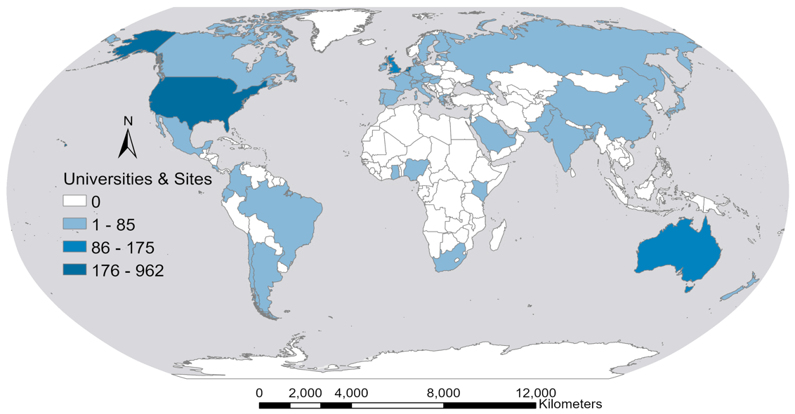

Supplementary Fig. 1: Countries that are using wastewater surveillance for SARS-CoV-2 RNA in wastewater.

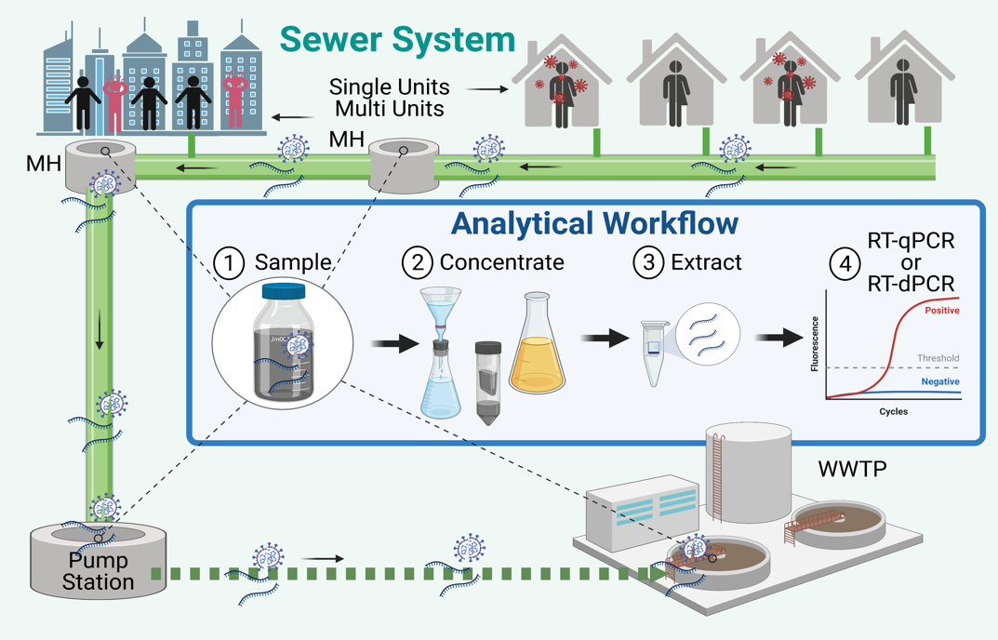

Supplementary Fig. 2: A conceptual diagram of a typical sewer catchment with sampling points and analytical workflow of SARS-CoV-2 RNA surveillance in wastewater. MH: Maintenance hole.

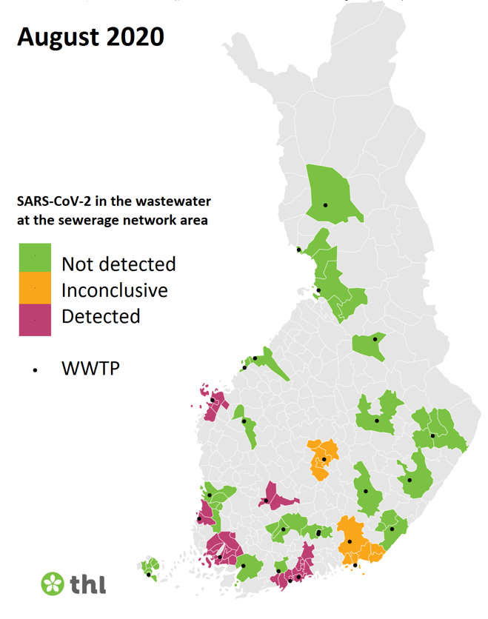

Supplementary Fig. 3: A weekly report from August 2020 of the national dashboard reporting SARS-CoV-2 RNA surveillance results by using N2 assay at 28 WWTPs in Finland. “Not detected” is denoted when none of the four RT-qPCR replicates exhibit Cq <40. “Inconclusive” means that only one replicate has exhibited Cq <40 (>MLOD but <MLOQ) and the re-run produced non-detection. “Detected” denotes for Cq <40 in more than one replicate of the RT-qPCR reactions/sample. Data from Finnish Institute for Health and Welfare (THL), 2020.

