Supplementary Table 1: NCBI accession no. of FMDV Serotype O Isolates used in Phylogenetic analysis

Name of Isolate | Accession No. | Name of Isolate | Accession No.
BAN/TG/Ba-268/2015 | KY077621.1 | BAN/LA/Ad-278/2016 | KY077623.1
BAN/TG/Ba-265/2015 | KY077620.1 | BAN/KU/Fu-283/2016 | KY077624.1
BAN/GA/Kk-192/2013 | KY077603.1 | BAN/MG/Sa-294/2016 | KY077626.1
BAN/NL/Lo-245/2015 | KY077611.1 | BAN/TA/Dh-299/2016 | KY077627.1
BAN/LK/Sa-248/2015 | KY077612.1 | BAN/TA/Dh-301/2016 | KY077628.1
BAN/LK/Sa-249/2015 | KY077613.1 | BAN/GO/Ka-236(Pig)/2015 | KX712091.1
BAN/NO/Be-250/2015 | KY077614.1 | BAN/NA/Ha-156/2013 | KF985189.1
BAN/NO/Be-251/2015 | KY077615.1 | BAN/MG/Sa-287/2016 | KY077625.1
BAN/DI/Sa-252/2015 | KY077616.1 | BAN PA Kg-20 2012 | KJ175180.1
BAN/DI/Sa-254/2015 | KY077617.1 | BAN FA Do-12 2012 | KJ175179.1
BAN/PG/At-262/2015 | KY077618.1 | BAN LA Sa-137 2013 | KJ175182.1
BAN/PG/At-264/2015 | KY077619.1 | BAN/BO/Na-162/2013 | KY077601.1
BAN/MA/Ku-269/2015 | KY077622.1 | BAN/BO/Na-161/2013 | KY077600.1
BAN LA Du-135 2013 | KJ175181.1 | BAN JA Ma-180 2013 | KJ175183.1
BAN/PA/Ch-228/2015 | KY077609.1 | BAN/GA/Kk-191/2013 | KY077602.1
BAN/DH/Dh-216/2015 | KY077608.1 | BAN/GA/Ka-213/2014 | KY077606.1
BAN TA Dh-186 2013 | KJ175185.1 | BAN/GA/Ka-212/2014 | KY077605.1
BAN/GA/Ka-215/2015 | KY077607.1 | BAN TA Dh-184 2013 | KJ175184.1
BAN/TA/Ma-200/2014 | KY077604.1 | BAN/SI/Sh-234/2015 | KY077610.1
BAN FA Do-11 2012 | KJ175178.1 | BAN FA Kh-05 2012 | KC795947.1

Supplementary Table 2: NCBI accession no. of FMDV Serotype A Isolates used in Phylogenetic analysis
Name of Isolate | Accession No. | Name of Isolate | Accession No.
BAN/CH/Sa-304/2016 | MK088171 | BAN_CH_Ra-08_2012 | KC795949. 1
BAN_CH_Ra-15_2012 | KC795951.1 | BAN/CH/Sa-302/2016 | KY077629
BAN_CH_Ra-16_2012 | KC795952.1 | BAN CH Ra-28 2012 | KC795955.1
BAN_CH_Ra-18_2012 | KC795953.1 | BAN CH Ra-26 2012 | KC795954.1
BAN_GA_Sa-197_2013 | KJ754939.1 | BAN CH Ra-14 2012 | KC795950.1

Supplementary Table-3: Immunization Plan of Experimental guinea pigs
- Total no of GP: 49
- Body Weight: 300-450 gm
- Immunization Route: Subcutaneous
- Immunization Schedule:
Day 1 --- Primary immunization of all GP
Day 14– Secondary (Booster) Immunization
Day 28 – Blood collection of all groups

Animal Group |  | Antigen Type/Conc. | No of GP |  | Total No. of Animals
 |  |  | B1 | B3
Experimental Group (n=24; B1= 20; B3=20) |  | 100 µg/dose | (A) 5 | (E) 5 | 10
 |  | 50 µg/dose | (B) 5 | (F) 5 | 10
 |  | 10 µg/dose | (C) 5 | (G) 5 | 10
 |  | 2 µg/dose | (D) 5 | (H) 5 | 10
Control Group (n=9) | Positive Control | Inactivated Type-O monovalent vaccine (BAN/DH/Dh-301/2016) | (X) 3 |  | 3
 |  | Inactivated Type-A monovalent vaccine (BAN/CH/Sa-304/2016) | (Y) 3 |  | 3
 | Negative Control | PBS with Montanide 201Vg | (Z) 3 |  | 3
Total No of Guinea Pig models |  |  |  |  | 49

Supplementary Table-4: Physicochemical parameters of B1 and B3
Characteristics | B1 | B3
MW (kDa) | 41.3 | 39.8
Isoelectric Point (pI) | 7.75 | 8.51
No. of Amino Acid | 390 | 383
Recombinant protein solubility Prediction | 100.0 percent | 100.0 percent
Estimated half-life | >10 hours (E. coli, in vivo) | >10 hours (E. coli, in vivo)

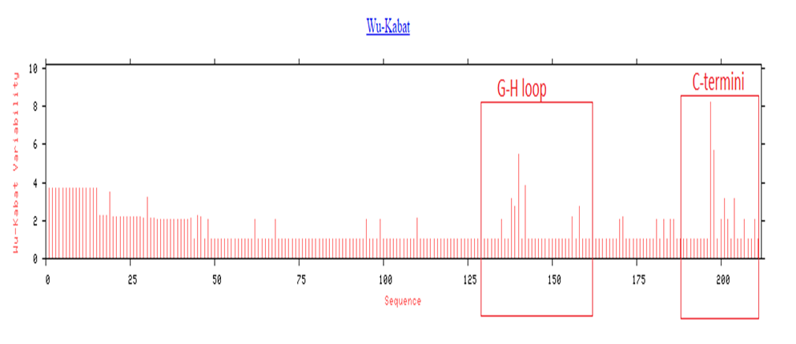
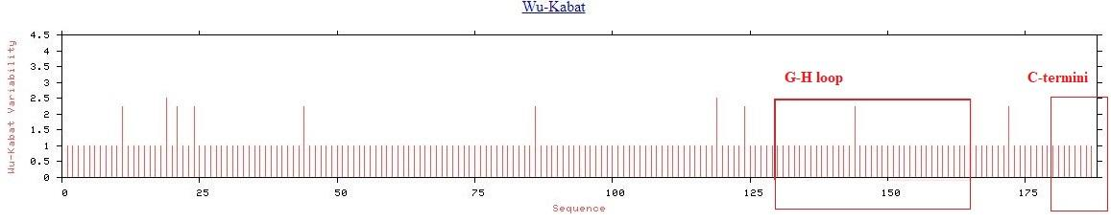
Suppl. Figure 1: Wu-Kabat protein variability plot for VP1 type O and A circulating in Bangladesh. Variability was most observed at G-H loop [135-158] and C-termini [195-211] positions. (a) Variability plot of the whole VP1 protein of serotype O, (b) Variability plot of the whole VP1 protein of serotype A.
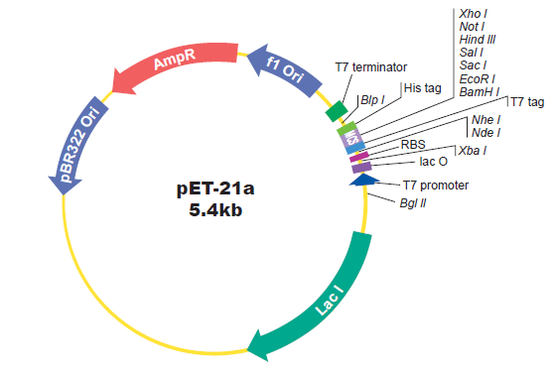
Suppl. Figure-2: Map of pET 21a(+) expression vector with selectable marker

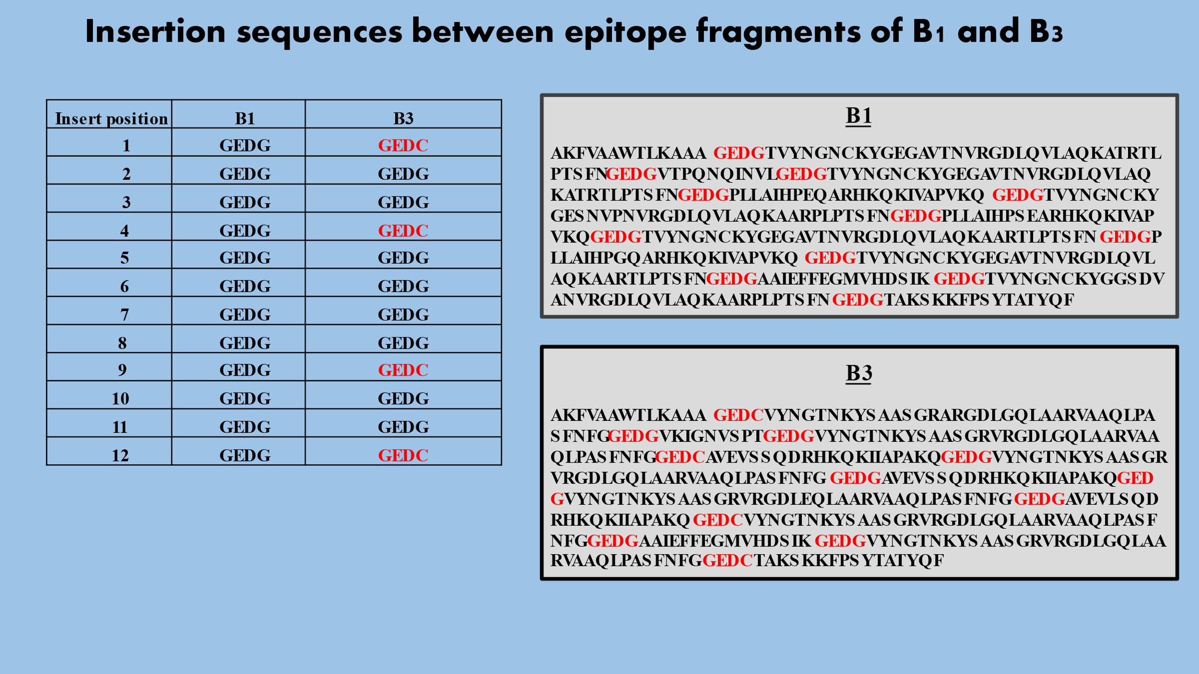
Suppl. Figure-3: Insertion sequences and amino acid sequences of B1 and B3.
Suppl. Figure-4: Ethical Clearance for the experiment (Ref:66/Biol. Sci./2018-19; Date: 14-11-2018)

