Supplementary material for:
Satellite and in situ sampling mismatches: consequences for the estimate of satellite sea surface salinity uncertainties.

This supplementary materials document accompanies the above-referenced article. We include, for completeness, a number of figures that were left out of the main manuscript.

Figure 1: Monthly GLORYS SSS SFV, 15/02/2017

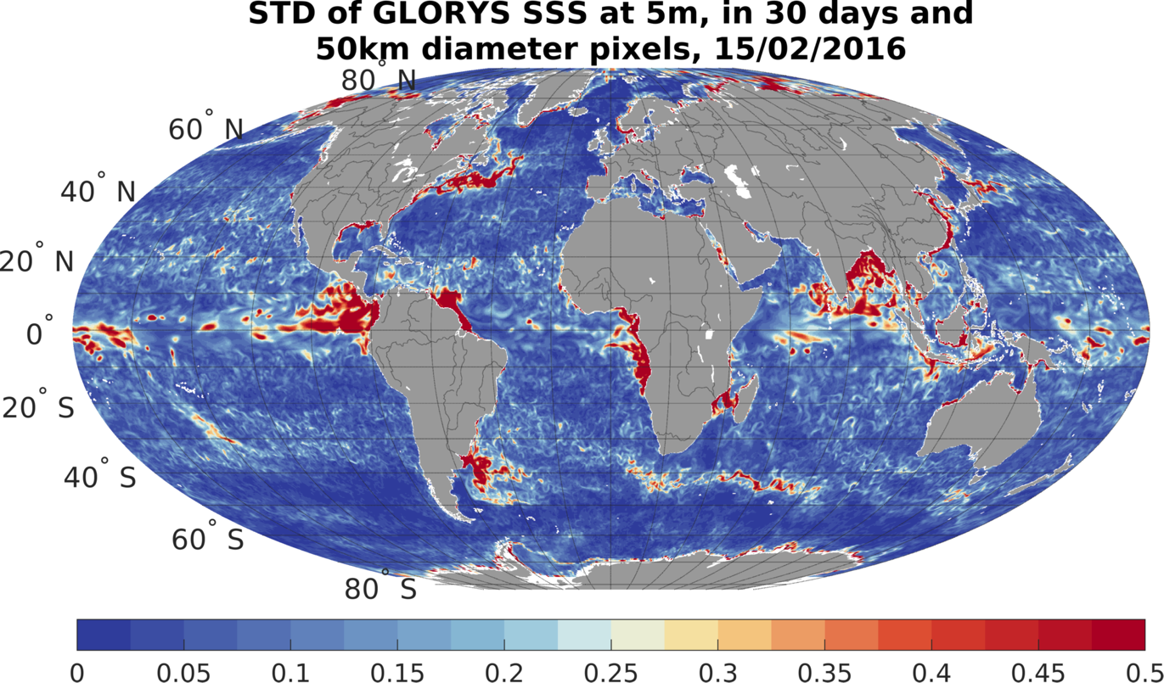

Table 1: Median SSS SFV, computed from GLORYS for a 50 km footprint for the all the months of the year, for comparison with Bingham 2021 results. Unitless color scale, with the colors scaling with the base 10 logarithm of the SFV. The month is given at the top of each panel.

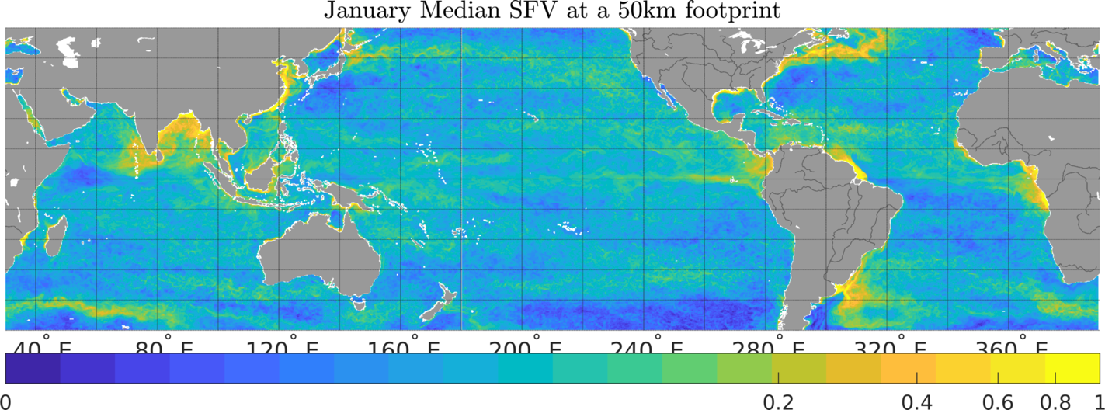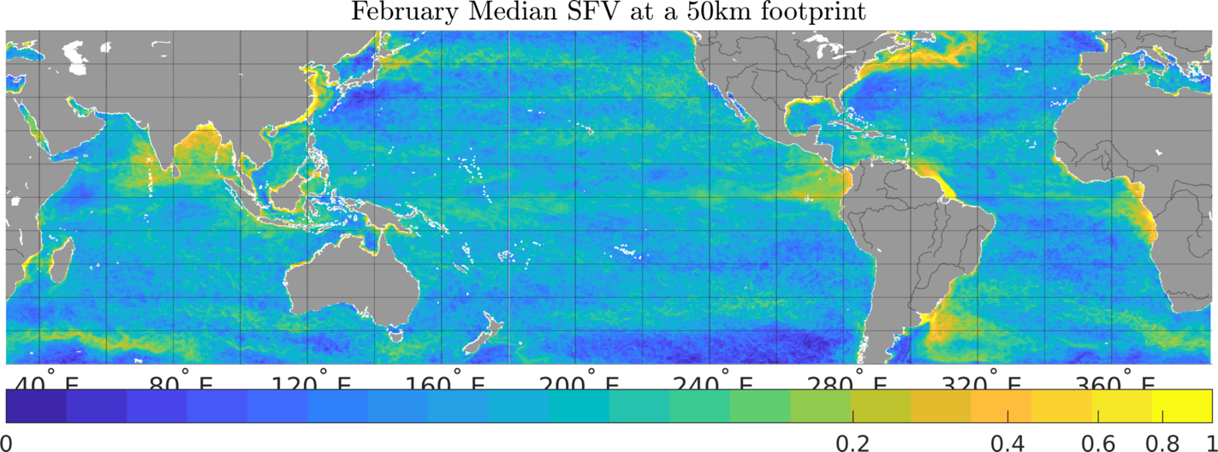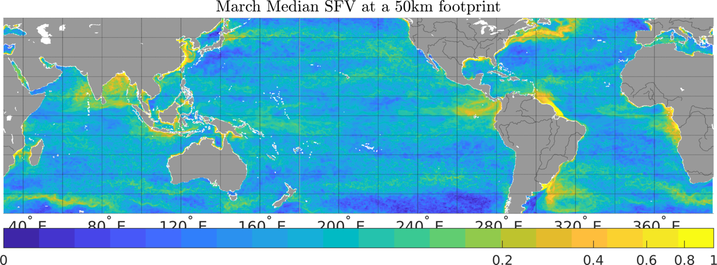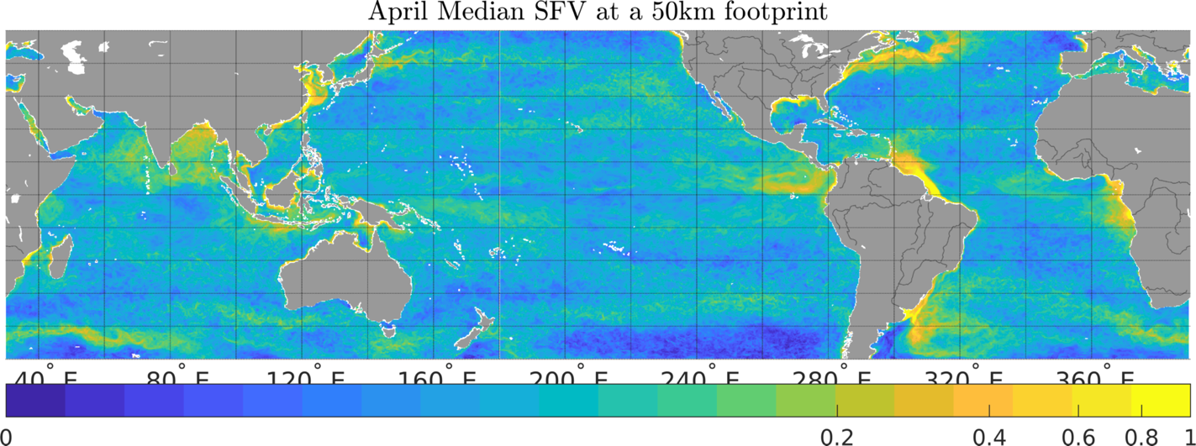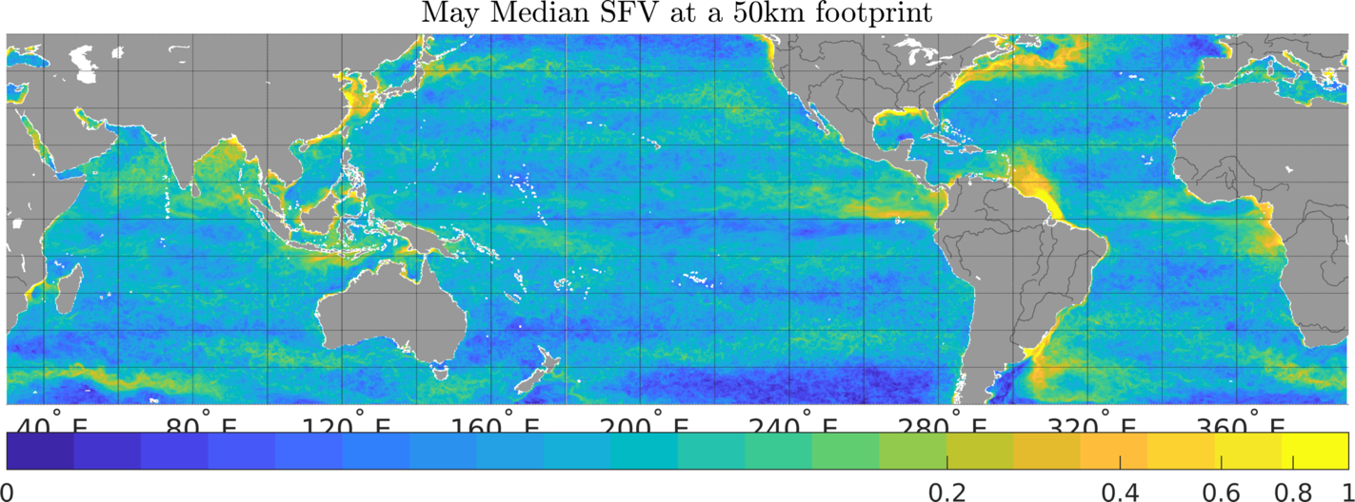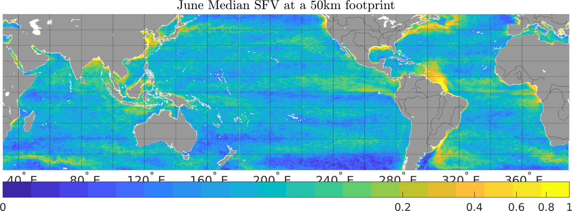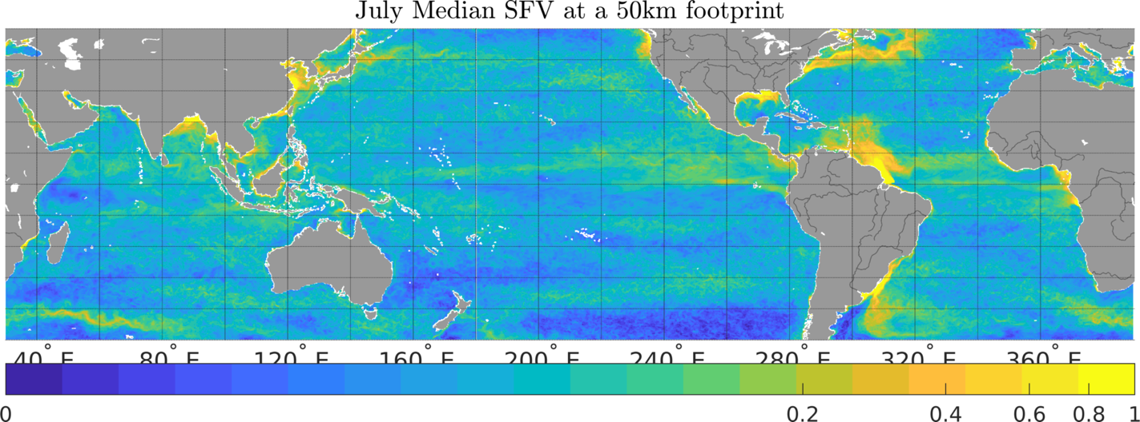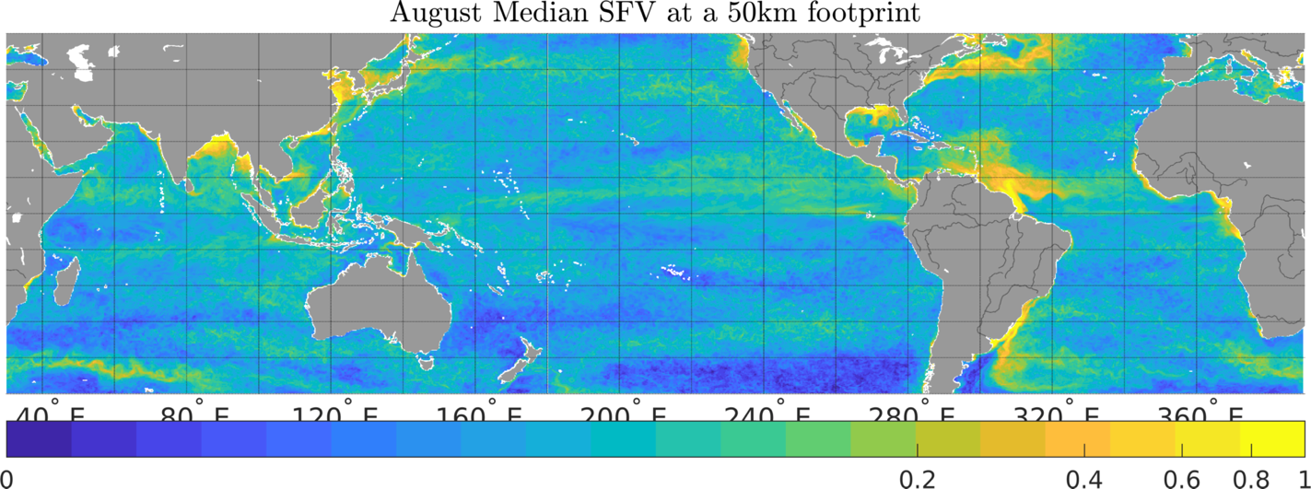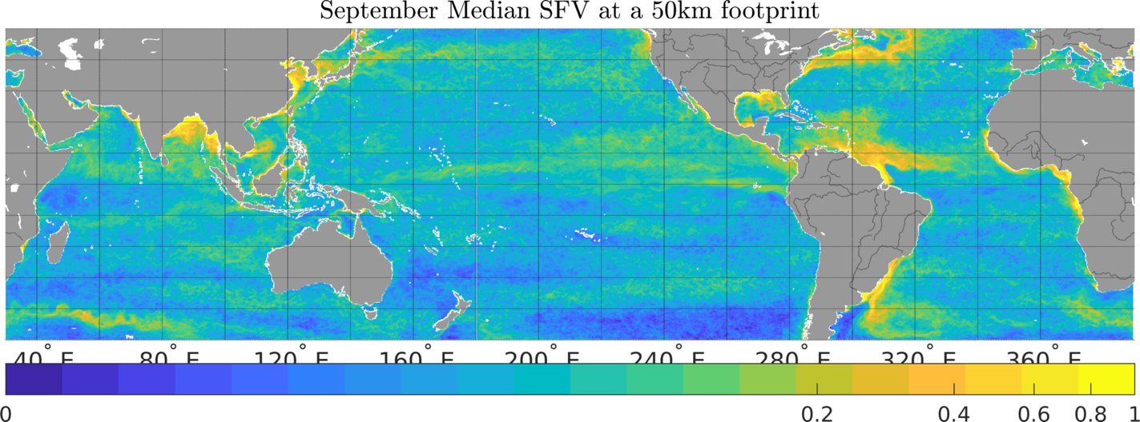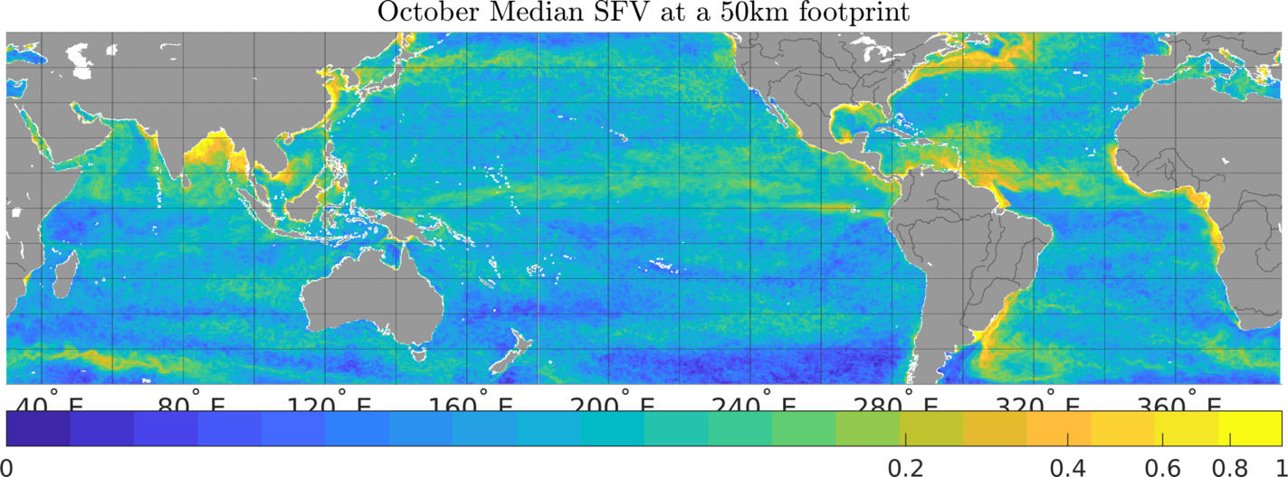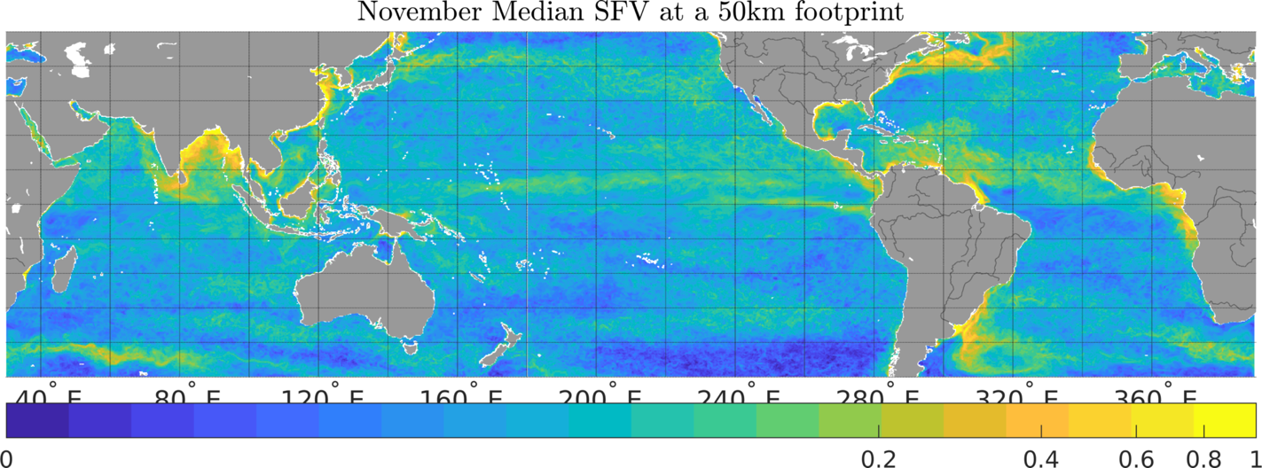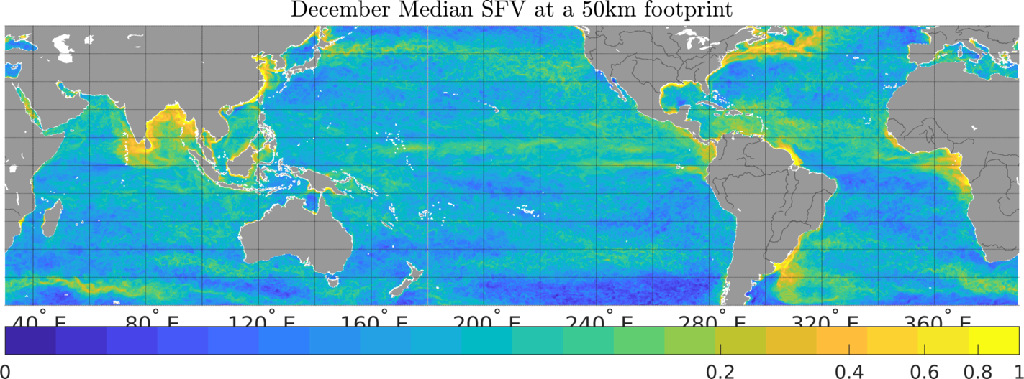

Figure 2: Same as Figure 4 and 5 of main paper, for CCI v3.2 monthly products.
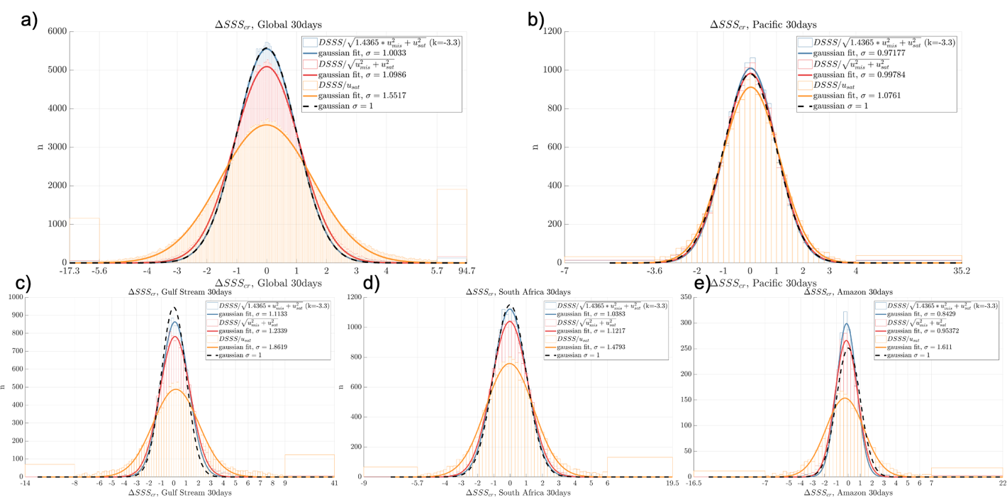

Figure 3: Same as Figure 4 and 5 of main paper, for CCI v2.3 weekly products.
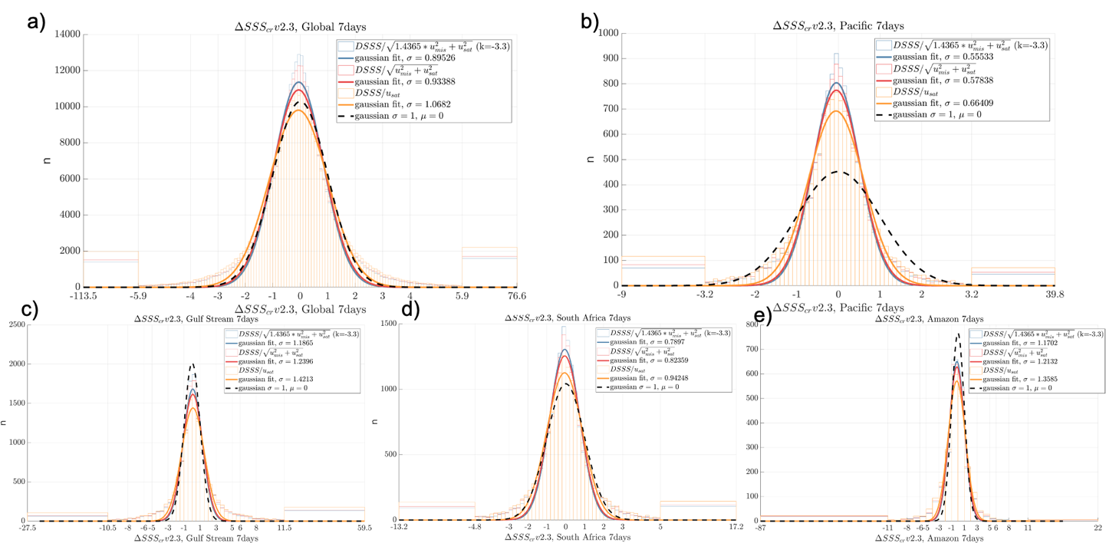

Figure 4: Same as Figure 4 and 5 of main paper, for CCI v2.3 monthly products.
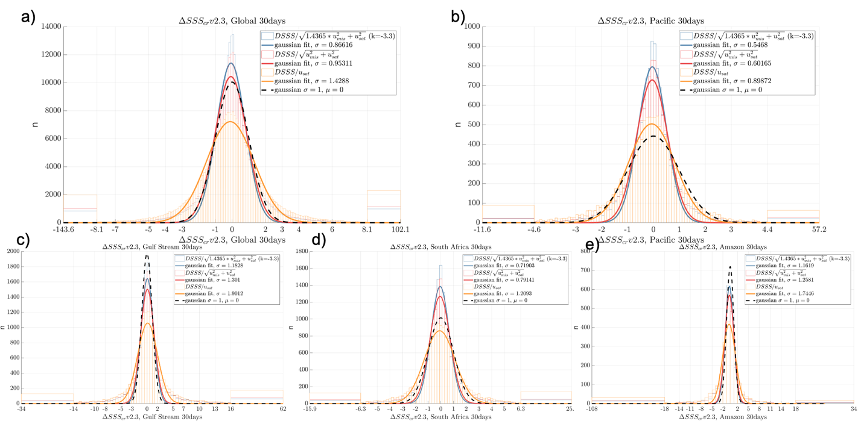

Figure 5: Same as Figures 6 and 7 of main paper, for CCI v3.2 monthly products.
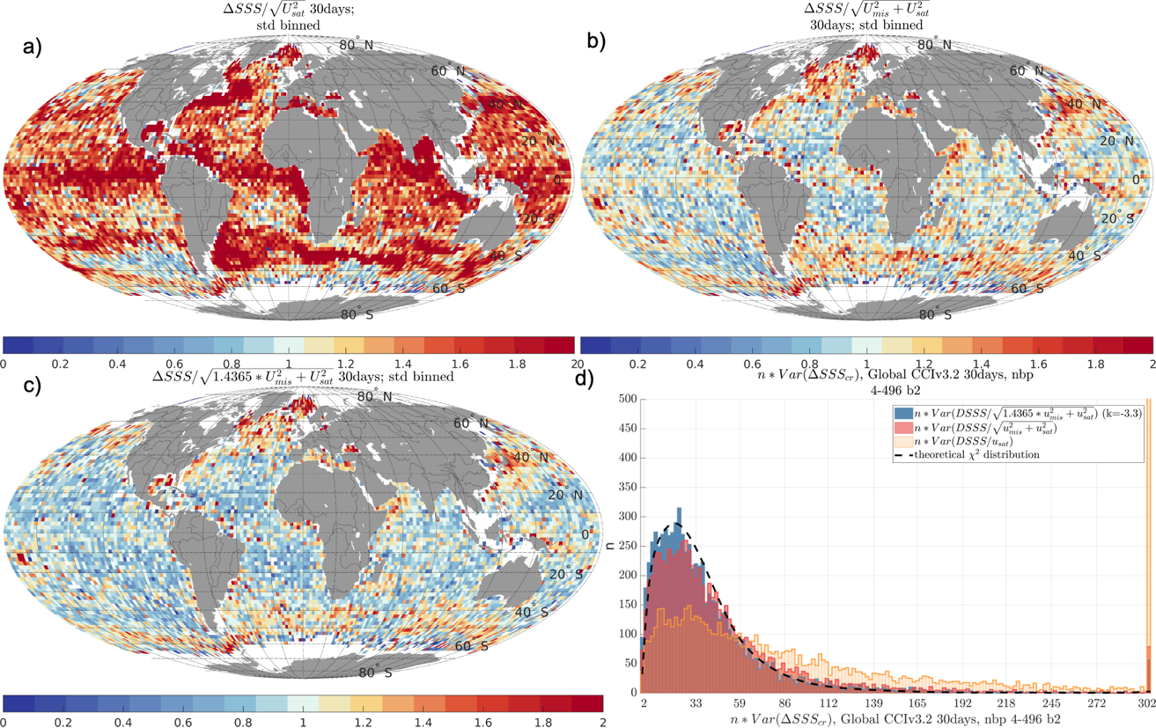

Figure 6: Same as Figures 6 and 7 of main paper, for CCI v2.3 weekly products.
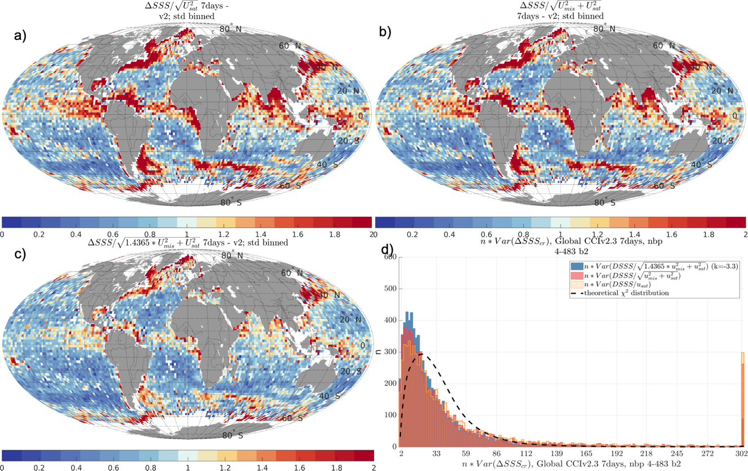

Figure 7: Same as Figures 6 and 7 of main paper, for CCI v2.3 monthly products.
