Journal: Minerals

Title of the manuscript: Indicator Minerals, Pathfinder Elements, and Portable Analytical Instruments in Mineral Exploration Studies

Authored by: 1. V. Balaram, 2. S. S. Sawant

(This form is signed by Corresponding author)
has not previously been published in whole or in part, is not currently being considered elsewhere for publication, and, if accepted for publication in the above Journal, will not be published elsewhere in any language, without the consent of the editor and the publisher.
2) I acknowledge that it is a condition of acceptance by the editor that the publisher, Research India Publications acquires automatically the copyright in the manuscript throughout the world.
3) I confirm that I have obtained all the necessary permissions to include in the paper items such as quotations, figures, and the results of government sponsored research.
4) I enclose where necessary written permission of authors and publishers to use any copyright material (e.g. previously published figures and tables).
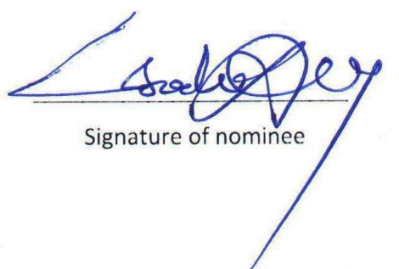
V. Balaram

