Test name, purpose & task description | Outcome measures
Screening/familiarisation test: Motor screening (MOT).
Purpose: Screens for visual, movement and comprehension difficulties and can also be used to familiarise the subject with the CANTAB user interface (tablet with touchscreen).  Task description: A series of crosses is shown in different locations on the screen. After a demonstration of the correct way to point, using the forefinger of the dominant hand, the subject must touch the crosses in turn. | 1. MOT Mean latency  Mean latency is defined as the time (measured in milliseconds (ms.)) taken for the subject to touch the cross after it appeared.
2. MOT Mean error
Mean error is a measure of the accuracy of the subject’s pointing. The distance is measured in “pixel units”.
Visual memory test: Paired Associates Learning (PAL).
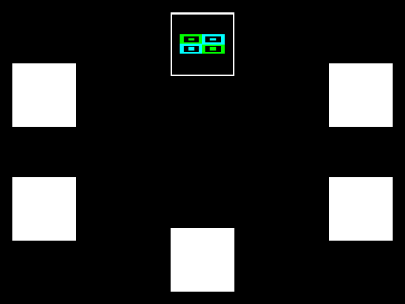
Purpose: Assesses episodic memory (a type of long-term memory that involves conscious recollection of previous experiences together with their context in terms of time, place, associated emotions, etc.) and learning.  Task description: We used the mode with eight stages, which the subjects must complete in order. First two stages were to practice, the subsequent six were assessed. For each stage, boxes are displayed on the screen. These boxes are opened one at a time, in a randomized order. One or more of them will contain a pattern. The patterns shown in the boxes are then displayed in the middle of the screen, one at a time, and the subject must touch the box where the pattern was originally located. Maximum trials were ten. | 1. PAL Total errors (adjusted)  This measure reports the total number of errors across all assessed problems and all stages, with an adjustment for each stage not attempted due to previous failure.
Semantic/verbal memory test: Verbal Recognition Memory – Immediate (Dutch version).
 | 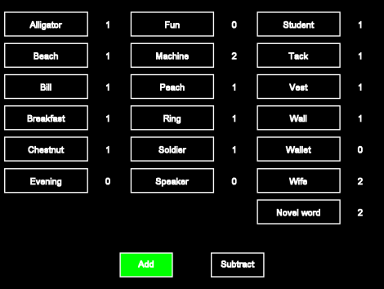
Purpose: Assesses free recall, and immediate and delayed recognition memory for verbal information.  Task description: In the VRM - immediate test, the subject is shown a list of 18 words and then, asked to:  - produce (recall) as many of the words as possible immediately following the presentation.  - recognise the words they have seen before from a list of 36 words containing the original 18 words and 18 distractors. | 1. VRM Free recall total correct  In the free recall phase, the total number of distinct words correctly recalled from the presentation phase. Range: 0 to 18.  2. VRM Recognition total correct  In the recognition phase, the total number of words that the subject correctly recognizes from the presentation phase.
Semantic/verbal memory tests: Verbal Recognition Memory – delayed test (Dutch version).
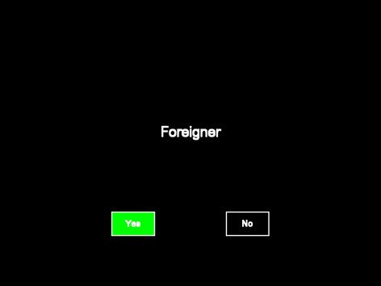

Purpose: Assesses delayed recognition memory for verbal information.  Task description: In the VRM – delayed test, the subject is shown a list of 18, words and then, asked to  - following a delay of 20-30 minutes, recognise the words they have seen before from another list of 36 words containing the original list and 18 new distractors.  - following a delay of 20-30 minutes, recall as many of the words as possible. | 1. VRM-2 recognition total correct  In the recognition phase, the total number of words that the subject correctly recognizes from the presentation phase.
Attention test: Rapid Visual Information Processing (RVP).
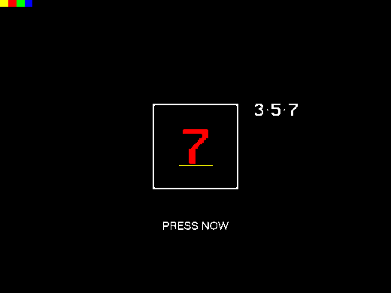  The RVP test screen in the training stage | 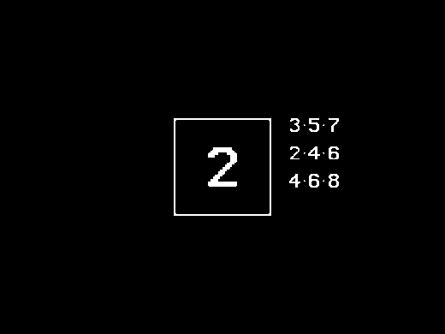  The RVP test screen in the test stage
Purpose: Tests visual sustained attention. This test is sensitive to dysfunction in the parietal and frontal lobe areas of the brain and is also a sensitive measure of general performance.  Task description: A white box appears in the centre of the computer screen, inside which digits, from 2 to 9, appear in a pseudo-random order, at the rate of 100 digits per minute. The test is in two parts; a ‘warm-up’ practice phase which lasts for two minutes and is not scored, and a test phase which lasts for four minutes, the last three and a half of which are assessed.  Subjects are requested to detect target sequences of digits (for example, 2-4-6, 3-5-7, 4-6-8) and to register responses using the press pad. Target sequences occur at the rate of 16 every 2 minutes (16 every 5 minutes in the slow mode). | For scoring purposes, Cantab calculates the number of responses recorded as having occurred within 1800 milliseconds of the final digit presentation for each of the target sequences.  1. RVP A′ (Probabilities and sensitivity calculated using SDT)  A′ is the signal detection measure of sensitivity to the target, regardless of response tendency (range 0.00 to 1.00; bad to good). In essence, this measure is a measure of how good the subject is at detecting target sequences using the probability of a ‘hit’ (p(hit)) and the probability of a false alarm (p(fa)).  2. RVP Mean Latency  This measure details the mean time taken to respond and is reported in milliseconds. It only includes correct responses made within the response window of 1800 milliseconds. Response latency in the RVP task is a good indicator of sustained attentional function.
Attention test: Reaction Time (RTI).
 | 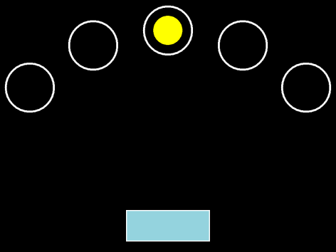
Purpose: Measures speed of response and movement in single and 5-choice paradigms. This task is designed to measure the subject’s speed of response to a visual target where the stimulus is either predictable (simple reaction time) or unpredictable (choice reaction time).  Task description: A yellow spot appears on the screen, in either one location or one of five possible locations. The touch screen version of the test was used.  Stage 1 Simple release and touch, non-assessed, with 10 trials; if criterion is not reached within 10 trials this stage is repeated (practice phase).  Stage 2 Simple release and touch, with 15 trials; there is no criterion requirement for this stage (assessed phase).  Stage 3 Five-choice release and touch non-assessed, with 10 trials; if criterion is not reached within 10 trials this stage is repeated(practice phase).  Stage 4 Five-choice release and touch, with 15 trials; there is no criterion requirement for this stage (assessed phase). | 1. RTI Mean Simple Reaction Time  This is the speed with which the subject releases the press pad button in response to the onset of a stimulus in a single location. Reaction time latency is measured in ms.  2. RTI Mean five-choice reaction time*  This is the speed with which the subject releases the press pad button in response to a stimulus in any one of five locations. Reaction time latency is measured in ms.  3. RTI Mean simple movement time  This is the time taken to touch the stimulus after the press pad button has been released in trials where stimuli appear in one location only. Lower is better. Movement time latency is measured in ms.  4. RTI Mean five-choice movement time*  This is the time taken to touch the stimulus after the press pad button has been released in trials where the stimulus has been presented in one of five possible locations. Lower is better. Movement time latency is measured in ms.
Executive function, working memory and planning test: Spatial Working Memory (SWM).
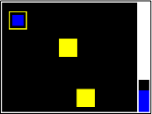

Purpose: Assesses working memory and strategy use. SWM is a test of the subject's ability to retain spatial information and to manipulate remembered items in working memory. It is a self-ordered task, which also assesses heuristic strategy. This test is a sensitive measure of frontal lobe and ‘executive’ dysfunction.  Task description: The test begins with a number of coloured squares (boxes) being shown on the screen. The aim of this test is that, by process of elimination, the subject should find one blue ‘token’ in each of a number of boxes and use them to fill up an empty column on the right-hand side of the screen. The number of boxes is gradually increased from three to eight boxes (or to ten in the second mode). The colour and position of the boxes used are changed from trial to trial to discourage the use of stereotyped search strategies. The subject must touch each box in turn until one opens with a blue token inside (a search). When a blue token has been found, the subject has to place it in the right column (‘home’) by touching the right-hand side of the screen. The subject must then begin a new search for the next blue token. It may be in any of the boxes that so far have been empty. This is repeated, until a blue token has been found in every box on the current screen.  Touching any box in which a blue token has already been found is an error. The subject decides the order in which the boxes are searched. The computer determines the number of empty boxes that must be visited (discounting errors). Performance at the harder levels of this task is enhanced by the use of a heuristic search strategy. | 1. SWM Total errors  This is the number of times a box is selected that is certain not to contain a blue token and therefore should not have been visited by the subject, i.e. between errors + within errors - double errors.  2. SWM Strategy (n to m boxes)  This measure allows you to specify the lower and upper numbers of boxes for which you wish to calculate the SWM strategy measure, using the Boxes (lower bound) and Boxes (upper bound) options.  This is the mean time for the subject’s last response for a problem, for problems with the specified number of boxes. This is calculated from the time between the problem being presented to the subject and the subject’s last screen touch to open a box to locate the final token for the problem. The Box option applies to this measure.
Executive function, working memory and planning test: One Touch Stockings of Cambridge (OTS).
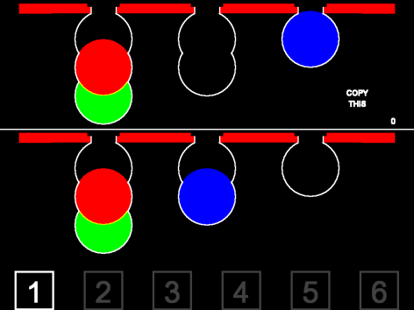

Purpose: OTS is a spatial planning test variant based upon the CANTAB Stockings of Cambridge test. This test gives a measure of frontal lobe function.  Task description: The subject is shown two displays containing three coloured balls. The displays are presented in such a way that they can easily be perceived as stacks of coloured balls held in stockings or socks suspended from a beam. This arrangement makes the 3-D concepts involved apparent to the subject, and fits with the verbal instructions. There is a row of boxes containing numbers at the bottom of the screen, from one upwards. | 1. OTS Problems solved on first choice  This measure gives the number of problems which were solved on the subject’s first choice. If the Moves option is applied, and n moves selected, the results used to calculate this measure are limited to n-move problems. The result is an integer.
Executive function, working memory and planning test: Intra/ Extradimensional Set Shift (IED) .
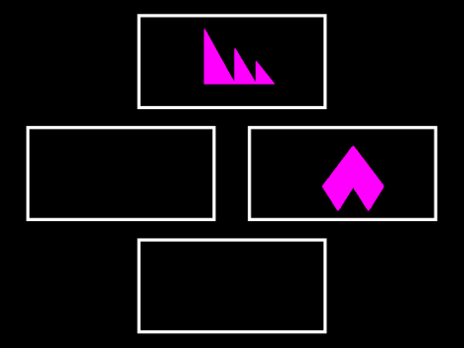 | 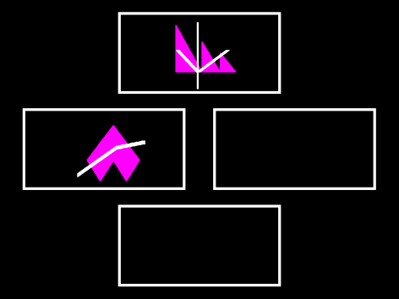
Task Description
Purpose: Assesses rule acquisition and attentional set shifting.  Task description: Two artificial dimensions are used in the test: colour-filled shapes & white lines. Simple stimuli are made up of just one of these dimensions, whereas compound stimuli are made up of both, namely white lines overlying colour-filled shapes.  Subjects progress through the test by satisfying a set criterion of learning at each stage (6 consecutive correct responses). If at any stage the subject fails to reach this criterion after 50 trials, the test terminates.  The test starts with Block 1, the presentation of two simple, colour-filled shapes. The subject must learn which of the stimuli is correct by touching it, and continue until the criterion is reached. In Block 2, the contingencies are reversed, so that now the previously incorrect stimulus is correct.  In Block 3, the second dimension is then introduced, initially lying adjacent to, and then, for Block 4, overlapping, the first dimension. The contingencies do not change, remaining the same as at the end of the simple discrimination. Once the criterion has been reached with the overlapping compound stimulus in Block 4, the contingencies are reversed for Block 5, within the original dimension. It is important to note that the second dimension is entirely redundant to the solution of the problem at this stage.  Once the subject has learned the compound discrimination, new compound stimuli are presented (Block 6), still varying along the same 2 dimensions (of shape and of line). Subjects are required to continue to attend to the previously relevant dimension of shape and learn which of the two new exemplars is correct (the ‘intradimensional shift’).  Once the subject has completed a successful intradimensional shift, followed by a reversal (Block 7), again the compound stimuli are changed. For this stage (Block 8), subjects are required to shift attention to the previously irrelevant dimension and learn which of the two exemplars in this dimension is now correct (the ‘extradimensional shift’). In Block 9 the contingencies are again reversed. | 1. EDS (extra-dimensional stage) Errors  Errors made in the extra-dimensional stage of the task are labelled EDS errors, as they have been committed at the stage where the subject is required to make an extra-dimensional shift. Errors committed at the reversal stage following the EDS stage are not included.  2. Total errors (adjusted)  This is a measure of the subject’s efficiency in attempting the test. Thus, whilst a subject may pass all nine stages, a substantial number of errors may be made in doing so. It is crucial to note that subjects failing at any stage of the test by definition have had less opportunity to make errors. Therefore, this adjusted score is calculated by adding 25 for each stage not attempted due to failure. This value of 25 is used since subjects must complete 50 trials to fail a stage and half of these could be correct by chance alone.

