Supplemental materials
Table S1
Words for the prosodic stimulus set
咖啡  (coffee) | 香蕉  (banana) | 飞机  (airplane) | 冰箱  (refrigerator)
蜻蜓  (dragonfly) | 番茄  (tomato) | 菠萝  (pineapple) | 窗帘  (curtain)
斑马  (zebra) | 钢笔  (pen) | 书本  (book) | 铅笔  (pencil)
风扇  (fan) | 鸡蛋  (egg) | 衣架  (hanger) | 蟋蟀  (cricket)
台灯  (lamp) | 牙刷  (toothbrush) | 围巾  (scarf) | 皮箱  (leather suitcase)
河流  (river) | 蝴蝶  (butterfly) | 白糖  (sugar) | 篮球  (basketball)
毛毯  (blanket) | 苹果  (apple) | 啤酒  (beer) | 牛奶  (milk)
肥皂  (soap) | 茶叶  (tea) | 名片  (business card) | 邮票  (stamp)
水杯  (cup) | 饼干  (biscuit) | 纸巾  (tissue) | 手机  (cell phone)
火柴  (match) | 草莓  (strawberry) | 纸牌  (card) | 果皮  (peel)
手套  (glove) | 草帽  (straw hat) | 口罩  (mask) | 假发  (wig)
面包  (bread) | 闹钟  (alarm) | 汽车  (car) | 豆浆  (soy milk)
树林  (woods) | 贝壳  (shell) | 饭盒  (lunch box) | 橡皮  (eraser)
报纸  (newspaper) | 字典  (dictionary) | 木桶  (barrel) | 大米  (rice)
大象  (elephant) | 电话  (telephone) | 照片  (photo) | 木棍  (stick)

Table S2
Words for the semantic stimulus set
Happiness | Neutrality | Sadness
开心  (glad) | 中间  (middle) | 悲观  (pessimistic)
欢心  (exulted) | 居中  (central) | 悲哀  (mournful)
欢愉  (joyful) | 均一  (even) | 哀伤  (plaintive)
欣然  (pleased) | 通俗  (popular) | 心酸  (poignant)
欢腾  (rapturous) | 通常  (routine) | 伤心  (sad)
欢喜  (delighted) | 中游  (middle reach) | 忧伤  (mirthless)
舒坦  (comfortable) | 中层  (middle-level) | 悲伤  (downhearted)
欣喜  (blissful) | 均匀  (uniform) | 灰心  (discouraged)
兴奋  (excited) | 相同  (identical) | 揪心  (anxious)
欢乐  (gay) | 平缓  (mild) | 消极  (negative)
舒适  (snug) | 基本  (fundamental) | 凄凉  (dismal)
欢快  (cheerful) | 基础  (basic) | 哀愁  (grieved)
舒畅  (eased) | 中立  (impartial) | 消沉  (low-spirited)
高兴  (happy) | 通用  (universal) | 苍凉  (desolate)
欢悦  (joyous) | 中性  (neutral) | 忧愁  (woebegone)
安乐  (cosy) | 相对  (relative) | 心疼  (worried)
欣慰  (thankful) | 相似  (similar) | 悲凉  (dreary)
酣畅  (heartily) | 相互  (mutual) | 凄楚  (forlorn)
欢闹  (tumultuous) | 中部  (middle) | 酸楚  (distressed)
欢畅  (elated) | 平均  (average) | 凄惨  (tragic)
康乐  (healthy and happy) | 折中  (compromised) | 伤感  (sentimental)
微笑  (smile) | 常规  (conventional) | 悲苦  (sorrowful)
狂欢  (boisterous) | 直接  (direct) | 凄苦  (miserable)
和谐  (harmonious) | 平常  (ordinary) | 失落  (downcast)
祥和  (serene) | 平凡  (undistinguished) | 失望  (lamentable)
怡然  (enjoyable) | 平时  (normal) | 凄怆  (bleak)
吉祥  (auspicious) | 平衡  (balanced) | 悲怆  (despairing)
怡人  (nice) | 平直  (straight) | 悲痛  (heartrending)
明朗  (clear) | 平时  (usual) | 哀痛  (anguished)
甜美  (mellifluous) | 寻常  (commonplace) | 悲愤  (grieved and indignant)
狂喜  (thrilled) | 持平  (same) | 忧郁  (glum)
愉快  (merry) | 垂直  (vertical) | 心痛  (heart-broken)
融洽  (cordial) | 平整  (smooth) | 低落  (dejected)
得意  (jaunty) | 平坦  (flat) | 压抑  (repressed)
愉悦  (pleasurable) | 平稳  (steady) | 伤痛  (grievous)
甜蜜  (sweet) | 同等  (equal) | 忧虑  (apprehensive)
如愿  (fulfilled) | 平淡  (bland) | 忧闷  (morose)
陶醉  (intoxicated) | 常见  (common) | 愁苦  (melancholy)
满足  (fulfilled) | 平日  (everyday) | 沉痛  (heavyhearted)
美好  (glorious) | 国际  (international) | 惆怅  (disconsolate)
爽朗  (bright) | 国内  (domestic) | 颓丧  (crestfallen)
满意  (contented) | 同类  (homogeneous) | 难过  (upset)
有趣  (interesting) | 普通  (plain) | 难受  (uncomfortable)
爽快  (straightforward) | 水平  (horizontal) | 愁闷  (gloomy)
喜庆  (festive) | 等同  (equivalent) | 绝望  (desperate)
喜悦  (jubilant) | 可能  (possible) | 苦闷  (doleful)
乐观  (optimistic) | 等距  (equidistant) | 沮丧  (dispirited)
顺心  (satisfactory) | 等量  (equivalent) | 惨痛  (agonizing)
称心  (gratified) | 一般  (general) | 苦涩  (bitter)
自如  (free) | 适中  (moderate) | 扫兴  (disappointed)
快活  (jolly) | 间接  (indirect) | 痛心  (inconsolable)
幸福  (beatific) | 日常  (daily) | 痛惜  (regrettable)
豁达  (open-minded) | 正常  (regular) | 气馁  (demoralized)
痛快  (outright) | 自然  (natural) | 懊悔  (remorseful)
惬意  (agreeable) | 共同  (joint) | 懊恼  (annoyed)
畅快  (carefree) | 静止  (static) | 痛苦  (painful)
快乐  (happy) | 适度  (appropriate) | 郁闷  (depressed)
自在  (freely) | 固定  (fixed) | 暗淡  (dim)
乐意  (willing) | 适当  (proper) | 抑郁  (depressive)
庆幸  (lucky) | 自动  (automatic) | 丧气  (frustrated)

Tables S3
Duration (milliseconds) of the experimental stimuli
Stimulus type | Happy |  | Neutral |  | Sad |  | Mean | SD
 | Mean | SD | Mean | SD | Mean | SD
Prosody | 1140.75 | 134.95 | 992.37 | 88.10 | 1626.77 | 187.24 | 1253.29 | 306.19
Semantics | 999.28 | 78.57 | 995.12 | 72.44 | 997.96 | 72.47 | 997.45 | 74.57
Mean/SD | 1072.16 | 131.81 | 993.70 | 80.90 | 1321.89 | 345.49 | 1129.25 | 259.50
Note. “SD” stands for standard deviation.
Table S4
Mean f0 (Hertz) of the experimental stimuli
Stimulus type | Happy |  | Neutral |  | Sad |  | Mean | SD
 | Mean | SD | Mean | SD | Mean | SD
Prosody | 237.95 | 37.41 | 144.47 | 36.25 | 137.74 | 30.22 | 173.38 | 57.13
Semantics | 152.31 | 30.10 | 152.99 | 28.97 | 156.87 | 28.09 | 154.06 | 29.14
Mean/SD | 196.42 | 54.70 | 148.60 | 32.33 | 147.02 | 30.73 | 164.01 | 46.76
Table S5
Familiarity rating for the spoken words used in prosodic and semantic tasks
Stimulus type | Verbal content | Mean | SD
Prosody | semantically neutral concrete nouns | 6.80 | .20
Semantics | adjectives with happy semantics | 6.75 | .25
 | adjectives with neutral semantics | 6.76 | .25
 | adjectives with sad semantics | 6.71 | .28
Note. Participants rated the familiarity of the words on a 7-point scale (1 = not familiar, 7 = very familiar).
Table S6
Identification accuracy of emotional category and rating of emotional arousal for the experimental stimuli
Stimulus type | Emotion category | Identification accuracy of emotional category |  | Rating of emotional arousal
 |  | Mean | SD | Mean | SD
Prosody | Happy | 98.83% | 2.48% | 6.04 | .30
 | Neutral | 98.75% | 2.17% | 3.74 | .15
 | Sad | 99.50% | 1.50% | 1.64 | .23
Semantics | Happy | 97.40% | 3.80% | 5.41 | .63
 | Neutral | 98.30% | 2.60% | 3.83 | .23
 | Sad | 98.50% | 3.10% | 1.97 | .27
Note. Participants identified the emotional category of the stimuli, and rated the emotional arousal on a 7-point scale (1= low, 7 = high).

Linear mixed-effects model
The full model with intercepts, coefficients, and error terms for the analysis of each neurophysiological measure is shown as follows:
Each neurophysiological measure _{i} = β₀ + (β₁ × channel) +(β₂ × emotion) + (β₃ × task) + (β₄ × channel × emotion) + (β₅ × channel × task) + (β₆ × emotion × task) + (β₇ × channel × emotion × task) + b_{0i} + ε_{i}
In the model, β₀ was the intercept, which represented the predicted value when all other factors were equal to 0. β₁, β₂…β₇ stood for the coefficients for communication channel, emotion category, task type and their interactions respectively. These coefficients suggested the extent to which the outcome variable changed relative to a unit of change in the corresponding predictors. The random intercepts were represented as b_{0i}, where i changed according to individual subjects. An error term (ε) was also added in the two models to indicate the distance between the predicted outcome and the actual data point (i.e., residual).
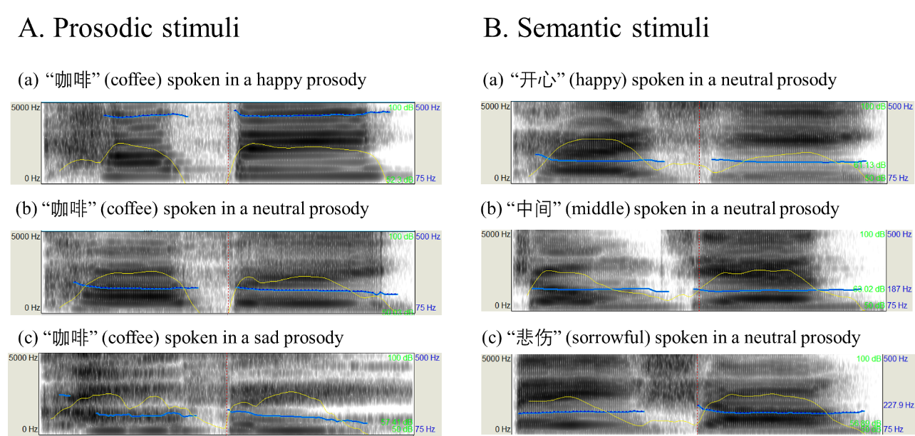
Figure S1. Spectral images of the (A) prosodic and (B) semantic stimuli for the (a) happy, (b) neutral and (c) sad emotions

