**Supplementary material (Figures S1-S3)**

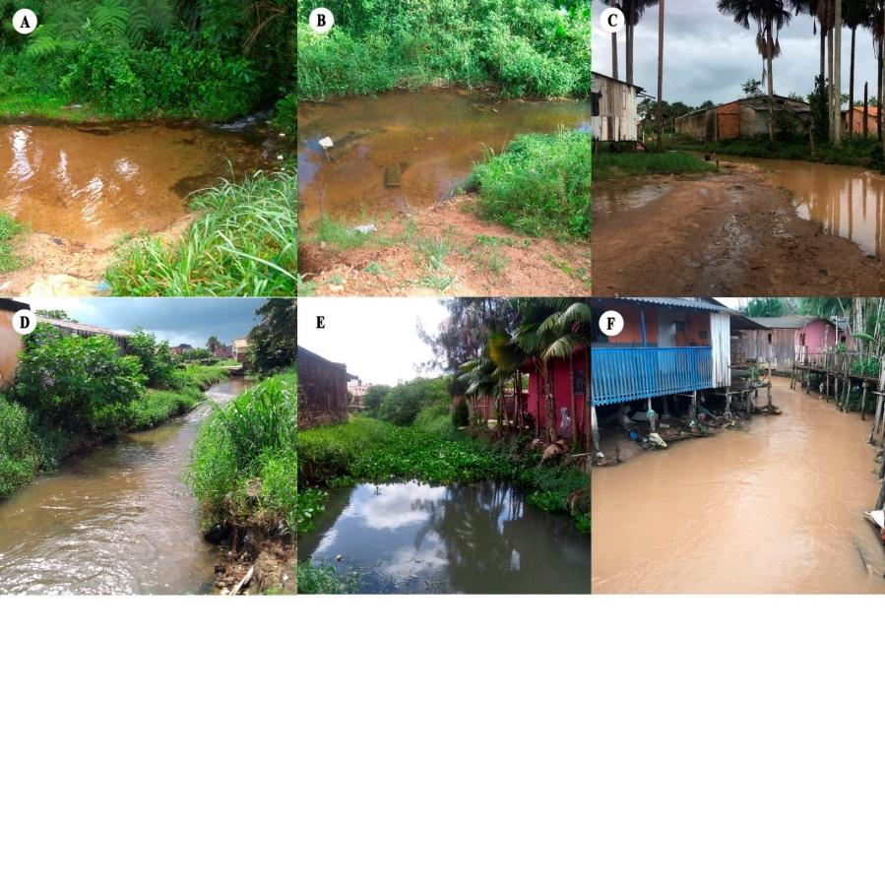

Figure S1. (A) sampling at P1, near the source of the Cereja River; (B) P2 area with low territorial occupation; (C) P3 shows loss of vegetation associated with the erosion in the margins and the deposition of sediment on the riverbed; (D) P4 shows unplanned occupation on the margins; (E) P5 shows unplanned occupation on the margins and the presence of macrophyte; (F) P6, near the mouth of the Cereja River and shows unplanned occupation on the margins and the presence of solid waste.

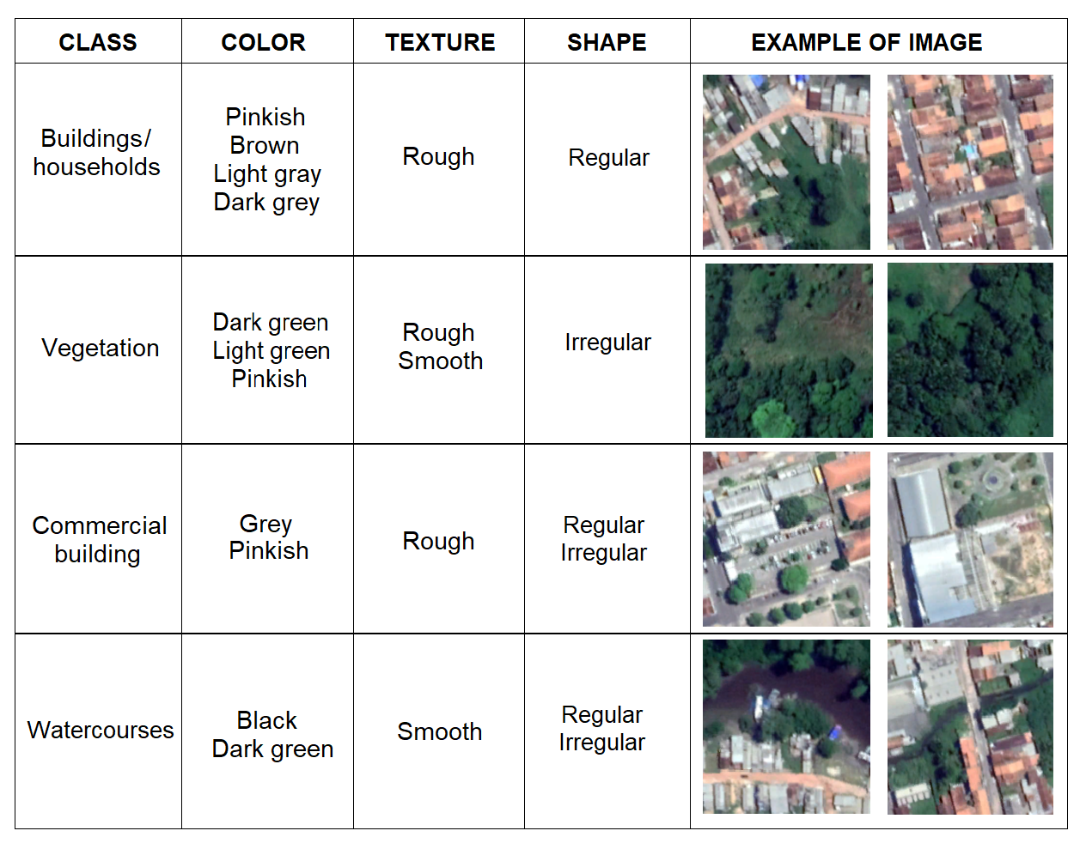

Figure S2. Interpretation key for the evaluation of the basin of the Cereja River.



Figure S3.Summary of the DPSWR management model for the Cereja River.

**Supplementary material (Tables S1-S6)**

Table S1. Localization of the sample stations.

|  |  |  |  |
| --- | --- | --- | --- |
| Sample Station | Location | Coordinates (S) | Coordinates (W) |
| P1 | Vila Nova | 01°03’521”S | 46°47’227”W |
| P2 | Vila Sinhá | 01°03’327”S | 46°46’581”W |
| P3 | Taíra | 01°03’148”S | 46°46’185”W |
| P4 | Padre Luiz | 01°03’560”S | 46°45’586”W |
| P5 | Aldeia | 01° 03’23”S | 46° 45’480”W |
| P6 | Aldeia | 01° 03’551”S | 46° 45’423”W |

Table S2. Types of freshwater use, according to CONAMA.

|  |  |
| --- | --- |
| Classes | Types of Use |
| Special class | Water that can be used for (a) human consumption following disinfection; b) the preservation of the natural balance of aquatic communities; and (c) the preservation of aquatic environments in strictly-protected conservation units. |
| Class 1 | Water that can be used for (a) human consumption, after simple treatment; (b) the protection of aquatic communities; (c) recreational activities involving primary contact, such as swimming, water skiing, and diving (CONAMA resolution 274/2000); (d) irrigation of fruit and vegetables that are consumed raw without removing the skin or harvested close to the soil, and (e) the protection of aquatic communities on indigenous lands. |
| Class 2 | Water that can be used for (a) human consumption, after conventional treatment; (b) the protection of aquatic communities; (c) recreational activities involving primary contact, such as swimming, water skiing, and diving (CONAMA resolution 274/2000); (d) the irrigation of vegetables, fruit, and parks, gardens, and sports fields, with which the public may come into direct contact, and (e) aquaculture and fisheries. |
| Class 3 | Water that can be used for (a) human consumption, after conventional or advanced treatment; (b) the irrigation of tree, cereal, and forage crops; (c) amateur angling; (d) recreational activities with secondary contact, and (e) the watering of animals. |
| Class 4 | Water that can be used for (a) navigation, and b) landscaping. |

Table S3. Percentage of limits of hydrological variables, considering national resolution and international classification.

|  |  |  |
| --- | --- | --- |
| Variables | Limits | Samples (%) |
| pH | a60-90 (ideal Class 1, 2, 3, 4) | 88% |
| Turbidity | aUp to 40 NTU observed (ideal, Class 1)  aUp to 100 NTU observed (ideal, Class 2, 3) | 98%  98% |
| Dissolved Oxygen | aMore than 6 mg L-1 (ideal, Class 1)  aMore than 5 mg L-1 (ideal, Class 2)  aMore than 4 mg L-1 (ideal, Class 3)  aMore than 2 mg L-1 (ideal, Class 4) | 0%  17%  43%  79% |
|  | bAnoxia 0 mg L-1 | 0% |
|  | bHypoxia >0 < 2 mg L-1 | 21% |
|  | bBiol Stress> 2< 5 mg L-1  b> 5 mgL-1 (ideal) | 60%  17% |
| Chlorophyll-a | aUp to 10 mg m-3 (ideal, Class 1)  aUp to 30 mg m-3 (ideal, Class 2)  aUp to 60 mg m-3 (ideal, Class 3) | 57%  98%  100% |
|  | bHypereutrophic > 60 mg m-3 | 0% |
|  | bHigh > 20, < 60 mg m-3 | 12% |
|  | bMedium > 5, < 20 mg m-3 | 74% |
|  | bLow > 0 and 5 mg m-3 | 14% |
| TSI | cUltra-oligotrophic ≤ 47 | 0% |
|  | cOligotrophic 47≤IET≤52 | 2% |
|  | cMesotrophic 52≤IET≤59 | 10% |
|  | cEutrophic 59≤IET≤63 | 19% |
|  | cSuper-eutrophic 63≤IET≤67 | 26% |
|  | cHyperthophic > 67 | 43% |

CONAMA (2000 a, 2005 b) and Lamparellic

Table S4. Temporal and spatial *Enterococcus* sp. and thermotolerant coliform data in Cereja River

|  |  |  |  |  |  |  |  |  |  |
| --- | --- | --- | --- | --- | --- | --- | --- | --- | --- |
| Points/ |  | *Enterococcus* sp. (MPN 100 mL-1)1 and  Thermotolerant coliforms (MPN 100 mL-1)2 | | | | | | | |
| Neighborhood |  | Nov13 | Apr14 | Aug14 |  | Jun18 | Nov18 | Apr18 | Jul19 |
| P1 – Vila Nova | 1 | - | - | - |  | 12 | 2 | 101 | 0 |
|  | 2 | 240 | 93 | 36 |  | >1,100 | 75 | 1,1 | 1,1 |
| P2 – Vila Sinhá | 1 | - | - | - |  | 207 | 146 | 258 | 153 |
|  | 2 | 1,1 | 1,1 | >1,100 |  | >1,100 | >1,100 | >1,100 | >1,100 |
| P3 – Taíra | 1 | - | - | - |  | 261 | 161 | 369 | 213 |
|  | 2 | >1,100 | >1,100 | >1,100 |  | >1,100 | >1,100 | >1,100 | >1,100 |
| P4 – Padre Luiz | 1 | - | - | - |  | 371 | 541 | 541 | 235 |
|  | 2 | >1,100 | >1,100 | >1,100 |  | >1,100 | >1,100 | >1,100 | >1,100 |
| P5 – Aldeia | 1 | - | - | - |  | 501 | 541 | 541 | 250 |
|  | 2 | >1,100 | >1,100 | 1,100 |  | >1,100 | >1,100 | >1,100 | >1,100 |
| P6 – Aldeia | 1 | - | - | - |  | 541 | 486 | 541 | 270 |
|  | 2 | >1,100 | 1,100 | 1,100 |  | >1,100 | >1,100 | >1,100 | >1,100 |

Table S5. Limits of thermotolerant coliforms and *Enterococcus* sp. per type of uses and the unappropriated samples (%), according to national and international classification

|  |  |  |
| --- | --- | --- |
|  | Use types and limits | Samples (%) |
|  | Thermotolerant coliforms (CONAMA resolutions) |  |
| Class 1 | Recreation of primary contact (CONAMA resolution 274/2000)* | 905%  (Unappropriated) |
|  | For the other uses, a limit of 200 MPN 100 mL-1 (CONAMA resolution 357/2005) ** | 929%  (Unappropriated) |
| Class 2 | Recreation of primary contact [(CONAMA resolution 274/2000)*  For the other uses, a limit of 1000 MPN 100 mL-1 (CONAMA resolution 357/2005)** | 905%  (Unappropriated)  905%  (Unappropriated) |
| Class 3 | Recreation of secondary contact, a limit of 2500 MPN 100 mL-1 (CONAMA resolution 357/2005) ** | *** |
|  | For the watering of confined animals, a limit of 1000 MPN 100 mL-1 (CONAMA resolution 357/2005)** | 905%  (Unappropriated) |
|  | For the other uses, a limit of 4000 MPN 100 mL-1 (CONAMA resolution 357/2005)** | *** |
|  | *Enterococcus* sp (USEPA 1986) | Samples (%) |
| Bathing | Recreation contact, a limit of 33 MPN 100 mL-1 | 93% (Unappropriated) |

*More than 80% of the samples with a maximal number of fecal coliforms per 100 mL: 250 (Excellent), 500 (Very Good), 1000 (Satisfactory) Unappropriated: More than 20% of the samples with a maximal number of 1000 fecal coliforms per 100 mL

**Should not be exceeded in 80% or more, from at least 6 samples collected during the period of one year

***Our values reached > 1100 MNP 100 mL-1.

Table S6 Number of inhabitants and irregular households with respective growth rate (%) on the margins of the Cereja River by neighborhoods and volume of effluents and thermotolerant coliform levels within the Cereja River.

|  |  |  |  |  |  |  |  |  |  |  |  |  |
| --- | --- | --- | --- | --- | --- | --- | --- | --- | --- | --- | --- | --- |
| **Neighborhoods** | **Nº of Inhabitants** | | **Growth rate (%) 2012-2019** | **Nº of Households** | | **Growth rate (%) 2012-2019** | **Effluents**  **(m3 day-1)** | | **Thermotolerant coliforms NMP 100 mL-1 (x10¹⁴)** | | | |
|
| **2012** | **2019** | **2012** | **2019** |
| **2012** | **2019** | **2012** | | **2019** | |
| **Min Max** | | **Min Max** | |
| **Vila Nova (P1)** | 52 | 112 | 54% | 12 | 26 | 538% | 77 | 168 | 5 | 21 | 11 | 45 |
| **Vila Sinhá (P2)** | 60 | 95 | 37% | 14 | 22 | 364% | 90 | 142 | 6 | 24 | 9 | 38 |
| **Taíra (P3)** | 129 | 172 | 25% | 30 | 40 | 250% | 194 | 258 | 13 | 52 | 17 | 69 |
| **Padre Luís (P4)** | 348 | 404 | 14% | 81 | 94 | 138% | 522 | 606 | 35 | 139 | 4 | 162 |
| **Aldeia (P5, P6)** | 237 | 237 | 0% | 55 | 55 | 0% | 355 | 355 | 24 | 95 | 24 | 95 |
| **Alegre** | 56 | 86 | 35% | 13 | 20 | 350% | 84 | 129 | 6 | 22 | 9 | 34 |
| **Centro** | 60 | 65 | 8% | 14 | 15 | 67% | 90 | 97 | 6 | 24 | 6 | 26 |
| **Cereja** | 181 | 198 | 9% | 42 | 46 | 87% | 271 | 297 | 18 | 72 | 2 | 79 |
| **Total** | 1,123 | 1,369 |  | 261 | 318 |  | 168 | 205 | 112 | 449 | 137 | 547 |