Supporting information

Passivation of defective states in single crystal MAPbBr₃ and their optoelectronic properties study

Hui Li,ª Zhenhua Chen*^{b}, Jin Wang,ª Nan Xu,^{c} Yaobo Huang^{b} and Zhi Guo^{b}

ªCollege of Science, Donghua University, Songjiang District, Shanghai 201620, China
^{b}Shanghai Synchrotron Radiation Facility (SSRF), Shanghai Advanced Research Institute, Chinese Academy of Sciences, Shanghai 201800, China
^{c}Institute of Advanced Studies, Wuhan University, Wuhan 430072, China

* Correspondence: chenzhenhua@sari.ac.cn

Table S1. XPS stoichiometry analysis for MAPbBr₃ seeds and large single crystal.

Stoichiometry analysis for MAPbBr₃ seeds.
Name | Start BE | Peak BE | End BE | FWHM eV | Area (P) CPS.eV | Area (N) TPP-2M | Atomic %
N1s | 409.98 | 401.64 | 392.18 | 1.25 | 7576.36 | 68.55 | 15.28
Pb4f | 152.98 | 138.31 | 133.18 | 1.16 | 141869.85 | 54.29 | 12.1
Br3d | 75.98 | 68.47 | 62.18 | 1.96 | 39425.2 | 178.19 | 39.73
C1s | 297.98 | 285.5 | 279.18 | 2.25 | 10273.7 | 144.13 | 32.14
The stoichiometry ratio between Pb and Br is 1:3 (Area (N) TPP-2M value).

Stoichiometry analysis for MAPbBr₃ seeds.
Name | Start BE | Peak BE | End BE | FWHM eV | Area (P) CPS.eV | Area (N) TPP-2M | Atomic %
N1s | 409.98 | 401.26 | 392.18 | 1.29 | 21342.41 | 193.05 | 14.53
Pb4f | 152.98 | 137.75 | 133.18 | 1.09 | 412726.92 | 157.88 | 11.88
Br3d | 75.98 | 67.78 | 62.18 | 1.91 | 107732.63 | 486.74 | 36.63
C1s | 297.98 | 285.02 | 279.18 | 2.44 | 34567.24 | 484.78 | 36.48
The stoichiometry ratio between Pb and Br is 1:3 (Area (N) TPP-2M value).

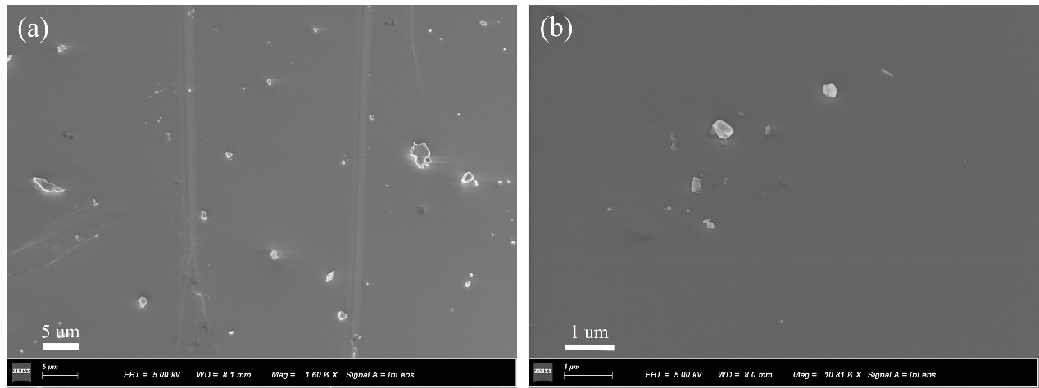
Figure S1. SEM image of as-prepared MAPbBr₃ single crystal with different magnification.

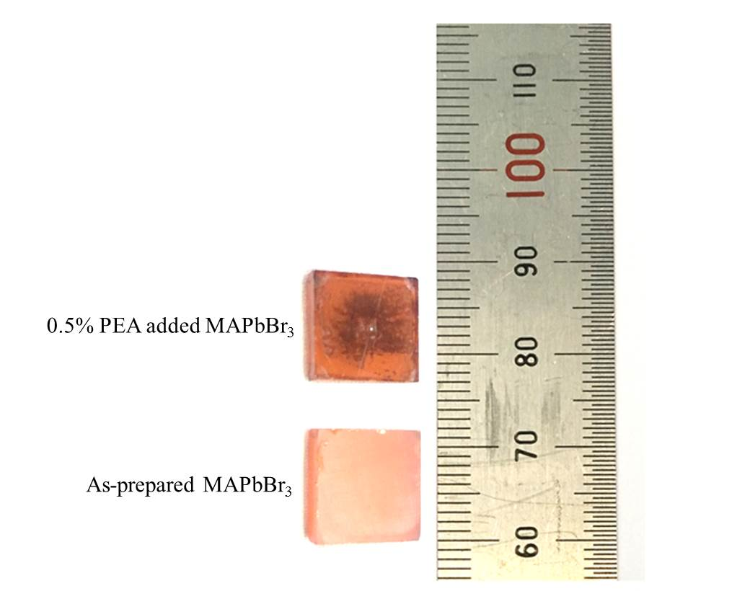
Figure S2. Optical image of as-prepared MAPbBr₃ single crystal and MAPbBr₃ crystal fabrication with 0.5wt% PEA additives.

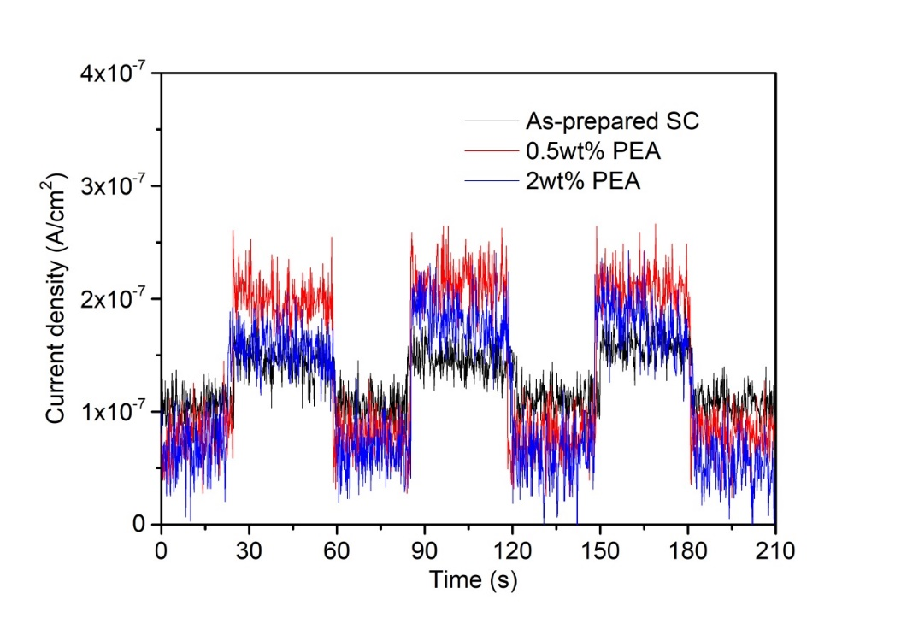
Figure S3. Temporal response of the MAPbBr₃ single crystals without and with 0.5wt% and 2wt% PEA additives based detectors under low dose (~3.4 mSv) X-ray illumination.

