Supplementary Material: SARS-CoV-2 Spike Protein S1 Induces MG-H1/RAGE Activation to Promote Inflammation in Human Bronchial BEAS-2B Cells
Dominga Manfredelli, Marilena Pariano, Claudio Costantini, Alessandro Graziani, Silvia Bozza, Luigina Romani, Paolo Puccetti, Vincenzo Nicola Talesa and Cinzia Antognelli

Figure S1. Cell morphology, by means of phase-contrast microscopy, of BEAS-2B and A549 cells exposed to 25 and 100 ng/ml SARS-CoV-2 spike protein S1 for 6 and 24 hours and controls (0 ng/ml). Scale bar = 200 μm (BEAS-2B-related images), = 400 μm (A549-related images).
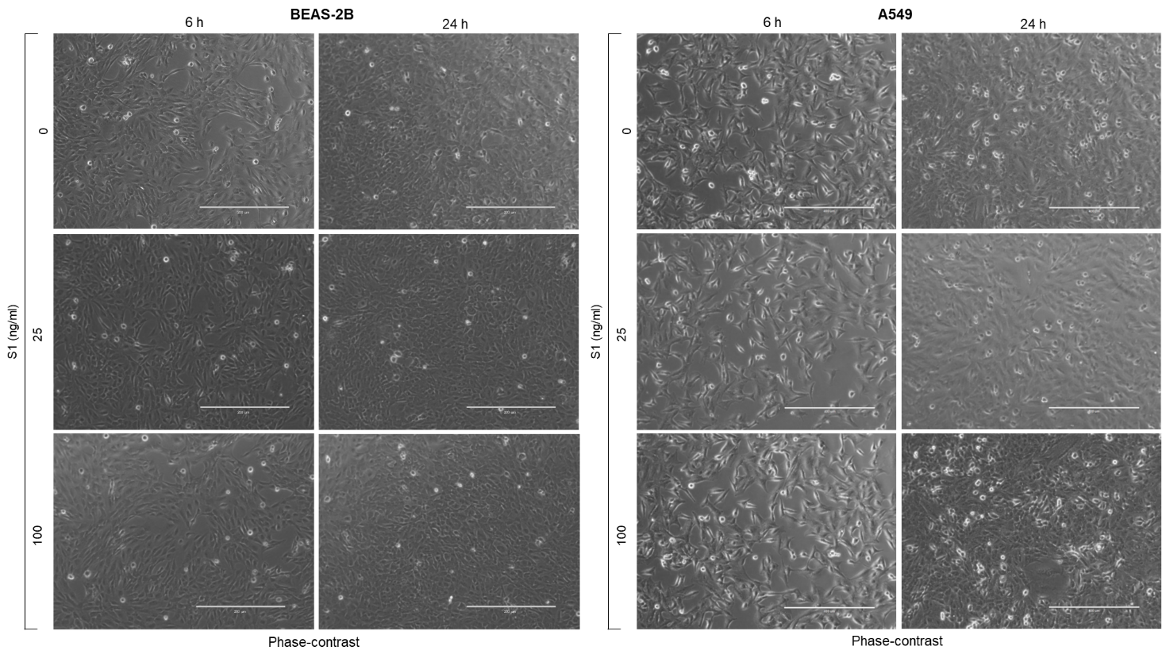

Figure S2. SARS-CoV-2 S1 Spike protein induces inflammatory cytokines in human bronchial BEAS-2B and alveolar A549 epithelial cells. BEAS-2B and A549 cells were stimulated with S1 at a concentration of 100 ng/ml. Six and 24 h post-stimulation, the expression of IL-1β was evaluated by real-time RT-PCR, while TNF-α, IL-6 and IL-8 levels, by ELISA. Data represent mean ± SD (n = 3). *p < 0.05, **p < 0.01, ***p < 0.001.
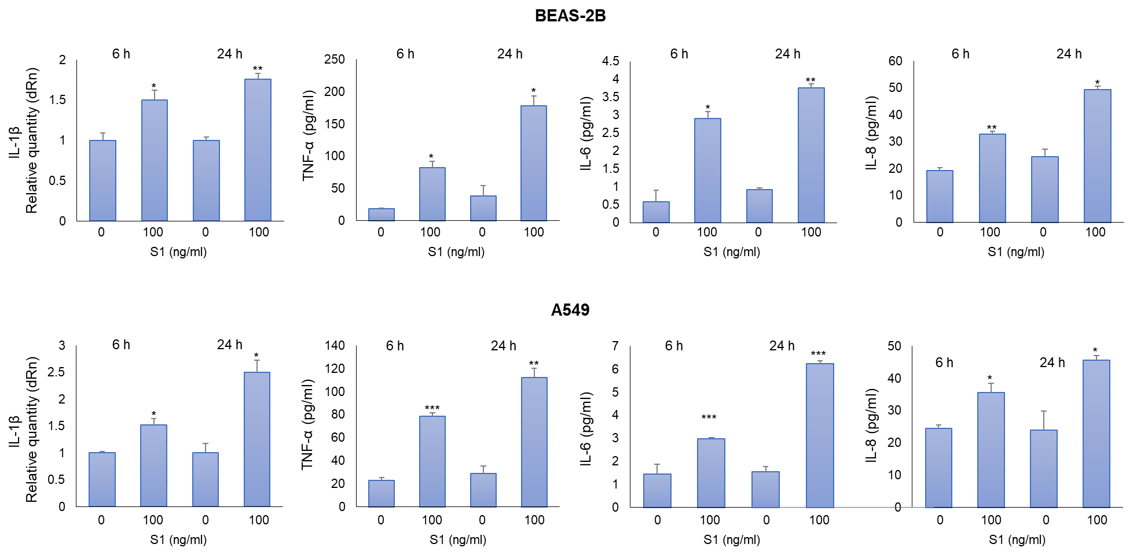

Figure S3. Glyoxalase 1 (Glo1) mRNA expression in alveolar A549 epithelial cells exposed to 25 ng/ml SARS-CoV-2 S1 spike protein for 24 h. Glo1 expression was evaluated by real-time RT-PCR. Data represent mean ± SD (n = 3). *p < 0.05.
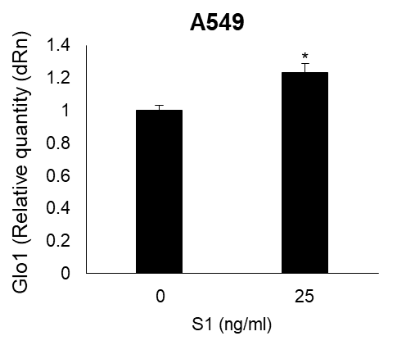

Figure S4. Whole blots reported in Figure 3b, Figure 3d and Figure 5a.
