Revisiting the Raman Spectra of Carbonate Minerals

SUPPLEMENTARY MATERIAL
Table Caption
Table S1: Samples information
Figure Captions
Figure S1: Results of EDS analysis for calcite A
Figure S2: Results of EDS analysis for calcite B
Figure S3: Results of EDS analysis for calcite C
Figure S4: Results of EDS analysis for calcite D
Figure S5: Results of EDS analysis for calcite E
Figure S6: Results of EDS analysis for aragonite A
Figure S7: Results of EDS analysis for aragonite B
Figure S8: Results of EDS analysis for aragonite C
Figure S9: Results of EDS analysis for dolomite A
Figure S10: Results of EDS analysis for dolomite B
Figure S11: Results of EDS analysis for dolomite C
Figure S12: Results of EDS analysis for dolomite D
Figure S13: Results of EDS analysis for magnesite A
Figure S14: Results of EDS analysis for magnesite B
Figure S15: Results of EDS analysis for rhodochrosite A
Figure S16: Results of EDS analysis for rhodochrosite B
Figure S17: Results of EDS analysis for witherite
Figure S18: Results of EDS analysis for siderite
Figure S19: Results of EDS analysis for azurite
Figure S20: Results of EDS analysis for malachite
Figure S21: Results of EDS analysis for calcites samples
Figure S22: Results of EDS analysis for aragonites samples
Figure S23: Results of EDS analysis for dolomites samples
Figure S24: Results of EDS analysis for magnesite samples
Figure S25: Results of EDS analysis for rhodochrosite samples
Figure S26: Results of EDS analysis for witherite sample
Figure S27: Results of EDS analysis for siderite sample
Figure S28: Results of EDS analysis for azurite sample
Figure S29: Results of EDS analysis for malachite sample
Figure S30: Raman spectra normalized by the B_{1g}, B_{2g} and B_{3g} symmetries for aragonite samples.
Figure S31: Raman spectra normalized by the E_{g} symmetry for dolomite samples.
Figure S32: Raman spectra normalized by the E_{g} symmetry for dolomite samples showing the bands at 1078 cm⁻¹ and 882 cm⁻¹
Figure S33: Raman spectra normalized by the E_{g} symmetry for Magnesite samples samples.
Figure S34: Raman spectra normalized by the B_{1g}, B_{2g} and B_{3g} symmetries for a comparison between aragonite and witherite samples.
Figure S35: Mineral samples photographs

Table S1
Sample | Characteristics | Origin Source
Calcites
A | Optical calcite; transparent | Minas Gerais
B | Gray; sulphur and graphite traces | Minas Gerais
C | Orange, pink and white | Bahia
D | White | Minas Gerais
E | Orange | Minas Gerais
Magnesites
A | White | Bahia
B | Purple and white | Bahia
Dolomites
A | Pale purple | Minas Gerais
B | Gray; powder sample | São Paulo
C | White | Bahia
D | White and yellow | Minas Gerais
Aragonites
A | White | Minas Gerais
B | White, yellow, and brown | Spain
C | White | Minas Gerais
Rhodochrosites
A | Pink | Argentina
B | Pink | Argentina
Witherite
A | White with black dots | Prague
Siderite
B | Brown | Prague
 | Azurite
A | Blue | South Africa
 | Malachite
A | Green | South Africa

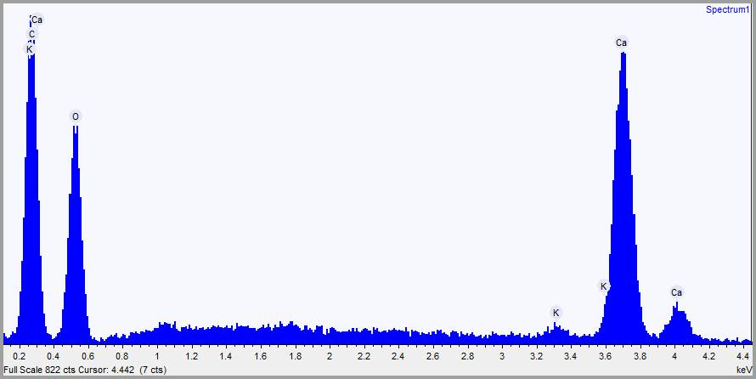
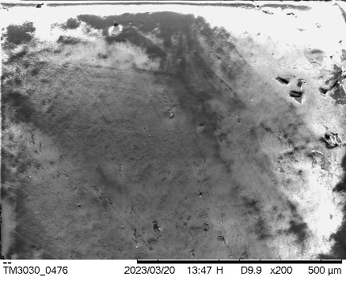
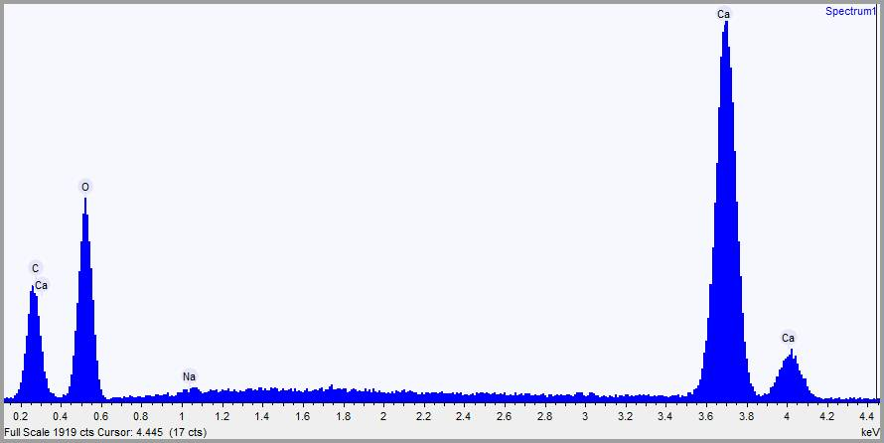
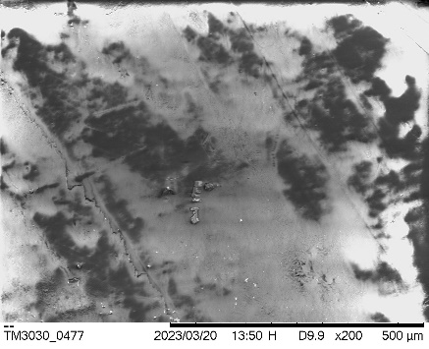
Figure S1 (calcite A)
R1
R2

Figure S2 (calcite B)
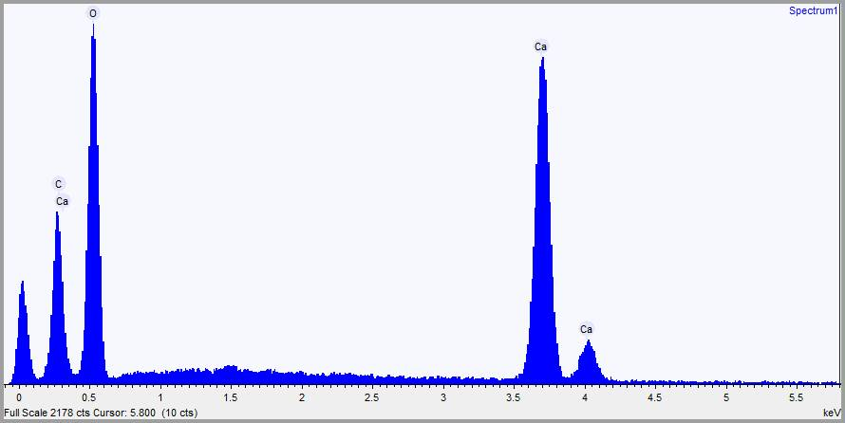
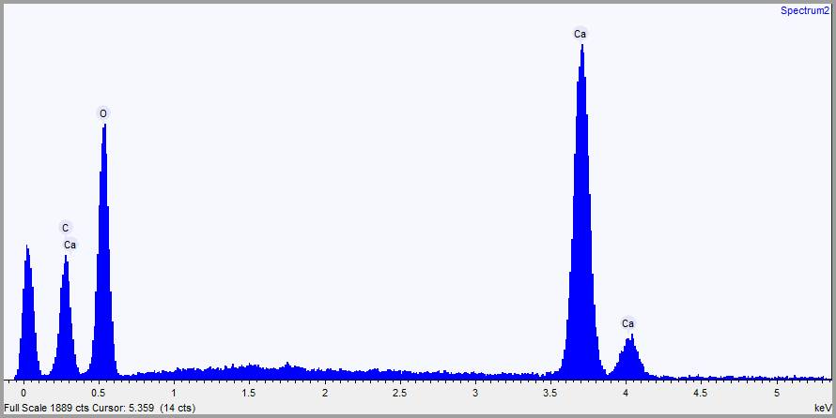
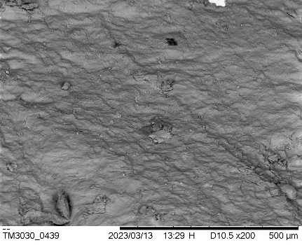
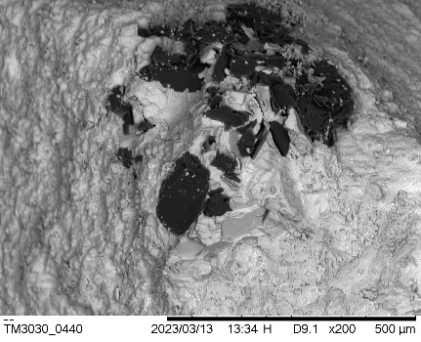
R1
R2

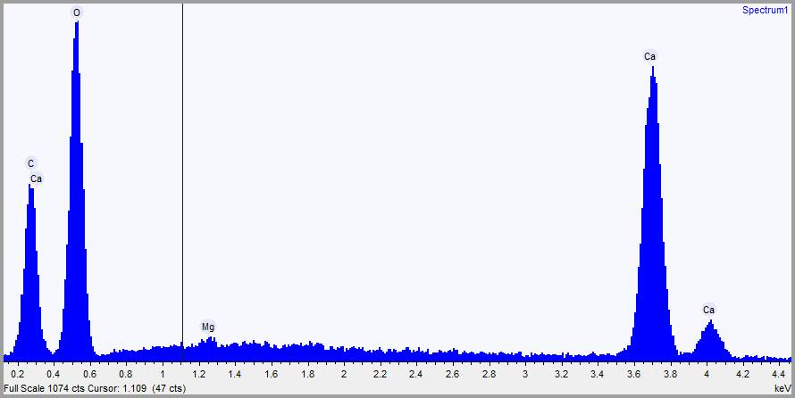
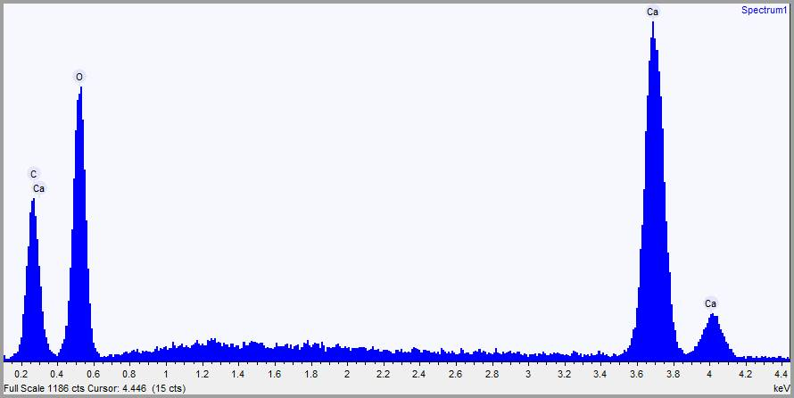
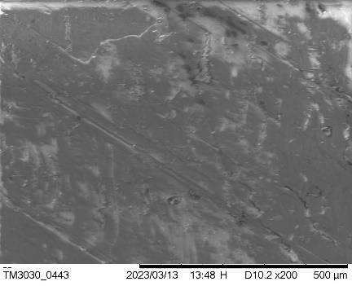
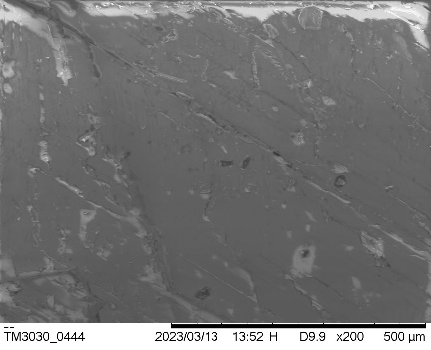
Figure S3 (calcite C)
R1
R2

Figure S4 (calcite D)
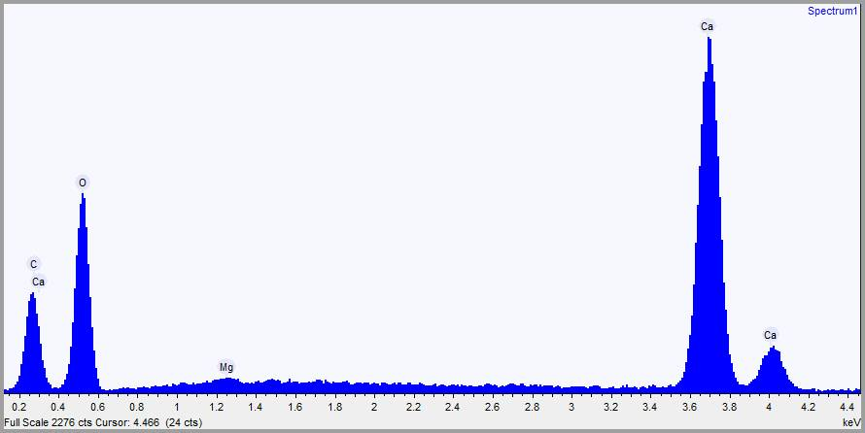
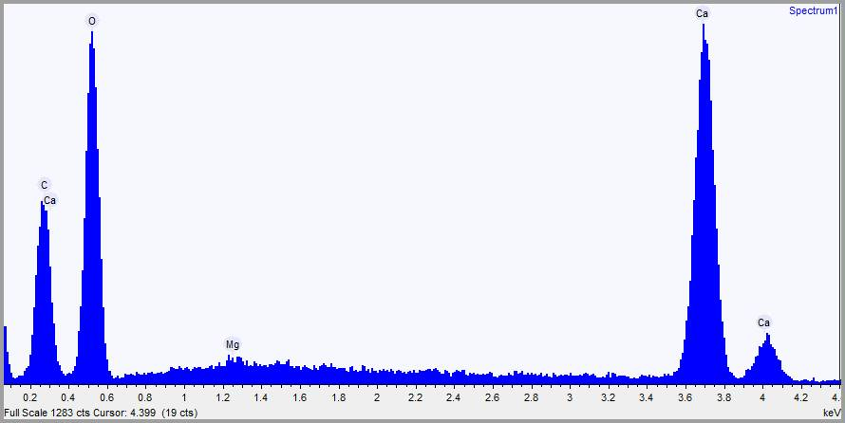
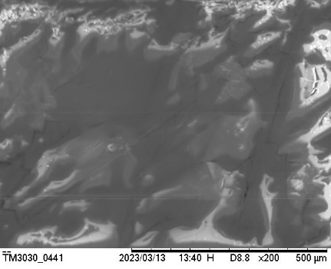
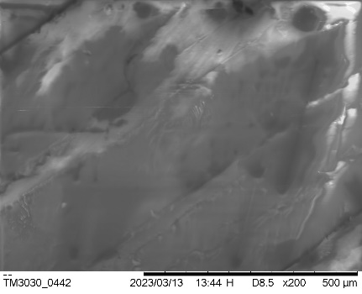
R1
R2

Figure S5 (calcite E)
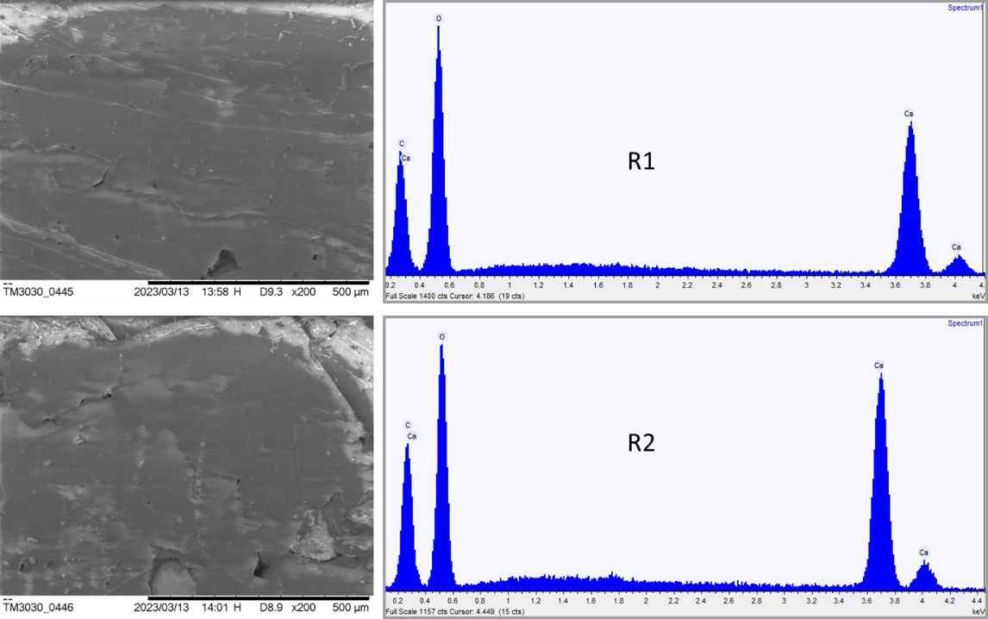
Figure S6 (aragonite A)
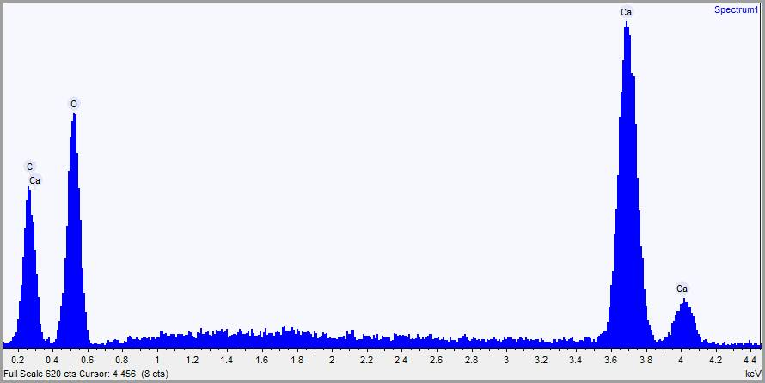
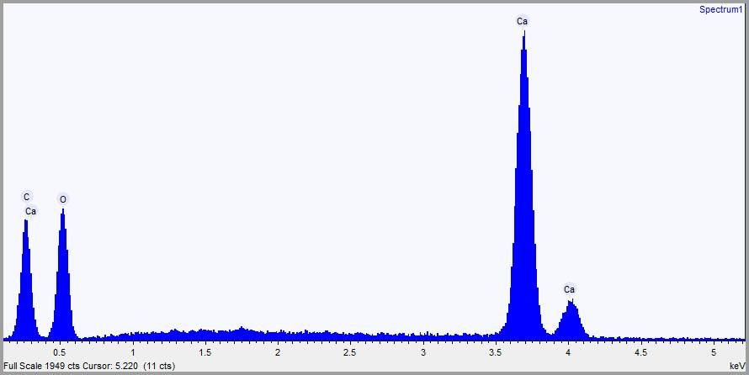
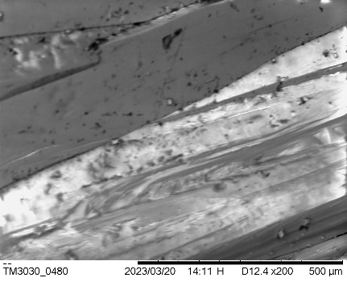
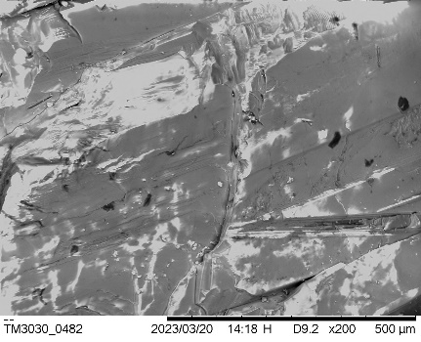
R1
R2

Figure S7 (aragonite B)
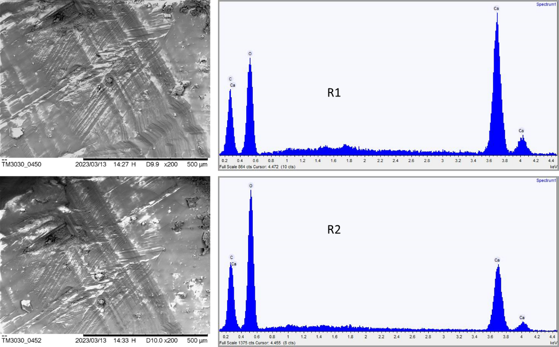
Figure S8 (aragonite C)
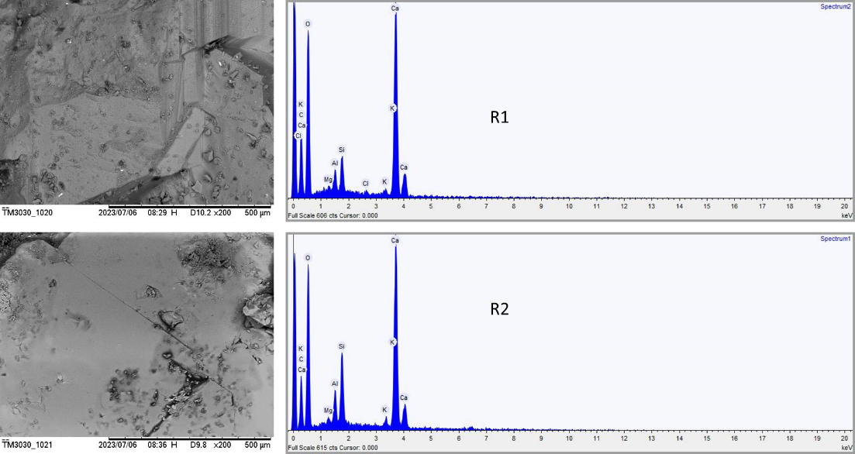

Figure S9 (dolomite A)
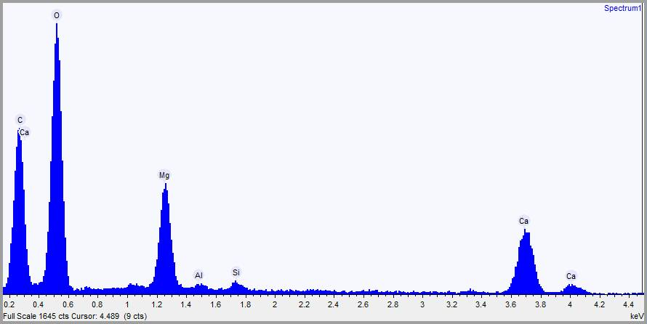
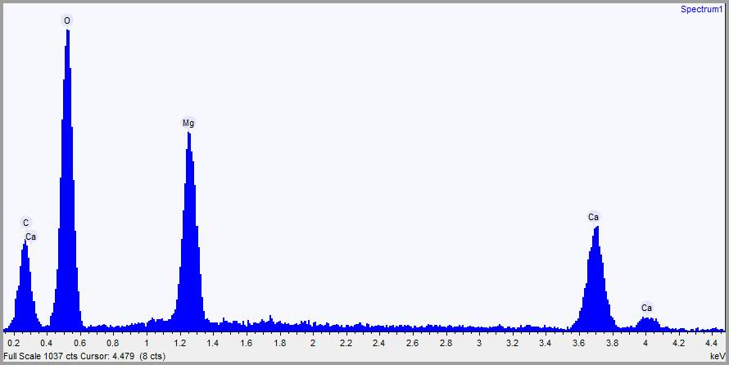
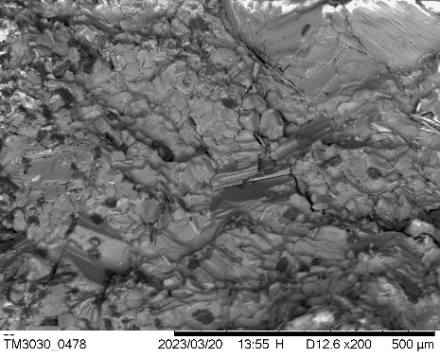
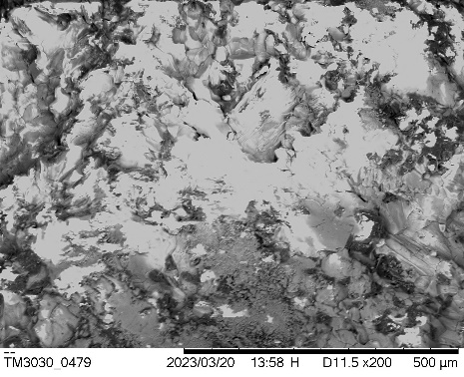
R1
R2
Figure S10 (dolomite B)
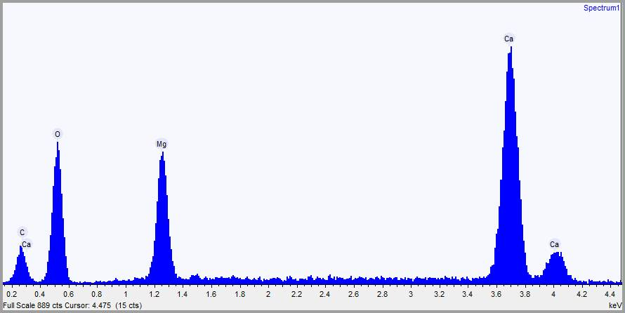
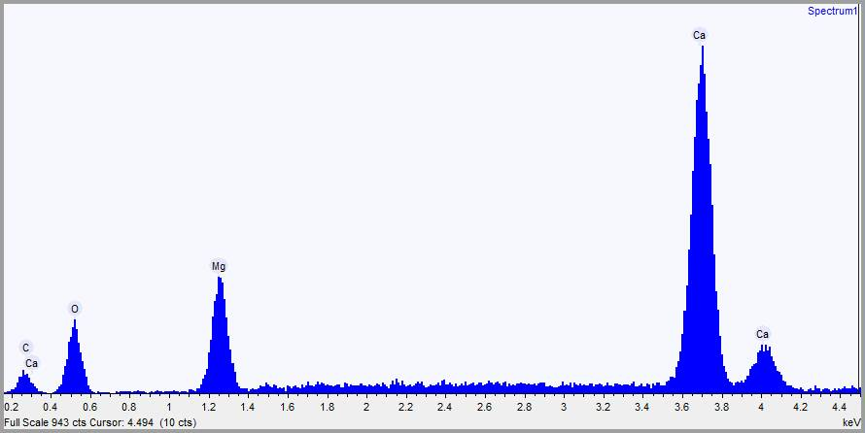
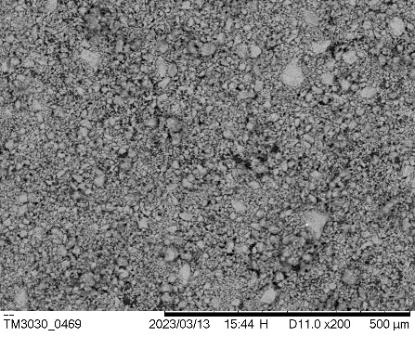
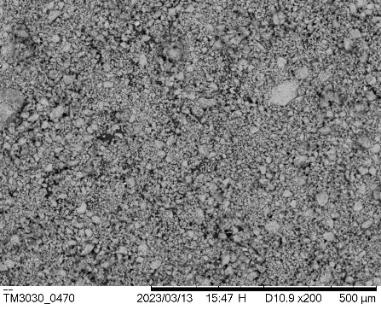
R1
R2

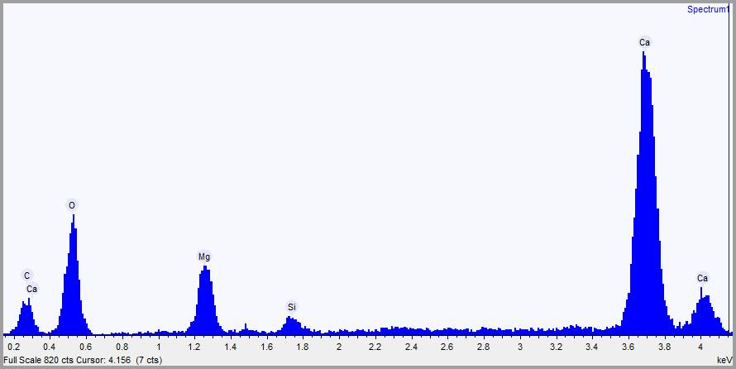
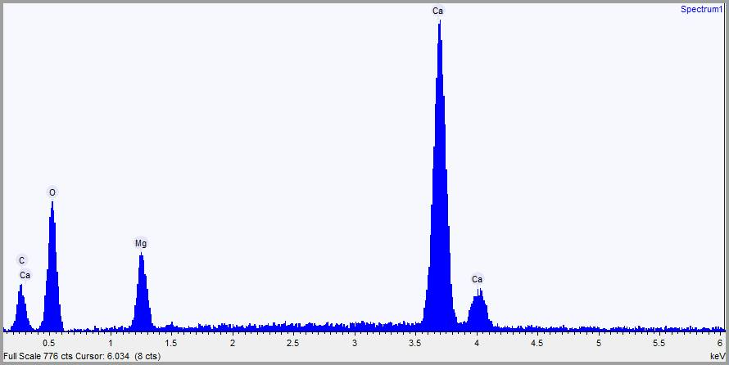
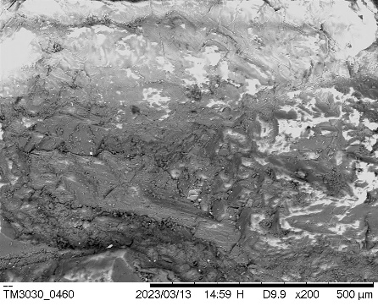
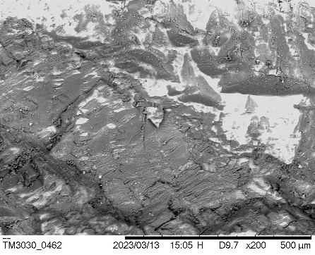
Figure S11 (dolomite C)
R1
R2

Figure S12 (dolomite D)
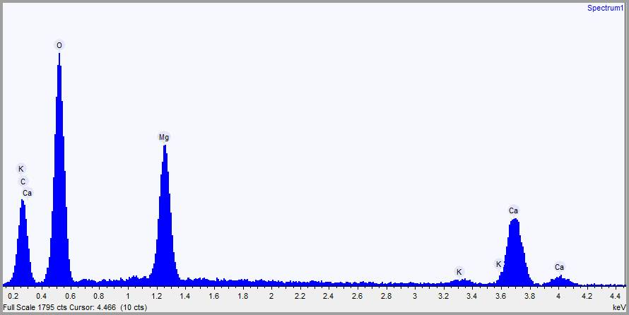
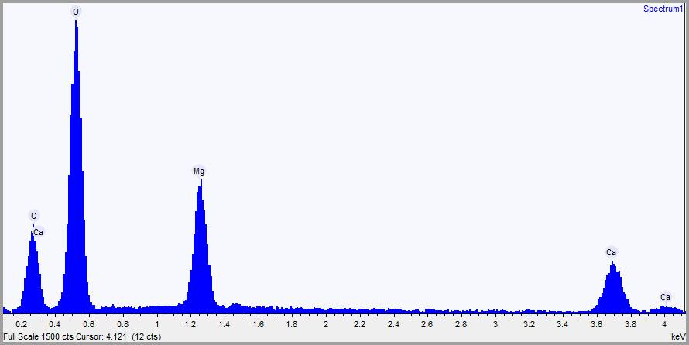
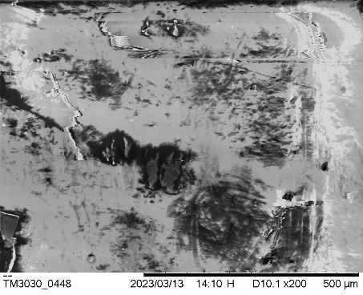
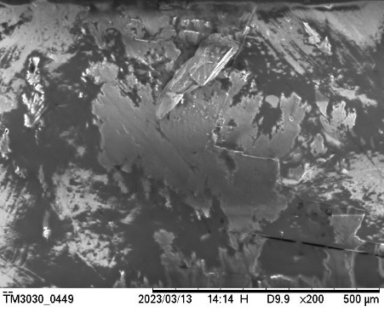
R1
R2

Figure S13 (magnesite A)
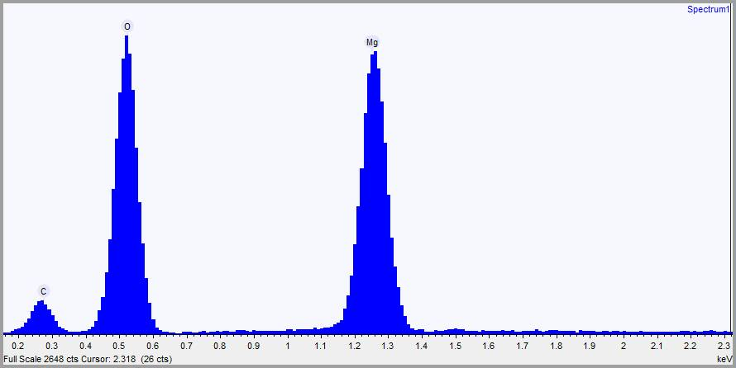
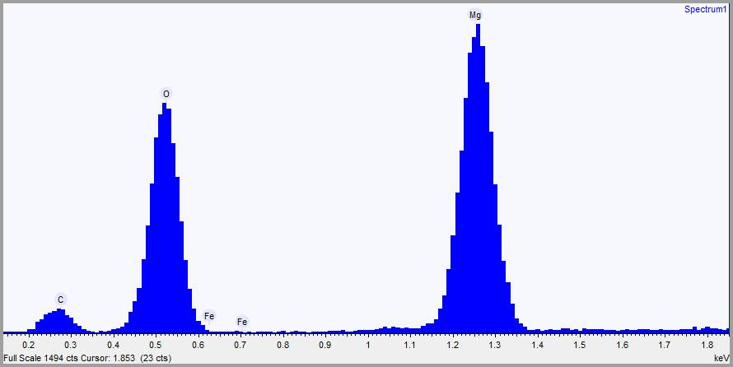
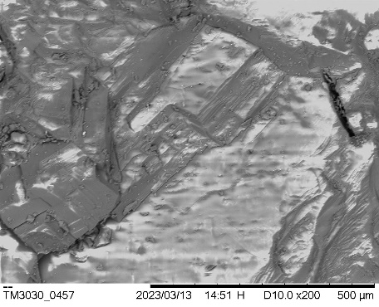
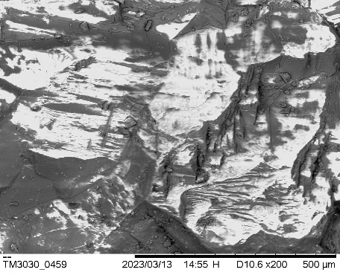
R1
R2
Figure S14 (magnesite B)
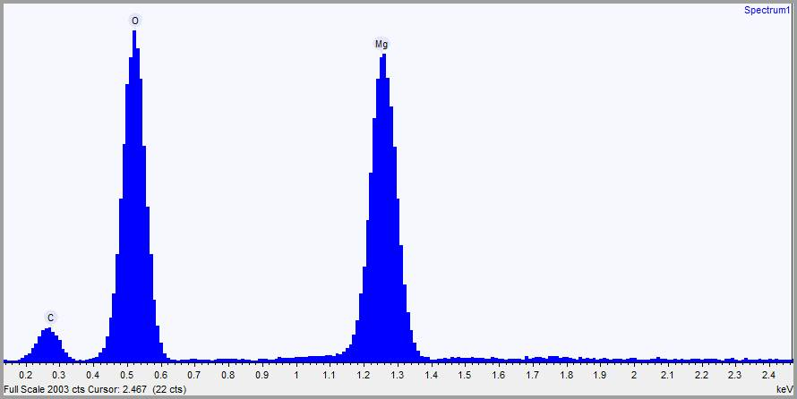
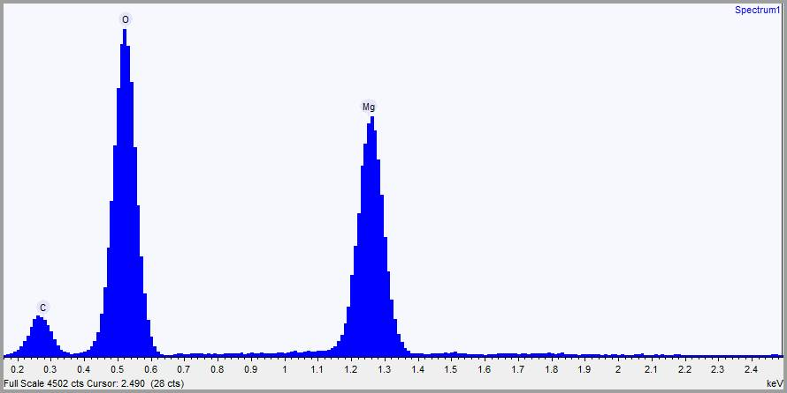
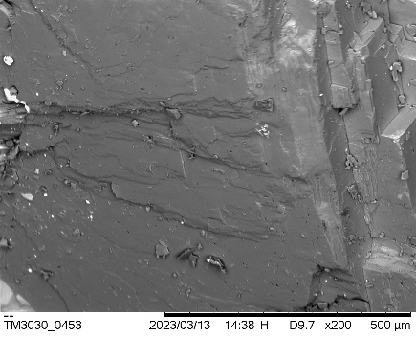
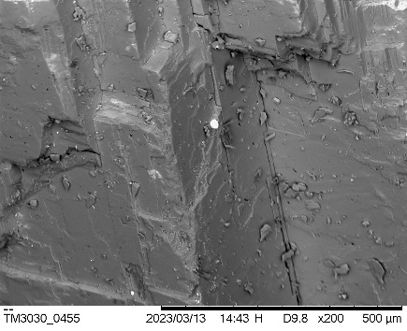
R1
R2

Figure S15 (rhodochrosite A)
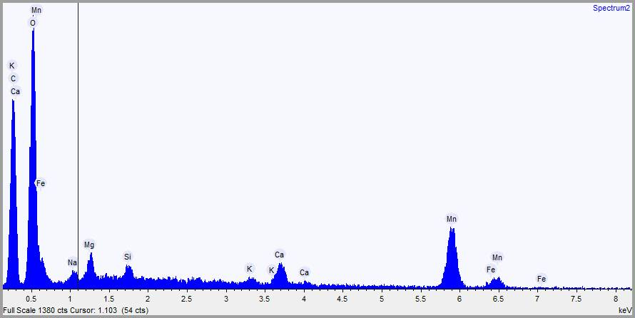
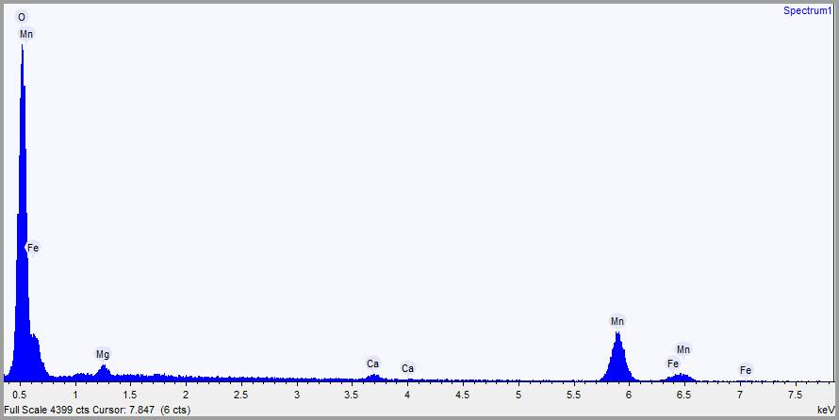
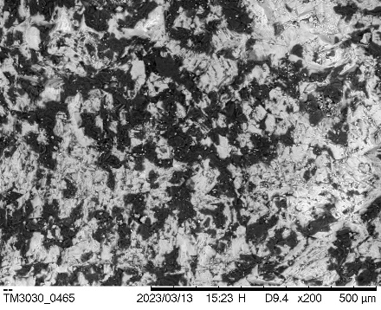
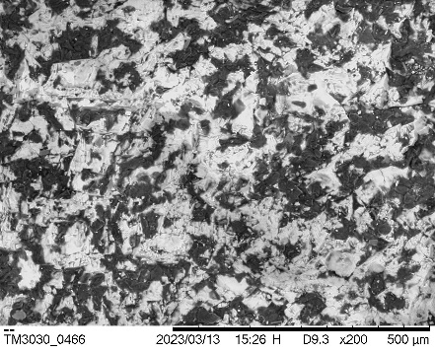
R1
R2
Figure S16 (rhodochrosite B)
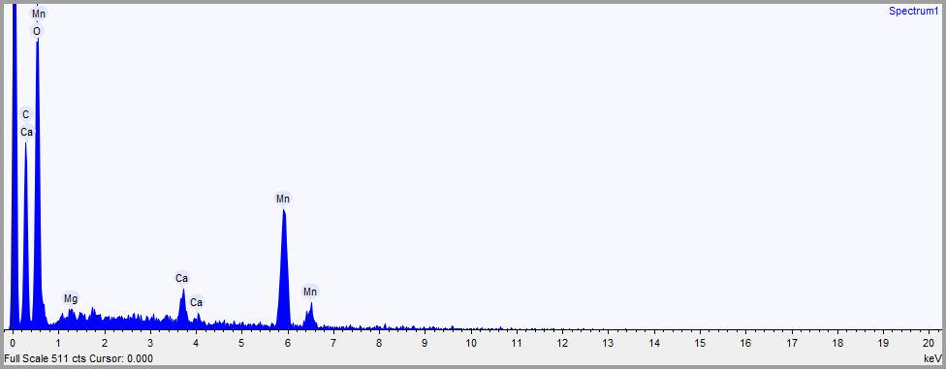
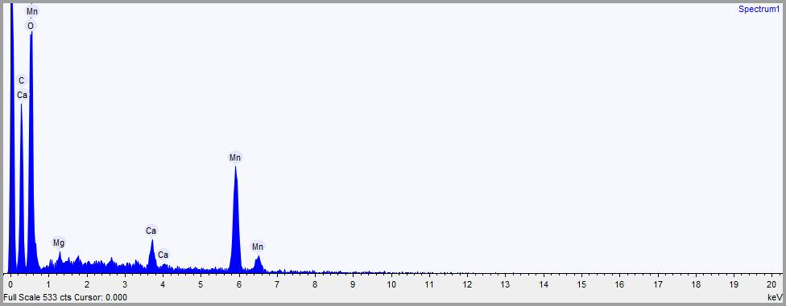
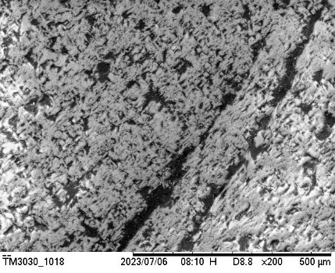
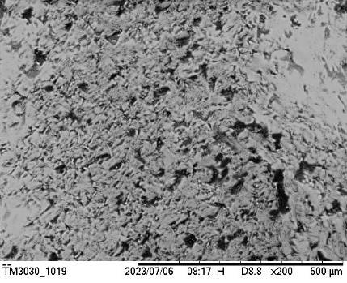
R1
R2

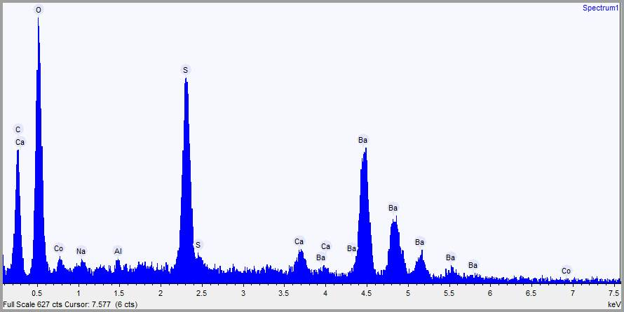
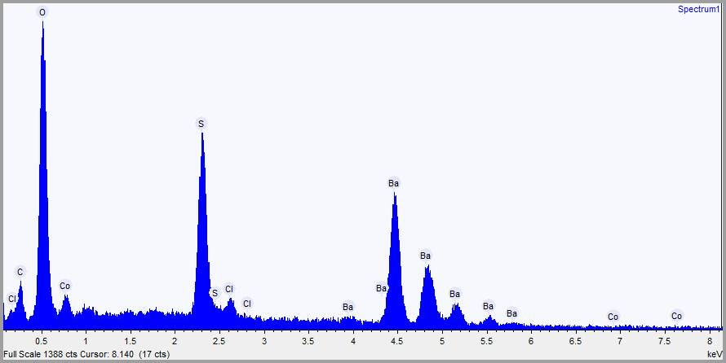
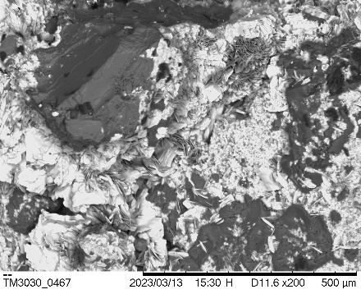
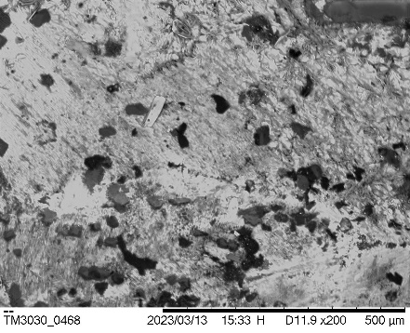
Figure S17 (witherite)
R1
R2

Figure S18 (siderite)
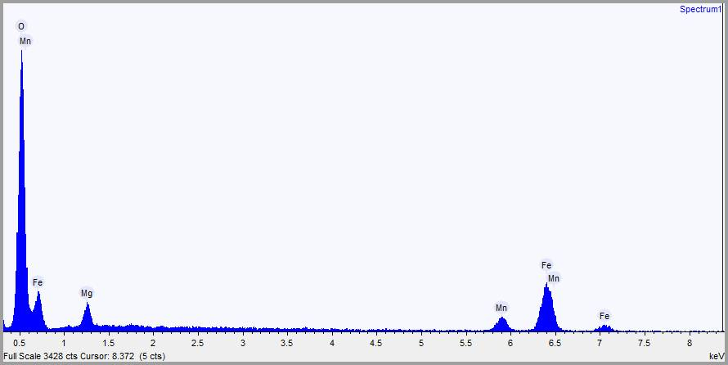
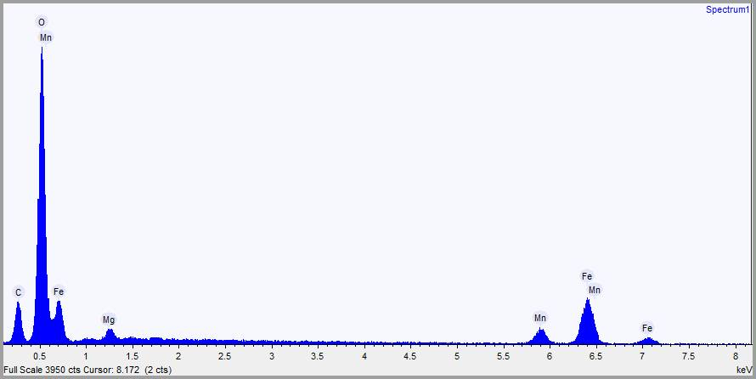
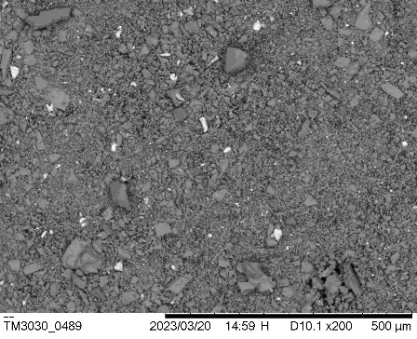
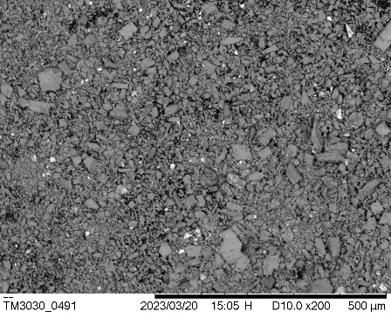
R1
R2

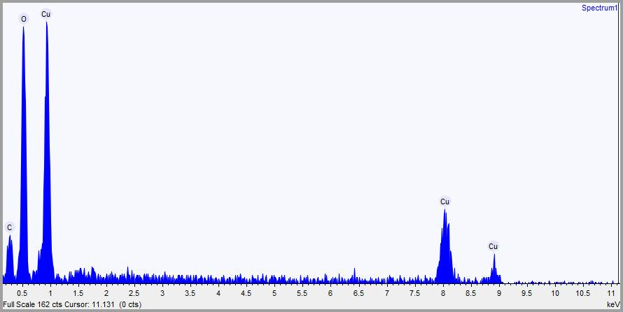
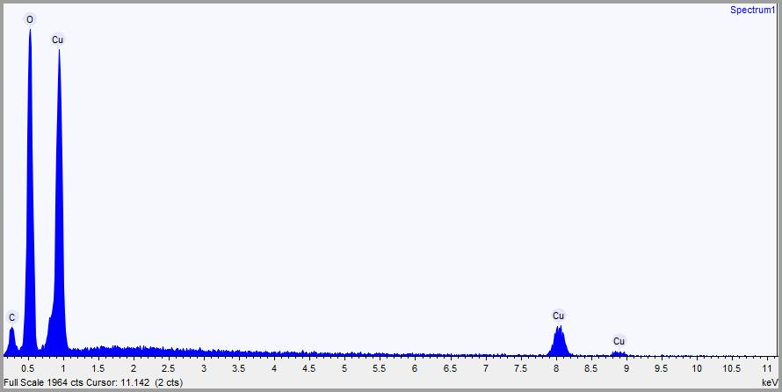
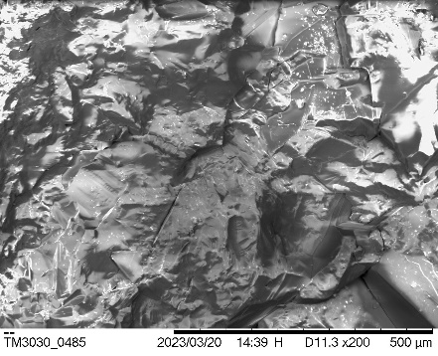
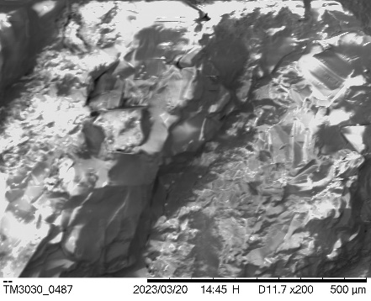
Figure S19 (azurite)
R1
R2

Figure S20 (malachite)
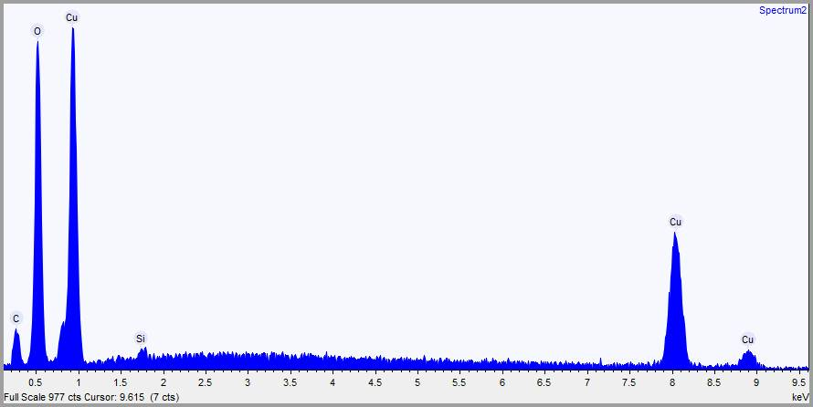
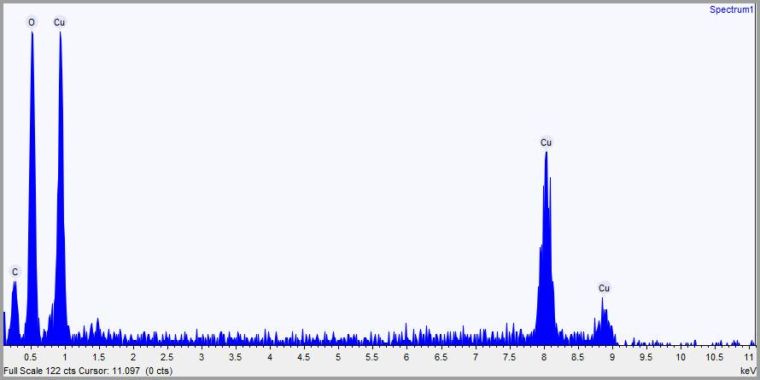
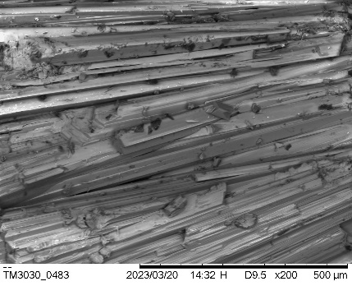
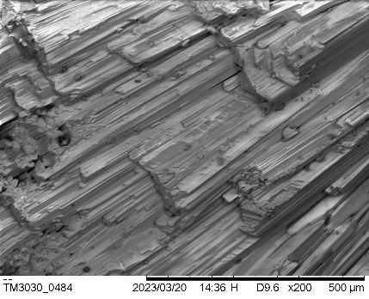
R1
R2

Figure S21 (calcites)

Figure S22 (aragonites)

Figure S23 (dolomites)
Figure S24 (magnesites)

Figure S25 (rhodochrosites)

Figure S26 (witherite)

Figure S27 (siderite)

Figure S28 (azurite)

Figure S29 (malachite)

Figure S30
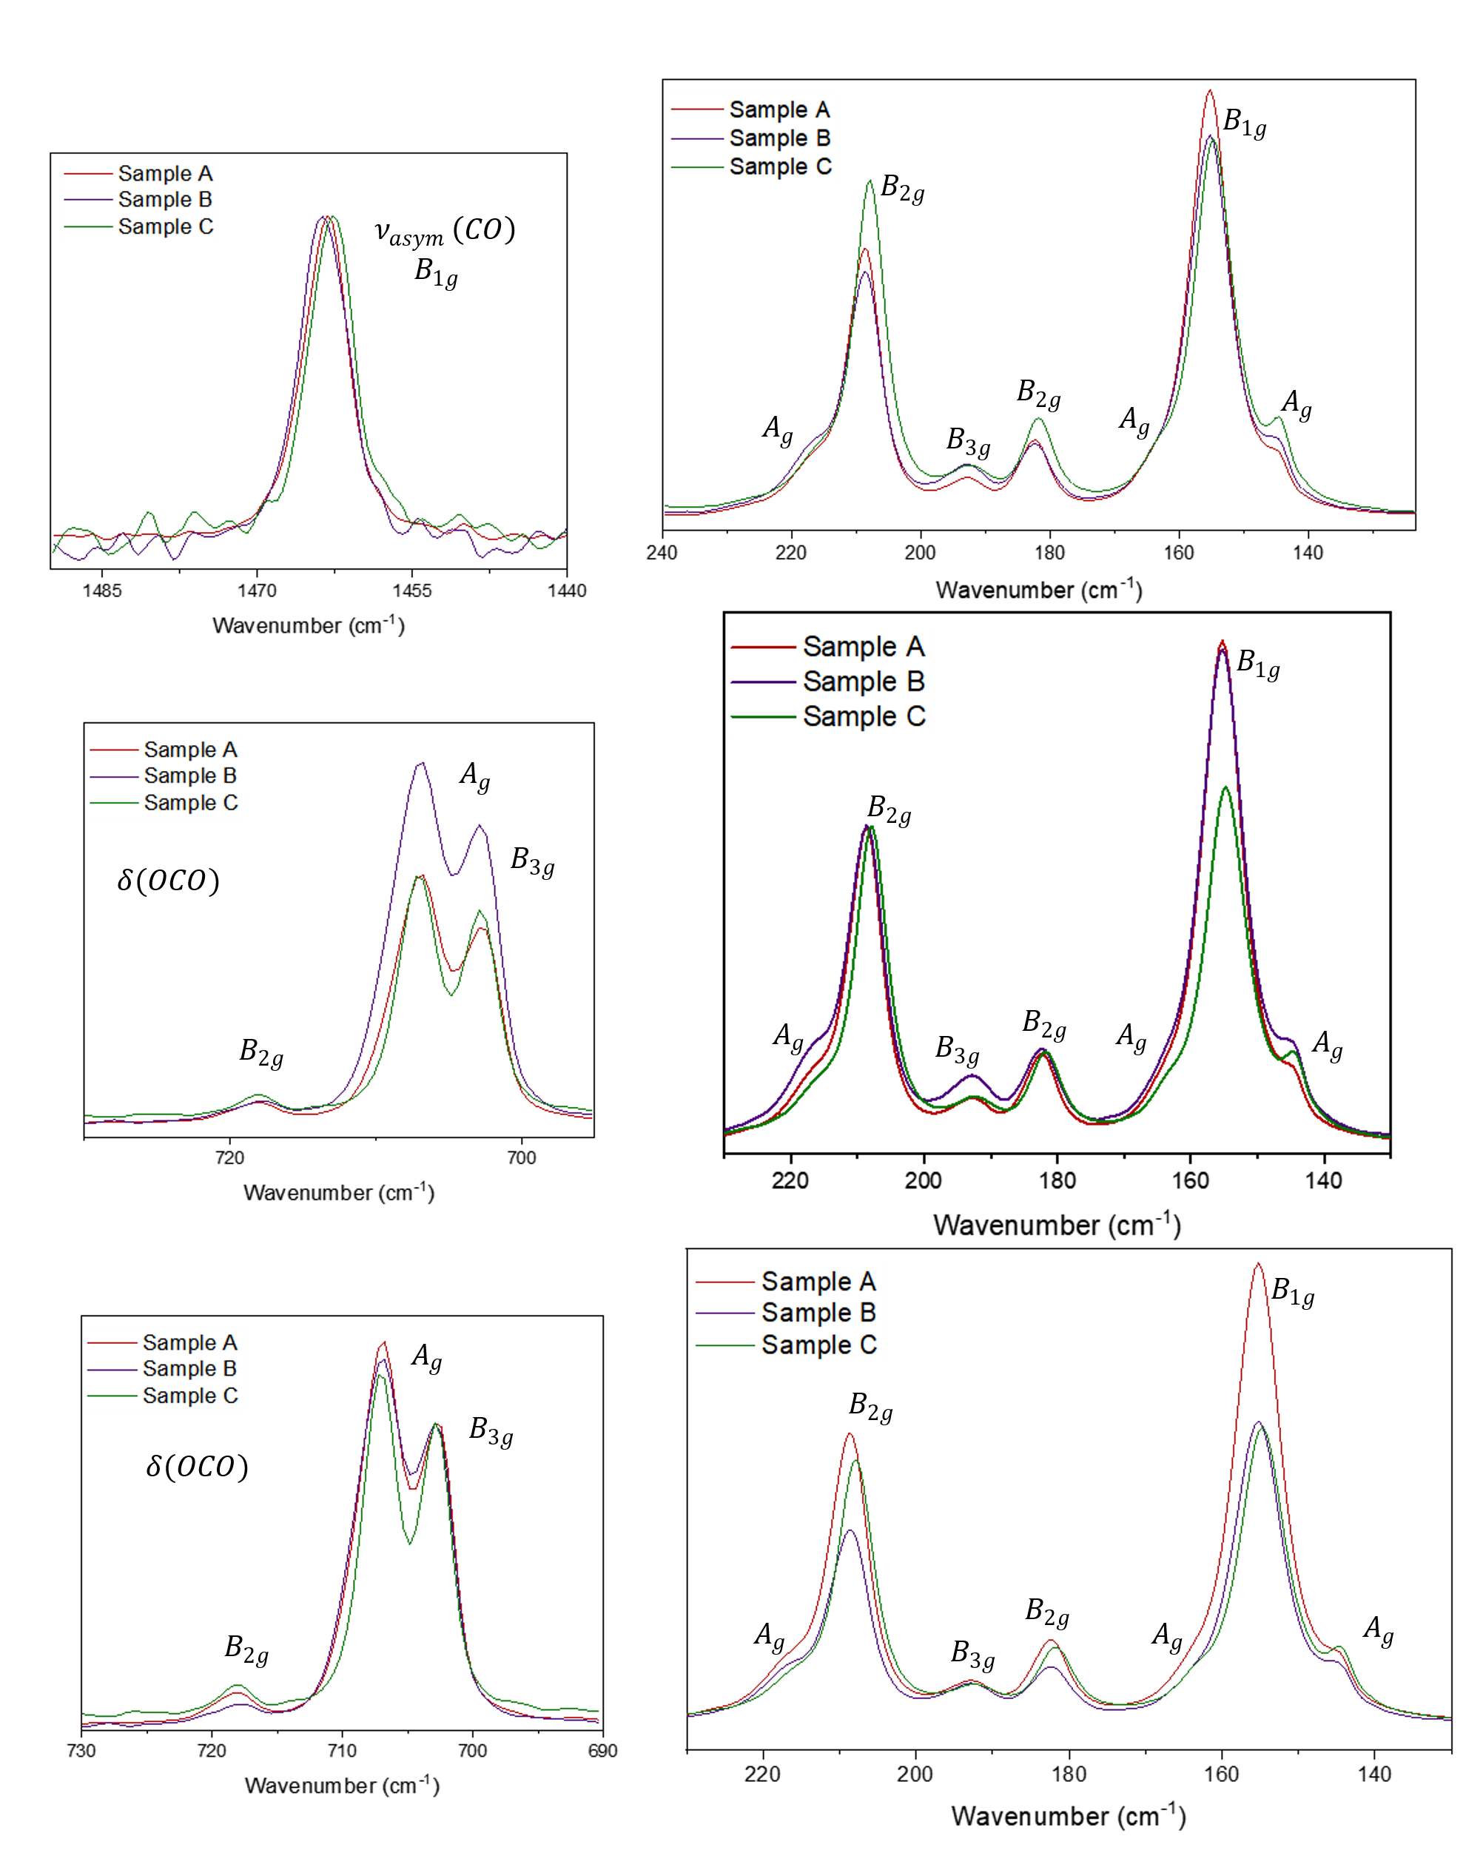

Figure S31
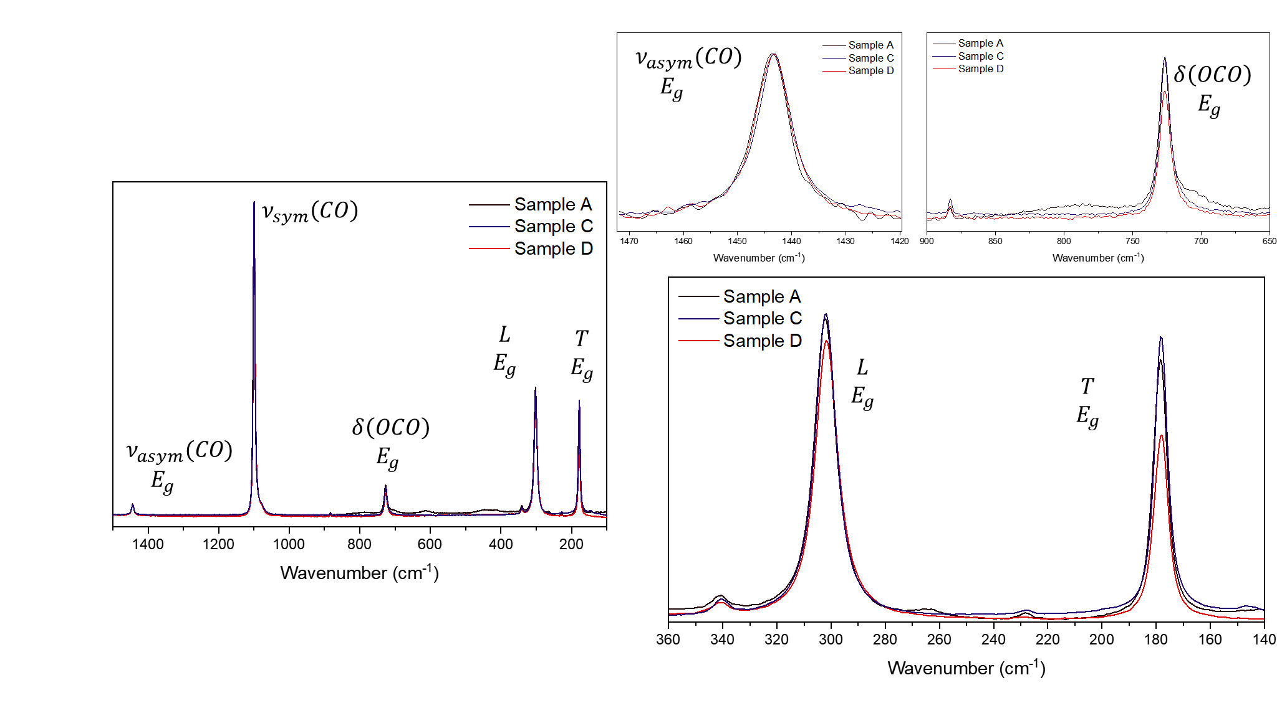
Figure S32
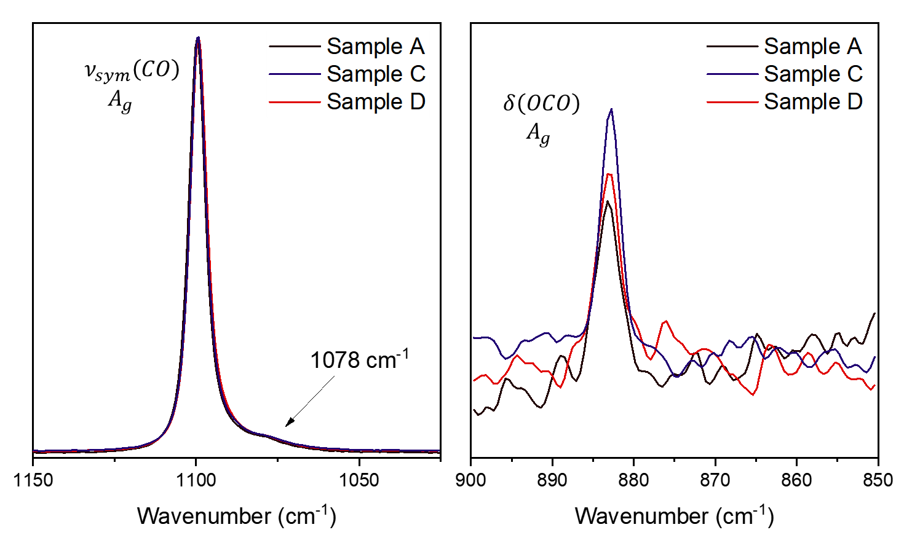
Figure S33
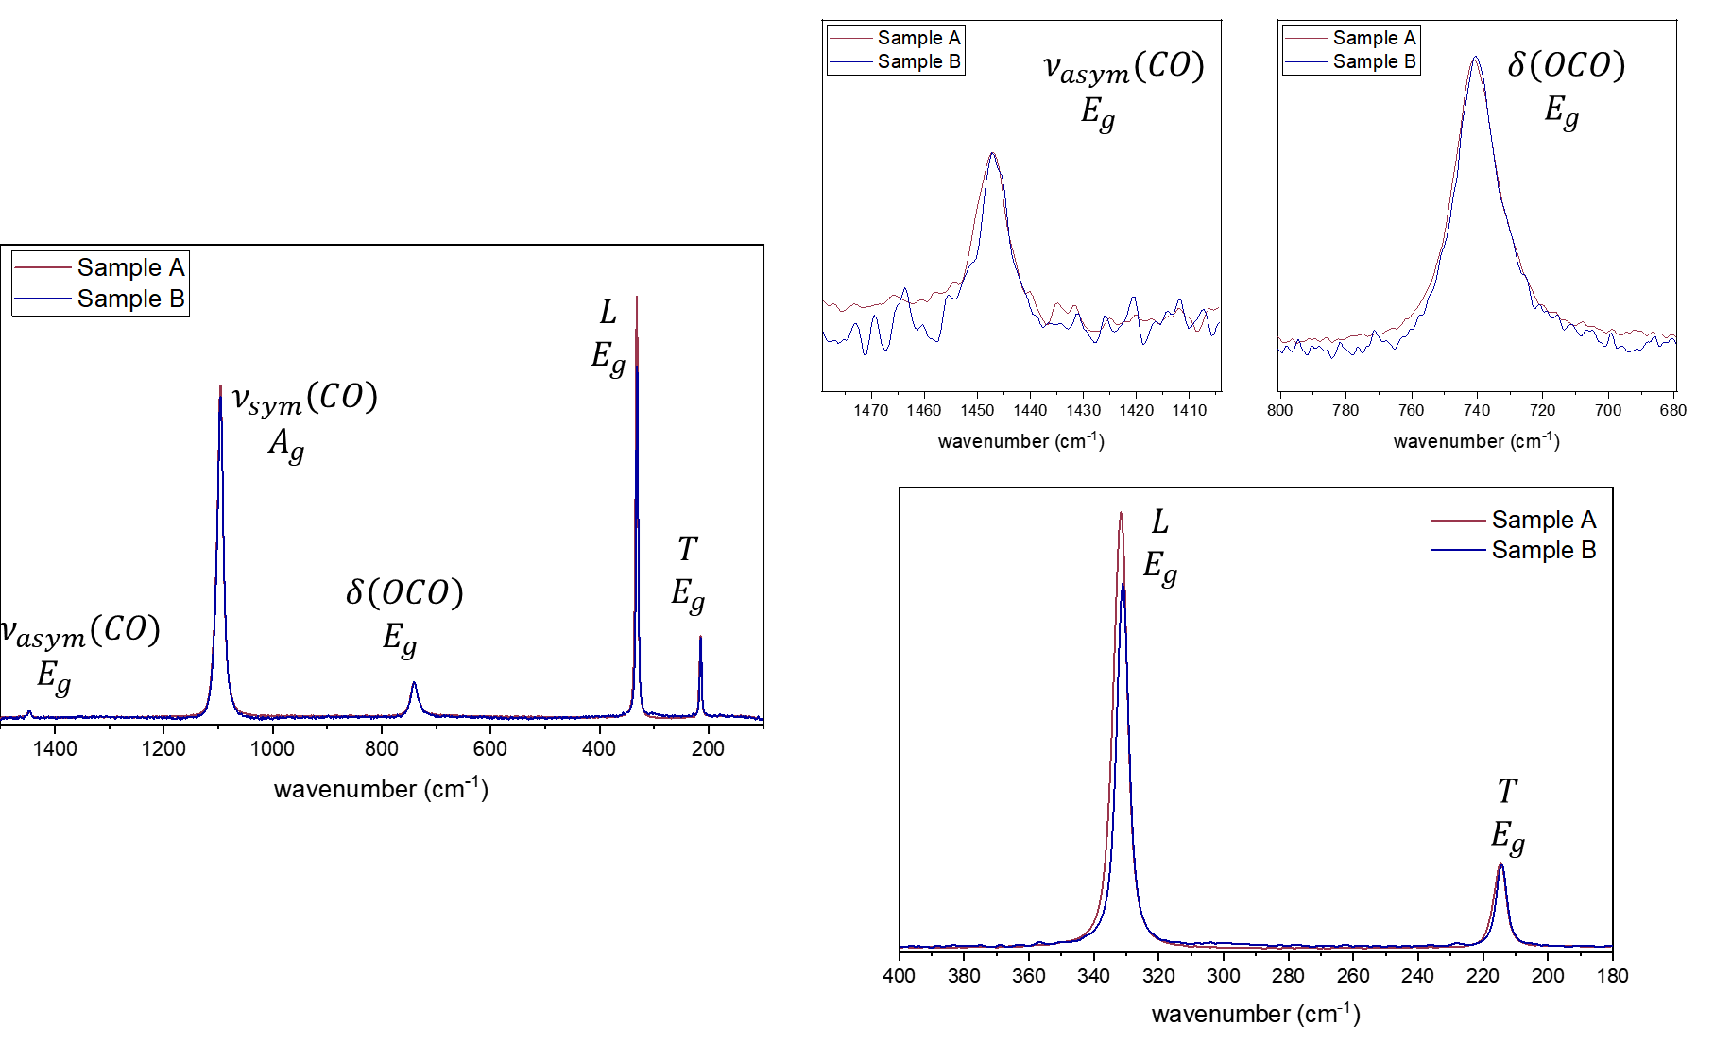

Figure S34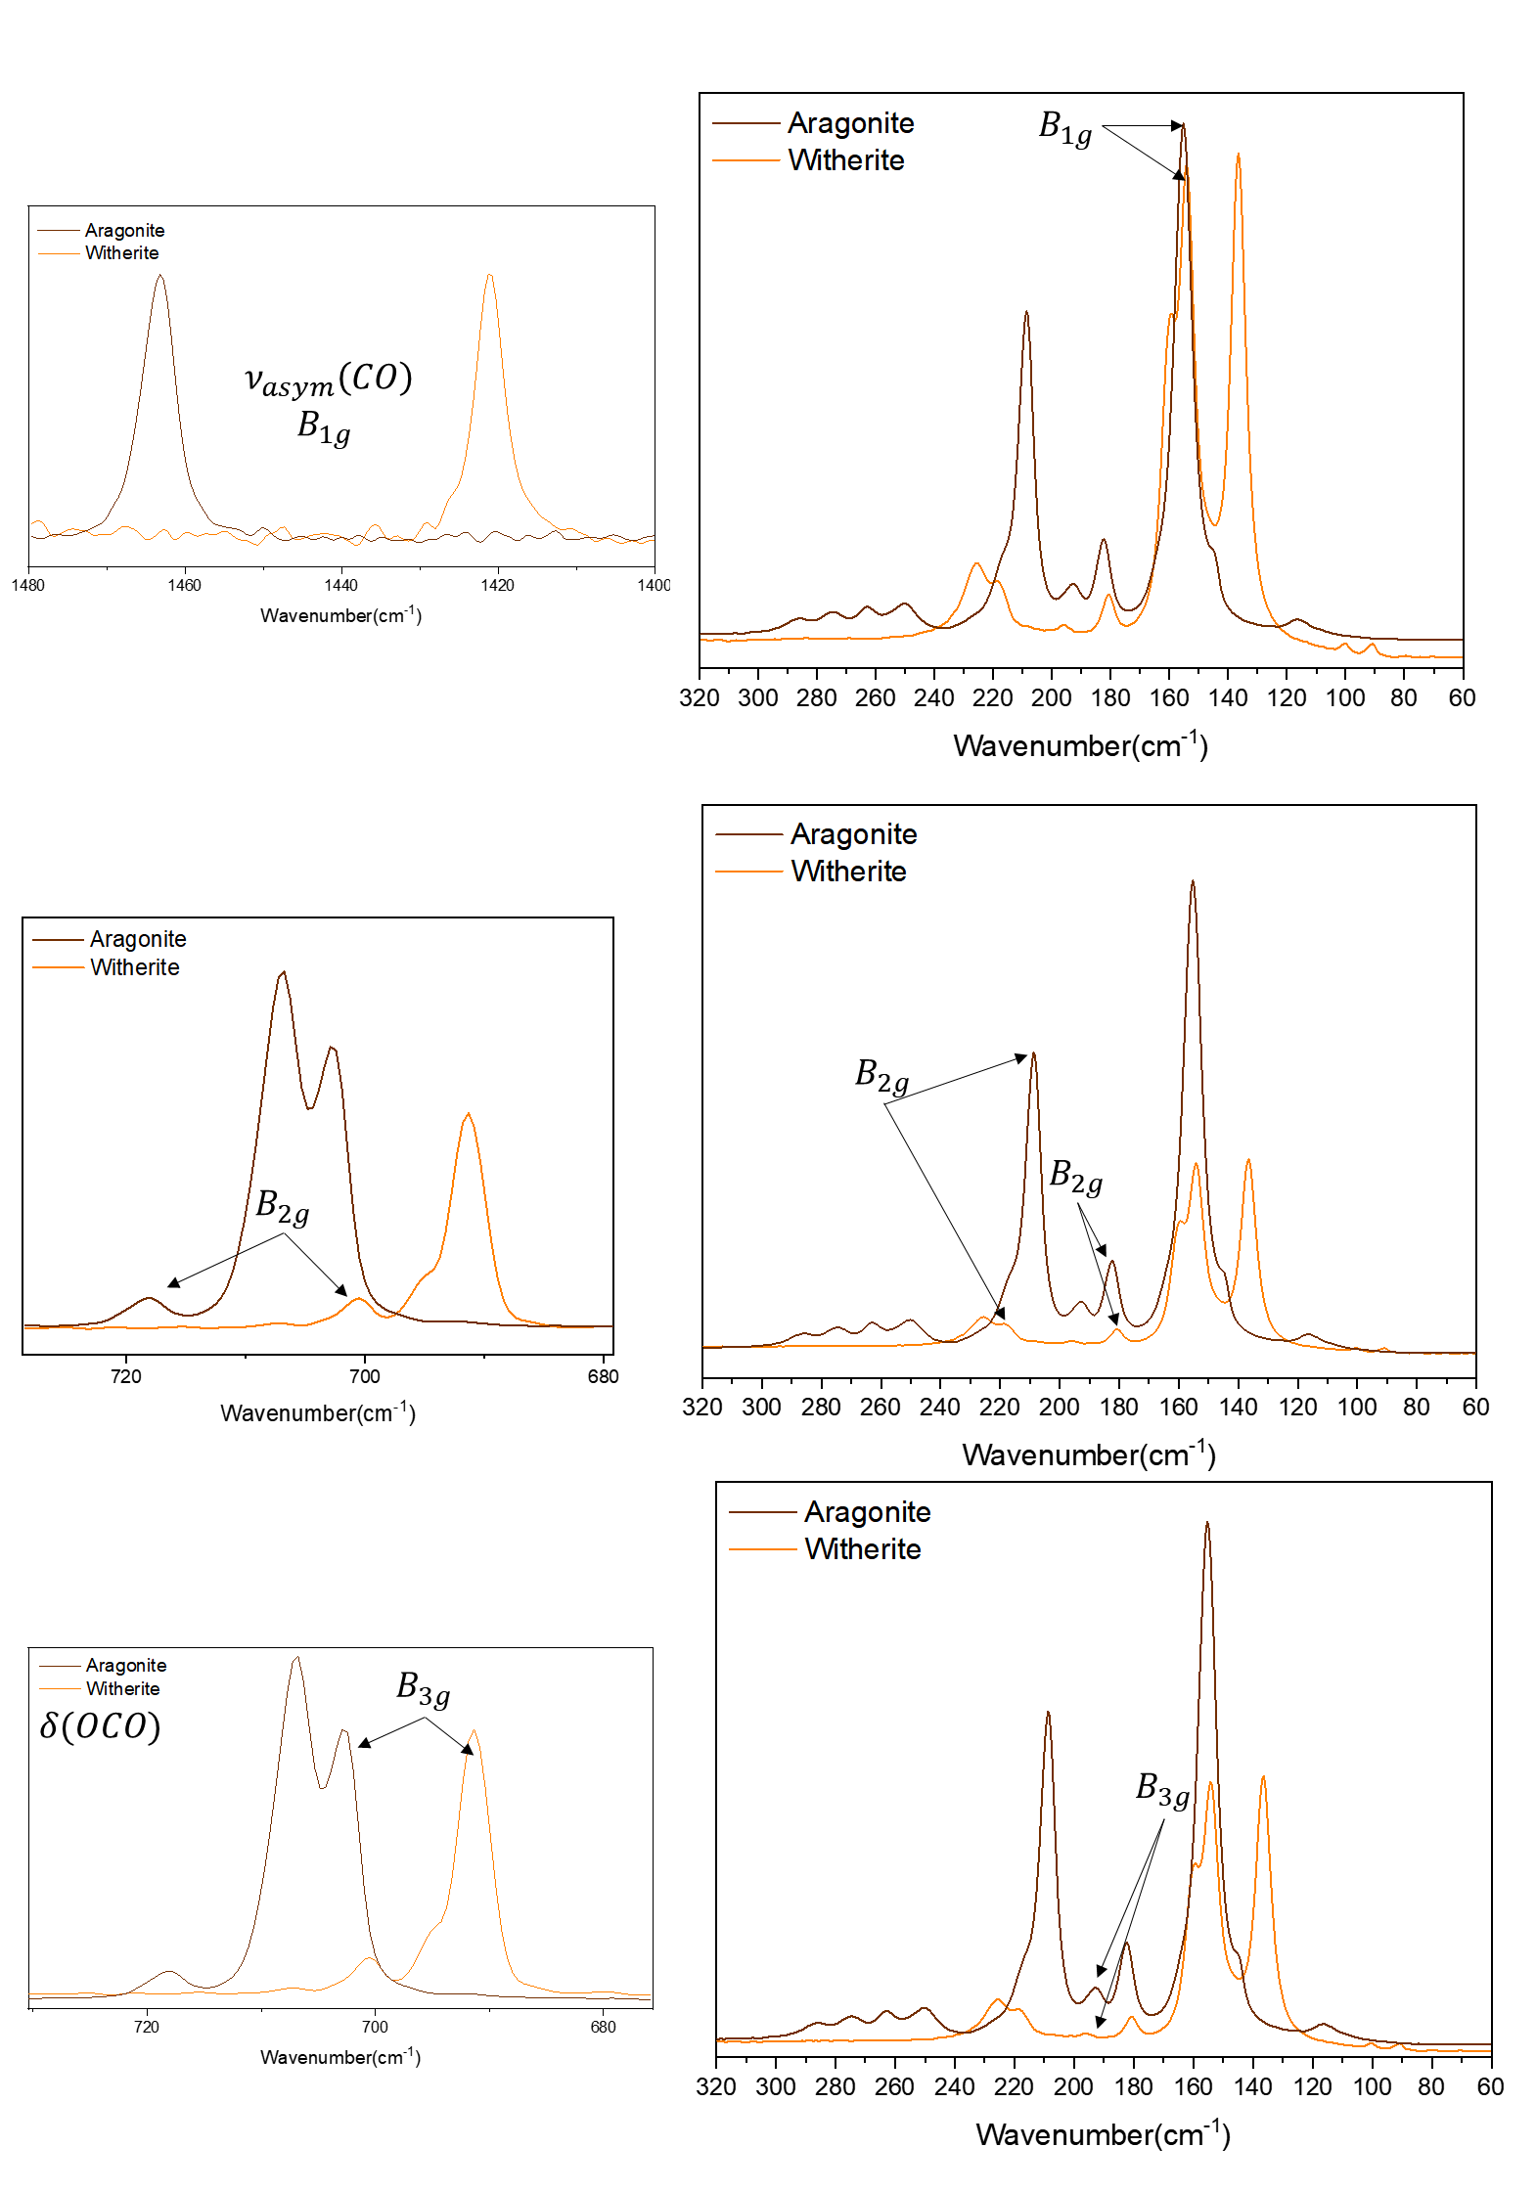

Figure S35
Calcite  A | Calcite  B | Calcite  C | Calcite  D | Calcite  E
Magnesite  A | Magnesite  B | Dolomite  A | Dolomite  B | Dolomite  C
Dolomite  D | Aragonite  A | Aragonite  B | Aragonite  C | Rhodochrosite  A
Rhodochrosite  B | Witherite | Siderite | Malachite | Azurite

