Supporting Information

Multifunctional nanoparticles with superparamagnetic manganese(II) ferrite and gold nanoclusters for multimodal imaging

Bárbara Casteleiro,^{a,b} Mariana Rocha,^{b,} Ana R. Sousa,^{b,c} André M. Pereira,^{c} José M. G. Martinho,ª Clara Pereira,^{b} José P. S. Farinhaª

ª Centro de Química Estrutural e Departamento de Engenharia Química, Instituto Superior Técnico, Universidade de Lisboa, 1049-001 Lisboa, Portugal
^{b} REQUIMTE/LAQV, Departamento de Química e Bioquímica, Faculdade de Ciências, Universidade do Porto, Rua do Campo Alegre s/n, 4169-007, Porto, Portugal
^{c} IFIMUP-Instituto de Física de Materiais Avançados, Nanotecnologia e Fotónica, Departamento de Física e Astronomia, Faculdade de Ciências, Universidade do Porto, Rua do Campo Alegre s/n, 4169-007, Porto, Portugal
E-mail: E-mail: jgmartinho@tecnico.ulisboa.pt; farinha@tecnico.ulisboa.pt; clara.pereira@fc.up.pt

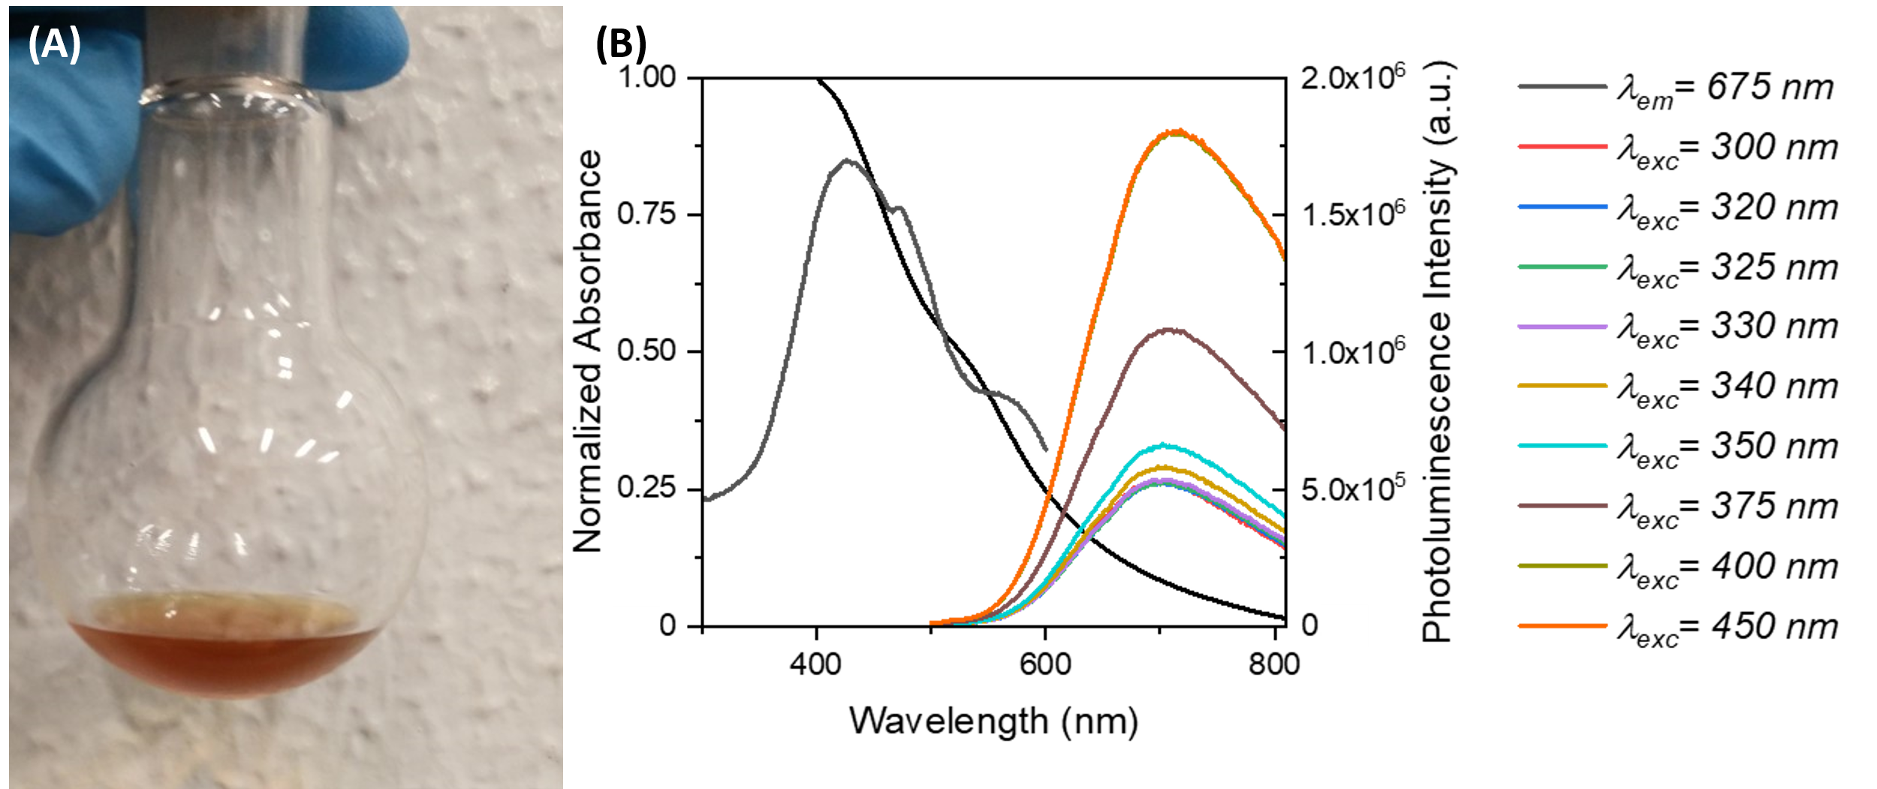
Figure S1. Characterization of MPTS-AuNCs in ethanol: (A) Photography of the dispersion after synthesis. (B) Linear optical properties. The MPTS-AuNCs show a Stokes shift of 290 nm, with photoluminescence excitation maximum λ_{exc}^{max} = 425 nm and emission maximum λ_{em}^{max} = 715 nm. Similar photoluminescence emission band regardless of the excitation wavelength, which is an indication of only one population of AuNCs

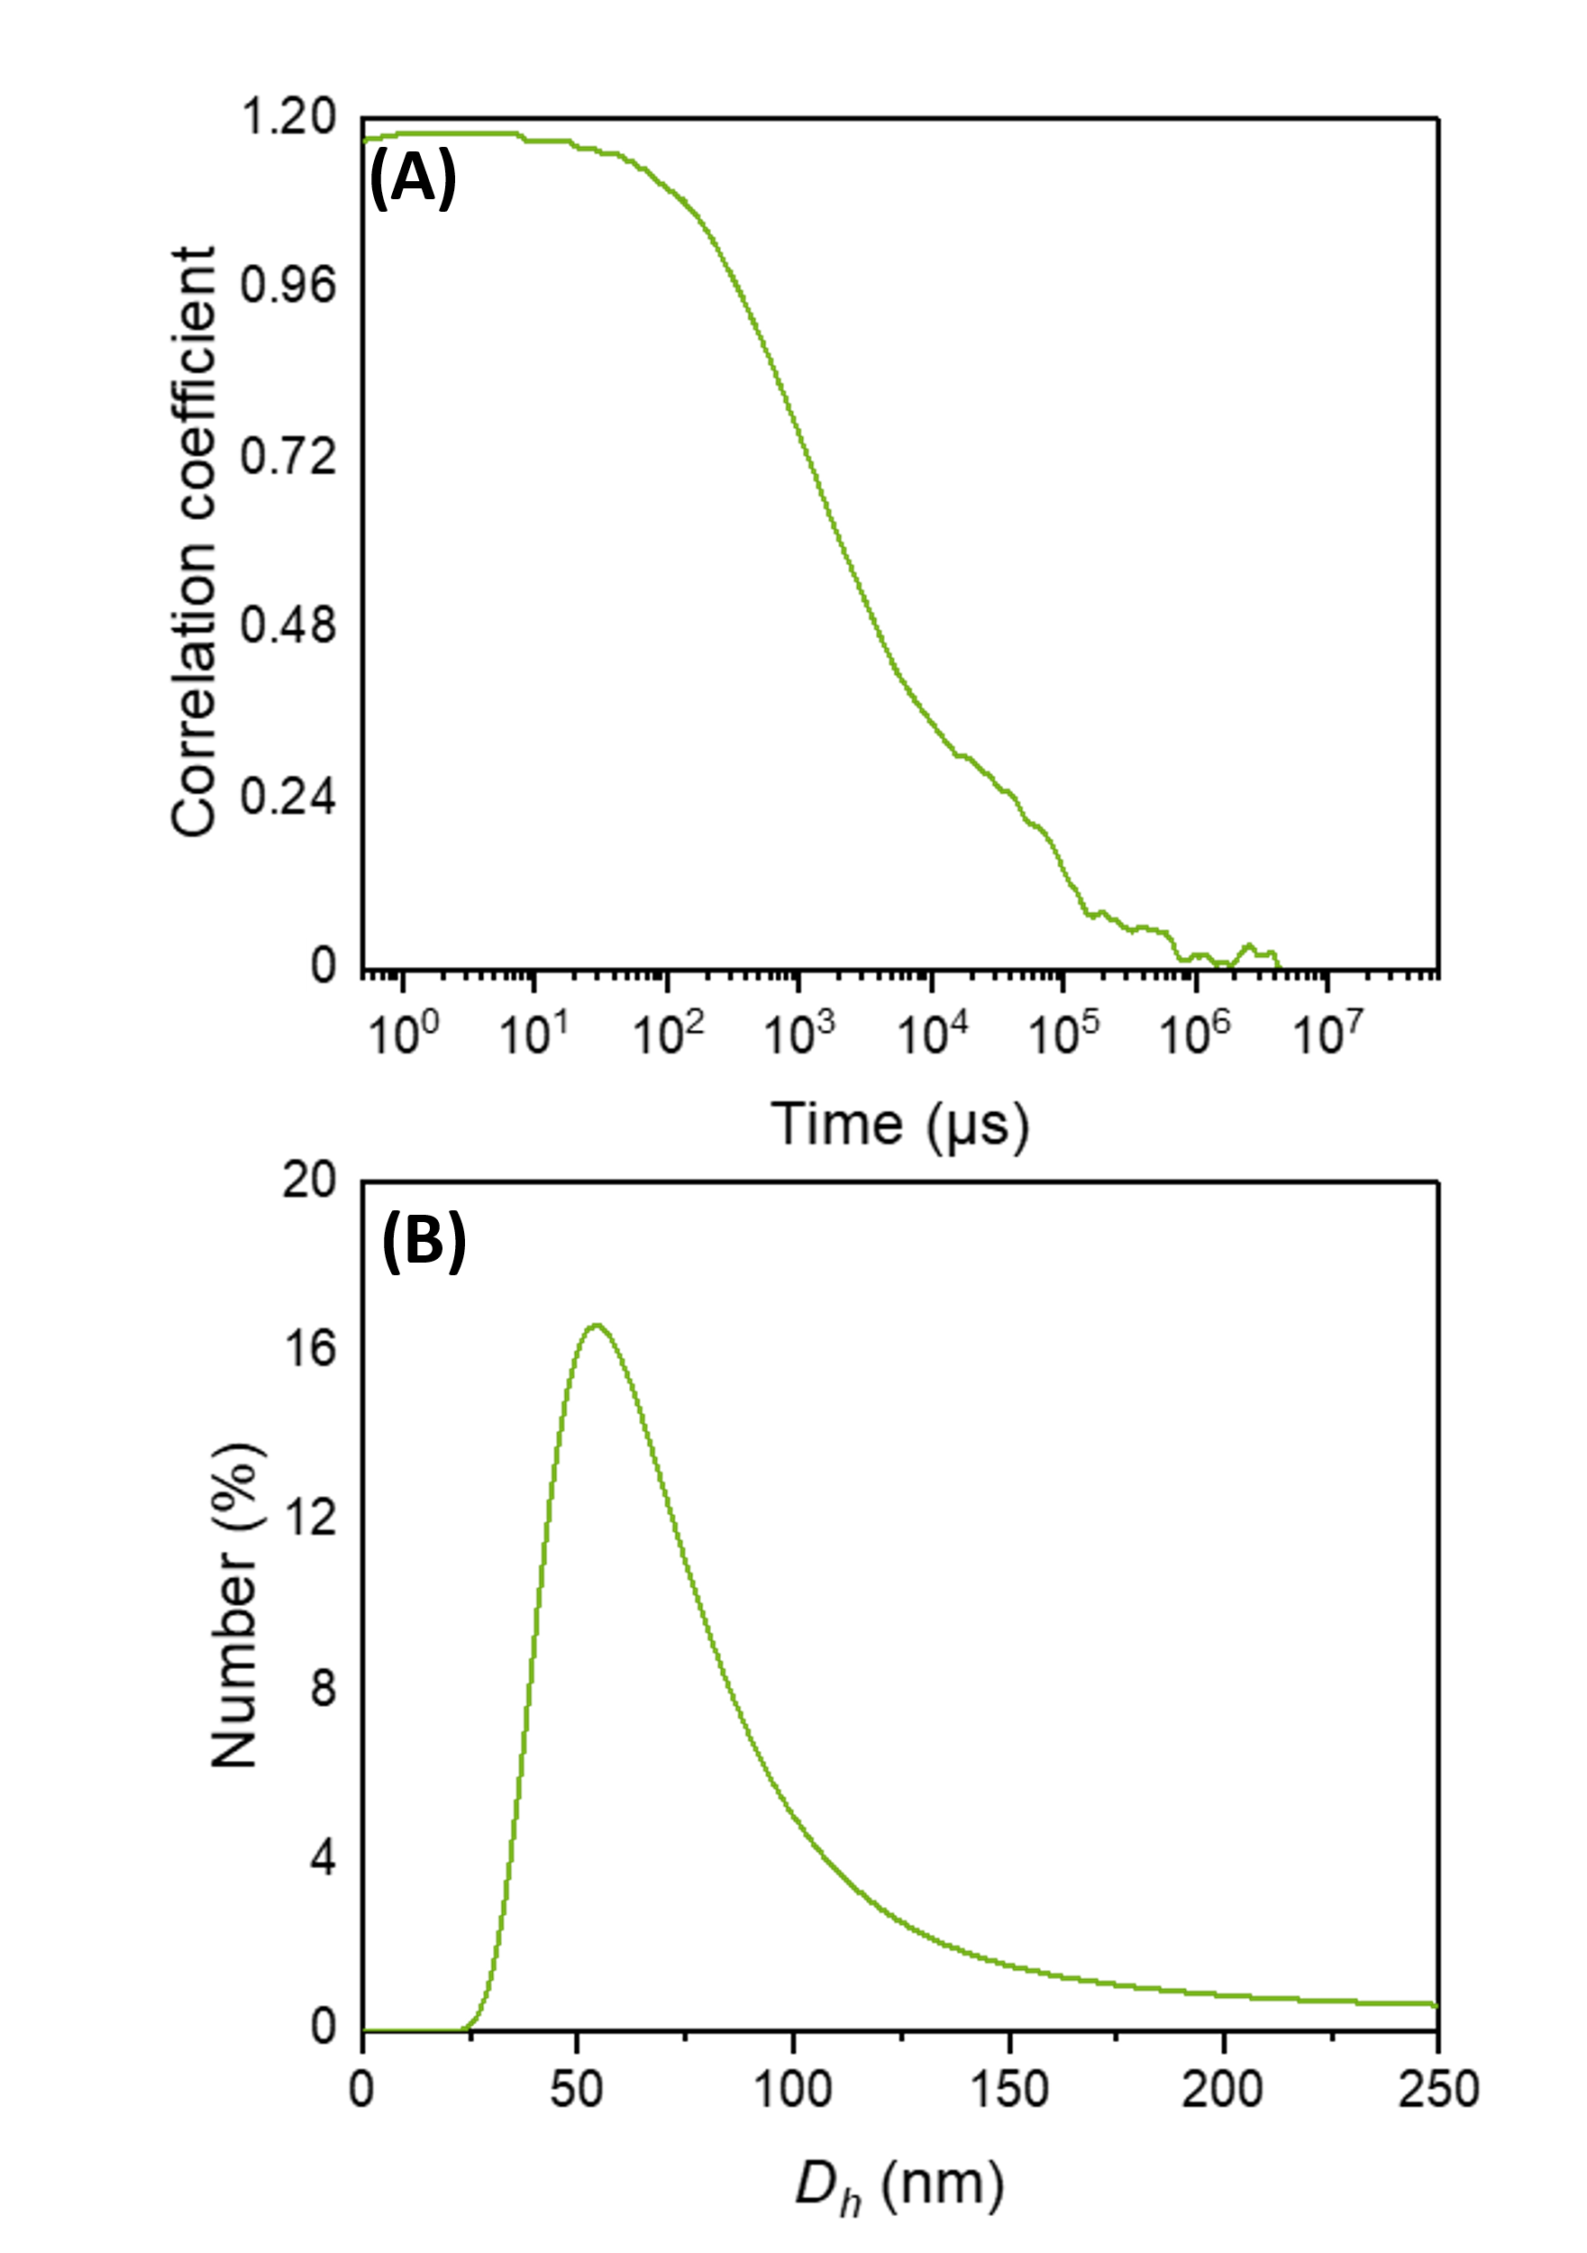
Figure S2. Dynamic light scattering of MPTS-AuNCs@MSN in water: (A) Autocorrelation curve. (B) Hydrodynamic diameter distribution curve by number. The autocorrelation curve shows a noisy baseline, indicating sedimentation of the MPTS-AuNCs@MSN during the measurements.

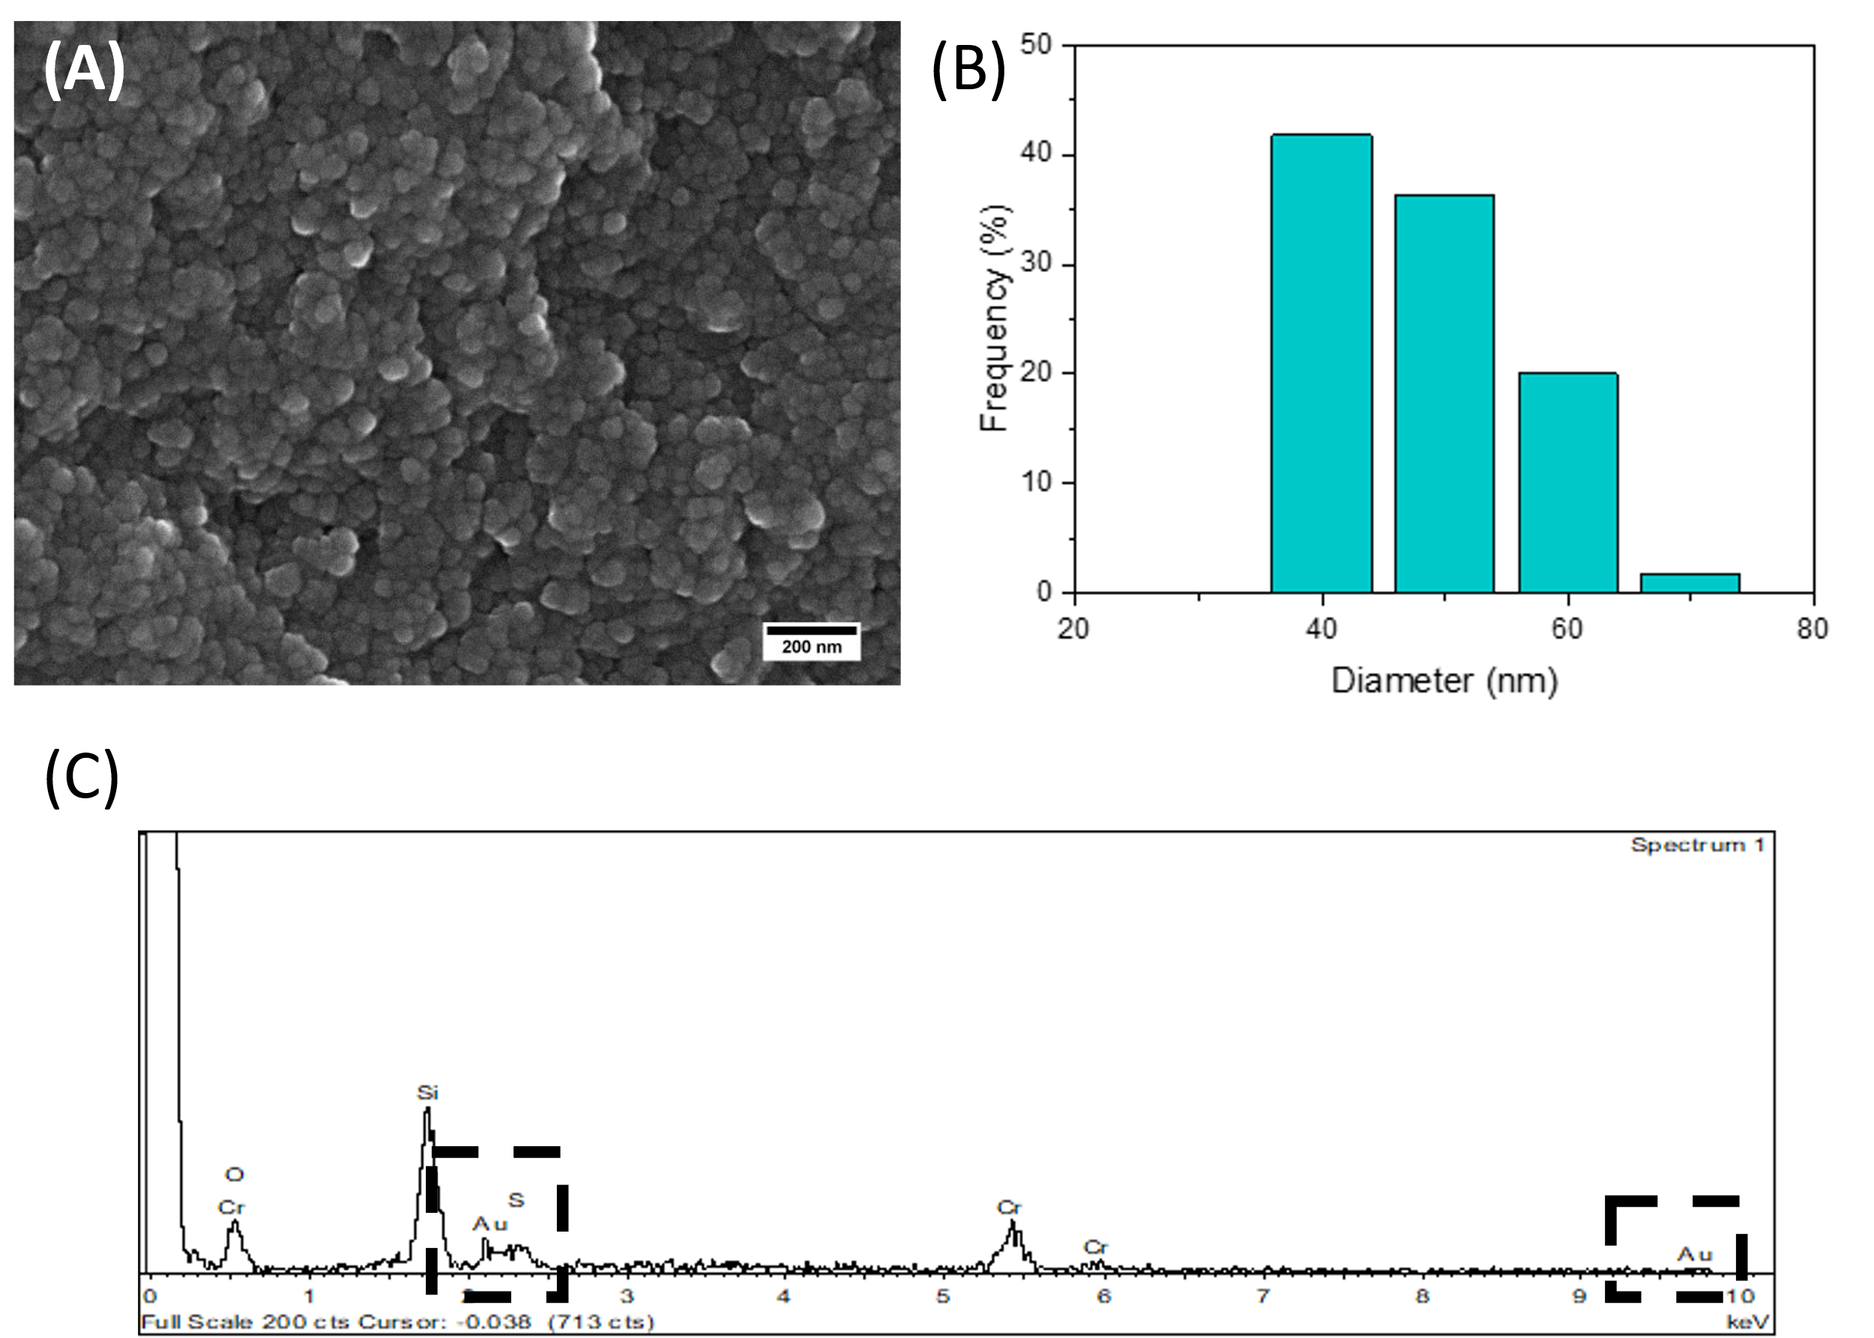
Figure S3. SEM characterization of MPTS-AuNC@MSN: (A) SEM image (magnification: 60 000×). (B) Particle size distribution (d = 49 ± 8 nm). (C) EDS spectrum shows the presence of Si, Au and S elements, confirming the incorporation of the AuNCs in the SiO₂ structure.

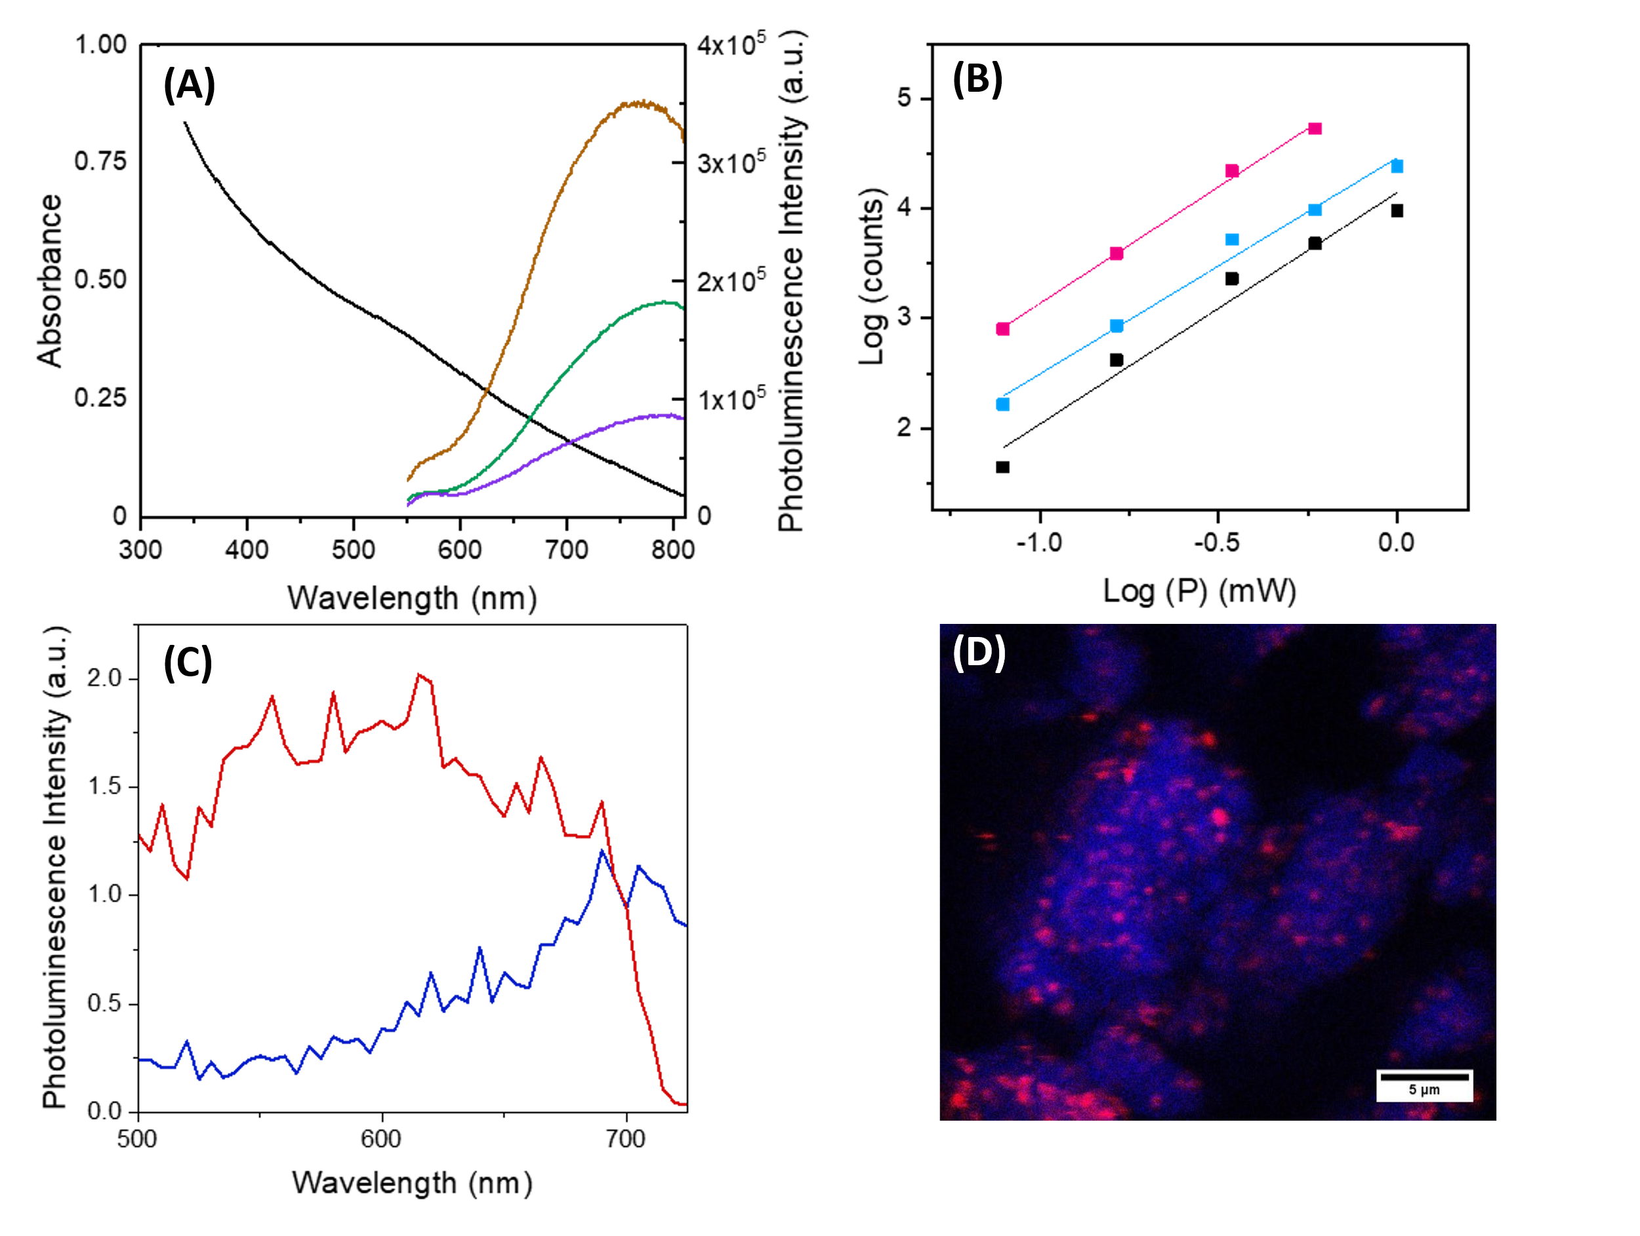
Figure S4. Optical characterization of MPTS-AuNCs@MSN in ethanol: (A) Linear optical properties (pink: UV-vis absorption spectrum; brown: emission spectrum by λ_{exc}=300 nm; green: emission spectrum by λ_{exc}=400 nm; purple: emission spectrum by λ_{exc}=500 nm). (B) Power dependence of the photoluminescence intensity upon two-photon excitation at 900 nm in several regions of interest (ROI) (black: ROI 1 (slope = 2.1; R² = 0.968); pink: ROI 2 (slope = 2.1; R² = 0.997); blue: ROI 3 (slope = 2.0; R² = 0.987)). (C) Photoluminescence emission spectra (blue: one-photon excitation λ_{exc}=458 nm; red: two-photon excitation λ_{exc}=900 nm). (D) Confocal image (one photon excitation λ_{exc}=458 nm: blue; two photon excitation λ_{exc}=900 nm: red). Blue channel corresponds most probably to the Raman scattering from the SiO₂, while the red channel corresponds to the non-linear response of the MPTS-AuNCs in the SiO₂ (demonstrated by the quadratic dependence of the luminescence intensity withpower).
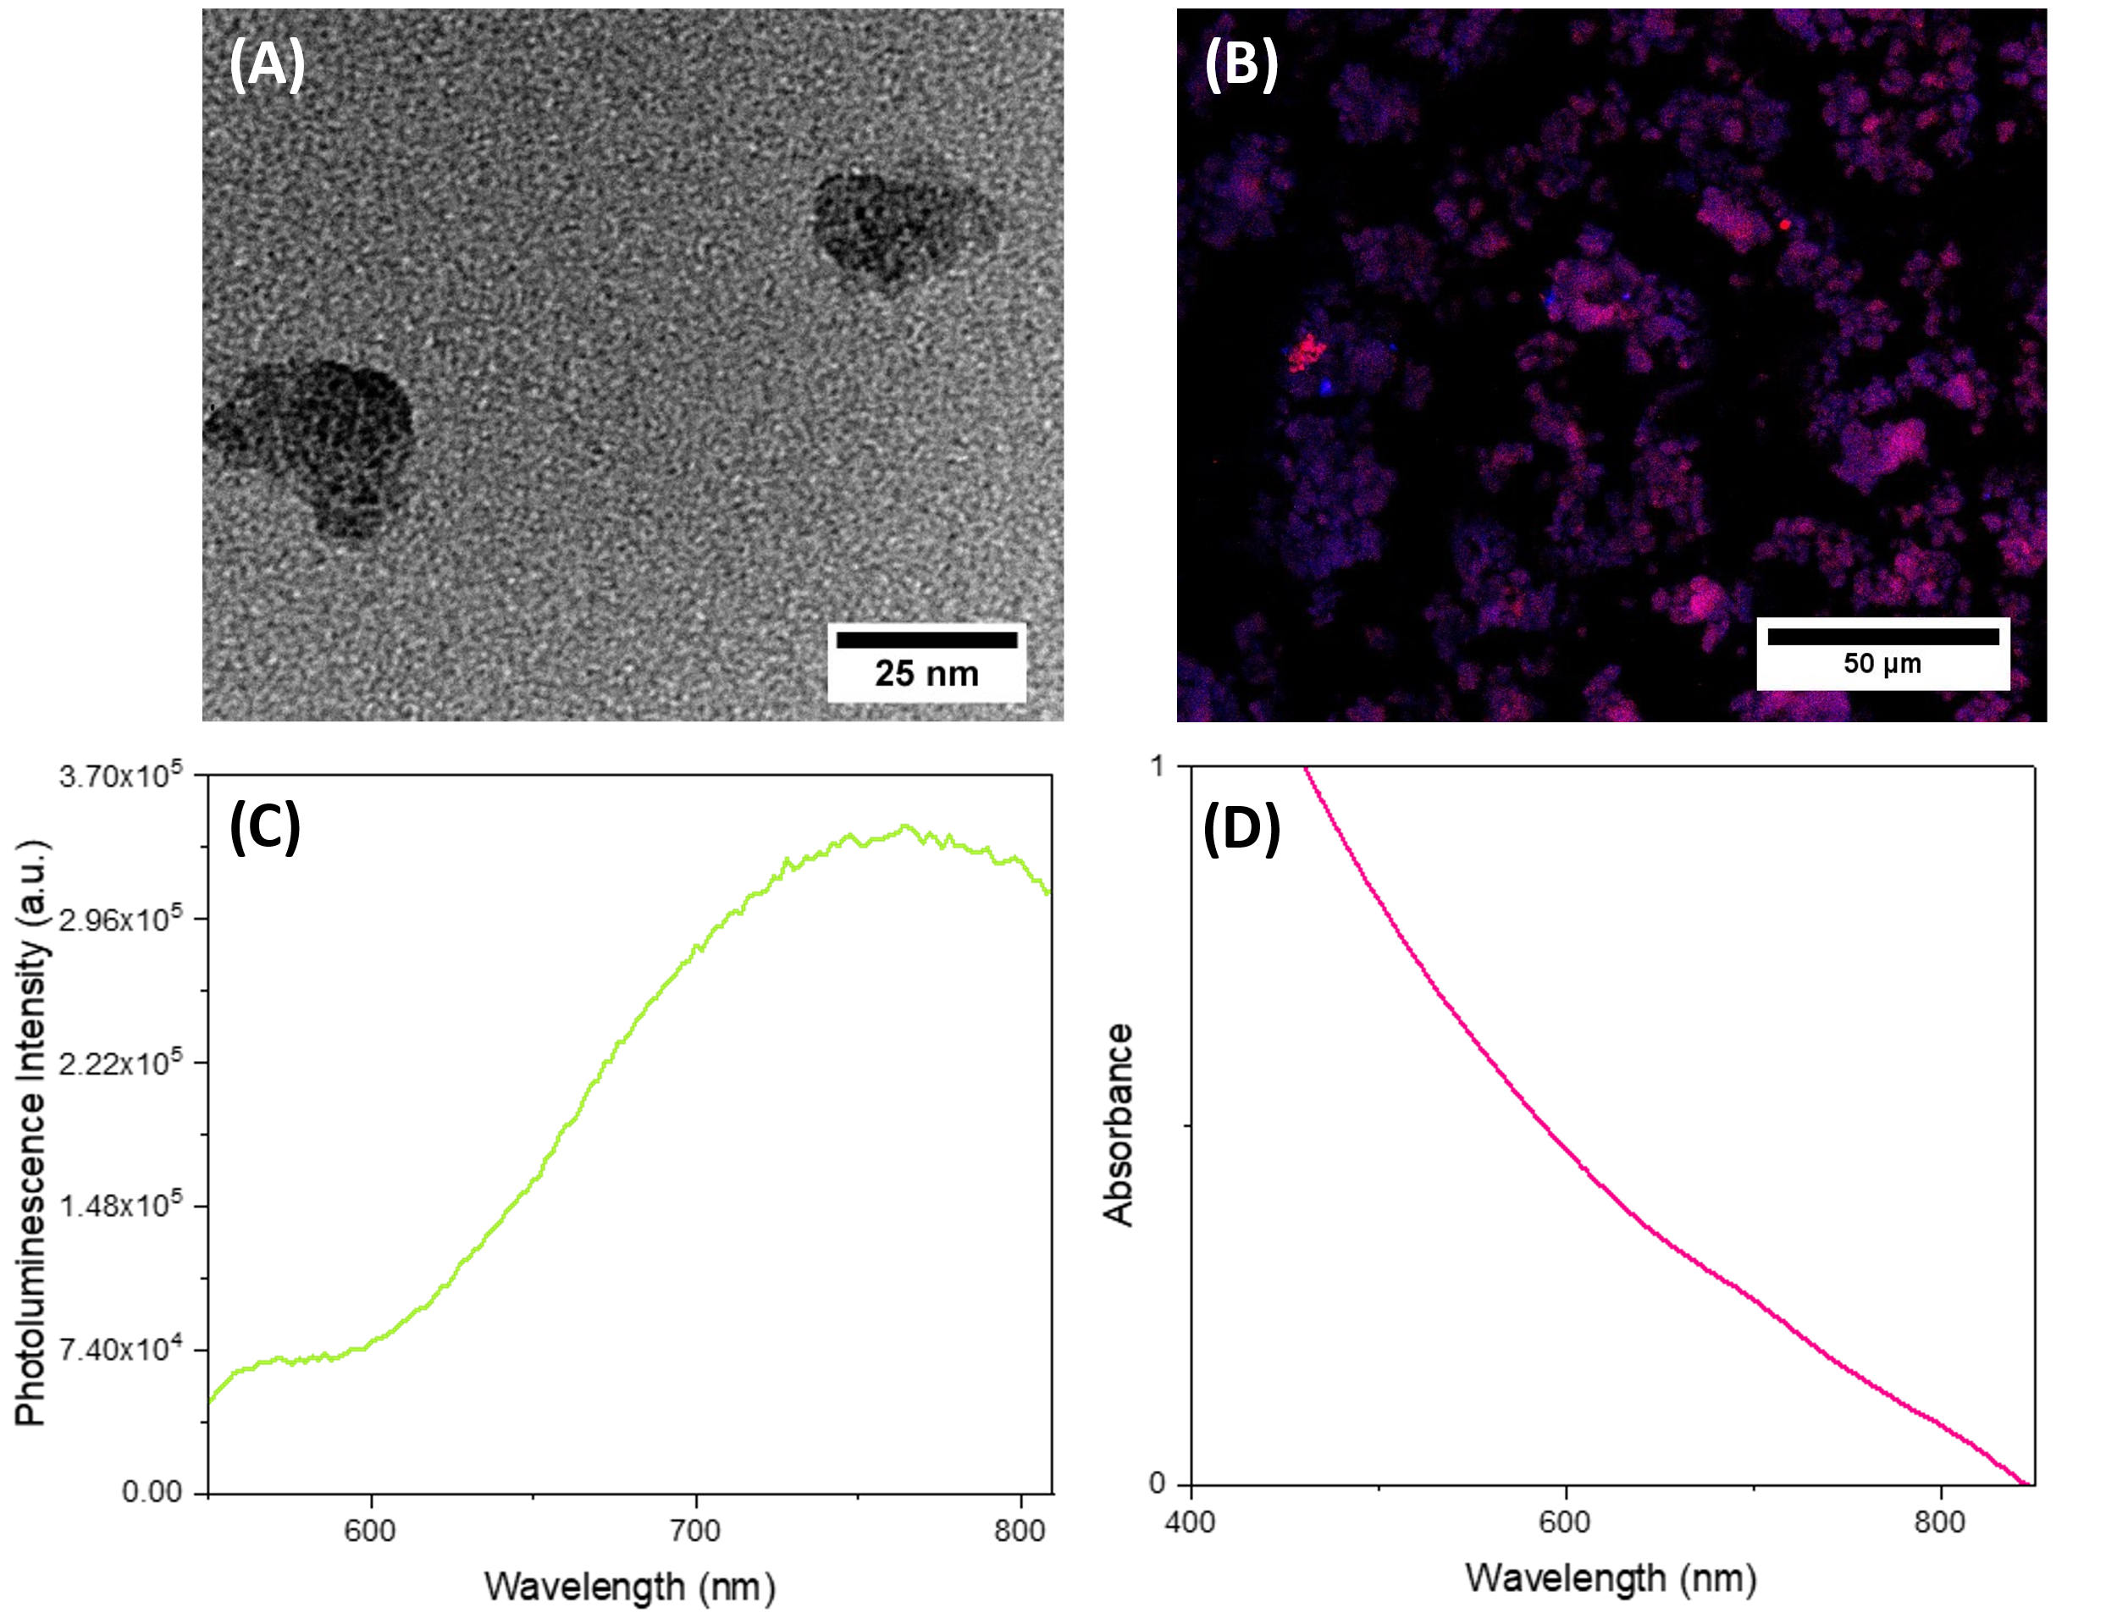
Figure S5. Characterization of MPTS-AuNCs@MSN with pH =10 adjusted using NaOH both in the starting solution containing CTAB and Au(III) and after TEOS addition: (A) TEM image (magnification: 800 000×). (B) Confocal (blue: λ_{exc} = 458 nm) and multiphoton (pink: λ_{exc} = 900 nm) image. (C) Photoluminescence emission spectrum (λ_{exc}=300 nm). (D) One-photon absorption spectrum.
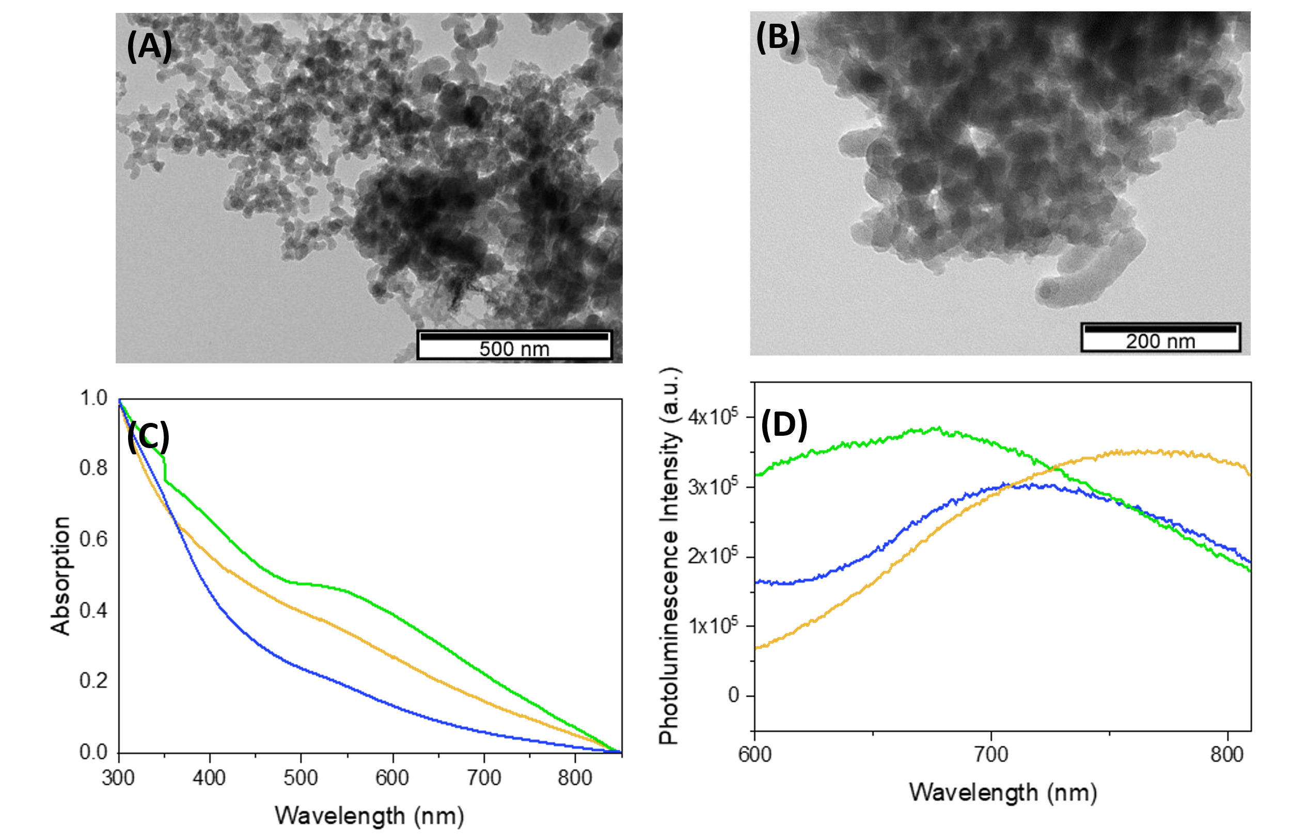
Figure S6. TEM image of MPTS-AuNCs@MSN synthesized at: (A) 35 °C (magnification: 20 000×). (B) 65 °C (magnification: 40 000×). One-photon optical properties of MPTS-AuNCs@MSN (orange: 30 °C; green: 35 °C; blue: 65 °C). (C) Absorption spectra. (D) Photoluminescence emission spectra by λ_{exc}=300 nm.
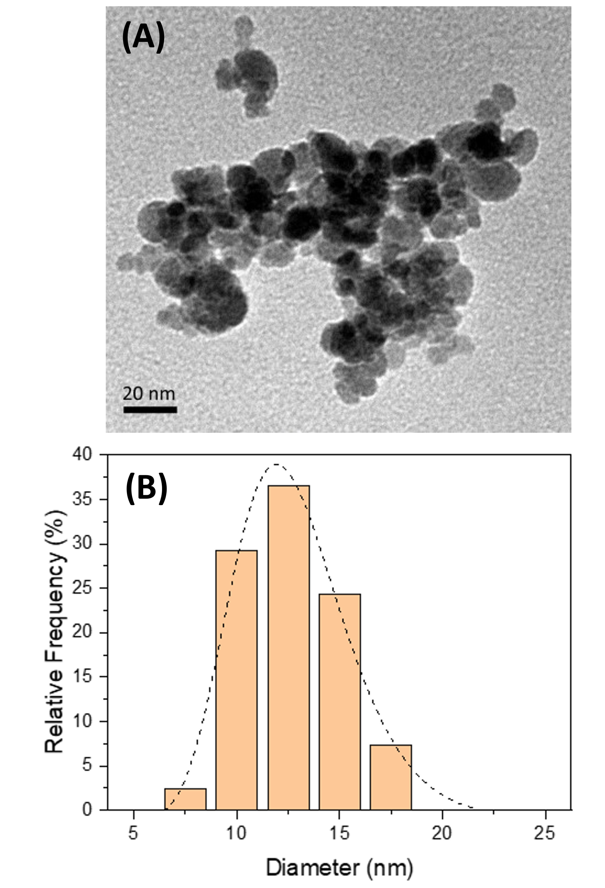
Figure S7. Morphological characterization of MnFe₂O₄ NPs: (A) TEM image (magnification: 500 000×). (B) TEM particle size distribution histogram with log-normal fit (d = 13; sigma = 3 nm; R² = 0.992).

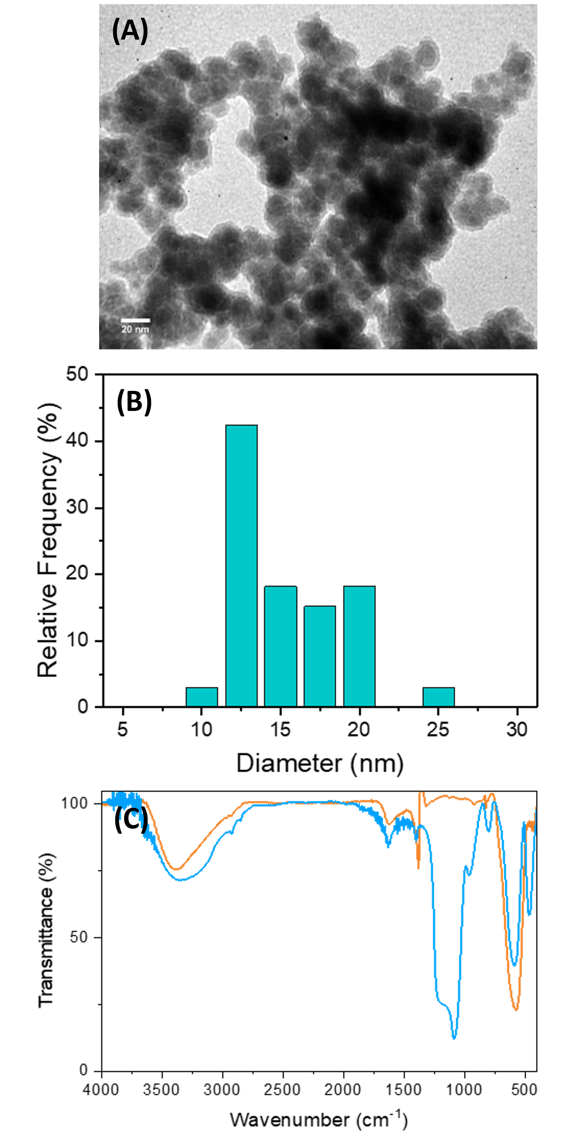
Figure S8. Characterization of Mn@SiO₂: (A) TEM image (magnification: 500 000×). (B) TEM particle size distribution histogram. (C) FTIR spectra of MnFe_{2.6}O₄ (orange) and Mn@SiO₂ (blue).

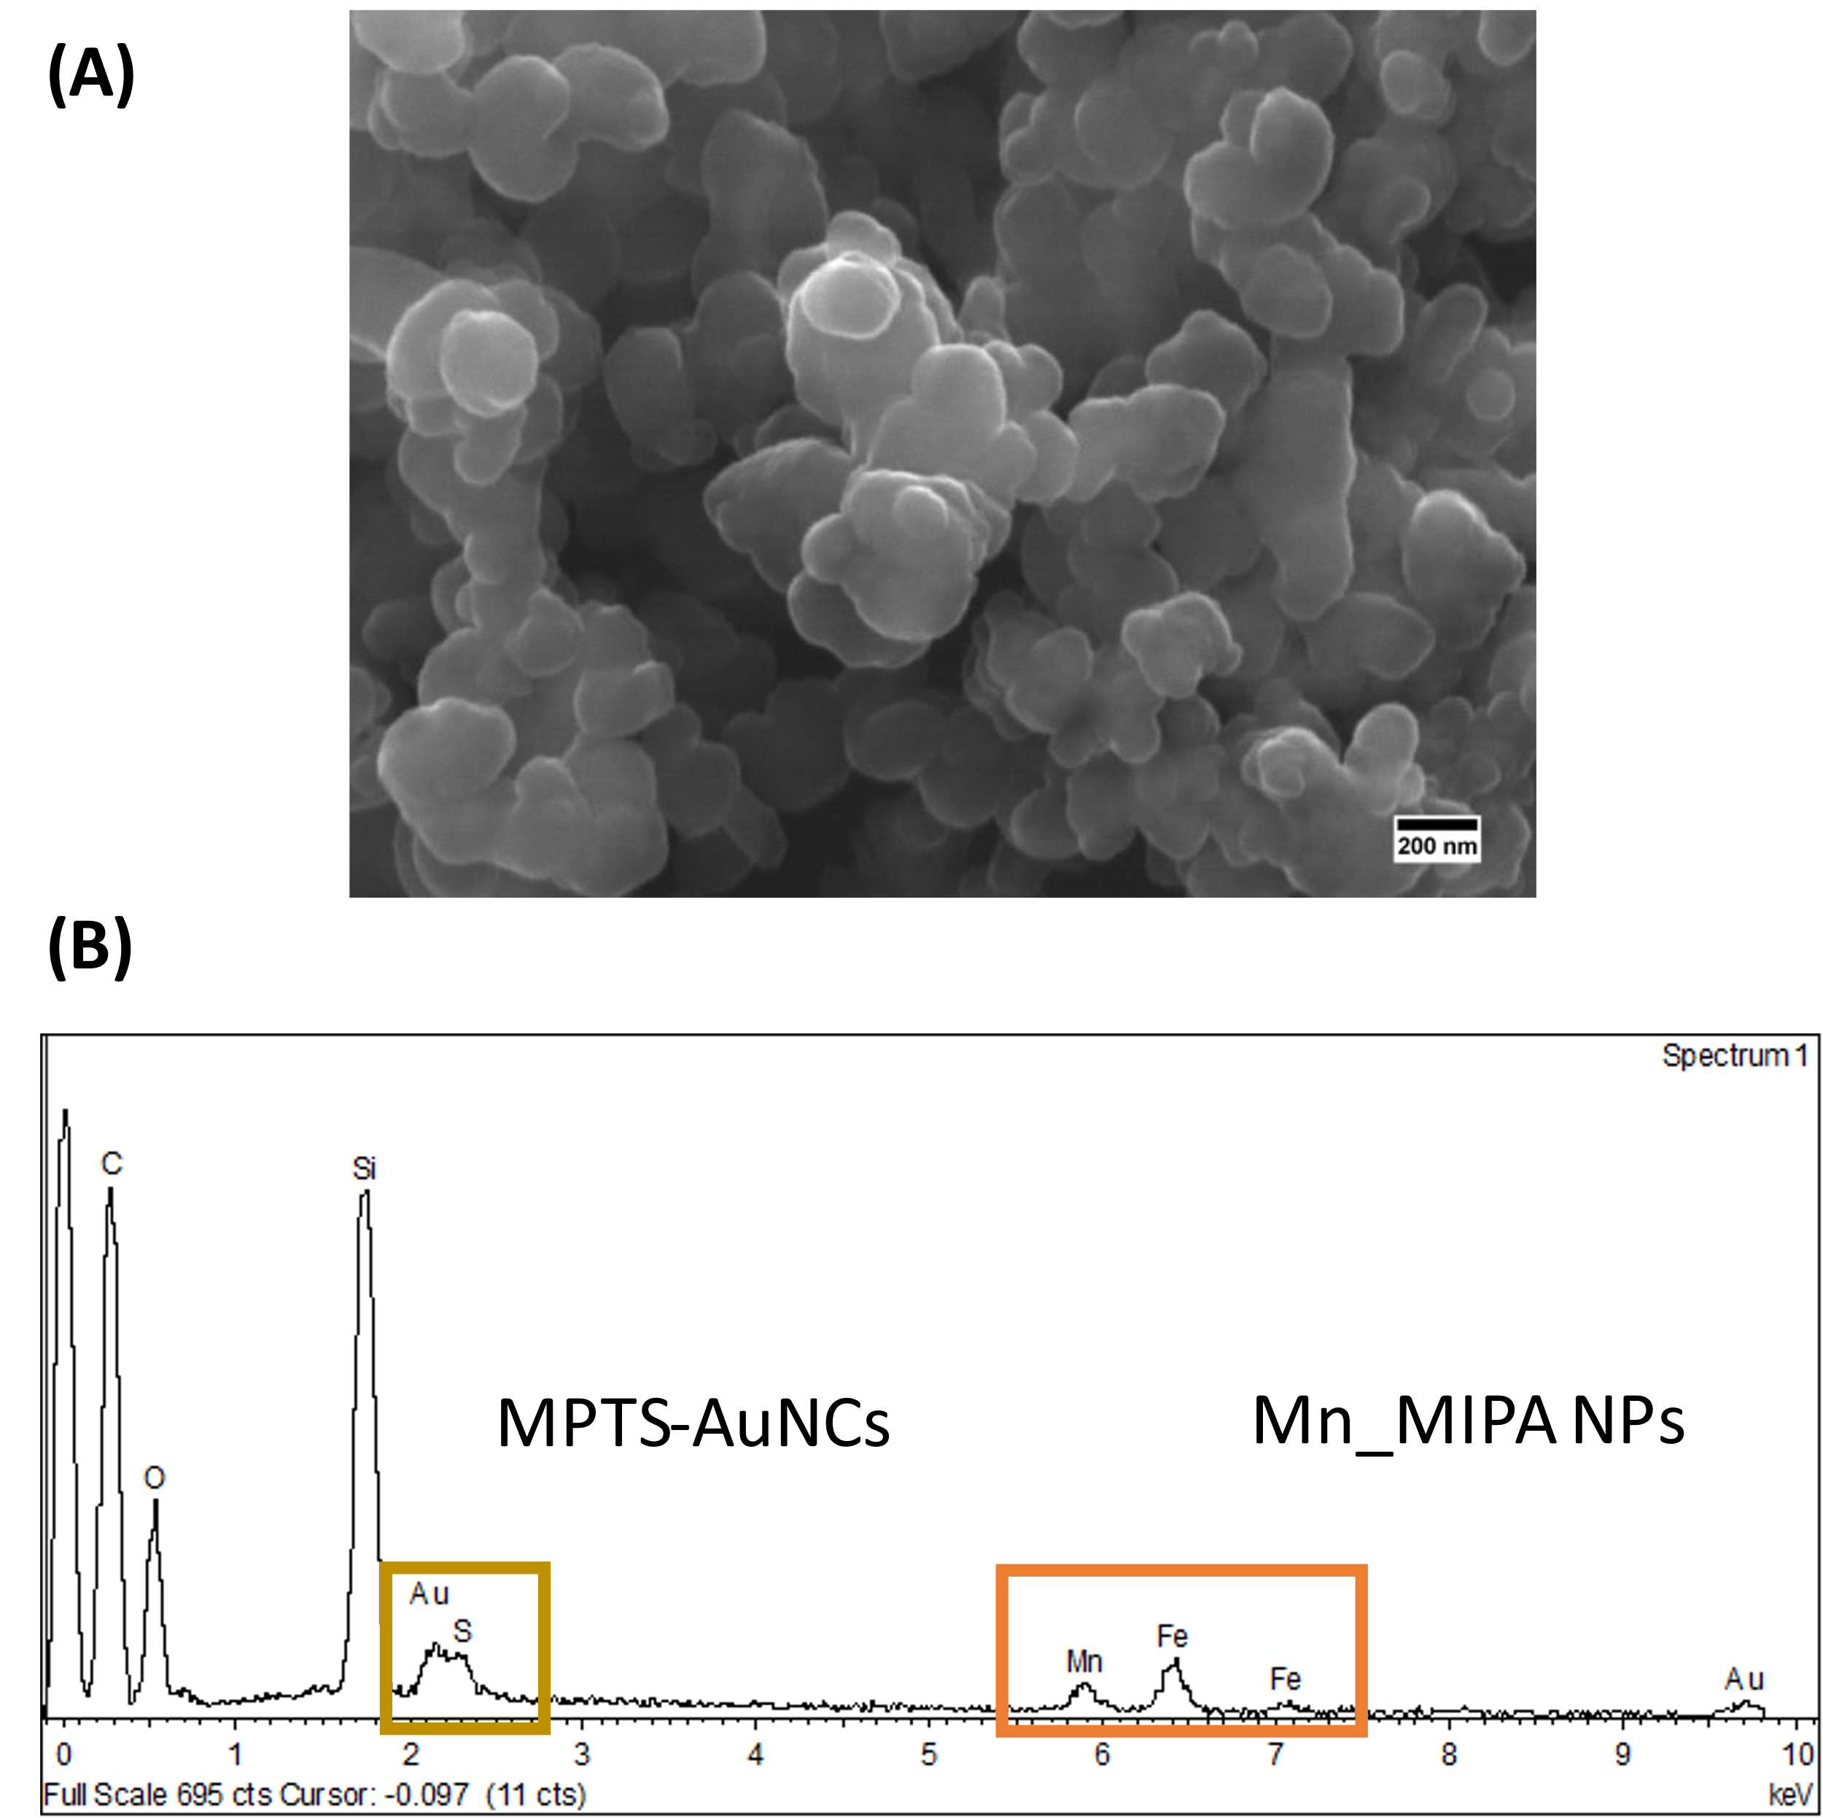
Figure S9. SEM-EDS characterization of Mn@SiO₂@AuNCs : (A) SEM image (magnification: 60 000×). (B) EDS spectrum.

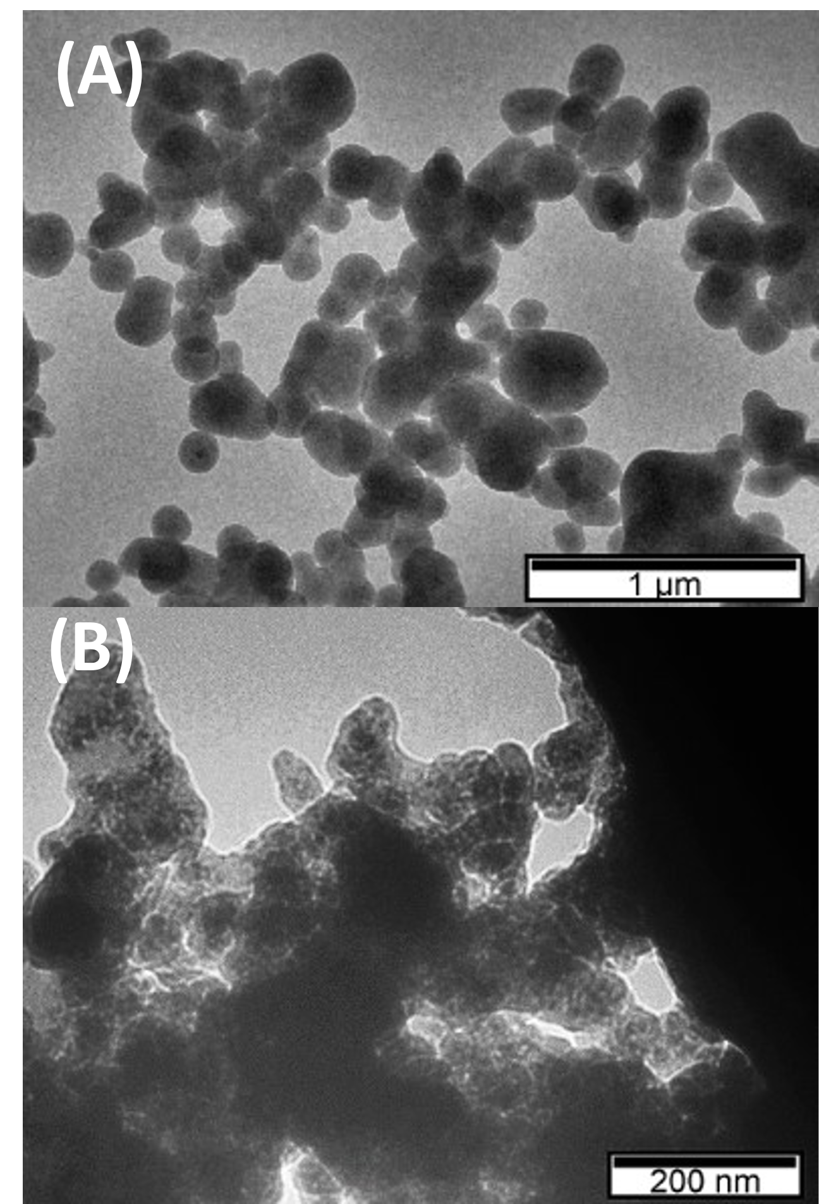
Figure S10. TEM images of (A) Au@MSN at 60 °C using TEA as base (magnification: 9 000×), (B) Mn@SiO₂@MSN (magnification: 30 000×).

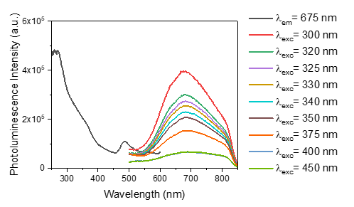
Figure S11. Linear optical properties of Mn@SiO₂@AuNCs in water (pH 10): photoluminescence excitation spectrum (λ_{em}=675 nm) and emission spectra (300 nm < λ_{exc} < 450 nm).

Current affiliation: IFIMUP - Instituto de Física de Materiais Avançados, Nanotecnologia e Fotónica, Departamento de Física e Astronomia, Faculdade de Ciências, Universidade do Porto, Rua do Campo Alegre s/n, 4169-007, Porto, Portugal.

