Supplementary material
Talaramide: a new ceramide from the cytotoxic extract of the endophytic fungus Talaromyces wortmannii
Fatma M. Abdel Bar^{1,2*}, Amal A. Galala^{2,3}, Mohamed M. El-Sokkary⁴, Ashraf T. Khalil² and Amal Sallam²
¹ Department of Pharmacognosy, College of Pharmacy, Prince Sattam Bin Abdulaziz University, Al-Kharj, 11942, Saudi Arabia; f.abdelbar@psau.edu.sa (FMA)
² Department of pharmacognosy, Faculty of Pharmacy, Mansoura University, Mansoura 35516, Egypt; amalgalala@mans.edu.eg (AAG); khalat@mans.edu.eg (ATK); asallam@mans.edu.eg (AS)
³ Department of Pharmacognosy, Faculty of Pharmacy, Horus University-Egypt, New Damietta, 34517, Egypt
⁴ Department of Microbiology and Immunology, Faculty of Pharmacy, Mansoura University, Mansoura 35516, Egypt; melsokkary@mans.edu.eg (ME-S)

ORCID
Fatma M. Abdel Bar: https://orcid.org/0000-0003-0823-4015
Amal A. Galala: https://orcid.org/0000-0002-9639-5849
Mohamed M. El-Sokkary: https://orcid.org/0000-0003-2479-3984
Ashraf T. Khalil: https://orcid.org/0000-0003-1073-7375
Amal Sallam: https://orcid.org/0000-0001-9561-8337

* Correspondence author
Fatma M. Abdel Bar: Emails; f.abdelbar@psau.edu.sa and fatma_maar@yahoo.com

Table of content | Page
Figure S1. ¹H NMR spectrum of compound 1A (Pyridine-d₅, 400 MHz). | 4
Figure S2. ¹H NMR spectrum expansion (0.3 - 1.6 ppm) of compound 1A (Pyridine-d₅, 400 MHz). | 4
Figure S3. ¹H NMR spectrum expansion (4.0 - 9.0 ppm) of compound 1A (Pyridine-d₅, 400 MHz). | 5
Figure S4. ¹H NMR spectrum of compound 1A (pyridine-d5, 400 MHz). | 5
Figure S5. APT spectrum of compound 1A (Pyridine-d₅, 400 MHz). | 6
Figure S6. HSQC spectrum of compound 1A (Pyridine-d₅). | 6
Figure S7. HMBC spectrum of compound 1A (Pyridine-d₅). | 7
Figure S8. COSY spectrum of compound 1A (Pyridine-d₅). | 7
Figure S9. ¹H NMR spectrum of compound 1 (Pyridine-d₅, 500 MHz). | 8
Figure S10. HSQC spectrum of compound 1 (Pyridine-d₅). | 8
Figure S11. HSQC spectrum expansion of compound 1 (Pyridine-d₅). | 9
Figure S12. HSQC spectrum expansion of compound 1 (Pyridine-d₅). | 9
Figure S13. COSY spectrum of compound 1 (Pyridine-d₅). | 10
Figure S14. NEOSY spectrum of compound 1 (Pyridine-d₅). | 10
Figure S15. HR-ESI-MS positive mode spectrum of compound 1. | 11
Figure S16. HR-ESI-MS negative mode spectrum of compound 1. | 11
Figure S17. Proposed fragmentation pattern for compound 1. | 12
Figure S18. APT spectrum of compound 2 (Stigmasterol, CDCl₃, 100 MHz). | 13
Figure S19. ¹H NMR spectrum of compound 3 (Thymine, pyridine-d₅, 400 MHz). | 14
Figure S20. ¹H NMR spectrum of compound 4 (Uracil, pyridine-d₅, 400 MHz). | 15
Figure S21. ¹H NMR spectrum of compound 5 (Stigmasterol-3-O-β-D-glucoside pyridine-d₅, 400 MHz). | 16
Figure S22. APT spectrum of compound 5 (Stigmasterol-3-O-β-D-glucoside pyridine-d₅, 100 MHz). | 17
Figure S23. Effect of methotrexate on MCF7 cancer cells. | 21
Figure S24. Effect of methotrexate on HepG2 cancer cells. | 22
Figure S25. Effect of methotrexate on A549 cancer cells. | 23
Figure S26. Effect of the ethyl acetate extract of white beans culture of the endophytic fungus Talaromyces wortmannii isolated from Arundo donax L. on WI38 normal cells. | 24
Figure S27. Effect of methotrexate on WI38 normal cells. | 25
Table S1. Optical densities (OD) for determination of the ethyl acetate extract of white beans culture of the endophytic fungus Talaromyces wortmannii isolated from Arundo donax L. cytotoxicity on cells (MTT protocol) showing triplicate treatments at (1000, 500, 250, 125, 62.5, and 31.25 μg/mL) on MCF7 cancer cells. | 18
Table S2. Optical densities (OD) for determination of the ethyl acetate extract of white beans culture of the endophytic fungus Talaromyces wortmannii isolated from Arundo donax L. cytotoxicity on cells (MTT protocol) showing triplicate treatments at (1000, 500, 250, 125, 62.5, and 31.25 μg/mL) on HepG2 cancer cells. | 19
Table S3. Optical densities (OD) for determination of the ethyl acetate extract of white beans culture of the endophytic fungus Talaromyces wortmannii isolated from Arundo donax L. cytotoxicity on cells (MTT protocol) showing triplicate treatments at (1000, 500, 250, 125, 62.5, and 31.25 μg/mL) on A549 cancer cells. | 20
Table S4. Optical densities (OD) for determination of methotrexate cytotoxicity on cells (MTT protocol) showing triplicate treatments at (1000, 500, 250, 125, 62.5, and 31.25 μg/mL) on MCF7 cancer cells. | 21
Table S5. Optical densities (OD) for determination of methotrexate cytotoxicity on cells (MTT protocol) showing triplicate treatments at (1000, 500, 250, 125, 62.5, and 31.25 μg/mL) on HepG2 cancer cells. | 22
Table S6. Optical densities (OD) for determination of methotrexate cytotoxicity on cells (MTT protocol) showing triplicate treatments at (1000, 500, 250, 125, 62.5, and 31.25 μg/mL) on A549 cancer cells. | 23
Table S7. Optical densities (OD) for determination of the ethyl acetate extract of white beans culture of the endophytic fungus Talaromyces wortmannii isolated from Arundo donax L. cytotoxicity on cells (MTT protocol) showing triplicate treatments at (1000, 500, 250, 125, 62.5, and 31.25 μg/mL) on WI38 normal cells. | 24
Table S8. Optical densities (OD) for determination of methotrexate cytotoxicity on cells (MTT protocol) showing triplicate treatments at (1000, 500, 250, 125, 62.5, and 31.25 μg/mL) on WI38 normal cells. | 25

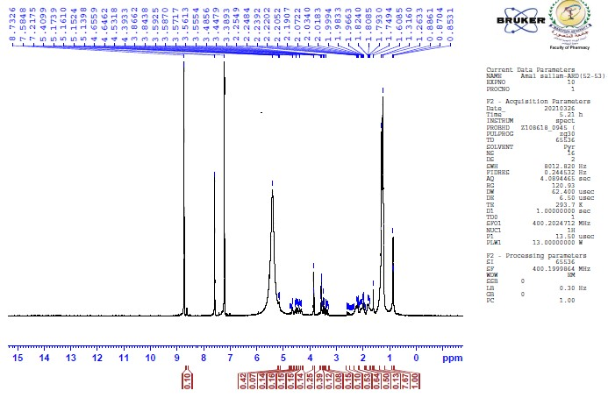
Figure S1. ¹H NMR spectrum of compound 1A (Pyridine-d₅, 400 MHz).

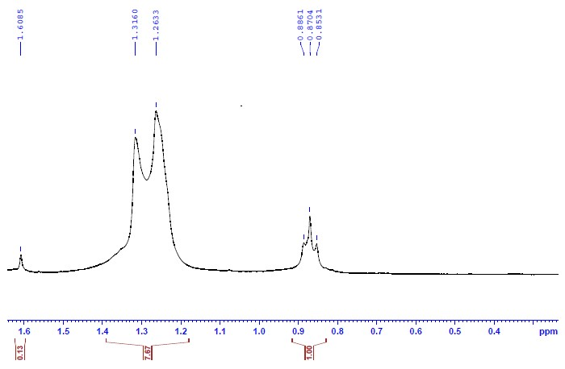
Figure S2. ¹H NMR spectrum expansion (0.3 - 1.6 ppm) of compound 1A (Pyridine-d₅, 400 MHz).
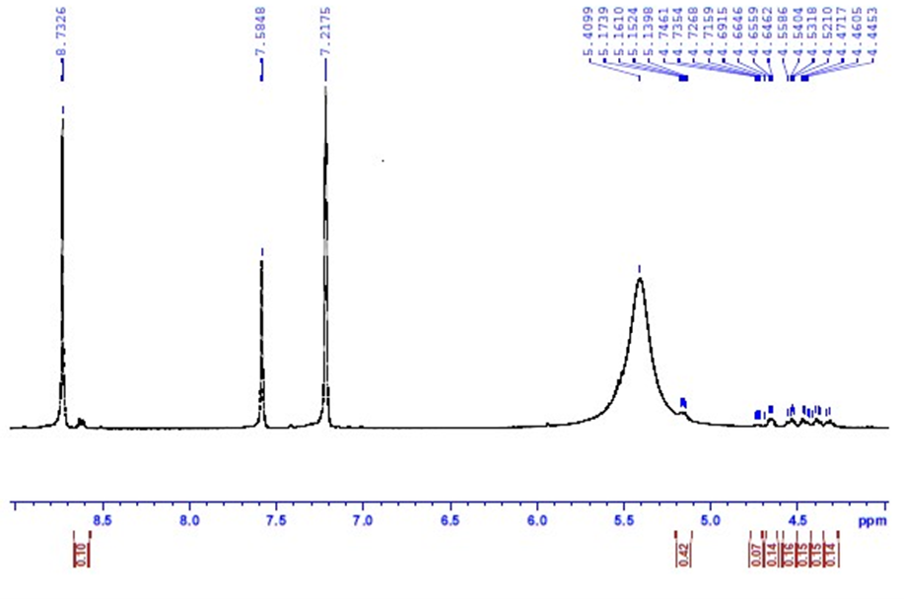
Figure S3. ¹H NMR spectrum expansion (4.0 - 9.0 ppm) of compound 1A (Pyridine-d₅, 400 MHz).

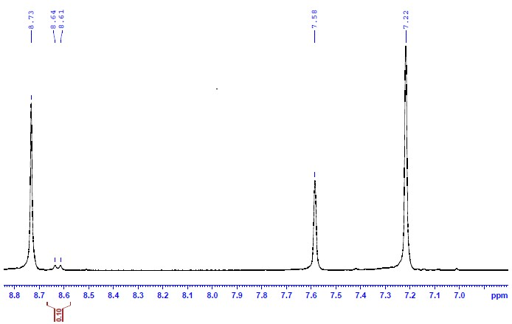
Figure S4. ¹H NMR spectrum of compound 1A (pyridine-d₅, 400 MHz).
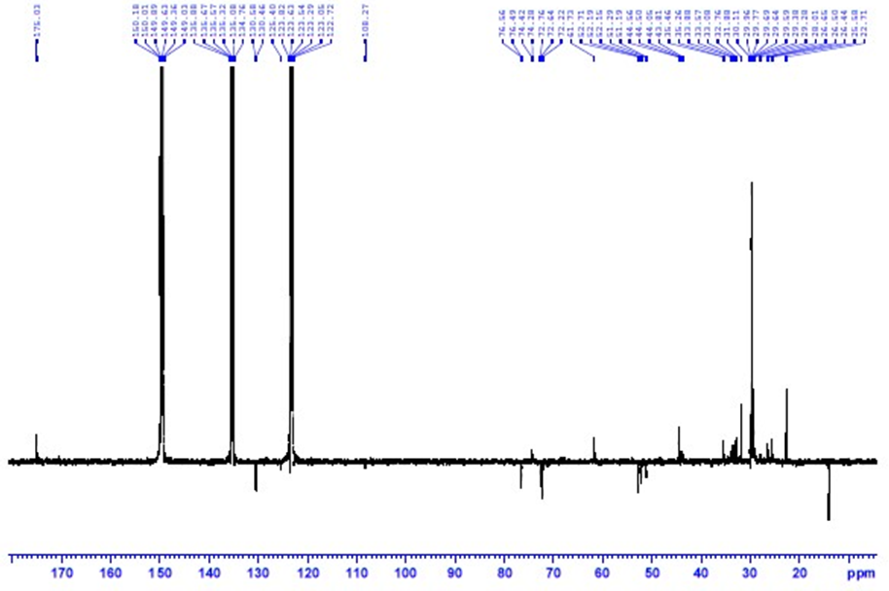
Figure S5. APT spectrum of compound 1A (Pyridine-d₅, 100 MHz).

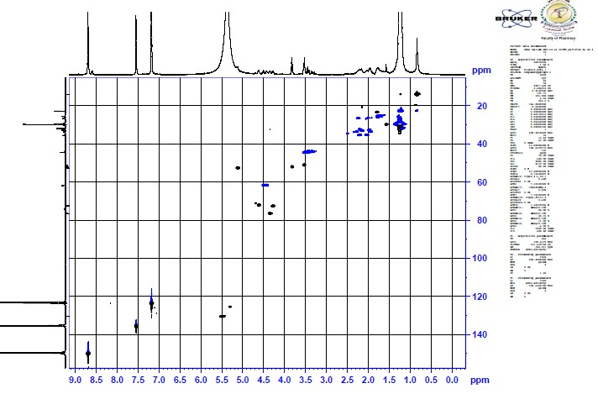
Figure S6. HSQC spectrum of compound 1A (Pyridine-d₅).
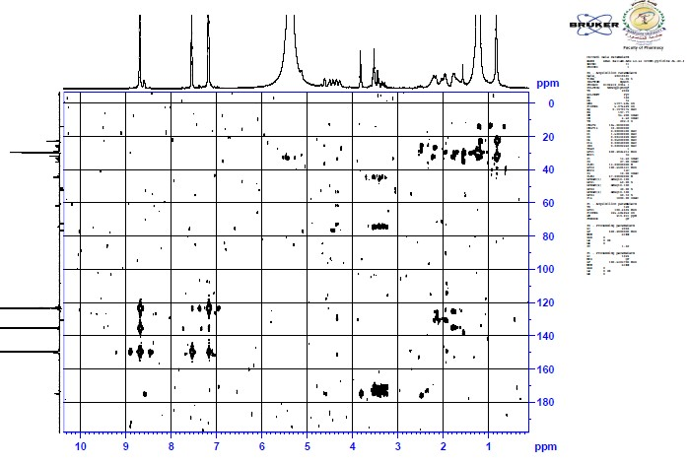
Figure S7. HMBC spectrum of compound 1A (Pyridine-d₅).

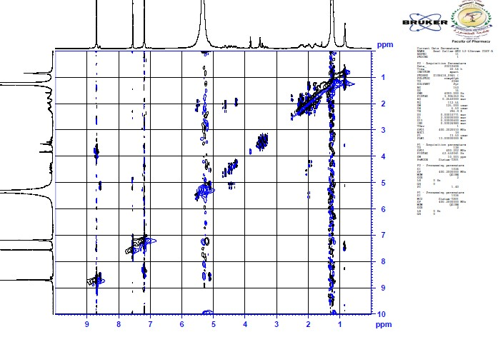
Figure S8. COSY spectrum of compound 1A (Pyridine-d₅).
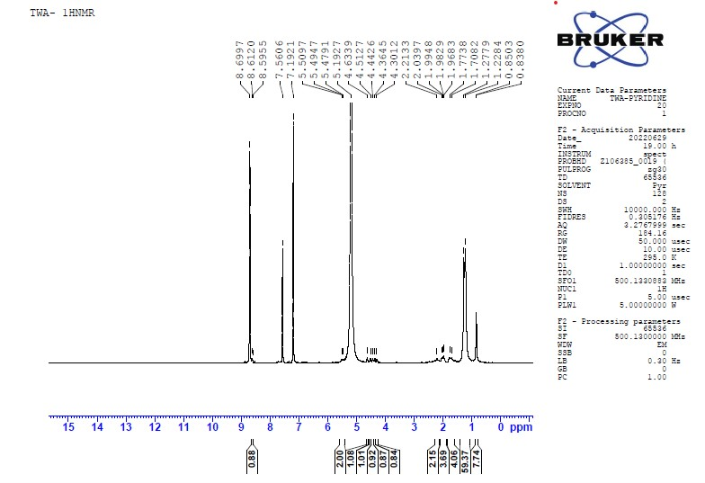
Figure S9. ¹H NMR spectrum of compound 1 (Pyridine-d₅, 500 MHz).

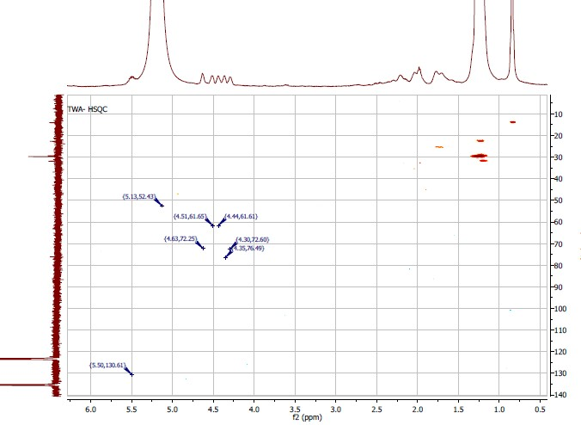
Figure S10. HSQC spectrum of compound 1 (Pyridine-d₅).
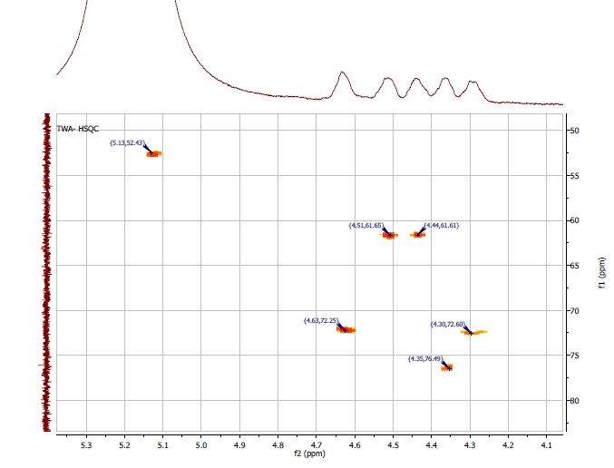
Figure S11. HSQC spectrum expansion of compound 1 (Pyridine-d₅).

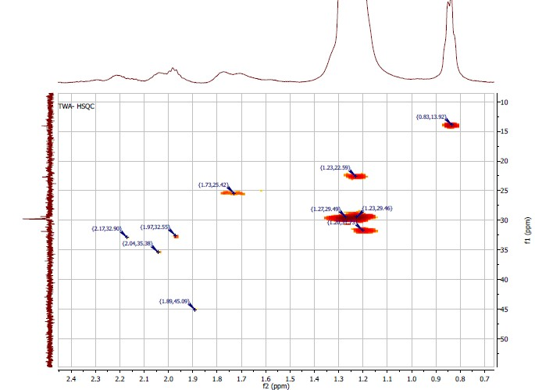
Figure S12. HSQC spectrum expansion of compound 1 (Pyridine-d₅).
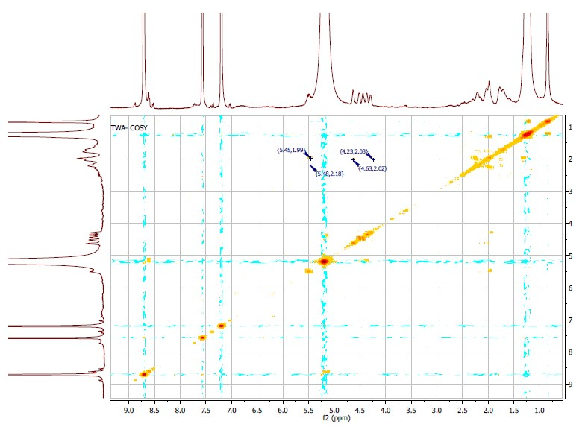
Figure S13. COSY spectrum of compound 1 (Pyridine-d₅).

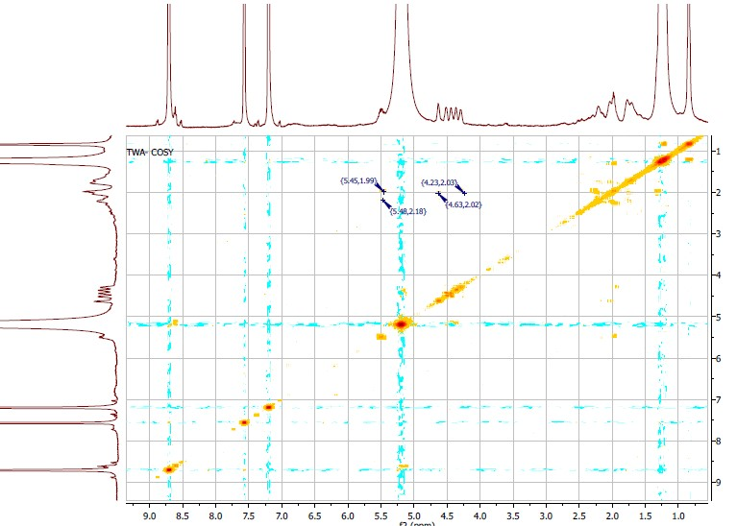
Figure S14. NEOSY spectrum of compound 1 (Pyridine-d₅).
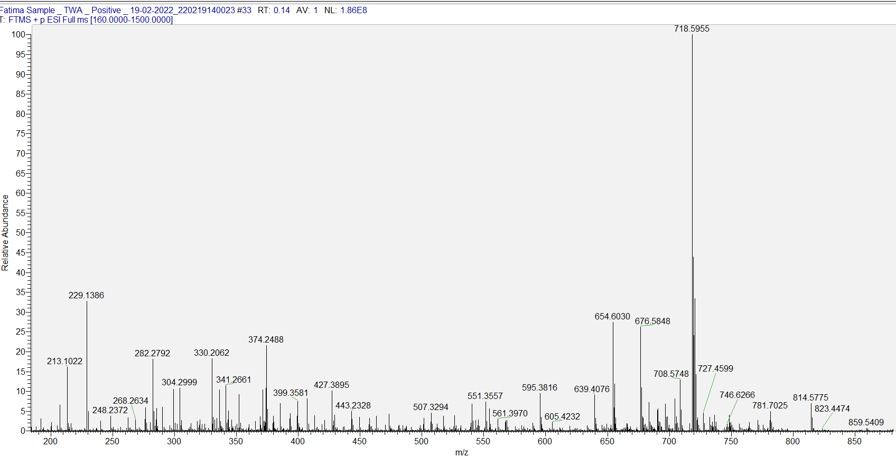
Figure S15. HR-ESI-MS positive mode spectrum of compound 1.

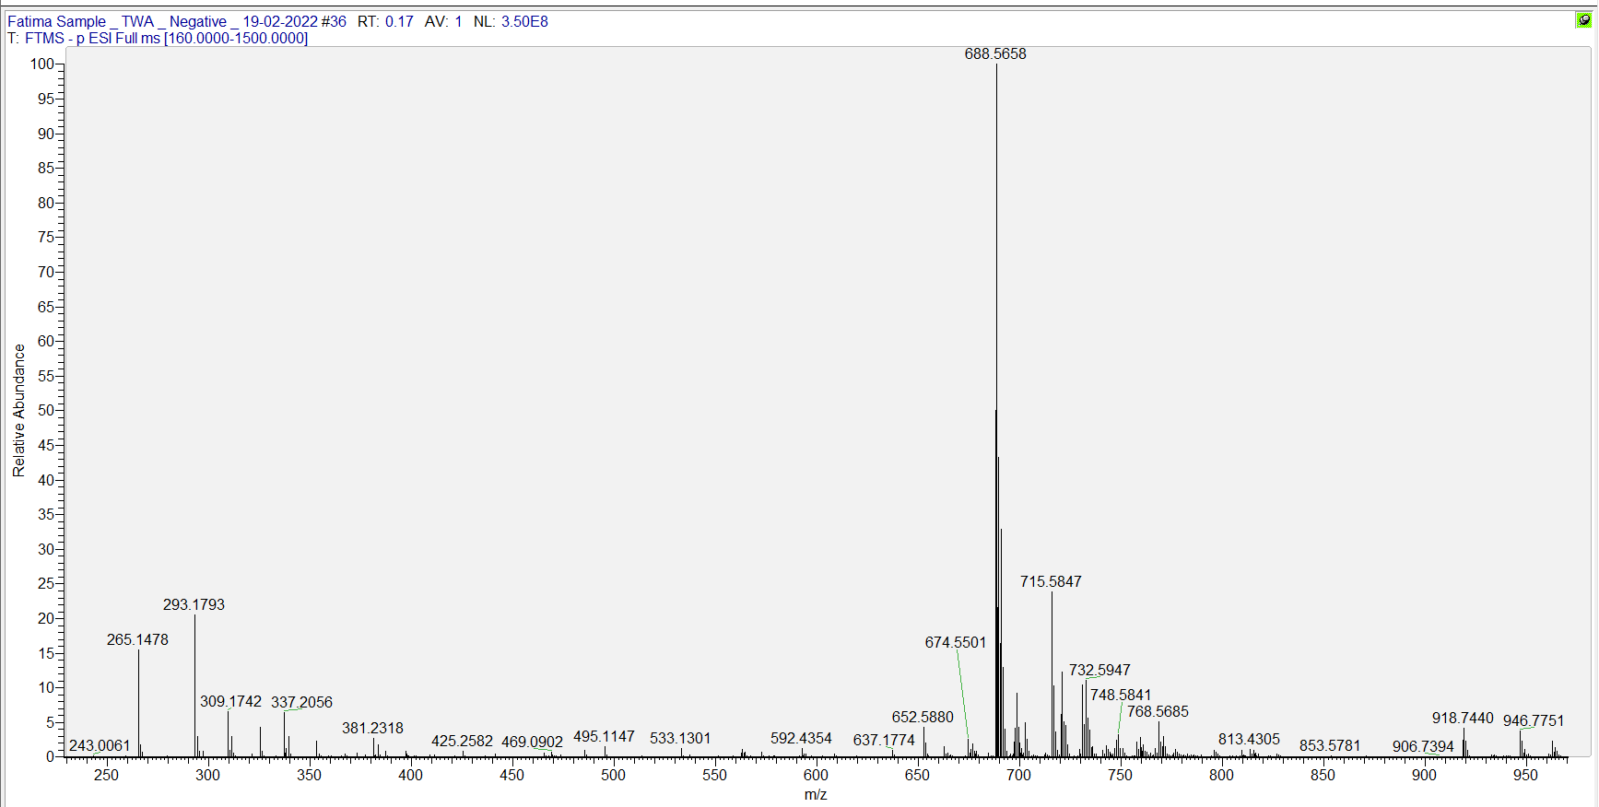
Figure S16. HR-ESI-MS negative mode spectrum of compound 1.

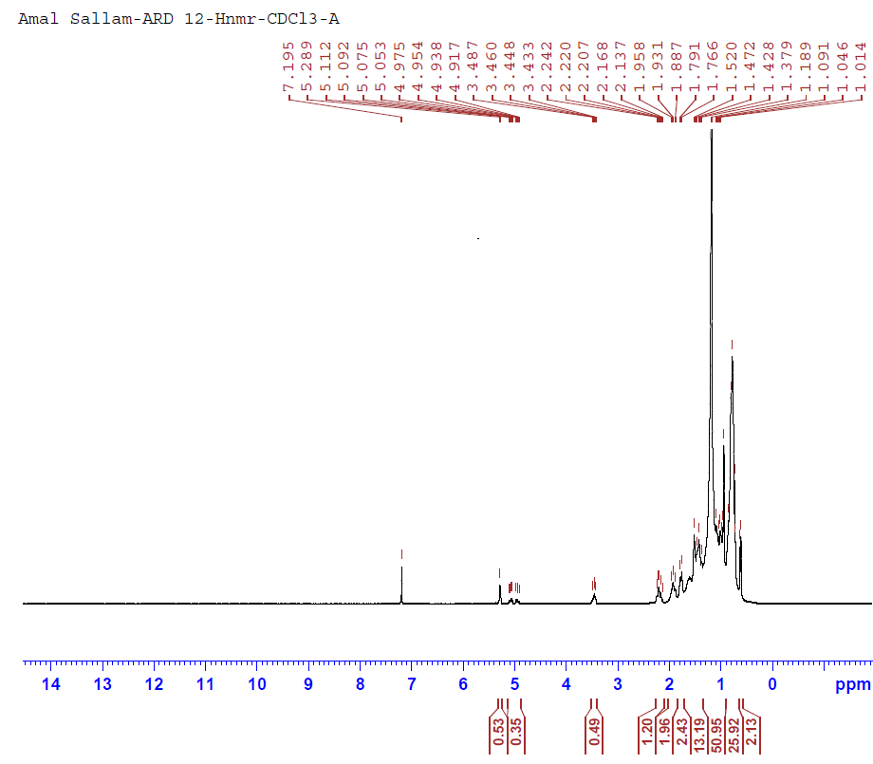
Figure S17. ¹H NMR spectrum of compound 2 (Stigmasterol, CDCl₃, 400 MHz).
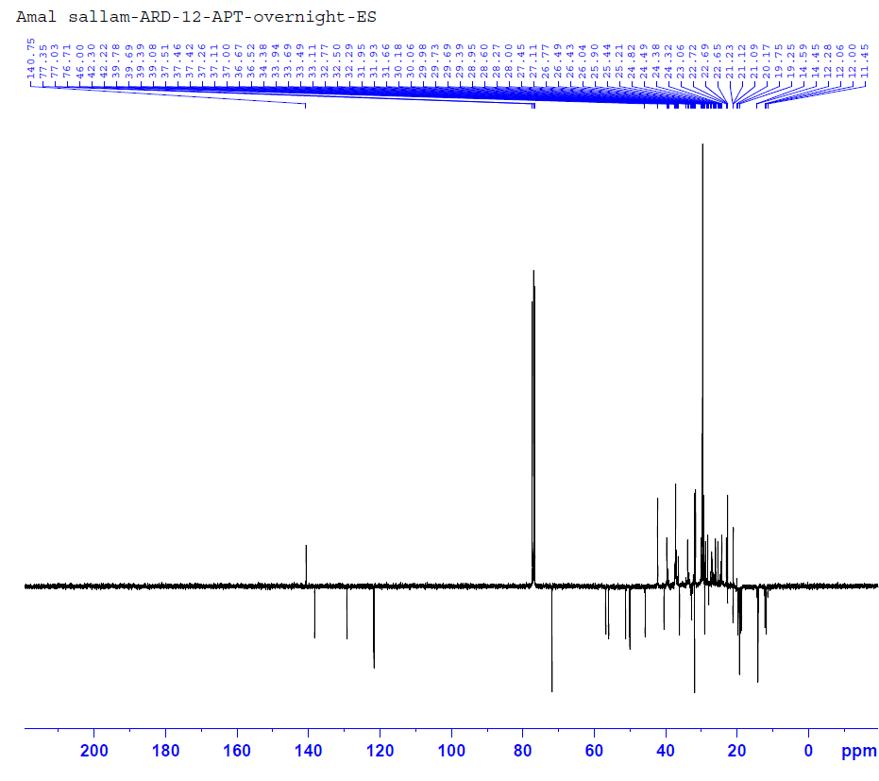
Figure S18. APT spectrum of compound 2 (Stigmasterol, CDCl₃, 100 MHz).

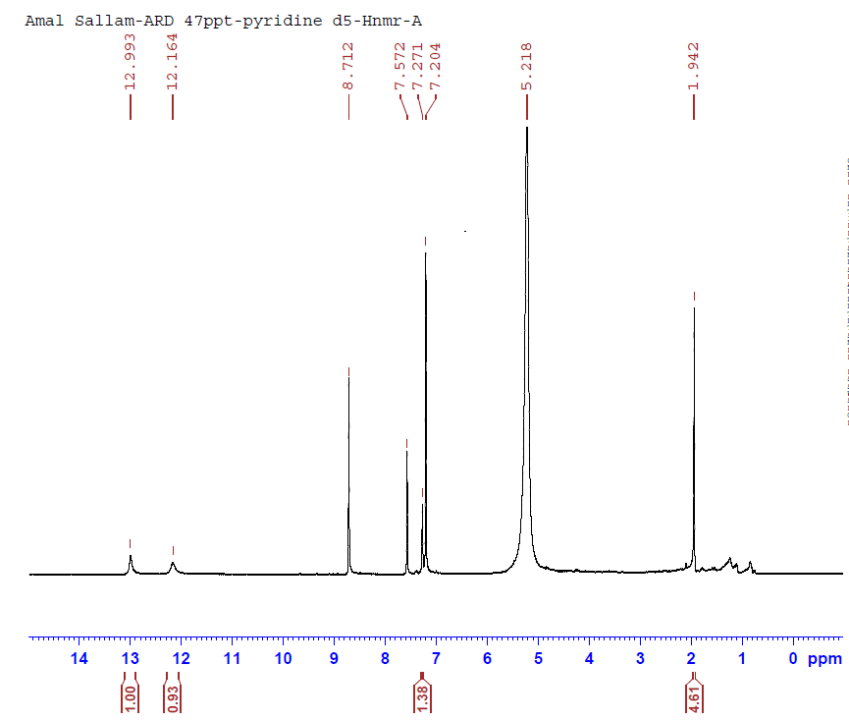

Figure S19. ¹H NMR spectrum of compound 3 (Thymine, pyridine-d₅, 400 MHz).

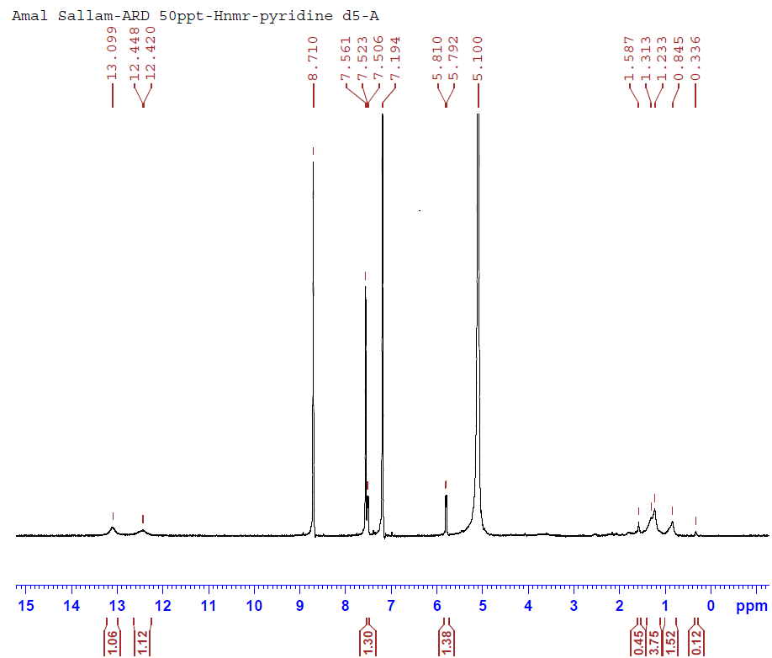

Figure S20. ¹H NMR spectrum of compound 4 (Uracil, pyridine-d₅, 400 MHz).

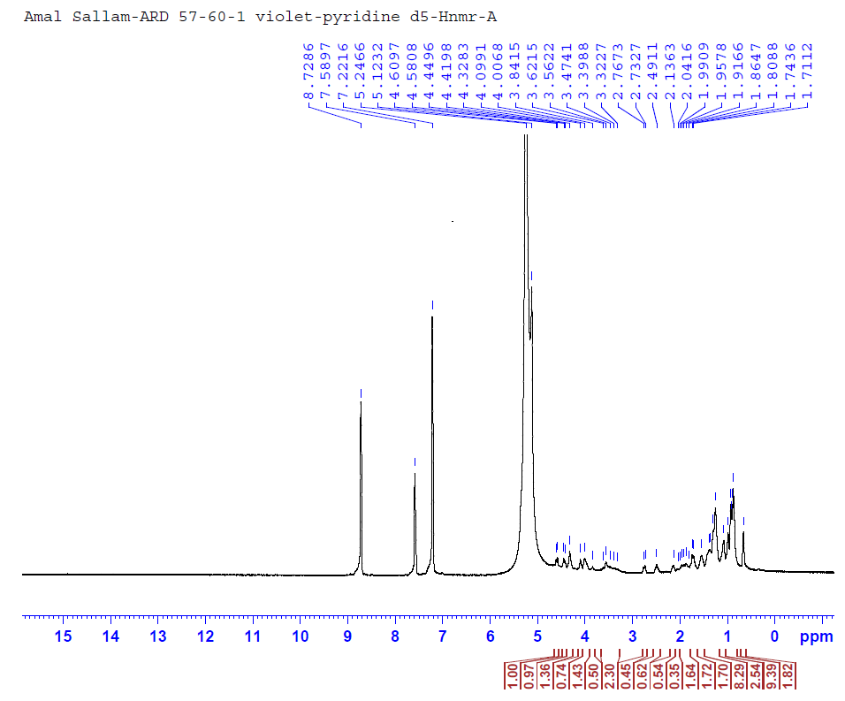
Figure S21. ¹H NMR spectrum of compound 5 (Stigmasterol-3-O-β-D-glucoside pyridine-d₅, 400 MHz).

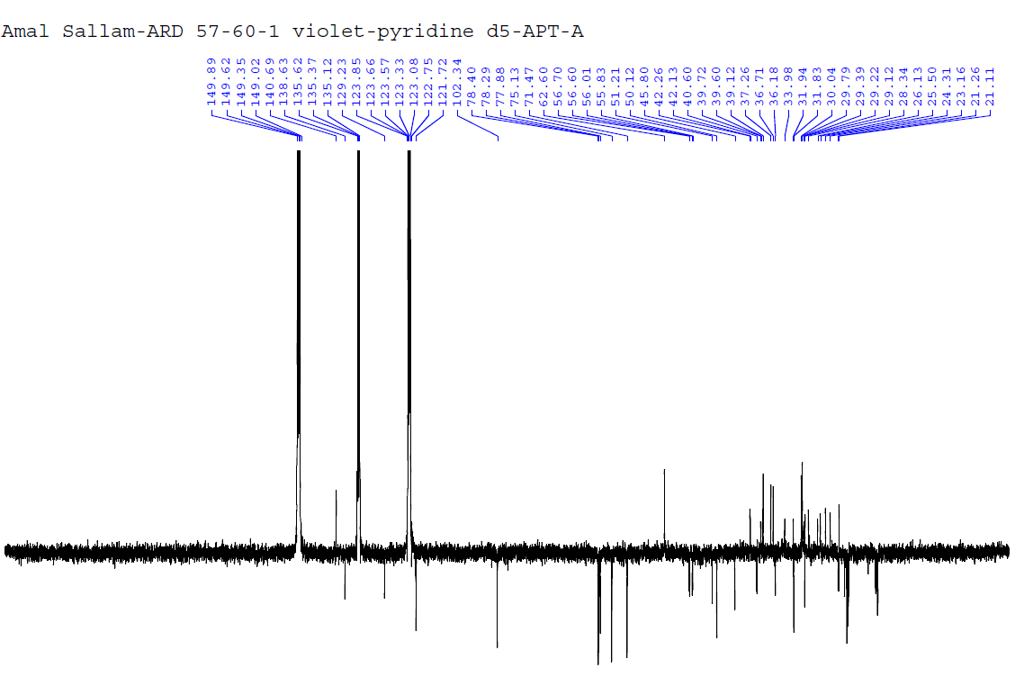
Figure S22. APT spectrum of compound 5 (Stigmasterol-3-O-β-D-glucoside pyridine-d₅, 100 MHz).

Table S1. Optical densities (OD) for determination of the ethyl acetate extract of white beans culture of the endophytic fungus Talaromyces wortmannii isolated from Arundo donax L. cytotoxicity on cells (MTT protocol) showing triplicate treatments at (1000, 500, 250, 125, 62.5, and 31.25 μg/mL) on MCF7 cancer cells.
ID | ug/ml | OD |  |  | Mean OD | ±SE | Viability % | Toxicity % | IC50  ± SD
Mcf7 | -------- | 0.796 | 0.808 | 0.811 | 0.805 | 0.004583 | 100 | 0 | ug
Talaro ext. | 1000 | 0.018 | 0.017 | 0.018 | 0.017667 | 0.000333 | 2.194616977 | 97.80538302 | 54.57 ± 0.27
 | 500 | 0.019 | 0.02 | 0.022 | 0.020333 | 0.000882 | 2.525879917 | 97.47412008
 | 250 | 0.043 | 0.046 | 0.06 | 0.049667 | 0.005239 | 6.169772257 | 93.83022774
 | 125 | 0.148 | 0.154 | 0.16 | 0.154 | 0.003464 | 19.13043478 | 80.86956522
 | 62.5 | 0.314 | 0.321 | 0.318 | 0.317667 | 0.002028 | 39.46169772 | 60.53830228
 | 31.25 | 0.645 | 0.662 | 0.649 | 0.652 | 0.005132 | 80.99378882 | 19.00621118

Table S2. Optical densities (OD) for determination of the ethyl acetate extract of white beans culture of the endophytic fungus Talaromyces wortmannii isolated from Arundo donax L. cytotoxicity on cells (MTT protocol) showing triplicate treatments at (1000, 500, 250, 125, 62.5, and 31.25 μg/mL) on HepG2 cancer cells.
ID | ug/ml | OD |  |  | Mean OD | ±SE | Viability % | Toxicity % | IC50  ± SD
HepG2 | -------- | 0.742 | 0.738 | 0.728 | 0.736 | 0.004163 | 100 | 0 | ug
Talaro ext. | 1000 | 0.022 | 0.021 | 0.024 | 0.022333 | 0.000882 | 3.03442029 | 96.96557971 | 57.12 ± 0.59
 | 500 | 0.042 | 0.036 | 0.041 | 0.039667 | 0.001856 | 5.389492754 | 94.61050725
 | 250 | 0.068 | 0.064 | 0.07 | 0.067333 | 0.001764 | 9.148550725 | 90.85144928
 | 125 | 0.087 | 0.124 | 0.116 | 0.109 | 0.01124 | 14.80978261 | 85.19021739
 | 62.5 | 0.296 | 0.311 | 0.303 | 0.303333 | 0.004333 | 41.21376812 | 58.78623188
 | 31.25 | 0.675 | 0.689 | 0.672 | 0.678667 | 0.005239 | 92.21014493 | 7.789855072

Table S3. Optical densities (OD) for determination of the ethyl acetate extract of white beans culture of the endophytic fungus Talaromyces wortmannii isolated from Arundo donax L. cytotoxicity on cells (MTT protocol) showing triplicate treatments at (1000, 500, 250, 125, 62.5, and 31.25 μg/mL) on A549 cancer cells.
ID | ug/ml | OD |  |  | Mean OD | ±SE | Viability % | Toxicity % | IC50  ± SD
A549 | -------- | 0.65 | 0.666 | 0.649 | 0.655 | 0.005508 | 100 | 0 | ug
Talaro ext. | 1000 | 0.019 | 0.02 | 0.022 | 0.020333 | 0.000882 | 3.1043257 | 96.8956743 | 84.33 ± 1.07
 | 500 | 0.045 | 0.053 | 0.04 | 0.046 | 0.003786 | 7.022900763 | 92.97709924
 | 250 | 0.055 | 0.063 | 0.057 | 0.058333 | 0.002404 | 8.905852417 | 91.09414758
 | 125 | 0.163 | 0.147 | 0.15 | 0.153333 | 0.00491 | 23.40966921 | 76.59033079
 | 62.5 | 0.364 | 0.375 | 0.352 | 0.363667 | 0.006642 | 55.5216285 | 44.4783715
 | 31.25 | 0.661 | 0.647 | 0.651 | 0.653 | 0.004163 | 99.69465649 | 0.305343511

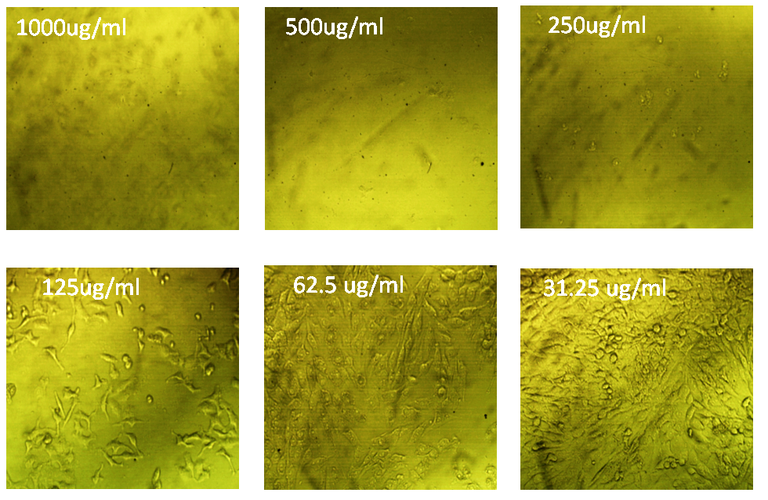
Figure S23. Effect of methotrexate on MCF7 cancer cells.
-------------------------------------------------------------------------------------------------------------------------
Table S4. Optical densities (OD) for determination of methotrexate cytotoxicity on cells (MTT protocol) showing triplicate treatments at (1000, 500, 250, 125, 62.5, and 31.25 μg/mL) on MCF7 cancer cells.
ID | ug/ml | OD |  |  | Mean OD | ±SE | Viability % | Toxicity % | IC50  ± SD
Mcf7 | -------- | 0.832 | 0.809 | 0.825 | 0.822 | 0.006807 | 100 | 0 | ug
methotrextate | 1000 | 0.019 | 0.018 | 0.019 | 0.018667 | 0.000333 | 2.270884023 | 97.72911598 | 80.25 ± 1.11
 | 500 | 0.022 | 0.019 | 0.021 | 0.020667 | 0.000882 | 2.514193025 | 97.48580697
 | 250 | 0.053 | 0.047 | 0.063 | 0.054333 | 0.004667 | 6.609894566 | 93.39010543
 | 125 | 0.194 | 0.216 | 0.188 | 0.199333 | 0.008511 | 24.24979724 | 75.75020276
 | 62.5 | 0.41 | 0.397 | 0.407 | 0.404667 | 0.00393 | 49.22952149 | 50.77047851
 | 31.25 | 0.785 | 0.769 | 0.76 | 0.771333 | 0.007311 | 93.83617194 | 6.163828062

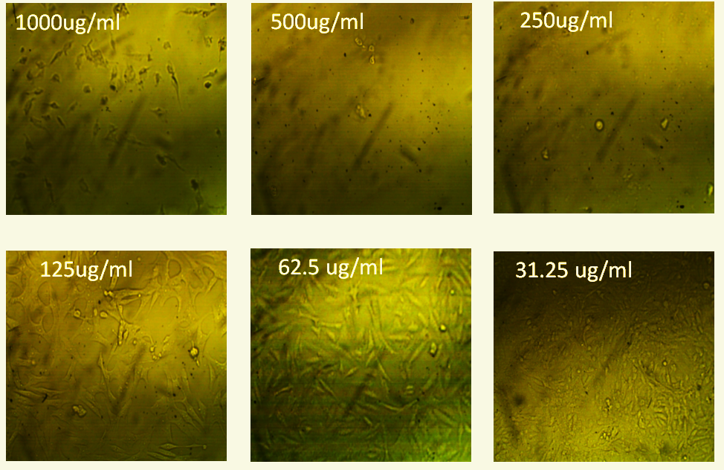
Figure S24. Effect of methotrexate on HepG2 cancer cells.
-------------------------------------------------------------------------------------------------------------------------
Table S5. Optical densities (OD) for determination of methotrexate cytotoxicity on cells (MTT protocol) showing triplicate treatments at (1000, 500, 250, 125, 62.5, and 31.25 μg/mL) on HepG2 cancer cells.
ID | ug/ml | OD |  |  | Mean OD | ±SE | Viability % | Toxicity % | IC50  ± SD
HepG2 | -------- | 0.732 | 0.718 | 0.725 | 0.725 | 0.004041 | 100 | 0 | ug
methotrextate | 1000 | 0.02 | 0.017 | 0.018 | 0.018333 | 0.000882 | 2.528735632 | 97.47126437 | 83.83 ± 0.74
 | 500 | 0.025 | 0.053 | 0.044 | 0.040667 | 0.008253 | 5.609195402 | 94.3908046
 | 250 | 0.089 | 0.094 | 0.088 | 0.090333 | 0.001856 | 12.45977011 | 87.54022989
 | 125 | 0.189 | 0.179 | 0.18 | 0.182667 | 0.00318 | 25.1954023 | 74.8045977
 | 62.5 | 0.378 | 0.385 | 0.399 | 0.387333 | 0.006173 | 53.42528736 | 46.57471264
 | 31.25 | 0.711 | 0.695 | 0.723 | 0.709667 | 0.00811 | 97.88505747 | 2.114942529

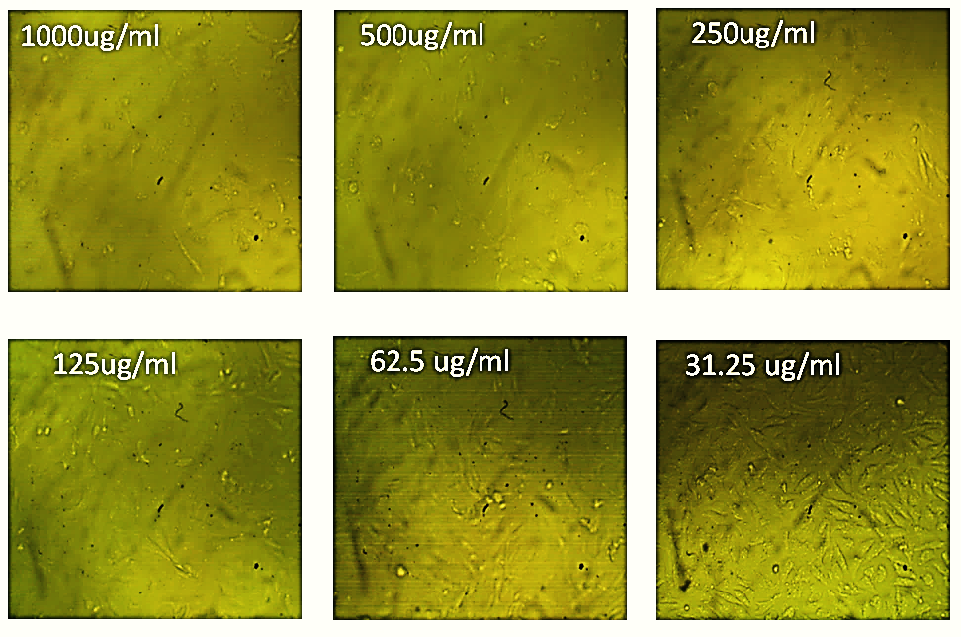
Figure S25. Effect of methotrexate on A549 cancer cells.
-------------------------------------------------------------------------------------------------------------------------
Table S6. Optical densities (OD) for determination of methotrexate cytotoxicity on cells (MTT protocol) showing triplicate treatments at (1000, 500, 250, 125, 62.5, and 31.25 μg/mL) on A549 cancer cells.
ID | ug/ml | OD |  |  | Mean OD | ±SE | Viability % | Toxicity % | IC50  ± SD
A549 | -------- | 0.618 | 0.633 | 0.63 | 0.627 | 0.004583 | 100 | 0 | ug
methotrextate | 1000 | 0.018 | 0.019 | 0.017 | 0.018 | 0.000577 | 2.870813397 | 97.1291866 | 153.2 ± 2.03
 | 500 | 0.056 | 0.074 | 0.05 | 0.06 | 0.007211 | 9.56937799 | 90.43062201
 | 250 | 0.097 | 0.089 | 0.104 | 0.096667 | 0.004333 | 15.41733121 | 84.58266879
 | 125 | 0.354 | 0.34 | 0.348 | 0.347333 | 0.004055 | 55.39606592 | 44.60393408
 | 62.5 | 0.521 | 0.538 | 0.54 | 0.533 | 0.006028 | 85.00797448 | 14.99202552
 | 31.25 | 0.621 | 0.629 | 0.63 | 0.626667 | 0.002848 | 99.94683679 | 0.053163211

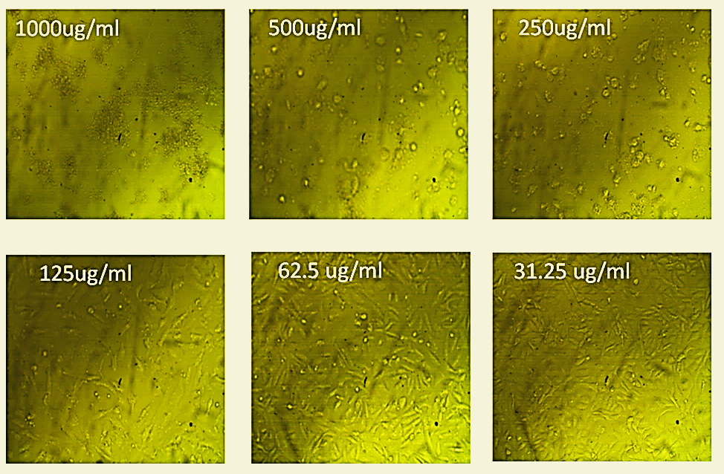
Figure S26. Effect of the ethyl acetate extract of white beans culture of the endophytic fungus Talaromyces wortmannii isolated from Arundo donax L. on WI38 normal cells.
-------------------------------------------------------------------------------------------------------------------------
Table S7. Optical densities (OD) for determination of the ethyl acetate extract of white beans culture of the endophytic fungus Talaromyces wortmannii isolated from Arundo donax L. cytotoxicity on cells (MTT protocol) showing triplicate treatments at (1000, 500, 250, 125, 62.5, and 31.25 μg/mL) on WI38 normal cells.
ID | ug/ml | OD |  |  | Mean OD | ±SE | Viability % | Toxicity % | IC50  ± SD
Wi38 | -------- | 0.673 | 0.678 | 0.668 | 0.673 | 0.002887 | 100 | 0 | ug
Talaro ext. | 1000 | 0.018 | 0.023 | 0.021 | 0.020667 | 0.001453 | 3.070827142 | 96.92917286 | 115.43 ± 1.92
 | 500 | 0.056 | 0.063 | 0.058 | 0.059 | 0.002082 | 8.766716196 | 91.2332838
 | 250 | 0.083 | 0.092 | 0.099 | 0.091333 | 0.004631 | 13.57107479 | 86.42892521
 | 125 | 0.299 | 0.278 | 0.285 | 0.287333 | 0.006173 | 42.69440317 | 57.30559683
 | 62.5 | 0.639 | 0.652 | 0.647 | 0.646 | 0.003786 | 95.98811293 | 4.011887073
 | 31.25 | 0.675 | 0.671 | 0.67 | 0.672 | 0.001528 | 99.85141159 | 0.14858841

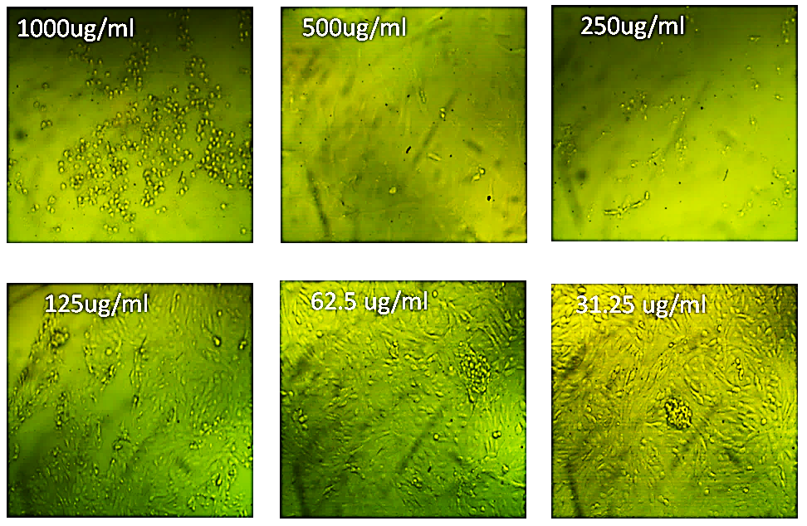
Figure S27. Effect of methotrexate on WI38 normal cells.
-------------------------------------------------------------------------------------------------------------------------
Table S8. Optical densities (OD) for determination of methotrexate cytotoxicity on cells (MTT protocol) showing triplicate treatments at (1000, 500, 250, 125, 62.5, and 31.25 μg/mL) on WI38 normal cells.
ID | ug/ml | OD |  |  | Mean OD | ±SE | Viability % | Toxicity % | IC50  ± SD
Wi38 | -------- | 0.685 | 0.664 | 0.673 | 0.674 | 0.006083 | 100 | 0 | ug
methotrextate | 1000 | 0.019 | 0.017 | 0.018 | 0.018 | 0.000577 | 2.670623145 | 97.32937685 | 156.03 ± 0.63
 | 500 | 0.032 | 0.036 | 0.044 | 0.037333 | 0.003528 | 5.539070227 | 94.46092977
 | 250 | 0.099 | 0.075 | 0.078 | 0.084 | 0.00755 | 12.46290801 | 87.53709199
 | 125 | 0.365 | 0.348 | 0.35 | 0.354333 | 0.005364 | 52.57171118 | 47.42828882
 | 62.5 | 0.664 | 0.67 | 0.673 | 0.669 | 0.002646 | 99.25816024 | 0.741839763
 | 31.25 | 0.674 | 0.663 | 0.678 | 0.671667 | 0.004485 | 99.65380811 | 0.346191889

End of Supplementary material

