**Supplementary material**

**Figures:**

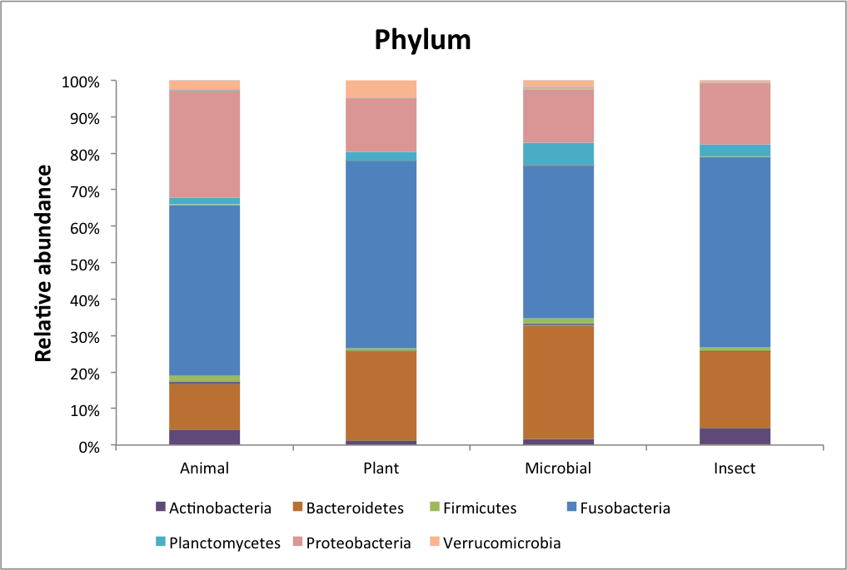

**Figure S1:** Percentage of abundance at phylum and genus level for tilapia fed diets containing different protein sources: Animal, insect, Plant and Microbial. Legend represents the most abundant phyla for each treatment.

**Tables:**

**Table S1:** Absolute values for amino acid intake per treatment.

|  |  |  |  |  |
| --- | --- | --- | --- | --- |
| **Amino Acids** | **Intake (mg/fish/day)** | | | |
| **ANIMAL** | **PLANT** | **MICROBIAL** | **INSECT** |
| Arg | 36,27 | 33,43 | 36,18 | 33,65 |
| His | 12,77 | 11,89 | 10,95 | 10,56 |
| Ile | 18,30 | 19,16 | 18,94 | 18,04 |
| Leu | 37,83 | 41,96 | 38,49 | 41,02 |
| Lys | 26,42 | 24,71 | 27,45 | 29,01 |
| Thr | 18,79 | 17,74 | 27,12 | 19,31 |
| Trp | 4,09 | 4,15 | 4,45 | 4,13 |
| Val | 21,37 | 21,57 | 22,08 | 22,79 |
| Met | 10,95 | 11,24 | 12,91 | 11,59 |
| Cys | 6,18 | 5,86 | 5,25 | 6,64 |
| Phe | 24,73 | 26,13 | 23,25 | 23,63 |
| Tyr | 21,93 | 24,69 | 21,08 | 21,68 |
| Asx | 32,27 | 32,57 | 34,14 | 33,82 |
| Glx | 64,61 | 78,88 | 67,94 | 71,75 |
| Ala | 24,81 | 23,81 | 26,07 | 25,53 |
| Gly | 33,97 | 25,80 | 30,40 | 30,87 |
| Pro | 30,58 | 33,08 | 28,35 | 31,74 |
| Ser | 20,09 | 21,59 | 19,81 | 24,07 |

**Table S2:** Whole body composition of fish under the dietary treatments.

|  |  |  |  |  |  |
| --- | --- | --- | --- | --- | --- |
| **Diet** | **Fresh matter** | | | | |
| **Moisture** | **Ash** | **Protein** | **Fat** | **Energy** |
| Initial | 76,28 | 4,26 | 14,99 | 4,07 | 4,88 |
| ANIMAL | 73,93±0,42 | 3,12±0,18 | 14,80±0,34 | 6,99±0,23 | 6,07±0,07 |
| PLANT | 73,90±0,85 | 3,16±0,03 | 14,70±0,63 | 7,18±0,12 | 6,12±0,18 |
| MICROBIAL | 73,99±0,46 | 3,61±0,35 | 14,67±0,44 | 6,61±0,23 | 5,94±0,12 |
| INSECT | 74,53±0,63 | 3,16±0,19 | 14,60±0,64 | 6,44±0,13 | 5,82±0,17 |

**Table S3****:** DADA2 table output

|  |  |  |  |  |  |  |  |  |  |
| --- | --- | --- | --- | --- | --- | --- | --- | --- | --- |
| **sample-id** | **Treatments** | **input** | **filtered** | **% of input passed filter** | **denoised** | **merged** | **% of input merged** | **non-chimeric** | **% of input non-chimeric** |
| S20-31-1-V1V2 | Animal | 65361 | 43059 | 65.88 | 42695 | 41815 | 63.98 | 28473 | 43.56 |
| S20-31-10-V1V2 | Plant | 74653 | 51726 | 69.29 | 51062 | 49332 | 66.08 | 40537 | 54.3 |
| S20-31-11-V1V2 | Plant | 73776 | 53734 | 72.83 | 53000 | 50676 | 68.69 | 36095 | 48.93 |
| S20-31-12-V1V2 | Plant | 84180 | 59461 | 70.64 | 58528 | 55781 | 66.26 | 40487 | 48.1 |
| S20-31-13-V1V2 | Animal | 88619 | 60274 | 68.01 | 59193 | 56472 | 63.72 | 43155 | 48.7 |
| S20-31-14-V1V2 | Animal | 67321 | 47629 | 70.75 | 47233 | 46029 | 68.37 | 30943 | 45.96 |
| S20-31-15-V1V2 | Animal | 63888 | 32119 | 50.27 | 31854 | 31338 | 49.05 | 21373 | 33.45 |
| S20-31-16-V1V2 | Microbial | 12371 | 81867 | 66.17 | 80707 | 77695 | 62.8 | 60910 | 49.23 |
| S20-31-17-V1V2 | Microbial | 84987 | 62793 | 73.89 | 61964 | 57777 | 67.98 | 34241 | 40.29 |
| S20-31-18-V1V2 | Microbial | 87991 | 43759 | 49.73 | 43345 | 42244 | 48.01 | 29282 | 33.28 |
| S20-31-19-V1V2 | Insect | 76437 | 55109 | 72.1 | 54322 | 50400 | 65.94 | 33902 | 44.35 |
| S20-31-2-V1V2 | Animal | 58065 | 31359 | 54.01 | 30898 | 29589 | 50.96 | 20574 | 35.43 |
| S20-31-20-V1V2 | Insect | 10713 | 31671 | 29.56 | 31371 | 30959 | 28.9 | 22470 | 20.97 |
| S20-31-21-V1V2 | Insect | 56981 | 37977 | 66.65 | 37613 | 36502 | 64.06 | 29717 | 52.15 |
| S20-31-22-V1V2 | Plant | 63715 | 44995 | 70.62 | 44456 | 42967 | 67.44 | 31679 | 49.72 |
| S20-31-23-V1V2 | Plant | 40893 | 25787 | 63.06 | 25482 | 24614 | 60.19 | 19473 | 47.62 |
| S20-31-24-V1V2 | Plant | 99616 | 74154 | 74.44 | 73336 | 68780 | 69.05 | 42222 | 42.38 |
| S20-31-25-V1V2 | Animal | 62697 | 46641 | 74.39 | 45609 | 43345 | 69.13 | 26409 | 42.12 |
| S20-31-26-V1V2 | Animal | 52954 | 37693 | 71.18 | 36883 | 35157 | 66.39 | 25936 | 48.98 |
| S20-31-27-V1V2 | Animal | 51596 | 31574 | 61.19 | 31139 | 30160 | 58.45 | 26060 | 50.51 |
| S20-31-28-V1V2 | Microbial | 66053 | 49000 | 74.18 | 48345 | 45724 | 69.22 | 27647 | 41.86 |
| S20-31-29-V1V2 | Microbial | 61913 | 39740 | 64.19 | 39189 | 37920 | 61.25 | 25963 | 41.93 |
| S20-31-3-V1V2 | Animal | 55504 | 30152 | 54.32 | 29935 | 29369 | 52.91 | 19833 | 35.73 |
| S20-31-30-V1V2 | Microbial | 61983 | 45692 | 73.72 | 45026 | 43055 | 69.46 | 28294 | 45.65 |
| S20-31-31-V1V2 | Insect | 49172 | 34598 | 70.36 | 34148 | 32022 | 65.12 | 18318 | 37.25 |
| S20-31-32-V1V2 | Insect | 89435 | 64527 | 72.15 | 63848 | 61559 | 68.83 | 41641 | 46.56 |
| S20-31-33-V1V2 | Insect | 65507 | 49563 | 75.66 | 48990 | 47076 | 71.86 | 30249 | 46.18 |
| S20-31-34-V1V2 | Plant | 65767 | 49341 | 75.02 | 48651 | 46343 | 70.47 | 28455 | 43.27 |
| S20-31-35-V1V2 | Plant | 52733 | 35874 | 68.03 | 35456 | 34081 | 64.63 | 28858 | 54.72 |
| S20-31-36-V1V2 | Plant | 76281 | 51974 | 68.13 | 51114 | 48694 | 63.84 | 33877 | 44.41 |
| S20-31-4-V1V2 | Microbial | 63161 | 45839 | 72.57 | 45549 | 43250 | 68.48 | 31674 | 50.15 |
| S20-31-5-V1V2 | Microbial | 53890 | 40868 | 75.84 | 40750 | 39859 | 73.96 | 31914 | 59.22 |
| S20-31-6-V1V2 | Microbial | 65243 | 44027 | 67.48 | 43762 | 42751 | 65.53 | 24744 | 37.93 |
| S20-31-7-V1V2 | Insect | 45853 | 32869 | 71.68 | 32698 | 31604 | 68.92 | 26115 | 56.95 |
| S20-31-8-V1V2 | Insect | 110255 | 74680 | 67.73 | 73368 | 70675 | 64.1 | 49777 | 45.15 |
| S20-31-9-V1V2 | Insect | 50559 | 38391 | 75.93 | 38024 | 36784 | 72.75 | 26320 | 52.06 |

**Table S4:** Kruscall-wallis stats

**Table S5:** Permanova values for weighted and unweighted Unifrac.

|  |  |  |  |  |  |  |
| --- | --- | --- | --- | --- | --- | --- |
| **Group 1** | **Group 2** | **Sample size** | **Permutations** | **pseudo-F** | **p-value** | **q-value** |
| **Unweighted-Unifrac** | | | | | | |
| Animal | Insect | 18 | 999 | 1,127 | 0,272 | 0,3432 |
| Microbial | 18 | 999 | 1,283 | 0,152 | 0,3432 |
| Plant | 18 | 999 | 1,119 | 0,286 | 0,3432 |
| Insect | Microbial | 18 | 999 | 0,940 | 0,485 | 0,485 |
| Plant | 18 | 999 | 1,432 | 0,098 | 0,3432 |
| Microbial | Plant | 18 | 999 | 1,241 | 0,175 | 0,3432 |
| **Weighted-Unifrac** | | | | | | |
| Animal | Insect | 18 | 999 | 0.838 | 0.461 | 0.564 |
| Microbial | 18 | 999 | 2.124 | 0.077 | 0.231 |
| Plant | 18 | 999 | 2.535 | 0.051 | 0.231 |
| Insect | Microbial | 18 | 999 | 0.728 | 0.556 | 0.564 |
| Plant | 18 | 999 | 0.720 | 0.564 | 0.564 |
| Microbial | Plant | 18 | 999 | 0.825 | 0.472 | 0.564 |

**Table S6:** Abundance of the predicted pathways that evidenced correlation with amino acid intake in the three diets when compared with ANIMAL.

