Transcriptomic Analysis of CRISPR/Cas9-Mediated TDP1-Knockout HEK293A Cells
Nadezhda S. Dyrkheeva ¹, Alexandra L. Zakharenko ¹, Anastasia A. Malakhova ^{1,2}, Larisa S. Okorokova ³, Dmitry N. Shtokalo ^{3,4}, Sergey P. Medvedev ^{1,2}, Suren M. Zakian ^{1,2}, Alexey A. Tupikin ¹, Marsel R. Kabilov ¹, Olga I. Lavrik ¹*
¹ Institute of Chemical Biology and Fundamental Medicine, Siberian Branch of the Russian Academy of Sciences, 8 Lavrentyeva Ave., 630090 Novosibirsk, Russia; dyrkheeva.n.s@gmail.com (N.S.D.), a.zakharenko73@gmail.com (A.L.Z.), kabilov@niboch.nsc.ru (M.R.K.), alenare@niboch.nsc.ru (A.A.T.), lavrik@niboch.nsc.ru (O.I.L.)
² Federal Research Center Institute of Cytology and Genetics, Siberian Branch of the Russian Academy of Sciences, 10 Lavrentyeva Ave., 630090 Novosibirsk, Russia; amal@bionet.nsc.ru (A.A.M.), medvedev@bionet.nsc.ru (S.P.M.), zakian@bionet.nsc.ru (S.M.Z.)
³ AcademGene LLC, 6 Lavrentyeva Ave., 630090 Novosibirsk, Russia; larisaok123@gmail.com (L.S.O.)
⁴ A.P. Ershov Institute of Informatics Systems SB RAS, 6 Lavrentyeva Ave., 630090 Novosibirsk, Russia; shtokalod2@gmail.com (D.N.S.)
* Correspondence: Olga I. Lavrik lavrik@niboch.nsc.ru

A
B
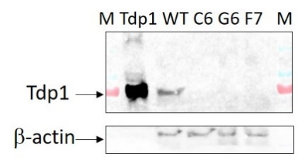

C
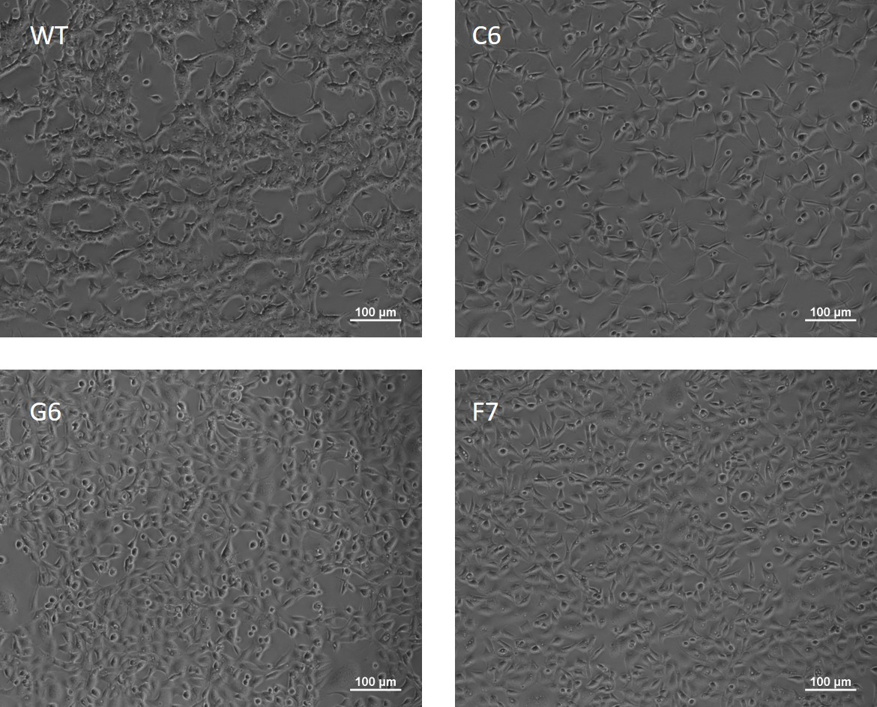

Figure S1. (A) Scheme of deletion in Tdp1 gene; (B) Western-blot analysis: whole cell extracts were separated by Laemmli electrophoresis in SDS-PAAG, transferred on nitrocellulose membrane, and probed with rabbit antibody to TDP1 (Thermo Fisher Scientific PA5-27111) or rabbit antibody to β-actin (Abcam 8226-100). Lanes: 1) protein ladder (Thermo Fisher Scientific); 2) purified TDP1 (20 ng); 3) HEK293A WT cells; 4) HEK293A clone C6; 5) HEK293A clone G6; 6) HEK293A clone F7; 7) protein ladder (Thermo Fisher Scientific); (C) TDP1 knockout changes morphology of HEK293A cells.

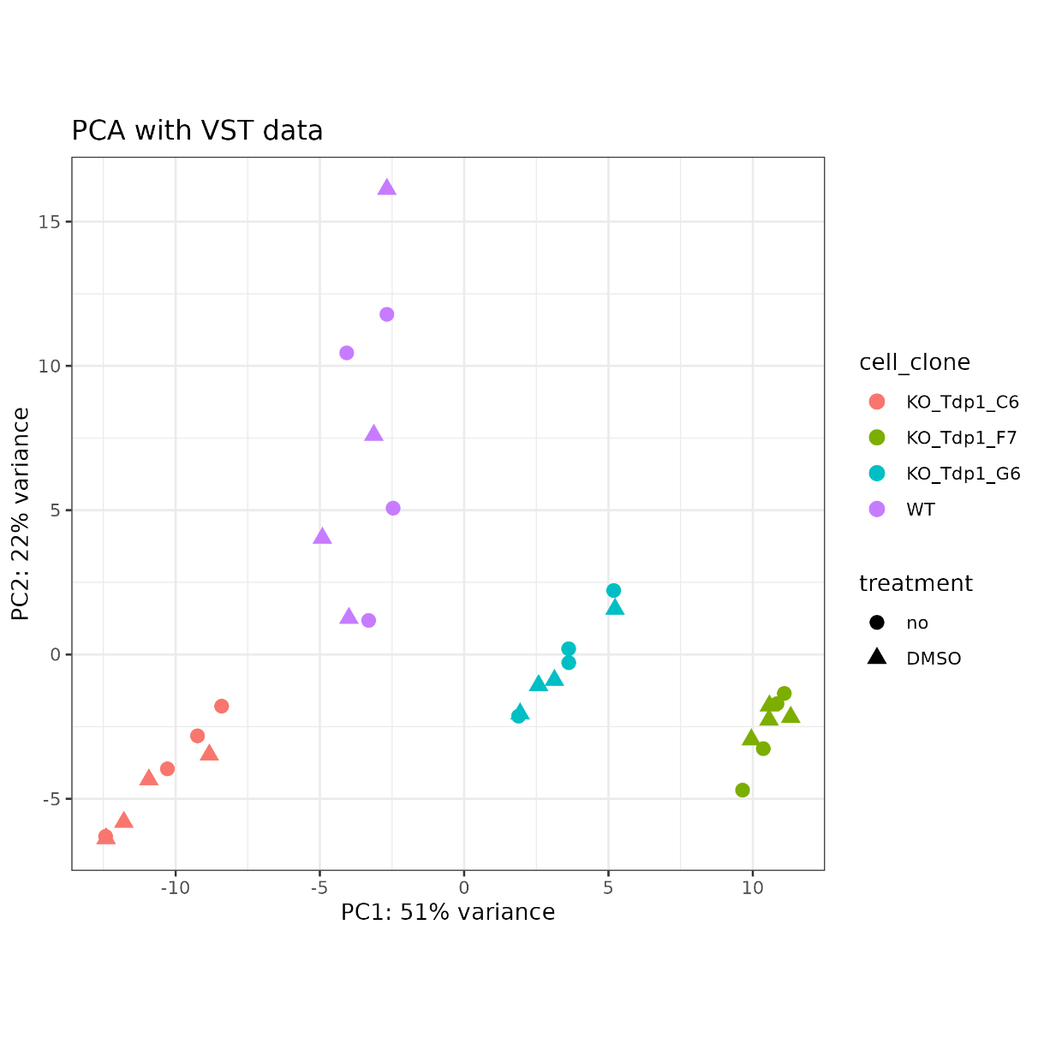
Figure S2. Principal component analysis (PCA) plot illustrates the transcriptional pattern of cells by the profiles of gene expression in wild type (WT, violet) and TDP1 knockout (KO_Tdp1_C6, red; KO_Tdp1_F7, green; KO_Tdp1_G6, blue) cells. Samples clustering based on a PCA of differentially expressed genes. The axes: the principal components PC1 and PC2 with the proportion of explained variance of the data for each principal component.

C6 vs WT
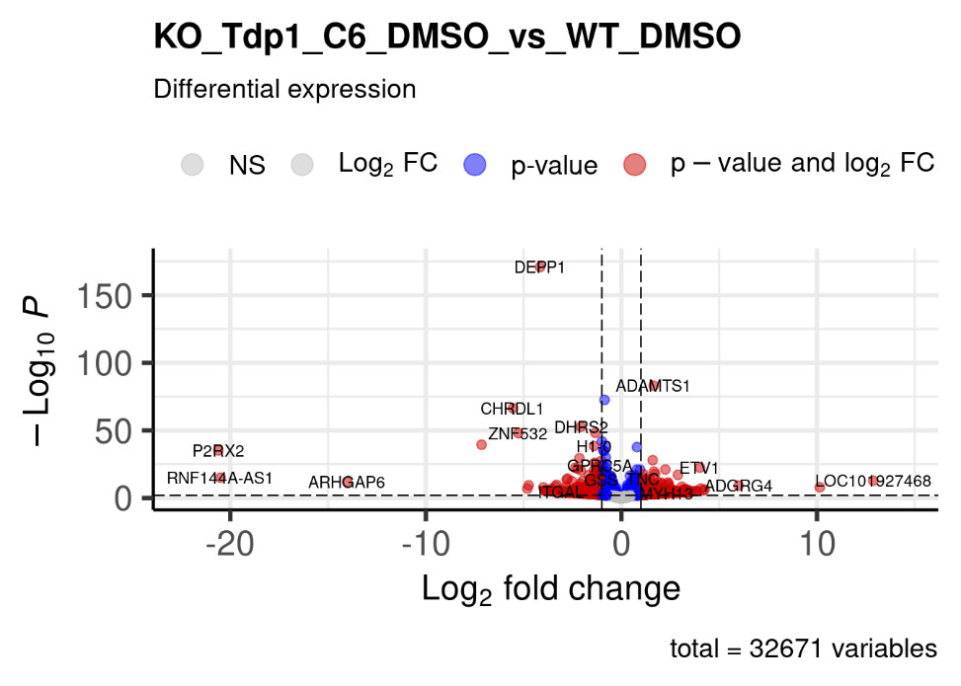

G6 vs WT
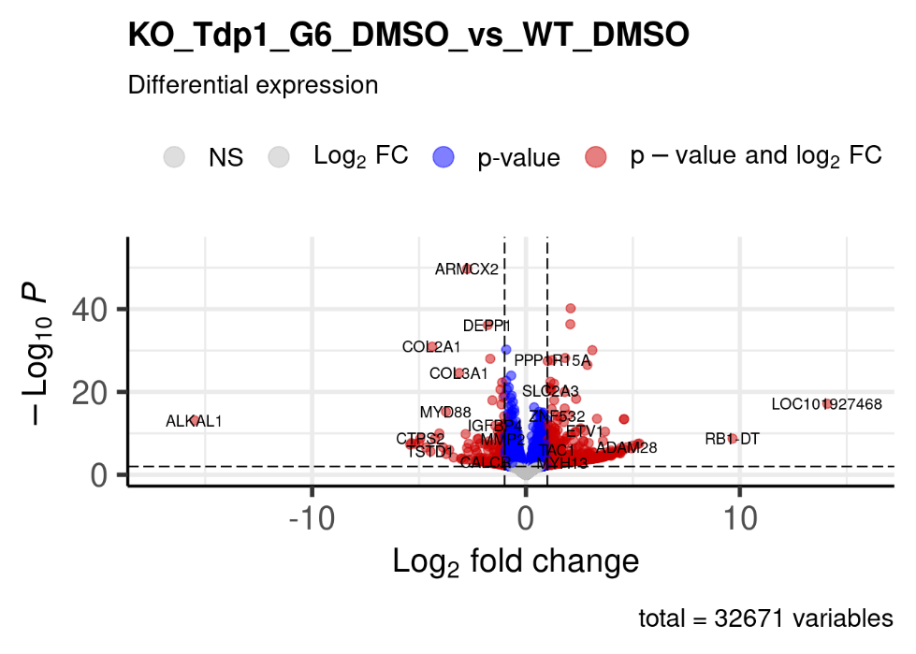

F7 vs WT
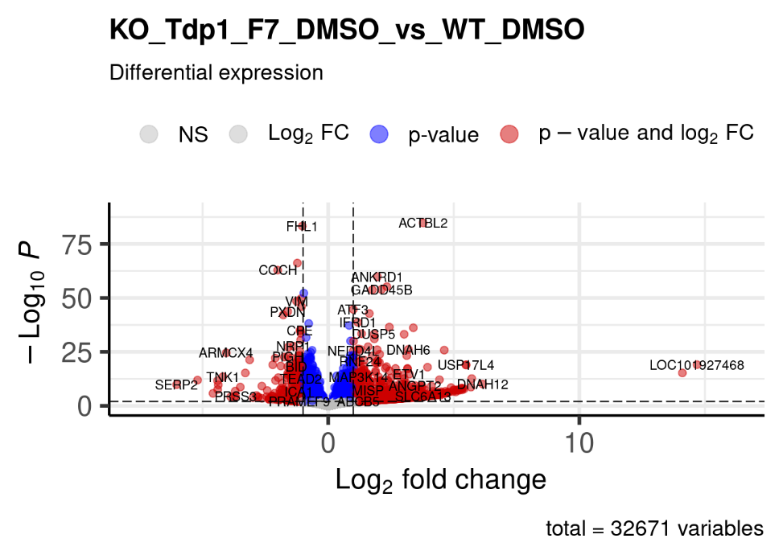
Figure S3. TDP1 knockout effect on HEK293A cells. Volcano Plot for differential gene expression in HEK293A cells with CRISPR/Cas9-mediated delition in Tdp1 gene (cell clones C6, G6, F7) vs wild type HEK293A cells.

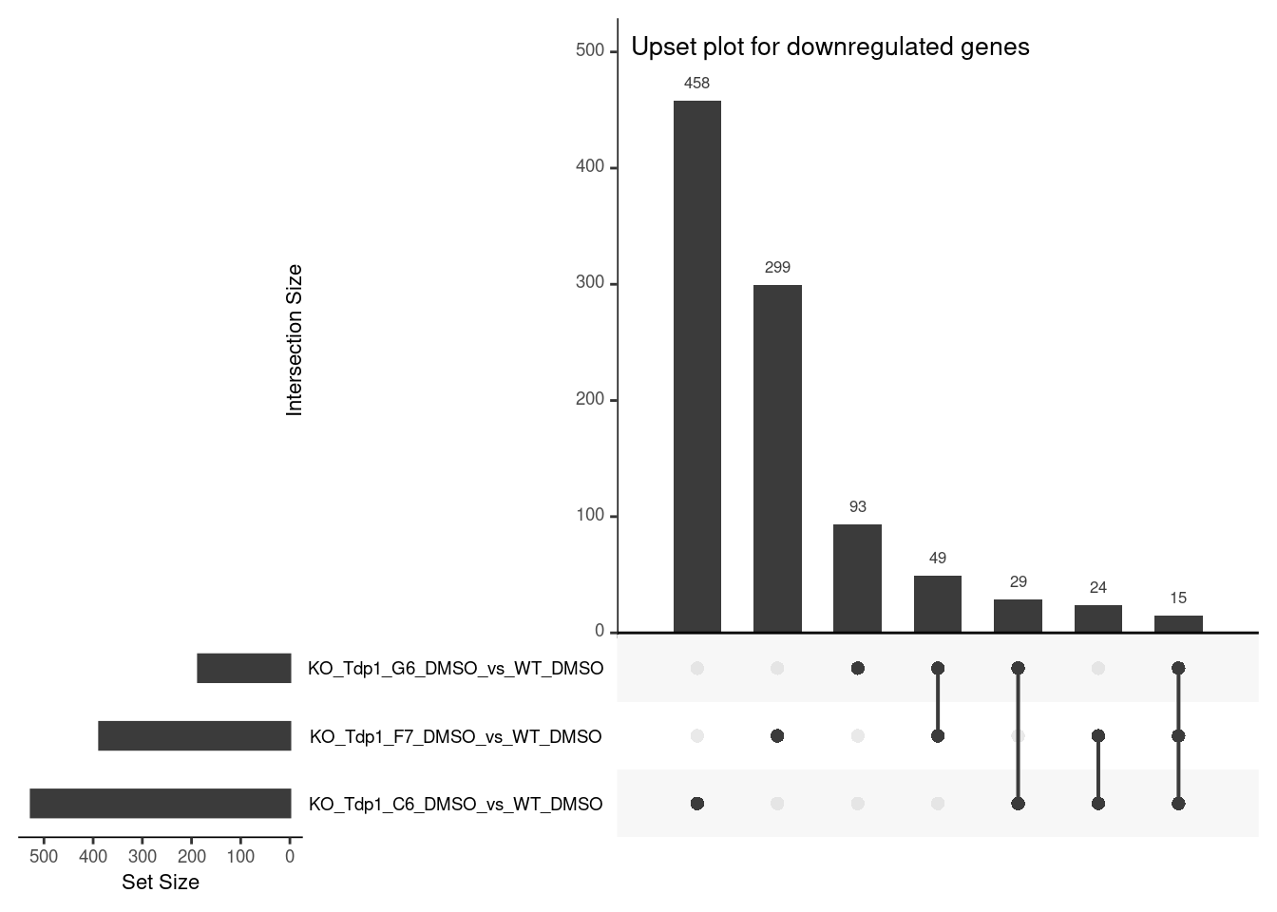
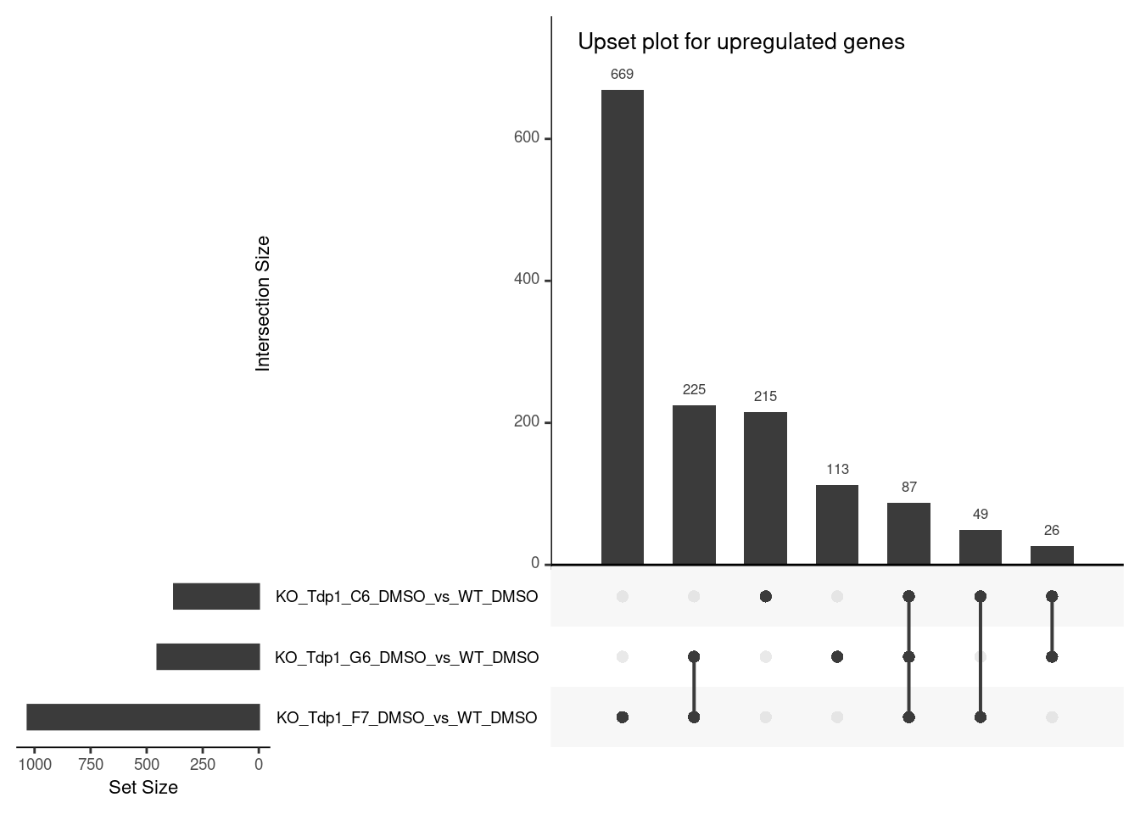
Figure S4. Upset barplot of the differentially expressed genes in TDP1-deficient cells compared to the control WT HEK293A cell line.

Table S1. TDP1 knockout effect on gene expression in HEK293A cells. Gene set enrichment analysis (GSEA total) results: pathways significantly associated with differentially expressed genes. Normalized enrichment scores (NES) indicate the distribution of KEGG and Reactome pathways across a list of genes ranked by log2FoldChange. Higher enrichment scores indicate a shift of genes belonging to certain pathway towards either end of the ranked list, representing up or down regulation (positive or negative values, respectively).

C6 cell clone
KEGG database
Pathway | p-value | p-adj | NES | Number | Genes
Glutathione metabolism | 6.4e-05 | 0.016 | -2.134 | 4 | GSTM4, GPX3, GSS, GGT7

Reactome database
Pathway | p-value | p-adj | NES | Number | Genes
Gene expression (Transcription) | 2.1e-05 | 0.006 | 2.554 | 47 | ZIK1, CCN2, ZNF776, ZNF486, WRN, CDK6, PRKCB, ZNF253, ZNF615, ZNF708, MEF2C, ZNF100, ZNF737, LIFR, TDRD6, RUNX2, ZNF680, ZNF675, ZNF92, ZNF730, ZNF439, ZNF626, ZNF582, ZNF221, ZNF569, THRB
Generic Transcription Pathway | 5.2e-06 | 0.003 | 2.688 | 43 | ZIK1, CCN2, ZNF776, ZNF486, WRN, CDK6, PRKCB, ZNF253, ZNF615, ZNF708, MEF2C, ZNF100, ZNF737, LIFR, RUNX2, ZNF680, ZNF675, ZNF92, ZNF730, ZNF439, ZNF626, ZNF582, ZNF221, ZNF569, THRB
Metabolism | 1.1e-05 | 0.004 | -2.451 | 92 | AHCY, INPP5D, FADS2, CPNE1, UCP2, SLC3A2, IDH3B, GSTM4, GSS, ALDOC, NR1H3, PLAAT3, TM7SF2, GGT7, ACAD8, GLRX, PSME2, CERS1, HSD17B11, FITM2, CES3, ST3GAL4, PYCR3, SLC37A4, RBP1, PLEKHA6, B3GAT3, B3GNT3, BCHE, HMOX1, PYCR1, HOGA1, ITPA, LDHC, VAMP2, FABP5, ABHD14B, TKFC, PLAAT4, CHST2, PLA2R1, UGT3A2, BDH2, FDXR, NMNAT1, LPIN3, PSMB9, NQO1, FUT2, ABCA1, CDA, SLC19A3, CHSY3, SLC16A3, ACY3, PTGS1, PARP10, PTGIS, NOS3, NUDT18, CHST7, GPC5
RNA Polymerase II Transcription | 5.2e-06 | 0.003 | 2.688 | 43 | ZIK1, CCN2, ZNF776, ZNF486, WRN, CDK6, PRKCB, ZNF253, ZNF615, ZNF708, MEF2C, ZNF100, ZNF737, LIFR, RUNX2, ZNF680, ZNF675, ZNF92, ZNF730, ZNF439, ZNF626, ZNF582, ZNF221, ZNF569, THRB

F7 cell clone
KEGG database
Pathway | p-value | p-adj | NES | Number | Genes
NF-kappa B signaling pathway | 3.1e-04 | 0.029 | 2.215 | 16 | TNFAIP3, GADD45B, NFKB2, ICAM1, MAP3K14, RELB, BIRC3, LTA
MAPK signaling pathway | 1.8e-04 | 0.026 | 2.384 | 37 | GADD45B, DUSP5, NFKB2, PLA2G4C, DUSP6, VEGFA, EPHA2, NGFR, MAP3K14, EGFR, NR4A1, DDIT3, RELB, ANGPT2, TGFB2, RASGRP2, PLA2G4D, CSF1R, GADD45G
Transcriptional misregulation in cancer | 8.2e-06 | 0.002 | 2.68 | 26 | GADD45B, ETV5, DUSP6, BAIAP3, ETV1, NGFR, CEBPB, ETV4, DDIT3, BIRC3, NR4A3, RUNX1, PAX3, MITF, BCL6, CSF1R, GADD45G, IGFBP3

Reactome database
Pathway | p-value | p-adj | NES | Number | Genes
TNFR2 non-canonical NF-kB pathway | 1.8e-05 | 0.027 | 2.361 | 8 | NFKB2, MAP3K14, RELB, BIRC3, LTA, TNFRSF9, TNFRSF12A

