Supplementary Materials: Multi-scale Sources of Precipitation Predictability in the Northern Great Plains
Carlos M. Carrillo¹, Francisco Muñoz-Arriola^{1,2}*, Liang Chen³

Supplementary Tables
Table S1. List of acronyms used.
GP-LLJ | Great Plains low-level jet
CGT | Circumglobal Teleconnection
NGP | Northern Great Plains
EOF | Empirical Orthogonal Function
EOF1 | EOF one
EOF2 | EOF two
PC | Principal Component
GCM | General Circulation Model
NARR | North American Regional Reanalysis
NOAA | National Oceanic and Atmospheric Administration
NOAA GFDL | NOAA Geophysical Fluid Dynamics Laboratory
NASA | National Aeronautics and Space Administration
NASA GISS | NASA Goddard Institute for space Studies
NASA GMAO | NASA Global Modeling and Assimilation Office
DOE | Department of Energy
DOE ACME | DOE Accelerated Climate Modeling for Energy
NCEP | National Centers for Environmental Prediction
NCEP CFS | NCEP Climate Forecast System
NCEP-NCAR | National Center for Atmospheric Research
CFS | Climate Forecast System
CFSv1 | CFS version 1
CFSv1 | CFS version 2
CFS-RR | CFS retrospective reanalysis
CFS-R | CFS reforecast version
NOMADS | NOAA National Operational Model Archive and Distribution System
HGT | geopotential height
P-Index | Precipitation index
PRISM | Parameter-Elevation Regressions on Independent Slopes Model
CPC | Climate Prediction Center
MJJ | May through July
MJJA | May through August
NE | Nebraska
IA | Iowa
MN | Minnesota
IL | Illinois
SD | North Dakota
ND | South Dakota

Supplementary Figures
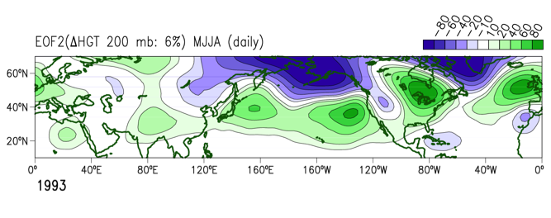
Figure S1. Spatial pattern of the Empirical Orthogonal Function mode 2 (EOF2) from 200-mb geopotential height anomalies (∆HGT). The HGT is obtained from the Climate Forecast System (CFS) retrospective reanalysis. The EOF is calculated with daily fields from May 1 through September 1 (MJJA) of 1993, with explained variance of 6%.
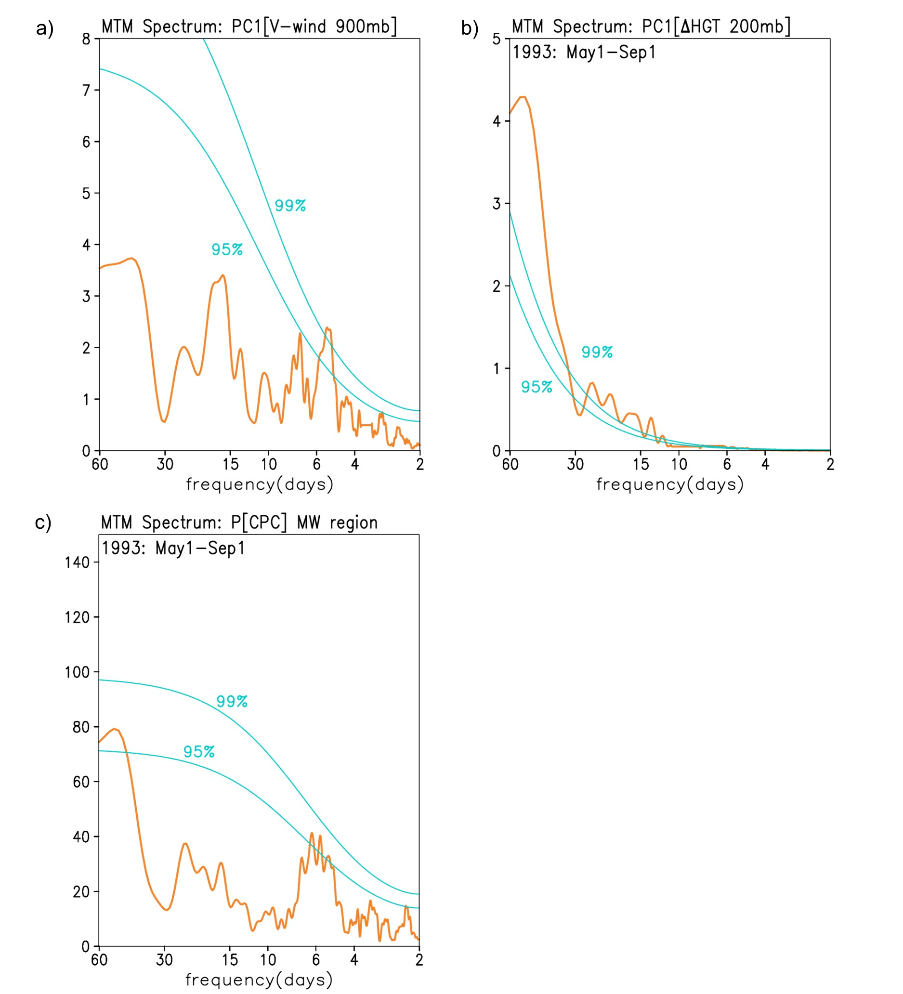
Figure S2. Multi-taper method (MTM) power spectrum of the temporal dominant Principal Components (PC) of both 900-mb meridional wind (V-wind PC1; a) and 200-mb geopotential height anomalies (∆HGT PC2; b) for the daily period from May 1 through Sep1, 1993. MTM power spectrum of precipitation ([P]; c) for the northern Great Plains precipitation index averaged over the region defined at 37.5-45°N; 103-90°W (MW). The two superimposed lines are the levels of confidence at the 95% and 99%.
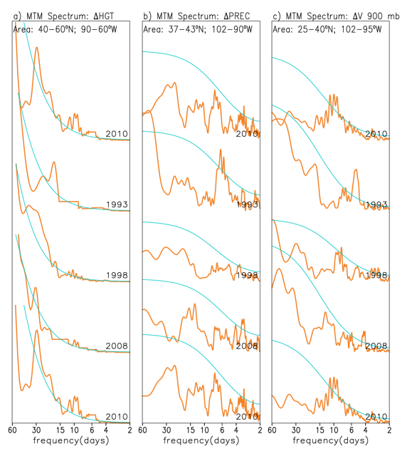
Figure S3. Multi-taper method (MTM) power spectrum of 200-mb geopotential height (a), Precipitation (b), and meridional wind at 900-mb (c). The spectrum is calculated for several years indicated in the plot: 2010, 1993, 1998, 2008, and 2010. The time series of each field are average over different areas for precipitation (is 37-43N; 102-90W), HGT (40-60N; 90-60W), and V900 (25-40; 102-95W). The time series are daily for the period from May 1 through Sep1, 1993. The superimposed line is the levels of confidence at the 95% level of confidence for each case.
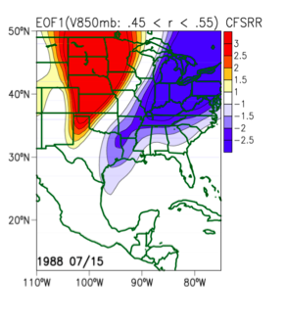
Figure S4. Spatial pattern of the Empirical Orthogonal Function mode 1 (EOF1) from 850-mb meridional wind (V850mb). The V850mb was obtained from the Climate Forecast System (CFS) retrospective reanalysis (CFSRR). The EOF is calculated with daily fields from May 1 through September 1 (MJJA) of 1988. A correlation of 0.54 is found between the associated V850 PC1 and the analogous NARR PC1 for a 30-day length after Jul 15, this correlation is in the range [0.45, 0.55] as defined in Fig. 9. Also, a correlation of 0.36 is found between this V850 PC1 and NGP precipitation. This 1988 is considered a dry year for the Northern Great Plains as identified by the time in Figure 2b.
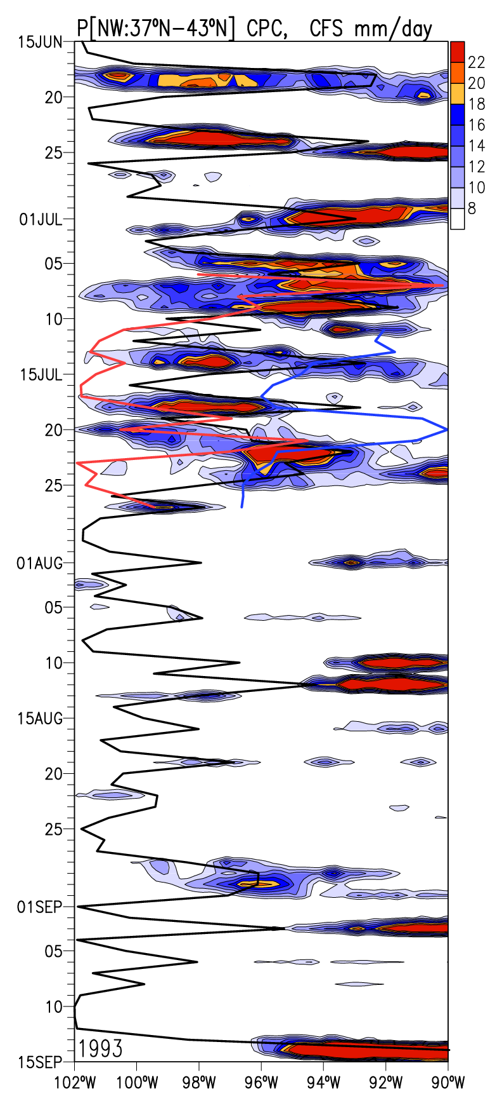
Figure S5. Longitudinal-time Hovmoller diagram of Climate Precipitation Center (CPC) precipitation averaged among 37ºN and 43ºN (in shaded is the same precipitation plot as in Fig. 3). The superimposed black line is the CPC observed precipitation average over the region 37º-43ºN; 102º-90ºW. The superimposed red and blue lines are precipitation average over the same as the black line, but for Climate Forecast System (CFS) reforecast simulations starting in Jul 5 (red line) and Jul 10 (blue line).
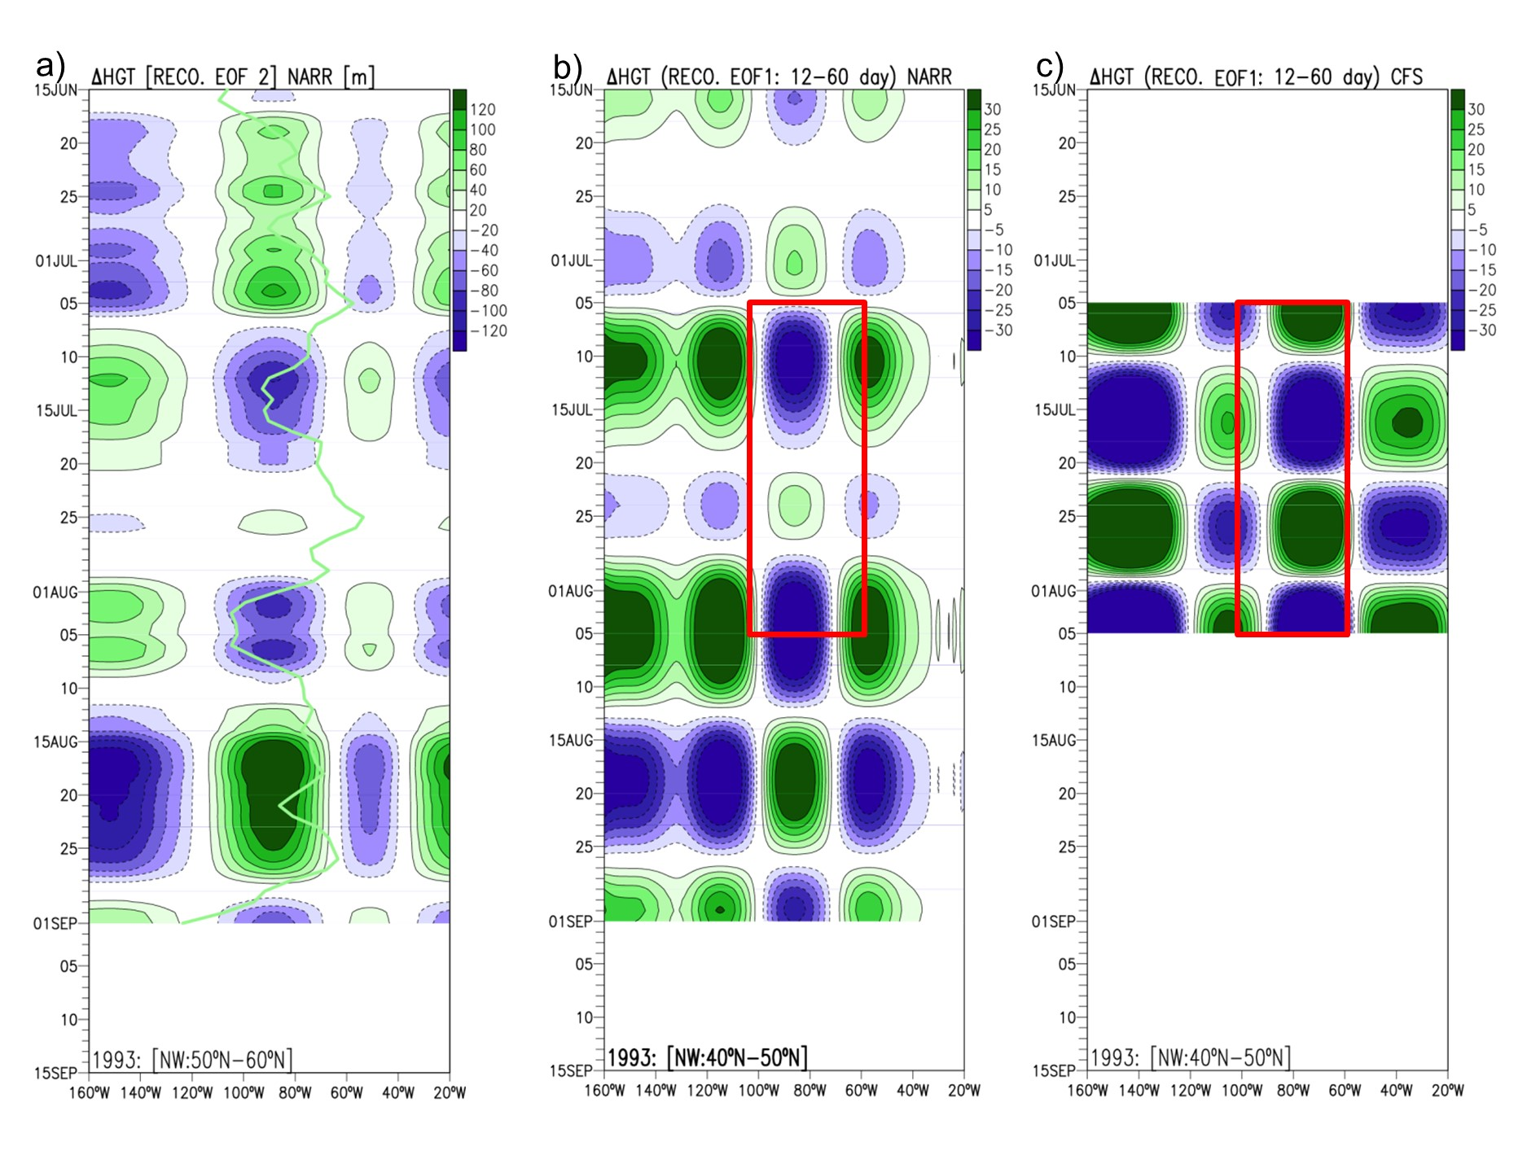
Figure S6. Hovmoller spatiotemporal variability of a reconstructed 200-mb geopotential height anomaly (∆HGT). (a) Using the second Empirical Orthogonal Function (EOF2) mode. The superimposed green line is the PC2 associated with this mode. (b) Using the EOF1 mode with original NARR HGT data previously filtered with a 10- to 60-day band-pass filter. (c) Using the EOF1 mode 1 (also previously filtered with a 10- to 60-day band-pass filter) from the Climate Forecast System reforecast (CFS-R). Boxes represent the region of correlation analysis.

