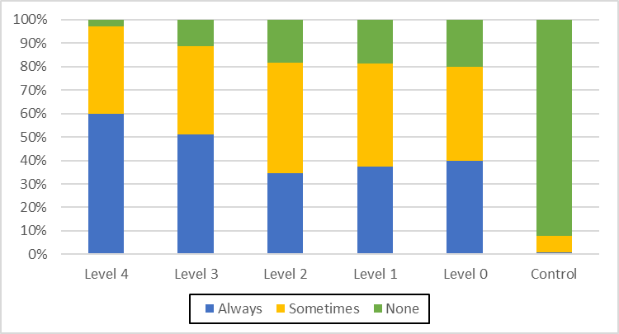
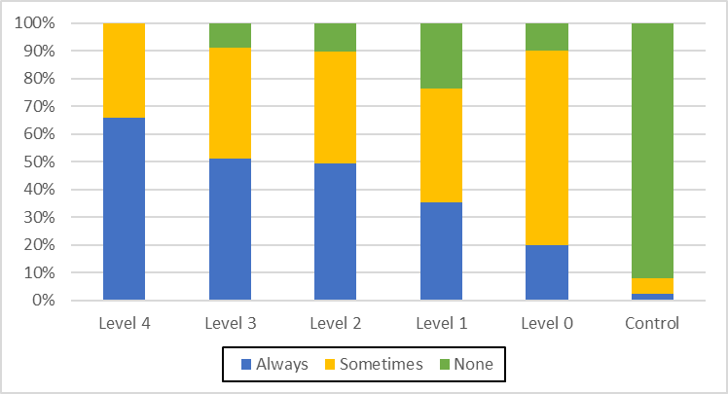
Figure S1-1. Prevalence of "Sensory numbness in both hands" (Q1) in each sensory disturbance level (χ²(10) =227.8, p=0.000)
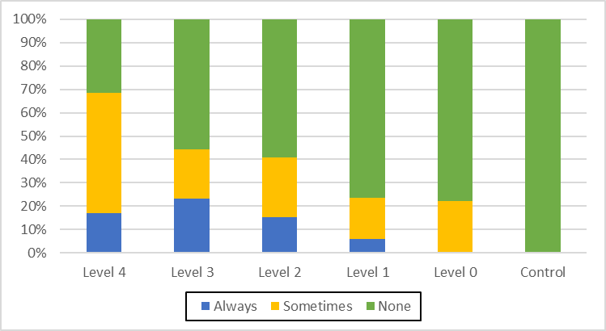
Figure S1-3. Prevalence of "No pain when burn or wounded" (Q5) in each sensory disturbance level (χ²(10) =101.8, p=0.000)

Figure S1-2. Prevalence of "Sensory numbness in both legs" (Q2) in each sensory disturbance level (χ²(10) =200.8, p=0.000)
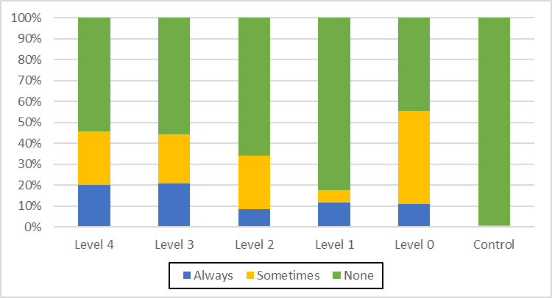
Figure S1-4. Prevalence of "Difficulty in judging the adequate temperature of bath water" (Q6) in each sensory disturbance level (χ²(10) =74.8, p=0.000)

Figure S1-5. Prevalence of "Hanging a bag with elbow or shoulder instead of holding it in your hand" (Q7) in each sensory disturbance level (χ²(10) =158.5, p=0.000)
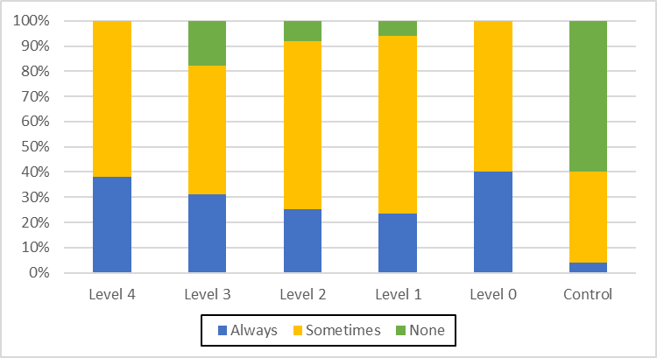
Figure S1-7. Prevalence of "Muscle cramps" (Q11) in each sensory disturbance level (χ²(10) =113.5, p=0.000)

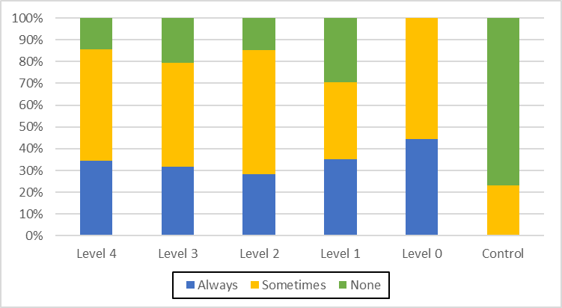
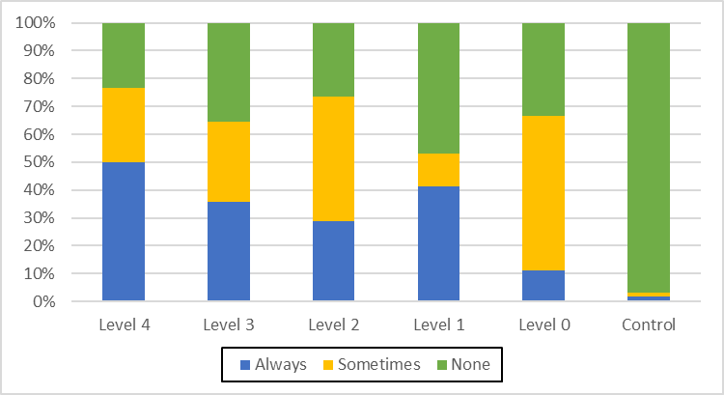
Figure S1-6. Prevalence of "Headache" (Q8) in each sensory disturbance level (χ²(10) =128.2, p=0.000)
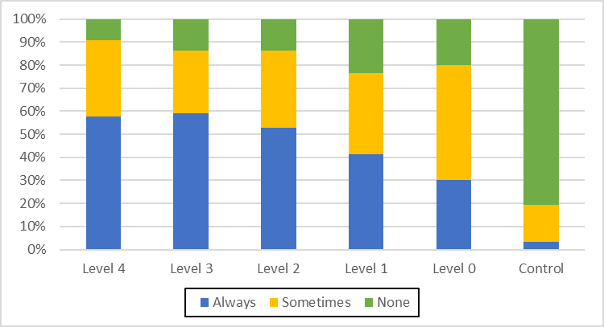
Figure S1-8. Prevalence of "Disturbed vision" (Q12) in each sensory disturbance level (χ²(10) =152.7, p=0.000)

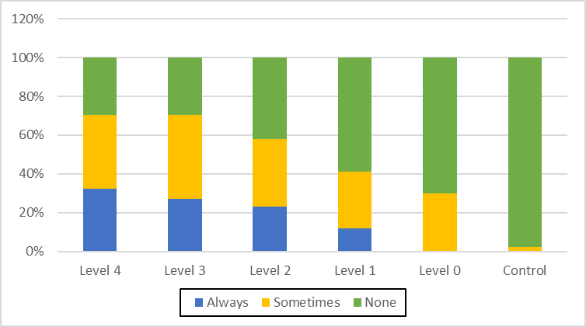
Figure S1-9. Prevalence of "Difficulty in recognizing a thing in your sight when you continue to stare it" (Q14) in each sensory disturbance level (χ²(10) =121.3, p=0.000)
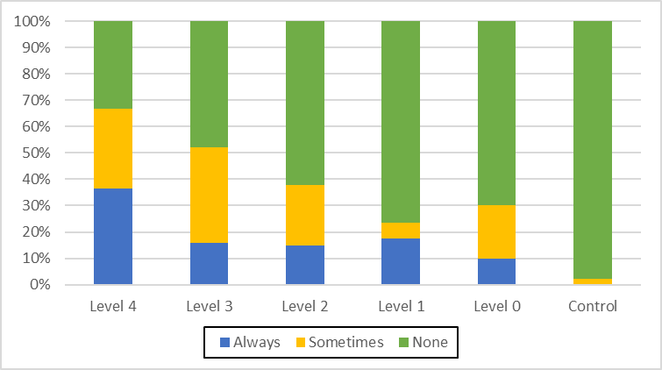
Figure S1-11. Prevalence of "Difficulty in tasting" (Q20) in each sensory disturbance level (χ²(10) =92.3, p=0.000)

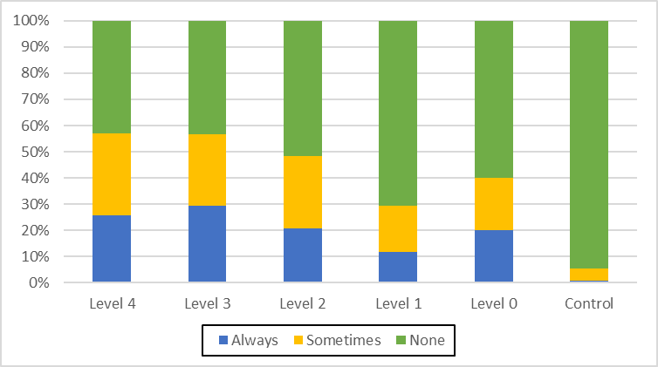
Figure S1-10. Prevalence of "Difficulty in smelling" (Q19) in each sensory disturbance level (χ²(10) =76.1, p=0.000)
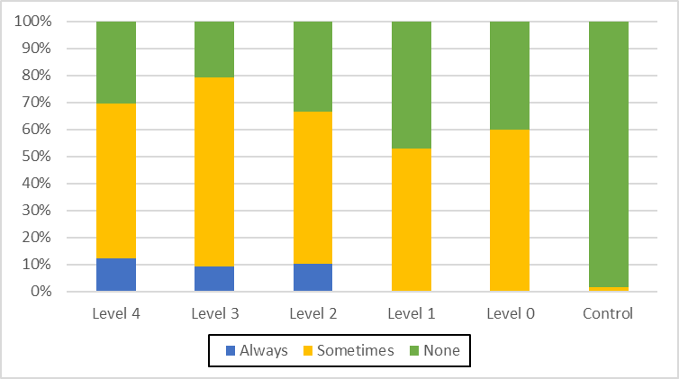
Figure S1-12. Prevalence of "Stumbling on flat ground" (Q22) in each sensory disturbance level (χ²(10) =149.3, p=0.000)

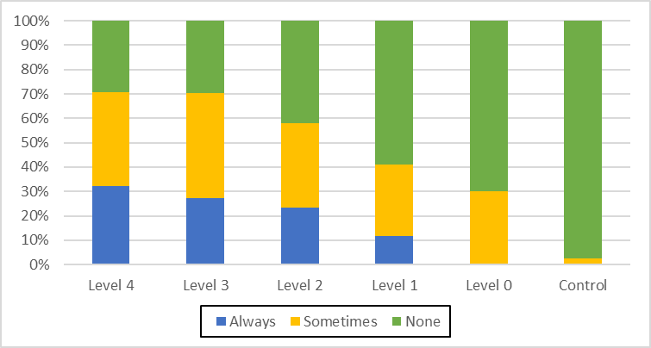
Figure S1-13. Prevalence of "Difficulty in wearing slippers" (Q23) in each sensory disturbance level (χ²(10) =165.7, p=0.000)
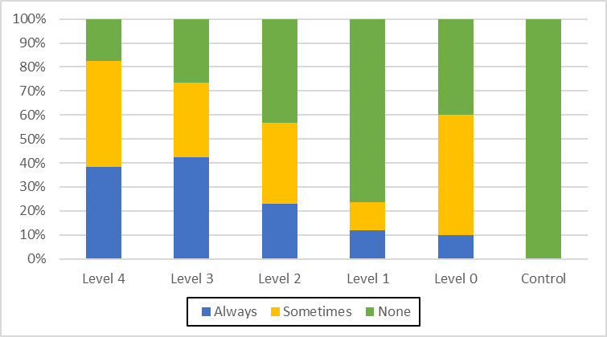
Figure S1-15. Prevalence of "Difficulty in buttoning" (Q26) in each sensory disturbance level (χ²(10) =155.4, p=0.000)

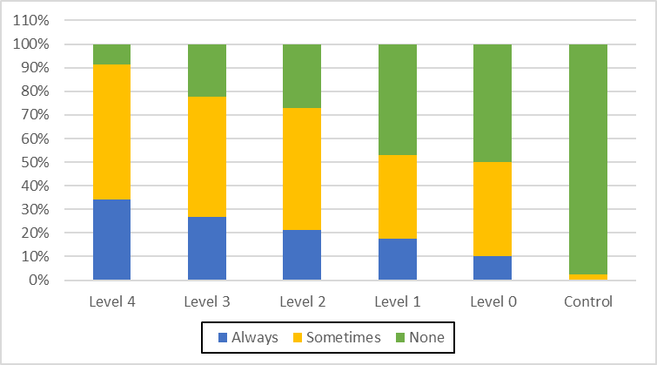
Figure S1-14. Prevalence of "Coming off your slippers or sandals while walking" (Q24) in each sensory disturbance level (χ²(10) =173.0, p=0.000)
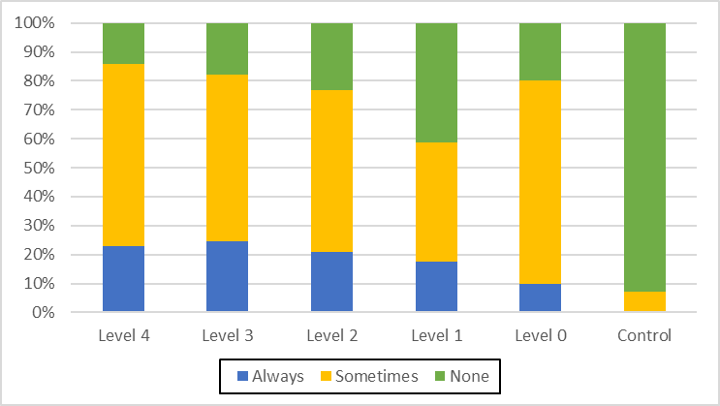
Figure S1-16. Prevalence of "Dropping things in the hand" (Q27) in each sensory disturbance level (χ²(10) =162.2, p=0.000)

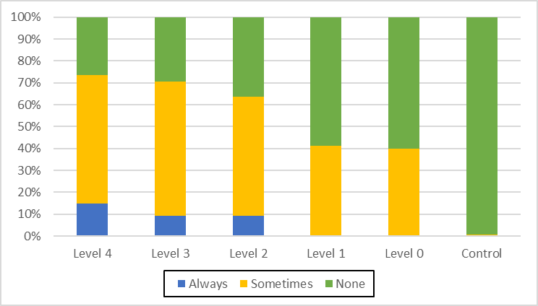
Figure S1-17. Prevalence of "Dropping chopsticks while eating" (Q28) in each sensory disturbance level (χ²(10) =139.7, p=0.000)

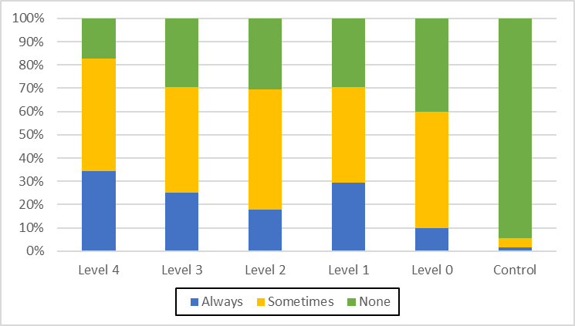
Figure S1-18. Prevalence of "Hand tremor while moving" (Q32) in each sensory disturbance level (χ²(10) =142.5, p=0.000)

Table S1-1. Threshold of "minimal tactile sense" in each touch disturbance type by examination (Evaluator size = log([gram]) + 4)
 | Lower lip | Chest | Index finger (R) | Index finger (L) | Great toe (R) | Great toe (L)
General (V) | 3.66±0.79 (n=14) | 4.92±0.60 (n=14) | 4.96±0.68 (n=14) | 4.98±0.72 (n=14) | 5.98±0.58 (n=14) | 5.89±0.57 (n=14)
General + 4 Limbs (IV) | 3.60±0.84 (n=21) | 4.82±0.45 (n=21) | 4.92±0.61 (n=21) | 4.93±0.76 (n=21) | 5.70±0.71 (n=21) | 5.71±0.69 (n=21)
4 Limbs (III) | 2.64±0.55 (n=120) | 4.17±0.48 (n=123) | 4.23±0.52 (n=122) | 4.20±0.58 (n=122) | 5.01±0.67 (n=122) | 5.03±0.68 (n=122)
1-3 Limb(s) (II) | 2.08±0.23 (n=17) | 3.73±0.50 (n=18) | 3.67±0.47 (n=18) | 3.67±0.34 (n=18) | 4.20±0.41 (n=18) | 4.18±0.46 (n=18)
None(I) | 2.23±0.39 (n=13) | 3.64±0.70 (n=13) | 3.71±0.39 (n=14) | 3.63±0.38 (n=14) | 4.50±0.54 (n=14) | 4.44±0.60 (n=14)
Control | 2.03±0.22 (n=185) | 2.82±0.58 (n=189) | 3.12±0.38 (n=189) | 3.04±0.35 (n=189) | 3.78±0.35 (n=189) | 3.81±0.40 (n=189)

Table S1-2. Threshold of "vibration sense" in each touch disturbance type by examination (second)
 | Chest | Wrist (R) | Wrist (L) | Ankle (R) | Ankle (L)
General (V) | 7.21±3.23 (n=14) | 6.92±4.10 (n=14) | 6.92±3.75 (n=14) | 4.78±2.39 (n=14) | 4.57±2.17 (n=14)
General + 4 Limbs (IV) | 7.86±3.05 (n=22) | 6.54±3.06 (n=22) | 6.86±3.32 (n=22) | 4.13±2.53 (n=22) | 4.18±2.55 (n=22)
4 Limbs (III) | 9.87±3.04 (n=128) | 9.42±3.47 (n=128) | 9.76±3.83 (n=128) | 6.62±2.68 (n=128) | 6.73±3.15 (n=128)
1-3 Limb(s) (II) | 11.3±2.25 (n=18) | 11.3±2.95 (n=18) | 11.7±2.96 (n=18) | 8.44±2.87 (n=18) | 8.27±2.78 (n=18)
None(I) | 12±2.80 (n=14) | 12.1±3.84 (n=14) | 12.3±4.37 (n=14) | 8.42±3.45 (n=14) | 8.71±3.87 (n=14)
Control | 14.8±2.87 (n=196) | 16.8±3.08 (n=196) | 17.2±2.86 (n=196) | 13.7±3.55 (n=196) | 13.8±3.66 (n=196)

Table S1-3. Threshold of "position sense" in each touch disturbance type by examination (mm)
 | Index finger (R Upper) | Index finger (R Lower) | Index finger (L Upper) | Index finger (L Lower)
General (V) | 22.8±21.3 (n=14) | 22.1±23.2 (n=14) | 26.0±26.3 (n=14) | 23.2±21.3 (n=14)
General + 4 Limbs (IV) | 22.5±28.1 (n=22) | 22.9±27.3 (n=22) | 23.6±29.2 (n=22) | 23.4±26.7 (n=22)
4 Limbs (III) | 8.56±5.51 (n=128) | 8.61±5.31 (n=128) | 8.30±5.19 (n=128) | 8.96±5.88 (n=128)
1-3 Limb(s) (II) | 5.55±1.61 (n=18) | 5.55±1.61 (n=18) | 5.55±1.61 (n=18) | 5.83±1.91 (n=18)
None(I) | 6.42±2.34 (n=15) | 5.71±1.81 (n=15) | 6.42±2.34 (n=15) | 6.07±2.12 (n=15)
Control | 5±0 (n=197) | 5.11±0.75 (n=197) | 5±0 (n=197) | 5±0 (n=197)
Table S1-3. (Cont.)
 | Great toe (R Upper) | Great toe (R Lower) | Great toe (L Upper) | Great toe (L Lower)
General (V) | 27.8±16.4 (n=14) | 26.7±17.9 (n=14) | 29.6±17.4 (n=14) | 27.5±17.4 (n=14)
General + 4 Limbs (IV) | 23.8±15.1 (n=22) | 24.0±17.4 (n=22) | 25.9±15.6 (n=22) | 26.1±18.7 (n=22)
4 Limbs (III) | 13.2±10.0 (n=128) | 13.1±9.61 (n=128) | 12.6±9.21 (n=128) | 13.5±9.96 (n=128)
1-3 Limb(s) (II) | 7.5±4.28 (n=18) | 8.88±6.31 (n=18) | 7.22±3.07 (n=18) | 7.5±3.09 (n=18)
None(I) | 8.66±7.89 (n=15) | 9±6.03 (n=15) | 8±7.74 (n=15) | 8.33±5.87 (n=15)
Control | 5.15±1.06 (n=197) | 5.03±0.43 (n=197) | 5.07±0.61 (n=197) | 5.03±0.43 (n=197)

Table S1-4. Threshold of "" in each touch disturbance type by examination (degree)
 | Lower lip | Index finger (R) | Index finger (L)
General (V) | 31.3±12.8 (n=14) | 35.8±9.16 (n=14) | 36.7±8.06 (n=14)
General + 4 Limbs (IV) | 17.6±13.3 (n=22) | 28.2±13.7 (n=22) | 29.9±12.8 (n=22)
4 Limbs (III) | 9.29±10.1 (n=128) | 15.4±13.7 (n=128) | 16.4±14.5 (n=128)
1-3 Limb(s) (II) | 4.94±3.84 (n=18) | 7.5±5.45 (n=18) | 8.61±8.38 (n=18)
None(I) | 3.78±1.36 (n=15) | 4.78±1.88 (n=15) | 6.42±5.72 (n=15)
Control | 2.11±0.98 (n=197) | 2.82±1.20 (n=197) | 3.04±1.55 (n=197)

Table S1-5. Threshold of visual field by Goldmann's perimeter in each touch disturbance type by examination (dB)
 | Right otolateral | Right nasal | Left otolateral | Left nasal
General (V) | 72.5±20.5 (n=12) | 51.7±14.4 (n=12) | 72.9±16.0 (n=12) | 56.1±11.1 (n=12)
General + 4 Limbs (IV) | 73.8±13.7 (n=20) | 51.7±10.1 (n=20) | 70.5±13.2 (n=20) | 53.3±10.5 (n=20)
4 Limbs (III) | 82.8±8.69 (n=119) | 57.4±9.33 (n=118) | 80.3±10.2 (n=119) | 59.0±7.62 (n=119)
1-3 Limb(s) (II) | 85.2±7.88 (n=18) | 59.8±8.05 (n=18) | 81.4±9.28 (n=17) | 59.2±6.58 (n=17)
None(I) | 85.3±9.63 (n=14) | 59.1±9.02 (n=14) | 81.3±10.8 (n=13) | 61.3±6.89 (n=13)

Table S1-6. Auditory acuity by audiometer in each touch disturbance type by examination
 | Right ear | Left ear
General (V) | 33.9±12.6 (n=14) | 41.7±14.9 (n=14)
General + 4 Limbs (IV) | 46.2±26.2 (n=22) | 45.6±26.7 (n=22)
4 Limbs (III) | 30.8±15.8 (n=128) | 31.3±18.1 (n=128)
1-3 Limb(s) (II) | 20.5±10.8 (n=18) | 21.7±11.0 (n=18)
None(I) | 25.7±12.6 (n=15) | 27.4±14.9 (n=15)

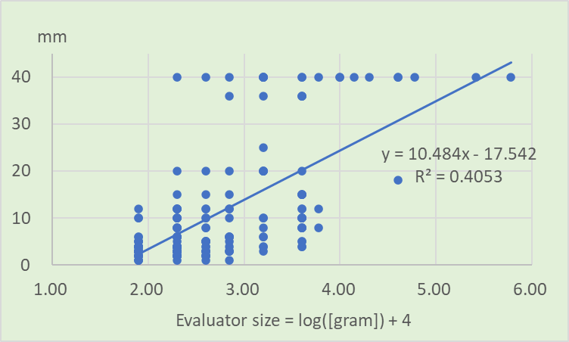
Figure S2-1. Relation between minimal tactile sense and two-point discrimination sense (Lower lip) - Exposed group (n=184).
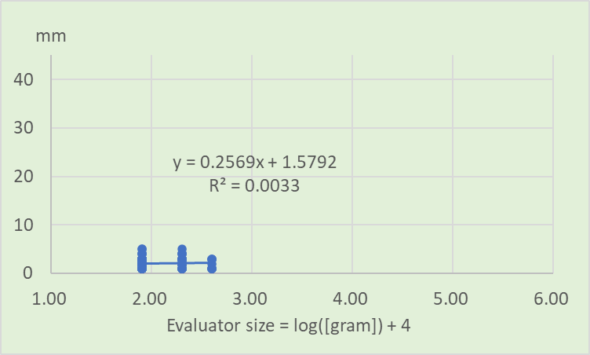
Figure S2-2. Relation between minimal tactile sense and two-point discrimination sense (Lower lip) - Control group (n=128).
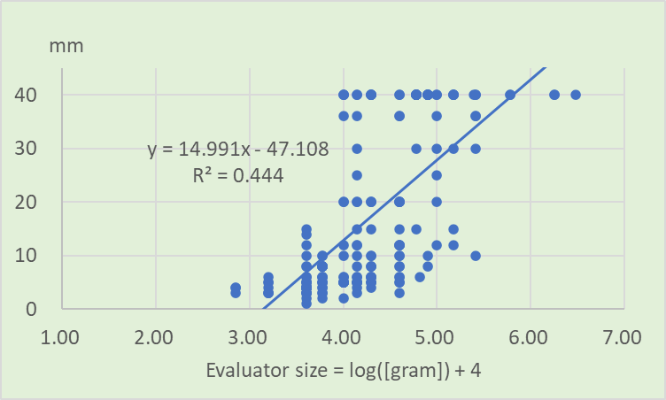
Figure S2-3. Relation between minimal tactile sense and two-point discrimination sense (Right index finger) - Exposed group (n=188).

Figure S2-4. Relation between minimal tactile sense and two-point discrimination sense (Right index finger) - Control group (n=126).

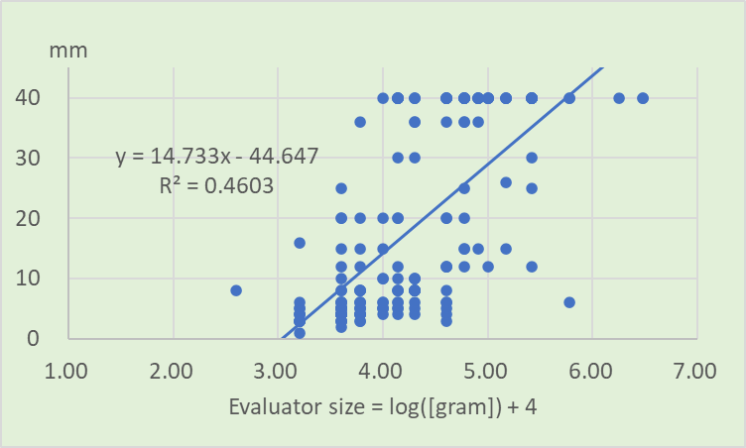
Figure S2-5. Relation between minimal tactile sense and two-point discrimination sense (Left index finger) - Exposed group (n=188).
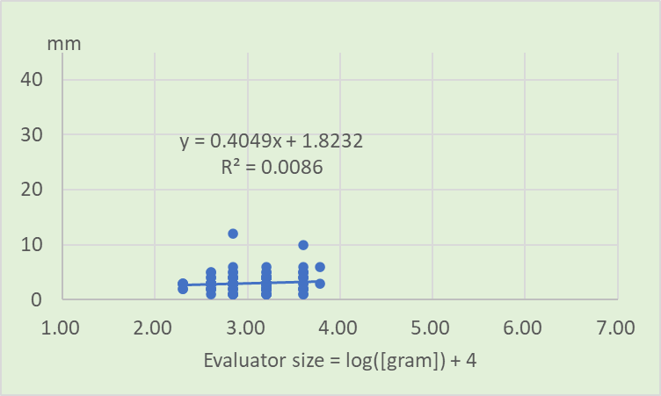
Figure S2-6. Relation between minimal tactile sense and two-point discrimination sense (Left index finger) - Control group (n=127).

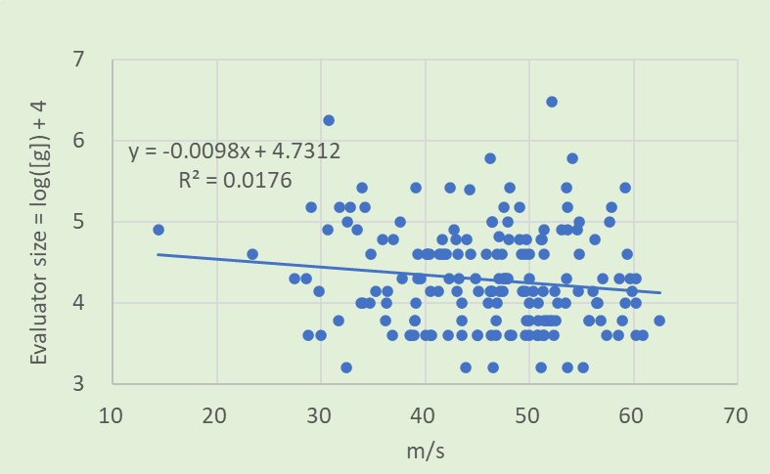

Figure S3-1. Threshold of minimal tactile sense in right index finger and SCV in right median nerve (n=179)
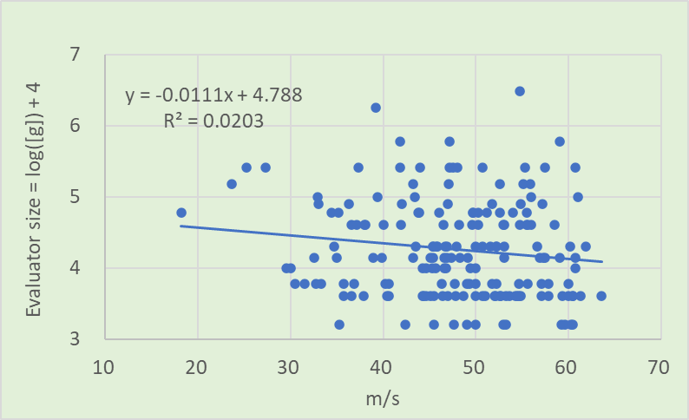

Figure S3-2. Threshold of minimal tactile sense in left index finger and SCV in left median nerve (n=179)
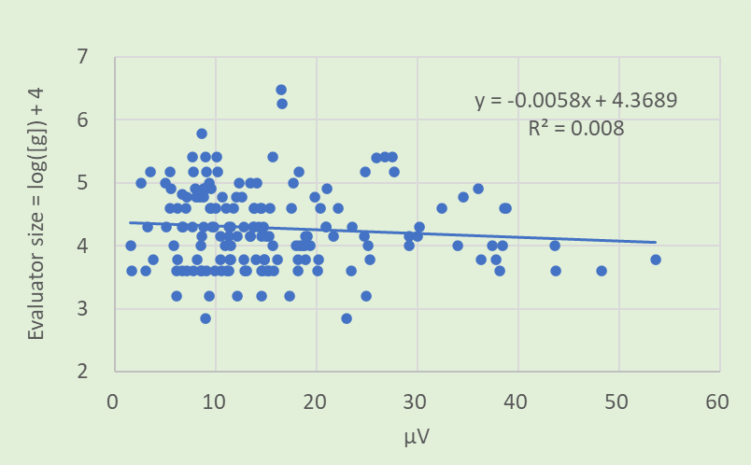

Figure S3-3. Threshold of minimal tactile sense in right index finger and SCA in right median nerve (n=165)
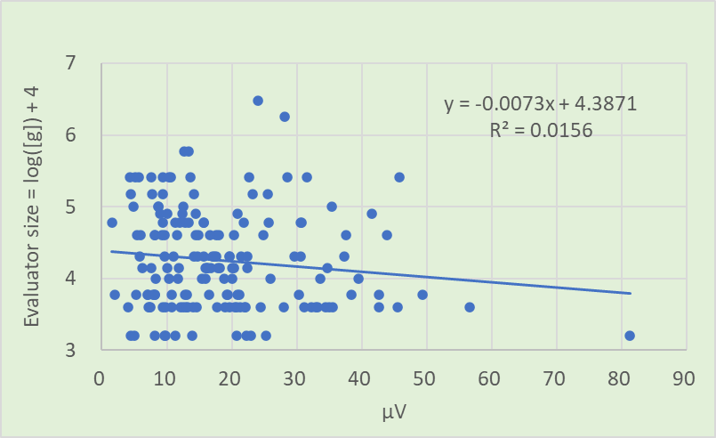

Figure S3-4. Threshold of minimal tactile sense in left index finger and SCA in left median nerve (n=165)

Table S2-1 Beta coefficient and 95% confidence interval in multivariate analysis on the data of Figure S3-1
 | β  Coefficient | 95% Conf. Interval | p-value
Velocity | 0.0021 | (-0.009 to 0.013) | 0.720
Age | 0.0189 | (0.010 to 0.027) | 0.000
Sex | -0.1919 | (-0.377 to -0.006) | 0.043
Complications | 0.2065 | (0.002 to 0.410) | 0.047

Table S2-2 Beta coefficient and 95% confidence interval in multivariate analysis on the data of Figure S3-2
 | β  Coefficient | 95% Conf. Interval | p-value
Velocity | 0.0035 | (-0.009 to 0.015) | 0.584
Age | 0.0198 | (0.010 to 0.029) | 0.000
Sex | -0.2025 | (-0.399 to -0.005) | 0.044
Complications | 0.2655 | (0.041 to 0.489) | 0.021

Table S2-3 Beta coefficient and 95% confidence interval in multivariate analysis on the data of Figure S3-3
 | β Coefficient | 95% Conf. Interval | p-value
Amplitude | 0.0027 | (-0.007 to 0.012) | 0.609
Age | 0.0204 | (0.010 to 0.030) | 0.000
Sex | -0.1537 | (-0.349 to 0.041) | 0.123
Complications | 0.2265 | (0.029 to 0.423) | 0.025

Table S2-4 Beta coefficient and 95% confidence interval in multivariate analysis on the data of Figure S3-4
 | β Coefficient | 95% Conf. Interval | p-value
Amplitude | 0.0005 | (-0.009 to 0.010) | 0.991
Age | 0.2104 | (0.010 to 0.031) | 0.000
Sex | -0.1615 | (-0.376 to 0.053) | 0.140
Complications | 0.2593 | (0.046 to 0.471) | 0.017

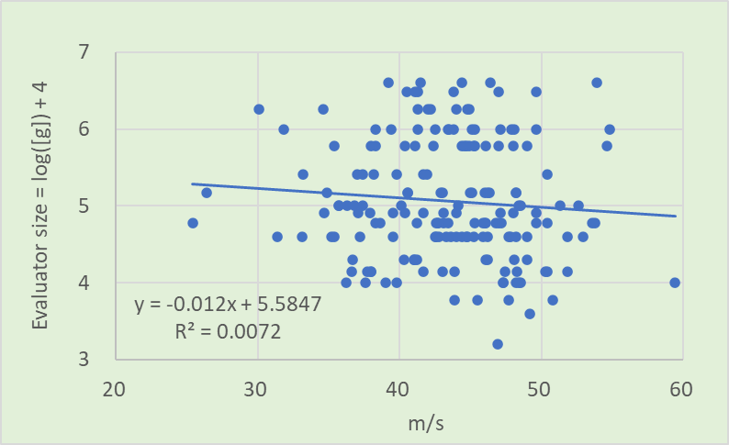

Figure S3-5. Threshold of minimal tactile sense in right toe and SCV in right sural nerve (n=175)
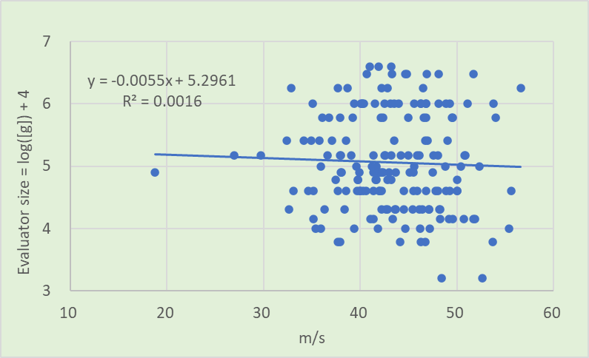

Figure S3-6. Threshold of minimal tactile sense in left toe and SCV in left sural nerve (n=175)
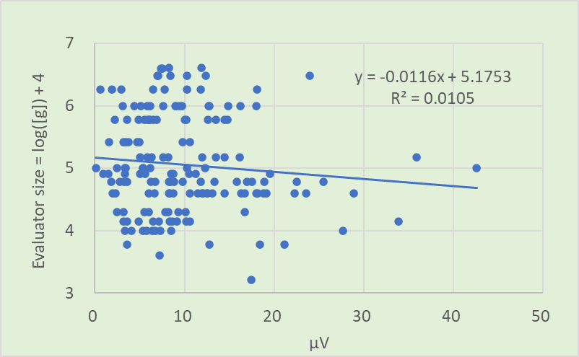

Figure S3-7. Threshold of minimal tactile sense in right toe and SCA in right sural nerve (n=163)
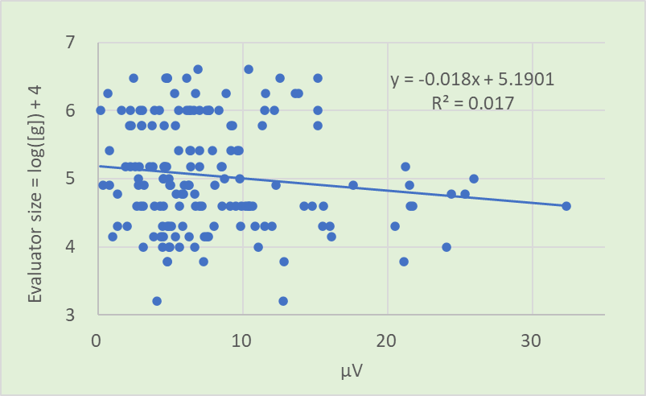

Figure S3-8. Threshold of minimal tactile sense in left toe and SCA in left sural nerve (n=163)

Table S2-5 Beta coefficient and 95% confidence interval in multivariate analysis on the data of Figure S3-5
 | β Coefficient | 95% Conf. Interval | p-value
Velocity | -0.0040 | （-0.024 to 0.016) | 0.710
Age | 0.0215 | (0.010 to 0.032) | 0.000
Sex | -0.2465 | (-0.476 to -0.016) | 0.036
Complications | 0.2844 | (0.046 to 0.522) | 0.019

Table S2-6 Beta coefficient and 95% confidence interval in multivariate analysis on the data of Figure S3-6
 | β Coefficient | 95% Conf. Interval | p-value
Velocity | -0.0005 | （-0.021 to 0.020) | 0.961
Age | 0.0197 | (0.008 to 0.030) | 0.001
Sex | -0.2551 | (-0.490 to -0.019) | 0.034
Complications | 0.3490 | (0.108 to 0.589) | 0.005

Table S2-7 Beta coefficient and 95% confidence interval in multivariate analysis on the data of Figure S3-7
 | β Coefficient | 95% Conf. Interval | p-value
Amplitude | 0.0033 | （-0.014 to 0.021) | 0.721
Age | 0.0232 | (0.010 to 0.035) | 0.000
Sex | -0.2057 | (-0.446 to -0.035) | 0.094
Complications | 0.3203 | (0.076 to 0.563) | 0.010

Table S2-8 Beta coefficient and 95% confidence interval in multivariate analysis on the data of Figure S3-8
 | β Coefficient | 95% Conf. Interval | p-value
Amplitude | -0.0047 | （-0.026 to 0.016) | 0.667
Age | 0.0193 | (0.006 to 0.031) | 0.003
Sex | -0.2524 | (-0.495 to -0.009) | 0.042
Complications | 0.3725 | (0.127 to 0.617) | 0.003

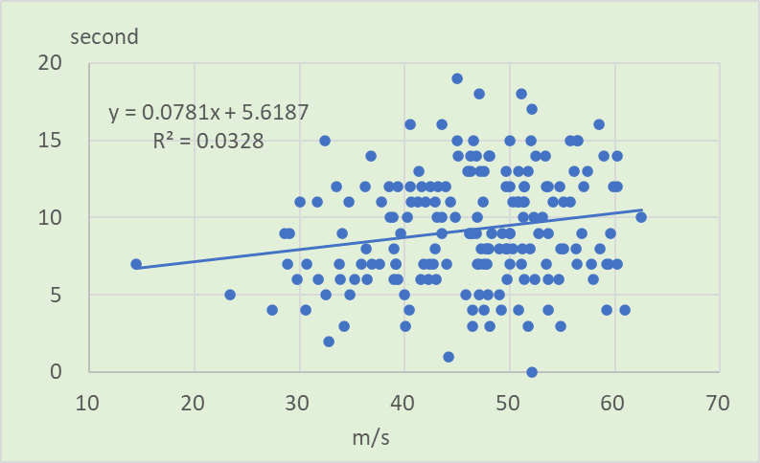

Figure S4-1. Threshold of vibration sense in right wrist and SCV in right median nerve (n=185)
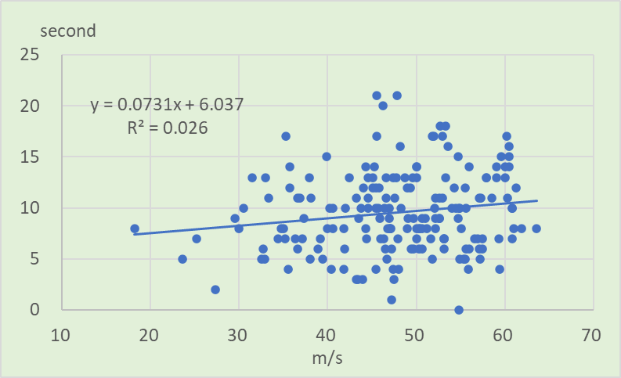

Figure S4-2. Threshold of vibration sense in left wrist and SCV in left median nerve (n=185)
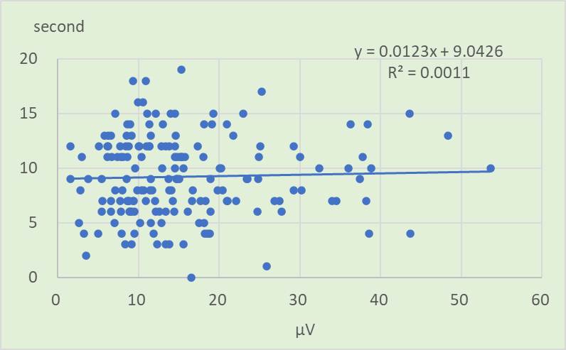

Figure S4-3. Threshold of vibration sense in right wrist and SCA in right median nerve (n=171)
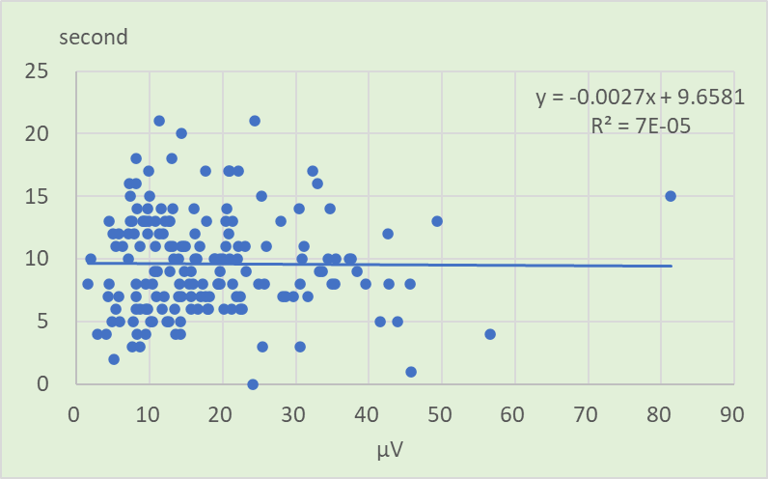

Figure S4-4. Threshold of vibration sense in left wrist and SCA in left median nerve (n=171)

Table S3-1 Beta coefficient and 95% confidence interval in multivariate analysis on the data of Figure S4-1
 | β Coefficient | 95% Conf. Interval | p-value
Velocity | 0.0335 | （-0.033 to 0.100) | 0.327
Age | -0.0724 | (-0.124 to -0.020) | 0.007
Sex | 0.8622 | (-0.221 to 1.945) | 0.118
Complications | -0.7628 | (-1.944 to 0.419) | 0.205

Table S3-2 Beta coefficient and 95% confidence interval in multivariate analysis on the data of Figure S4-2
 | β Coefficient | 95% Conf. Interval | p-value
Velocity | 0.0275 | (-0.044 to 0.099) | 0.455
Age | -0.0936 | (-0.149 to -0.037) | 0.001
Sex | 0.8160 | (-0.326 to 1.958) | 0.160
Complications | -0.4842 | (-1.772 to 0.804) | 0.459

Table S3-3 Beta coefficient and 95% confidence interval in multivariate analysis on the data of Figure S4-3
 | β Coefficient | 95% Conf. Interval | p-value
Amplitude | -0.0175 | （-0.079 to 0.044) | 0.575
Age | -0.0709 | (-0.128 to -0.012) | 0.017
Sex | 1.0360 | (-0.121 to 2.193) | 0.079
Complications | -1.2193 | (-2.389 to -0.049) | 0.041

Table S3-4 Beta coefficient and 95% confidence interval in multivariate analysis on the data of Figure S4-4
 | β Coefficient | 95% Conf. Interval | p-value
Amplitude | -0.0363 | (-0.092 to 0.020) | 0.206
Age | -0.1023 | (-0.165 to -0.039) | 0.002
Sex | 0.7654 | (-0.499 to 2.029) | 0.234
Complications | -0.9630 | (-2.215 to 0.289) | 0.131

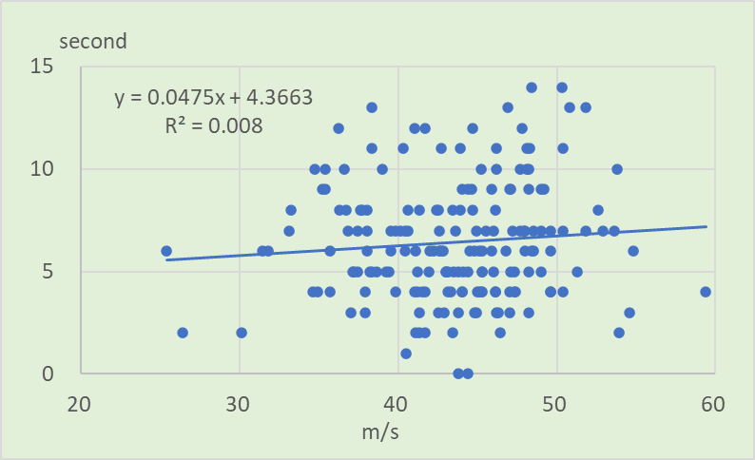

Figure S4-5. Threshold of vibration sense in right ankle and SCV in right sural nerve (n=179)
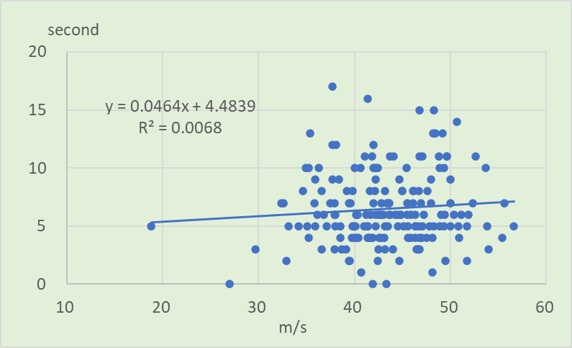

Figure S4-6. Threshold of vibration sense in left ankle and SCV in left sural nerve (n=180)
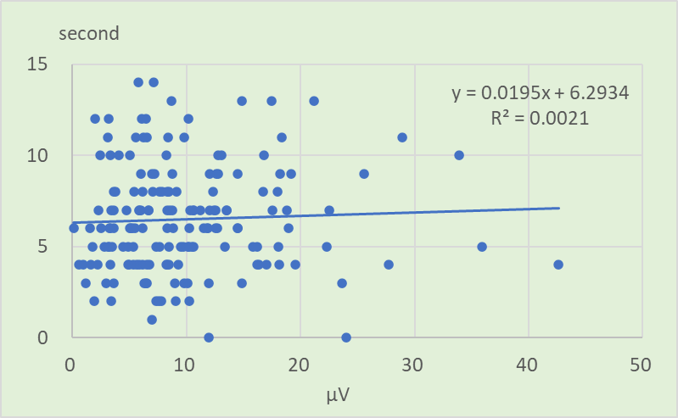

Figure S4-7. Threshold of vibration sense in right ankle and SCA in right sural nerve (n=167)
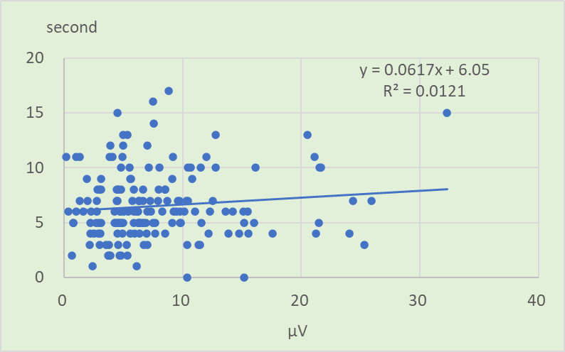

Figure S4-8. Threshold of vibration sense in left ankle and SCA in left sural nerve (n=167)

Table S3-5 Beta coefficient and 95% confidence interval in multivariate analysis on the data of Figure S4-5
 | β Coefficient | 95% Conf. Interval | p-value
Velocity | 0.0257 | (-0.051 to 0.102) | 0.512
Age | -0.0949 | (-0.135 to -0.054) | 0.000
Sex | 1.0058 | (0.164 to 1.847) | 0.019
Complications | -0.6904 | (-1.555 to 0.174) | 0.117

Table S3-6 Beta coefficient and 95% confidence interval in multivariate analysis on the data of Figure S4-6
 | β Coefficient | 95% Conf. Interval | p-value
Velocity | 0.0355 | (-0.044 to 0.115) | 0.383
Age | -0.1191 | (-0.162 to -0.075) | 0.000
Sex | 0.9899 | (0.077 to 1.902) | 0.034
Complications | -0.4675 | (-1.394 to 0.459) | 0.321

Table S3-7 Beta coefficient and 95% confidence interval in multivariate analysis on the data of Figure S4-7
 | β Coefficient | 95% Conf. Interval | p-value
Amplitude | -0.0304 | (-0.096 to 0.036) | 0.368
Age | -0.0965 | (-0.142 to -0.050) | 0.000
Sex | 1.0818 | (0.197 to 1.966) | 0.017
Complications | -0.8948 | (-1.788 to -0.000) | 0.050

Table S3-8 Beta coefficient and 95% confidence interval in multivariate analysis on the data of Figure S4-8
 | β Coefficient | 95% Conf. Interval | p-value
Amplitude | -0.0002 | (-0.086 to 0.085) | 0.996
Age | -0.1129 | (-0.162 to -0.062) | 0.000
Sex | 1.0901 | (0.135 to 2.045) | 0.026
Complications | -0.6522 | (-1.612 to 0.307) | 0.182

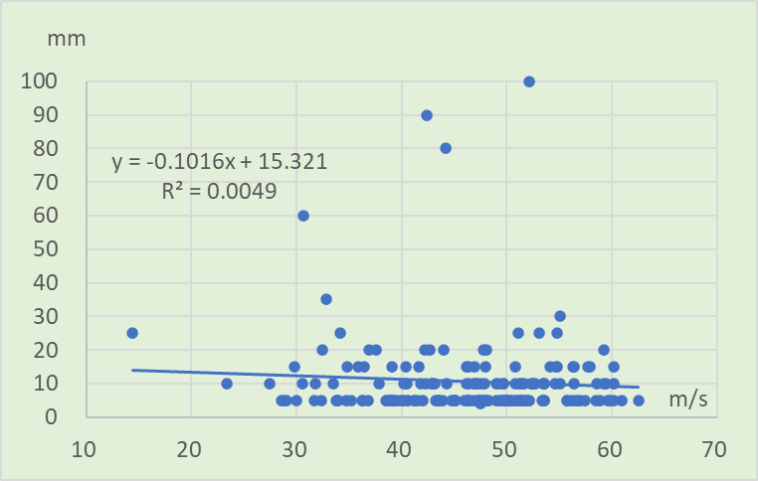

Figure S5-1. Threshold of upper position sense in right index finger and SCV in right median nerve (n=183)
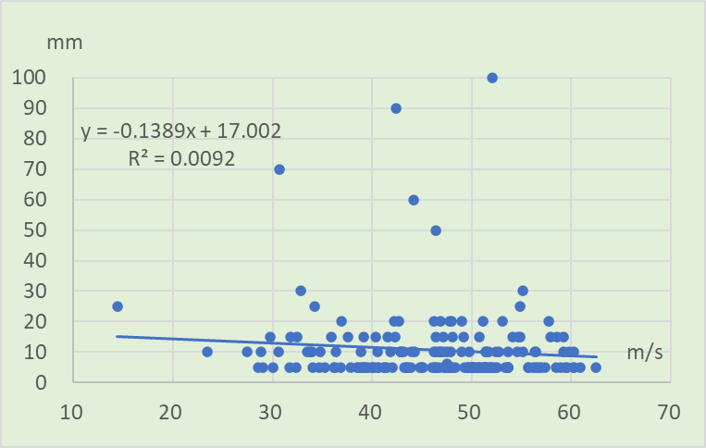

Figure S5-2. Threshold of lower position sense in left index finger and SCV in left median nerve (n=183)
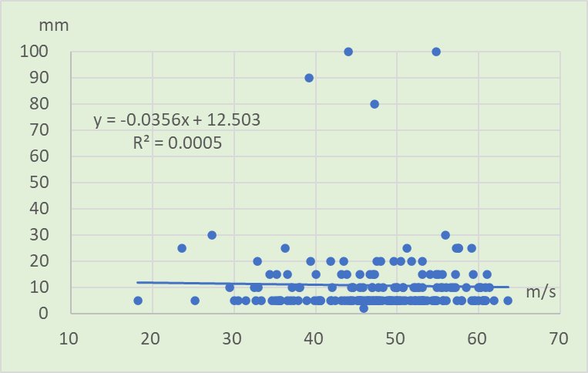

Figure S5-3. Threshold of upper position sense in left index finger and SCV in left median nerve (n=183)
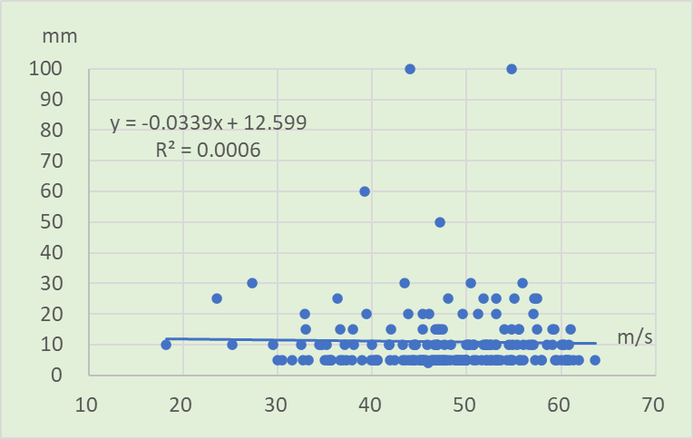

Figure S5-4. Threshold of lower position sense in left index finger and SCV in left median nerve (n=183)

 | β Coefficient | 95% Conf. Interval | p-value
Velocity | 0.0557 | （-0.174 to 0.285) | 0.663
Age | 0.2141 | (0.035 to 0.393) | 0.019
Sex | -4.6799 | (-8.392 to -0.967) | 0.014
Complications | 2.8550 | (-1.216 to 6.926) | 0.168
Table S4-1 Beta coefficient and 95% confidence interval in multivariate analysis on the data of Figure S5-1

Table S4-2 Beta coefficient and 95% confidence interval in multivariate analysis on the data of Figure S5-2
 | β Coefficient | 95% Conf. Interval | p-value
Velocity | 0.0102 | (-0.217 to 0.237) | 0.929
Age | 0.2408 | (0.063 to 0.417) | 0.008
Sex | -5.4755 | (-9.148 to -1.802) | 0.004
Complications | 1.8874 | (-2.140 to 5.915) | 0.356

Table S4-3 Beta coefficient and 95% confidence interval in multivariate analysis on the data of Figure S5-3
 | β Coefficient | 95% Conf. Interval | p-value
Velocity | 0.1464 | (-0.107 to 0.400) | 0.258
Age | 0.2706 | (0.073 to 0.467) | 0.007
Sex | -5.5235 | (-9.543 to -1.503) | 0.007
Complications | 3.2714 | (-1.284 to 7.827) | 0.158

Table S4-4 Beta coefficient and 95% confidence interval in multivariate analysis on the data of Figure S5-4
 | β Coefficient | 95% Conf. Interval | p-value
Velocity | 0.1387 | (-0.087 to 0.364) | 0.227
Age | 0.2645 | (0.089 to 0.439) | 0.003
Sex | -5.5939 | (-9.163 to -2.024) | 0.002
Complications | 2.9815 | (-1.064 to 7.027) | 0.148

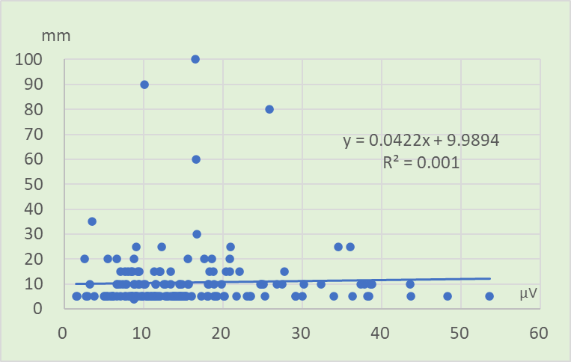

Figure S5-5. Threshold of upper position sense in right index finger and SCA in right median nerve (n=169)
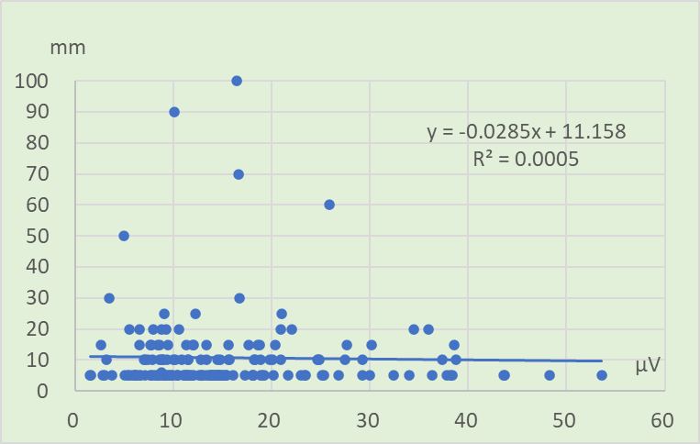

Figure S5-6. Threshold of lower position sense in right index finger and SCA in right median nerve (n=169)
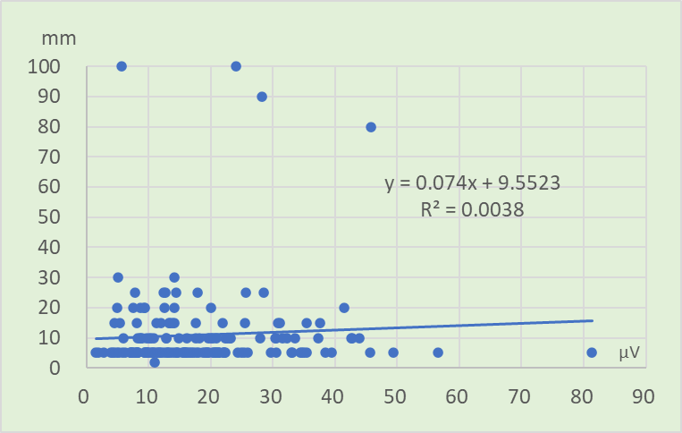

Figure S5-7. Threshold of upper position sense in left index finger and SCA in left median nerve (n=169)
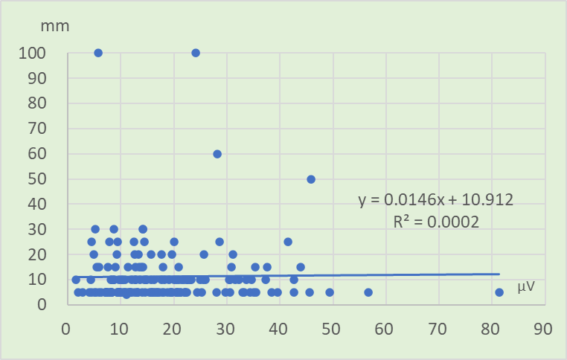

Figure S5-8. Threshold of lower position sense in left index finger and SCA in left median nerve (n=169)

Table S4-5 Beta coefficient and 95% confidence interval in multivariate analysis on the data of Figure S5-5
 | β Coefficient | 95% Conf. Interval | p-value
Amplitude | 0.1260 | （-0.087 to 0.339) | 0.245
Age | 0.2523 | (0.050 to 0.454) | 0.015
Sex | -4.2737 | (-8.298 to -0.249) | 0.038
Complications | 3.1907 | (-0.883 to 7.264) | 0.124

Table S4-6 Beta coefficient and 95% confidence interval in multivariate analysis on the data of Figure S5-6
 | β Coefficient | 95% Conf. Interval | p-value
Amplitude | 0.0312 | (-0.180 to 0.242) | 0.772
Age | 0.2578 | (0.056 to 0.458) | 0.012
Sex | -5.4688 | (-9.465 to -1.472) | 0.008
Complications | 2.2571 | (-1.788 to 6.302) | 0.272

Table S4-7 Beta coefficient and 95% confidence interval in multivariate analysis on the data of Figure S5-7
 | β Coefficient | 95% Conf. Interval | p-value
Amplitude | 0.1572 | (-0.043 to 0.357) | 0.123
Age | 0.3215 | (0.096 to 0.546) | 0.005
Sex | -4.4471 | (-8.948 to 0.053) | 0.053
Complications | 3.1740 | (-1.291 to 7.639) | 0.162

Table S4-8 Beta coefficient and 95% confidence interval in multivariate analysis on the data of Figure S5-8
 | β Coefficient | 95% Conf. Interval | p-value
Amplitude | 0.0752 | (-0.102 to 0.253) | 0.406
Age | 0.2931 | (0.093 to 0.492) | 0.004
Sex | -5.2218 | (-9.223 to -1.220) | 0.011
Complications | 2.7828 | (-1.187 to 6.753) | 0.168

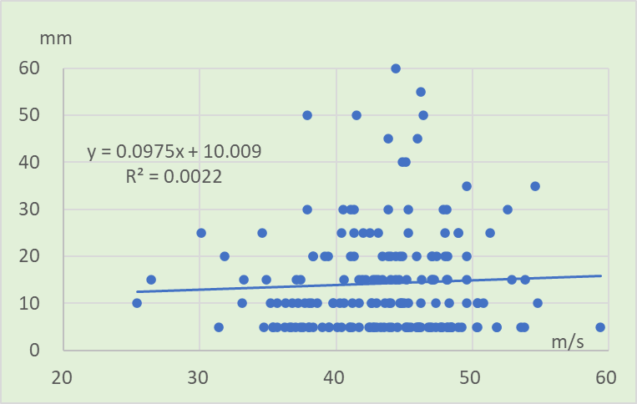

Figure S5-9. Threshold of upper position sense in right toe and SCV in right sural nerve (n=179)
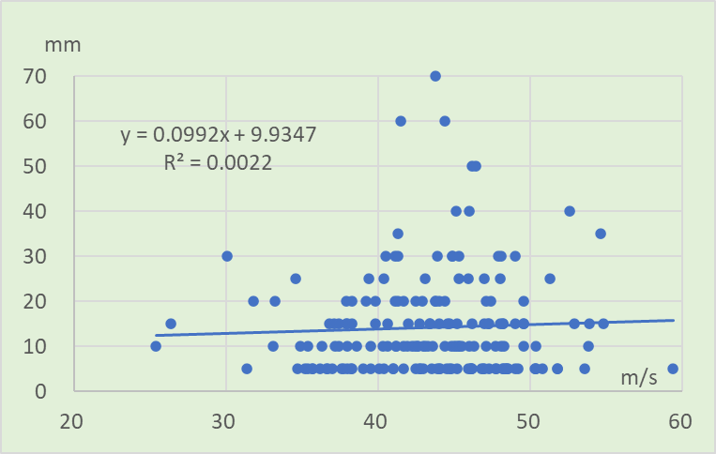

Figure S5-10. Threshold of lower position sense in right toe and SCV in right sural nerve (n=179)
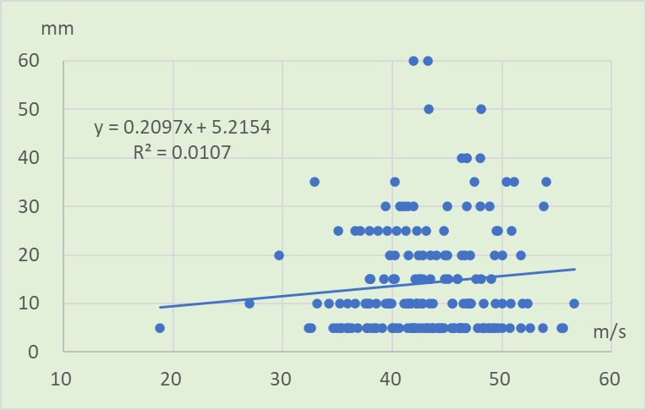

Figure S5-11. Threshold of upper position sense in left toe and SCV in left sural nerve (n=181)
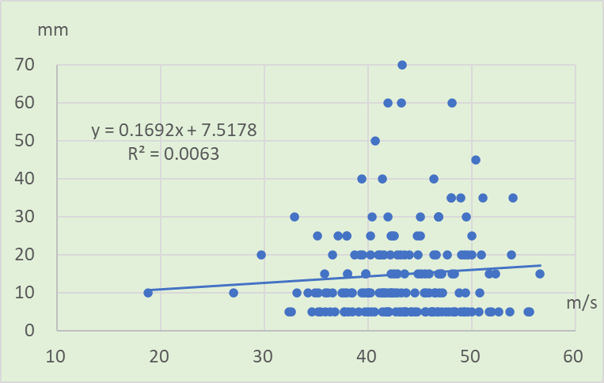

Figure S5-12. Threshold of lower position sense in left toe and SCV in left sural nerve (n=181)

Table S4-9 Beta coefficient and 95% confidence interval in multivariate analysis on the data of Figure S5-9
 | β Coefficient | 95% Conf. Interval | p-value
Amplitude | 0.1461 | （-0.163 to 0.455) | 0.353
Age | 0.3008 | (0.137 to 0.464) | 0.000
Sex | -3.2965 | (-6.677 to 0.084) | 0.056
Complications | 1.3931 | (-2.081 to 4.868) | 0.430

Table S4-10 Beta coefficient and 95% confidence interval in multivariate analysis on the data of Figure S5-10
 | β Coefficient | 95% Conf. Interval | p-value
Amplitude | 0.0910 | (-0.229 to 0.411) | 0.577
Age | 0.2179 | (0.048 to 0.387) | 0.012
Sex | -4.2582 | (-7.761 to -0.755) | 0.017
Complications | 1.0185 | (-2.582 to 4.619) | 0.577

Table S4-11 Beta coefficient and 95% confidence interval in multivariate analysis on the data of Figure S5-11
 | β Coefficient | 95% Conf. Interval | p-value
Amplitude | 0.1873 | (-0.109 to 0.484) | 0.215
Age | 0.3033 | (0.141 to 0.464) | 0.000
Sex | -4.8254 | (-8.204 to -1.446) | 0.005
Complications | 1.4106 | (-2.034 to 4.856) | 0.420

Table S4-12 Beta coefficient and 95% confidence interval in multivariate analysis on the data of Figure S5-12
 | β Coefficient | 95% Conf. Interval | p-value
Amplitude | 0.1254 | (-0.192 to 0.443) | 0.438
Age | 0.2702 | (0.097 to -0.442) | 0.002
Sex | -5.1382 | (-8.752 to -1.523) | 0.006
Complications | 1.0776 | (-2.607 to 4.762) | 0.565

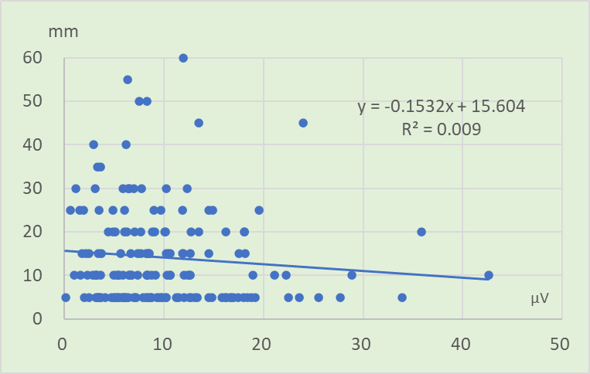

Figure S5-13. Threshold of upper position sense in right toe and SCA in right sural nerve (n=167)
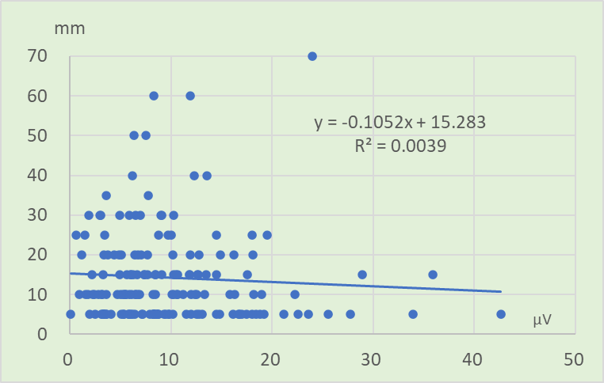

Figure S5-14. Threshold of lower position sense in right toe and SCA in right sural nerve (n=167)
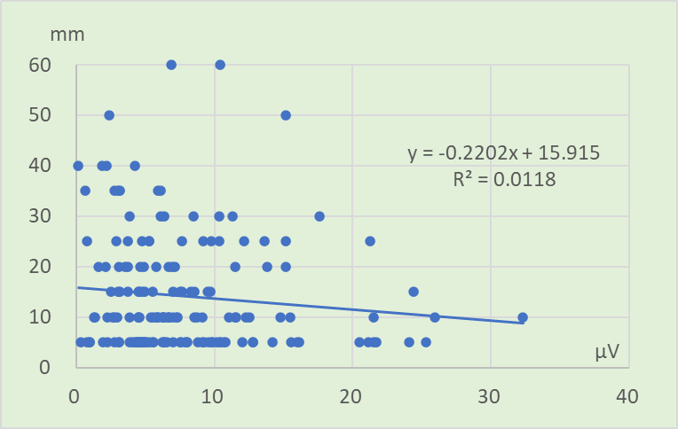

Figure S5-15. Threshold of upper position sense in left toe and SCA in left sural nerve (n=168)
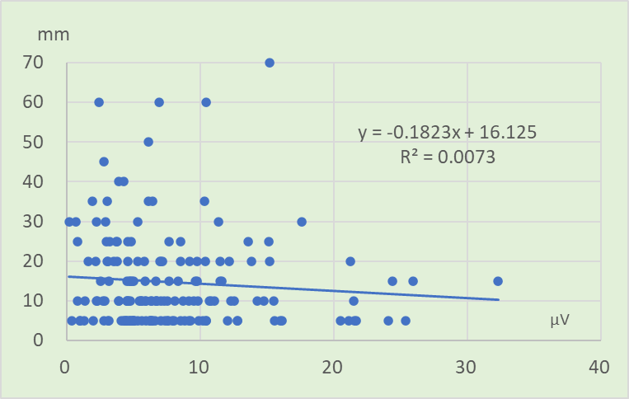

Figure S5-16. Threshold of lower position sense in left toe and SCA in left sural nerve (n=168)

Table S4-13 Beta coefficient and 95% confidence interval in multivariate analysis on the data of Figure S5-13
 | β Coefficient | 95% Conf. Interval | p-value
Amplitude | -0.0641 | （-330 to 0.201) | 0.635
Age | 0.2310 | (0.045 to 0.416) | 0.015
Sex | -3.4005 | (-6.939 to 0.137) | 0.060
Complications | 0.9923 | (-2.584 to 4.569) | 0.585

Table S4-14 Beta coefficient and 95% confidence interval in multivariate analysis on the data of Figure S5-14
 | β Coefficient | 95% Conf. Interval | p-value
Amplitude | -0.4650 | (-0.325 to 0.232) | 0.743
Age | 0.2063 | (0.012 to -0.400) | 0.038
Sex | -4.4357 | (-8.149 to -0.721) | 0.020
Complications | 0.7919 | (-2.962 to 4.546) | 0.678

Table S4-15 Beta coefficient and 95% confidence interval in multivariate analysis on the data of Figure S5-15
 | β Coefficient | 95% Conf. Interval | p-value
Amplitude | -0.1236 | (-0.446 to 0.199) | 0.451
Age | 0.2607 | (0.074 to 0.447) | 0.006
Sex | -5.0349 | (-8.602 to -1.467) | 0.006
Complications | 0.9088 | (-2.692 to 4.510) | 0.619

Table S4-16 Beta coefficient and 95% confidence interval in multivariate analysis on the data of Figure S5-16
 | β Coefficient | 95% Conf. Interval | p-value
Amplitude | -0.1205 | (-0.465 to 0.224) | 0.491
Age | 0.2156 | (-0.016 to -0.414) | 0.034
Sex | -5.2980 | (-9.106 to -1.488) | 0.007
Complications | 0.7509 | (-3.094 to 4.595) | 0.586

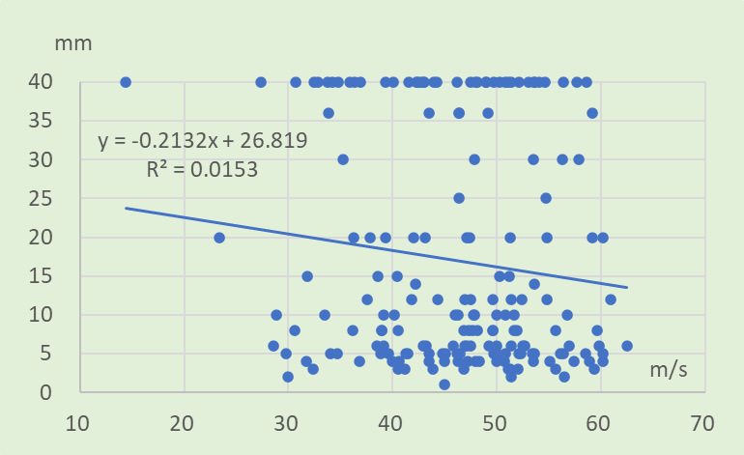

Figure S6-1. Threshold of two-point discrimination sense in right index finger and SCV in right median nerve (n=182)
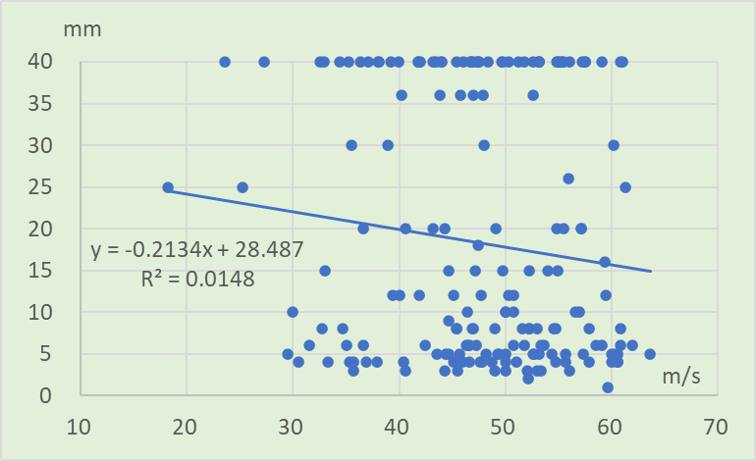

Figure S6-2. Threshold of two-point discrimination sense in left index finger and SCV in left median nerve (n=182)
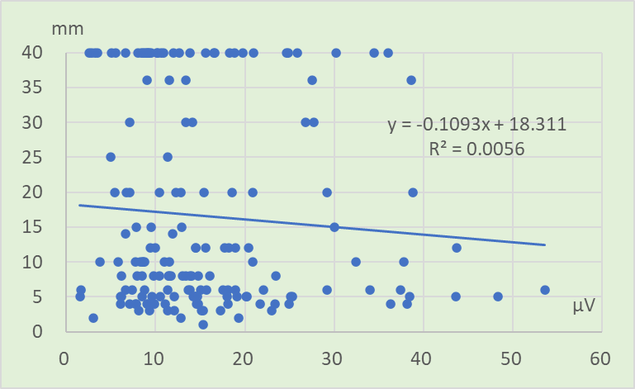

Figure S6-3. Threshold of two-point discrimination sense in right index finger and SCA in right median nerve (n=168)
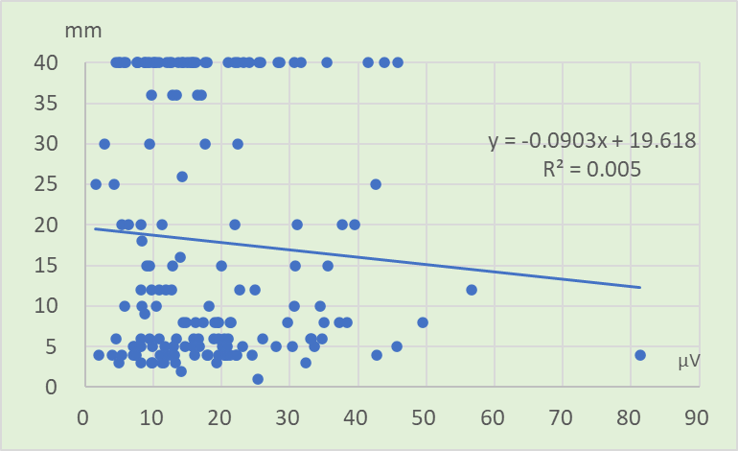

Figure S6-4. Threshold of two-point discrimination sense in left index finger and SCA in left median nerve (n=168)

Table S5-1 Beta coefficient and 95% confidence interval in multivariate analysis on the data of Figure S6-1
 | β Coefficient | 95% Conf. Interval | p-value
Amplitude | -0.0279 | （-0.262 to 0.236) | 0.835
Age | 0.4754 | (0.270 to 0.680) | 0.000
Sex | -3.5775 | (-7.822 to 0.667) | 0.098
Complications | 1.1543 | (-3.495 to 5.803) | 0.625

Table S5-2 Beta coefficient and 95% confidence interval in multivariate analysis on the data of Figure S6-2
 | β Coefficient | 95% Conf. Interval | p-value
Amplitude | -0.0264 | (-0.302 to 0.249) | 0.850
Age | 0.4828 | (0.266 to 0.698) | 0.000
Sex | -4.3877 | (-8.769 to -0.006) | 0.050
Complications | 0.8757 | (-4.072 to 5.823) | 0.727

Table S5-3 Beta coefficient and 95% confidence interval in multivariate analysis on the data of Figure S6-3
 | β Coefficient | 95% Conf. Interval | p-value
Amplitude | 0.0083 | （-0.226 to 0.243) | 0.944
Age | 0.4341 | (0.208 to 0.659) | 0.000
Sex | -3.7259 | (-8.179 to 0.727) | 0.100
Complications | 1.0941 | (-3.399 to 5.588) | 0.631

Table S5-4 Beta coefficient and 95% confidence interval in multivariate analysis on the data of Figure S6-4
 | β Coefficient | 95% Conf. Interval | p-value
Amplitude | -0.0024 | (-0.214 to 0.209) | 0.983
Age | 0.4435 | (0.202 to 0.684) | 0.000
Sex | -4.7731 | (-9.553 to 0.007) | 0.050
Complications | 1.0460 | (-3.679 to 5.771) | 0.663

