ELECTRONIC SUPPORTING INFORMATION
Breathable Iron-based MIL–88 Framework as Dyes Adsorbent in Aqueous Solution
Dita A. Nurani ^{1,2}, Nabila Anisa ^{1,2,†}, Irena Khatrin ^{1,2,†}, Yasmine ^{1,2}, Grandprix T. M. Kadja ^{3,4,5}, Yuni K. Krisnandi ^{1,2,}*
¹ Department of Chemistry, Faculty of Mathematics and Natural Science, Universitas Indonesia, Depok 16424, Indonesia; d.arifa@sci.ui.ac.id (D.A.N); nabilaanisaa30@gmail.com (N.A.); irena.khatrin@sci.ui.ac.id (I.K.); yasaine.general@gmail.com (Y.); yuni.krisnandi@sci.ui.ac.id (Y.K.K.)
² Solid Inorganic Framework Laboratory, Department of Chemistry, Faculty of Mathematics and Natural Science, Universitas Indonesia, Depok 16424, Indonesia
³ Division of Inorganic and Physical Chemistry, Faculty of Mathematics and Natural Sciences, Institut Teknologi Bandung, Jalan Ganesha No. 10, Bandung 40132, Indonesia
⁴ Center for Catalysis and Reaction Engineering, Institut Teknologi Bandung, Jalan Ganesha No. 10, Bandung 40132, Indonesia
⁵ Research Center for Nanosciences and Nanotechnology, Institut Teknologi Bandung, Jalan Ganesha No. 10, Bandung 40132, Indonesia
† Both students share an equal amount of work
* Correspondence: yuni.krisnandi@sci.ui.ac.id; Tel.: +62 812-1856-7060

S1. Rietveld refinement on the XRD pattern of MIL-88B(Fe)
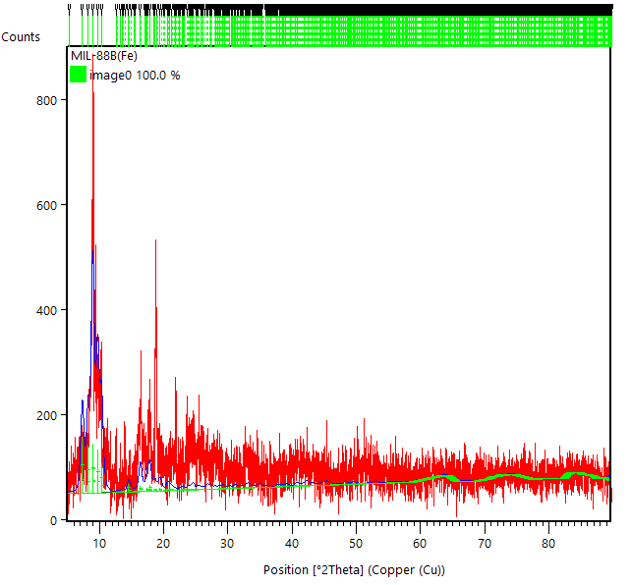
(a)

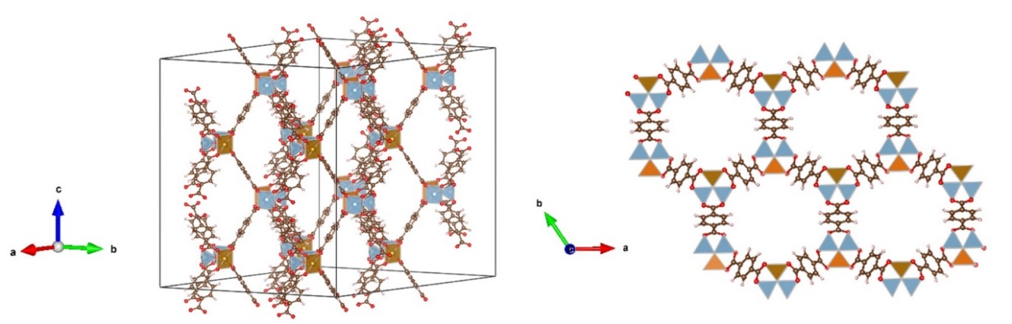
(b)

Figure S1. (a) Rietveld refinement on the XRD pattern of MIL-88B(Fe) based on the triclinic structure with P-1 space group, and (b) Predicted crystal structure of MIL-88B(Fe), with goodness of fit (defined by G = χ²) is found at 1.068.

S2. EDX Spectrum of MIL-88B(Fe)

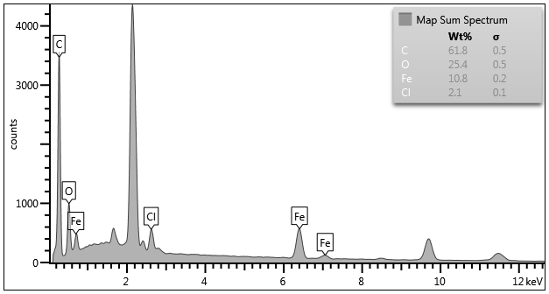
Figure S2. EDX spectrum of MIL-88B(Fe) polycrystalline crystals.

S3. N₂ physisorption Graphs

Figure S3. N₂ physisorption (a) adsorption-desorption isotherm and (b) pore size distribution of MIL-88B(Fe).

