Table S1: List of 36 clumped Hb-associated SNPs utilized in construction of Hb-PRS among Male Taiwanese Han Chinese of Taiwan Biobank
Chr | Related Genes and SNPs
1 | CHRM3/CHRM3-AS2 (lncRNA) rs891700
2 | PRKCE rs10168349, rs4952800, rs4953318; STAT1 rs41454245; BCL2L11 rs616582, rs616130
3 | LOC101927995 (ncRNA) rs9862857; PPM1M rs11717383
4 | MYOZ2 rs2168987
6 | LOC101929705 (lncRNA) rs833805; TRIM38 rs7740793
7 | CDHR3 rs11983073; RUNDC3B rs1029421
9 | ABO rs579459, rs8176741, rs4363269, rs7030248; CERCAM rs1009850
11 | PRR5L rs606442
14 | NOVA1 rs76420826
15 | ACAN rs112232636
16 | RHOT2 rs117821265; AXIN1 rs11866815; LUC7L rs1211375; HSD17B2 rs72628277
17 | MIR22HG (lncRNA) rs11078597
18 | PMAIP1 rs75766249
20 | JAG1 rs2423512
21 | PSMG1 rs9980212
22 | KCTD17/TMPRSS6 rs760719; TMPRSS6 rs2235321, rs9619658, rs9607412, rs228918; MPST rs5756490
*Hb-associated SNPs in bold were found common between Taiwanese Han Chinese and European Whites (i.e., between sex groups or across all sex groups). Chr, chromosome; Hb, hemoglobin; lncRNA, long non-coding RNA; ncRNA, non-coding RNA; PRS, polygenic risk score; SNP, single nucleotide polymorphism.

Table S2: List of 58 clumped Hb-associated SNPs utilized in construction of Hb-PRS among Female Taiwanese Han Chinese of Taiwan Biobank
Chr | Related Genes and SNPs
1 | ASH1L rs80142782; CNN3-DT (lncRNA) rs78122308, rs11165277; CAMK1G rs9430006; THEMIS2 rs2236074; DISP1 rs80162998
2 | PRKCE rs10168349, rs4952800, rs4953321; OSR1 rs7604748
3 | POMGNT2 rs938921; NLGN1 rs619092
4 | FAM47E rs1441920; AFAP1-AS1 (lncRNA) rs4689851; AC104619.2 (lncRNA) rs13128765
5 | CTNND2 rs17802003; TCF7 rs244662
6 | HBS1L rs9376090; TMEM63B rs72858128
7 | UNCX rs10277115; KIAA0895 rs79300405; STK31 rs1080935
8 | ZNF704 rs72671923
9 | ABO rs579459, rs4363269; AL589923.1 (lncRNA) rs77712720; GTF3C5 rs2283130; PUM3 rs10217194, rs4741769; EPB41L4B rs7864092
11 | FADS1 rs174555; SBF2/LOC101928008 (lncRNA) rs7946986, rs10500710; JRKL-AS1 (lncRNA) rs11021624
14 | AKAP6 rs1951681; NPAS3 rs117429775
15 | LIPC rs1800588
16 | AXIN1 rs11866815; RHOT2 rs117821265; NPRL3 rs2238367; CAPN15 rs3213574; TMEM8A (PGAP6) rs11248931; DECR2 rs62030830; PIGQ rs1981483; LUC7L rs1211375; LOC100134368 (lncRNA) rs11641180; ITFG3 (FAM234A) rs3213508; WWOX rs11645605; LMF1 rs72759441
18 | SMAD7 rs1873191
19 | HNRNPUL1 rs75131890
21 | CLDN14/LOC105369301 (ncRNA) rs128494
22 | TMPRSS6 rs5756504, rs2235321, rs9619658, rs9607412, rs1558955, rs5756515
*Hb-associated SNPs in bold were found common between Taiwanese Han Chinese and European Whites (i.e., between sex groups or across all sex groups). Chr, chromosome; Hb, hemoglobin; lncRNA, long non-coding RNA; ncRNA, non-coding RNA; PRS, polygenic risk score; SNP, single nucleotide polymorphism.

Table S3: List of 698 clumped Hb-associated SNPs utilized in construction of Hb-PRS among Male European Whites of UK Biobank
Chr | Related Genes and SNPs
1 | ATP2B4 rs4951070; PROX1 rs4282786; PROX1-AS1 (lncRNA)/PROX1 rs340874; PROX1-AS1 (lncRNA) rs111948736; PIK3R3 rs12090501, rs785467, rs12029005; MAST2 rs785479; CCDC17 rs3014238; EXOC8 rs10489609; EGLN1 rs2808595; MTX1 rs760077; PRDM16 rs112206206; TRIM58 rs3811444; LRRC47 rs6667255; LEPROT/LEPR rs3934256, rs7531110, rs17412403, rs6656451; PRDX1 rs12133294; TIE1 rs2282226; DNM3 rs10489297, rs572802, rs11584664; RPRD2 rs115584674; SZT2 rs839758; NSUN4 rs3737744; EPB41 rs57051210; CDC20 rs11210838; ST3GAL3 rs11587515; MPL rs11576614; ATP13A2 rs3738814; FCGR2A rs1801274; MFAP2 rs2311528; PDE4B rs1577844; CDC14A rs630646; FAM89A rs4074493; LINC01389 (lncRNA) rs10437097; SLC6A17 rs11811388
2 | PRKCE rs71422190, rs12623399, rs10495928, rs3768735, rs10495930, rs113797384, rs11690961, rs281473, rs921183, rs57322816, rs2594494, rs6742742, rs13405039, rs55639402, rs34496377, rs4952798, rs10171092, rs7601785, rs11686522; PSD4 rs752590; PAX8 rs72831838; TFCP2L1 rs11677172, rs6723509; LOC105377632 (ncRNA) rs7599954; GCKR rs780094; GPN1 rs3749147; TTLL4 rs3731877; ALPI rs790022; ZNF142 rs10187066; ITGB6 rs16844875; LOC101928278 (ncRNA) rs1861630; CYP27A1 rs6436090; LOC101929763 (LINC02580) (lncRNA) rs67929940; AC096666.1 (lncRNA) rs16824898; PSME4 rs7569370; HPCAL1 rs4669566; CTDSP1 rs921968; EPAS1 rs6758592; GALNT14 rs10179187
3 | SYN2 rs73813126; CTDSPL rs74878094; PPARG rs60290266; MECOM rs419076, rs7613621, rs6774494; ARHGEF3 rs3772219, rs4407379; TNK2 rs56260729, rs4927791; FGF12 rs112154005; TFRC rs7627706; MKRN2OS/MKRN2 rs2633443; LINC01991 (lncRNA) rs763342, rs2248422, rs9810106; RAF1 rs9817675; AADACL2 rs9834244; LOC647323 (LINC02026) (lncRNA) rs9814612, rs1873407; MITF rs10510988; MYRIP rs6776146; ABHD6 rs4681675, rs3773004; AHSG rs4917; C3orf43 (SMCO1) rs7629990
4 | KLHL8 rs10006766; MMAA rs11939702; TIGD2 rs17015027; SMAD1 rs959641; C4orf19 rs10026105
5 | NREP rs77080560; ITGA1 rs2279587; PTGER4 rs1505991; PPARGC1B rs17710855; CARMN (lncRNA) rs72840216; VCAN rs2591455; LINC01951 (lncRNA) rs11741337; ABLIM3 rs13174812
6 | SLC17A2 rs80215559, rs2071298, rs199741, rs199736, rs2071300; SLC17A2 rs17342717, rs17270561; LRRC16A (CARMIL1) rs2274089, rs72828723, rs55946641, rs13203202, rs12526480, rs1012899, rs9461183, rs368638; LRRC16A (CARMIL1)/LOC101928699* rs79693813, rs913455, rs55731467, rs2328881, rs12192665, rs77042711, rs12153885, rs9379764, rs9467515; HFE rs1799945, rs2794720, rs17596719, rs2071303; ZSCAN31 rs35814746, rs67340775, rs213240, rs7772827; SCGN rs932316, rs4711092, rs1074707, rs4712955, rs6935832; TRIM38 rs12216125, rs13212534, rs169219; GPX5 rs11757235; BTN1A1 rs13194984, rs3736780; TRNAW9 (TRW-CCA3-1) (tRNA) rs9467704, rs9467703; HIST1H2BC (H2BC4) rs13200797, rs198823; BTN3A1 rs41266839, rs1741738, rs10456045, rs3799378, rs1796520; TRNAS10 (TRS-AGA2-2) (tRNA) rs7749305, rs7761966; TRNAA10 (TRA-TGC5-1) (tRNA) rs3118362; HIST1H3J (H3C12) rs200973; HIST1H1B (H1-5) rs200953, rs200951; HIST1H2BO (H2BC17) rs13218875, rs731132; SLC17A4 rs4712972; LOC101928743 (ncRNA) rs9467714, rs9358929, rs9358928, rs9467715; TRNAA13 (TRA-AGC2-1) (tRNA) rs3118357; HLA-DMA rs1480380; CFB rs1270942; HLA-DRA rs3135394, rs9501626, rs3135338, rs1041885; TRNAY7 (TRY-GTA3-1) (tRNA) rs9393735; NOTCH4 rs3132956, rs374205, rs377763, rs424232, rs412657, rs507778; HLA-DRB1 rs9270493, rs502771, rs615672, rs9269831, rs3021304; SLC17A3 rs56027330, rs4712976, rs12664474; ATP6V1G2-DDX39B (lncRNA)/ATP6V1G2 rs9267488; ATP6V1G2-DDX39B (lncRNA)/DDX39B rs3093974; RNF39 rs9261290; BTNL2 rs28366191, rs2395165, rs3135363, rs2395166; TRNAA8 (TRA-AGC5-1) (tRNA) rs7775835; SNORD32B (snoRNA) rs926552; TRNAS16 (TRS-GCT6-1) (tRNA) rs994379; HBS1L rs9494145, rs9376090, rs76267242, rs6569992, rs10457631; HCG27 (lncRNA) rs3132510, rs3130474, rs3130953; HLA-DQA2 rs28371355; BTN3A2 rs72841509, rs11758089, rs12199613, rs1985732; TRNAS13 (TRS-GCT5-1) (tRNA) rs1233708; HIST1H3G (H3C8) rs11759682; HIST1H4G (H4C7) rs41266821; HLA-DOB rs9276731, rs4947350, rs3948793, rs2857161, rs9276726; HCP5 (lncRNA) rs3128987, rs2596454; HIST1H3I (H3C11) rs200956; DPCR1 (MUCL3) rs3132580; TNXB rs1150758; LINC00243 (lncRNA) rs3130641, rs3131064, rs3094111; HLA-B rs2507997, rs2596503, rs2523608, rs2156875; RNF5 rs3130349; LOC101929111 (LINC01149) (lncRNA) rs2516470, rs3128982, rs3131622, rs2263316, rs2395004; POLH rs9296418; TRNAL16 (TRL-TAA2-1) (tRNA) rs2056925, rs9295740; TNF rs1800629; PSORS1C1 rs3130564, rs3130552, rs3130553, rs2285803; PSORS1C1/CDSN rs3130989; PSORS1C1/PSORS1C2 rs3130573; TRNAF9 (TRF-GAA4-1) (tRNA) rs209181; RREB1 rs74640935, rs12192672, rs76052955, rs9379077, rs2714341, rs2714346, rs2256596, rs2842358; TRNAR10 (TRR-ACG2-3) (tRNA) rs13219354; LINC01015 (lncRNA) rs1233478; GPX6 rs722788; TRNAA38 (TRA-CGC5-1) (tRNA) rs6939576, rs1319075; TRNAA28 (TRA-AGC3-1) (tRNA) rs36103239; TRNAV7 (TRV-AAC1-5) (tRNA) rs4713120; TRIM31 rs9261387, rs2523986, rs2523990, rs9261424; OR2J2 rs3129152, rs3130740; VEGFA rs699947, rs25648; ZKSCAN4 rs9295768; TRNAA19 (TRA-TGC1-1) (tRNA) rs9257182; HIST1H1D (H1-3) rs16891464; LOC101929072 (MICA-AS1) (lncRNA) rs2251396; C6orf10 (TSBP1) rs9268135, rs6910668, rs3129943, rs926070, rs17422727, rs3129907, rs1003879, rs2050190, rs2273017; TRIM26 rs2517618, rs1345229, rs3132668; NCR3 rs2857595, rs2857596; BAG6 rs3130048, rs805303; HIST1H2AC (H2AC6) rs2856646; OR12D3 rs6934993, rs9257802, rs10807053; HLA-DQA1 rs9271489, rs9271824, rs5004277; TRNAI4 (TRI-AAT2-1) (tRNA) rs9348772; CCHCR1 rs1265086, rs1265078, rs130068; MICB rs3132469, rs3131633, LOC100294145 (ncRNA) rs9276915, rs2857218; HCG22 rs2517527, rs2517534, rs2523864, rs2844645; C6orf15 rs2233956, rs2535296, rs2517529, rs1265052; TRNAV20 (TRV-CAC9-1) (tRNA) rs9379960; EHMT2 rs652888; PSORS1C3 (lncRNA) rs887465; TRIM10 rs3094134, rs12212092; C6orf48 (SNHG32) (lncRNA) rs2471980; HIST1H4C (H4C3) rs198853; PRSS16 rs2295603; BTN3A3 rs2237236; ZNF322 rs7740197; TRNAQ21 (TRQ-CTG2-1) (tRNA) rs6915987; TRNAI1 (TRI-AAT9-1) (tRNA) rs7759694; BTN2A1 rs9358945; TRNAK19 (TRK-TTT6-1) (tRNA) rs9461366; MUC22 rs2517544, rs2844670; POLR1C rs9357429; DDAH2 rs805304; LY6G5C rs3115667; HLA-DQB1 rs6906021; LTA rs2071590; HIST1H2BJ (H2BC11) rs7745603; HIST1H1E (H1-4) rs806973; PSMB9 rs9276815; MICD/HCG9 (lncRNA) rs2735076; HCG9 (lncRNA) rs2394251; HLA-DQB2 rs2857211; ZNF184 rs7772160; ZNF165 rs203878; TRNAA29 (TRA-CGC1-1) (tRNA) rs1884947; OR2J3 rs3130766; PBX2 rs204993; TRNAV18 (TRV-AAC6-1) (tRNA) rs1233572, rs880638; SCAND3 (ZBED9) rs418092; TRNAA41 (TRA-AGC13-1) (tRNA) rs2498399; HSPA1L/HSPA1A rs1043618; TRIM15 rs2844787; HLA-C rs7759127, rs2894202, rs2894186, rs6923313; LINC02571 (lncRNA) rs3094682, rs396243, rs3915971; TRNAD9 (TRD-GTC3-1) (tRNA) rs12197514; NFKBIL1 rs2857605, rs2239707; TRNAS5 (TRS-GCT2-1) (tRNA) rs4559087; TRNAM1 (TRX-CAT1-2) (tRNA) rs9379842, rs10946810; VARS (VARS1) rs2736426; RSPO3 rs9491696, rs6569474; TAP2 rs2071465, rs2239701; LOC105375005 (ncRNA) rs1033568; HIST1H2AA (H2AC1) rs9467583; PTP4A1 rs1923521; HIST1H2BH (H2BC9) rs6935954; GMPR rs1042391; ZKSCAN3 rs6922111; HLA-F-AS1 (lncRNA) rs1736913; IER3 rs2535319; TRIM40 rs2107202; COL11A2 rs9277935, rs2254287; HLA-DPB1 rs3128965; HLA-E rs3131115; POU5F1 rs9263804; SSR1 rs10004; HCG24 (lncRNA) rs3116971; GMDS rs11242732, rs234944; ABCF1 rs1264431; CASC15 (lncRNA) rs4712653, rs9393228, rs1207775; CASC15 (lncRNA)/CASC14 (NBAT1) (lncRNA) rs6939340, rs9460707, rs6934891; PRKN rs9458501; NKAIN2 rs2689888; PDE10A rs13217316; CAGE1 rs9505168; LOC105377882 (ncRNA) rs4706304
7 | PRKAG2 rs10224002, rs56148928, rs6967507, rs6947064, rs2374270, rs28533208, rs4726086, rs62478183; GIGYF1 rs56148928; USP42 rs55962331, rs2107853; CYTH3 rs6463537; PRKAR1B rs9719145, rs62431456, rs62432166; ZNF804B rs73202737, rs2189055, rs73204774; EIF2AK1/ANKRD61 rs12334093; DAGLB rs836534; ZCWPW1 rs7783159; ZNF679 rs35638959; MYL10 rs4602817; KPNA7 rs10953283, rs62473013; SEMA3C rs1358503
8 | SMIM19 rs2974359; COL22A1 rs67263012; SLC20A2 rs55840085, rs6988165, rs2978456; TDRP rs2290072, rs3735918, rs55785048; TRPS1 rs3779881, rs800897; FAM135B rs55976017, rs7015202, rs11166827; LOC105375739 (ncRNA) rs10088262; FBXO25 rs3735923; LINC01609 (lncRNA) rs76622126; DPY19L4 rs9643349, rs13267007; RB1CC1 rs2884945; ZHX2 rs3802266; PLEKHA2 rs7386365; NECAB1 rs35918434; LOC100288748 (lncRNA) rs10504938; LOC101926977 (ncRNA) rs1426172; HAS2-AS1 (lncRNA) rs3910553; ESRP1 rs72676907
9 | ABO rs507666, rs8176749, rs7853989, rs687621, rs8176720; C9orf96 (STKLD1) rs41302673, rs3124747; SURF4 rs56343119; ADAMTS13 rs4962153; OBP2B rs7864821; SLC2A6 rs73553519; ZNF462 rs7027110; LOC100505478 (TEX48) rs78996265; GLIS3 rs72693873; RALGDS rs11244009; DCAF12 rs10971956
10 | HK1 rs16926246, rs7909192, rs7072268, rs2084274; HKDC1 rs12359891; LINC02561 (lncRNA) rs72778452; BICC1 rs1658457; CXCL12 rs4948877, rs266100; CTBP2 rs2949371, rs3781445; LRMDA rs4745785; ACSL5 rs1926564; ZNF438 rs10160116; AKR1C3 rs11252918; ATRNL1 rs11197481; FRMD4A rs55830730; OAT rs2361610
11 | SBF2 rs56352102, rs16907334, rs35815123, rs7938570; CAND1.11 (lncRNA) rs7129220; FADS1 rs174548; MYRF rs108499; NLRP6 rs17156153; FEN1 rs4246215; ST5 (DENND2B) rs3794153; MRVI1 (IRAG1) rs7940646, rs4909947; AMPD3 rs72859103, rs7416; NELL1 rs16907672; SWAP70 rs2649048, rs12223505; RRM1 rs12806698; NUP98 rs10767588; OR4B1 rs10769322; LOC105369381 (ncRNA) rs1791936
12 | ATXN2 rs653178, rs1029388; BRAP rs11065987; PTPN11 rs2079175, rs2301756, rs11066301; NAA25 rs7965087, rs4767364; TRAFD1 rs17630235; ACAD10 rs4766897; ALDH2 rs4646777, rs2238151; CUX2 rs1265565, rs79592135, rs10849937, rs4766558, rs10849931, rs4766568, rs7297186, rs3809291, rs7970490, rs4766567, rs4378452, rs2106410; PFKM rs4760682; OR10AD1 rs11168459, rs4760622; CACNA1C rs35407591; RPH3A rs10744782; GPRC5A rs12811512; ETV6 rs2856319; IFT81 rs11065340; RPH3A rs7132088; MIR1302-1 (miRNA) rs3803064; KSR2 rs73208197; CCND2 rs10849018; ALG10 rs11053075; CPNE8 rs10506126; PAH rs937475
13 | STARD13 rs9536654, rs2858813, rs797194, rs652184, rs9315204; GAS6 rs6602910; MED4 rs1571256; LINC00427 (lncRNA) rs60264756
14 | ESR2 rs7157428, rs12435857; TEX22 rs74541291; GPATCH2L rs2121074; BCL11B rs7151737; ZFYVE1 rs1007934; LINC02291 (lncRNA) rs17583994; LOC107987211 rs74093831
15 | UBR1 rs62020698; DNAJA4 rs11856774, rs3169166; NRG4 rs8024155; ACSBG1 rs80071140, rs4887019; ZNF106 rs74009095, rs12440118, rs4924678; LINC02248 (lncRNA) rs4545787; WDR72 rs16966245, rs491567; TPM1 rs72743223; WDR61 rs4887029; FBXL22 rs8035931; GLDN rs2446417; SMAD3 rs17228212; BLM rs7162960; EIF2AK4 rs566792
16 | PSKH1 rs16942887; PIEZO1 rs57374020, rs78579285, rs2879906; PKD1L3 rs74343175; NFATC3 rs74024145; TBX6 rs3809627; DEF8 rs7192165; ADCY9 rs387212; CDK10 rs12924572; DPEP1 rs164749; PAPD5 (TENT4B) rs8055697; SPIRE2 rs8060934; NPRL3 rs7185768; DUS2 rs2285912; IRX6 rs24117; TERF2 rs3785073; CACNG3 rs4787433; COG8 rs3759979
17 | PLEKHM1 rs5026246; ARHGAP27 rs12939187; MAPT rs8070723, rs1001945; ARL17A/LRRC37A2 rs145809511; CRHR1 rs117615688, rs9303521; WNT3 rs916888, rs199501; BCAS3 rs7214149; GOSR2 rs17608766, rs197920; LOC100996660 (ncRNA) rs11656267; GCGR rs144150986; P4HB rs35788525; LRRC37A2/LOC101927060 (ncRNA) rs4968295, rs2316758; LRRC37A2 rs8079694, rs6504635; HEATR6 rs3744375; PLXDC1 rs11650037; FAAP100 rs11552304
18 | PIEZO2 rs55646160; GREB1L rs62089245; MBP rs470970, rs17660901
19 | DOT1L rs3803915, rs12986413, rs12976923, rs12983546, rs3815145, rs3815308; SH3GL1 rs732716; TDRD12 rs58026555; PTBP1 rs123698; CHAF1A rs2230636; AP3D1 rs2238610; ANKRD27 rs405858, rs12462871, rs2287669; ZNF71 rs10405623; QPCTL rs2302593; SNRPD2 rs10403723; LILRA4 rs8102662
20 | PCMTD2 rs75501408; CDH4 rs6061618; LOC100505664 (ncRNA) rs11698127; MIR1-1HG (lncRNA) rs6062234, rs35271296
21 | LOC105369301 (ncRNA) rs218642; NRIP1 rs2229742; ITSN1 rs2834285, rs3787717; ATP5O rs2834297; BACH1 rs372883, rs407712; LOC105372789 (ncRNA)/LOC105372790 (ncRNA) rs2834345; LOC101928126 (lncRNA) rs2834323; ATP5PO rs2834298; LINC00649 (lncRNA) rs13049489
22 | TMPRSS6 rs4820268, rs881144, rs2235321, rs2543515, rs7286184, rs855788, rs73160055, rs17750152, rs228918, rs5756515; MPST rs3753145; WNT7B rs9330813, rs28605102, rs28663466; TEX33 rs2413447, rs743749; PNPLA3 rs738409; FBLN1 rs75939739; LOC100506241 (LL22NC01-81G9.3) (lncRNA) rs17749540; A4GALT rs5758896, rs34091628; PARVB rs2073080; XBP1 rs2239815
*Hb-associated SNPs in bold were found common between European Whites and Taiwanese Han Chinese (i.e., between sex groups or across all sex groups). Chr, chromosome; Hb, hemoglobin; lncRNA, long non-coding RNA; miRNA, microRNA; ncRNA, non-coding RNA; PRS, polygenic risk score; snoRNA, small nucleolar RNA; SNP, single nucleotide polymorphism; tRNA, transfer RNA.

Table S4: List of 805 clumped Hb-associated SNPs utilized in construction of Hb-PRS among Female European Whites of UK Biobank
Chr | Related Genes and SNPs
1 | MTX1 rs760077; PROX1 rs4282786; E2F2 rs12144921; EGLN1 rs6677989; MUC1 rs4072037; HSPB7 rs12725641, rs945420; CLIC4 rs4601530; MAST2 rs785479; KDM4A rs660899; GALNT2 rs4846914; TIE1 rs1209384; SZT2 rs2782643; FLVCR1 rs7528119; TNFRSF8 rs2486316; PTPRF rs2842185; USH2A rs10864216; OLFML2B rs2880058; NOS1AP rs12143842; LOC149351 (LINC02609) (lncRNA) rs11578876
2 | PRKCE rs71422190, rs12623399, rs10495928, rs10495930, rs11690961, rs3768735, rs113797384, rs7601785, rs11686522; TFCP2L1 rs11677172; PAIP2B rs115883483; ATOH8 rs6706567; ZFP36L2 rs77030801, rs35266644; ASXL2 rs6729339, rs34579290; DTNB rs28407131, rs7582059; LNPK rs34897061; RQCD1 (CNOT9) rs589967; TTLL4 rs3731876; PAX8 rs6734610; LOC100129455 (ncRNA) rs2592394; ERMN rs13028288; LINC00299 (lncRNA) rs76281458; HAGLR (lncRNA)/HAGLROS (lncRNA) rs2072590; LOC101929763 (LINC02580) (lncRNA) rs756110; SFTPB rs59494763; SNED1 rs34586607; LINC00607 (lncRNA) rs13427941; COMMD1 rs17514412; THSD7B rs10197612; AGAP1 rs13014851; LOC728730 (MAP4K3-DT) (lncRNA) rs887970; TMEM194B (NEMP2) rs4439990; B3GNT2 rs79813025; CCT4 rs76248080; ATG16L1 rs3792109; LOC105374329 (ncRNA) rs6756785; TMEM178A rs2716716
3 | STAB1 rs1010553, rs4434138, rs731831; LIPH rs74474250; PBRM1 rs13083798, rs2251219; MITF rs6805563; PPARG rs60290266, rs62243565, rs2960422; GLYCTK rs9311474; PHF7 rs13094687; ULK4 rs73071203; ITIH3 rs3617; DNAH1 rs4687612; TWF2 rs353547; ALAS1 rs352169; ITIH4 rs2071042; PRKCD rs3821690, rs12490645; LRIG1 rs6793110; SLC25A26 rs782722; DCP1A rs62250805, rs62257007; C3orf20 rs6765537, rs11710203; CAND2 rs4684883; NR1I2 rs2461823; CNTN4 rs13088710
4 | SLC39A8 rs13107325; FGF5 rs16998073; FRAS1 rs55860532; LRBA rs115370855; SMIM14 rs7673664; N4BP2 rs17619392; ARHGAP10 rs2358182, rs7697204
5 | RGS14 rs4075958; NR3C1 rs10482633; SLC25A46 rs381661; PCDHB5 rs56197059; HK3 rs539822; MRPS27 rs9293282; CAST rs13184900; CAMK4 rs11960269; HSPB3 rs62354468; ADRB2 rs10875641
6 | SLC17A2 rs80215559, rs6932113, rs7748167, rs199741, rs2071300; SLC17A1 rs17342717, rs17270561; LRRC16A (CARMIL1) rs2274089, rs72828723, rs55946641, rs78114836, rs13203202, rs35676593, rs7760067, rs12526480, rs419563, rs742132, rs1012899, rs368638, rs9461183; LRRC16A (CARMIL1)/LOC101928699* rs79693813, rs55731467, rs12192665, rs77042711, rs9379764, rs12153885, rs2328881, rs913455, rs927984, rs969645, rs9461167; HFE rs1799945, rs17596719, rs2071303; SCGN rs932316, rs4711092, rs1074707, rs6935832, rs4712955; ZKSCAN3 rs71559077, rs11751928; ZSCAN31/ZKSCAN3 rs1474589; TRNAA10 (TRA-TGC5-1) (tRNA) rs3118362; TRIM38 rs12216125, rs13212534, rs169219, rs199725; HIST1H4B (H4C2) rs3752419; BTN3A2 rs36085954, rs9393714, rs12199613, rs1985732, rs11758089; TRIM31 rs9261387; TRIM31/TRIM31-AS1 (lncRNA) rs3132679, rs9261407, rs2523990; TRIM31-AS1 (lncRNA) rs2517597, rs9261431, rs1015465; FAM65B (RIPOR2) rs12193223, rs12194442, rs370748, rs303880, rs7743187; SLC17A3 rs523383, rs56027330, rs4712976, rs12664474; TRIM10 rs3094134, rs2517645; HBS1L rs7775698, rs9494145, rs6569992, rs72974176, rs76267242, rs10484494, rs10457631, rs9494139, rs6940258, rs1135205; TRNAS16 (TRS-GCT6-1) (tRNA) rs994379; BTN3A1 rs41266839, rs1741738, rs3799378, rs10456045, rs742090; HIST1H4G (H4C7) rs41266821; SLC17A4 rs4712972; LOC101928743 (ncRNA) rs9467714, rs9358929, rs9467715, rs9358928, rs6930616, rs2179152, rs7755741; GPX6 rs722788, rs434112; TRNAS10 (TRS-AGA2-2) (tRNA) rs7749305; PPT2-EGFL8 (lncRNA)/EGFL8 rs41268924; HIST1H4C (H4C3) rs2229768; EHMT2 rs2844456, rs7743807; MDC1 rs3094093; HIST1H3G (H3C8) rs11759682; HCP5 (lncRNA) rs2255223, rs2255221, rs3131618; AIF1 rs34451818; ZSCAN12 rs2232423, rs2232422; NOTCH4 rs8192575, rs3134942, rs374205, rs377763, rs715299, rs915894, rs3134931, rs2395106, rs483574; HIST1H2AK (H2AC15) rs34706883; ABCF1 rs3132611, rs3132610; TRNAA2 (TRA-AGC11-1) (tRNA) rs13214027; OR2B6 rs7767176; BAG6 rs743400, rs3117583, rs3130048; HIST1H2AM (H2AC17) rs200968; LINC00243 (lncRNA) rs3129988, rs3094123, rs3130648, rs3130654, rs3130787, rs2250264; TRIM15 rs9261536, rs2844787; ZSCAN26 rs1419183, rs2179174; C6orf10 (TSBP1) rs9268219, rs28366175, rs3117111, rs3129949, rs4348357, rs9268220, rs521828, rs9268199, rs9268213, rs3129945, rs910050, rs9268103, rs1003879, rs17422727, rs2273017, rs2050190; HIST1H3I (H3C11) rs200956; VEGFA rs62401198, rs943072, rs699947; LINC01015 (lncRNA) rs1233478, rs3094564, rs3130855; HIST1H3C (H3C3) rs7756117; AGPAT1 rs1269839; OR12D3 rs9257802, rs9257794; HCG27 (lncRNA) rs3132510, rs3130474; ZNRD1 (POLR1H) rs8321; HIST1H2BN (H2BC15) rs200994; HLA-B rs2507997, rs2596503, rs2156875; LOC101929111 (LINC01149) (lncRNA) rs2516470, rs3131622, rs3099836; ZKSCAN4 rs1736904, rs2185955; MSH5-SAPCD1 (lncRNA)/MSH5 rs3117575; TRIM40 rs1419675, rs3132676, rs2523995; OR2B2 rs149878, rs731132; PSORS1C1 rs3130564, rs3130552, rs3130989; HCG17 (lncRNA)/HCG18 (lncRNA) rs1048664; HCG17 (lncRNA)/HLA-L rs2021107; PRSS16 rs4452638; MICD/HCG9 (lncRNA) rs2735076; HLA-DQA1 rs9271541, rs9271489, rs9272105; NCR3 rs2857596, rs2857595; ZNF322 rs148210763, rs1027204; TRNAS13 (TRS-GCT5-1) (tRNA) rs1233708; OR2J3 rs3129106; HIST1H4A (H4C1) rs75397441; BTNL2 rs2395165, rs2395166; HIST1H3F (H3C7) rs11759720; BTN1A1 rs2093169; TRNAL16 (TRL-TAA2-1) (tRNA) rs2056925; HIST1H2AC (H2AC6) rs707901, rs2856646; EDN1 rs1629862, rs2070699, rs10947946; DDR1 rs3132572; TRNAF9 (TRF-GAA4-1) (tRNA) rs209181; ZKSCAN8 rs1890809; HLA-DOB rs3948793, rs2621383; TRNAA28 (TRA-AGC3-1) (tRNA) rs36103239; ZFP57 rs3870968, rs445150; MICB rs2534674, rs3132469, rs9267404; DPCR1 (MUCL3) rs3131921; HLA-DRB1 rs502771, rs615672, rs9269822, rs9269910, rs3021304; TRNAS17 (TRS-GCT4-1) (tRNA) rs6901724; C6orf15 rs2517448, rs1265053, rs2517529, rs2233974, rs2233956; TRNAA29 (TRA-CGC1-1) (tRNA) rs1884947; ABHD16A rs1475865; HLA-F-AS1 (lncRNA)/MICE rs9258224; HLA-F-AS1 (lncRNA) rs1736913; HIST1H2BH (H2BC9) rs809871; LOC101929072 (MICA-AS1) (lncRNA) rs2251396; LOC100131289 (lncRNA) rs9295747; HIST1H4D (H4C4) rs6906367; TRNAI20 (TRI-AAT5-2) (tRNA) rs911186, rs13194053; HIST1H1E (H1-4) rs806973; CCHCR1 rs1265086; GSTA1 rs6917325; TRNAA19 (TRA-TGC1-1) (tRNA) rs9257182; NFKBIL1 rs2071591; L3MBTL3 rs13209890, rs9388768; HIST1H2BF (H2BC7) rs806794; TRNAA38 (TRA-CGC5-1) (tRNA) rs6939576; SFTA2 rs2253588; GABBR1 rs3025642, rs29221; HIST1H4F (H4C6) rs9358913; HLA-DRA rs3129867, rs2239806, rs3135344, rs9268633; GSTA5 rs4715354, rs13219949; GNL1 rs2534804; LTA rs2071590; TRNAV20 (TRV-CAC9-1) (tRNA) rs9379960; HCG22 rs2523864, rs2844645; TRNAK19 (TRK-TTT6-1) (tRNA) rs9461366; HIST1H2BC (H2BC4) rs198823; PRSS16 rs2295603; TRNAL28 (TRL-CAA2-1) (tRNA) rs6456799; RSPO3 rs72961013, rs6932207, rs9968920; HLA-A rs7745413; HLA-E rs3131115; HCG9 (lncRNA) rs2394250, rs2246638, rs2246642, rs3823374, rs2735071; HIST1H2AA (H2AC1) rs9467583; MICA rs3094584; MUC22 rs2517544; GPSM3 rs3134605; CDK19 rs12208594; VARS (VARS1) rs2736426; OR2J2 rs3130740; GSTA3 rs62412923; PBX2 rs204993; IER3 rs2535319; MOG rs3129073, rs2535260, rs1233367; GMDS rs11242732, rs234944; TSBP1-AS1 (lncRNA) rs424232, rs507778, rs412657; PSMB9 rs6938130; PIM1 rs9357237, rs55866815; MUC21 rs1634731; C6orf47 rs805262; COL11A2 rs79131379; LST1 rs2256974; ZSCAN23 rs13190937; GMPR rs4716056, rs9396650; QKI rs783140; BACH2 rs79786487; SRSF3 rs9380580; IYD rs1033446; ALDH8A1 rs9321479; GTF2H4 rs1264309; KCNK5 rs2815104; LOC100132354 (LINC01512) (lncRNA) rs1003167; PLEKHG1 rs6919129; MYO6 rs2748940; PNRC1 rs1573857
7 | GIGYF1 rs56148928; PRKAG2 rs10224002, rs6967507, rs2374270, rs6947064, rs4726086, rs2538045, rs2538038; EPO rs1617640; UNCX rs6950388, rs12702509, rs4724805; ZAN rs2293767, rs10953303; TFR2 rs4434553; ZC3HC1 rs11556924, rs12536542, rs1464890; EPHB4 rs2571607; UBE2H rs62491541; STRIP2 rs17553578; NYAP1 rs12539172; AP1S1 rs34699890; LRCH4 rs909152; SERPINE1 rs13238709; PDE1C rs6955875; TRG-AS1 (lncRNA) rs1006867; TMEM176B rs3757410
8 | ZBTB10 rs76592669; LOC157273 (lncRNA) rs2126259, rs6984305, rs11779870; GPAT4 rs34733644; DPY19L4 rs9643349; DLC1 rs2119910; NDUFAF6 rs2923814; NAT2 rs10103029, rs1495741; HNF4G rs1464093; ERICH1-AS1 (DLGAP2)/DLGAP2 rs17740640; PENK rs111273977; KIAA1456 (TRMT9B) rs12677529; MIR4471 (miRNA) rs16898310; ZC2HC1A/IL7 rs7010897; RNF19A rs1371867; MSC rs10096875; ZFPM2 rs6995272; DLGAP2 rs9650539; STC1 rs218871
9 | ABO rs8176749, rs507666, rs7853989, rs612169, rs8176720, rs581107, rs688976, rs512770; SURF4 rs56343119; C9orf96 (STKLD1) rs41302673, rs3124747; ADAMTS13 rs4962153, rs3124776, rs2301612; OBP2B rs11244035, rs7864821; ENG rs4837197, rs12379490, rs41432051; AK1 rs4226; ST6GALNAC4 rs3818509; SLC2A6 rs2073935; GBGT1 rs6597604, rs6597604; MED22 rs7870707; GLIS3 rs10814852; EXD3 rs28374197, rs11534411; GNG10 rs12353546; RGS3 rs41305473; NELFB rs78469234; SURF6 rs10793964; FAM166A rs9802950; RPL12 rs1139400; NIBAN2 rs2244830; UAP1L1 rs7037849; SLC2A8 rs3824414; POLE3 rs14419; SLC24A2 rs10757124; CDC37L1 rs10974736; DELEC1 (lncRNA) rs10114224; C9orf66 (DOCK8-AS1) (lncRNA)/DOCK8 rs636922; DOCK8 rs506121; GTF3C5 rs2905095;  BANCR (lncRNA) rs10867296; CCDC171 rs10962128
10 | HK1 rs16926246, rs4746839, rs7909192, rs7072268, rs35932296; GDF2 rs34130368; PGAM1 rs60890987; ADAM12 rs80314400, rs7075337; SLC16A9 rs12356193; C10orf71-AS1 (lncRNA) rs12411581; PFKP rs7393395; PLEKHS1 rs3127078; PITRM1 rs7916396
11 | CAND1.11 (lncRNA) rs72852812; FADS2 rs174583, rs174591, rs61897793, rs174611, rs174609; LOC101928338 (ncRNA) rs963837, rs628093; MYRF rs108499, rs509360; DCDC5 (DCDC1) rs163884, rs273613; RAB3IL1 rs174479; NRIP3 rs7479407; MPPED2-AS1 (lncRNA) rs294348; ST5 (DENND2B) rs2742552, rs10840128; FADS3 rs1000778, rs174455; SBF2 rs1822295, rs7938543, rs2403259; AP003174.1 (lncRNA) rs11215599; BDNF-AS (lncRNA) rs16960959; WT1 rs16921914; MIR4491 (miRNA) rs1893990, rs12365324; PSMC3 rs11600581; SPI1 rs72896066; PICALM rs3844143; NUP98 rs10767588; PDGFD rs11226142; ZBTB16 rs2519193
12 | SH2B3 rs3184504; BRAP rs11065987; TRAFD1 rs17630235; PTPN11 rs11066301, rs58116261, rs2301756; MAPKAPK5 rs16941724; ACAD10 rs4766897, rs627308; HECTD4 rs57866673; ATXN2 rs657197; PFKM rs4760682; CUX2 rs1265565, rs16941264, rs4378452, rs10849937, rs1265566, rs7297186, rs4766540, rs7970490, rs10849933, rs916683, rs6490029, rs4766567, rs10774613, rs10849931; GPRC5A rs12811512, rs11055137; ALDH2 rs2238151; OR10AD1 rs79054759, rs61941006; FAM109A (PHETA1) rs3809272; NAA25 rs4767364; H1FNT (H1-7) rs2054905; COL2A1 rs11168351, rs12308909, rs1793923; LOC100131138 (LINC01405) (lncRNA) rs1056620; MYL2 rs6489835; SETD1B rs1678960; HNF1A rs2259816; PSMD9 rs2230681; SLC8B1 rs73192857; SENP1 rs4258439; TMEM106C rs2286024, rs4760674; RASAL1 rs73207101; IQCD rs34767568; TBX3 rs6489973
13 | GAS6-AS1 (lncRNA)/GAS6 rs9577924, rs7331124, rs12860172; GAS6 rs6602910; LINC00462 (lncRNA) rs9568051, rs1009718; RB1/PPP1R26P1 rs3825417; CYSLTR2 rs12585234; RCBTB2 rs990814, rs1536394; ITM2B rs9534996; TRPC4 rs7991324; GPC5 rs345491; LINC00423 (lncRNA) rs4941700; MTIF3 rs7334690; STK24 rs912330
14 | RALGAPA1 rs113670117
15 | TP53BP1 rs999047, rs2242067; MFAP1 rs3825783; MAP1A rs2245715; LCMT2 rs3742970, rs1095386; FMN1 rs75411053, rs71462837, rs345748; LIPC rs1800588, rs2043085, rs10468017, rs11857386; SPPL2A rs12911654; AP4E1 rs2306333; UBE2Q2 rs1394125; TRPM7 rs11635825; CYP19A1/MIR4713HG (lncRNA) rs12439137; SPRED1 rs972091; STARD9 rs7168835; HAUS2 rs12439377; ZNF106 rs4924678; TEX9 rs72740533; ADAMTS7 rs113052063, rs8034658; RFX7 rs72740509; SMAD6 rs7497064, rs2439385; CSNK1G1 rs8034754; IREB2 rs4436747; CHRNA5 rs11637635; CHRNB4 rs950776; PSMA4 rs8053; CHRNA3 rs8025188; HMG20A rs7178572
16 | ACSF3 rs72819315; LUC7L rs7197253; ANKRD11 rs72821345; GSE1/LOC727710* rs72821345; DPEP1 rs72821345, rs12930346, rs391773; CDK10 rs12924138; SPIRE2 rs12924138, rs8060934; CTU2 rs4782321; CASC16 (lncRNA) rs4594251; PIEZO1 rs4594251, rs9788969; PIEZO1/LOC100289580 (lncRNA) rs13333358, rs726884; FANCA rs3743860, rs2238526; LOC102723323 (ncRNA) rs4784307
17 | CRHR1 rs62057061, rs9303521; PLEKHM1 rs55663797, rs5026246, rs62065400; NSF rs199533; HDAC5 rs8065686; WNT3 rs916888, rs9890413, rs11657305; ABCA10 rs2886232, rs72631343; AC091059.1 (lncRNA) rs34557869; SMURF2 rs34557869; METRNL rs7223467; PFAS rs4791641; ARHGEF15 rs4791641, rs3744647; ODF4 rs12945939, rs60312514; ENDOV rs41300752; CORO6 rs13723; SPECC1 rs62066348, rs62066348; ARSG rs34497818; TMEM95 rs34755955
18 | CTIF rs9960798; SMAD7 rs4464148; PSTPIP2 rs4890613; PTPN2 rs7234029; LOC101927548 (ncRNA) rs7240035; LOC107985179 (ncRNA) rs1454738; ZBTB7C rs6507806; IMPA2 rs627965; CDH20 rs723769; RNF125 rs12454708
19 | CEBPA rs78744187; PTBP1 rs13169, rs112763660, rs123698, rs62131354; DOT1L rs12986413, rs12976923, rs3815308, rs12983546, rs3815145, rs1003531; AP3D1 rs2238610, rs34615083; ZNF616 rs8100114; ZSCAN5A/LOC100506374 (EDDM13) rs758758, rs11882259; PLPPR3 rs602186; EXOC3L2 rs11083767; LTBP4 rs1051303, rs2303729; HDGFRP2 (HDGFL2) rs7249084; PLIN4 rs16989695; QPCTL rs2302593; RSPH6A rs12463359; LOC101927411 (LINC01782) (lncRNA) rs3943790; MEIOSIN rs10422883; ZNF536 rs73019621; ZBTB45 rs73066251; NCAN rs10402294; GNG7 rs72989164; SULT2A1 rs4149452; ZNF83 rs8106200; BCAM rs1871045
20 | CYP24A1 rs2585414; TP53INP2 rs6129156
21 | CHAF1B rs35705526; CLDN14 rs2835354, rs219757, rs2071050; LOC101927745 (ncRNA) rs1040360, rs2823285, rs34814096, rs62218374; PRDM15 rs76291974; DOP1B rs41418546; ATP5O rs2834297; SIM2 rs2252821; LOC105369292 (lncRNA) rs4817754; LOC101928126 (lncRNA) rs2834318; SLC19A1 rs77632903
22 | TMPRSS6 rs2413450, rs2235321, rs881144, rs2543515, rs855788, rs7286184, rs73160055, rs228918, rs17750152, rs5756515, rs228906; TST rs4764; MPST rs3753145; KCTD17 rs130627; TEX33 rs1573672, rs2413447; PNPLA3 rs738409; SAMM50 rs3761472; FBLN1 rs2016518; LOC100506737 (LINC01589) (lncRNA) rs17564843; WNT7B rs17564843, rs28663466; LOC100506241 (LL22NC01-81G9.3) (lncRNA) rs17749540; IL2RB rs5750383; A4GALT rs5758896, rs738526; PARVB rs2073080; CBX6 rs760481
*Hb-associated SNPs in bold were found common between European Whites and Taiwanese Han Chinese (i.e., between sex groups or across all sex groups). Chr, chromosome; Hb, hemoglobin; lncRNA, long non-coding RNA; miRNA, microRNA; ncRNA, non-coding RNA; PRS, polygenic risk score; SNP, single nucleotide polymorphism; tRNA, transfer RNA.

Table S5: Means and standard deviations of Hb-PRS and beta coefficients regressing Hb on Hb-GRS by sex and by ethnic group: Taiwanese Han Chinese of Taiwan Biobank and European Whites of UK Biobank
 | Hb-PRS | Hb (g/dL) per unit change of Hb-PRS
 | Mean ± S.D. (Range) | Coefficient | SE | F | p | r²
Taiwanese Han Chinese (N=61,352)
Males (n=19,012) | 0.0391 ± 0.005 (0.0193-0.0554) | 36.85 | 1.83 | 404.0 | <0.0001 | 0.0208
Females (n=42,340) | 0.0301 ± 0.003 (0.0164-0.0396) | 62.00 | 2.41 | 659.5 | <0.0001 | 0.0153
European Whites (N=271,366)
Males (n=128,549) | 0.0157 ± 0.002 (0.0082-0.0212) | 62.01 | 1.61 | 1,478.9 | <0.0001 | 0.0114
Females (n=142,817) | 0.0127 ± 0.001 (0.0071-0.0180) | 97.84 | 2.05 | 2,284.7 | <0.0001 | 0.0157

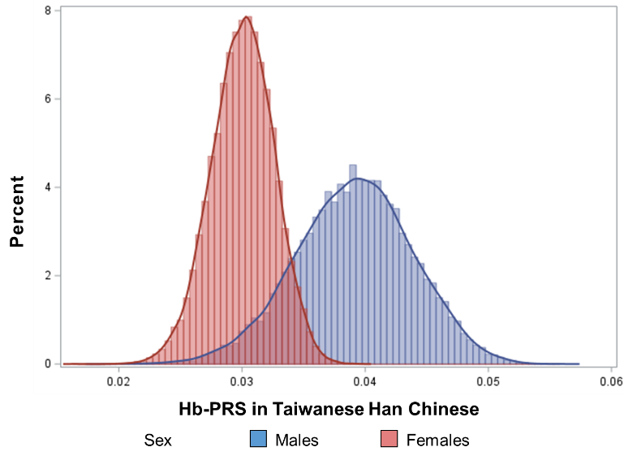 | 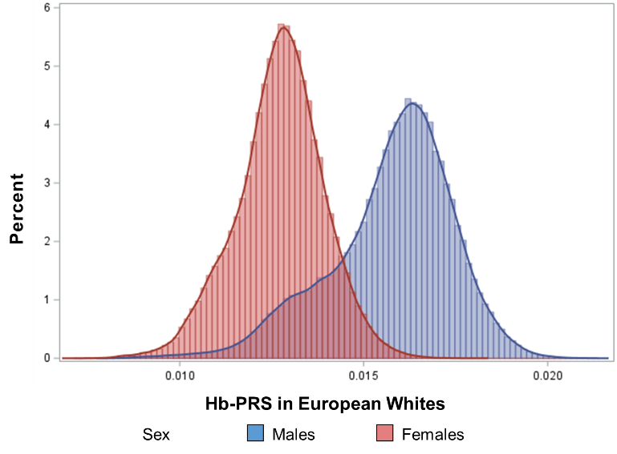
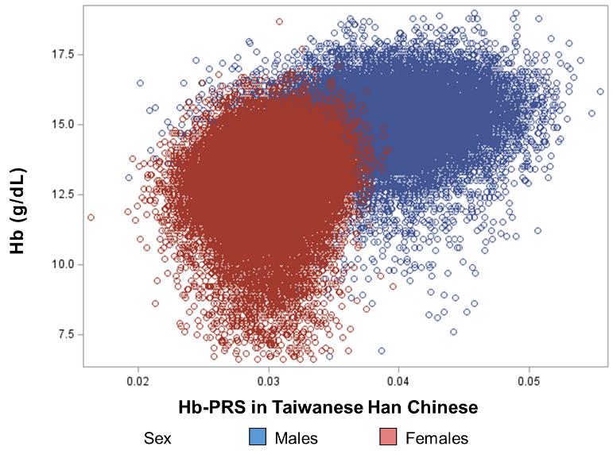 | 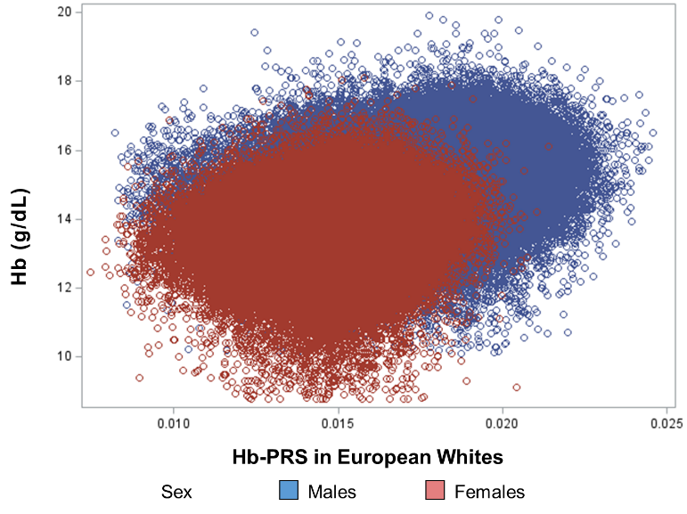
Figure S1: Overlay histograms of sex-specific Hb-PRSs (top) and scatterplots of sex-specific Hb concentration against Hb-PRSs (bottom) among Taiwanese Han Chinese of TWB (N=61,352) and European Whites of UKB (N=271,366).

Table S6: Characteristics of subjects in Taiwan Biobank (N=61,352) across quintiles of Hb-PRS
Variables | All | Q1 | Q2 | Q3 | Q4 | Q5 | P-trend
Males, n | 19,012 | 3,802 | 3,803 | 3,802 | 3,803 | 3,802
Hemoglobin, g/dL | 15.04 ± 1.21 | 14.79 ± 1.21 | 14.98 ± 1.21 | 15.04 ± 1.16 | 15.11 ± 1.20 | 15.28 ± 1.20 | <0.0001
Anemia (Hb <13.0 g/dL), % | 917 (4.8) | 264 (7.0) | 202 (5.3) | 161 (4.2) | 168 (4.4) | 122 (3.2) | <0.0001
Age, y | 50.8 ± 11.2 | 50.8 ± 11.3 | 51.0 ± 11.1 | 50.9 ± 11.3 | 50.8 ± 11.1 | 50.7 ± 11.3 | 0.3543
30-39 y, % | 4,008 (21.1) | 820 (21.6) | 770 (20.3) | 811 (21.3) | 799 (21.0) | 808 (21.3)
40-49 y, % | 4,230 (22.3) | 817 (21.5) | 839 (22.1) | 854 (22.5) | 871 (22.9) | 849 (22.3)
50-59 y, % | 5,471 (28.8) | 1,075 (28.3) | 1,132 (29.8) | 1,048 (27.6) | 1,099 (28.9) | 1,117 (29.4)
60-70 y, % | 5,296 (27.9) | 1,088 (28.6) | 1,062 (27.9) | 1,088 (28.6) | 1,032 (27.2) | 1,026 (27.0)
Weight, kg | 73.1 ± 11.8 | 72.8 ± 11.6 | 72.9 ± 11.8 | 73.0 ± 11.6 | 73.3 ± 12.0 | 73.5 ± 11.9 | 0.0123
Body mass index, kg/m² | 25.4 ± 3.5 | 25.3 ± 3.5 | 25.4 ± 3.5 | 25.4 ± 3.5 | 25.5 ± 3.6 | 25.5 ± 3.5 | 0.0122
Waist circumference, cm | 88.3 ± 9.4 | 88.0 ± 9.4 | 88.1 ± 9.3 | 88.2 ± 9.3 | 88.5 ± 9.6 | 88.5 ± 9.3 | 0.0112
Waist-hip ratio | 0.904 ± 0.06 | 0.903 ± 0.06 | 0.904 ± 0.06 | 0.904 ± 0.06 | 0.906 ± 0.06 | 0.905 ± 0.06 | 0.0199
Systolic blood pressure, mm Hg | 127.0 ± 16.8 | 126.6 ± 16.7 | 126.9 ± 16.7 | 126.9 ± 16.8 | 127.1 ± 17.0 | 127.4 ± 17.0 | 0.0320
Diastolic blood pressure, mm Hg | 78.6 ± 10.6 | 78.2 ± 10.4 | 78.4 ± 10.5 | 78.6 ± 10.7 | 78.8 ± 10.8 | 79.0 ± 10.7 | 0.0004
Fasting blood glucose, mg/dL | 99.6 ± 23.6 | 99.4 ± 24.4 | 99.0 ± 20.2 | 100.0 ± 24.8 | 99.9 ± 24.1 | 99.9 ± 24.4 | 0.0934
Glycated hemoglobin, % | 5.91 ± 0.93 | 5.93 ± 0.96 | 5.88 ± 0.83 | 5.93 ± 0.98 | 5.91 ± 0.92 | 5.90 ± 0.98 | 0.7050
Triglycerides, mg/dL | 140.0 ± 119.7 | 139.4 ± 128.0 | 137.9 ± 115.7 | 135.5 ± 102.4 | 141.9 ± 111.8 | 145.1 ± 137.1 | 0.0005
Total cholesterol, mg/dL | 191.6 ± 35.0 | 192.2 ± 35.0 | 191.5 ± 34.7 | 191.3 ± 34.7 | 191.4 ± 34.7 | 191.0 ± 35.7 | 0.0289
LDL-cholesterol, mg/dL | 120.8 ± 31.3 | 121.9 ± 31.7 | 121.0 ± 31.3 | 120.8 ± 31.3 | 120.6 ± 31.3 | 119.6 ± 31.0 | 0.0017
HDL-cholesterol, mg/dL | 47.9 ± 11.1 | 48.0 ± 11.0 | 48.0 ± 11.3 | 48.0 ± 11.1 | 47.7 ± 11.1 | 47.8 ± 11.1 | 0.2137
Uric acid, mg/dL | 6.42 ± 1.37 | 6.41 ± 1.39 | 6.40 ± 1.36 | 6.42 ± 1.35 | 6.44 ± 1.35 | 6.44 ± 1.37 | 0.1744
Smoking status |  |  |  |  |  |  | 0.0129
Never smoked | 10,178 (53.6) | 2,041 (53.7) | 1,992 (52.4) | 2,006 (52.8) | 2,040 (53.7) | 2,099 (55.2)
Stopped smoked | 4,722 (24.9) | 959 (25.2) | 985 (25.9) | 985 (25.9) | 902 (23.7) | 891 (23.5)
Occasionally smoking | 121 (0.6) | 20 (0.53) | 38 (1.00) | 24 (0.63) | 19 (0.50) | 20 (0.53)
Currently smoking | 3,984 (21.0) | 780 (20.5) | 788 (20.7) | 786 (20.7) | 840 (22.1) | 790 (20.8)
Alcohol drinking status |  |  |  |  |  |  | 0.5537
Stopped drinking | 1,092 (5.8) | 199 (5.2) | 222 (5.8) | 211 (5.6) | 229 (6.0) | 231 (6.1)
Occasionally drinking | 15,381 (80.9) | 3,121 (82.1) | 3,056 (80.4) | 3,081 (81.1) | 3,052 (80.3) | 3,071 (80.8)
Currently drinking | 2,532 (13.3) | 480 (12.6) | 525 (13.8) | 509 (13.4) | 520 (13.7) | 498 (13.1)
Physical activity |  |  |  |  |  |  | 0.2042
With regular exercise | 8,286 (43.6) | 1,662 (43.8) | 1,701 (44.7) | 1,656 (43.6) | 1,632 (42.9) | 1,635 (43.0)
Females, n | 42,340 | 8,468 | 8,466 | 8,470 | 8,468 | 8,468
Hemoglobin, g/dL | 13.01 ± 1.27 | 12.78 ± 1.26 | 12.93 ± 1.26 | 13.04 ± 1.26 | 13.11 ± 1.26 | 13.21 ± 1.25 | <0.0001
Anemia (Hb <12.0 g/dL), % | 6,503 (15.4) | 1,706 (20.2) | 1,415 (16.7) | 1,240 (14.6) | 1,129 (13.3) | 1,013 (12.0) | <0.0001
Age, y | 50.3 ± 10.4 | 50.4 ± 10.5 | 50.3 ± 10.4 | 50.4 ± 10.4 | 50.3 ± 10.3 | 50.4 ± 10.4 | 0.6924
30-39 y, % | 8,305 (19.6) | 1,691 (20.0) | 1,669 (19.7) | 1,645 (19.4) | 1,657 (19.6) | 1,643 (19.4)
40-49 y, % | 9,965 (23.5) | 1,918 (22.7) | 2,039 (24.1) | 1,992 (23.5) | 1,981 (23.4) | 2,035 (24.0)
50-59 y, % | 14,658 (34.6) | 2,954 (34.9) | 2,891 (34.2) | 2,899 (34.3) | 3,010 (35.6) | 2,904 (34.3)
60-70 y, % | 9,400 (22.2) | 1,905 (22.5) | 1,866 (22.0) | 1,928 (22.8) | 1,818 (21.5) | 1,883 (22.2)
Had menopause, % | 21,685 (51.2) | 4,383 (51.8) | 4,291 (50.7) | 4,319 (51.0) | 4,323 (51.1) | 4,369 (51.6) | 0.8361
Age at menopause, y | 46.0 ± 13.2 | 46.2 ± 13.0 | 45.9 ± 13.5 | 46.1 ± 13.2 | 46.0 ± 13.2 | 46.0 ± 13.3 | 0.8031
Weight, kg | 58.6 ± 9.8 | 58.5 ± 9.8 | 58.6 ± 9.8 | 58.4 ± 9.7 | 58.6 ± 9.9 | 58.7 ± 10.0 | 0.2311
Body mass index, kg/m² | 23.6 ± 3.7 | 23.6 ± 3.7 | 23.6 ± 3.7 | 23.6 ± 3.7 | 23.6 ± 3.7 | 23.7 ± 3.8 | 0.1888
Waist circumference, cm | 80.9 ± 9.6 | 80.9 ± 9.6 | 80.8 ± 9.7 | 80.8 ± 9.6 | 80.8 ± 9.6 | 81.0 ± 9.7 | 0.5908
Waist-hip ratio | 0.849 ± 0.07 | 0.850 ± 0.07 | 0.848 ± 0.07 | 0.849 ± 0.07 | 0.848 ± 0.07 | 0.849 ± 0.07 | 0.1821
Systolic blood pressure, mm Hg | 117.6 ± 18.0 | 117.4 ± 17.8 | 117.6 ± 17.9 | 117.7 ± 18.2 | 117.5 ± 17.9 | 117.9 ± 18.3 | 0.0901
Diastolic blood pressure, mm Hg | 71.1 ± 10.2 | 70.8 ± 10.0 | 71.0 ± 10.1 | 71.2 ± 10.3 | 71.3 ± 10.2 | 71.3 ± 10.3 | 0.0002
Fasting blood glucose, mg/dL | 94.2 ± 18.8 | 94.2 ± 18.8 | 94.3 ± 18.5 | 94.2 ± 18.6 | 94.3 ± 19.0 | 94.0 ± 19.1 | 0.4432
Glycated hemoglobin, % | 5.77 ± 0.75 | 5.79 ± 0.76 | 5.79 ± 0.77 | 5.77 ± 0.73 | 5.76 ± 0.74 | 5.76 ± 0.74 | <0.0001
Triglycerides, mg/dL | 104.0 ± 71.7 | 104.6 ± 75.6 | 102.7 ± 71.0 | 103.6 ± 70.4 | 103.7 ± 68.3 | 105.5 ± 72.9 | 0.0430
Total cholesterol, mg/dL | 198.6 ± 35.9 | 199.3 ± 36.1 | 198.1 ± 35.7 | 198.9 ± 36.0 | 198.4 ± 35.7 | 198.0 ± 35.6 | 0.0729
LDL-cholesterol, mg/dL | 120.7 ± 31.8 | 121.1 ± 31.8 | 120.3 ± 31.7 | 120.7 ± 31.9 | 120.8 ± 31.8 | 120.4 ± 31.6 | 0.4871
HDL-cholesterol, mg/dL | 58.2 ± 13.2 | 58.1 ± 13.1 | 58.2 ± 13.2 | 58.4 ± 13.3 | 58.2 ± 13.2 | 58.0 ± 13.3 | 0.6839
Uric acid, mg/dL | 4.88 ± 1.13 | 4.87 ± 1.13 | 4.87 ± 1.13 | 4.87 ± 1.11 | 4.89 ± 1.13 | 4.91 ± 1.15 | 0.0079
Smoking status |  |  |  |  |  |  | 0.5040
Never smoked | 40,095 (94.7) | 8,041 (95.0) | 8,027 (94.8) | 8,009 (94.6) | 7,988 (94.4) | 8,030 (94.9)
Stopped smoked | 967 (2.3) | 184 (2.2) | 205 (2.4) | 188 (2.2) | 206 (2.4) | 184 (2.2)
Occasionally smoking | 39 (0.09) | 6 (0.07) | 8 (0.09) | 8 (0.09) | 5 (0.06) | 12 (0.14)
Currently smoking | 1,227 (2.9) | 237 (2.8) | 225 (2.7) | 259 (3.1) | 267 (3.2) | 239 (2.8)
Alcohol drinking status |  |  |  |  |  |  | 0.9006
Stopped drinking | 349 (0.8) | 64 (0.8) | 80 (1.0) | 66 (0.8) | 70 (0.8) | 69 (0.8)
Occasionally drinking | 41,216 (97.4) | 8,258 (97.5) | 8,236 (97.3) | 8,246 (97.4) | 8,231 (97.2) | 8,245 (97.4)
Currently drinking | 762 (1.8) | 146 (1.7) | 149 (1.8) | 152 (1.8) | 164 (1.9) | 151 (1.8)
Physical activity |  |  |  |  |  |  | 0.8738
With regular exercise | 17,204 (40.7) | 3,426 (40.5) | 3,405 (40.2) | 3,500 (41.4) | 3,472 (41.0) | 3,401 (40.2)
Continuous variables are presented as mean ± s.d., whereas categorical characteristics are in n (%).

Table S7: Characteristics of subjects in UK Biobank (N=271,366) across quintiles of Hb-PRS
Variables | All | Q1 | Q2 | Q3 | Q4 | Q5 | P-trend
Males, n | 128,549 | 25,709 | 25,710 | 25,712 | 25,709 | 25,709
Hemoglobin, g/dL | 15.03 ± 0.98 | 14.91 ± 0.98 | 14.94 ± 0.98 | 15.00 ± 0.97 | 15.08 ± 0.97 | 15.21 ± 0.97 | <0.0001
Anemia (Hb <13.0 g/dL), % | 2,841 (2.2) | 732 (2.9) | 644 (2.5) | 554 (2.2) | 498 (1.9) | 413 (1.6) | <0.0001
Age, y | 56.6 ± 8.1 | 56.5 ± 8.1 | 56.5 ± 8.1 | 56.6 ± 8.1 | 56.6 ± 8.1 | 56.7 ± 8.2 | 0.0040
40-49 y, % | 30,247 (23.5) | 6,112 (23.8) | 6,169 (24.0) | 6,024 (23.4) | 5,962 (23.2) | 5,980 (23.3)
50-59 y, % | 41,848 (32.6) | 8,377 (32.6) | 8,399 (32.7) | 8,382 (32.6) | 8,380 (32.6) | 8,310 (32.3)
60-70 y, % | 56,454 (43.9) | 11,220 (43.6) | 11,142 (43.3) | 11,306 (44.0) | 11,367 (44.2) | 11,419 (44.4)
Weight, kg | 86.2 ± 14.2 | 86.5 ± 14.4 | 86.4 ± 14.4 | 85.9 ± 14.1 | 86.2 ± 14.1 | 86.1 ± 14.1 | 0.0008
Body mass index, kg/m² | 27.8 ± 4.2 | 27.9 ± 4.3 | 27.9 ± 4.3 | 27.8 ± 4.2 | 27.8 ± 4.2 | 27.8 ± 4.2 | 0.0005
Waist circumference, cm | 96.9 ± 11.3 | 96.9 ± 11.5 | 97.0 ± 11.4 | 96.8 ± 11.2 | 96.9 ± 11.2 | 96.9 ± 11.2 | 0.1797
Waist-hip ratio | 0.934 ± 0.07 | 0.933 ± 0.07 | 0.935 ± 0.07 | 0.935 ± 0.06 | 0.935 ± 0.06 | 0.935 ± 0.07 | 0.1102
Systolic blood pressure, mm Hg | 140.8 ± 17.4 | 140.9 ± 17.6 | 140.8 ± 17.4 | 140.8 ± 17.1 | 140.7 ± 17.4 | 140.9 ± 17.5 | 0.7467
Diastolic blood pressure, mm Hg | 84.1 ± 10.0 | 83.8 ± 9.9 | 84.0 ± 10.0 | 84.1 ± 10.0 | 84.1 ± 10.0 | 84.4 ± 10.1 | <0.0001
Glucose, mmol/L | 5.17 ± 1.37 | 5.19 ± 1.45 | 5.19 ± 1.41 | 5.16 ± 1.37 | 5.16 ± 1.36 | 5.14 ± 1.26 | <0.0001
Glycated hemoglobin, mmol/mol | 36.2 ± 7.2 | 36.5 ± 7.3 | 36.5 ± 7.4 | 36.3 ± 7.3 | 36.1 ± 6.9 | 35.6 ± 6.7 | <0.0001
Triglycerides, mmol/L | 1.98 ± 1.14 | 1.94 ± 1.13 | 1.97 ± 1.14 | 1.98 ± 1.14 | 2.00 ± 1.16 | 1.98 ± 1.14 | <0.0001
Total cholesterol, mmol/L | 5.51 ± 1.12 | 5.49 ± 1.12 | 5.53 ± 1.12 | 5.54 ± 1.12 | 5.52 ± 1.12 | 5.48 ± 1.12 | 0.0741
LDL-cholesterol, mmol/L | 3.50 ± 0.86 | 3.49 ± 0.86 | 3.51 ± 0.86 | 3.52 ± 0.86 | 3.50 ± 0.86 | 3.47 ± 0.86 | 0.0024
HDL-cholesterol, mmol/L | 1.29 ± 0.31 | 1.28 ± 0.31 | 1.29 ± 0.31 | 1.29 ± 0.31 | 1.29 ± 0.31 | 1.28 ± 0.31 | 0.8549
Uric acid, µmol/L | 354.3 ± 71.0 | 355.9 ± 72.0 | 353.2 ± 71.1 | 352.7 ± 70.1 | 353.9 ± 70.8 | 355.6 ± 70.8 | 0.9998
Smoking status |  |  |  |  |  |  | 0.4764
Never smoked | 63,363 (49.3) | 12,880 (50.1) | 12,666 (49.3) | 12,661 (49.3) | 12,581 (49.0) | 12,575 (48.9)
Stopped smoked | 49,356 (38.4) | 9,745 (37.9) | 9,889 (38.5) | 9,868 (38.4) | 9,883 (38.5) | 9,971 (38.8)
Occasionally smoking | 4,466 (3.5) | 871 (3.4) | 898 (3.5) | 910 (3.5) | 919 (3.6) | 868 (3.4)
Currently smoking | 11,313 (8.8) | 2,206 (8.6) | 2,247 (8.7) | 2,261 (8.8) | 2,317 (9.0) | 2,282 (8.9)
Alcohol drinking status |  |  |  |  |  |  | 0.0486
Never drank | 2,232 (1.7) | 444 (1.7) | 435 (1.7) | 488 (1.9) | 462 (1.8) | 403 (1.6)
Stopped drinking | 4,156 (3.2) | 848 (3.3) | 790 (3.1) | 805 (3.1) | 819 (3.2) | 894 (3.5)
Occasionally drinking | 8,532 (6.6) | 1,636 (6.4) | 1,758 (6.8) | 1,714 (6.7) | 1,706 (6.6) | 1,718 (6.7)
Currently drinking | 113,533 (88.4) | 22,757 (88.6) | 22,711 (88.4) | 22,689 (88.3) | 22,706 (88.4) | 22,670 (88.3)
Physical activity |  |  |  |  |  |  | 0.3242
Low | 20,601 (18.8) | 4,130 (18.9) | 4,149 (19.0) | 4,148 (19.0) | 4,083 (18.6) | 4,091 (18.7)
Moderate | 42,537 (38.9) | 8,604 (39.4) | 8,562 (39.1) | 8,520 (39.0) | 8,461 (38.6) | 8,390 (38.3)
High | 46,254 (42.3) | 9,097 (41.7) | 9,185 (42.0) | 9,170 (42.0) | 9,365 (42.7) | 9,437 (43.1)
Females, n | 142,817 | 28,566 | 28,560 | 28,566 | 28,564 | 28,561
Hemoglobin, g/dL | 13.52 ± 0.93 | 13.39 ± 0.92 | 13.43 ± 0.92 | 13.49 ± 0.92 | 13.58 ± 0.92 | 13.71 ± 0.95 | <0.0001
Anemia (Hb <12.0 g/dL), % | 6,784 (4.8) | 1,637 (5.7) | 1,529 (5.4) | 1,386 (4.9) | 1,180 (4.1) | 1,052 (3.7) | <0.0001
Age, y | 56.1 ± 7.9 | 56.1 ± 7.9 | 56.1 ± 7.9 | 56.2 ± 7.9 | 56.1 ± 8.0 | 56.2 ± 7.9 | 0.2192
40-49 y, % | 34,432 (24.1) | 6,846 (24.0) | 7,021 (24.6) | 6,762 (23.7) | 6,969 (24.4) | 6,834 (23.9)
50-59 y, % | 50,235 (35.2) | 10,152 (35.5) | 10,047 (35.2) | 10,119 (35.4) | 9,924 (34.7) | 9,993 (35.0)
60-70 y, % | 58,150 (40.7) | 11,568 (40.5) | 11,492 (40.2) | 11,685 (40.9) | 11,671 (40.9) | 11,734 (41.1)
Had menopause, % | 85,641 (60.0) | 17,244 (60.4) | 16,988 (59.5) | 17,107 (59.9) | 17,139 (60.0) | 17,163 (60.1) | 0.3513
Age at menopause, y | 46.6 ± 13.5 | 46.4 ± 13.5 | 46.5 ± 13.6 | 46.8 ± 13.2 | 46.5 ± 13.6 | 46.5 ± 13.5 | 0.4418
Weight, kg | 71.3 ± 14.0 | 71.6 ± 14.3 | 71.3 ± 14.0 | 71.2 ± 13.8 | 71.2 ± 13.9 | 71.4 ± 13.9 | 0.0132
Body mass index, kg/m² | 26.9 ± 5.1 | 27.0 ± 5.2 | 26.9 ± 5.1 | 26.9 ± 5.1 | 26.9 ± 5.1 | 26.9 ± 5.1 | 0.0190
Waist circumference, cm | 84.3 ± 12.5 | 84.4 ± 12.7 | 84.2 ± 12.5 | 84.3 ± 12.4 | 84.2 ± 12.5 | 84.4 ± 12.4 | 0.5857
Waist-hip ratio | 0.815 ± 0.07 | 0.814 ± 0.07 | 0.814 ± 0.07 | 0.816 ± 0.07 | 0.815 ± 0.07 | 0.816 ± 0.07 | 0.0275
Systolic blood pressure, mm Hg | 134.8 ± 19.1 | 134.8 ± 19.1 | 134.7 ± 19.1 | 134.8 ± 19.1 | 134.8 ± 19.1 | 135.0 ± 19.1 | 0.1680
Diastolic blood pressure, mm Hg | 80.5 ± 9.9 | 80.2 ± 9.9 | 80.3 ± 9.9 | 80.5 ± 10.0 | 80.6 ± 10.0 | 80.9 ± 9.9 | <0.0001
Glucose, mmol/L | 5.05 ± 1.03 | 5.07 ± 1.08 | 5.05 ± 1.02 | 5.05 ± 1.02 | 5.04 ± 1.01 | 5.03 ± 1.00 | <0.0001
Glycated hemoglobin, mmol/mol | 35.5 ± 5.7 | 35.8 ± 5.8 | 35.7 ± 5.6 | 35.6 ± 5.6 | 35.4 ± 5.8 | 35.1 ± 5.5 | <0.0001
Triglycerides, mmol/L | 1.53 ± 0.84 | 1.51 ± 0.83 | 1.53 ± 0.84 | 1.54 ± 0.85 | 1.54 ± 0.84 | 1.56 ± 0.86 | <0.0001
Total cholesterol, mmol/L | 5.89 ± 1.12 | 5.88 ± 1.12 | 5.91 ± 1.12 | 5.90 ± 1.11 | 5.88 ± 1.12 | 5.86 ± 1.11 | 0.0010
LDL-cholesterol, mmol/L | 3.63 ± 0.86 | 3.63 ± 0.86 | 3.65 ± 0.87 | 3.64 ± 0.86 | 3.62 ± 0.87 | 3.61 ± 0.86 | <0.0001
HDL-cholesterol, mmol/L | 1.61 ± 0.38 | 1.60 ± 0.38 | 1.61 ± 0.38 | 1.61 ± 0.38 | 1.61 ± 0.38 | 1.60 ± 0.37 | 0.1012
Uric acid, µmol/L | 269.3 ± 65.4 | 270.4 ± 66.0 | 268.1 ± 64.9 | 268.4 ± 64.9 | 268.7 ± 65.1 | 270.7 ± 66.0 | 0.3715
Smoking status |  |  |  |  |  |  | 0.2223
Never smoked | 84,688 (59.3) | 17,161 (60.1) | 16,820 (58.9) | 16,814 (58.9) | 16,932 (59.3) | 16,961 (59.4)
Stopped smoked | 45,603 (32.0) | 8,909 (31.2) | 9,253 (32.4) | 9,247 (32.4) | 9,074 (31.8) | 9,120 (31.9)
Occasionally smoking | 3,012 (2.1) | 598 (2.1) | 601 (2.1) | 587 (2.1) | 643 (2.3) | 583 (2.0)
Currently smoking | 9,445 (6.6) | 1,890 (6.6) | 1,865 (6.5) | 1,902 (6.7) | 1,898 (6.7) | 1,890 (6.6)
Alcohol drinking status |  |  |  |  |  |  | 0.6109
Never drank | 6,061 (4.3) | 1,204 (4.2) | 1,204 (4.2) | 1,199 (4.2) | 1,247 (4.4) | 1,207 (4.2)
Stopped drinking | 4,945 (3.5) | 971 (3.4) | 990 (3.5) | 1,006 (3.5) | 977 (3.4) | 1,001 (3.5)
Occasionally drinking | 19,783 (13.9) | 3,983 (14.0) | 3,928 (13.8) | 4,086 (14.3) | 3,867 (13.6) | 3,919 (13.7)
Currently drinking | 111,936 (78.4) | 22,389 (78.4) | 22,426 (78.6) | 22,252 (78.0) | 22,456 (78.7) | 22,413 (78.5)
Physical activity |  |  |  |  |  |  | 0.0756
Low | 20,340 (18.1) | 4,196 (18.7) | 4,095 (18.2) | 3,913 (17.5) | 4,006 (17.8) | 4,130 (18.4)
Moderate | 48,402 (43.1) | 9,741 (43.4) | 9,658 (42.9) | 9,610 (43.0) | 9,724 (43.2) | 9,669 (43.1)
High | 43,547 (38.8) | 8,505 (37.9) | 8,786 (39.0) | 8,851 (39.6) | 8,758 (39.0) | 8,647 (38.5)
Continuous variables are presented as mean ± s.d., whereas categorical characteristics are in n (%).

Table S8: Overall distributions of metabolic outcomes in Taiwan Biobank†
Metabolic Outcomes | All (N=61,352) | Males (n=19,012) | Females (n=42,340)
A. Metabolic syndrome‡ | 14,611 (23.8) | 5,546 (29.2) | 9,065 (21.4)
B. Central obesity§ | 27,400 (44.7) | 7,169 (37.7) | 20,231 (47.8)
C. Hypertension | 14,636 (23.9) | 6,523 (34.3) | 8,113 (19.2)
High blood pressure | 10,167 (16.6) | 4,690 (24.7) | 5,477 (12.9)
Self-reported hypertension | 7,926 (12.9) | 3,496 (18.4) | 4,430 (10.5)
D. Diabetes mellitus | 6,238 (10.2) | 2,575 (13.6) | 3,663 (8.7)
Hyperglycemia | 5,597 (9.1) | 2,319 (12.2) | 3,278 (7.7)
Self-reported diabetes | 3,324 (5.4) | 1,411 (7.4) | 1,913 (4.5)
E. Dyslipidemia | 21,019 (34.3) | 6,895 (36.6) | 14,124 (33.4)
Hypertriglyceridemia and/or low HDL-C levels | 18,245 (29.7) | 5,870 (30.9) | 12,375 (29.2)
Self-reported hyperlipidemia | 4,877 (8.0) | 1,893 (10.0) | 2,984 (7.1)
F. Gout | 12,382 (20.2) | 6,294 (33.1) | 6,088 (14.4)
Hyperuricemia | 11,598 (18.9) | 5,613 (29.5) | 5,985 (14.1)
Self-reported gout | 2,127 (3.5) | 1,896 (10.0) | 231 (0.6)
Data are presented as n (%). †In the TWB, outcomes are ascertained from elevated metabolic traits and self-reported metabolic conditions. ‡Following National Cholesterol Education Program Adult Treatment Panel III criteria. §Based on ethnic-specific cut-off for waist circumference. HDL-C, high-density lipoprotein cholesterol.

Table S9: Overall distributions of metabolic outcomes in UK Biobank†
Metabolic Outcomes | All (N=271,366) | Males (n=128,549) | Females (n=142,817)
A. Metabolic syndrome‡ | 109,437 (40.3) | 62,252 (48.4) | 51,880 (36.3)
B. Central obesity§ | 152,201 (56.1) | 71,359 (55.5) | 80,842 (56.6)
C. Hypertension | 150,964 (55.6) | 81,218 (63.2) | 69,746 (48.8)
High blood pressure | 114,935 (42.4) | 62,691 (48.8) | 52,244 (36.6)
Self-reported hypertension | 80,826 (29.8) | 44,071 (34.3) | 36,755 (25.7)
ICD diagnoses | 56,606 (20.9) | 31,659 (24.6) | 24,947 (17.5)
D. Diabetes mellitus | 19,027 (7.0) | 11,815 (9.2) | 7,212 (5.1)
Hyperglycemia | 8,750 (3.2) | 5,659 (4.4) | 3,091 (2.2)
Self-reported diabetes | 12,915 (4.8) | 8,172 (6.4) | 4,743 (3.3)
ICD diagnoses | 14,680 (5.4) | 9,240 (7.2) | 5,440 (3.8)
E. Dyslipidemia | 169,152 (62.3) | 89,276 (69.5) | 79,876 (55.9)
Hypertriglyceridemia and/or low HDL-C levels | 144,147 (53.1) | 75,732 (58.9) | 68,415 (47.9)
Self-reported dyslipidemia | 57,503 (21.2) | 33,383 (26.0) | 24,120 (16.9)
ICD diagnoses | 26,760 (9.9) | 16,652 (13.0) | 10,108 (7.1)
F. Gout | 38,273 (14.1) | 25,112 (19.5) | 13,161 (9.2)
Hyperuricemia | 35,125 (12.9) | 22,255 (17.3) | 12,870 (9.0)
Self-reported gout | 4,195 (1.5) | 3,920 (3.1) | 275 (0.20)
ICD diagnoses | 2,757 (1.0) | 2,417 (1.9) | 340 (0.24)
Data are presented as n (%). †In the UKB, outcomes are ascertained from elevated metabolic traits, self-reported metabolic conditions, and hospital in-patient records of subjects. ‡Following National Cholesterol Education Program Adult Treatment Panel III criteria. §Based on ethnic-specific cut-off for waist circumference. HDL-C, high-density lipoprotein cholesterol; ICD, International Classification of Diseases.

Table S10: Distributions of different metabolic conditions among subjects in Taiwan Biobank (N=61,352) across quintiles of Hb-PRS
Metabolic Conditions | All | Q1 | Q2 | Q3 | Q4 | Q5 | P-trend
Males, n | 19,012 | 3,802 | 3,803 | 3,802 | 3,803 | 3,802
Mean Hemoglobin, g/dL | 15.04 | 14.79 | 14.98 | 15.04 | 15.11 | 15.28
MetS-NCEP ATP III | 4,884 (25.7) | 920 (24.2) | 978 (25.7) | 944 (24.8) | 1,035 (27.2) | 1,007 (26.5) | 0.0066
Obesity (BMI >27.0 kg/m²)† | 5,369 (28.3) | 1,067 (28.1) | 1,070 (28.1) | 1,063 (28.0) | 1,079 (28.4) | 1,090 (28.7) | 0.5267
Overweight (BMI=24.0-26.9 kg/m²)† | 6,809 (35.8) | 1,317 (34.7) | 1,337 (35.2) | 1,386 (36.5) | 1,399 (36.8) | 1,370 (36.1)
Central Obesity (WC >90 cm in males, >80 cm in females) | 7,169 (37.7) | 1,398 (36.8) | 1,428 (37.6) | 1,427 (37.5) | 1,474 (38.8) | 1,442 (37.9) | 0.1696
Hypertension (SBP/DBP >140/>90 mm Hg)‡ | 4,685 (24.7) | 913 (24.0) | 941 (24.7) | 914 (24.1) | 941 (24.8) | 976 (25.7) | 0.1322
Prehypertension (SBP=120-139 mm Hg or DBP=80-89 mm Hg)‡ | 8,223 (43.3) | 1,651 (43.5) | 1,638 (43.1) | 1,669 (43.9) | 1,646 (43.3) | 1,619 (42.6)
Hyperglycemia based on FBG (>126 mg/dL) | 1,200 (6.3) | 232 (6.1) | 234 (6.2) | 245 (6.5) | 242 (6.4) | 247 (6.5) | 0.4213
Impaired FBG (100-125 mg/dL) | 4,240 (22.3) | 780 (20.5) | 856 (22.5) | 874 (23.0) | 873 (23.0) | 857 (22.6)
Hyperglycemia based on HbA1c (>6.5%) | 2,221 (11.7) | 429 (11.3) | 428 (11.3) | 460 (12.1) | 455 (12.0) | 449 (11.8) | 0.2830
Elevated HbA1c (5.7-6.4%) | 8,667 (45.6) | 1,846 (48.6) | 1,747 (45.9) | 1,759 (46.3) | 1,701 (44.8) | 1,614 (42.5)
Hypertriglyceridemia (TG >200 mg/dL) | 3,122 (16.4) | 598 (15.7) | 607 (16.0) | 593 (15.6) | 665 (17.5) | 659 (17.3) | 0.0125
Elevated TG (150-199 mg/dL) | 2,635 (13.9) | 515 (13.6) | 518 (13.6) | 526 (13.8) | 524 (13.8) | 552 (14.5)
Hypercholesterolemia (TC >240 mg/dL) | 1,671 (8.8) | 335 (8.8) | 337 (8.9) | 324 (8.5) | 323 (8.5) | 352 (9.3) | 0.7148
Elevated TC (200-239 mg/dL) | 5,624 (29.6) | 1,168 (30.7) | 1,125 (29.6) | 1,120 (29.5) | 1,122 (29.5) | 1,089 (28.7)
High LDL-C (>160 mg/dL) | 2,024 (10.7) | 408 (10.7) | 427 (11.2) | 386 (10.2) | 397 (10.4) | 406 (10.7) | 0.5742
Elevated LDL-C (130-159 mg/dL) | 5,080 (26.7) | 1,092 (28.7) | 984 (25.9) | 1,015 (26.7) | 1,026 (27.0) | 963 (25.3)
Low HDL-C (<40 mg/dL in males, <50 mg/dL in females) | 4,384 (23.1) | 843 (22.2) | 903 (23.7) | 846 (22.3) | 902 (23.7) | 890 (23.4) | 0.2551
Hyperuricemia (SUA >7.0 mg/dL in males, >6.0 mg/dL in females) | 5,611 (29.5) | 1,131 (29.8) | 1,090 (28.7) | 1,131 (29.8) | 1,122 (29.5) | 1,137 (29.9) | 0.6161
Females, n | 42,340 | 8,468 | 8,466 | 8,470 | 8,468 | 8,468
Mean Hemoglobin, g/dL | 13.01 | 12.78 | 12.93 | 13.04 | 13.11 | 13.21
MetS-NCEP ATP III | 7,939 (18.8) | 1,573 (18.6) | 1,537 (18.2) | 1,554 (18.4) | 1,587 (18.8) | 1,688 (19.9) | 0.0134
Obesity (BMI >27.0 kg/m²)† | 6,920 (16.4) | 1,364 (16.1) | 1,353 (16.0) | 1,361 (16.1) | 1,388 (16.4) | 1,454 (17.2) | 0.1508
Overweight (BMI=24.0-26.9 kg/m²)† | 9,734 (23.0) | 1,958 (23.1) | 1,957 (23.1) | 1,931 (22.8) | 1,977 (23.4) | 1,911 (22.6)
Central Obesity (WC >90 cm in males, >80 cm in females) | 20,231 (47.8) | 4,119 (48.6) | 3,994 (47.2) | 4,021 (47.5) | 4,035 (47.7) | 4,062 (48.0) | 0.6222
Hypertension (SBP/DBP >140/>90 mm Hg)‡ | 5,474 (12.9) | 1,053 (12.4) | 1,071 (12.7) | 1,098 (13.0) | 1,116 (13.2) | 1,136 (13.4) | 0.0302
Prehypertension (SBP=120-139 mm Hg or DBP=80-89 mm Hg)‡ | 12,113 (28.6) | 2,423 (28.6) | 2,445 (28.9) | 2,431 (28.7) | 2,385 (28.2) | 2,429 (28.7)
Hyperglycemia based on FBG (>126 mg/dL) | 1,522 (3.6) | 301 (3.6) | 317 (3.7) | 310 (3.7) | 307 (3.6) | 287 (3.4) | 0.4851
Impaired FBG (100-125 mg/dL) | 5,731 (13.5) | 1,147 (13.6) | 1,140 (13.5) | 1,122 (13.3) | 1,162 (13.7) | 1,160 (13.7)
Hyperglycemia based on HbA1c (>6.5%) | 3,151 (7.4) | 681 (8.0) | 648 (7.7) | 617 (7.3) | 612 (7.2) | 593 (7.0) | 0.0056
Elevated HbA1c (5.7-6.4%) | 17,897 (42.3) | 3,738 (44.1) | 3,548 (41.9) | 3,556 (42.0) | 3,517 (41.5) | 3,538 (41.8)
Hypertriglyceridemia (TG >200 mg/dL) | 3,083 (7.3) | 607 (7.2) | 633 (7.5) | 615 (7.3) | 586 (6.9) | 642 (7.6) | 0.7573
Elevated TG (150-199 mg/dL) | 3,869 (9.1) | 767 (9.1) | 719 (8.5) | 742 (8.8) | 807 (9.5) | 834 (9.9)
Hypercholesterolemia (TC >240 mg/dL) | 5,239 (12.4) | 1,112 (13.1) | 1,010 (11.9) | 1,088 (12.9) | 1,008 (11.9) | 1,021 (12.1) | 0.0557
Elevated TC (200-239 mg/dL) | 14,306 (33.8) | 2,852 (33.7) | 2,886 (34.1) | 2,863 (33.8) | 2,903 (34.3) | 2,802 (33.1)
High LDL-C (>160 mg/dL) | 4,760 (11.3) | 978 (11.6) | 940 (11.1) | 950 (11.2) | 936 (11.1) | 956 (11.3) | 0.6058
Elevated LDL-C (130-159 mg/dL) | 10,684 (25.2) | 2,140 (25.3) | 2,134 (25.2) | 2,141 (25.3) | 2,177 (25.7) | 2,092 (24.7)
Low HDL-C (<40 mg/dL in males, <50 mg/dL in females) | 11,601 (27.4) | 2,331 (27.5) | 2,310 (27.3) | 2,280 (26.9) | 2,287 (27.0) | 2,393 (28.3) | 0.4302
Hyperuricemia (SUA >7.0 mg/dL in males, >6.0 mg/dL in females) | 5,977 (14.1) | 1,167 (13.8) | 1,206 (14.3) | 1,129 (13.3) | 1,237 (14.6) | 1,238 (14.6) | 0.0865
Data are presented as n (%). †Taiwan Ministry of Health classification for obesity and overweight. ‡Taiwan Society of Cardiology and Taiwan Hypertension Society classification. BMI, body mass index; DBP, diastolic blood pressure; FBG, fasting blood glucose; HbA1c, glycosylated hemoglobin; HDL-C, high-density lipoprotein cholesterol; LDL-C, low-density lipoprotein cholesterol; MetS-NCEP ATP III, metabolic syndrome following National Cholesterol Education Program Adult Treatment Panel III criteria; SBP, systolic blood pressure; SUA, serum uric acid; TC, total cholesterol; TG, triglyceride; WC, waist circumference.

Table S11: Distributions of different metabolic conditions among subjects in UK Biobank (N=271,366) across quintiles of Hb-PRS
Metabolic Conditions | All | Q1 | Q2 | Q3 | Q4 | Q5 | P-trend
Males, n | 128,549 | 25,709 | 25,710 | 25,712 | 25,709 | 25,709
Mean Hemoglobin, g/dL | 15.03 | 14.91 | 14.94 | 15.00 | 15.08 | 15.21
MetS-NCEP ATP III | 51,741 (40.3) | 10,243 (39.8) | 10,402 (40.5) | 10,358 (40.3) | 10,382 (40.4) | 10,356 (40.3) | 0.4065
Obesity (BMI >30.0 kg/m²) | 32,225 (25.2) | 6,615 (25.7) | 6,596 (25.7) | 6,296 (24.5) | 6,432 (25.0) | 6,286 (24.5) | 0.0043
Overweight (BMI=25.0-29.9 kg/m²) | 63,454 (49.5) | 12,512 (48.8) | 12,568 (49.0) | 12,809 (50.0) | 12,716 (49.6) | 12,849 (50.1)
Central Obesity (WC >94 cm in males, >80 cm in females) | 71,359 (55.5) | 14,222 (55.3) | 14,370 (55.9) | 14,162 (55.1) | 14,346 (55.8) | 14,259 (55.5) | 0.8410
Hypertension (SBP/DBP >140/>90 mm Hg)† | 62,691 (52.1) | 12,431 (51.8) | 12,543 (52.0) | 12,616 (52.2) | 12,479 (51.8) | 12,622 (52.6) | 0.3450
Prehypertension (SBP=130-139 mm Hg or DBP=85-89 mm Hg)† | 27,224 (22.6) | 5,468 (22.8) | 5,479 (22.7) | 5,524 (22.9) | 5,385 (22.4) | 5,368 (22.4)
Hyperglycemia based on GLU‡ (>11.1 mmol/L) | 1,237 (1.0) | 286 (1.11) | 266 (1.03) | 241 (0.94) | 242 (0.94) | 202 (0.79) | 0.0001
Hyperglycemia based on HbA1c (>48 mmol/mol) | 5,528 (4.3) | 1,179 (4.6) | 1,140 (4.4) | 1,136 (4.4) | 1,070 (4.2) | 1,003 (3.9) | <0.0001
Hypertriglyceridemia (TG >2.30 mmol/L) | 35,393 (28.8) | 6,791 (27.6) | 7,058 (28.7) | 7,150 (29.0) | 7,227 (29.4) | 7,167 (29.1) | <0.0001
Elevated TG (1.70-2.29 mmol/L) | 25,840 (21.0) | 5,145 (20.9) | 5,232 (21.2) | 5,184 (21.0) | 5,120 (20.8) | 5,159 (20.9)
Hypercholesterolemia (TC >6.20 mmol/L) | 32,154 (25.0) | 6,263 (24.4) | 6,580 (25.6) | 6,556 (25.5) | 6,549 (25.5) | 6,206 (24.1) | 0.5098
Elevated TC (5.20-6.29 mmol/L) | 42,170 (34.2) | 8,451 (34.3) | 8,342 (33.8) | 8,577 (34.7) | 8,443 (34.3) | 8,357 (33.9)
High LDL-C (>4.10 mmol/L) | 29,144 (22.7) | 5,802 (22.6) | 5,941 (23.1) | 5,969 (23.2) | 5,855 (22.8) | 5,577 (21.7) | 0.0116
Elevated LDL-C (3.40-4.09 mmol/L) | 36,907 (30.0) | 7,393 (30.1) | 7,378 (30.0) | 7,454 (30.3) | 7,343 (29.9) | 7,339 (29.8)
Low HDL-C (<1.00 mmol/L in males, <1.30 mmol/L in females) | 33,613 (26.2) | 6,853 (26.7) | 6,704 (26.1) | 6,638 (25.8) | 6,718 (26.1) | 6,700 (26.1) | 0.1904
Hyperuricemia (SUA >416.0 µmol/L in males, >357.0 µmol/L in females) | 22,255 (17.3) | 4,662 (18.1) | 4,334 (16.9) | 4,284 (16.7) | 4,389 (17.1) | 4,586 (17.8) | 0.6138
Females, n | 142,817 | 28,566 | 28,560 | 28,566 | 28,564 | 28,561
Mean Hemoglobin, g/dL | 13.52 | 13.39 | 13.43 | 13.49 | 13.58 | 13.71
MetS-NCEP ATP III | 44,322 (31.0) | 8,768 (30.7) | 8,768 (30.7) | 8,859 (31.0) | 8,828 (30.9) | 9,099 (31.9) | 0.0034
Obesity (BMI >30.0 kg/m²) | 32,140 (22.5) | 6,717 (23.5) | 6,377 (22.3) | 6,329 (22.2) | 6,306 (22.1) | 6,411 (22.5) | 0.0007
Overweight (BMI=25.0-29.9 kg/m²) | 51,690 (36.3) | 10,090 (35.4) | 10,397 (36.5) | 10,509 (36.9) | 10,252 (36.0) | 10,442 (36.6)
Central Obesity (WC >94 cm in males, >80 cm in females) | 80,842 (56.6) | 16,196 (56.7) | 16,136 (56.5) | 16,207 (56.7) | 16,080 (56.3) | 16,223 (56.8) | 0.9958
Hypertension (SBP/DBP >140/>90 mm Hg)† | 52,244 (39.2) | 10,411 (39.0) | 10,312 (38.6) | 10,475 (39.3) | 10,473 (39.2) | 10,573 (39.8) | 0.1858
Prehypertension (SBP=130-139 mm Hg or DBP=85-89 mm Hg)† | 26,595 (19.9) | 5,284 (19.8) | 5,365 (20.1) | 5,305 (19.9) | 5,321 (19.9) | 5,320 (20.0)
Hyperglycemia based on GLU‡ (>11.1 mmol/L) | 591 (0.4) | 145 (0.51) | 125 (0.44) | 114 (0.40) | 109 (0.38) | 98 (0.34) | 0.0013
Hyperglycemia based on HbA1c (>48 mmol/mol) | 3,046 (2.1) | 654 (2.3) | 613 (2.2) | 617 (2.2) | 615 (2.2) | 547 (1.9) | 0.0061
Hypertriglyceridemia (TG >2.30 mmol/L) | 19,632 (14.3) | 3,768 (13.7) | 3,881 (14.2) | 3,943 (14.5) | 3,960 (14.5) | 4,080 (14.9) | 0.0001
Elevated TG (1.70-2.20 mmol/L) | 22,937 (16.8) | 4,493 (16.4) | 4,499 (16.5) | 4,649 (17.0) | 4,565 (16.7) | 4,731 (17.3)
Hypercholesterolemia (TC >6.20 mmol/L) | 50,551 (35.4) | 10,080 (35.3) | 10,286 (36.0) | 10,259 (35.9) | 10,074 (35.3) | 9,852 (34.5) | 0.0092
Elevated TC (5.20-6.20 mmol/L) | 48,027 (35.1) | 9,676 (35.3) | 9,607 (35.1) | 9,515 (34.8) | 9,630 (35.1) | 9,599 (35.1)
High LDL-C (>4.10 mmol/L) | 37,766 (26.4) | 7,602 (26.6) | 7,721 (27.0) | 7,648 (26.8) | 7,503 (26.3) | 7,292 (25.5) | 0.0004
Elevated LDL-C (3.40-4.10 mmol/L) | 41,574 (30.4) | 8,437 (30.8) | 8,403 (30.8) | 8,163 (29.9) | 8,289 (30.3) | 8,282 (30.3)
Low HDL-C (<1.00 mmol/L in males, <1.30 mmol/L in females) | 44,996 (31.5) | 9,053 (31.7) | 8,909 (31.2) | 8,930 (31.3) | 8,998 (31.5) | 9,106 (31.9) | 0.4278
Hyperuricemia (SUA >416.0 µmol/L in males, >357.0 µmol/L in females) | 12,870 (9.0) | 2,661 (9.3) | 2,517 (8.8) | 2,493 (8.7) | 2,542 (8.9) | 2,657 (9.3) | 0.9087
Data are presented as n (%). †European Society of Cardiology/National Institute for Health and Care Excellence classification. ‡Based on non-fasting/random blood biochemistry measured within 24 hours. BMI, body mass index; DBP, diastolic blood pressure; GLU, blood glucose; HbA1c, glycosylated hemoglobin; HDL-C, high-density lipoprotein cholesterol; LDL-C, low-density lipoprotein cholesterol; MS-NCEP ATP III, metabolic syndrome following National Cholesterol Education Program Adult Treatment Panel III criteria; SBP, systolic blood pressure; SUA, serum uric acid; TC, total cholesterol; TG, triglyceride; WC, waist circumference.

Table S12: Distributions of self-reported metabolic conditions among subjects in Taiwan Biobank (N=61,352) across quintiles of Hb-PRS
Self-reported Metabolic Conditions | All | Q1 | Q2 | Q3 | Q4 | Q5 | P-trend
Males, n | 19,012 | 3,802 | 3,803 | 3,802 | 3,803 | 3,802
Mean Hemoglobin, g/dL | 15.04 | 14.79 | 14.98 | 15.04 | 15.11 | 15.28
Hypertension | 3,494 (18.4) | 663 (17.5) | 718 (18.9) | 707 (18.6) | 713 (18.8) | 693 (18.2) | 0.4634
Diabetes mellitus | 1,409 (7.4) | 275 (7.2) | 274 (7.2) | 279 (7.3) | 294 (7.7) | 287 (7.6) | 0.3874
Hyperlipidemia | 1,891 (10.0) | 408 (10.7) | 377 (9.9) | 344 (9.1) | 383 (10.1) | 379 (10.0) | 0.3747
Gout | 1,896 (10.0) | 382 (10.1) | 367 (9.7) | 350 (9.2) | 420 (11.1) | 377 (9.9) | 0.4596
Females, n | 42,340 | 8,468 | 8,466 | 8,470 | 8,468 | 8,468
Mean Hemoglobin, g/dL | 13.01 | 12.78 | 12.93 | 13.04 | 13.11 | 13.21
Hypertension | 4,427 (10.5) | 893 (10.6) | 859 (10.2) | 882 (10.4) | 903 (10.7) | 890 (10.5) | 0.6653
Diabetes mellitus | 1,911 (4.5) | 394 (4.7) | 398 (4.7) | 396 (4.7) | 381 (4.5) | 342 (4.0) | 0.0456
Hyperlipidemia | 2,981 (7.0) | 624 (7.4) | 586 (6.9) | 603 (7.1) | 575 (6.8) | 593 (7.0) | 0.3292
Gout | 231 (0.55) | 47 (0.56) | 42 (0.50) | 46 (0.54) | 47 (0.56) | 49 (0.58) | 0.6737
Data are presented as n (%).

Table S13: Distributions of self-reported metabolic conditions among subjects in UK Biobank (N=271,366) across quintiles of Hb-PRS
Self-reported Metabolic Conditions | All | Q1 | Q2 | Q3 | Q4 | Q5 | P-trend
Men | 128,549 | 25,709 | 25,710 | 25,712 | 25,709 | 25,709
Mean Hemoglobin, g/dL | 15.03 | 14.91 | 14.94 | 15.00 | 15.08 | 15.21
Hypertension | 44,071 (34.2) | 8,694 (33.8) | 8,759 (34.1) | 8,878 (34.5) | 8,798 (34.2) | 8,942 (34.8) | 0.0261
Diagnosis by a doctor† | 32,612 (25.4) | 6,444 (25.1) | 6,487 (25.2) | 6,563 (25.5) | 6,523 (25.4) | 6,595 (25.7)
Use of medication‡ | 12,393 (9.6) | 2,390 (9.3) | 2,421 (9.4) | 2,478 (9.6) | 2,470 (9.6) | 2,634 (10.3)
Type of medication§ | 32,321 (25.1) | 6,345 (24.7) | 6,439 (25.0) | 6,477 (25.2) | 6,497 (25.3) | 6,563 (25.5)
Non-cancer illness†† | 37,806 (29.4) | 7,422 (28.9) | 7,527 (29.3) | 7,625 (29.7) | 7,588 (29.5) | 7,644 (29.7)
Diabetes mellitus | 8,172 (6.4) | 1,711 (6.7) | 1,709 (6.7) | 1,628 (6.3) | 1,595 (6.2) | 1,529 (6.0) | 0.0001
Diagnosis by a doctor† | 8,039 (6.3) | 1,677 (6.5) | 1,684 (6.6) | 1,605 (6.2) | 1,570 (6.1) | 1,503 (5.9)
Use of medication‡ | 250 (0.19) | 59 (0.23) | 55 (0.21) | 51 (0.20) | 53 (0.21) | 32 (0.12)
Type of medication§ | 5,852 (4.6) | 1,246 (4.9) | 1,245 (4.8) | 1,164 (4.5) | 1,129 (4.4) | 1,068 (4.2)
Non-cancer illness†† | 7,867 (6.1) | 1,634 (6.4) | 1,635 (6.4) | 1,565 (6.1) | 1,546 (6.0) | 1,487 (5.8)
Hyperlipidemia | 33,383 (26.0) | 6,679 (26.0) | 6,665 (25.9) | 6,773 (26.3) | 6,707 (26.1) | 6,559 (25.5) | 0.3773
Use of medication‡ | 28,197 (21.9) | 5,627 (21.9) | 5,631 (21.9) | 5,728 (22.3) | 5,675 (22.1) | 5,536 (21.5)
Type of medication§ | 30,447 (23.7) | 6,103 (23.7) | 6,073 (23.6) | 6,167 (24.0) | 6,091 (23.7) | 6,013 (23.4)
Non-cancer illness†† | 18,932 (14.7) | 3,799 (14.8) | 3,810 (14.8) | 3,816 (14.8) | 3,872 (15.1) | 3,635 (14.1)
Gout | 3,920 (3.1) | 853 (3.3) | 818 (3.2) | 730 (2.8) | 748 (2.9) | 771 (3.0) | 0.0073
Type of medication§ | 2,837 (2.2) | 602 (2.3) | 580 (2.3) | 545 (2.1) | 560 (2.2) | 550 (2.1)
Non-cancer illness†† | 3,546 (2.8) | 788 (3.1) | 735 (2.9) | 650 (2.5) | 672 (2.6) | 701 (2.7)
Women | 142,817 | 28,566 | 28,560 | 28,566 | 28,564 | 28,561
Mean Hemoglobin, g/dL | 13.52 | 13.39 | 13.43 | 13.49 | 13.58 | 13.71
Hypertension | 36,755 (25.7) | 7,220 (25.3) | 7,216 (25.3) | 7,338 (25.7) | 7,412 (26.0) | 7,569 (26.5) | 0.0001
Diagnosis by a doctor† | 30,595 (21.4) | 5,991 (21.0) | 5,987 (21.0) | 6,108 (21.4) | 6,214 (21.8) | 6,295 (21.0)
Use of medication‡ | 13,765 (9.6) | 2,693 (9.4) | 2,656 (9.3) | 2,758 (9.7) | 2,788 (9.8) | 2,870 (10.1)
Type of medication§ | 26,005 (18.2) | 5,087 (17.8) | 5,057 (17.7) | 5,249 (18.4) | 5,237 (18.3) | 5,375 (18.8)
Non-cancer illness†† | 31,663 (22.2) | 6,208 (21.7) | 6,190 (21.7) | 6,346 (22.2) | 6,384 (22.4) | 6,535 (22.9)
Diabetes mellitus | 4,743 (3.3) | 1,027 (3.6) | 934 (3.3) | 917 (3.2) | 927 (3.3) | 938 (3.3) | 0.0536
Diagnosis by a doctor† | 4,632 (3.2) | 1,003 (3.5) | 920 (3.2) | 893 (3.1) | 907 (3.2) | 909 (3.2)
Use of medication‡ | 168 (0.12) | 45 (0.16) | 42 (0.15) | 36 (0.13) | 22 (0.08) | 23 (0.08)
Type of medication§ | 3,147 (2.2) | 716 (2.5) | 628 (2.2) | 601 (2.1) | 610 (2.1) | 592 (2.1)
Non-cancer illness†† | 4,103 (2.9) | 876 (3.1) | 806 (2.8) | 797 (2.8) | 812 (2.8) | 812 (2.8)
Hyperlipidemia | 24,120 (16.9) | 4,808 (16.8) | 4,779 (16.7) | 4,883 (17.1) | 4,804 (16.8) | 4,846 (17.0) | 0.3513
Use of medication‡ | 16,977 (11.9) | 3,342 (11.7) | 3,325 (11.6) | 3,482 (12.2) | 3,425 (12.0) | 3,403 (11.9)
Type of medication§ | 21,850 (15.3) | 4,342 (15.2) | 4,330 (15.2) | 4,443 (15.6) | 4,327 (15.2) | 4,408 (15.4)
Non-cancer illness†† | 13,220 (9.3) | 2,535 (8.9) | 2,581 (9.0) | 2,724 (9.5) | 2,722 (9.5) | 2,658 (9.3)
Gout | 275 (0.19) | 48 (0.17) | 63 (0.22) | 57 (0.20) | 50 (0.18) | 57 (0.20) | 0.8306
Type of medication§ | 190 (0.13) | 29 (0.10) | 49 (0.17) | 38 (0.13) | 33 (0.12) | 41 (0.14)
Non-cancer illness†† | 231 (0.16) | 39 (0.14) | 52 (0.18) | 43 (0.15) | 45 (0.16) | 52 (0.18)
Data are presented as n (%). †UKB data fields 6150 and 2443 for self-reported diagnosis of high blood pressure and diabetes by a doctor. ‡Data fields 6177 and 6153 for self-reported use of medications. §Data field 20003 for type of prescription medications by verbal interview. ††Data field 20002 for self-reported non-cancer illnesses (hypertension, essential hypertension, diabetes, type 2 diabetes, high cholesterol, and gout).

Table S14: Cases of metabolic conditions identified from hospital in-patient records of UK Biobank subjects (N=271,366) across quintiles of Hb-PRS
Diagnoses† | All | Q1 | Q2 | Q3 | Q4 | Q5 | P-trend
Men | 128,549 | 25,709 | 25,710 | 25,712 | 25,709 | 25,709
Mean Hemoglobin, g/dL | 15.03 | 14.91 | 14.94 | 15.00 | 15.08 | 15.21
Hypertension | 31,659 (24.6) | 6,224 (24.2) | 6,351 (24.7) | 6,389 (24.9) | 6,291 (24.5) | 6,404 (24.9) | 0.1693
ICD9 diagnoses | 67 (0.05) | 13 (0.05) | 15 (0.06) | 13 (0.05) | 12 (0.05) | 14 (0.05)
ICD10 diagnoses | 31,632 (24.6) | 6,219 (24.2) | 6,347 (24.7) | 6,385 (24.8) | 6,286 (24.5) | 6,395 (24.9)
Diabetes Mellitus | 9,240 (7.2) | 1,949 (7.6) | 1,906 (7.4) | 1,847 (7.2) | 1,794 (7.0) | 1,744 (6.8) | <0.0001
ICD9 diagnoses | 49 (0.04) | 16 (0.06) | 8 (0.03) | 10 (0.04) | 7 (0.03) | 8 (0.03)
ICD10 diagnoses | 9,230 (7.2) | 1,942 (7.6) | 1,905 (7.4) | 1,845 (7.2) | 1,794 (7.0) | 1,744 (6.8)
Lipids Disorders | 16,652 (13.0) | 3,325 (12.9) | 3,339 (13.0) | 3,436 (13.4) | 3,386 (13.2) | 3,166 (12.3) | 0.1116
ICD9 diagnoses | 22 (0.02) | 5 (0.02) | 4 (0.02) | 6 (0.02) | 3 (0.01) | 4 (0.02)
ICD10 diagnoses | 16,638 (12.9) | 3,324 (12.9) | 3,335 (13.0) | 3,431 (13.3) | 3,384 (13.2) | 3,164 (12.3)
Gout | 2,417 (1.9) | 509 (2.0) | 490 (1.9) | 444 (1.7) | 484 (1.9) | 490 (1.9) | 0.5231
ICD9 diagnoses | 4 | 3 (0.01) | 0 | 0 | 1 | 0
ICD10 diagnoses | 2,414 (1.9) | 507 (2.0) | 490 (1.9) | 444 (1.7) | 483 (1.9) | 490 (1.9)
Women | 142,817 | 28,566 | 28,560 | 28,566 | 28,564 | 28,561
Mean Hemoglobin, g/dL | 13.52 | 13.39 | 13.43 | 13.49 | 13.58 | 13.71
Hypertension | 24,947 (17.5) | 4,908 (17.2) | 4,930 (17.3) | 5,032 (17.6) | 4,996 (17.5) | 5,081 (17.8) | 0.0418
ICD9 diagnoses | 49 (0.03) | 7 (0.02) | 15 (0.05) | 10 (0.04) | 4 (0.01) | 13 (0.05)
ICD10 diagnoses | 24,921 (17.5) | 4,902 (17.2) | 4,922 (17.2) | 5,029 (17.6) | 4,994 (17.5) | 5,074 (17.8)
Diabetes Mellitus | 5,440 (3.8) | 1,113 (3.9) | 1,066 (3.7) | 1,089 (3.8) | 1,107 (3.9) | 1,065 (3.7) | 0.5924
ICD9 diagnoses | 30 (0.02) | 9 (0.03) | 8 (0.03) | 7 (0.02) | 5 (0.02) | 1
ICD10 diagnoses | 5,429 (3.8) | 1,112 (3.9) | 1,064 (3.7) | 1,084 (3.8) | 1,104 (3.9) | 1,065 (3.7)
Lipids Disorders | 10,108 (7.1) | 1,989 (7.0) | 2,004 (7.0) | 2,088 (7.3) | 2,009 (7.0) | 2,018 (7.1) | 0.6435
ICD9 diagnoses | 9 (0.01) | 1 | 4 (0.01) | 1 | 2 (0.01) | 1
ICD10 diagnoses | 10,102 (7.1) | 1,988 (7.0) | 2,001 (7.0) | 2,088 (7.3) | 2,008 (7.0) | 2,017 (7.1)
Gout | 340 (0.24) | 63 (0.22) | 70 (0.25) | 62 (0.22) | 63 (0.22) | 82 (0.29) | 0.2337
ICD9 diagnoses | 1 | 0 | 0 | 1 | 0 | 0
ICD10 diagnoses | 339 (0.24) | 63 (0.22) | 70 (0.25) | 61 (0.21) | 63 (0.22) | 82 (0.29)
Data are presented as n (%). †UKB data fields 41203 and 41205 provided diagnoses data from the hospital in-patient records of a subject, which were coded according to the International Classification of Diseases version-9 (ICD-9). Data fields 41202 and 41204 provided diagnoses data from the hospital in-patient records of a subject, which were coded according to the International Classification of Diseases version-10 (ICD-10).

Table S15: Odds ratios of metabolic syndrome across quintiles of Hb-PRS among Taiwanese Han Chinese and European Whites
Metabolic Syndrome | Cases  n (%) | Crude  OR (95% CI) | P | Model 1†  OR (95% CI) | P | Model 2‡  OR (95% CI) | P
Taiwanese Han Chinese (N=61,352)
Males (n=19,012) | 5,546 (29.2)
Q1 (14.79 g/dL) | 1,064 (28.0) | Reference | - | Reference | - | Reference | -
Q2 (14.98 g/dL) vs. Q1 | 1,102 (29.0) | 1.08 (0.98, 1.20) | 0.1293 | 1.08 (0.97, 1.20) | 0.1589 | 1.07 (0.96, 1.19) | 0.2088
Q3 (15.04 g/dL) vs. Q1 | 1,095 (28.8) | 1.03 (0.93, 1.15) | 0.5265 | 1.04 (0.93, 1.15) | 0.5033 | 1.03 (0.93, 1.15) | 0.5710
Q4 (15.11 g/dL) vs. Q1 | 1,150 (30.3) | 1.17 (1.06, 1.30) | 0.0026 | 1.17 (1.06, 1.30) | 0.0026 | 1.17 (1.05, 1.29) | 0.0039
Q5 (15.28 g/dL) vs. Q1 | 1,135 (29.9) | 1.13 (1.02, 1.25) | 0.0218 | 1.13 (1.02, 1.26) | 0.0202 | 1.13 (1.02, 1.26) | 0.0183
Females (n=42,340) | 9,065 (21.4)
Q1 (12.78 g/dL) | 1,795 (21.2) | Reference | - | Reference | - | Reference | -
Q2 (12.93 g/dL) vs. Q1 | 1,785 (21.1) | 0.99 (0.91, 1.08) | 0.8488 | 1.00 (0.92, 1.09) | 0.9512 | 1.00 (0.92, 1.09) | 0.9955
Q3 (13.04 g/dL) vs. Q1 | 1,790 (21.1) | 1.02 (0.94, 1.11) | 0.6579 | 1.02 (0.94, 1.11) | 0.6301 | 1.02 (0.94, 1.11) | 0.6411
Q4 (13.11 g/dL) vs. Q1 | 1,804 (21.3) | 1.01 (0.93, 1.09) | 0.8991 | 1.01 (0.93, 1.10) | 0.7537 | 1.01 (0.93, 1.10) | 0.7646
Q5 (13.21 g/dL) vs. Q1 | 1,891 (22.3) | 1.12 (1.03, 1.22) | 0.0062 | 1.13 (1.04, 1.22) | 0.0055 | 1.13 (1.04, 1.22) | 0.0048
European Whites (N=271,366)
Males (n=128,549) | 62,252 (48.4)
Q1 (14.91 g/dL) | 12,364 (48.1) | Reference | - | Reference | - | Reference | -
Q2 (14.94 g/dL) vs. Q1 | 12,461 (48.5) | 1.02 (0.98, 1.05) | 0.3944 | 1.02 (0.98, 1.05) | 0.3234 | 1.02 (0.98, 1.05) | 0.4173
Q3 (15.00 g/dL) vs. Q1 | 12,493 (48.6) | 1.02 (0.99, 1.06) | 0.2604 | 1.02 (0.98, 1.06) | 0.2881 | 1.02 (0.98, 1.05) | 0.3836
Q4 (15.08 g/dL) vs. Q1 | 12,516 (48.7) | 1.02 (0.99, 1.06) | 0.1798 | 1.02 (0.99, 1.06) | 0.2758 | 1.02 (0.98, 1.05) | 0.3568
Q5 (15.21 g/dL) vs. Q1 | 12,418 (48.3) | 1.01 (0.97, 1.04) | 0.6338 | 1.00 (0.97, 1.04) | 0.8688 | 1.00 (0.96, 1.04) | 0.9439
Females (n=142,817) | 51,880 (36.3)
Q1 (13.39 g/dL) | 10,348 (36.2) | Reference | - | Reference | - | Reference | -
Q2 (13.43 g/dL) vs. Q1 | 10,267 (36.0) | 0.99 (0.96, 1.02) | 0.5571 | 1.00 (0.96, 1.03) | 0.8848 | 1.00 (0.96, 1.04) | 0.9776
Q3 (13.49 g/dL) vs. Q1 | 10,325 (36.1) | 1.00 (0.97, 1.04) | 1.0000 | 1.00 (0.97, 1.04) | 0.9869 | 1.00 (0.96, 1.03) | 0.8881
Q4 (13.58 g/dL) vs. Q1 | 10,345 (36.2) | 1.01 (0.97, 1.04) | 0.7673 | 1.01 (0.97, 1.05) | 0.6109 | 1.01 (0.98, 1.05) | 0.4677
Q5 (13.71 g/dL) vs. Q1 | 10,595 (37.1) | 1.04 (1.01, 1.08) | 0.0141 | 1.04 (1.01, 1.08) | 0.0193 | 1.05 (1.01, 1.08) | 0.0156
†Model 1 adjusted for age, age-squared and the first ten genetic principal components. ‡Model 2 further adjusted for smoking and alcohol consumption (and menopausal status in women).

Table S16: Odds ratios of hypertension across quintiles of Hb-PRS among Taiwanese Han Chinese and European Whites
Hypertension | Cases  n (%) | Crude  OR (95% CI) | P | Model 1†  OR (95% CI) | P | Model 2‡  OR (95% CI) | P
Taiwanese Han Chinese (N=61,352)
Males (n=19,012) | 6,523 (34.3)
Q1 (14.79 g/dL) | 1,266 (33.3) | Reference | - | Reference | - | Reference | -
Q2 (14.98 g/dL) vs. Q1 | 1,315 (34.6) | 1.06 (0.96, 1.16) | 0.2438 | 1.05 (0.95, 1.15) | 0.3279 | 1.04 (0.95, 1.15) | 0.3991
Q3 (15.04 g/dL) vs. Q1 | 1,298 (34.1) | 1.08 (0.99, 1.18) | 0.1031 | 1.09 (0.99, 1.19) | 0.0850 | 1.08 (0.98, 1.19) | 0.1048
Q4 (15.11 g/dL) vs. Q1 | 1,320 (34.7) | 1.07 (0.98, 1.18) | 0.1241 | 1.08 (0.98, 1.19) | 0.1104 | 1.08 (0.98, 1.18) | 0.1242
Q5 (15.28 g/dL) vs. Q1 | 1,324 (34.8) | 1.09 (0.99, 1.19) | 0.0642 | 1.10 (1.004, 1.21) | 0.0417 | 1.10 (1.001, 1.21) | 0.0473
Females (n=42,340) | 8,113 (19.2)
Q1 (12.78 g/dL) | 1,583 (18.7) | Reference | - | Reference | - | Reference | -
Q2 (12.93 g/dL) vs. Q1 | 1,596 (18.9) | 1.01 (0.94, 1.09) | 0.7895 | 1.02 (0.94, 1.11) | 0.5630 | 1.02 (0.94, 1.11) | 0.5854
Q3 (13.04 g/dL) vs. Q1 | 1,618 (19.1) | 1.03 (0.95, 1.11) | 0.4951 | 1.04 (0.95, 1.12) | 0.4124 | 1.04 (0.96, 1.12) | 0.3935
Q4 (13.11 g/dL) vs. Q1 | 1,666 (19.7) | 1.06 (0.99, 1.15) | 0.1122 | 1.09 (1.01, 1.19) | 0.0325 | 1.09 (1.01, 1.19) | 0.0333
Q5 (13.21 g/dL) vs. Q1 | 1,650 (19.5) | 1.05 (0.98, 1.14) | 0.1930 | 1.06 (0.98, 1.15) | 0.1576 | 1.06 (0.98, 1.15) | 0.1446
European Whites (N=271,366)
Males (n=128,549) | 81,218 (63.2)
Q1 (14.91 g/dL) | 16,061 (62.5) | Reference | - | Reference | - | Reference | -
Q2 (14.94 g/dL) vs. Q1 | 16,205 (63.0) | 1.02 (0.99, 1.06) | 0.1888 | 1.03 (0.99, 1.07) | 0.0824 | 1.03 (0.99, 1.07) | 0.1026
Q3 (15.00 g/dL) vs. Q1 | 16,368 (63.7) | 1.05 (1.02, 1.09) | 0.0053 | 1.06 (1.02, 1.10) | 0.0039 | 1.06 (1.02, 1.10) | 0.0052
Q4 (15.08 g/dL) vs. Q1 | 16,204 (63.0) | 1.02 (0.99, 1.06) | 0.1900 | 1.02 (0.98, 1.06) | 0.3526 | 1.02 (0.98, 1.06) | 0.3931
Q5 (15.21 g/dL) vs. Q1 | 16,380 (63.7) | 1.06 (1.02, 1.09) | 0.0035 | 1.05 (1.01, 1.09) | 0.0130 | 1.05 (1.01, 1.09) | 0.0194
Females (n=142,817) | 69,746 (48.8)
Q1 (13.39 g/dL) | 13,827 (48.4) | Reference | - | Reference | - | Reference | -
Q2 (13.43 g/dL) vs. Q1 | 13,770 (48.2) | 1.00 (0.97, 1.04) | 0.9858 | 1.01 (0.97, 1.05) | 0.6235 | 1.01 (0.97, 1.05) | 0.5749
Q3 (13.49 g/dL) vs. Q1 | 13,984 (49.0) | 1.02 (0.99, 1.06) | 0.1802 | 1.03 (0.99, 1.06) | 0.1884 | 1.03 (0.99, 1.07) | 0.1644
Q4 (13.58 g/dL) vs. Q1 | 13,981 (49.0) | 1.03 (0.99, 1.06) | 0.1470 | 1.03 (1.00, 1.07) | 0.0732 | 1.04 (1.00, 1.08) | 0.0495
Q5 (13.71 g/dL) vs. Q1 | 14,184 (49.7) | 1.06 (1.02, 1.09) | 0.0023 | 1.07 (1.03, 1.11) | 0.0006 | 1.07 (1.03, 1.11) | 0.0004
†Model 1 adjusted for age, age-squared and the first ten genetic principal components. ‡Model 2 further adjusted for smoking and alcohol consumption (and menopausal status in women).

Table S17: Odds ratios of dyslipidemia across quintiles of Hb-PRS among Taiwanese Han Chinese and European Whites
Dyslipidemia | Cases  n (%) | Crude  OR (95% CI) | P | Model 1†  OR (95% CI) | P | Model 2‡  OR (95% CI) | P
Taiwanese Han Chinese (N=61,352)
Males (n=19,012) | 6,895 (36.3)
Q1 (14.79 g/dL) | 1,364 (35.9) | Reference | - | Reference | - | Reference | -
Q2 (14.98 g/dL) vs. Q1 | 1,397 (36.7) | 1.07 (0.97, 1.18) | 0.1626 | 1.06 (0.96, 1.17) | 0.2423 | 1.07 (0.97, 1.17) | 0.2076
Q3 (15.04 g/dL) vs. Q1 | 1,329 (35.0) | 0.99 (0.90, 1.10) | 0.8744 | 0.99 (0.89, 1.09) | 0.8114 | 0.99 (0.90, 1.09) | 0.8627
Q4 (15.11 g/dL) vs. Q1 | 1,409 (37.1) | 1.11 (1.01, 1.22) | 0.0401 | 1.10 (0.99, 1.21) | 0.0668 | 1.10 (1.001, 1.22) | 0.0485
Q5 (15.28 g/dL) vs. Q1 | 1,396 (36.7) | 1.08 (0.98, 1.20) | 0.1059 | 1.08 (0.98, 1.20) | 0.1114 | 1.08 (0.98, 1.19) | 0.1211
Females (n=42,340) | 14,124 (33.4)
Q1 (12.78 g/dL) | 2,858 (33.8) | Reference | - | Reference | - | Reference | -
Q2 (12.93 g/dL) vs. Q1 | 2,801 (33.1) | 1.00 (0.93, 1.07) | 0.9445 | 1.00 (0.93, 1.07) | 0.9247 | 1.00 (0.94, 1.07) | 0.9894
Q3 (13.04 g/dL) vs. Q1 | 2,807 (33.1) | 0.98 (0.91, 1.04) | 0.4579 | 0.97 (0.91, 1.04) | 0.4067 | 0.97 (0.91, 1.04) | 0.4047
Q4 (13.11 g/dL) vs. Q1 | 2,761 (32.6) | 0.97 (0.91, 1.03) | 0.3306 | 0.97 (0.90, 1.03) | 0.2931 | 0.96 (0.90, 1.03) | 0.2871
Q5 (13.21 g/dL) vs. Q1 | 2,897 (34.2) | 1.04 (0.98, 1.11) | 0.2080 | 1.04 (0.97, 1.11) | 0.2655 | 1.04 (0.97, 1.11) | 0.2539
European Whites (N=271,366)
Males (n=128,549) | 89,276 (69.5)
Q1 (14.91 g/dL) | 17,684 (68.8) | Reference | - | Reference | - | Reference | -
Q2 (14.94 g/dL) vs. Q1 | 17,923 (69.7) | 1.05 (1.01, 1.09) | 0.0223 | 1.05 (1.01, 1.09) | 0.0217 | 1.04 (1.004, 1.08) | 0.0305
Q3 (15.00 g/dL) vs. Q1 | 17,963 (69.9) | 1.05 (1.01, 1.09) | 0.0080 | 1.05 (1.01, 1.09) | 0.0104 | 1.05 (1.01, 1.09) | 0.0166
Q4 (15.08 g/dL) vs. Q1 | 17,927 (69.7) | 1.05 (1.01, 1.09) | 0.0198 | 1.04 (1.004, 1.08) | 0.0307 | 1.04 (1.001, 1.08) | 0.0468
Q5 (15.21 g/dL) vs. Q1 | 17,779 (69.2) | 1.02 (0.98, 1.06) | 0.3610 | 1.01 (0.98, 1.05) | 0.5047 | 1.01 (0.97, 1.05) | 0.6437
Females (n=142,817) | 79,876 (55.9)
Q1 (13.39 g/dL) | 16,007 (56.0) | Reference | - | Reference | - | Reference | -
Q2 (13.43 g/dL) vs. Q1 | 15,884 (55.6) | 0.99 (0.96, 1.02) | 0.5076 | 0.99 (0.96, 1.03) | 0.6058 | 0.99 (0.96, 1.03) | 0.6886
Q3 (13.49 g/dL) vs. Q1 | 15,932 (55.8) | 1.01 (0.97, 1.04) | 0.7823 | 1.01 (0.97, 1.04) | 0.7605 | 1.00 (0.97, 1.04) | 0.8292
Q4 (13.58 g/dL) vs. Q1 | 15,987 (56.0) | 1.01 (0.98, 1.04) | 0.6334 | 1.01 (0.98, 1.04) | 0.5810 | 1.01 (0.98, 1.05) | 0.4256
Q5 (13.71 g/dL) vs. Q1 | 16,066 (56.3) | 1.04 (1.01, 1.08) | 0.0188 | 1.04 (1.01, 1.07) | 0.0236 | 1.04 (1.01, 1.08) | 0.0220
†Model 1 adjusted for age, age-squared and the first ten genetic principal components. ‡Model 2 further adjusted for smoking and alcohol consumption (and menopausal status in women).

Table S18: Odds ratios of central obesity across quintiles of Hb-PRS among Taiwanese Han Chinese and European Whites
Central Obesity | Cases  n (%) | Crude  OR (95% CI) | P | Model 1†  OR (95% CI) | P | Model 2‡  OR (95% CI) | P
Taiwanese Han Chinese (N=61,352)
Males (n=19,012) | 7,169 (37.7)
Q1 (14.79 g/dL) | 1,398 (36.8) | Reference | - | Reference | - | Reference | -
Q2 (14.98 g/dL) vs. Q1 | 1,428 (37.6) | 1.03 (0.94, 1.13) | 0.4955 | 1.03 (0.94, 1.13) | 0.5030 | 1.03 (0.94, 1.13) | 0.5930
Q3 (15.04 g/dL) vs. Q1 | 1,427 (37.5) | 1.03 (0.94, 1.13) | 0.5144 | 1.03 (0.94, 1.13) | 0.4937 | 1.03 (0.94, 1.13) | 0.5621
Q4 (15.11 g/dL) vs. Q1 | 1,474 (38.8) | 1.09 (0.99, 1.19) | 0.0731 | 1.09 (0.99, 1.19) | 0.0843 | 1.08 (0.99, 1.19) | 0.0939
Q5 (15.28 g/dL) vs. Q1 | 1,442 (37.9) | 1.05 (0.96, 1.15) | 0.3211 | 1.05 (0.96, 1.15) | 0.3263 | 1.05 (0.96, 1.15) | 0.3032
Females (n=42,340) | 20,231 (47.8)
Q1 (12.78 g/dL) | 4,119 (48.6) | Reference | - | Reference | - | Reference | -
Q2 (12.93 g/dL) vs. Q1 | 3,994 (47.2) | 0.94 (0.89, 1.00) | 0.0573 | 0.95 (0.89, 1.01) | 0.0806 | 0.95 (0.89, 1.01) | 0.0813
Q3 (13.04 g/dL) vs. Q1 | 4,021 (47.5) | 0.95 (0.90, 1.01) | 0.1199 | 0.96 (0.90, 1.02) | 0.1545 | 0.96 (0.90, 1.02) | 0.1566
Q4 (13.11 g/dL) vs. Q1 | 4,035 (47.7) | 0.96 (0.91, 1.02) | 0.1960 | 0.97 (0.91, 1.03) | 0.3269 | 0.97 (0.91, 1.03) | 0.3083
Q5 (13.21 g/dL) vs. Q1 | 4,062 (48.0) | 0.97 (0.92, 1.04) | 0.3926 | 0.98 (0.92, 1.04) | 0.5027 | 0.98 (0.92, 1.04) | 0.5205
European Whites (N=271,366)
Males (n=128,549) | 71,359 (55.5)
Q1 (14.91 g/dL) | 14,222 (55.3) | Reference | - | Reference | - | Reference | -
Q2 (14.94 g/dL) vs. Q1 | 14,370 (55.9) | 1.02 (0.99, 1.06) | 0.1908 | 1.03 (0.99, 1.06) | 0.1259 | 1.03 (0.99, 1.06) | 0.1761
Q3 (15.00 g/dL) vs. Q1 | 14,162 (55.1) | 0.99 (0.96, 1.03) | 0.5840 | 0.99 (0.96, 1.03) | 0.6392 | 0.99 (0.95, 1.02) | 0.5057
Q4 (15.08 g/dL) vs. Q1 | 14,346 (55.8) | 1.02 (0.99, 1.06) | 0.2712 | 1.02 (0.98, 1.06) | 0.2975 | 1.02 (0.98, 1.05) | 0.3620
Q5 (15.21 g/dL) vs. Q1 | 14,259 (55.5) | 1.01 (0.97, 1.04) | 0.7426 | 1.00 (0.97, 1.04) | 0.9092 | 1.00 (0.96, 1.03) | 0.9305
Females (n=142,817) | 80,842 (56.6)
Q1 (13.39 g/dL) | 16,196 (56.7) | Reference | - | Reference | - | Reference | -
Q2 (13.43 g/dL) vs. Q1 | 16,136 (56.5) | 0.99 (0.96, 1.03) | 0.6328 | 1.00 (0.97, 1.04) | 0.9322 | 1.00 (0.97, 1.04) | 0.8702
Q3 (13.49 g/dL) vs. Q1 | 16,207 (56.7) | 1.00 (0.97, 1.04) | 0.9260 | 1.01 (0.97, 1.04) | 0.6983 | 1.01 (0.97, 1.04) | 0.7774
Q4 (13.58 g/dL) vs. Q1 | 16,080 (56.3) | 0.98 (0.95, 1.02) | 0.3321 | 0.99 (0.96, 1.02) | 0.5201 | 0.99 (0.96, 1.03) | 0.6337
Q5 (13.71 g/dL) vs. Q1 | 16,223 (56.8) | 1.00 (0.97, 1.04) | 0.8012 | 1.00 (0.97, 1.04) | 0.9212 | 1.00 (0.97, 1.04) | 0.8919
†Model 1 adjusted for age, age-squared and the first ten genetic principal components. ‡Model 2 further adjusted for smoking and alcohol consumption (and menopausal status in women).

Table S19: Odds ratios of gout or hyperuricemia across quintiles of Hb-PRS among Taiwanese Han Chinese and European Whites
Gout or Hyperuricemia | Cases  n (%) | Crude  OR (95% CI) | P | Model 1†  OR (95% CI) | P | Model 2‡  OR (95% CI) | P
Taiwanese Han Chinese (N=61,352)
Males (n=19,012) | 6,294 (33.1)
Q1 (14.79 g/dL) | 1,274 (33.5) | Reference | - | Reference | - | Reference | -
Q2 (14.98 g/dL) vs. Q1 | 1,220 (32.1) | 0.93 (0.83, 1.05) | 0.2693 | 0.94 (0.83, 1.06) | 0.2885 | 0.93 (0.82, 1.05) | 0.2375
Q3 (15.04 g/dL) vs. Q1 | 1,256 (33.0) | 0.98 (0.87, 1.10) | 0.6920 | 0.98 (0.87, 1.10) | 0.7006 | 0.97 (0.86, 1.10) | 0.6344
Q4 (15.11 g/dL) vs. Q1 | 1,277 (33.6) | 1.01 (0.89, 1.13) | 0.9275 | 1.01 (0.89, 1.14) | 0.9044 | 1.00 (0.89, 1.13) | 0.9522
Q5 (15.28 g/dL) vs. Q1 | 1,267 (33.3) | 1.02 (0.91, 1.15) | 0.6943 | 1.02 (0.91, 1.15) | 0.7017 | 1.02 (0.91, 1.15) | 0.7221
Females (n=42,340) | 6,088 (14.4)
Q1 (12.78 g/dL) | 1,189 (14.0) | Reference | - | Reference | - | Reference | -
Q2 (12.93 g/dL) vs. Q1 | 1,226 (14.5) | 0.99 (0.88, 1.12) | 0.9087 | 1.00 (0.89, 1.12) | 0.9647 | 1.00 (0.89, 1.13) | 0.9972
Q3 (13.04 g/dL) vs. Q1 | 1,158 (13.7) | 0.97 (0.86, 1.10) | 0.6549 | 0.97 (0.86, 1.09) | 0.6282 | 0.98 (0.87, 1.10) | 0.6849
Q4 (13.11 g/dL) vs. Q1 | 1,256 (14.8) | 1.06 (0.95, 1.20) | 0.2954 | 1.07 (0.95, 1.20) | 0.2704 | 1.06 (0.95, 1.20) | 0.3021
Q5 (13.21 g/dL) vs. Q1 | 1,259 (14.9) | 1.14 (1.02, 1.28) | 0.0274 | 1.13 (1.01, 1.27) | 0.0346 | 1.14 (1.01, 1.28) | 0.0321
European Whites (N=271,366)
Males (n=128,549) | 25,112 (19.5)
Q1 (14.91 g/dL) | 5,260 (20.5) | Reference | - | Reference | - | Reference | -
Q2 (14.94 g/dL) vs. Q1 | 4,903 (19.1) | 0.92 (0.88, 0.96) | <0.0001 | 0.92 (0.88, 0.96) | 0.0002 | 0.92 (0.88, 0.96) | 0.0002
Q3 (15.00 g/dL) vs. Q1 | 4,834 (18.8) | 0.90 (0.86, 0.94) | <0.0001 | 0.90 (0.87, 0.95) | <0.0001 | 0.90 (0.87, 0.94) | <0.0001
Q4 (15.08 g/dL) vs. Q1 | 4,952 (19.3) | 0.93 (0.89, 0.97) | 0.0007 | 0.93 (0.89, 0.97) | 0.0011 | 0.93 (0.89, 0.97) | 0.0012
Q5 (15.21 g/dL) vs. Q1 | 5,163 (20.1) | 0.98 (0.94, 1.02) | 0.2873 | 0.97 (0.93, 1.02) | 0.2236 | 0.97 (0.93, 1.02) | 0.1994
Females (n=142,817) | 13,161 (9.2)
Q1 (13.39 g/dL) | 2,718 (9.5) | Reference | - | Reference | - | Reference | -
Q2 (13.43 g/dL) vs. Q1 | 2,581 (9.0) | 0.95 (0.89, 1.00) | 0.0491 | 0.95 (0.90, 1.01) | 0.0885 | 0.95 (0.90, 1.01) | 0.1006
Q3 (13.49 g/dL) vs. Q1 | 2,549 (8.9) | 0.93 (0.88, 0.99) | 0.0145 | 0.93 (0.88, 0.99) | 0.0142 | 0.93 (0.88, 0.98) | 0.0122
Q4 (13.58 g/dL) vs. Q1 | 2,594 (9.1) | 0.95 (0.90, 1.01) | 0.0745 | 0.95 (0.90, 1.01) | 0.0889 | 0.95 (0.90, 1.01) | 0.1049
Q5 (13.71 g/dL) vs. Q1 | 2,719 (9.5) | 1.00 (0.95, 1.06) | 0.9832 | 0.99 (0.94, 1.05) | 0.8147 | 1.00 (0.94, 1.05) | 0.8559
†Model 1 adjusted for age, age-squared and the first ten genetic principal components. ‡Model 2 further adjusted for smoking and alcohol consumption (and menopausal status in women).

Table S20: Odds ratios of diabetes or hyperglycemia across quintiles of Hb-PRS among Taiwanese Han Chinese and European Whites
Diabetes or Hyperglycemia | Cases  n (%) | Crude  OR (95% CI) | P | Model 1†  OR (95% CI) | P | Model 2‡  OR (95% CI) | P
Taiwanese Han Chinese (N=61,352)
Males (n=19,012) | 11,727 (61.7)
Q1 (14.79 g/dL) | 2,422 (63.7) | Reference | - | Reference | - | Reference | -
Q2 (14.98 g/dL) vs. Q1 | 2,359 (62.1) | 0.93 (0.85, 1.02) | 0.1418 | 0.92 (0.83, 1.01) | 0.0721 | 0.91 (0.83, 1.01) | 0.0671
Q3 (15.04 g/dL) vs. Q1 | 2,366 (62.3) | 0.94 (0.86, 1.03) | 0.1864 | 0.93 (0.85, 1.03) | 0.1658 | 0.93 (0.85, 1.03) | 0.1562
Q4 (15.11 g/dL) vs. Q1 | 2,326 (61.2) | 0.90 (0.82, 0.99) | 0.0235 | 0.89 (0.81, 0.98) | 0.0165 | 0.89 (0.81, 0.98) | 0.0166
Q5 (15.28 g/dL) vs. Q1 | 2,254 (59.3) | 0.83 (0.76, 0.91) | <0.0001 | 0.82 (0.75, 0.91) | <0.0001 | 0.83 (0.75, 0.91) | <0.0001
Females (n=42,340) | 21,936 (51.8)
Q1 (12.78 g/dL) | 4,582 (54.1) | Reference | - | Reference | - | Reference | -
Q2 (12.93 g/dL) vs. Q1 | 4,361 (51.5) | 0.90 (0.85, 0.96) | 0.0007 | 0.89 (0.84, 0.95) | 0.0006 | 0.89 (0.84, 0.95) | 0.0007
Q3 (13.04 g/dL) vs. Q1 | 4,353 (51.4) | 0.90 (0.85, 0.95) | 0.0004 | 0.88 (0.83, 0.94) | 0.0001 | 0.88 (0.83, 0.94) | 0.0002
Q4 (13.11 g/dL) vs. Q1 | 4,320 (51.0) | 0.88 (0.83, 0.94) | <0.0001 | 0.87 (0.82, 0.93) | <0.0001 | 0.87 (0.82, 0.93) | <0.0001
Q5 (13.21 g/dL) vs. Q1 | 4,320 (51.0) | 0.88 (0.83, 0.94) | <0.0001 | 0.86 (0.81, 0.92) | <0.0001 | 0.86 (0.81, 0.92) | <0.0001
European Whites (N=271,366)
Males (n=128,549) | 15,688 (12.2)
Q1 (14.91 g/dL) | 3,250 (12.6) | Reference | - | Reference | - | Reference | -
Q2 (14.94 g/dL) vs. Q1 | 3,290 (12.8) | 1.01 (0.96, 1.07) | 0.5977 | 1.01 (0.96, 1.06) | 0.7333 | 1.01 (0.95, 1.06) | 0.8665
Q3 (15.00 g/dL) vs. Q1 | 3,122 (12.1) | 0.96 (0.91, 1.01) | 0.0858 | 0.95 (0.90, 0.99) | 0.0402 | 0.94 (0.89, 0.99) | 0.0181
Q4 (15.08 g/dL) vs. Q1 | 3,068 (11.9) | 0.94 (0.89, 0.99) | 0.0145 | 0.93 (0.88, 0.98) | 0.0049 | 0.92 (0.87, 0.97) | 0.0021
Q5 (15.21 g/dL) vs. Q1 | 2,958 (11.5) | 0.90 (0.85, 0.95) | <0.0001 | 0.89 (0.84, 0.94) | <0.0001 | 0.88 (0.83, 0.93) | <0.0001
Females (n=142,817) | 11,769 (8.2)
Q1 (13.39 g/dL) | 2,517 (8.8) | Reference | - | Reference | - | Reference | -
Q2 (13.43 g/dL) vs. Q1 | 2,330 (8.2) | 0.92 (0.87, 0.98) | 0.0051 | 0.92 (0.87, 0.97) | 0.0047 | 0.92 (0.87, 0.98) | 0.0081
Q3 (13.49 g/dL) vs. Q1 | 2,340 (8.2) | 0.92 (0.87, 0.98) | 0.0079 | 0.92 (0.86, 0.97) | 0.0035 | 0.91 (0.86, 0.97) | 0.0031
Q4 (13.58 g/dL) vs. Q1 | 2,346 (8.2) | 0.93 (0.87, 0.98) | 0.0104 | 0.92 (0.87, 0.98) | 0.0080 | 0.93 (0.87, 0.98) | 0.0134
Q5 (13.71 g/dL) vs. Q1 | 2,236 (7.8) | 0.88 (0.83, 0.93) | <0.0001 | 0.87 (0.82, 0.93) | <0.0001 | 0.87 (0.82, 0.93) | <0.0001
†Model 1 adjusted for age, age-squared and the first ten genetic principal components. ‡Model 2 further adjusted for smoking and alcohol consumption (and menopausal status in women).

Table S21: Odds ratios of type 2 diabetes across quintiles of Hb-PRS among Taiwanese Han Chinese and European Whites
Type 2 Diabetes | Cases  n (%) | Crude  OR (95% CI) | P | Model 1†  OR (95% CI) | P | Model 2‡  OR (95% CI) | P
Taiwanese Han Chinese (N=61,352)
Males (n=19,012) | 2,575 (13.6)
Q1 (14.79 g/dL) | 491 (12.9) | Reference | - | Reference | - | Reference | -
Q2 (14.98 g/dL) vs. Q1 | 509 (13.4) | 1.04 (0.91, 1.19) | 0.5414 | 1.04 (0.91, 1.19) | 0.5811 | 1.03 (0.90, 1.18) | 0.6471
Q3 (15.04 g/dL) vs. Q1 | 524 (13.8) | 1.08 (0.94, 1.23) | 0.2659 | 1.09 (0.95, 1.24) | 0.2349 | 1.08 (0.94, 1.24) | 0.2576
Q4 (15.11 g/dL) vs. Q1 | 531 (14.0) | 1.10 (0.96, 1.25) | 0.1788 | 1.11 (0.97, 1.27) | 0.1320 | 1.10 (0.96, 1.26) | 0.1677
Q5 (15.28 g/dL) vs. Q1 | 520 (13.7) | 1.07 (0.94, 1.22) | 0.3274 | 1.09 (0.95, 1.24) | 0.2385 | 1.08 (0.94, 1.24) | 0.2565
Females (n=42,340) | 3,663 (8.7)
Q1 (12.78 g/dL) | 785 (9.3) | Reference | - | Reference | - | Reference | -
Q2 (12.93 g/dL) vs. Q1 | 750 (8.9) | 0.95 (0.86, 1.06) | 0.3489 | 0.96 (0.86, 1.07) | 0.4404 | 0.96 (0.86, 1.07) | 0.4313
Q3 (13.04 g/dL) vs. Q1 | 726 (8.6) | 0.92 (0.83, 1.02) | 0.1118 | 0.92 (0.82, 1.02) | 0.1204 | 0.92 (0.82, 1.02) | 0.1175
Q4 (13.11 g/dL) vs. Q1 | 705 (8.3) | 0.89 (0.80, 0.99) | 0.0301 | 0.90 (0.81, 1.00) | 0.0542 | 0.90 (0.80, 1.00) | 0.0495
Q5 (13.21 g/dL) vs. Q1 | 697 (8.2) | 0.88 (0.79, 0.98) | 0.0168 | 0.88 (0.78, 0.98) | 0.0162 | 0.88 (0.78, 0.98) | 0.0165
European Whites (N=271,366)
Males (n=128,549) | 11,815 (9.2)
Q1 (14.91 g/dL) | 2,248 (9.5) | Reference | - | Reference | - | Reference | -
Q2 (14.94 g/dL) vs. Q1 | 2,449 (9.5) | 0.96 (0.89, 1.05) | 0.3663 | 0.96 (0.88, 1.04) | 0.2920 | 0.95 (0.88, 1.03) | 0.2337
Q3 (15.00 g/dL) vs. Q1 | 2,357 (9.2) | 0.96 (0.88, 1.04) | 0.2921 | 0.95 (0.87, 1.03) | 0.2013 | 0.94 (0.86, 1.02) | 0.1321
Q4 (15.08 g/dL) vs. Q1 | 2,320 (9.0) | 0.90 (0.83, 0.98) | 0.0112 | 0.89 (0.82, 0.97) | 0.0059 | 0.88 (0.81, 0.96) | 0.0036
Q5 (15.21 g/dL) vs. Q1 | 2,241 (8.7) | 0.84 (0.77, 0.91) | <0.0001 | 0.83 (0.76, 0.91) | <0.0001 | 0.82 (0.76, 0.90) | <0.0001
Females (n=142,817) | 7,212 (5.1)
Q1 (13.39 g/dL) | 1,478 (5.2) | Reference | - | Reference | - | Reference | -
Q2 (13.43 g/dL) vs. Q1 | 1,420 (5.0) | 0.93 (0.83, 1.04) | 0.1871 | 0.93 (0.83, 1.04) | 0.1798 | 0.93 (0.84, 1.04) | 0.2275
Q3 (13.49 g/dL) vs. Q1 | 1,425 (5.0) | 0.94 (0.84, 1.05) | 0.2380 | 0.93 (0.83, 1.04) | 0.1868 | 0.92 (0.83, 1.03) | 0.1641
Q4 (13.58 g/dL) vs. Q1 | 1,440 (5.0) | 0.93 (0.83, 1.03) | 0.1679 | 0.92 (0.83, 1.03) | 0.1561 | 0.93 (0.83, 1.04) | 0.2059
Q5 (13.71 g/dL) vs. Q1 | 1,449 (5.1) | 0.82 (0.74, 0.92) | 0.0008 | 0.82 (0.73, 0.92) | 0.0006 | 0.82 (0.73, 0.92) | 0.0009
†Model 1 adjusted for age, age-squared and the first ten genetic principal components. ‡Model 2 further adjusted for smoking and alcohol consumption (and menopausal status in women).

Table S22: Sex-specific MR-Egger regressions of associations between iron status and risks of metabolic outcomes among Taiwanese Han Chinese and European Whites
Metabolic Outcomes | Taiwanese Han Chinese |  |  |  | European Whites
 | Beta (95% CI) | P | Intercept (95% CI) | P | Beta (95% CI) | P | Intercept (95% CI) | P
Males
Metabolic Syndrome | 0.22 (-0.03, 0.47) | 0.084 | -0.006 (-0.022, 0.010) | 0.483 | -0.01 (-0.04, 0.02) | 0.562 | 0.000 (0.000, 0.001) | 0.270
Hypertension | 0.12 (-0.07, 0.31) | 0.214 | -0.006 (-0.020, 0.007) | 0.339 | 0.04 (0.01, 0.07) | 0.027 | 0.000 (-0.001, 0.000) | 0.316
Dyslipidemia | -0.06 (-0.24, 0.11) | 0.480 | 0.008 (-0.005, 0.021) | 0.227 | 0.05 (0.02, 0.08) | 0.004 | -0.001 (-0.002, 0.000) | 0.055
Central Obesity | -0.14 (-0.37, 0.08) | 0.207 | 0.012 (-0.003, 0.028) | 0.121 | -0.02 (-0.04, 0.01) | 0.204 | 0.000 (0.000, 0.001) | 0.149
Gout or Hyperuricemia | 0.09 (-0.09, 0.27) | 0.326 | -0.004 (-0.016, 0.007) | 0.454 | -0.03 (-0.09, 0.03) | 0.404 | 0.000 (-0.002, 0.001) | 0.840
Diabetes or Hyperglycemia | -0.31 (-0.58, -0.05) | 0.019 | 0.015 (0.000, 0.031) | 0.055 | -0.16 (-0.24, -0.08) | <0.001 | 0.002 (0.000, 0.004) | 0.042
Females
Metabolic Syndrome | 0.16 (-0.07, 0.40) | 0.175 | -0.003 (-0.012, 0.006) | 0.540 | 0.03 (0.004, 0.05) | 0.023 | 0.000 (-0.001, 0.000) | 0.593
Hypertension | 0.13 (-0.05, 0.31) | 0.157 | -0.004 (-0.012, 0.004) | 0.332 | 0.05 (0.02, 0.09) | 0.003 | -0.001 (-0.001, 0.000) | 0.072
Dyslipidemia | -0.19 (-0.41, 0.03) | 0.083 | 0.009 (-0.002, 0.019) | 0.097 | 0.006 (-0.01, 0.02) | 0.553 | 0.000 (0.000, 0.001) | 0.709
Central Obesity | 0.02 (-0.10, 0.14) | 0.715 | -0.001 (-0.007, 0.005) | 0.782 | -0.01 (-0.03, 0.01) | 0.413 | 0.000 (0.000, 0.001) | 0.457
Gout or Hyperuricemia | 0.10 (-0.11, 0.32) | 0.342 | -0.001 (-0.011, 0.009) | 0.891 | 0.06 (-0.01, 0.14) | 0.104 | -0.001 (-0.003, 0.001) | 0.244
Diabetes or Hyperglycemia | -0.36 (-0.69, -0.04) | 0.028 | 0.014 (-0.001, 0.028) | 0.060 | -0.12 (-0.19, -0.05) | 0.001 | 0.001 (-0.001, 0.003) | 0.359

Figure S2: Sex-specific MR-Egger plots of SNP-outcome estimates against SNP-exposure estimates for binary metabolic outcomes among Taiwanese Han Chinese

Males | Females
A. Metabolic syndrome
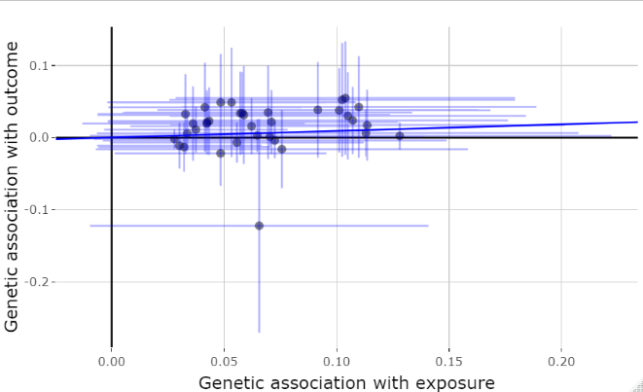 | 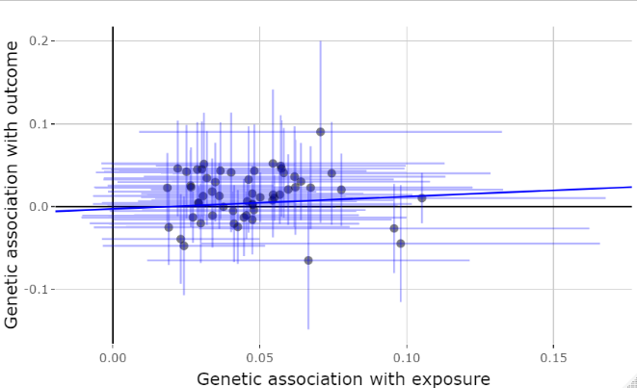
B. Central obesity
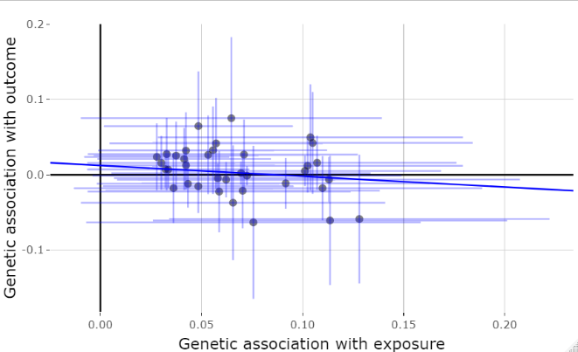 | 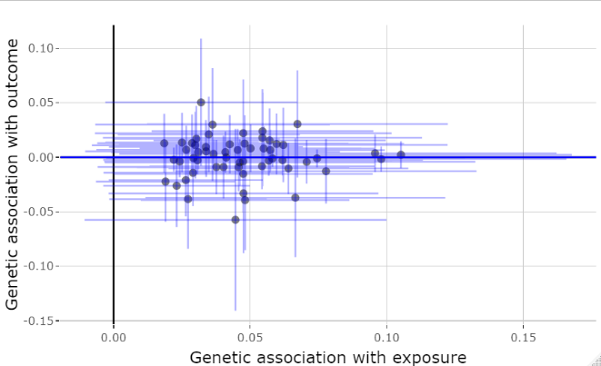
C. Hypertension
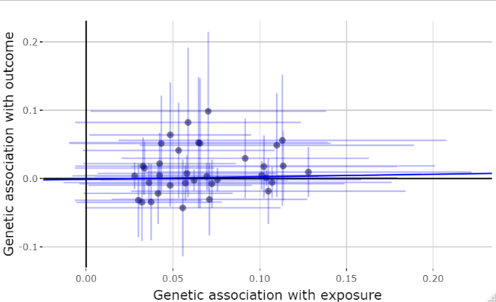 | 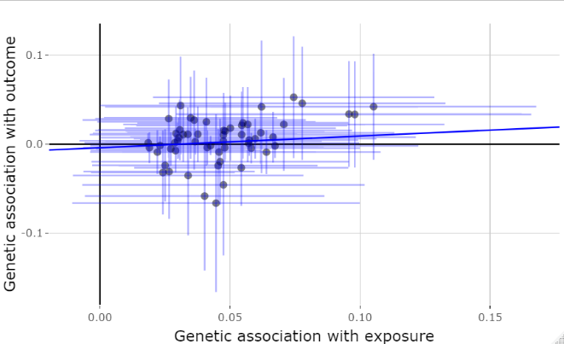
D. Dyslipidemia
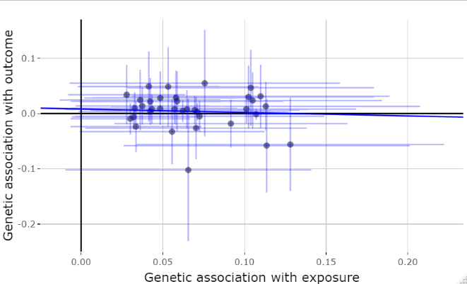 | 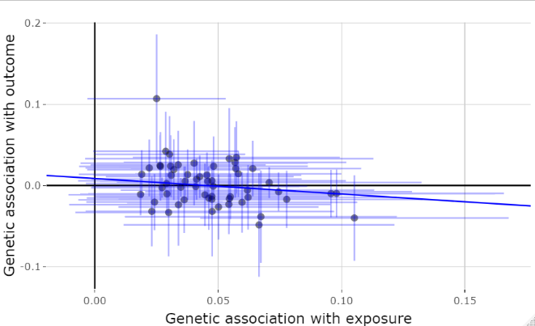  *
The blue line represents the MR-Egger model slope. Red asterisk indicates the SNP/s that may have possibly presented pleiotropic effects.

Figure S2 (cont’d): Sex-specific MR-Egger plots of SNP-outcome estimates against SNP-exposure estimates for binary metabolic outcomes among Taiwanese Han Chinese

Males | Females
E. Gout or hyperuricemia
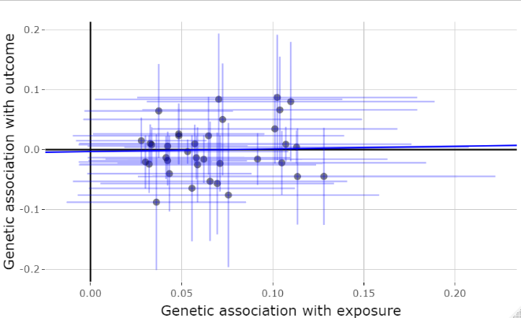 | 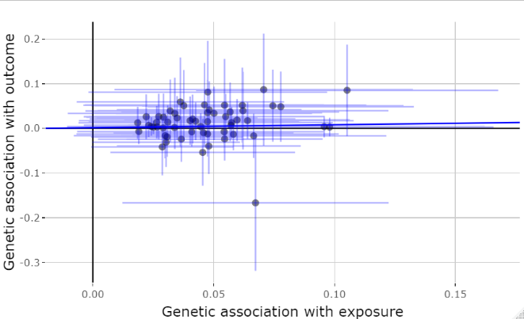
F. Diabetes or hyperglycemia
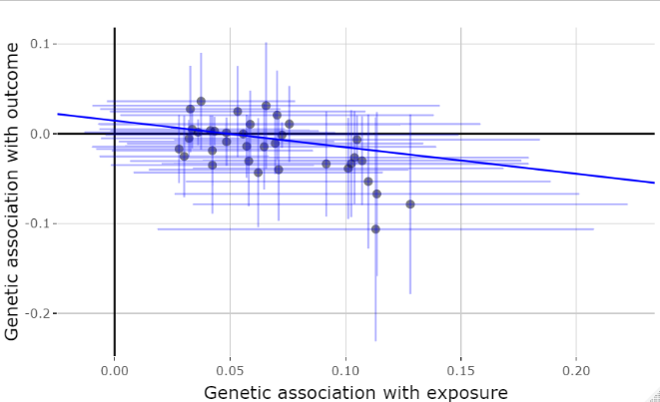  * | 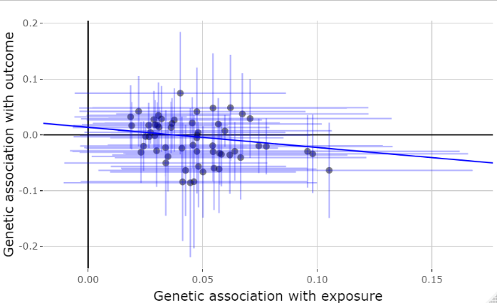  *
The blue line represents the MR-Egger model slope. Red asterisk indicates the SNP/s that may have possibly presented pleiotropic effects.

Figure S3: Sex-specific MR-Egger plots of SNP-outcome estimates against SNP-exposure estimates for binary metabolic outcomes among European Whites

Males | Females
A. Metabolic syndrome
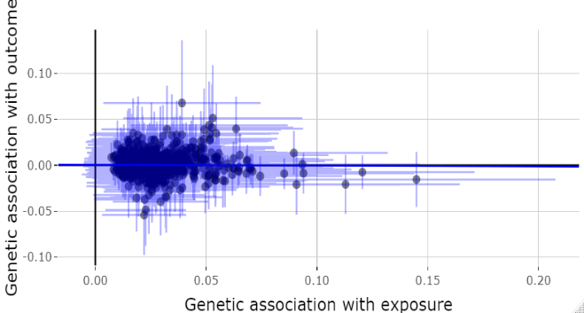 | 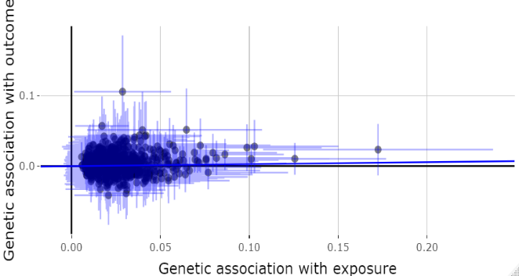
B. Central obesity
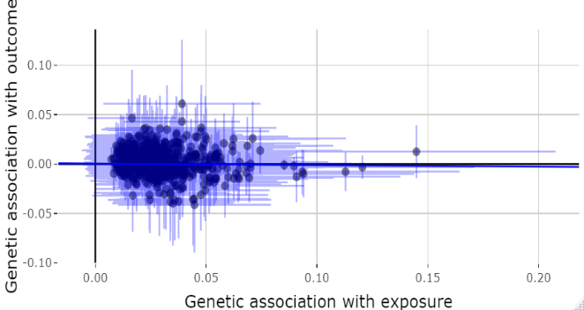 | 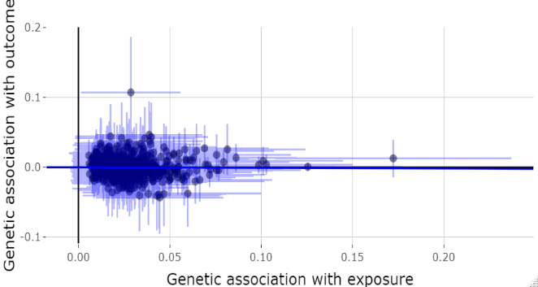
C. Hypertension
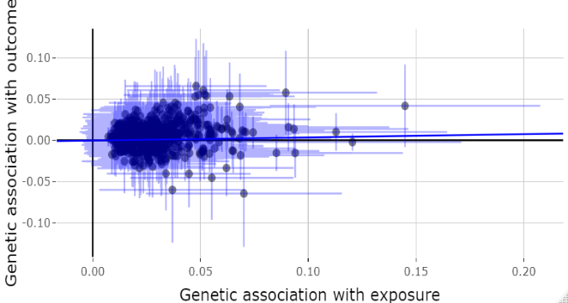 | 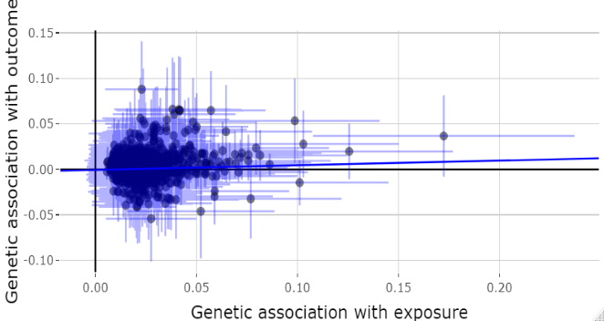  *
D. Dyslipidemia
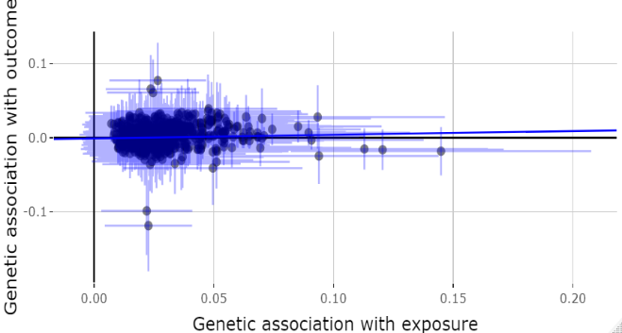  * | 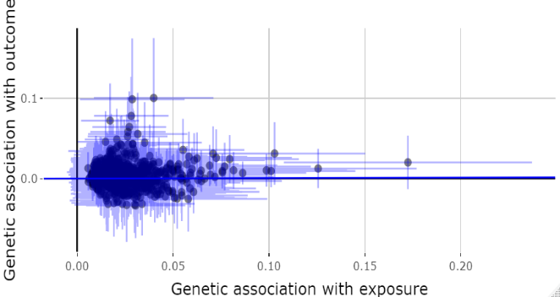
The blue line represents the MR-Egger model slope. Red asterisk indicates the SNP/s that may have possibly presented pleiotropic effects.

Figure S3 (cont’d): Sex-specific MR-Egger plots of SNP-outcome estimates against SNP-exposure estimates for binary metabolic outcomes among European Whites

Males | Females
E. Gout or hyperuricemia
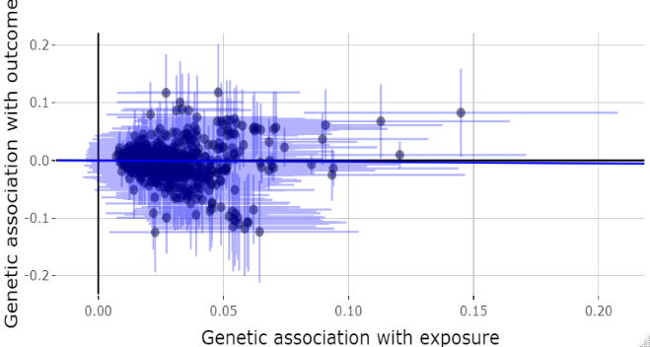 | 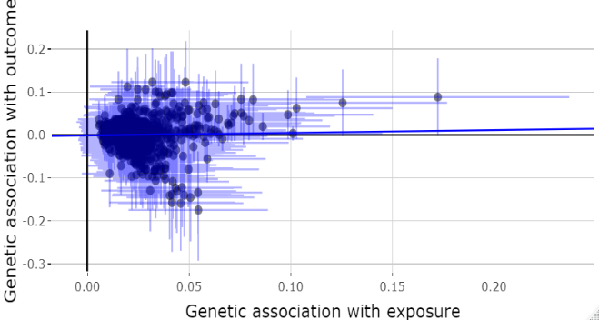
F. Diabetes or hyperglycemia
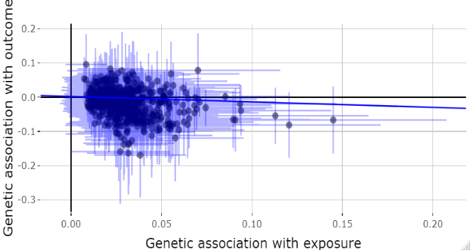  * | 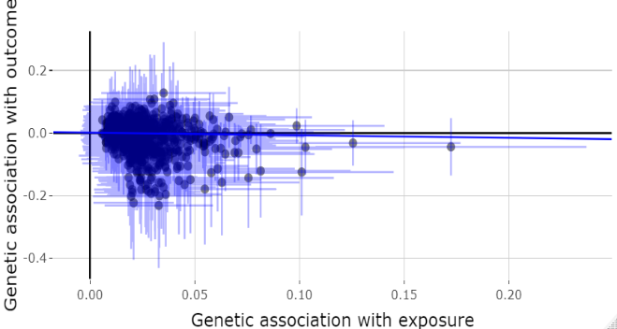
The blue line represents the MR-Egger model slope. Red asterisk indicates the SNP/s that may have possibly presented pleiotropic effects.

Table S23: Sex-specific MR-Egger regressions of associations between iron status and metabolic traits among Taiwanese Han Chinese and European Whites
Metabolic Traits | Taiwanese Han Chinese |  |  |  | European Whites
 | Beta (95% CI) | P | Intercept (95% CI) | P | Beta (95% CI) | P | Intercept (95% CI) | P
Males
Waist circumference | 0.20 (-0.72, 1.13) | 0.669 | 0.003 (-0.052, 0.057) | 0.927 | -0.02 (-0.04, 0.01) | 0.204 | 0.000 (0.000, 0.001) | 0.149
Systolic blood pressure | 0.40 (-0.74, 1.55) | 0.489 | -0.008 (-0.082, 0.066) | 0.832 | -0.01 (-0.19, 0.16) | 0.879 | 0.000 (-0.006, 0.006) | 1.000
Diastolic blood pressure | 1.55 (0.21, 2.89) | 0.024 | -0.058 (-0.136, 0.019) | 0.140 | 0.39 (0.19, 0.59) | <0.001 | -0.004 (-0.009, 0.001) | 0.109
Fasting blood glucose | 1.34 (-0.93, 3.61) | 0.248 | -0.034 (-0.172, 0.104) | 0.625 | -0.004 (-0.02, 0.01) | 0.513 | 0.000 (-0.001, 0.000) | 0.072
Triglycerides | 2.68 (-10.15, 15.52) | 0.682 | 0.119 (-0.730, 0.968) | 0.784 | 0.03 (0.01, 0.06) | 0.009 | 0.000 (-0.001, 0.000) | 0.564
HDL-cholesterol | -0.12 (-1.07, 0.82) | 0.797 | -0.009 (-0.071, 0.054) | 0.786 | 0.003 (-0.002, 0.01) | 0.224 | 0.000 (0.000, 0.000) | 0.234
Uric acid | 0.005 (-0.10, 0.11) | 0.923 | 0.000 (-0.009, 0.008) | 0.924 | 0.04 (-1.51, 1.58) | 0.964 | -0.011 (-0.055, 0.033) | 0.621
Females
Waist circumference | -0.11 (-0.68, 0.45) | 0.697 | 0.013 (-0.015, 0.041) | 0.363 | -0.04 (-0.16, 0.09) | 0.589 | 0.001 (-0.002, 0.004) | 0.568
Systolic blood pressure | 0.56 (-0.64, 1.77) | 0.361 | -0.012 (-0.065, 0.041) | 0.667 | 0.11 (-0.19, 0.40) | 0.478 | -0.001 (-0.009, 0.008) | 0.877
Diastolic blood pressure | 0.39 (-0.34, 1.13) | 0.295 | -0.005 (-0.034, 0.024) | 0.732 | 0.23 (0.03, 0.42) | 0.021 | 0.000 (-0.005, 0.005) | 0.969
Fasting blood glucose | -1.12 (-2.33, 0.09) | 0.069 | 0.041 (-0.004, 0.086) | 0.075 | -0.004 (-0.02, 0.01) | 0.524 | 0.000 (-0.001, 0.000) | 0.293
Triglycerides | 0.22 (-6.19, 6.62) | 0.947 | 0.038 (-0.277, 0.353) | 0.812 | 0.01 (-0.004, 0.02) | 0.176 | 0.000 (0.000, 0.001) | 0.382
HDL-cholesterol | 0.65 (-0.92, 2.22) | 0.416 | -0.033 (-0.105, 0.040) | 0.376 | -0.002 (-0.01, 0.01) | 0.695 | 0.000 (0.000, 0.000) | 0.776
Uric acid | 0.05 (-0.05, 0.15) | 0.318 | 0.000 (-0.005, 0.004) | 0.831 | 0.89 (-0.80, 2.58) | 0.301 | -0.017 (-0.061, 0.026) | 0.434

Figure S4: Sex-specific MR-Egger plots of SNP-outcome estimates against SNP-exposure estimates for quantitative metabolic traits among Taiwanese Han Chinese

Males | Females
A. Waist circumference
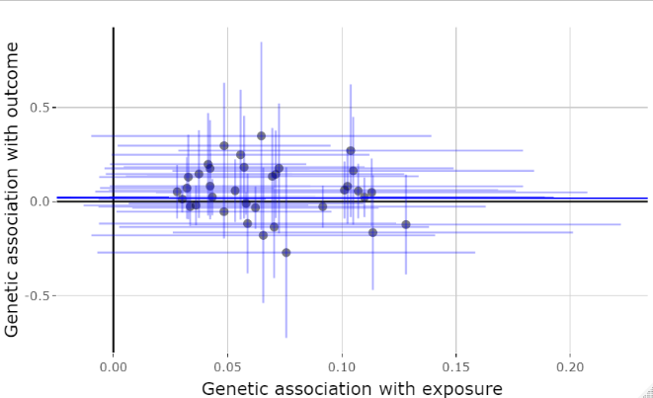 | 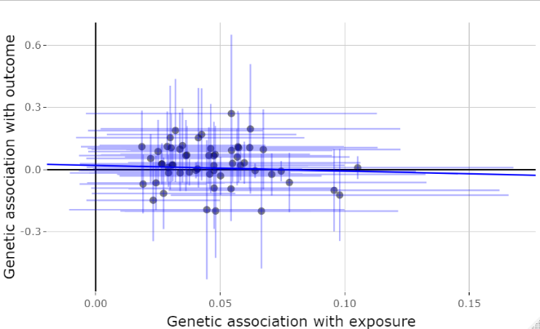
B. Systolic blood pressure
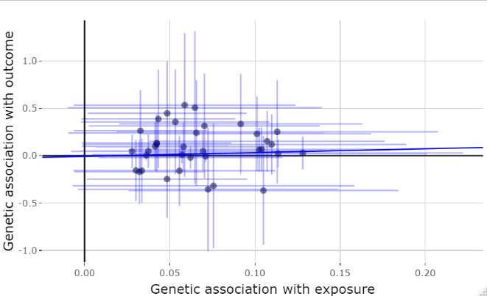 | 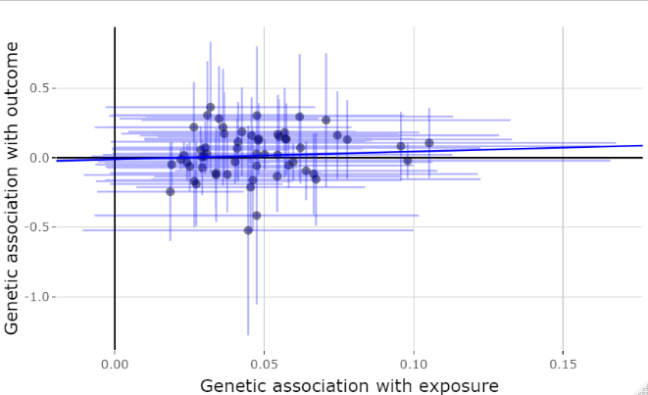
C. Diastolic blood pressure
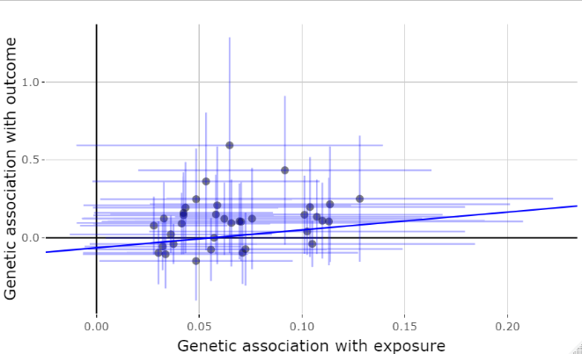 | 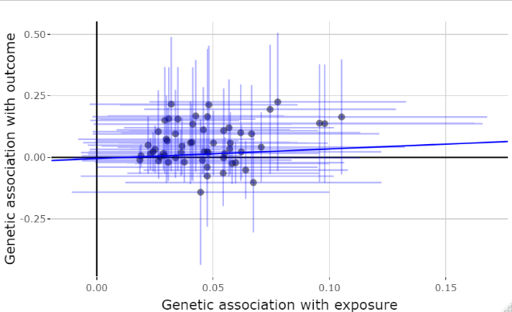
D. Fasting blood glucose
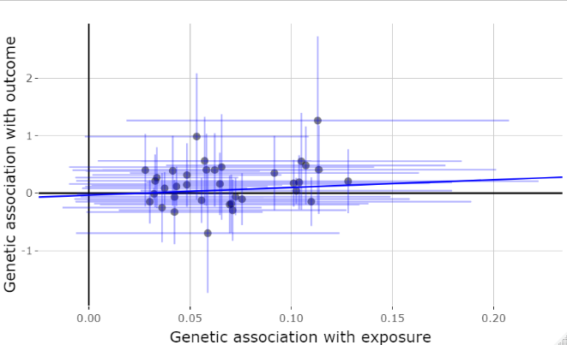 | 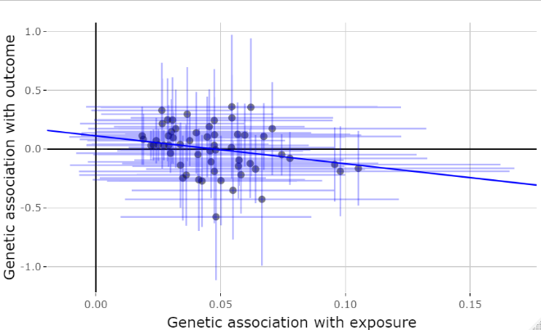  *
The blue line represents the MR-Egger model slope. Red asterisk indicates the SNP/s that may have possibly presented pleiotropic effects.

Figure S4 (cont’d): Sex-specific MR-Egger plots of SNP-outcome estimates against SNP-exposure estimates for quantitative metabolic traits among Taiwanese Han Chinese

Males | Females
E. Triglycerides
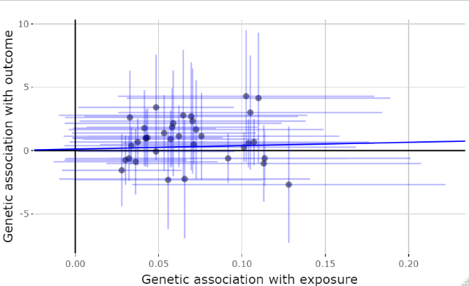 | 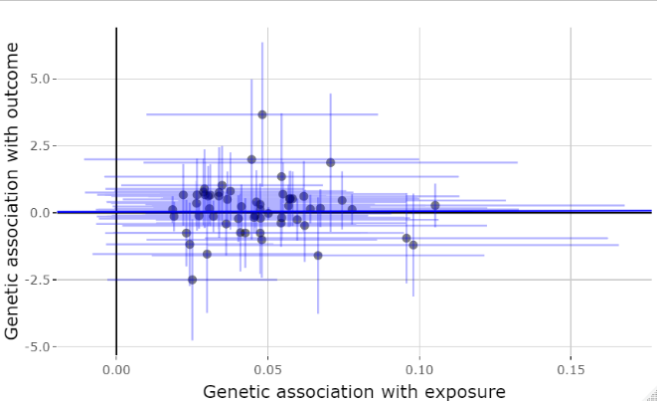
F. HDL-cholesterol
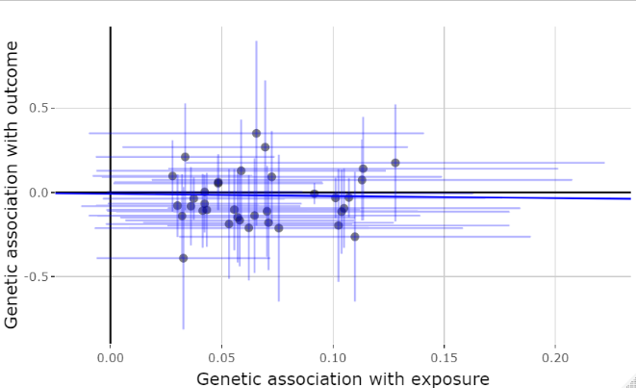 | 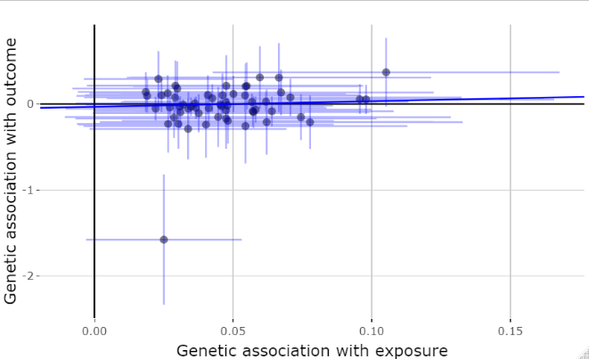
G. Uric acid
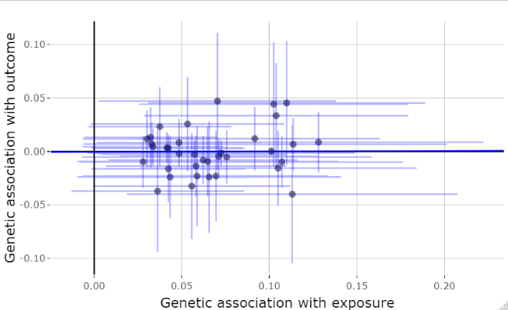 | 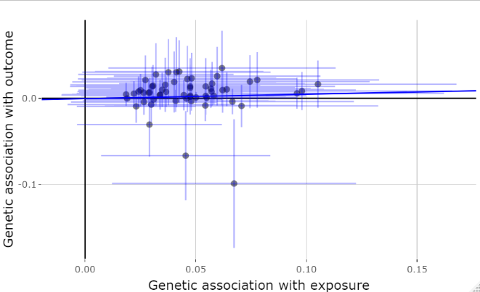
The blue line represents the MR-Egger model slope. Red asterisk indicates the SNP/s that may have possibly presented pleiotropic effects.

Figure S5: Sex-specific MR-Egger plots of SNP-outcome estimates against SNP-exposure estimates for quantitative metabolic traits among European Whites

Males | Females
A. Waist circumference
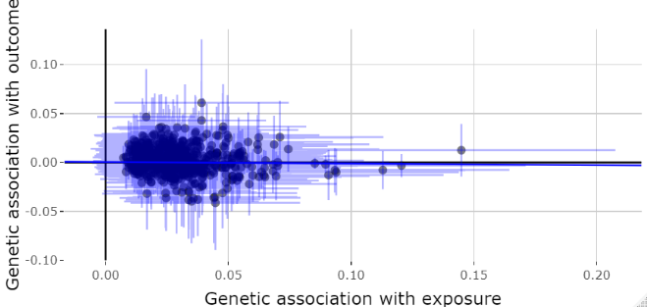 | 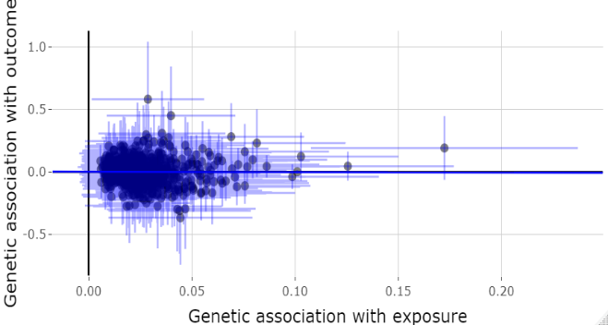
B. Systolic blood pressure
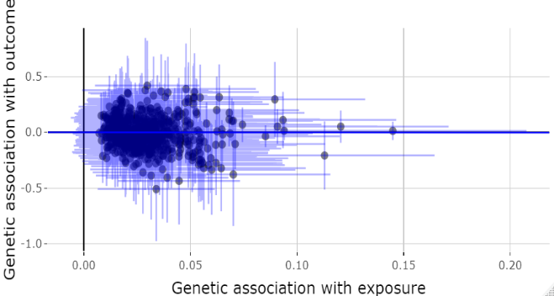 | 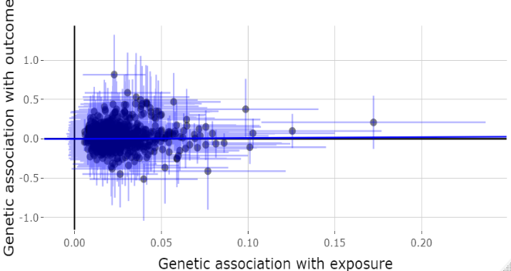
C. Diastolic blood pressure
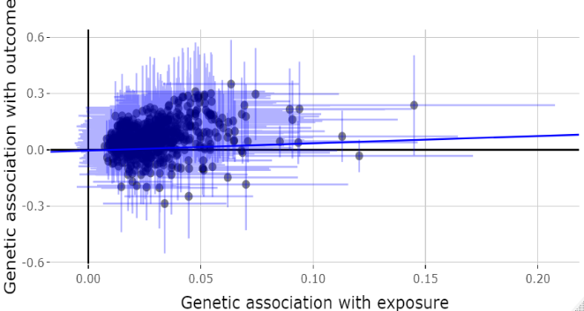 | 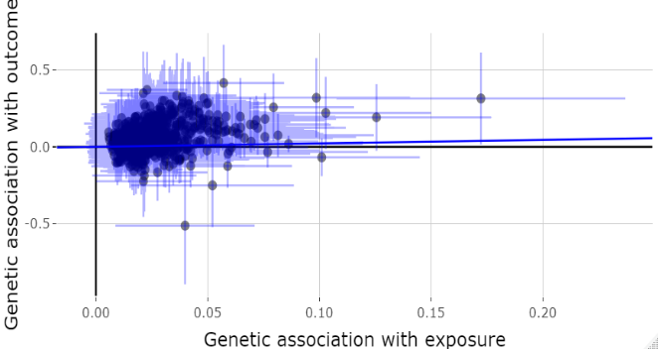
D. Blood glucose
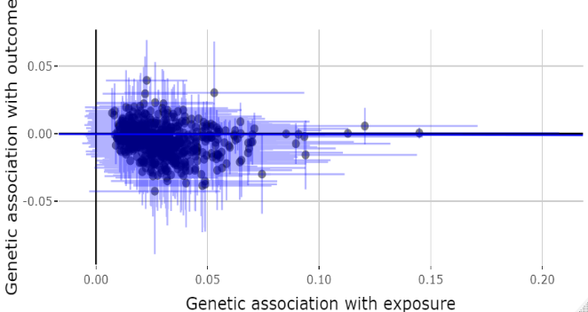  * | 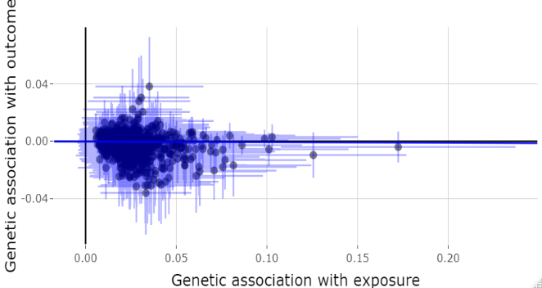
The blue line represents the MR-Egger model slope. Red asterisk indicates the SNP/s that may have possibly presented pleiotropic effects.

Figure S5 (cont’d): Sex-specific MR-Egger plots of SNP-outcome estimates against SNP-exposure estimates for quantitative metabolic traits among European Whites

Males | Females
E. Triglycerides
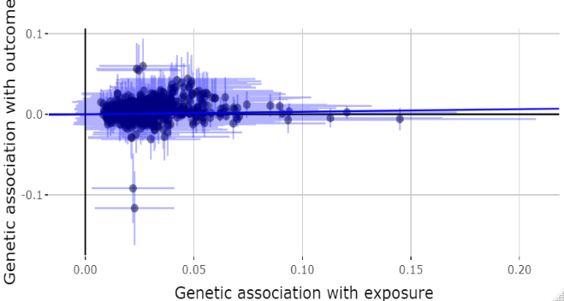 | 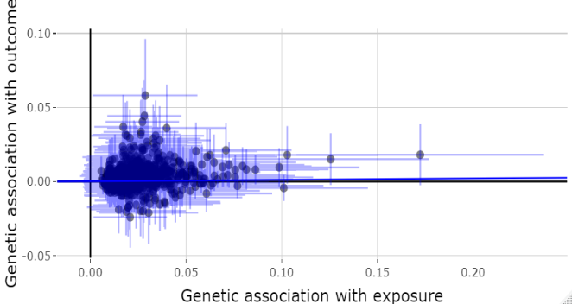
F. HDL-cholesterol
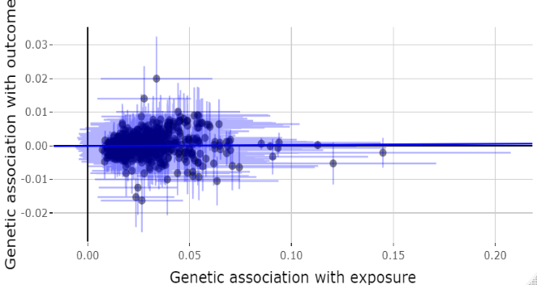 | 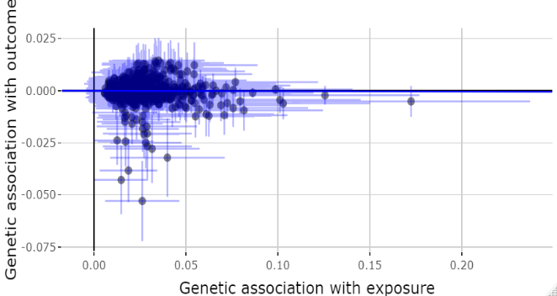
G. Uric acid
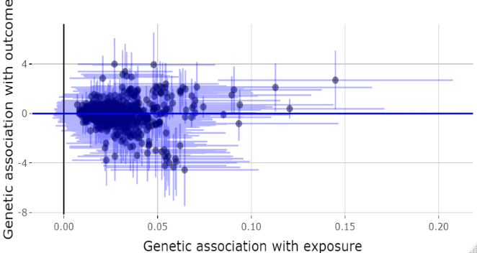 | 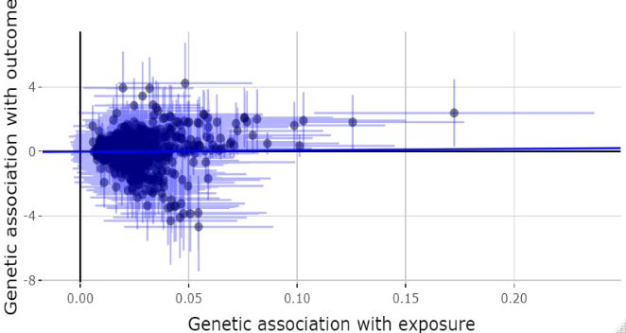
The blue line represents the MR-Egger model slope. Red asterisk indicates the SNP/s that may have possibly presented pleiotropic effects.

Figure S6: Comparison of OR plots between main MR and sensitivity analyses among Taiwanese Han Chinese, depicting causal roles of iron status on MetS and other metabolic outcomes

Main MR Analyses | Sensitivity Analyses
A. Metabolic Syndrome
Males
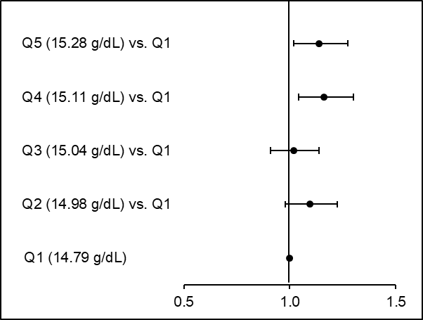 | 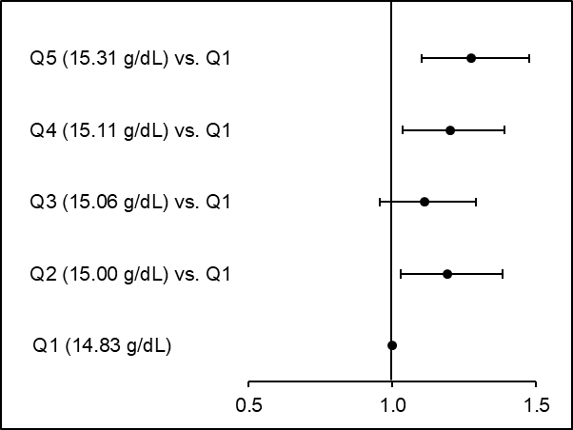
Females
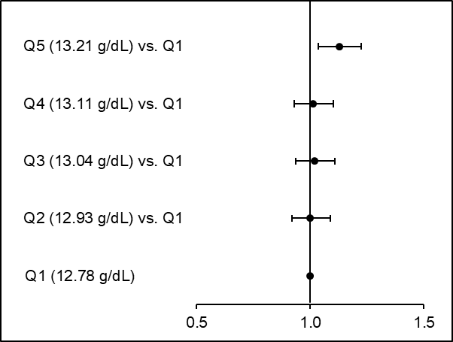 | 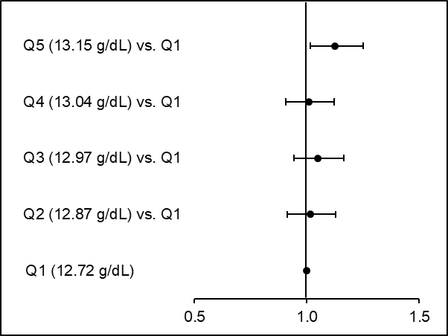
B. Hypertension
Males
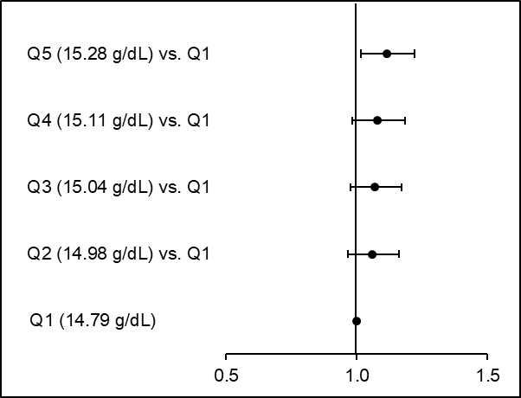 | 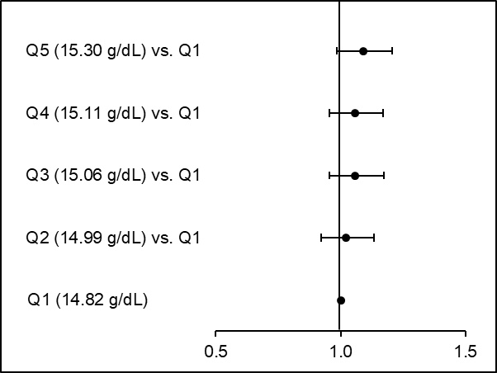
Females
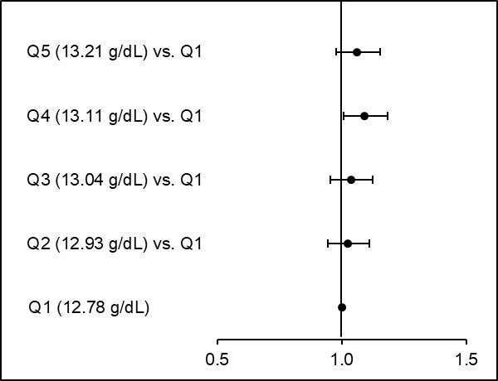 | 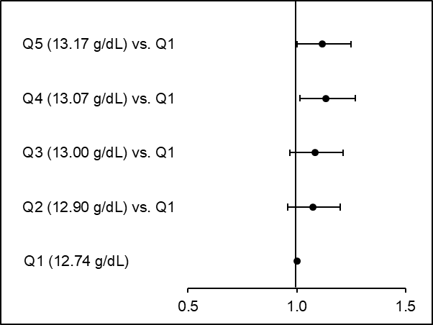
ORs from the final models are presented for both main MR and sensitivity analyses, which fully adjusted for age, age-squared, first ten genetic principal components, smoking status, and alcohol consumption, as well as menopausal status in females.
Figure S6 (cont’d): Comparison of OR plots between main MR and sensitivity analyses among Taiwanese Han Chinese, depicting causal roles of iron status on MetS and other metabolic outcomes

Main MR Analyses | Sensitivity Analyses
C. Dyslipidemia
Males
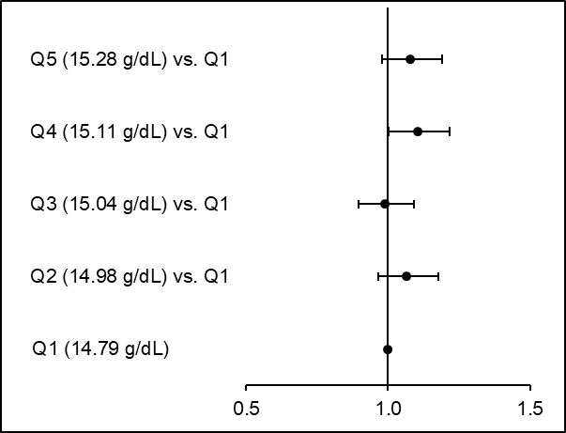 | 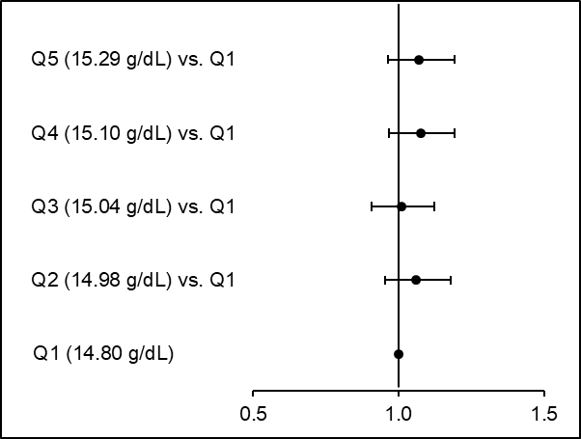
Females
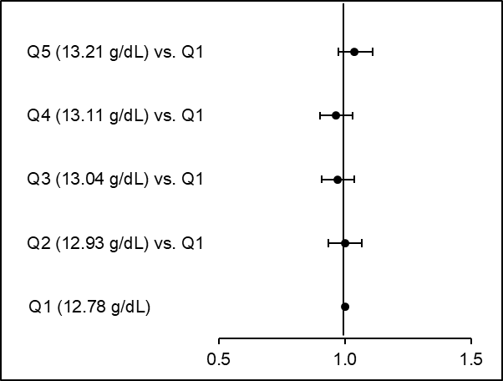 | 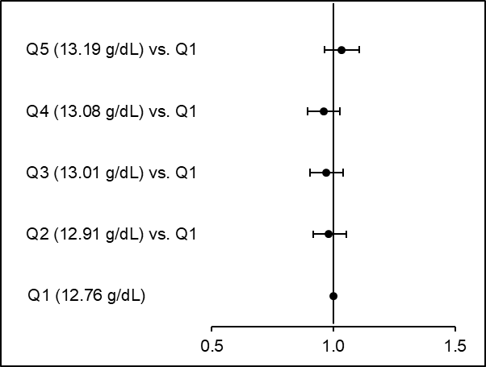
D. Gout or Hyperuricemia
Males
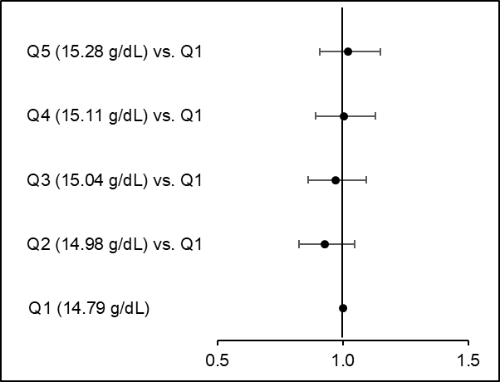 | 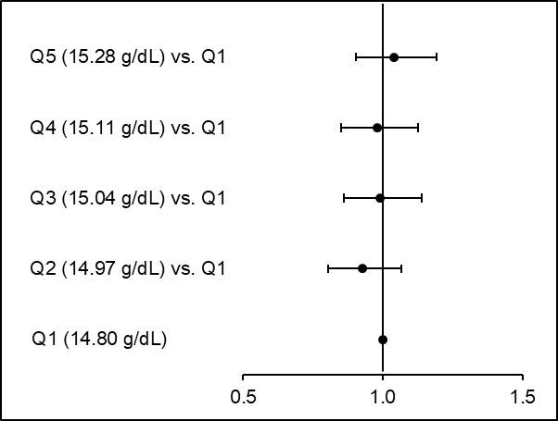
Females
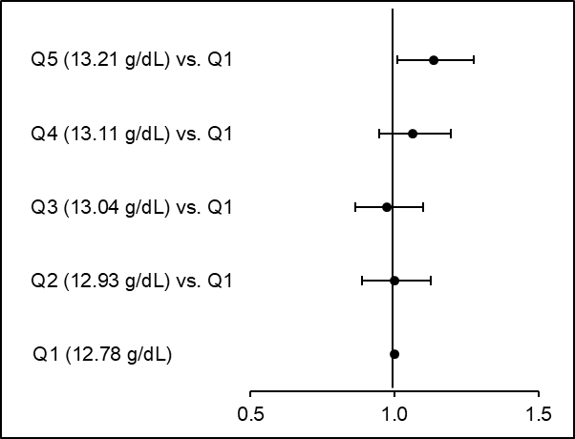 | 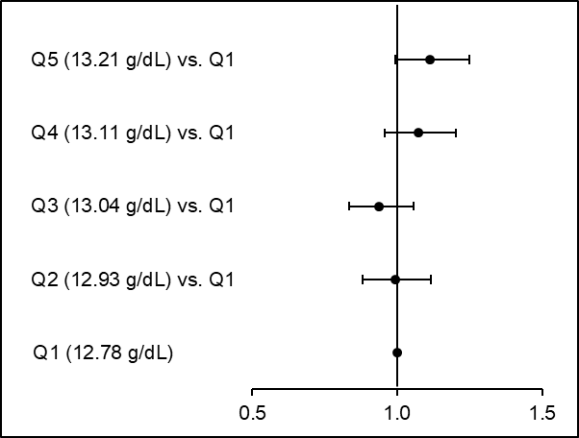
ORs from the final models are presented for both main MR and sensitivity analyses, which fully adjusted for age, age-squared, first ten genetic principal components, smoking status, and alcohol consumption, as well as menopausal status in females.
Figure S6 (cont’d): Comparison of OR plots between main MR and sensitivity analyses among Taiwanese Han Chinese, depicting causal roles of iron status on MetS and other metabolic outcomes

Main MR Analyses | Sensitivity Analyses
E. Diabetes or Hyperglycemia
Males
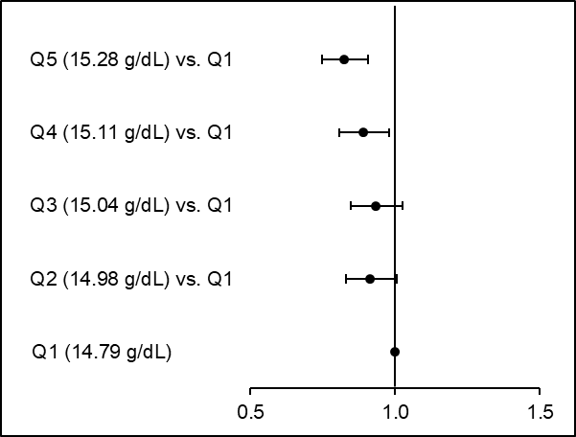 | 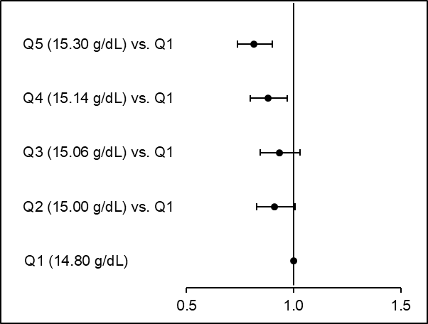
Females
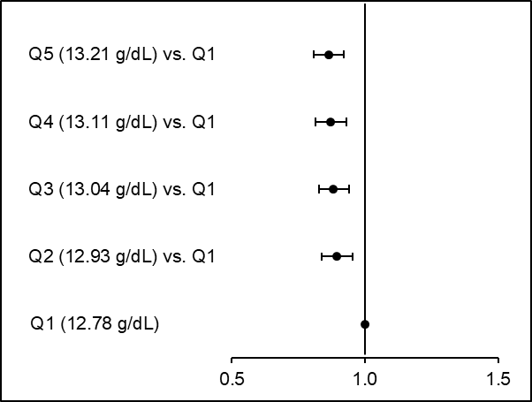 | 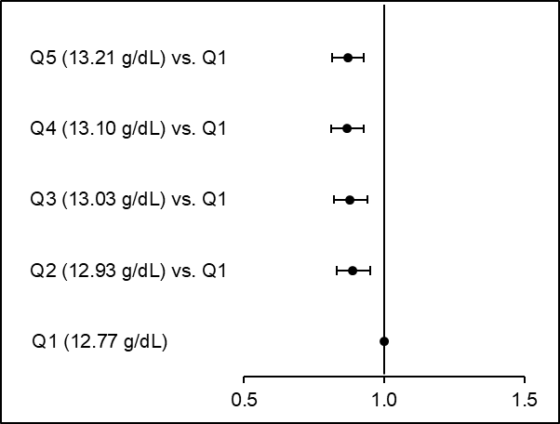
ORs from the final models are presented for both main MR and sensitivity analyses, which fully adjusted for age, age-squared, first ten genetic principal components, smoking status, and alcohol consumption, as well as menopausal status in females.

Figure S7: Comparison of OR plots between main MR and sensitivity analyses among European Whites, depicting causal roles of iron status on MetS and other metabolic outcomes
Main MR Analyses | Sensitivity Analyses
A. Metabolic Syndrome
Males
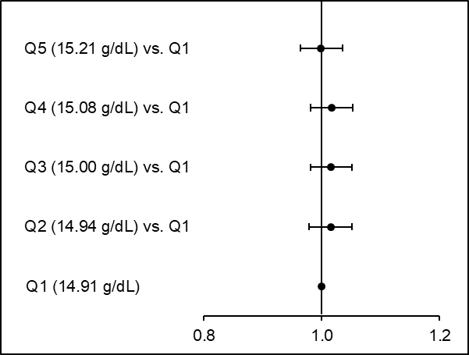 | 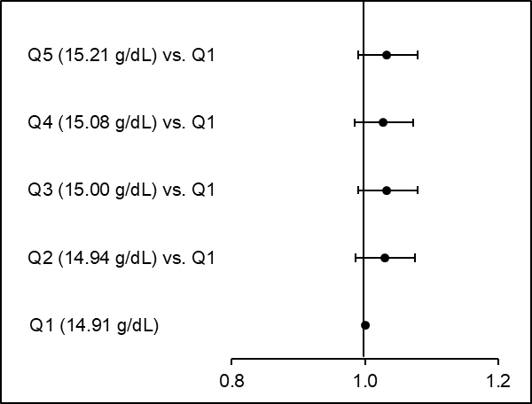
Females
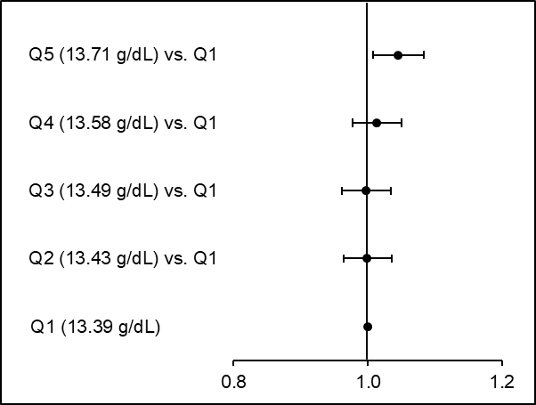 | 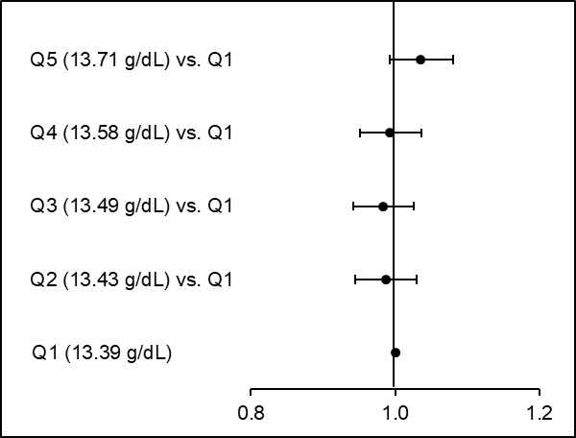
B. Hypertension
Males
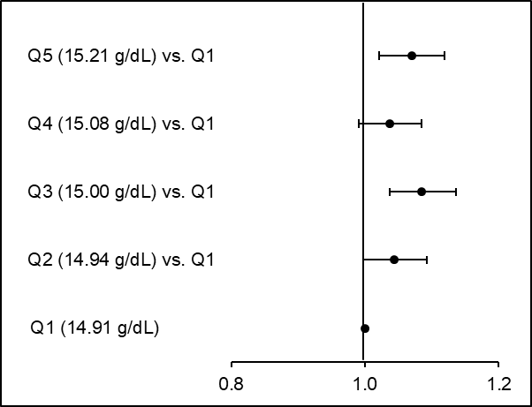 | 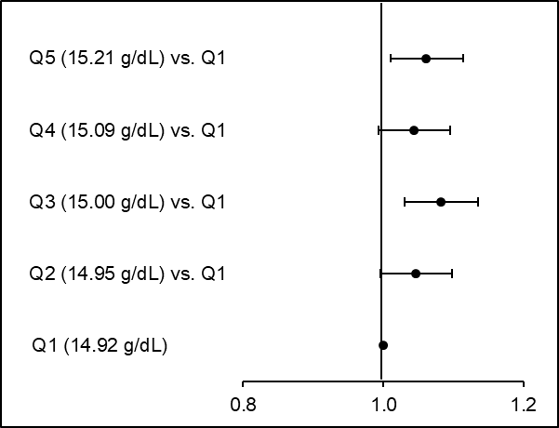
Females
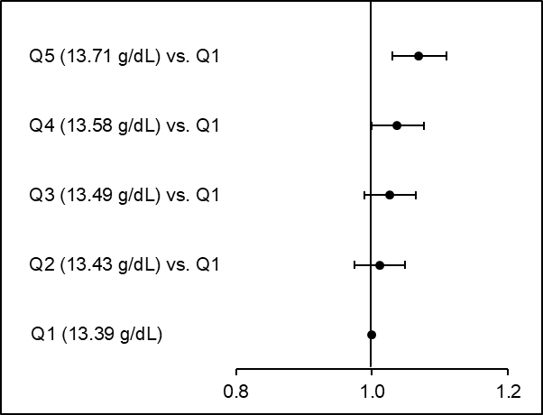 | 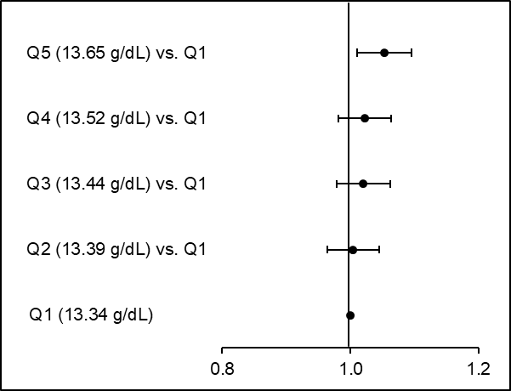
ORs from the final models are presented for both main MR and sensitivity analyses, which fully adjusted for age, age-squared, first ten genetic principal components, smoking status, and alcohol consumption, as well as menopausal status in females.

Figure S7 (cont’d): Comparison of OR plots between main MR and sensitivity analyses among European Whites, depicting causal roles of iron status on MetS and other metabolic outcomes

Main MR Analyses | Sensitivity Analyses
C. Dyslipidemia
Males
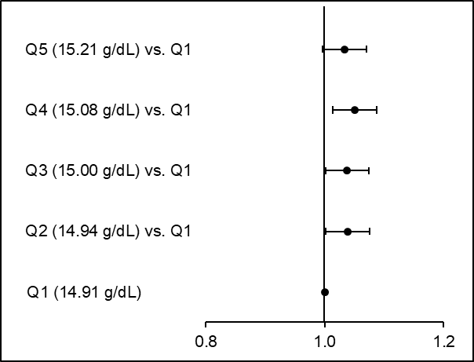 | 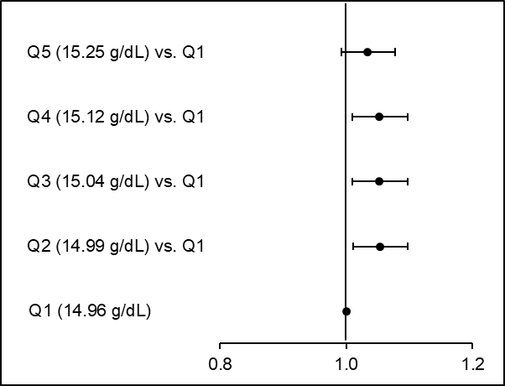
Females
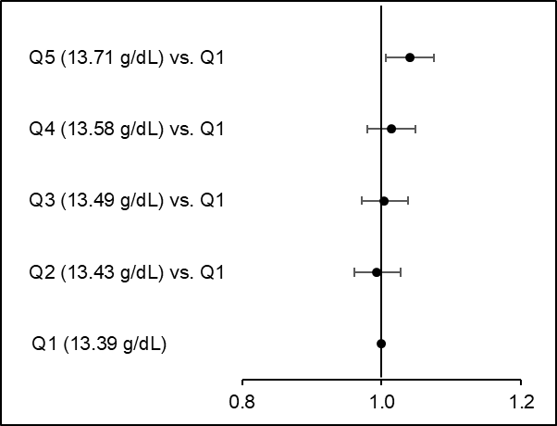 | 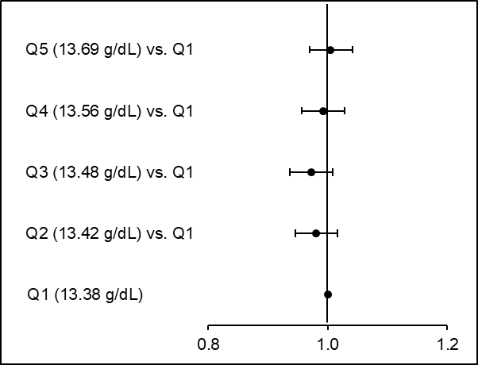
D. Gout or Hyperuricemia
Males
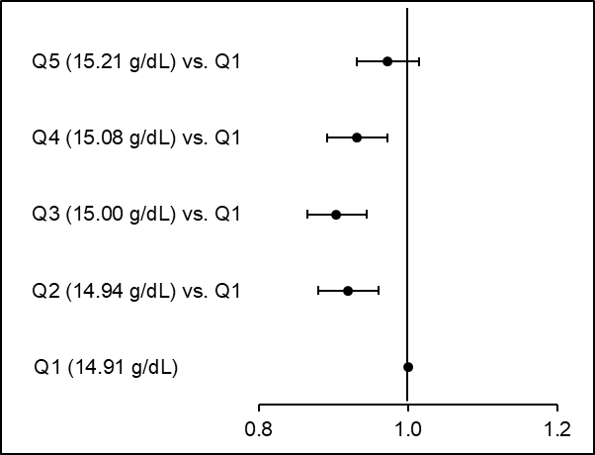 | 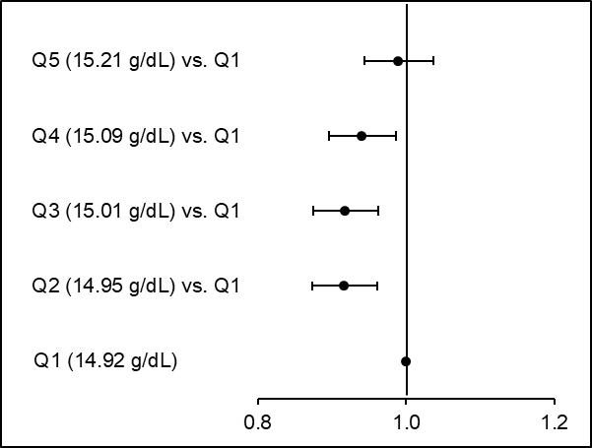
Females
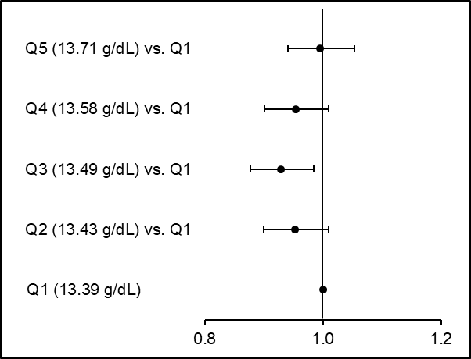 | 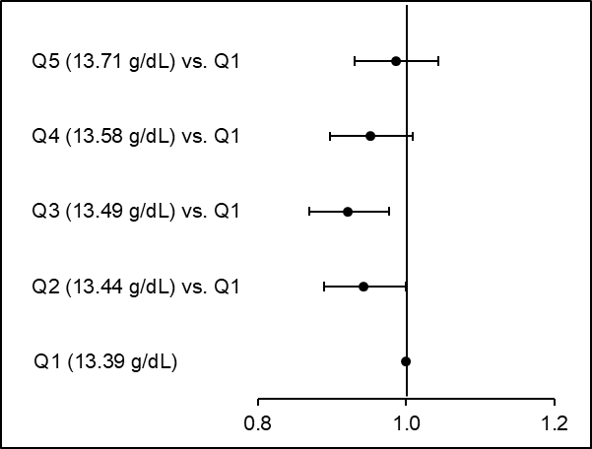
ORs from the final models are presented for both main MR and sensitivity analyses, which fully adjusted for age, age-squared, first ten genetic principal components, smoking status, and alcohol consumption, as well as menopausal status in females.

Figure S7 (cont’d): Comparison of OR plots between main MR and sensitivity analyses among European Whites, depicting causal roles of iron status on MetS and other metabolic outcomes

Main MR Analyses | Sensitivity Analyses
E. Diabetes or Hyperglycemia
Males
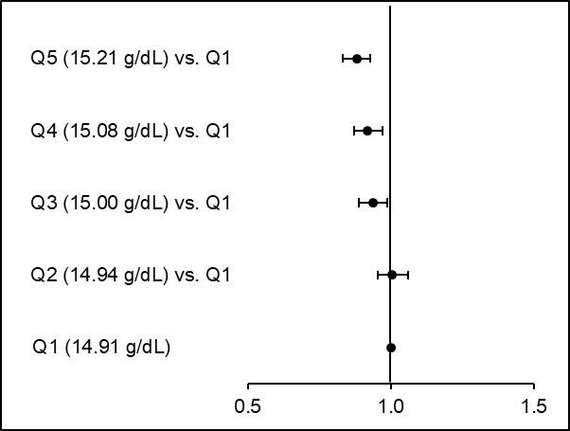 | 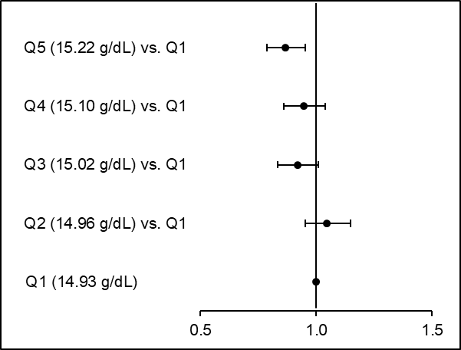
Females
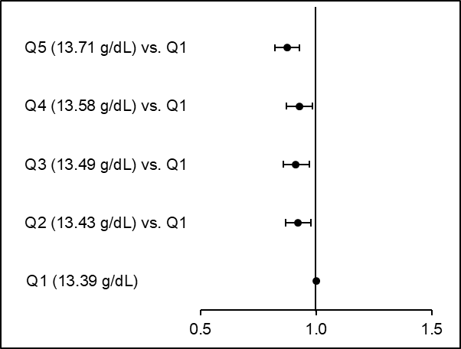 | 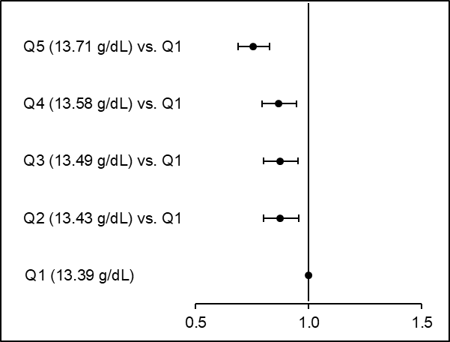
ORs from the final models are presented for both main MR and sensitivity analyses, which fully adjusted for age, age-squared, first ten genetic principal components, smoking status, and alcohol consumption, as well as menopausal status in females.

Table S24: Odds ratios from sensitivity analyses† of causal associations between metabolic syndrome and quintiles of Hb-PRS among Taiwanese Han Chinese and European Whites
Metabolic Syndrome | Cases  n (%) | Crude  OR (95% CI) | P | Model 1‡  OR (95% CI) | P | Model 2§  OR (95% CI) | P
Taiwanese Han Chinese (N=61,352)
Males (n=19,012) | 2,721 (19.5)
Q1 (14.83 g/dL) | 489 (17.5) | Reference | - | Reference | - | Reference | -
Q2 (15.00 g/dL) vs. Q1 | 546 (19.5) | 1.20 (1.04, 1.40) | 0.0134 | 1.20 (1.04, 1.39) | 0.0140 | 1.19 (1.03, 1.38) | 0.0202
Q3 (15.06 g/dL) vs. Q1 | 535 (19.1) | 1.12 (0.97, 1.30) | 0.1378 | 1.12 (0.97, 1.30) | 0.1327 | 1.11 (0.96, 1.29) | 0.1657
Q4 (15.11 g/dL) vs. Q1 | 573 (20.5) | 1.22 (1.05, 1.41) | 0.0090 | 1.21 (1.05, 1.40) | 0.0108 | 1.20 (1.04, 1.39) | 0.0156
Q5 (15.31 g/dL) vs. Q1 | 578 (20.7) | 1.28 (1.10, 1.48) | 0.0010 | 1.28 (1.10, 1.48) | 0.0011 | 1.27 (1.10, 1.48) | 0.0012
Females (n=42,340) | 4,783 (13.6)
Q1 (12.72 g/dL) | 935 (13.3) | Reference | - | Reference | - | Reference | -
Q2 (12.87 g/dL) vs. Q1 | 935 (13.3) | 1.01 (0.91, 1.12) | 0.8741 | 1.01 (0.91, 1.12) | 0.8560 | 1.01 (0.91, 1.13) | 0.7984
Q3 (12.97 g/dL) vs. Q1 | 943 (13.4) | 1.04 (0.94, 1.16) | 0.4541 | 1.05 (0.94, 1.16) | 0.4100 | 1.05 (0.94, 1.17) | 0.3849
Q4 (13.04 g/dL) vs. Q1 | 949 (13.5) | 1.00 (0.90, 1.12) | 0.9356 | 1.01 (0.91, 1.12) | 0.8858 | 1.01 (0.91, 1.12) | 0.8807
Q5 (13.15 g/dL) vs. Q1 | 1,021 (14.6) | 1.12 (1.01, 1.24) | 0.0291 | 1.12 (1.01, 1.25) | 0.0287 | 1.13 (1.01, 1.25) | 0.0259
European Whites (N=271,366)
Males (n=128,549) | 22,276 (30.8)
Q1 (14.92 g/dL) | 4,375 (30.3) | Reference | - | Reference | - | Reference | -
Q2 (14.96 g/dL) vs. Q1 | 4,483 (31.0) | 1.03 (0.99, 1.08) | 0.1739 | 1.03 (0.99, 1.08) | 0.1242 | 1.03 (0.99, 1.08) | 0.1845
Q3 (15.00 g/dL) vs. Q1 | 4,462 (30.9) | 1.04 (0.99, 1.08) | 0.1063 | 1.04 (0.99, 1.08) | 0.0980 | 1.03 (0.99, 1.08) | 0.1364
Q4 (15.09 g/dL) vs. Q1 | 4,511 (31.2) | 1.03 (0.99, 1.08) | 0.1549 | 1.03 (0.99, 1.08) | 0.1692 | 1.03 (0.98, 1.07) | 0.2237
Q5 (15.20 g/dL) vs. Q1 | 4,445 (30.8) | 1.04 (1.00, 1.09) | 0.0776 | 1.04 (0.99, 1.08) | 0.0924 | 1.03 (0.99, 1.08) | 0.1386
Females (n=142,817) | 21,440 (22.4)
Q1 (13.33 g/dL) | 4,324 (22.6) | Reference | - | Reference | - | Reference | -
Q2 (13.38 g/dL) vs. Q1 | 4,240 (22.1) | 0.98 (0.94, 1.02) | 0.4035 | 0.99 (0.95, 1.03) | 0.5722 | 0.99 (0.95, 1.03) | 0.5333
Q3 (13.43 g/dL) vs. Q1 | 4,245 (22.2) | 0.99 (0.94, 1.03) | 0.4648 | 0.99 (0.95, 1.03) | 0.5212 | 0.98 (0.94, 1.03) | 0.4221
Q4 (13.51 g/dL) vs. Q1 | 4,210 (22.0) | 0.99 (0.95, 1.03) | 0.5176 | 0.99 (0.95, 1.03) | 0.6723 | 0.99 (0.95, 1.04) | 0.7296
Q5 (13.64 g/dL) vs. Q1 | 10,595 (37.1) | 1.03 (0.99, 1.08) | 0.1259 | 1.03 (0.99, 1.08) | 0.1259 | 1.04 (0.99, 1.08) | 0.1123
†Subjects ascertained from either self-reported data (i.e., physician-diagnosed health condition or intake of prescription medications) or hospital in-patient records were excluded from the sensitivity analyses. ‡Model 1 adjusted for age, age-squared and the first ten genetic principal components. §Model 2 further adjusted for smoking and alcohol consumption (and menopausal status in women).

Table S25: Odds ratios from sensitivity analyses† of causal associations between hypertension and quintiles of Hb-PRS among Taiwanese Han Chinese and European Whites
Hypertension | Cases  n (%) | Crude  OR (95% CI) | P | Model 1‡  OR (95% CI) | P | Model 2§  OR (95% CI) | P
Taiwanese Han Chinese (N=61,352)
Males (n=19,012) | 3,023 (19.5)
Q1 (14.82 g/dL) | 599 (19.3) | Reference | - | Reference | - | Reference | -
Q2 (14.99 g/dL) vs. Q1 | 595 (19.2) | 0.99 (0.87, 1.13) | 0.8975 | 0.99 (0.87, 1.13) | 0.8657 | 0.98 (0.86, 1.12) | 0.7976
Q3 (15.06 g/dL) vs. Q1 | 592 (19.1) | 0.99 (0.87, 1.12) | 0.8215 | 0.99 (0.87, 1.13) | 0.9053 | 0.99 (0.87, 1.12) | 0.8173
Q4 (15.11 g/dL) vs. Q1 | 609 (19.6) | 1.02 (0.90, 1.16) | 0.7532 | 1.03 (0.91, 1.17) | 0.6292 | 1.03 (0.90, 1.17) | 0.6690
Q5 (15.30 g/dL) vs. Q1 | 628 (20.3) | 1.06 (0.94, 1.20) | 0.3553 | 1.08 (0.95, 1.22) | 0.2603 | 1.07 (0.94, 1.22) | 0.2803
Females (n=42,340) | 3,683 (9.7)
Q1 (12.74 g/dL) | 691 (9.1) | Reference | - | Reference | - | Reference | -
Q2 (12.90 g/dL) vs. Q1 | 734 (9.7) | 1.07 (0.96, 1.19) | 0.2315 | 1.07 (0.96, 1.20) | 0.2181 | 1.07 (0.96, 1.20) | 0.2120
Q3 (13.00 g/dL) vs. Q1 | 735 (9.7) | 1.07 (0.96, 1.19) | 0.2200 | 1.08 (0.97, 1.21) | 0.1754 | 1.08 (0.97, 1.21) | 0.1568
Q4 (13.07 g/dL) vs. Q1 | 761 (10.0) | 1.11 (0.99, 1.24) | 0.0535 | 1.13 (1.01, 1.26) | 0.0296 | 1.14 (1.02, 1.27) | 0.0255
Q5 (13.17 g/dL) vs. Q1 | 762 (10.1) | 1.11 (1.00, 1.24) | 0.0499 | 1.11 (0.99, 1.25) | 0.0567 | 1.12 (1.00, 1.25) | 0.0499
European Whites (N=271,366)
Males (n=128,549) | 53,655 (69.3)
Q1 (14.92 g/dL) | 10,581 (68.4) | Reference | - | Reference | - | Reference | -
Q2 (14.95 g/dL) vs. Q1 | 10,720 (69.2) | 1.04 (0.99, 1.09) | 0.0914 | 1.05 (0.99, 1.10) | 0.0643 | 1.05 (0.99, 1.10) | 0.0705
Q3 (15.00 g/dL) vs. Q1 | 10,842 (70.0) | 1.08 (1.03, 1.14) | 0.0013 | 1.08 (1.03, 1.14) | 0.0014 | 1.08 (1.03, 1.14) | 0.0017
Q4 (15.09 g/dL) vs. Q1 | 10,738 (69.4) | 1.05 (0.99, 1.10) | 0.0562 | 1.04 (0.99, 1.10) | 0.0843 | 1.04 (0.99, 1.10) | 0.0849
Q5 (15.21 g/dL) vs. Q1 | 10,774 (69.6) | 1.06 (1.01, 1.11) | 0.0182 | 1.06 (1.01, 1.12) | 0.0143 | 1.06 (1.01, 1.11) | 0.0172
Females (n=142,817) | 53,592 (53.5)
Q1 (13.34 g/dL) | 10,651 (53.1) | Reference | - | Reference | - | Reference | -
Q2 (13.39 g/dL) vs. Q1 | 10,641 (53.1) | 1.00 (0.96, 1.04) | 0.9160 | 1.00 (0.96, 1.04) | 0.9058 | 1.00 (0.96, 1.05) | 0.8574
Q3 (13.44 g/dL) vs. Q1 | 10,742 (53.6) | 1.02 (0.98, 1.06) | 0.3679 | 1.02 (0.98, 1.06) | 0.3844 | 1.02 (0.98, 1.06) | 0.3385
Q4 (13.52 g/dL) vs. Q1 | 10,720 (53.5) | 1.01 (0.98, 1.05) | 0.4930 | 1.02 (0.98, 1.06) | 0.3274 | 1.02 (0.98, 1.06) | 0.2900
Q5 (13.65 g/dL) vs. Q1 | 14,184 (49.7) | 1.04 (0.99, 1.08) | 0.0620 | 1.05 (1.01, 1.10) | 0.0143 | 1.05 (1.01, 1.10) | 0.0123
†Subjects ascertained from either self-reported data (i.e., physician-diagnosed health condition or intake of prescription medications) or hospital in-patient records were excluded from the sensitivity analyses. ‡Model 1 adjusted for age, age-squared and the first ten genetic principal components. §Model 2 further adjusted for smoking and alcohol consumption (and menopausal status in women).
Table S26: Odds ratios from sensitivity analyses† of causal associations between dyslipidemia and quintiles of Hb-PRS among Taiwanese Han Chinese and European Whites
Dyslipidemia | Cases  n (%) | Crude  OR (95% CI) | P | Model 1‡  OR (95% CI) | P | Model 2§  OR (95% CI) | P
Taiwanese Han Chinese (N=61,352)
Males (n=19,012) | 4,998 (29.2)
Q1 (14.80 g/dL) | 965 (28.2) | Reference | - | Reference | - | Reference | -
Q2 (14.98 g/dL) vs. Q1 | 1,015 (29.7) | 1.07 (0.97, 1.19) | 0.1852 | 1.07 (0.96, 1.19) | 0.2116 | 1.06 (0.95, 1.18) | 0.2853
Q3 (15.04 g/dL) vs. Q1 | 975 (28.5) | 1.01 (0.91, 1.13) | 0.7944 | 1.02 (0.92, 1.13) | 0.7572 | 1.01 (0.91, 1.12) | 0.8693
Q4 (15.10 g/dL) vs. Q1 | 1,027 (30.0) | 1.09 (0.98, 1.21) | 0.1006 | 1.09 (0.98, 1.21) | 0.1144 | 1.08 (0.97, 1.19) | 0.1816
Q5 (15.29 g/dL) vs. Q1 | 1,016 (29.7) | 1.08 (0.97, 1.19) | 0.1765 | 1.07 (0.97, 1.19) | 0.1924 | 1.07 (0.96, 1.19) | 0.2010
Females (n=42,340) | 11,135 (28.3)
Q1 (12.76 g/dL) | 2,242 (28.5) | Reference | - | Reference | - | Reference | -
Q2 (12.90 g/dL) vs. Q1 | 2,212 (28.1) | 0.98 (0.92, 1.05) | 0.5920 | 0.98 (0.91, 1.05) | 0.5576 | 0.98 (0.92, 1.05) | 0.6116
Q3 (13.01 g/dL) vs. Q1 | 2,199 (27.9) | 0.97 (0.91, 1.04) | 0.4433 | 0.97 (0.91, 1.04) | 0.3906 | 0.97 (0.91, 1.04) | 0.3969
Q4 (13.08 g/dL) vs. Q1 | 2,182 (27.7) | 0.96 (0.90, 1.03) | 0.2851 | 0.96 (0.90, 1.03) | 0.2404 | 0.96 (0.89, 1.03) | 0.2357
Q5 (13.19 g/dL) vs. Q1 | 2,300 (29.2) | 1.04 (0.97, 1.11) | 0.3076 | 1.03 (0.96, 1.10) | 0.3905 | 1.03 (0.96, 1.11) | 0.3758
European Whites (N=271,366)
Males (n=128,549) | 52,479 (56.5)
Q1 (14.96 g/dL) | 10,324 (55.6) | Reference | - | Reference | - | Reference | -
Q2 (14.99 g/dL) vs. Q1 | 10,562 (56.8) | 1.05 (1.01, 1.10) | 0.0131 | 1.06 (1.01, 1.10) | 0.0113 | 1.05 (1.01, 1.10) | 0.0126
Q3 (15.04 g/dL) vs. Q1 | 10,557 (56.8) | 1.05 (1.01, 1.10) | 0.0152 | 1.05 (1.01, 1.10) | 0.0119 | 1.05 (1.01, 1.10) | 0.0150
Q4 (15.12 g/dL) vs. Q1 | 10,562 (56.8) | 1.05 (1.01, 1.10) | 0.0131 | 1.06 (1.01, 1.10) | 0.0099 | 1.05 (1.01, 1.10) | 0.0148
Q5 (15.25 g/dL) vs. Q1 | 10,474 (56.4) | 1.03 (0.99, 1.08) | 0.1147 | 1.04 (0.99, 1.08) | 0.0872 | 1.03 (0.99, 1.08) | 0.1102
Females (n=142,817) | 54,223 (45.2)
Q1 (13.38 g/dL) | 10,884 (45.3) | Reference | - | Reference | - | Reference | -
Q2 (13.42 g/dL) vs. Q1 | 10,783 (44.9) | 0.98 (0.94, 1.02) | 0.2421 | 0.98 (0.95, 1.02) | 0.3024 | 0.98 (0.95, 1.02) | 0.2995
Q3 (13.48 g/dL) vs. Q1 | 10,759 (44.8) | 0.97 (0.94, 1.01) | 0.1424 | 0.98 (0.94, 1.01) | 0.1624 | 0.97 (0.94, 1.01) | 0.1218
Q4 (13.56 g/dL) vs. Q1 | 10,843 (45.2) | 0.99 (0.95, 1.02) | 0.4562 | 0.99 (0.95, 1.03) | 0.5406 | 0.99 (0.96, 1.03) | 0.6751
Q5 (13.69 g/dL) vs. Q1 | 10,954 (45.6) | 1.01 (0.97, 1.04) | 0.7283 | 1.01 (0.97, 1.04) | 0.7736 | 1.01 (0.97, 1.04) | 0.7744
†Subjects ascertained from either self-reported data (i.e., physician-diagnosed health condition or intake of prescription medications) or hospital in-patient records were excluded from the sensitivity analyses. ‡Model 1 adjusted for age, age-squared and the first ten genetic principal components. §Model 2 further adjusted for smoking and alcohol consumption (and menopausal status in women).

Table S27: Odds ratios from sensitivity analyses† of causal associations between gout or hyperuricemia and quintiles of Hb-PRS among Taiwanese Han Chinese and European Whites
Gout or Hyperuricemia | Cases  n (%) | Crude  OR (95% CI) | P | Model 1‡  OR (95% CI) | P | Model 2§  OR (95% CI) | P
Taiwanese Han Chinese (N=61,352)
Males (n=19,012) | 4,396 (25.7)
Q1 (14.80 g/dL) | 891 (26.0) | Reference | - | Reference | - | Reference | -
Q2 (14.97 g/dL) vs. Q1 | 848 (24.8) | 0.93 (0.81, 1.07) | 0.3153 | 0.94 (0.81, 1.08) | 0.3624 | 0.93 (0.81, 1.07) | 0.2956
Q3 (15.04 g/dL) vs. Q1 | 903 (26.4) | 0.99 (0.87, 1.14) | 0.9361 | 1.00 (0.87, 1.15) | 0.9666 | 0.99 (0.86, 1.14) | 0.8932
Q4 (15.11 g/dL) vs. Q1 | 864 (25.3) | 0.98 (0.86, 1.13) | 0.8045 | 0.99 (0.86, 1.13) | 0.8264 | 0.98 (0.85, 1.13) | 0.7712
Q5 (15.28 g/dL) vs. Q1 | 890 (26.0) | 1.04 (0.91, 1.20) | 0.5554 | 1.04 (0.91, 1.19) | 0.5729 | 1.04 (0.91, 1.19) | 0.5878
Females (n=42,340) | 5,850 (13.9)
Q1 (12.78 g/dL) | 1,142 (13.6) | Reference | - | Reference | - | Reference | -
Q2 (12.93 g/dL) vs. Q1 | 1,181 (14.0) | 0.99 (0.88, 1.11) | 0.8095 | 0.99 (0.88, 1.11) | 0.8681 | 0.99 (0.88, 1.12) | 0.8912
Q3 (13.04 g/dL) vs. Q1 | 1,110 (13.2) | 0.94 (0.83, 1.05) | 0.2817 | 0.94 (0.83, 1.05) | 0.2664 | 0.94 (0.83, 1.06) | 0.2920
Q4 (13.11 g/dL) vs. Q1 | 1,206 (14.3) | 1.07 (0.96, 1.20) | 0.2232 | 1.08 (0.96, 1.21) | 0.1939 | 1.07 (0.96, 1.20) | 0.2309
Q5 (13.21 g/dL) vs. Q1 | 1,211 (14.4) | 1.12 (1.00, 1.25) | 0.0540 | 1.11 (0.99, 1.25) | 0.0654 | 1.11 (0.99, 1.25) | 0.0650
European Whites (N=271,366)
Males (n=128,549) | 20,045 (16.2)
Q1 (14.92 g/dL) | 4,181 (16.9) | Reference | - | Reference | - | Reference | -
Q2 (14.95 g/dL) vs. Q1 | 3,872 (15.7) | 0.91 (0.87, 0.96) | 0.0002 | 0.92 (0.87, 0.96) | 0.0004 | 0.92 (0.87, 0.96) | 0.0003
Q3 (15.01 g/dL) vs. Q1 | 3,880 (15.7) | 0.92 (0.87, 0.96) | 0.0002 | 0.92 (0.88, 0.96) | 0.0006 | 0.92 (0.88, 0.96) | 0.0005
Q4 (15.09 g/dL) vs. Q1 | 3,956 (16.0) | 0.94 (0.89, 0.98) | 0.0064 | 0.94 (0.90, 0.99) | 0.0103 | 0.94 (0.90, 0.99) | 0.0115
Q5 (15.21 g/dL) vs. Q1 | 4,156 (16.8) | 0.99 (0.95, 1.04) | 0.7624 | 0.99 (0.95, 1.04) | 0.7034 | 0.99 (0.94, 1.04) | 0.6568
Females (n=142,817) | 12,631 (8.9)
Q1 (13.39 g/dL) | 2,618 (9.2) | Reference | - | Reference | - | Reference | -
Q2 (13.44 g/dL) vs. Q1 | 2,469 (8.7) | 0.94 (0.88, 0.99) | 0.0222 | 0.94 (0.89, 0.99) | 0.0421 | 0.94 (0.89, 0.99) | 0.0493
Q3 (13.49 g/dL) vs. Q1 | 2,446 (8.6) | 0.92 (0.87, 0.98) | 0.0074 | 0.92 (0.87, 0.98) | 0.0072 | 0.92 (0.87, 0.98) | 0.0059
Q4 (13.58 g/dL) vs. Q1 | 2,499 (8.8) | 0.95 (0.90, 1.00) | 0.0677 | 0.95 (0.90, 1.01) | 0.0804 | 0.95 (0.90, 1.01) | 0.0962
Q5 (13.71 g/dL) vs. Q1 | 2,599 (9.1) | 0.99 (0.94, 1.05) | 0.7506 | 0.98 (0.93, 1.04) | 0.5896 | 0.99 (0.93, 1.04) | 0.6336
†Subjects ascertained from either self-reported data (i.e., physician-diagnosed health condition or intake of prescription medications) or hospital in-patient records were excluded from the sensitivity analyses. ‡Model 1 adjusted for age, age-squared and the first ten genetic principal components. §Model 2 further adjusted for smoking and alcohol consumption (and menopausal status in women).
Table S28: Odds ratios from sensitivity analyses† of causal associations between diabetes or hyperglycemia and quintiles of Hb-PRS among Taiwanese Han Chinese and European Whites
Diabetes or Hyperglycemia | Cases  n (%) | Crude  OR (95% CI) | P | Model 1‡  OR (95% CI) | P | Model 2§  OR (95% CI) | P
Taiwanese Han Chinese (N=61,352)
Males (n=19,012) | 10,318 (58.6)
Q1 (14.80 g/dL) | 2,141 (60.8) | Reference | - | Reference | - | Reference | -
Q2 (15.00 g/dL) vs. Q1 | 2,080 (59.1) | 0.93 (0.85, 1.02) | 0.1378 | 0.91 (0.83, 1.01) | 0.0698 | 0.91 (0.83, 1.01) | 0.0668
Q3 (15.06 g/dL) vs. Q1 | 2,087 (59.3) | 0.94 (0.85, 1.03) | 0.1839 | 0.94 (0.85, 1.03) | 0.1793 | 0.93 (0.85, 1.03) | 0.1686
Q4 (15.14 g/dL) vs. Q1 | 2,040 (58.0) | 0.89 (0.81, 0.98) | 0.0142 | 0.88 (0.80, 0.97) | 0.0104 | 0.88 (0.80, 0.97) | 0.0109
Q5 (15.30 g/dL) vs. Q1 | 1,970 (56.0) | 0.82 (0.74, 0.90) | <0.0001 | 0.81 (0.74, 0.90) | <0.0001 | 0.82 (0.74, 0.90) | <0.0001
Females (n=42,340) | 20,025 (49.5)
Q1 (12.77 g/dL) | 4,193 (51.9) | Reference | - | Reference | - | Reference | -
Q2 (12.93 g/dL) vs. Q1 | 3,971 (49.1) | 0.90 (0.84, 0.95) | 0.0005 | 0.89 (0.83, 0.95) | 0.0004 | 0.89 (0.83, 0.95) | 0.0005
Q3 (13.03 g/dL) vs. Q1 | 3,963 (49.0) | 0.89 (0.84, 0.95) | 0.0003 | 0.88 (0.82, 0.94) | 0.0001 | 0.88 (0.82, 0.94) | 0.0001
Q4 (13.10 g/dL) vs. Q1 | 3,939 (48.7) | 0.88 (0.83, 0.94) | <0.0001 | 0.87 (0.82, 0.93) | <0.0001 | 0.87 (0.81, 0.93) | <0.0001
Q5 (13.21 g/dL) vs. Q1 | 3,959 (49.0) | 0.89 (0.84, 0.95) | 0.0002 | 0.87 (0.82, 0.93) | <0.0001 | 0.87 (0.81, 0.93) | <0.0001
European Whites (N=271,366)
Males (n=128,549) | 4,409 (3.8)
Q1 (14.93 g/dL) | 912 (3.9) | Reference | - | Reference | - | Reference | -
Q2 (14.96 g/dL) vs. Q1 | 956 (4.1) | 1.05 (0.96, 1.15) | 0.2980 | 1.05 (0.95, 1.15) | 0.3353 | 1.05 (0.95, 1.15) | 0.3540
Q3 (15.02 g/dL) vs. Q1 | 854 (3.6) | 0.93 (0.85, 1.03) | 0.1593 | 0.93 (0.84, 1.02) | 0.1155 | 0.92 (0.84, 1.01) | 0.0823
Q4 (15.10 g/dL) vs. Q1 | 879 (3.8) | 0.96 (0.88, 1.06) | 0.4287 | 0.95 (0.87, 1.05) | 0.3231 | 0.95 (0.86, 1.04) | 0.2392
Q5 (15.22 g/dL) vs. Q1 | 808 (3.4) | 0.88 (0.80, 0.97) | 0.0107 | 0.87 (0.79, 0.96) | 0.0061 | 0.87 (0.79, 0.95) | 0.0037
Females (n=142,817) | 4,847 (3.6)
Q1 (13.39 g/dL) | 1,102 (4.1) | Reference | - | Reference | - | Reference | -
Q2 (13.43 g/dL) vs. Q1 | 964 (3.6) | 0.87 (0.80, 0.95) | 0.0020 | 0.87 (0.80, 0.95) | 0.0023 | 0.88 (0.80, 0.96) | 0.0033
Q3 (13.49 g/dL) vs. Q1 | 976 (3.6) | 0.88 (0.81, 0.96) | 0.0048 | 0.88 (0.80, 0.96) | 0.0031 | 0.87 (0.80, 0.95) | 0.0028
Q4 (13.58 g/dL) vs. Q1 | 961 (3.5) | 0.87 (0.79, 0.95) | 0.0016 | 0.87 (0.79, 0.95) | 0.0014 | 0.87 (0.79, 0.95) | 0.0018
Q5 (13.71 g/dL) vs. Q1 | 844 (3.1) | 0.76 (0.69, 0.83) | <0.0001 | 0.75 (0.69, 0.83) | <0.0001 | 0.75 (0.69, 0.83) | <0.0001
†Subjects ascertained from either self-reported data (i.e., physician-diagnosed health condition or intake of prescription medications) or hospital in-patient records were excluded from the sensitivity analyses. ‡Model 1 adjusted for age, age-squared and the first ten genetic principal components. §Model 2 further adjusted for smoking and alcohol consumption (and menopausal status in women).
Table S29: Causal estimates from sensitivity analyses† of associations between genetically instrumented hemoglobin concentration and metabolic traits among Taiwanese Han Chinese
Metabolic Trait | N | Model 1‡ |  |  | Model 2§
 |  | Beta | SE | P-value | Beta | SE | P-value
Males (n=19,005)
SBP, mm Hg | 15,511 | 38.76 | 25.60 | 0.1299 | 37.54 | 25.51 | 0.1411
DBP, mm Hg | 15,511 | 47.69 | 17.19 | 0.0055 | 46.36 | 17.12 | 0.0068
FBG, mg/dL | 17,596 | 42.77 | 26.80 | 0.1105 | 42.91 | 26.76 | 0.0702
TG, mg/dL | 17,114 | 660.00 | 175.96 | 0.0002 | 658.98 | 173.81 | 0.0002
HDL-C, mg/dL | 17,114 | -21.32 | 18.14 | 0.2399 | -21.17 | 17.91 | 0.2371
UA, mg/dL | 17,109 | 1.94 | 2.03 | 0.3391 | 2.20 | 2.02 | 0.2759
HbA1c, % | 17,596 | -1.65 | 1.11 | 0.1369 | -1.68 | 1.11 | 0.1308
TC, mg/dL | 17,114 | -91.26 | 55.29 | 0.0988 | -89.35 | 55.29 | 0.1061
LDL-C, mg/dL | 17,114 | -134.40 | 49.62 | 0.0068 | -132.41 | 49.57 | 0.0076
Females (n=42,330)
SBP, mm Hg | 37,903 | 43.20 | 30.82 | 0.1611 | 45.68 | 30.80 | 0.1380
DBP, mm Hg | 37,903 | 69.20 | 19.50 | 0.0004 | 70.18 | 19.49 | 0.0003
FBG, mg/dL | 40,419 | -26.73 | 27.35 | 0.3284 | -27.77 | 27.34 | 0.1213
TG, mg/dL | 39,348 | 165.71 | 135.06 | 0.2199 | 163.43 | 134.89 | 0.2257
HDL-C, mg/dL | 39,348 | 4.87 | 26.24 | 0.8529 | 4.04 | 26.17 | 0.8774
UA, mg/dL | 42,099 | 4.89 | 2.12 | 0.0207 | 4.74 | 2.11 | 0.0247
HbA1c, % | 40,419 | -4.58 | 1.09 | <0.0001 | -4.62 | 1.09 | <0.0001
TC, mg/dL | 39,348 | -152.38 | 66.96 | 0.0229 | -154.58 | 66.67 | 0.0204
LDL-C, mg/dL | 39,348 | -87.50 | 60.26 | 0.1465 | -88.35 | 60.08 | 0.1414
†Subjects ascertained from either self-reported data (i.e., physician-diagnosed health condition or intake of prescription medications) or hospital in-patient records were excluded from the sensitivity analyses. ‡Model 1 adjusted for age, age-squared and the first ten genetic principal components. §Model 2 further adjusted for smoking and alcohol consumption (and menopausal status in women).

Table S30: Causal estimates from sensitivity analyses† of associations between genetically instrumented hemoglobin concentration and metabolic traits among European Whites
Metabolic Trait | N | Model 1‡ |  |  | Model 2§
 |  | Beta | SE | P-value | Beta | SE | P-value
Males (n=128,549)
SBP, mm Hg | 77,410 | -30.57 | 32.94 | 0.3534 | -30.14 | 32.92 | 0.3598
DBP, mm Hg | 77,410 | 95.08 | 20.14 | <0.0001 | 95.15 | 20.13 | <0.0001
GLU, mmol/L | 117,271 | -2.15 | 1.38 | 0.0374 | -2.16 | 1.38 | 0.0382
TG, mmol/L | 90,356 | 9.38 | 2.25 | <0.0001 | 8.99 | 2.25 | <0.0001
HDL-C, mmol/L | 90,356 | 0.36 | 0.65 | 0.5798 | 0.47 | 0.64 | 0.4647
UA, μmol/L | 123,482 | -15.72 | 118.52 | 0.8945 | -18.70 | 117.67 | 0.8737
HbA1c, mmol/mol | 117,271 | -125.87 | 7.28 | <0.0001 | -127.97 | 7.21 | <0.0001
TC, mmol/L | 90,356 | -1.94 | 1.99 | 0.3308 | -1.93 | 1.98 | 0.3308
LDL-C, mmol/L | 90,356 | -3.68 | 1.53 | 0.0160 | -3.68 | 1.53 | 0.0158
Females (n=142,817)
SBP, mm Hg | 100,255 | 35.93 | 43.45 | 0.4083 | 35.93 | 43.41 | 0.4079
DBP, mm Hg | 100,255 | 174.95 | 24.92 | <0.0001 | 176.44 | 24.91 | <0.0001
GLU, mmol/L | 135,898 | -7.75 | 1.64 | <0.0001 | -7.81 | 1.64 | <0.0001
TG, mmol/L | 115,003 | 9.43 | 1.96 | <0.0001 | 9.68 | 1.94 | <0.0001
HDL-C, mmol/L | 115,003 | 0.62 | 0.98 | 0.5246 | 0.49 | 0.96 | 0.6079
UA, μmol/L | 142,287 | -32.58 | 143.64 | 0.8206 | -17.62 | 143.26 | 0.9021
HbA1c, mmol/mol | 135,898 | -190.44 | 8.30 | <0.0001 | -188.51 | 8.22 | <0.0001
TC, mmol/L | 115,003 | -7.23 | 2.47 | 0.0035 | -7.08 | 2.46 | 0.0041
LDL-C, mmol/L | 115,003 | -9.35 | 1.95 | <0.0001 | -9.14 | 1.94 | <0.0001
†Subjects ascertained from either self-reported data (i.e., physician-diagnosed health condition or intake of prescription medications) or hospital in-patient records were excluded from the sensitivity analyses. ‡Model 1 adjusted for age, age-squared and the first ten genetic principal components. §Model 2 further adjusted for smoking and alcohol consumption (and menopausal status in women).

Table S31: Odds ratios of anemia across quintiles of Hb-PRS among Taiwanese Han Chinese and European Whites
Anemia | Cases  n (%) | Crude  OR (95% CI) | P | Model 1†  OR (95% CI) | P | Model 2‡  OR (95% CI) | P
Taiwanese Han Chinese (N=61,352)
Males (n=19,012) | 917 (4.8)
Q1 (14.79 g/dL) | 264 (6.9) | Reference | - | Reference | - | Reference | -
Q2 (14.98 g/dL) vs. Q1 | 202 (5.3) | 0.75 (0.62, 0.91) | 0.0030 | 0.74 (0.61, 0.90) | 0.0021 | 0.74 (0.62, 0.90) | 0.0023
Q3 (15.04 g/dL) vs. Q1 | 161 (4.2) | 0.59 (0.48, 0.73) | <0.0001 | 0.59 (0.48, 0.72) | <0.0001 | 0.59 (0.48, 0.72) | <0.0001
Q4 (15.11 g/dL) vs. Q1 | 168 (4.4) | 0.62 (0.51, 0.76) | <0.0001 | 0.62 (0.51, 0.76) | <0.0001 | 0.62 (0.51, 0.76) | <0.0001
Q5 (15.28 g/dL) vs. Q1 | 122 (3.2) | 0.44 (0.36, 0.55) | <0.0001 | 0.44 (0.36, 0.55) | <0.0001 | 0.44 (0.36, 0.55) | <0.0001
Females (n=42,340) | 6,503 (15.4)
Q1 (12.78 g/dL) | 1,706 (20.2) | Reference | - | Reference | - | Reference | -
Q2 (12.93 g/dL) vs. Q1 | 1,415 (16.7) | 0.80 (0.74, 0.86) | <0.0001 | 0.78 (0.72, 0.85) | <0.0001 | 0.78 (0.72, 0.84) | <0.0001
Q3 (13.04 g/dL) vs. Q1 | 1,240 (14.6) | 0.68 (0.63, 0.74) | <0.0001 | 0.67 (0.61, 0.72) | <0.0001 | 0.66 (0.61, 0.72) | <0.0001
Q4 (13.11 g/dL) vs. Q1 | 1,129 (13.3) | 0.61 (0.56, 0.66) | <0.0001 | 0.59 (0.55, 0.64) | <0.0001 | 0.59 (0.54, 0.64) | <0.0001
Q5 (13.21 g/dL) vs. Q1 | 1,013 (12.0) | 0.54 (0.50, 0.59) | <0.0001 | 0.52 (0.48, 0.57) | <0.0001 | 0.52 (0.48, 0.57) | <0.0001
European Whites (N=271,366)
Males (n=128,549) | 2,841 (2.2)
Q1 (14.91 g/dL) | 732 (2.9) | Reference | - | Reference | - | Reference | -
Q2 (14.94 g/dL) vs. Q1 | 644 (2.5) | 0.88 (0.79, 0.98) | 0.0162 | 0.87 (0.78, 0.97) | 0.0143 | 0.87 (0.78, 0.97) | 0.0143
Q3 (15.00 g/dL) vs. Q1 | 554 (2.2) | 0.75 (0.67, 0.84) | <0.0001 | 0.75 (0.67, 0.84) | <0.0001 | 0.74 (0.66, 0.83) | <0.0001
Q4 (15.08 g/dL) vs. Q1 | 498 (1.9) | 0.67 (0.60, 0.76) | <0.0001 | 0.67 (0.60, 0.75) | <0.0001 | 0.67 (0.60, 0.75) | <0.0001
Q5 (15.21 g/dL) vs. Q1 | 413 (1.6) | 0.56 (0.49, 0.63) | <0.0001 | 0.55 (0.49, 0.62) | <0.0001 | 0.54 (0.48, 0.61) | <0.0001
Females (n=142,817) | 6,784 (4.8)
Q1 (13.39 g/dL) | 1,637 (5.7) | Reference | - | Reference | - | Reference | -
Q2 (13.43 g/dL) vs. Q1 | 1,529 (5.4) | 0.93 (0.87, 1.00) | 0.0486 | 0.92 (0.85, 0.99) | 0.0208 | 0.91 (0.85, 0.98) | 0.0110
Q3 (13.49 g/dL) vs. Q1 | 1,386 (4.9) | 0.84 (0.78, 0.90) | <0.0001 | 0.83 (0.77, 0.90) | <0.0001 | 0.83 (0.77, 0.89) | <0.0001
Q4 (13.58 g/dL) vs. Q1 | 1,180 (4.1) | 0.71 (0.66, 0.77) | <0.0001 | 0.70 (0.65, 0.76) | <0.0001 | 0.70 (0.65, 0.75) | <0.0001
Q5 (13.71 g/dL) vs. Q1 | 1,052 (3.7) | 0.63 (0.58, 0.68) | <0.0001 | 0.63 (0.58, 0.68) | <0.0001 | 0.62 (0.57, 0.67) | <0.0001
†Model 1 adjusted for age, age-squared and the first ten genetic principal components. ‡Model 2 further adjusted for smoking and alcohol consumption (and menopausal status in women).

