Supplementary Materials
Effect of positively charged lipids (DOTAP) on the insertion of CNT into liposomes and separation performance of TFN membranes
Jianjun Zhao ª, Junqing Sun ª, Kefeng Zhang^{a*}, Shan Wangª, Wande Ding ^{a,b*}, Zhenping Li^{c}
ª School of Municipal and Environmental Engineering, Shandong Jianzhu University, Jinan, 250101, China
^{b} Shandong Shuifa Environmental Technology Co., Ltd, Jining, 272000, China
^{c} State Key Laboratory of Biobased Material and Green Papermaking, Qilu University of Technology (Shandong Academy of Sciences), Jinan, 250353, China
*Corresponding author: Kefeng Zhang, kfz@sdjzu.edu.cn;
Wande Ding, dingwande18@sdjzu.edu.cn;

Text S1. Materials and chemicals
Polysulfone membranes (Mw=50000 Da) was purchased from Beijing Originwater Technology Co., Ltd. DOPE and DOTAP lipids (purity>99%) were supplied by Avanti Polar Lipids (USA). COOH-SWCNT (inner diameter 1-2 nm, length 1-3 μm, purity>95%) were provided by Jiangsu XF Nano Technology Co., LTD. Sodium chloride (NaCl) solution was selected to test the membrane separation performance and humic acid (HA)-NaCl solution was selected for membrane antifouling test. m-phenylenediamine (MPD) and trimesoyl chloride (TMC) were obtained from Sigma-Aldrich (USA) to prepare PA layer via IP process. Sodium dodecyl sulfate (SDS) was pursed form Sinopharm Chemical Reagent Co., Ltd. (Shanghai, China). Besides, deionized (DI) water was used to prepare the aqueous solution for this experiment.

Text S2. Preparation of liposomes and CNT-liposomes
0.5 g COOH-SWCNT was introduced to 200 ml DI water to shorten the length using a digital ultrasonic equipment (JY92-IIN, Ningbo Scient-z Biotechnology Co. Ningbo, China), equipped with a 13 mm disruptor horn. Detailed operating parameters: output power is 420 W, frequency is 20 ± 0.5 kHz, sonicator runs in 3 s pulses and 1 s pause, and it lasted for 16 h. Of note, an ice water bath is required to avoid overheating of the sample during the ultrasonic process. Finally, the shortened CNT were collected after filtration and vacuum drying.
For DOPE/DOTAP liposomes, 15 mL 1 mg/mL of DOPE and DOTAP chloroform solution (mass ratio between DOPE and DOTAP was 4:1 and 2:1, respectively) was placed in a round bottom flask, and then a dry phospholipid layer would be attached to the bottom of the flask after removing the solvent under the condition of vacuum drying at 40 ℃ overnight. After that, 15 mL PBS buffer solution were placed to the round bottom flask, and the solution were sonicated for 45 mins, followed by 30 mins vibration by using a vortex oscillator to complete the hydration process. Then, the DOPE/DOTAP liposomes underwent flash-frozen and thawing by using liquid nitrogen and water-bath, respectively. The freeze−thaw treatment repeated for 8 times, followed by the extrusion for 21 times through polycarbonate membrane with a pore size about 100 nm using a mini-extruder to ensure formation of unilamellar liposomes. The final concentration of DOPE/DOTAP_{4:1} and DOPE/DOTAP_{2:1} liposome was 1.0 mg/mL.
For DOPE/DOTAP-CNT liposomes, except for the difference that 15 mL PBS buffer solution were placed to the round bottom flask was replaced by 12 mL PBS buffer solution and 3 mL 0.5 mg/mL shortened CNT solution, other procedure was same as the preparation of DOPE/DOTAP liposomes. The final concentration of DOPE/DOTAP_{4:1}-CNT and DOPE/DOTAP_{2:1}-CNT liposome was also 1.0 mg/mL.

Text S3. Characterization of liposomes and membranes
The zeta potential and average size of the different liposomes were measured by dynamic light scattering (DLS, NanoZS 90, Malvern Instruments Limited, UK) and the pH value was 7.5. To analyze the chemical properties of the different liposomes, micro-Raman (Rainshaw, UK), Fourier-transform infrared spectrometer (ATR-FTIR, Tensor 27, Bruker) and Near Infrared Spectrum (NIR, GR/WQF-520, China) was used. To measure the permeability of liposomes and CNT-liposomes, the liposomes were rapidly mixed with a 0.5 mol·L⁻¹ sucrose solution, and the shrank rates induced by the osmolarity difference between liposomes and sucrose solution were analyzed by a stopped-flow apparatus (Applied Photophysics Ltd, UK), with a light source at an emission wavelength of 577 nm at 25℃. The osmotic pressure of 0.5 mol/L sucrose solution was determined by Automatic Cryoscopic Osmometer (Osmomat 030, Gonotec, Germany). The shrinkage rate (k, s⁻¹) and the water permeability (P_{f}, μm·s⁻¹) of DOPE/DOTAP and DOPE/DOTAP-CNT liposomes were determined by the following equation:
$Y=Ae^{-kt}$ (1)
$P_{f}=\frac{k}{S/V_{0}×V_{w}×∆_{osm}}$ (2)
where Y is the intensity of the signal, t is the recording time, A is a constant, and k is the initial rate constant. S/V₀ is the initial surface-to-volume ratio of liposomes, V_{W} is the molar volume of water (18 cm³·mol⁻¹), and Δ_{osm} is the osmolarity difference after mixing.
Prior to the different characterization of TFC and TFN membrane, heat-treatment at 40 ℃ overnight was needed. In order to detect the membrane surface functional groups, attenuated total reflection Fourier-transform infrared spectrometer (ATR-FTIR, Tensor 27, Bruker, Germany) was utilized ranging from 600 cm⁻¹ to 4000 cm⁻¹ with a 4 cm⁻¹ resolution. X-ray diffraction patterns (XRD, Rigaku Ultima IV, Japan) was carried out to investigate the nanostructure and crystallinity nature of polymers, with a scanning rate 2°/min in a scanning range of 10-80°. Besides, Thermofisher ESCALAB 250 X-ray photoelectron spectrometer (XPS) was also used to further confirm the element composition of the different membrane under ultra-high vacuum (<10⁻⁷ Pa). Through the analyze of the atomic concentrations of carbon (C), oxygen (O) and nitrogen (N), the cross-linking degree (D) of the TFC and TFN membranes can be calculated by the following equation:
$R_{O/N}=\frac{3M+4N}{3M+2N}$ (3)
$Cross-linking degree \left(D\right)=\frac{M}{M+N}*100\%$ (4)
where M and N represent the percent of the network cross-linked structure and the linear structure in the PA layer, respectively.
To determine the effect of liposomes on the membrane hydrophilicity, water contact angel was measured by an automatic contact angle meter (DSA100, Kruss, Germany), and each sample was measured at least six times to ensure the accuracy. To observe the surface morphology and PA layer structure, scanning electron microscope (SEM, S-4800, Hitachi, Japan) were used. To obtain the cross-section samples, the nonwoven fabrics of the membrane were first manually peeled off from the back side. After that, the membrane was frozen in liquid nitrogen and then cracked quickly. Prior to the SEM investigation, all samples were gold-sputtered for 50 s to enhance their conductivity. In order to determine the roughness of the TFC and TFN membranes, in situ atomic force microscopy (AFM, Nanoscope V MultiMode, Veeco, USA) was utilized with a scanning area 5×5 μm.

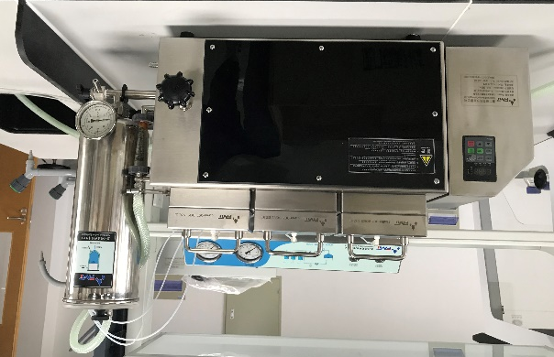
Figure S1. Experimental setup of RO.

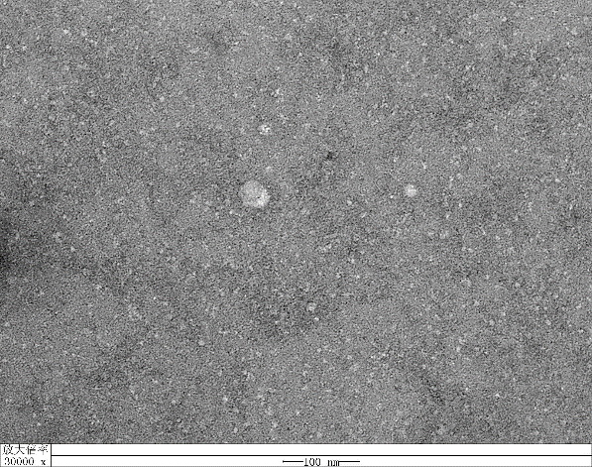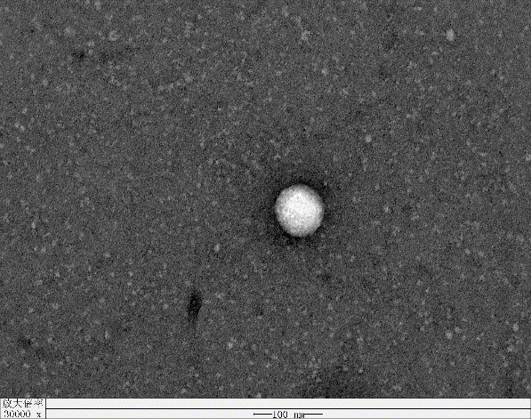
b
a

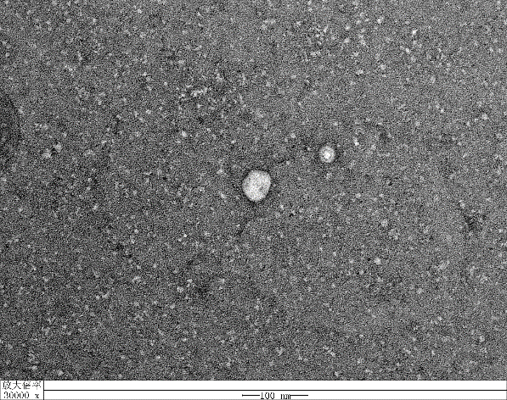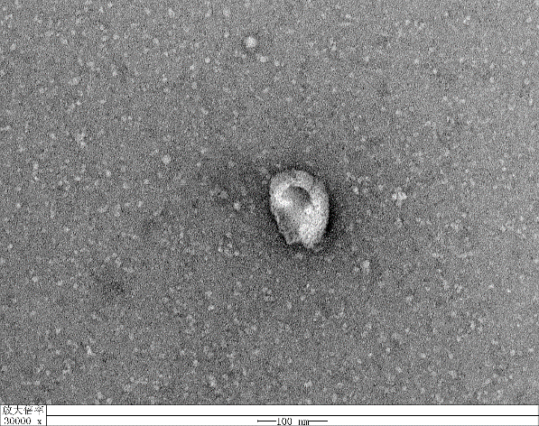
d
c
Figure S2. TEM images of DOPE/DOTAP_{4:1} (a), DOPE/DOTAP_{4:1}-CNT (b) , DOPE/DOTAP_{2:1} (c) and DOPE/DOTAP_{2:1}-CNT (d) liposomes.

a
b
Figure S3. Stopped-flow light scattering curves (a) and osmotic water permeability (b) of liposomes.

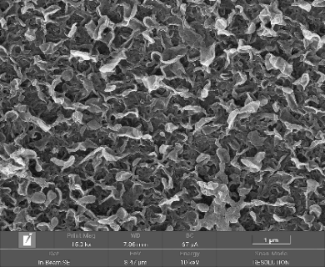
Figure S4. Surface morphology of TFC membranes.

TFN_{2:1}
TFN_{4:1}
TFC

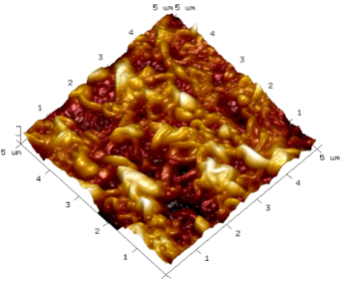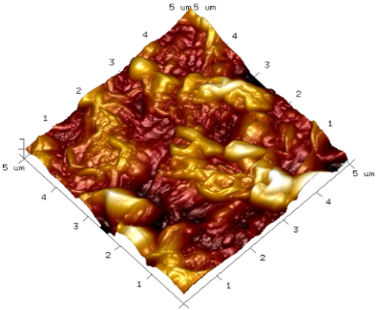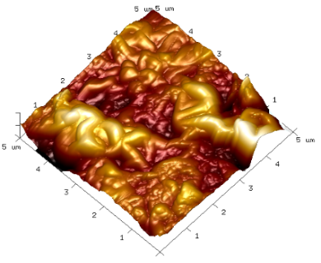
TFN_{2:1}-CNT
TFN_{4:1}-CNT
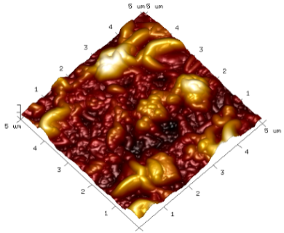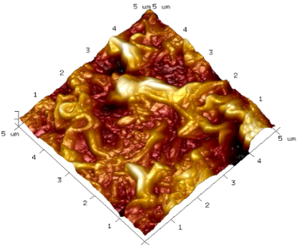
Figure S5. AFM images of TFC and TFN membranes.

d
c
b
a
Figure S6. Water flux and salt rejection of four TFN membranes under different loading concentration of liposomes.

