Table S1: Molecular and structural characteristics of zinc-dependent HDACs
Isoform | PDB structure code | UniProtKB accession | Location on chromosome | Molecular weight (kDa)
HDAC1 | 4BKX_2 | Q13547 | 1p35.2-p35.1 | 55.103
HDAC2 | 3MAX_1 | Q92769 | 6q21 | 55.364
HDAC3 | 4A69_1 | O15379 | 5q31.3 | 48.848
HDAC4 | 2VQV_1 | P56524 | 2q37.3 | 119.040
HDAC5 | AF_AFQ9UQL6F1_1 | Q9UQL6 | 17q21.31 | 121.978
HDAC6 | AF_AFQ9UBN7F1_1 | Q9UBN7 | Xp11.23 | 131.419
HDAC7 | 3C0Y_1 | Q8WUI4 | 12q13.11 | 102.927
HDAC8 | 1T64_1 | Q9BY41 | Xq13.1 | 41.758
HDAC9 | AF-Q9UKV0-F1 | Q9UKV0 | 7p21.1 | 111.297
HDAC10 | AF-Q969S8-F1 | Q969S8 | 22q13.33 | 71.445
HDAC11 | AF-Q96DB2-F1 | Q96DB2 | 3p25.1 | 39.183

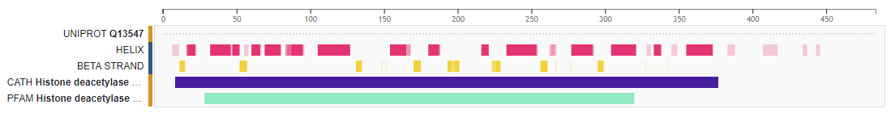
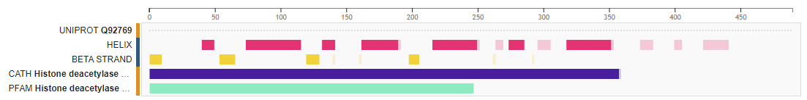
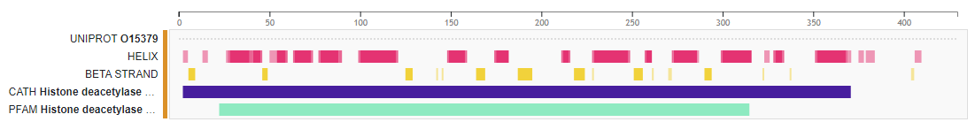
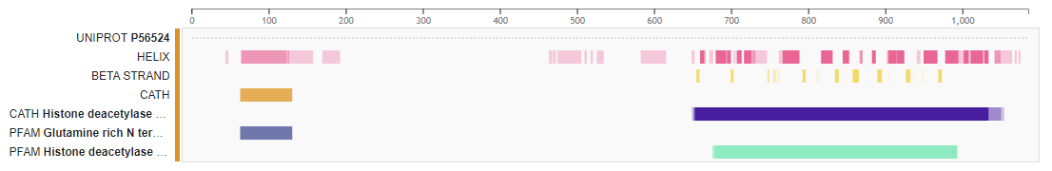
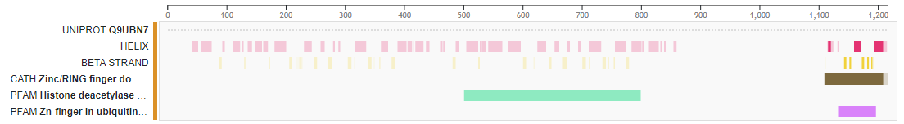
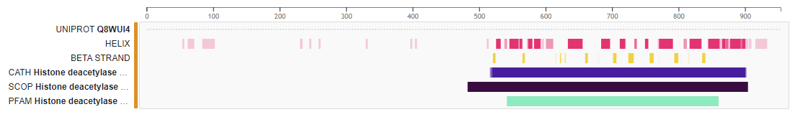
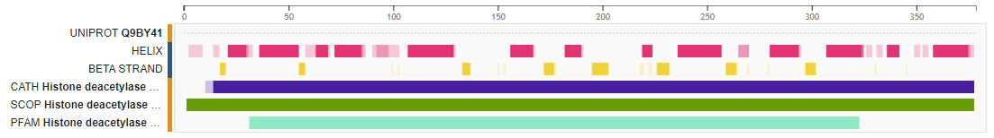
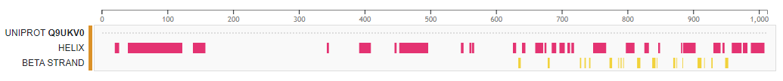
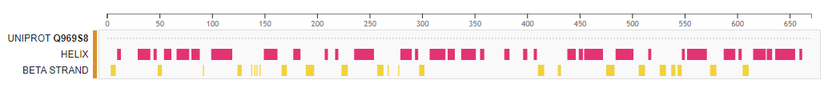
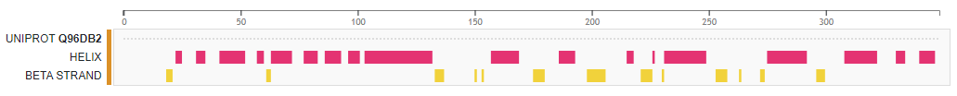
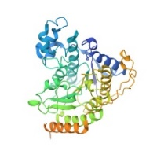
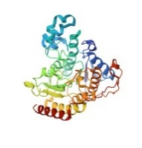
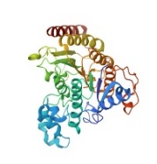
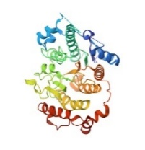
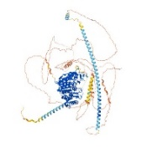
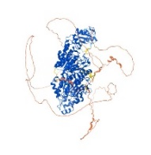
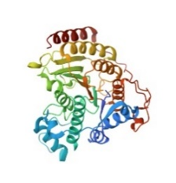
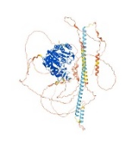
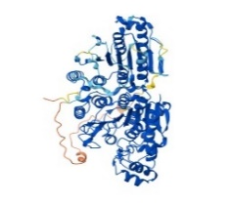
HDAC1
HDAC2
HDAC3
HDAC4
HDAC5
HDAC6
HDAC7
HDAC8
HDAC9
HDAC10
HDAC11
Figure S1: Secondary and tertiary structures of zinc-dependent HDACs derived upon protein data bank and UniProt.

