Supporting Information for

Investigation of Laser Induced Graphene (LIG) on a Flexible Substrate and its Functionalization with Metal-doping for Gas Sensing Application

Dongwook kwakª, Hyojin Kimª, Seung Hun Jang^{b}, Byoung Gak Kimª, Donghwi Choª, Hyunju Chang^{b}, and Jeong-O Lee^{a,*}

a Advanced Materials Division, Korea Research Institute of Chemical Technology, 141 Gajeongro, Yuseong-gu, Daejeon 34114, Republic of Korea
b Data Research Center, Korea Research Institute of Chemical Technology, 141 Gajeongro, Yuseong-gu, Daejeon 34114, Republic of Korea

List of Figures

Figure S1. Comparison of the responses of the P-LIG device to 1000 ppm NO₂ while varying temperature from 50℃ to 150℃.
Figure S2. (a,b) Cross-sectional SEM images of the P-LIG, (c,d) cross-sectional SEM and EDS images of the 4-nm-thick Au-doped LIG, and (e-g) EDS mapping images of the 2-nm-, 4-nm-, and 8-nm-thick Au-doped LIGs.
Figure S3. High resolution XPS spectra of Ag, Al, Au, Cu, In, and Pd metal dopants.
Figure S4. Electrical resistance variance of the P-LIG device at temperatures from RT to 150℃.
Figure S5. Comparison plot of gas responses of the P-LIG device to different concentrations of NO₂ and NH_{3.}
Figure S6. Gas responses of the P-LIG device to different concentrations of (a) NO₂ and (b) NH₃.
Figure S7. Gas response plots of the P- and M-LIG devices to 1000 ppm of NO₂ over three on/off cycles.
Figure S8. Gas response plots of the P- and M-LIG devices to 1000 ppm of NH₃ over three on/off cycles.
Table S1. XPS quantification results for the P- and M-LIG devices.

Figure S1. Comparison of the responses of the P-LIG device to 1000 ppm NO₂ while varying temperature from 50℃ to 150℃.

Figure S2. (a,b) Cross-sectional SEM images of the P-LIG, (c,d) cross-sectional SEM and EDS images of the 4-nm-thick Au-doped LIG, and (e-g) EDS mapping images of the 2-nm-, 4-nm-, and 8-nm-thick Au-doped LIGs.

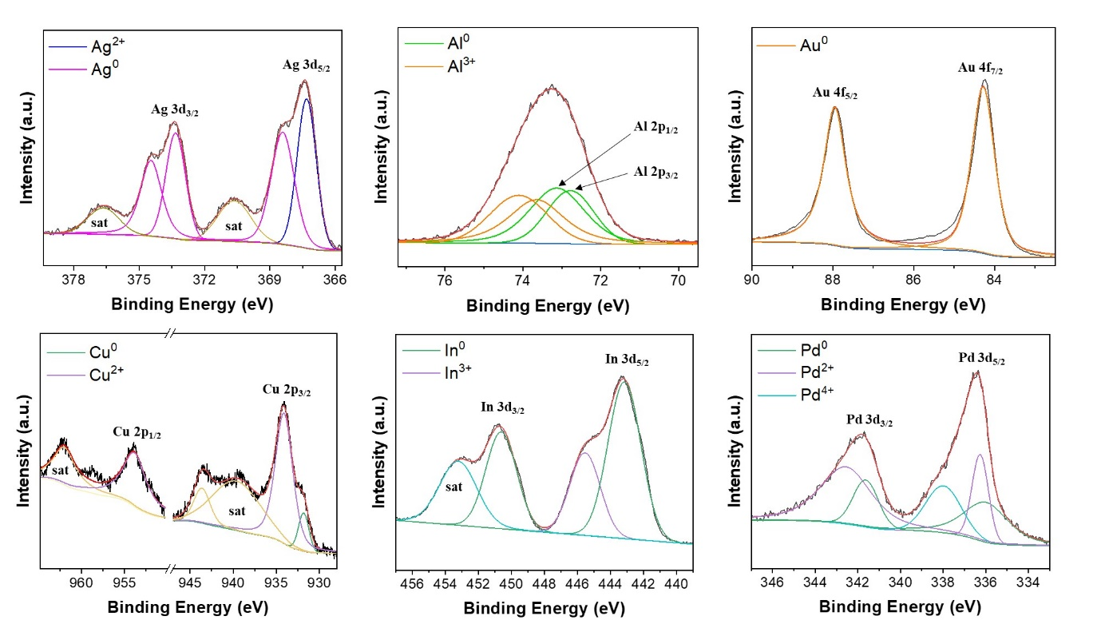
Figure S3. High resolution XPS spectra of Ag, Al, Au, Cu, In, and Pd metal dopants.

Table S1. XPS quantification results for the P- and M-LIG devices.

Figure S4. Electrical resistance variance of the P-LIG device at temperatures from RT to 150℃.

Figure S5. Comparison plot of gas responses of the P-LIG device to different concentrations of NO₂ and NH₃.

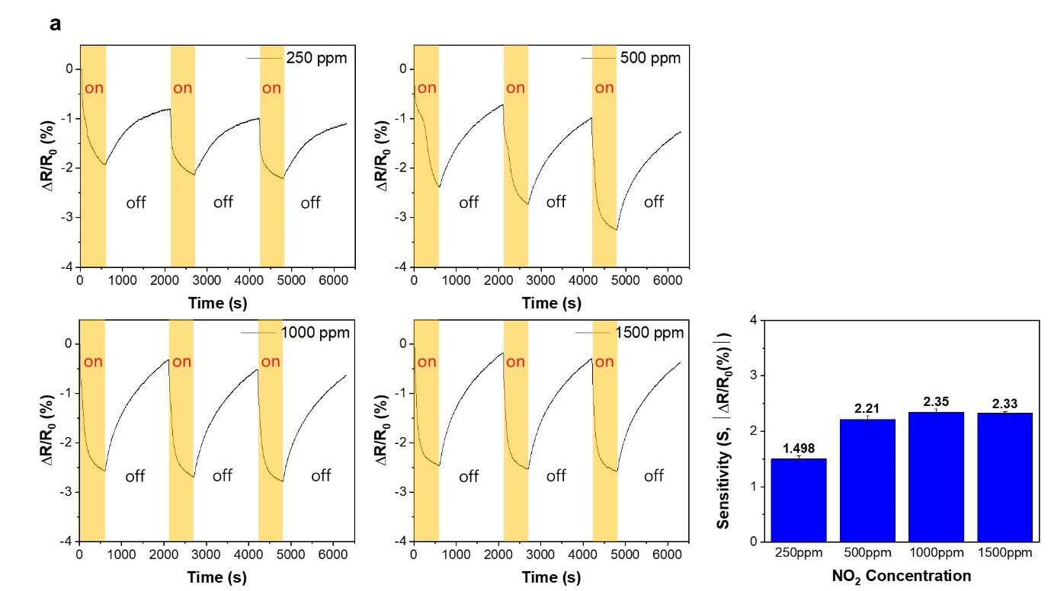
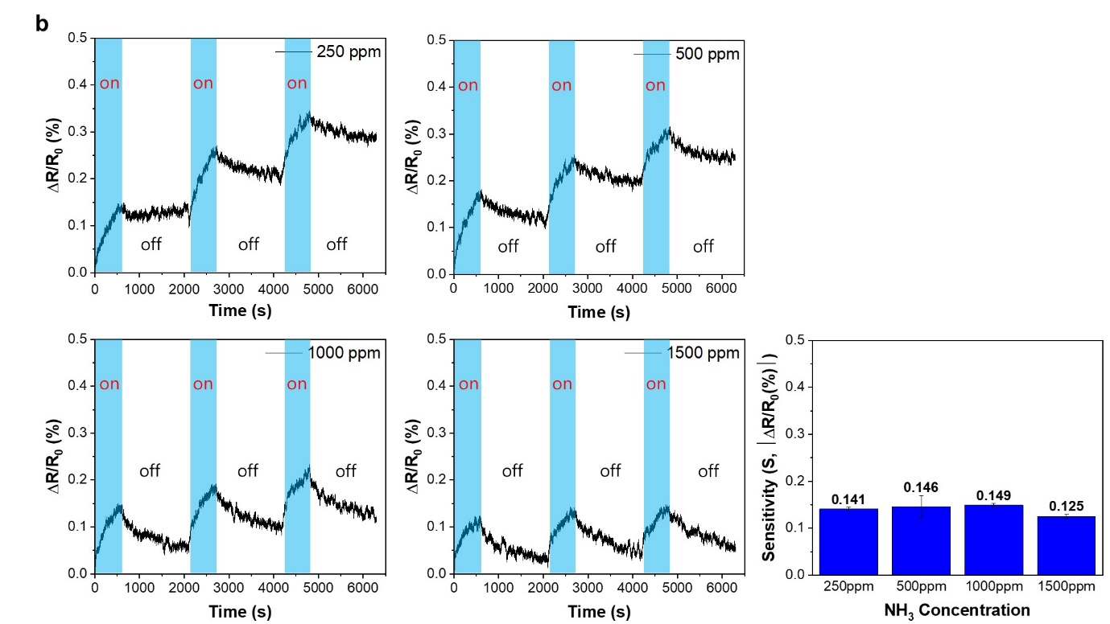
Figure S6. Gas responses of the P-LIG device to different concentrations of (a) NO₂ and (b) NH₃.

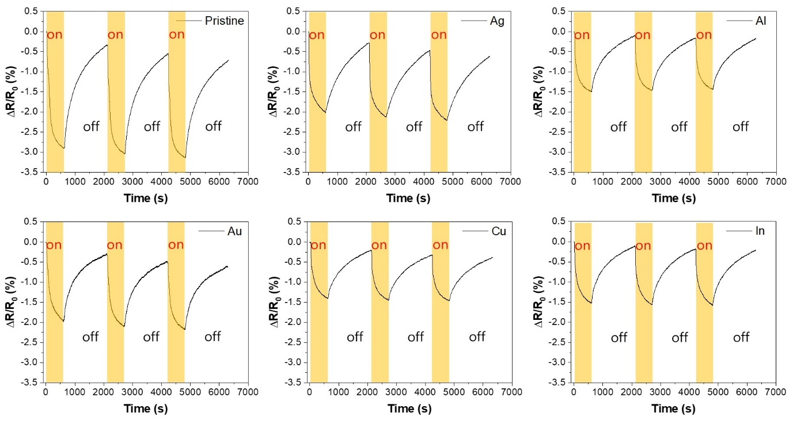

Figure S7. Gas response plots of the P- and M-LIG devices to 1000 ppm of NO₂ over three on/off cycles.

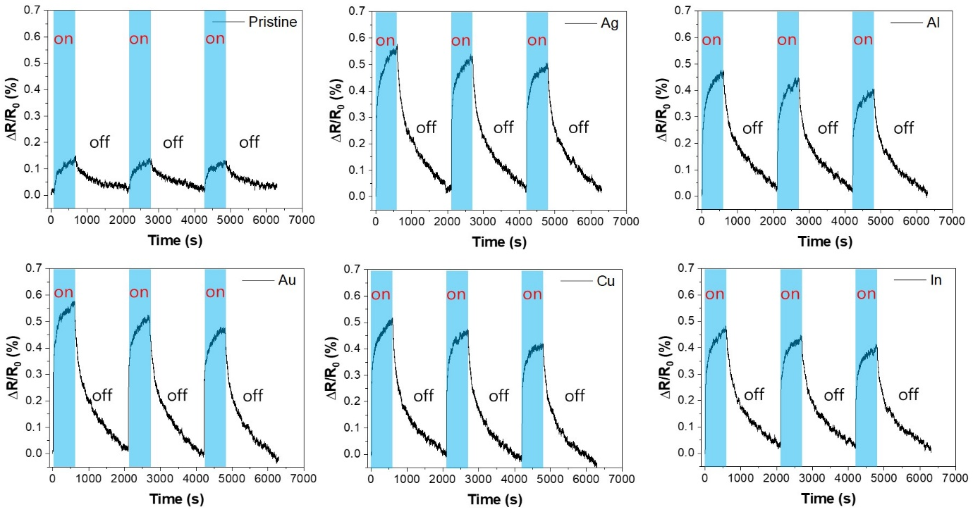

Figure S8. Gas response plots of the P- and M-LIG devices to 1000 ppm of NH₃ over three on/off cycles.

