Supporting Information

Duplex vertical flow rapid tests for point-of-care detection of anti-dsDNA and anti-nuclear autoantibodies

Rongwei Lei¹, Hufsa Arain¹, David Wang¹, Janani Arunachalam¹, Ramesh Saxena², Mohan Chandra¹*

1. Department Biomedical Engineering, University of Houston, Houston, TX, USA
2. UT Southwestern (Dallas, TX, USA), Ramesh Saxena
*Correspondence: cmohan@central.uh.edu; Tel.: +1-713-743-3709

Supplementary methods:
1. Performance of the duplex ANA-αDNA VFA using human anti-dsDNA positive control standard (ANA+, αDNA+)
Assay protocol-1: Since the engineered VFAs will be used to assay two different autoantibodies, these VFAs will be referred to as duplex ANA-αDNA VFA. 1 µl of 1 mg/ml of dsDNA in PBS was spotted on the top left of the nitrocellulose membrane (NCM), and this corner is referred to as the αDNA test zone. 1 µl of 10 µg/ml of Hep-2 cell lysates (source of nuclear antigens for ANA testing) in PBS was spotted on the lower left of the NCM, and this corner is referred to as the ΑΝΑ test zone. After air blowing the NCM for 5 min, the VFA was transferred to a UV lamp for 45 min irradiation. Then, 1 µl of 250 µg/ml of biotinylated-BSA in PBS was spotted on the top right of the NCM, and this corner is referred to as the positive control (“High”). 1 µl of assay diluent (1% BSA, 0.01% tween 20 in 10 mM PBS) was spotted on the lower right of the NCM, and this corner is referred to as the negative control (“Low”). After air blowing the NCM for 30 min, the VFA was stored at room temperature with desiccator packets for future use. Initially, three drops of Universal buffer were added to the NCM in the center of the cartridge (approximately 200 µl). Then, 200 µl of serially diluted human anti-dsDNA/ANA positive control antibody standard (ANA+, αDNA+) in assay diluent was loaded onto the membrane, followed by three drops of the universal buffer. Next, 10 µl of 10 µg/ml biotinylated anti-IgG (detection antibody or det-Ab) in assay diluent was loaded to the αDNA test zone, ANA test zone, positive control, and negative control zones separately, followed by three drops of Universal buffer. Next, 5 µl of OD=2 streptavidin-conjugated GNP in GNP diluent-1 (20 mM Tris, 150 mM NaCl, 1% BSA, 0.1% Tween 20, pH=8, filtered) was loaded to the αDNA test zone, ANA test zone, “High” control and “Low” control zones separately. Finally, ten drops of Universal buffer were loaded, as a wash step.

2. Evaluation of the duplex ANA-αDNA VFA using clinical samples
Assay protocol-2: At the top and lower left of NCM, 0.7 µl of 50 µg/ml of dsDNA and 5 µg/ml of Hep-2 cell lysate in PBS were spotted as αDNA and ANA test zones, respectively. A “Low” and “High” control zones were introduced to serve as a cut-off for reporting semiquantitative results. At the top right and lower right of the NCM, 0.7 µl of 50 µg/ml of biotinylated BSA and 800 µg/ml of biotinylated BSA in GNP diluent-2 (20 mM Tris, 150 mM NaCl, 0.2% Tween 20, 1% BSA, pH=8, filtered) were spotted, respectively, to serve as “Low” and “High” control zones. GNP diluent-2 was used as an all-purpose dilution buffer for clinical samples, det-Ab, and GNP preparation, while Universal buffer was used only for washing. A 1/100 serum dilution was used for all clinical samples as this has been optimal in other assay platforms. First, three drops of universal buffer were placed on the NCM, and then 200 µl of 100-fold diluted serum sample in GNP diluent-2 was loaded to the whole NCM, followed by three drops of the universal buffer. Next, 10 µl of 5 µg/ml det-Ab in GNP-2 diluent was loaded to the NCM αDNA test zone and ANA test zone followed by three Universal buffer drops. Next, 5 µl of OD = 2 streptavidin-conjugated GNP in GNP diluent-2 was individually loaded to the ANA and αDNA test zones, and 2 µl of OD=2 GNP in GNP diluent-2 was loaded individually to the “High” and “Low” control zones. Finally, seven drops of Universal buffer were loaded as a wash step.

3. Semiquantitative recording of duplex ANA-αDNA VFA
ANA and αDNA test zone results were recorded using an “Observer Score” (OS) from 0 (no visible trace or significantly less visible signal than “Low”), 1+ (similar to the intensity of “Low”), 2+ (higher than “Low” but lower than “High”), 3+ (similar to the intensity of “High”), to 4+ (higher than “High”) based on how the signal appears to the unaided human eye, shown as Figure S4. Additionally, the intensity of each VFA spot was quantified using ImageJ and recorded as an “Imaging score” (IS). In order to convert the IS into a semi-quantitative score that can be used across all VFAs, each IS was first expressed as a range, from (0.81 * IS) to (1.19 * IS). For example 3000 IS units on the test zone will be read as 2430 to 3570 IS units. For the semi-quantitative reporting of this readout, the IS intensity will be recorded as 0 if the upper limit of the test zone IS score was less than the “Low” control zone IS intensity. It will be recorded as 1+ if the lower limit of the test zone IS score was lower than the “Low” control zone intensity but the upper limit of the test zone IS score was higher than the “Low” control zone. It will be recorded as 2+ if the lower limit of the test zone IS score was higher than the “Low” control zone intensity, but the upper limit of the test zone IS score was less than the “High” control zone intensity. It will be recorded as 3+ if the upper limit of the test zone IS score was greater than the “High” control zone intensity but the lower limit fell below this. Finally, it will be recorded as 4+ if the lower limit of the test zone IS score was greater than the “High” control zone intensity.

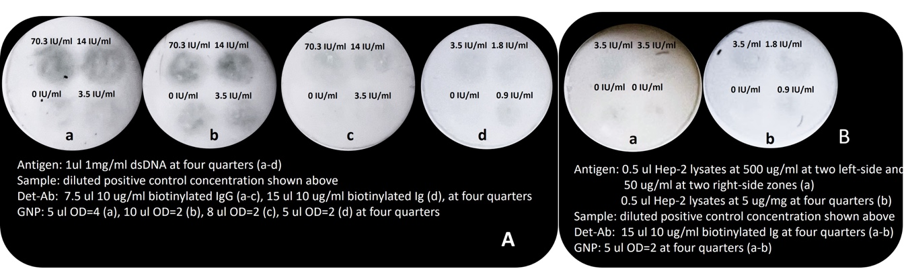

Figure S1. Optimization of protocols for αDNA VFA and ANA VFA. A) 0.5 µl 1 mg/ml dsDNA antigen was immobilized onto the four quarters of NCM of αDNA VFA (a-d). The positive control samples (spiked assay diluent) and negative control samples (non-spiked assay diluent) were prepared and loaded onto the four quarters of the NCM as concentrations indicated on the figure (a-d). Using 7.5 µl of 10 µg/ml of det-Ab in all quarters of NCM (a-c), 5 µl of OD=4 GNP (a), 10 µl of OD=2 GNP (b), and 8 µl of OD=2 GNP (c) were loaded to the four quarters of αDNA VFA NCM, individually. Using 15 µl of 10 µg/ml of det-Ab at all four quarters of NCM (d) with 5 µl of OD=2 of GNP at four quarters of NCM on the αDNA VFA. B-a) 0.5 µl of 500 µl/ml and 50 µg/ml of Hep-2 cell lysate were spotted in the two left-side zones and two right-side zones of the NCM of the ANA VFA. The positive control samples (assay diluent spiked with standards) and negative control samples (non-spiked assay diluent) were prepared and loaded onto the four quarters of the NCM as concentrations indicated on the figure. Under the test condition of 15 µl of 10 µg/ml of det-Ab and 5 µl of OD=2 GNP added to the four quarters, the membrane showed background at the negative zone (0 IU/ml). B-b) 0.5 µl of 5 µg/ml of Hep-2 cell lysate were spotted at the four quarters of the ANA VFA NCM. Under the test condition of 15 µl of 10 µg/ml of det-Ab and 5 µl of OD=2 GNP, the negative zone (0 IU/ml) remained clean. NCM: nitrocellulose membrane; det-Ab: biotinylated IgG; GNP: streptavidin conjugated gold nanoparticles.

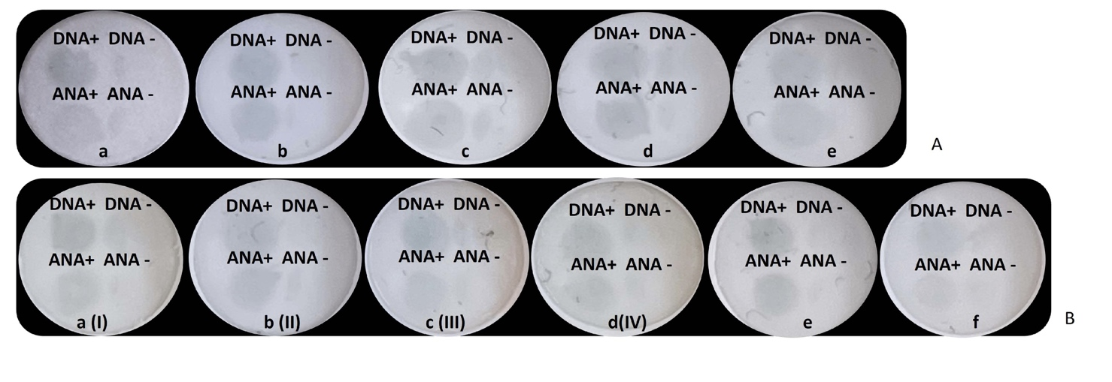

Figure S2. Optimization of duplex ANA-αDNA VFA for clinical samples.
A (a-c) Optimization of antigen concentration and detection antibody. 100 μg/ml dsDNA and10 µg/ml of Hep-2 cell lysates (a), 100 μg/ml dsDNA and 5 µg/ml of Hep-2 cell lysates (b), and 50 μg/ml dsDNA and 5 µg/ml of Hep-2 cell lysate (c), were evaluated using a 200-fold diluted positive patient sample (+) and healthy negative control sample (-). A (d-e) Using 50 µg/ml dsDNA and 5 µg/ml Hep-2 cell lysate antigen concentration (d, e), and 10 µl of 10 µg/ml det-Ab (d) and 10 µl of 5 µg/ml of det-Ab (e) were evaluated using the same positive (+) and negative samples (-), as above. B (a-d) Evaluation of four types of GNP diluents. I: 20 mM Tris, 150 mM NaCl, 1% BSA, 0.1% Tween 20; II: 20 mM Tris, 150 mM NaCl, 1% BSA, 0.2% Tween 20; III: 20 mM Tris, 150 mM NaCl, 1% BSA, 0.1% Tween 20, 0.5% PVP40; and IV: 20 mM Tris, 150 mM NaCl, 1% BSA, 0.1% Tween 20, 0.5% PEG, all at pH 8, filtered. 50 µg/ml dsDNA and 5 µg/ml Hep-2 cell lysate antigen concentration, the same positive (+) and negative samples (-) as above, 10 µl of 10 µg/ml det-Ab and 5 µl of OD=2 GNP were prepared in the corresponding GNP diluents, I-IV. GNP diluent-II showed more homogenous dispersion of GNP and better discrimination of positive (+) from negative (-) serum. B (e-f) Using 50 µg/ml dsDNA and 5 µg/ml Hep-2 cell lysate antigen concentration and GNP diluent-II buffer system, 10 µl of 5 µg/ml and 5 µl of 5 µg/ml of det-Ab were further evaluated in the duplex VFA, revealing 10 µl of 5 µg/ml det-Ab to yield optimal signal to noise ratio. Det-Ab: det-Ab: biotinylated IgG; GNP: streptavidin conjugated gold nanoparticles.

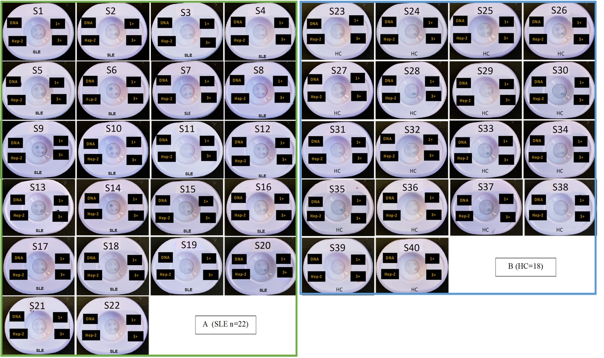

Figure S3. Images of 40 clinical serum samples (22 SLE and 18 HC) tested using the duplex ANA-αDNA VFA. Following assay protocol-2, at the top and lower left of NCM, 0.7 µl of 50 µg/ml of dsDNA and 5 µg/ml of Hep-2 cell lysate in PBS were spotted as αDNA (DNA) and ANA test zones (Hep-2), respectively. At the top right and lower right of the NCM, 0.7 µl of 50 µg/ml of biotinylated BSA and 800 µg/ml of biotinylated BSA in GNP diluent-2 were spotted, respectively, to serve as “1+” and “3+” control zones. GNP diluent-2 was used for the dilution of clinical samples, det-Ab, and GNP, while Universal buffer was used only for washing. First, three drops of universal buffer were placed on the NCM, and then 200 µl of 100-fold diluted serum sample was loaded to the whole NCM, followed by three drops of the universal buffer. Next, 10 µl of 5 µg/ml det-Ab was loaded to the NCM αDNA test zone and ANA test zone followed by three Universal buffer drops. Next, 5 µl of OD = 2 streptavidin-conjugated GNP was individually loaded to the ANA and αDNA test zones, and 2 µl of OD=2 GNP was loaded individually to the “3+” and “1+” control zones. Finally, seven drops of Universal buffer were loaded as a wash step. SLE: systemic lupus erythematosus; HC: healthy control.

Figure S4. ANA-αDNA VFA reference and test zone semiquantitative reporting. The images of ANA-αDNA VFA demonstrate two test zones indicative of anti-dsDNA and ANA detection and two reference zones used for the semiquantitative reporting of antibody level. The observer score (OS) from 0 to 4+ are indicated at the top of each image to show the level of intensities seen at the αDNA test zone (DNA) relative to “Low” and “High” control zone intensities whereas the ANA test zone (Hep-2) shows 0 at the first image of the first left and keeps intensity as 1+ for the rest of images, relative to “Low” and “High” control zone intensities. Thus, whereas the “1+” signal straddles the “Low” calibrator, the “3+” signal straddles the “High” calibrator. In this communication, the terms “quarters” and “corners” are used interchangeably to refer to the 4 assay zones shown.

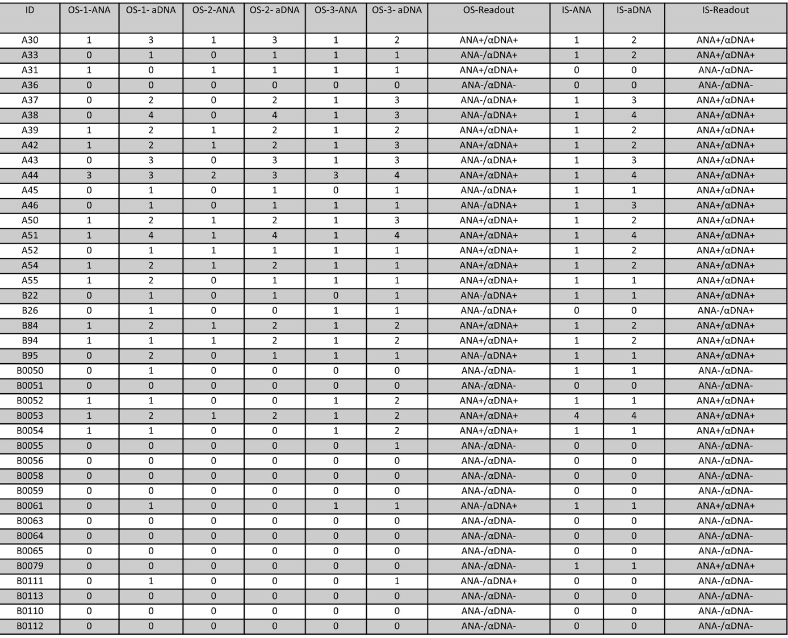

Figure S5. Observer score and imaging score of 40 clinical serum samples tested using the ANA-αDNA VFA. The OS was recorded by three researchers based on the visual intensity shown in Supplementary Figure S3. IS: imaging score; OS: observer score; ANA: anti-nuclear antibody.

