Electronic Supplementary Information

Amphiphilic graft copolymers as templates for the generation of binary metal oxide mesoporous interfacial layers for solid state photovoltaic cells

Seung Man Lim ª, Hayeon Jeong ª, Juyoung Moon ^{b}, Jung Tae Park ^{a,*}

ª Department of Chemical Engineering, Konkuk University,
120 Neungdong-ro, Gwangjin-gu, Seoul 05029, Republic of Korea
^{b} Department of Chemical and Biomolecular Engineering, Yonsei University,
50 Yonsei-ro, Seodaemun-gu, Seoul, 03722, Republic of Korea

* To whom correspondence should be addressed
Tel: +82-2-450-3538, Fax: +82-2-450-8895
E-mail: jtpark25@konkuk.ac.kr

Figure S1. Synthesis of amphiphilic PECH-g-PS graft copolymers via ATRP.
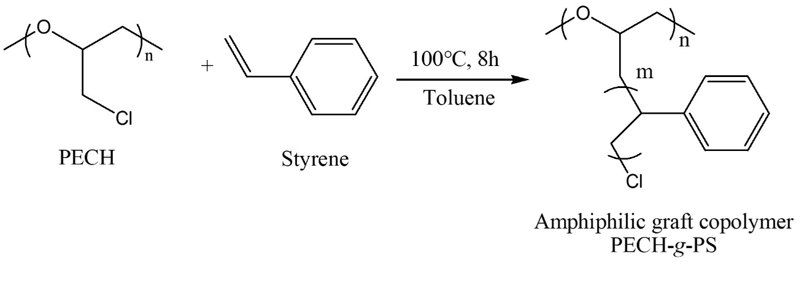

Figure S2. FT-IR spectra of amphiphilic PECH-g-PS graft copolymers.
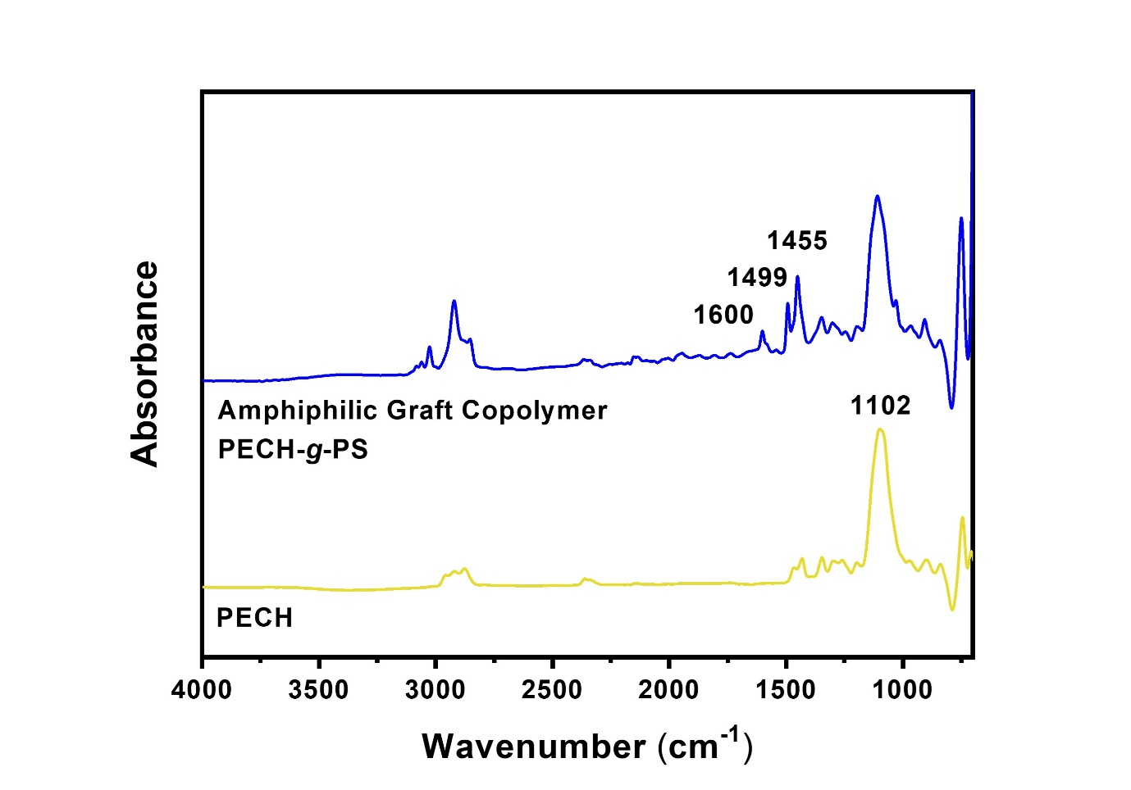

Figure S3. (a) SEM-EDS element mapping scan area, (b) Ti, and (c) Zn elemental maps of bi-MO meso IF layer TZ1.
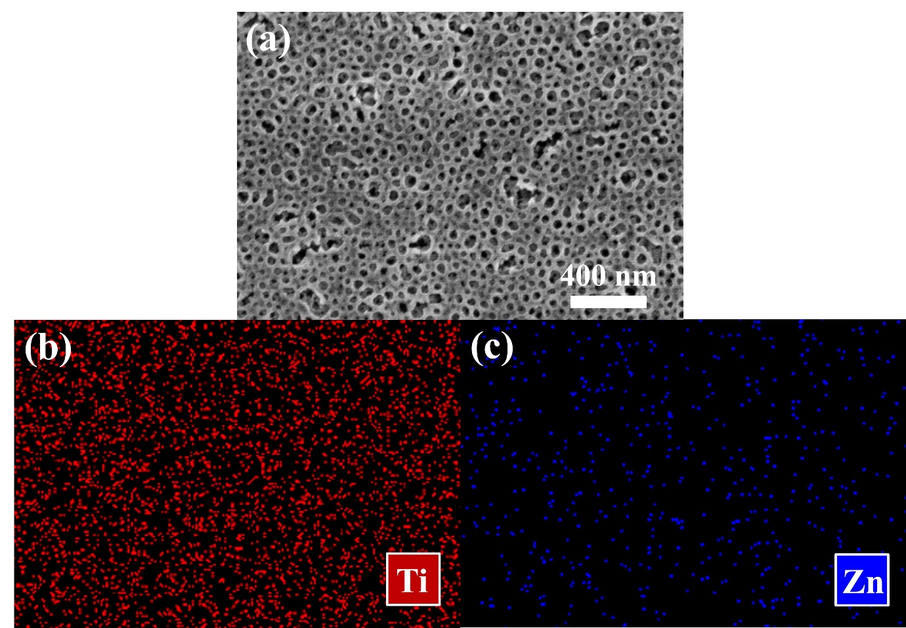

Figure S4. FE-SEM surface images of (a) bi-MO meso IF layer TZ0, (b) bi-MO meso IF layer TZ2 and (c) bi-MO meso IF layer TZ3.
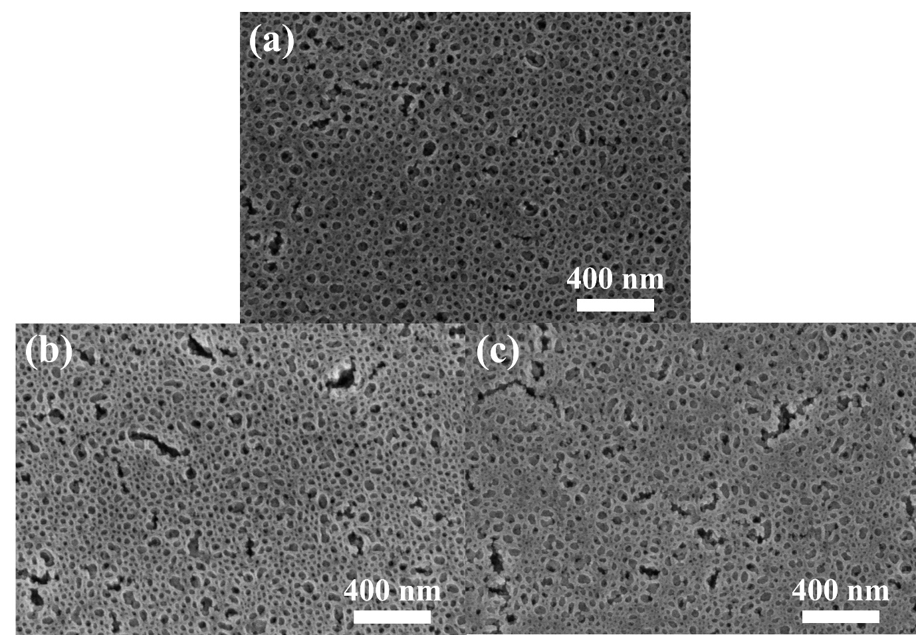

Figure S5. (a) SEM-EDS element mapping scan area, (b) Ti, and (c) Zn elemental maps of bi-MO meso IF layer TZ2.
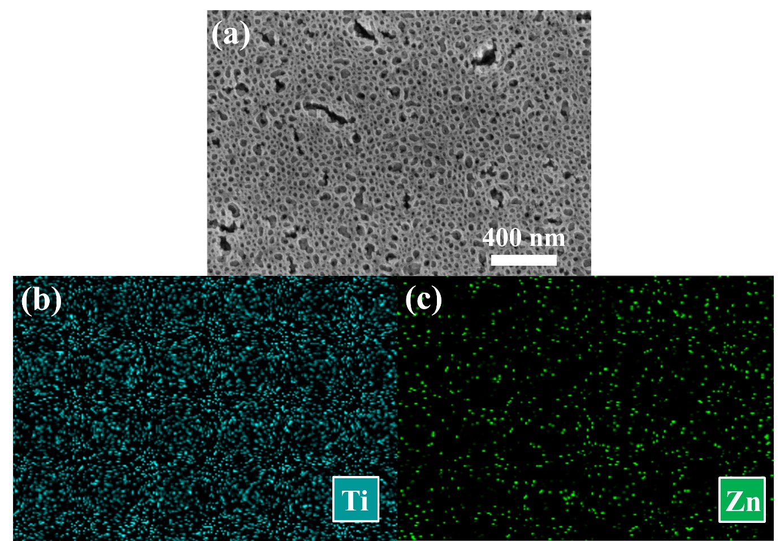

Figure S6. (a) SEM-EDS element mapping scan area, (b) Ti, and (c) Zn elemental maps of bi-MO meso IF layer TZ3.
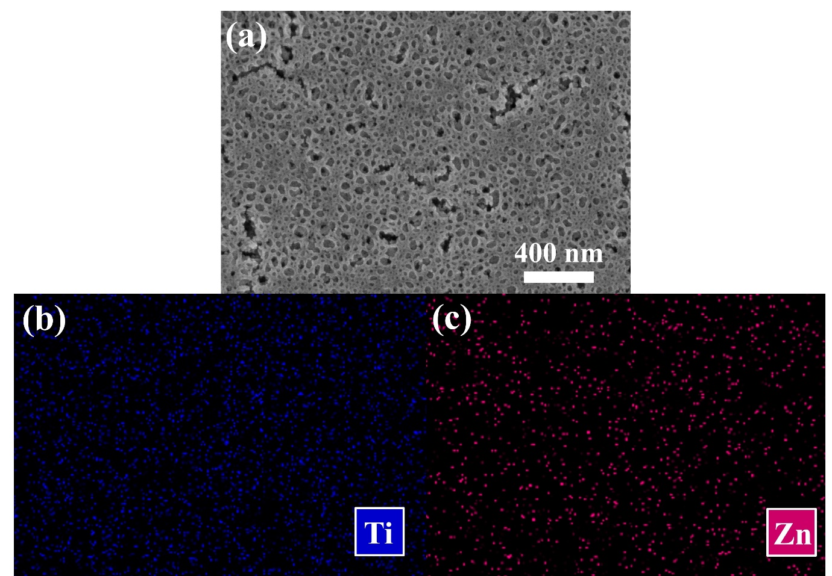

Figure S7. equivalent circuit diagram.
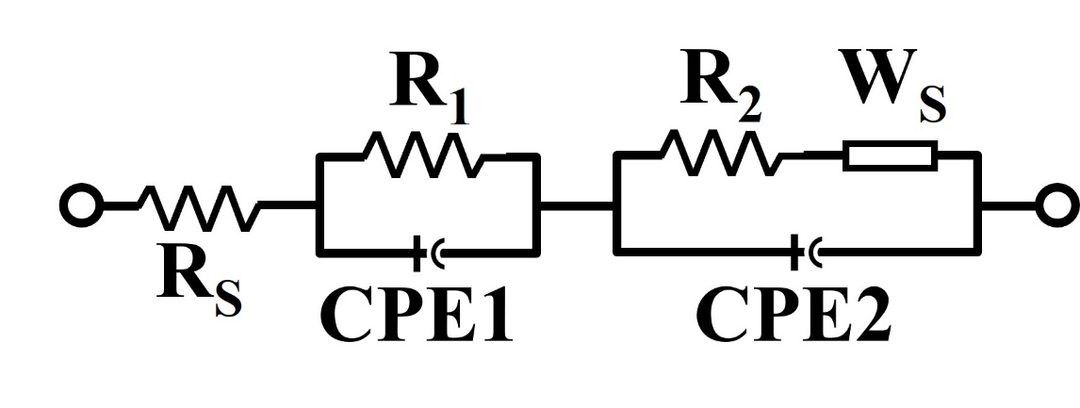

Figure S8. EIS Nyquist plots under dark condition.
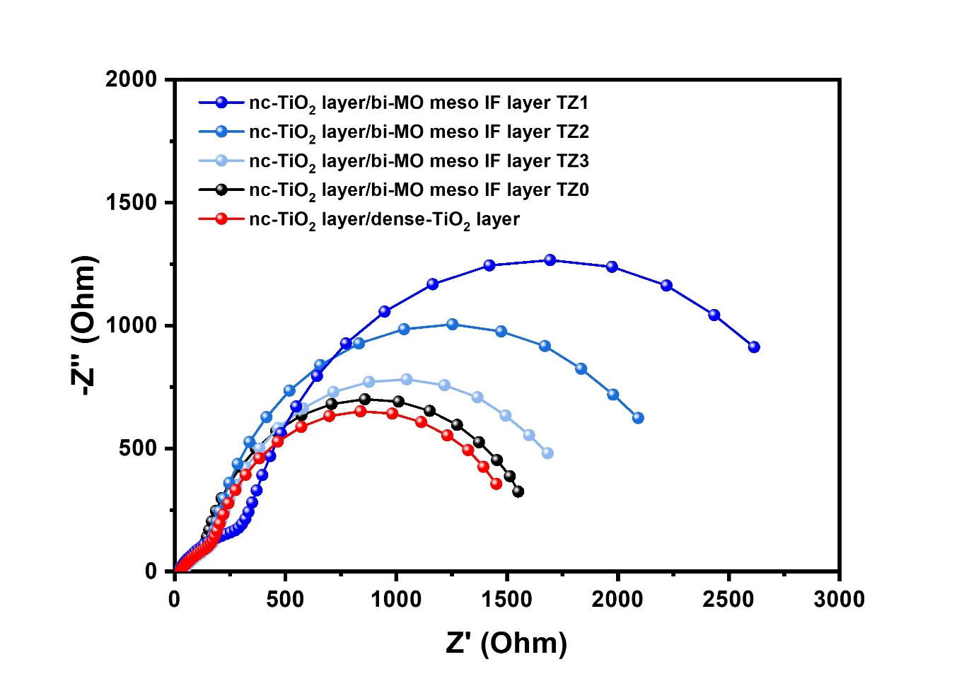

Figure S9. J-V curves of bi-MO meso IF layer based solid state photovoltaic cells with commercial scattering layer under 1 sun illumination (AM 1.5 G, 100 mW/cm²).^{a,b,c,d}
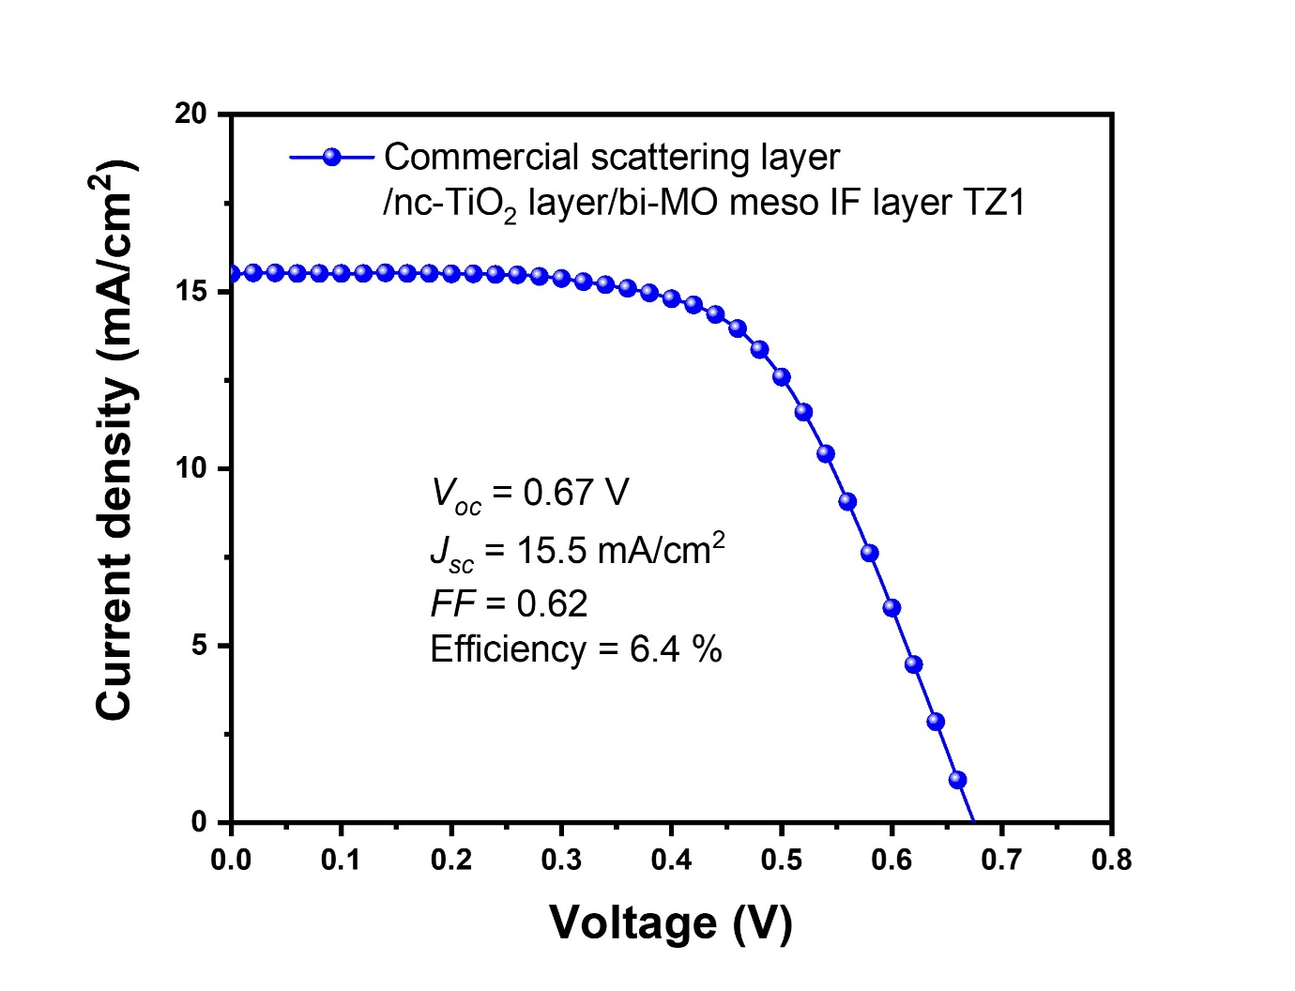
ª Solid-state electrolyte consists of PEG, LiI, MPII, and I₂ in acetonitrile.
^{b} The photoactive area for solid state photovoltaic cells was 0.16 cm².
^{c} The thickness of the photoanode was approximately 7 μm.
^{d} The commercial scattering layer was approximately 5 µm thick.

Table S1. Comparison of photovoltaic parameters of solid state photovoltaic cells with mesoporous layer reported in the literature.
Mesoporous layer | Solid-state electrolyte | Voc  (V) | Jsc  (mA/cm²) | FF | η  (%) | Reference
bi-MO meso IF layer | PEG | 0.74 | 9.8 | 0.69 | 5.0 | This work
bi-MO meso IF layer  w/ Scattering layer | PEG | 0.67 | 15.5 | 0.62 | 6.4 | This work
Mesoporous TiO₂ bead | HPC | 0.70 | 16.5 | 0.67 | 7.8 | [40]
TiO₂ film | MXene | 0.78 | 15.0 | 0.66 | 7.8 | [41]
TiO₂ film | Cs₂SnI₆ | 0.62 | 10.62 | 0.62 | 4.1 | [42]
TiO₂ film | PEG/WO₃ | 0.71 | 14.6 | 0.61 | 6.3 | [43]
TiO₂ film | PEG/ZrO₂ | 0.66 | 14.0 | 0.61 | 5.6 | [44]
TiO₂ film | PEG | 0.64 | 13.6 | 0.65 | 5.7 | [45]
TiO₂ film | PEG/ZIF-67 | 0.68 | 10.1 | 0.65 | 4.6 | [46]

