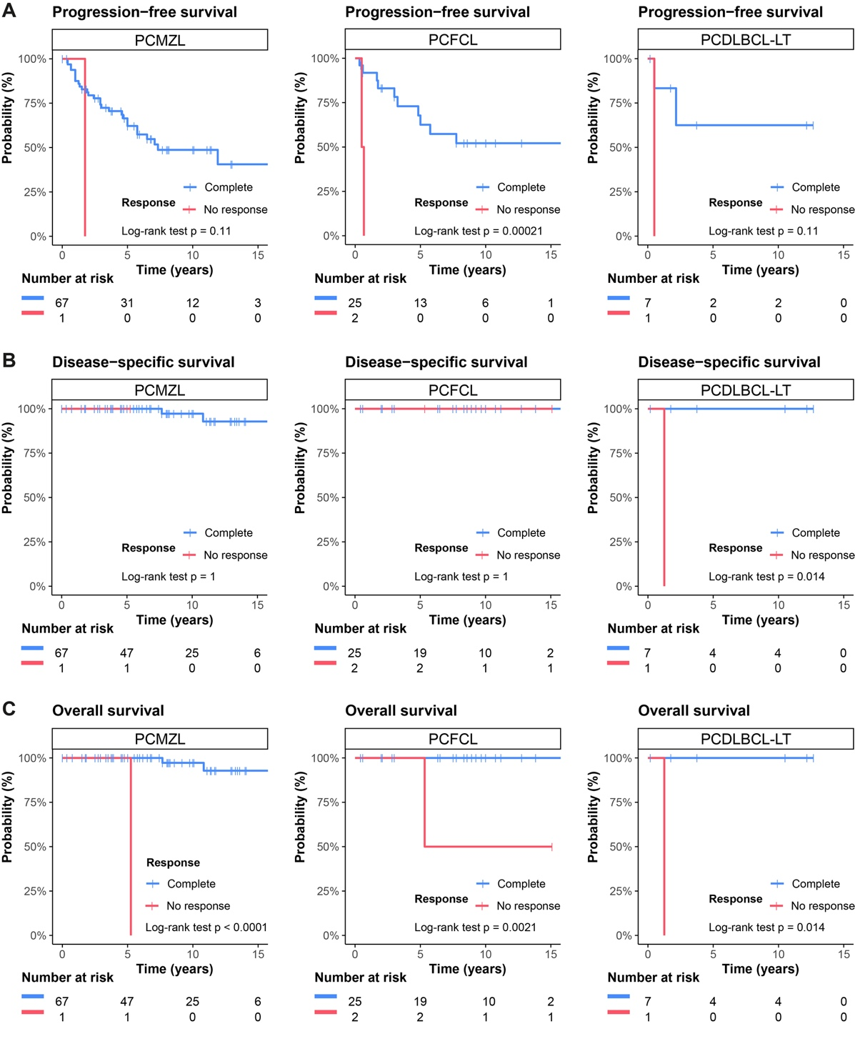
Supplementary Materials:

Figure S1: Kaplan‒Meier survival curves according to tumour histology (columnwise) and clinical response. A, progression-free survival; B, disease-specific survival; C, overall survival.

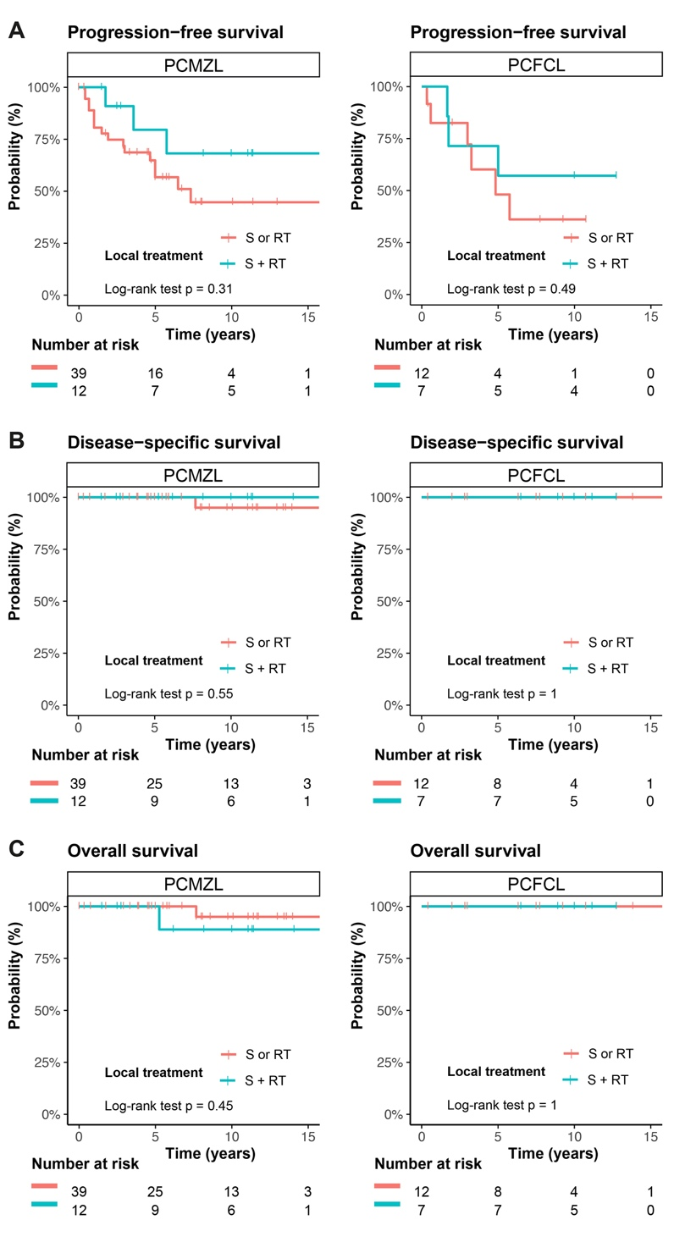
Figure S2: K‒M survival curves for patients who received local treatment (strata) and by tumour histology (columnwise). A, progression-free survival; B, disease-specific survival; C, overall survival.

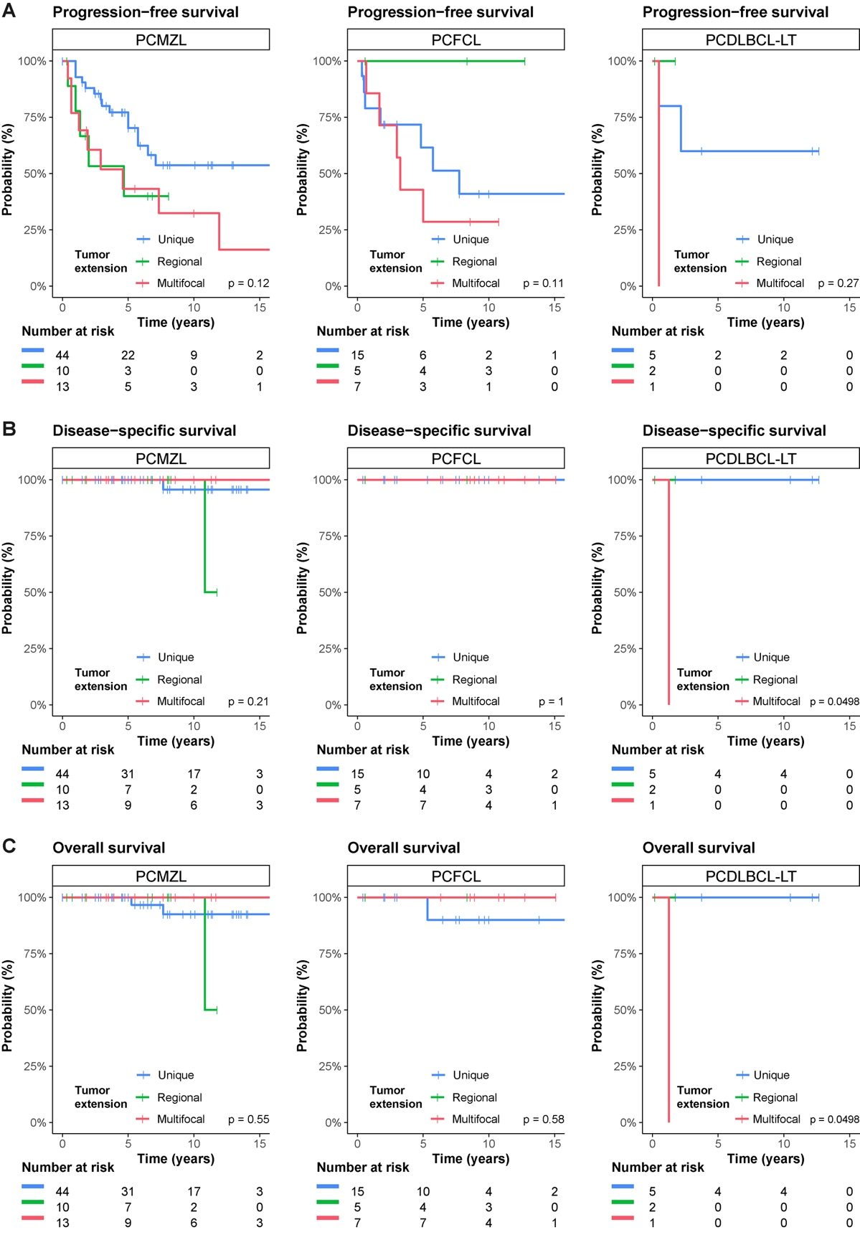
Figure S3: Kaplan‒Meier survival curves according to tumour histology (columnwise) and tumour extension. A, progression-free survival; B, disease-specific survival; C, overall survival.

