Pseudo-polymorphism in 2-pyridylmethoxy cone derivatives of
p-tert-butylcalix[4]arene and p-tert-butylhomooxacalix[n]arenes

Siddharth Joshi,ª Neal Hickey,ª Paula M. Marcos,^{bc} Silvano Geremia^{a*}

ªCentre of Excellence in Biocrystallography, Department of Chemical and Pharmaceutical Sciences, University of Trieste, via L. Giorgieri 1, 34127 Trieste, Italy

^{b}Centro de Química Estrutural, Institute of Molecular Sciences, Faculdade de Ciências, Universidade de Lisboa, Edifício C8, 1749-016 Lisboa, Portugal.

^{c}Faculdade de Farmácia da Universidade de Lisboa, Av. Prof. Gama Pinto, 1649-003 Lisboa, Portugal

Corresponding author:
Silvano Geremia
E-mail: sgeremia@units.it

Table S1a: Summary of the various crystalline forms of PyC4, PyHOC4 and PyH3OC3 obtained under various crystallisation conditions.

PyC4
PyC4-MeOH-α | PyC4-H₂O-α |  | PyC4-MeOH-β | PyC4⸦ACN-MeOH |  | PyC4⸦ACN-H₂O | PyC4
MeOH + a/d | MeOH + d |  | MeOH + CHCl₃ + c | MeOH + MeCN + a/b |  | DMSO + MeCN + b | MeOH + Toluene + f
MeOH + CHCl₃ + b |  |  | MeOH + Hexane + e | MeOH+MeCN+THF+e |  |  | MeOH + Hexane + a
MeOH + Hexane + b/c
PyHOC4
PyHOC4-DMSO |  | PyHOC4-MeCN-MeOH |  |  | PyHOC4-Hexane
DMSO + f |  | MeOH + MeCN + b |  |  | MeOH + Hexane + f

PyH3OC3
PyHO3C3 | PyHO3C3-H₂O-MeOH
MeOH + CHCl₃ + a/c/d/e | MeOH + CHCl₃ + b
MeCN + b/c
MeOH + b
MeOH + MeCN + a
DMSO + b
a La(NO₃)₃.6H₂O; b Er(NO₃)₃.5H₂O; c La(triflate); d Gd(NO₃)₃.6H₂O; e Yb(triflate; f Tb(triflate)

Table S2. Crystal data and structure refinements for PyC4 pseudo-polymorphs.

 | PyC4-MeOH-α | PyC4-H₂O-α | PyC4-MeOH-β | PyC4⸦MeCN-MeOH | PyC4⸦MeCN-H₂O | PyC4
Empirical formula | C68.2 H76.8 O4.2 N4 | C68 H76.8 O4.4 N4 | C68.75 H79 O4.75 N4 | C71 H83 O5 N5 | C70 H79.4 N5 O4.2 | C68 H76 O4 N4
Formula weight | 1019.73 | 1020.53 | 1037.35 | 1086.42 | 1057.99 | 1013.32
Temp. (K) | 100(2) | 100(2) | 100(2) | 100(2) | 100(2) | 100(2)
Wavelength (Ǻ) | 0.7 | 0.7 | 0.7 | 0.7 | 0.7 | 0.7
Crystal system | Monoclinic | Monoclinic | Triclinic | Monoclinic | Triclinic | Monoclinic
Space group | P 2₁/c | P 2₁/c | P -1 | P2₁ | P -1 | P 2₁/n
Unit cell  Dimensions (Ǻ. °) | a = 12.004(4)  b = 12.090(8)  c = 40.691(5)  α = 90  β = 95.857(13)  γ = 90 | a = 12.005(5)  b = 12.121(1)  c = 40.565(2)  α = 90  β = 95.98(2)  γ = 90 | a = 10.410(4)  b = 23.014(9)  c = 24.874(10)  α = 95.813(8)  β = 90.17(3)  γ = 97.56(3) | a = 13.936(2)  b = 15.260(1)  c = 14.125(2)  α = 90  β = 92.794(19)  γ = 90 | a = 13.239(2)  b = 14.358(1)  c = 18.297(2)  α = 95.419(8)  β = 100.656(11)  γ = 117.079(9) | a = 15.167(10)  b = 19.994(6)  c = 20.267(6)  α = 90  β = 108.878(12)  γ = 90
Volume (Ǻ³) | 5875(2) | 5871(2) | 5876(4) | 3000.3(6) | 2979.3(6) | 5815(4)
Z | 4 | 4 | 4 | 2 | 2 | 4
ρ _{calcd} (g/cm³) | 1.153 | 1.155 | 1.173 | 1.203 | 1.179 | 1.157
μ (mm^{–1}) | 0.068 | 0.069 | 0.070 | 0.072 | 0.070 | 0.071
F(000) | 2190 | 2192 | 2230 | 1168 | 1136 | 2176
Reflections collected | 92155 | 108677 | 26719 | 53761 | 55796 | 106058
Independent reflections | 16083 | 15795 | 14199 | 16697 | 15954 | 16910
parameters/ restr. | 747/8 | 747/0 | 1465/0 | 751/1 | 748/0 | 698/0
GOOF | 1.0072 | 1.049 | 1.032 | 1.043 | 1.043 | 1.047
R all data | 0.0633 | 0.0535 | 0.1459 | 0.0417 | 0.0522 | 0.0631
R [I>2σ(I)] | 0.0616 | 0.0444 | 0.0966 |  | 0.0479 | 0.0585
wR all data | 0.1664 | 0.1238 | 0.2930 | 0.1131 | 0.1333 | 0.1666
wR [I>2σ(I)] | 0.1646 | 0.1171 | 0.2538 | 0.1119 | 0.1295 | 0.1614
Largest Diff. peak (e Å⁻³) | 0.633/-0.350 | 0.351/-0.276 | 0.450/-0.357 | 0.336/-0.319 | 0.674/-0.358 | 0.592/-0.402
CCDC code | 2331929 | 2331930 | 2331931 | 2331932 | 2331933 | 2331934

Table S3. Crystal data and structure refinements for PyHOC4 pseudo-polymorphs.

 | PyHOC4-DMSO | PyHOC4⸦MeCN-MeOH | PyHOC4-Hexane
Empirical formula | C70.72 H81.68 N4 O5.86 S0.86 | C71.80 H84.20 N5 O5.80 | C78 H99 N4 O5
Formula weight | 1110.73 | 1110.04 | 1172.61
Temperature (K) | 100(2) | 100(2) | 100(2)
Wavelength (Ǻ) | 0.7 | 0.7 | 0.7
Crystal system | Triclinic | Triclinic | Triclinic
Space group | P -1 | P -1 | P -1
Unit cell  Dimensions (Ǻ. °) | a = 20.98(2)  b = 22.476(18)  c = 28.52(3)  α = 72.25(2)  β = 81.425(15)  γ = 89.765(16) | a = 13.969 (11)  b = 14.823(8)  c = 15.292(5)  α = 84.06(3)  β = 83.01(4)  γ = 87.134(16) | a = 11.686 (5)  b = 16.604(2)  c = 17.957(3)  α = 88.99(3)  β = 86.252(5)  γ = 77.253(5)
Volume (Ǻ³) | 12655(22) | 3124(3) | 3391.1(15)
Z | 8 | 2 | 2
ρ _{calcd} (g/cm³) | 1.164 | 1.18 | 1.148
μ (mm^{–1}) | 0.098 | 0.075 | 0.068
F(000) | 4758 | 1193 | 1272
Reflections collected | 101598 | 20556 | 123826
Independent reflections | 29067 | 6399 | 19724
parameters/ restr. | 2802/2286 | 714/0 | 801/0
GOOF | 1.025 | 1.062 | 1.032
R all data | 0.2285 | 0.1568 | 0.0673
R [I>2σ(I)] | 0.1659 | 0.1326 | 0.0643
wR all data | 0.5018 | 0.4251 | 0.1891
wR [I>2σ(I)] | 0.4387 | 0.3876 | 0.1857
Largest Diff. peak/ hole (e Å⁻³) | 0.841/-0.646 | 0.517/-0.325 | 1.047/-0.598
CCDC code | 2331935 | 2331936 | 2331937

Table S4. Crystal data and structure refinements for PyHO3C3 pseudo-polymorphs

 | PyHO3C3 | PyHO3C3-H₂O-MeOH
Empirical formula | C54 H63 N3 O6 | C55 H75 N3 O11
Formula weight | 850.07 | 954.18
Temperature (K) | 100(2) | 100(2)
Wavelength (Ǻ) | 0.7 | 0.7
Crystal system | Monoclinic | Monoclinic
Space group | P 2₁/c | P 2₁/c
Unit cell  Dimensions (Ǻ. °) | a = 24.022(3)  b = 10.7210(14)  c = 19.415(5)  α = 90  β = 111.667(7)  γ = 90 | a = 19.430(19)  b = 14.376(3)  c = 19.605(8)  α = 90  β = 106.84(5)  γ = 90
Volume (Ǻ³) | 4646.9(14) | 5241(6)
Z | 4 | 4
ρ _{calcd} (g/cm³) | 1.215 | 1.209
μ (mm^{–1}) | 0.075 | 0.080
F(000) | 1824 | 2056
Reflections collected | 85480 | 96321
Independent reflections | 13548 | 15397
Data/parameters/ restr. | 712/1570 | 659/0
GOOF | 1.091 | 1.020
R all data | 0.1104 | 0.0816
R [I>2σ(I)] | 0.0883 | 0.0567
wR all data | 0.2571 | 0.1605
wR [I>2σ(I)] | 0.2376 | 0.1434
Largest Diff. peak/ hole (e Å⁻³) | 0.699/-0.630 | 0.515/-0.296
CCDC code | 2331938 | 2331939

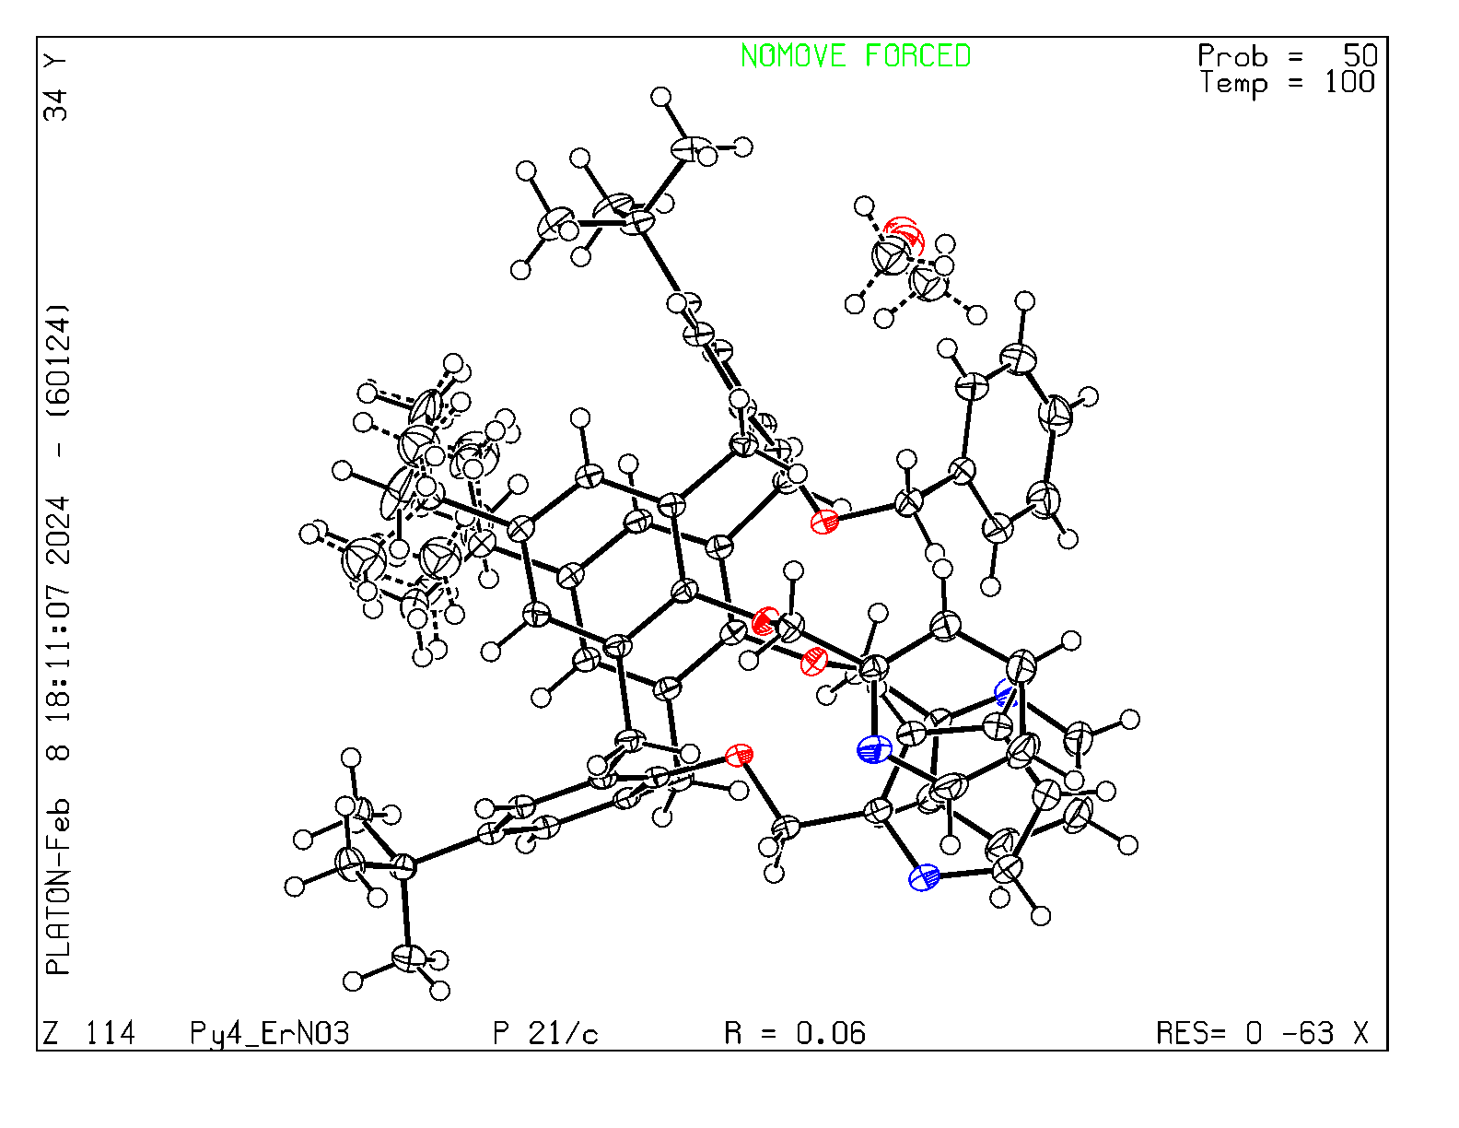
Figure S1. ORTEP drawing of the asymmetric unit for the PyC4-MeOH-α crystal form.

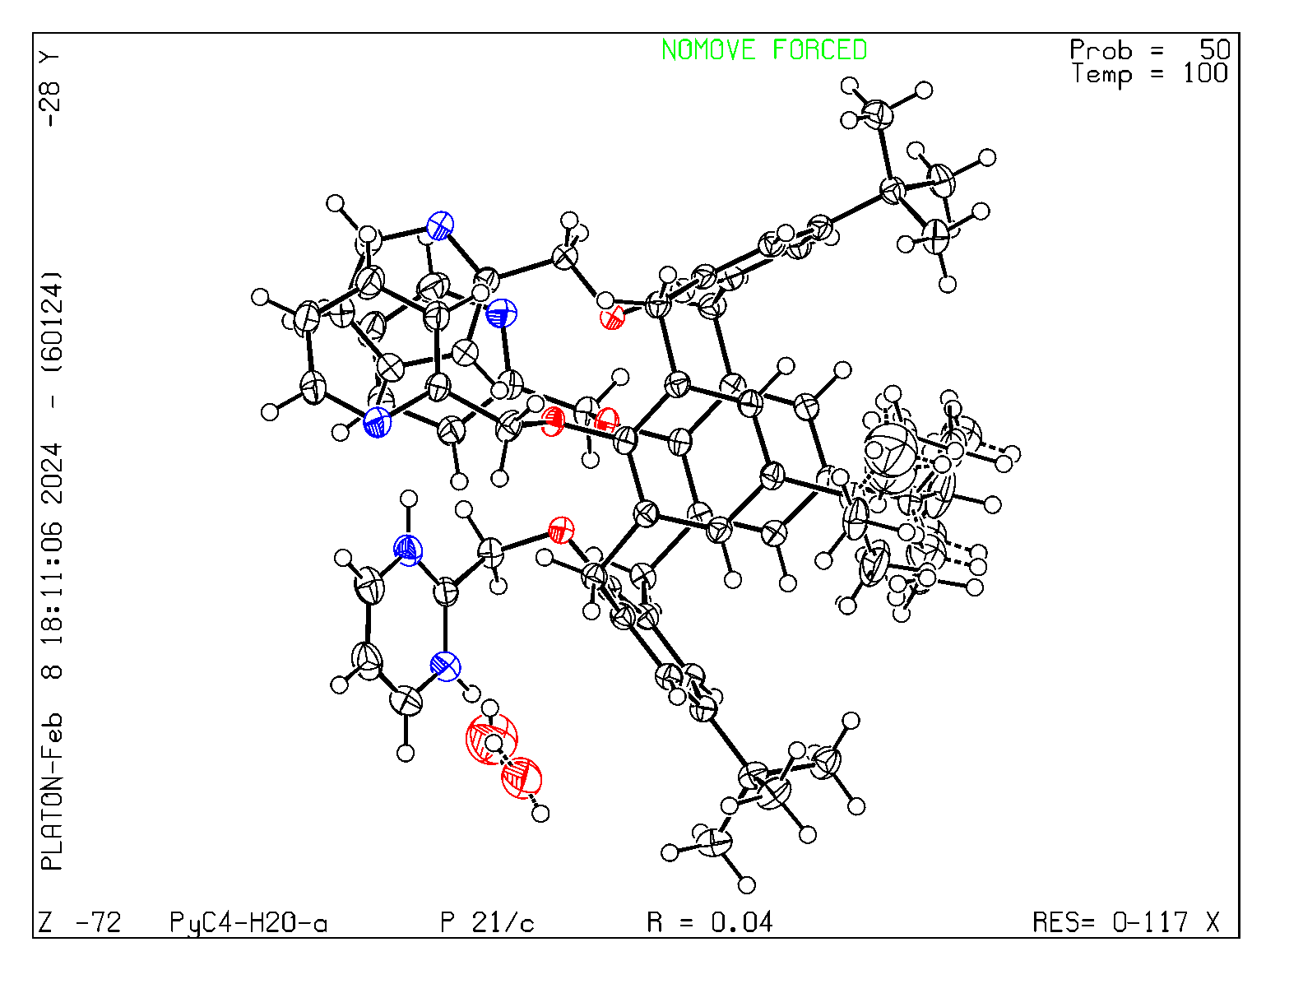
Figure S2. ORTEP drawing of the asymmetric unit for the PyC4-H₂O-α crystal form.
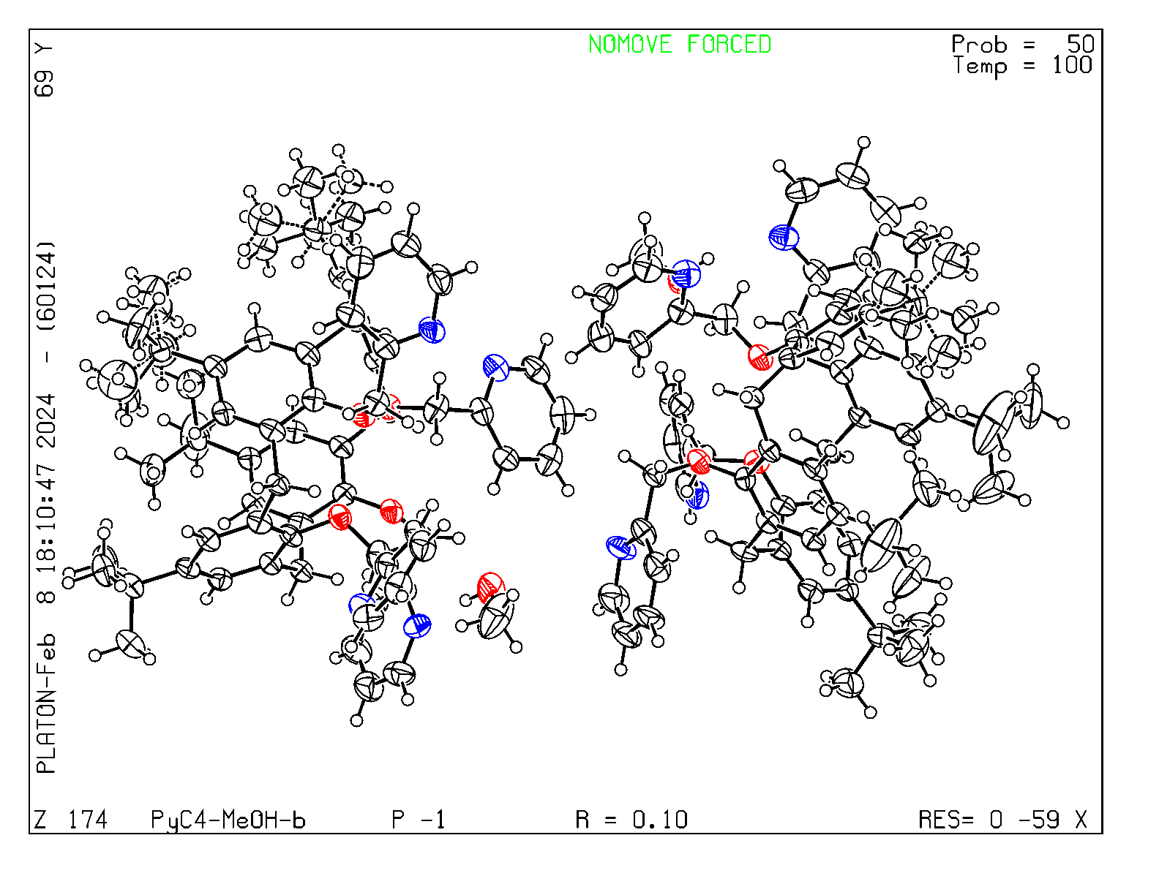
Figure S3. ORTEP drawing of the asymmetric unit for the PyC4-MeOH-β crystal form.

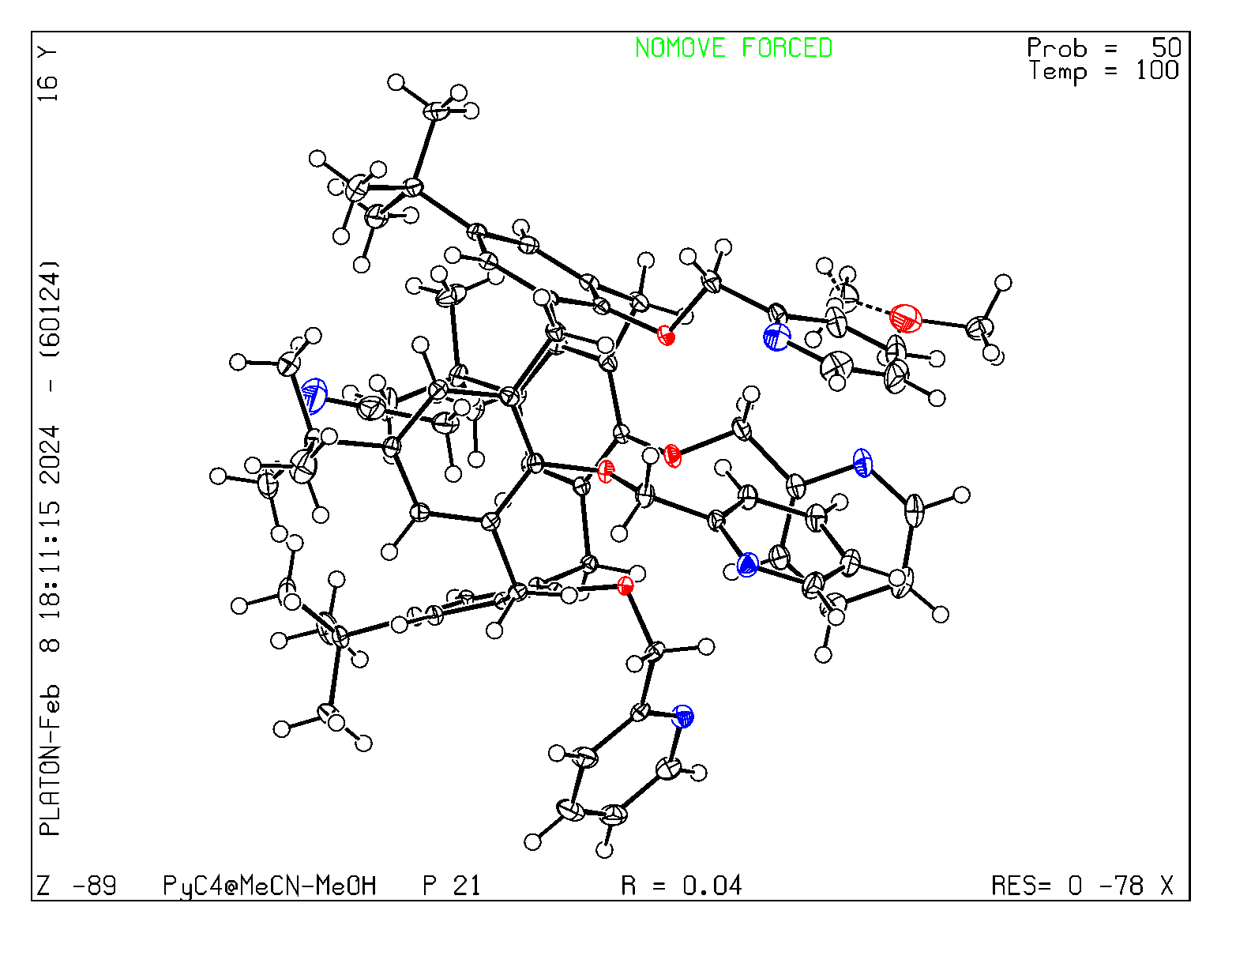
Figure S4. ORTEP drawing of the asymmetric unit for the PyC4⸦MeCN-MeOH crystal form.
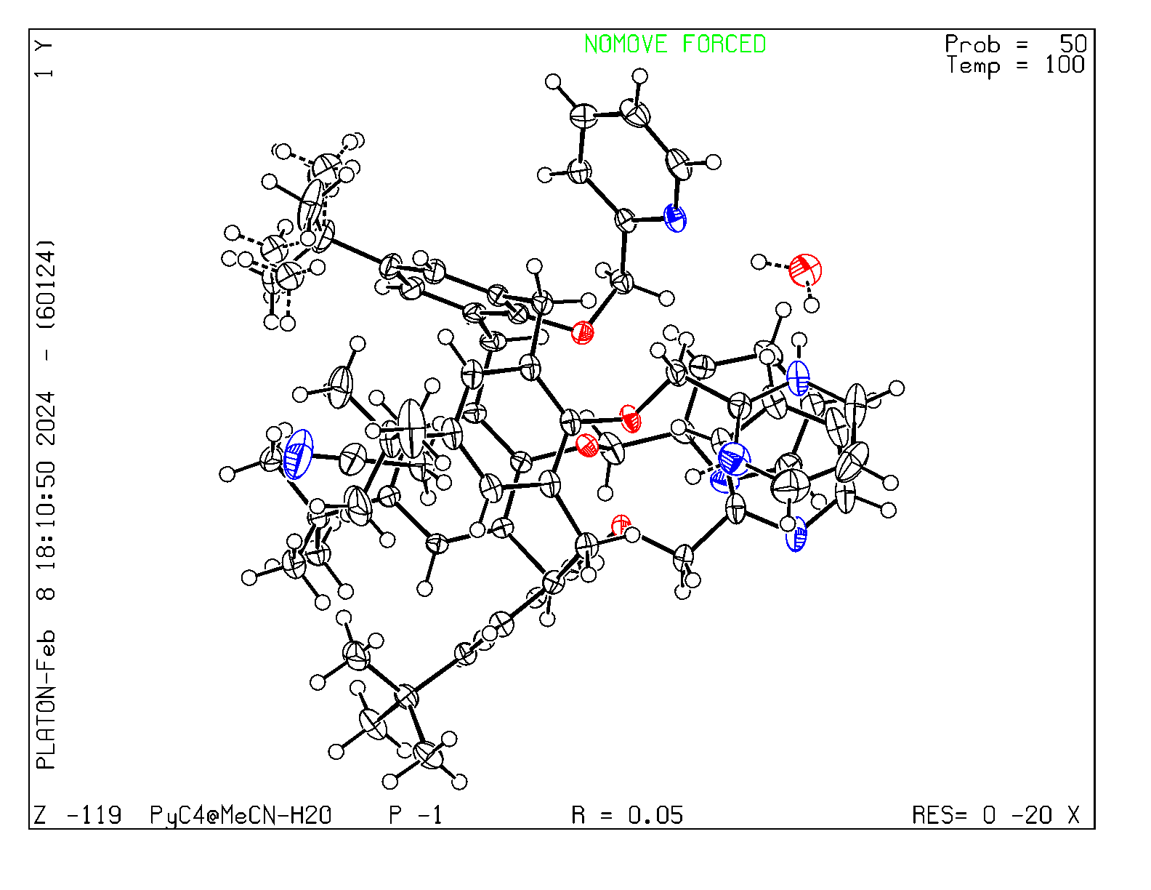
Figure S5. ORTEP drawing of the asymmetric unit for the PyC4⸦MeCN-H₂O crystal form.

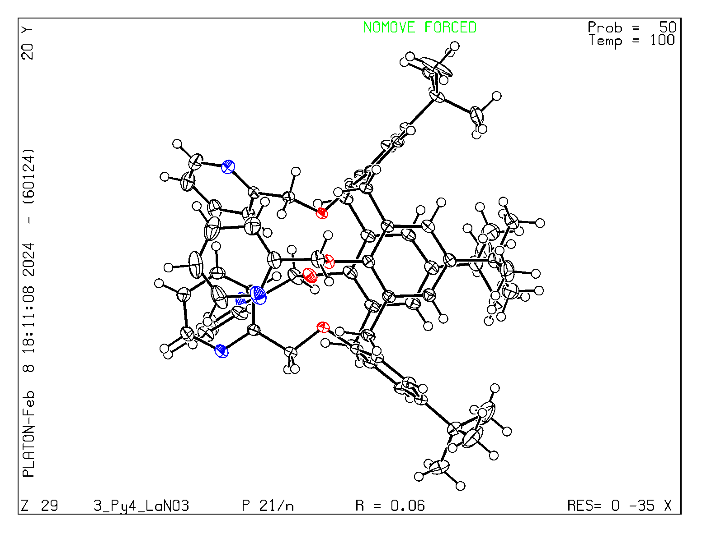
Figure S6. ORTEP drawing of the asymmetric unit for the PyC4 crystal form.
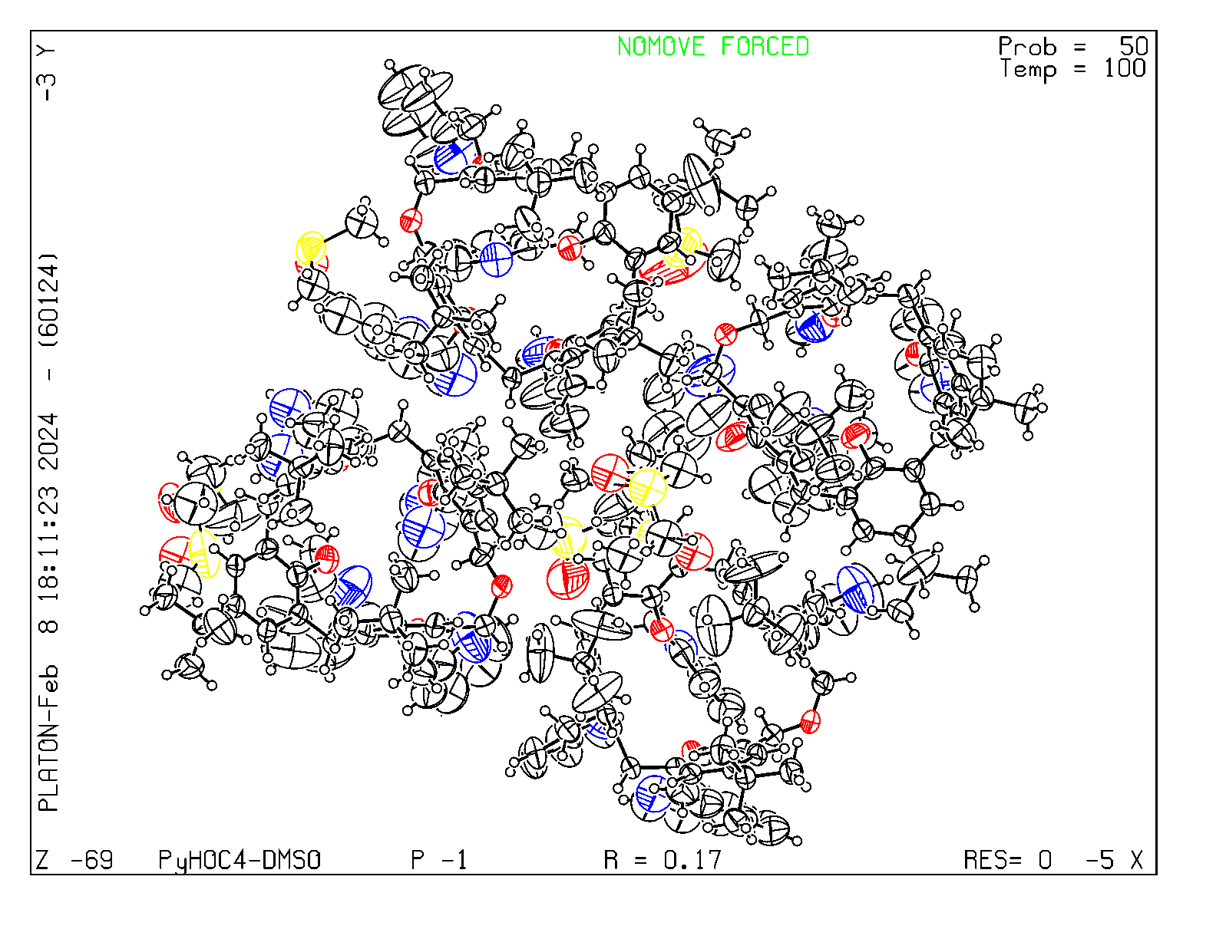
Figure S7. ORTEP drawing of the asymmetric unit for the PyHOC4-DMSO crystal form.

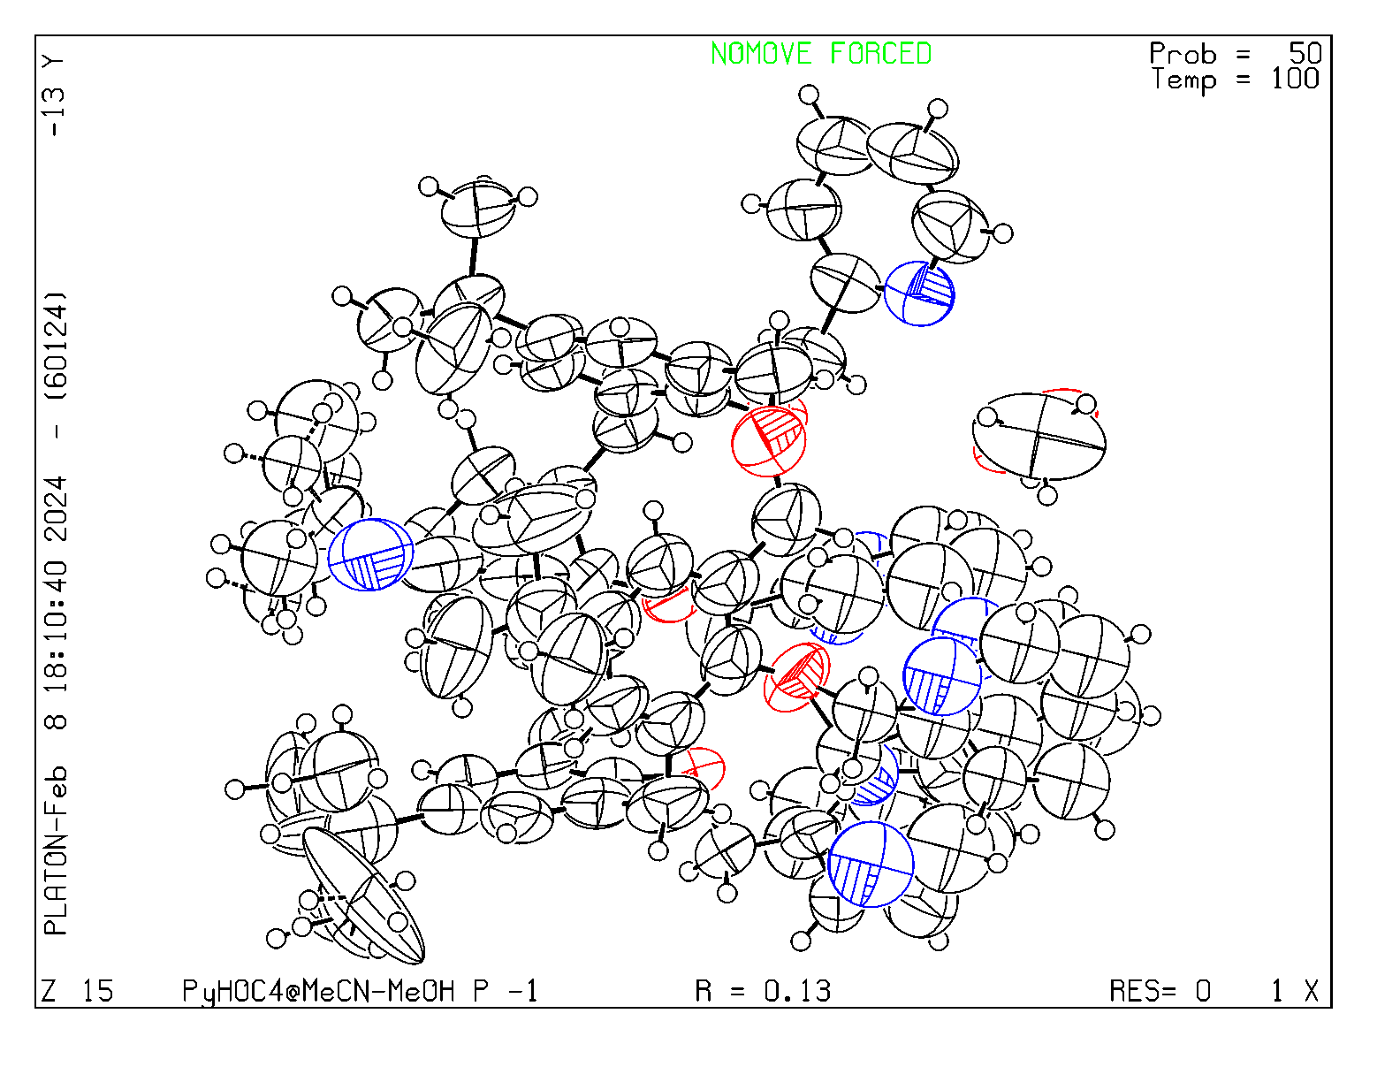
Figure S8. ORTEP drawing of the asymmetric unit for the PyHOC4⸦MeCN-MeOH crystal form.
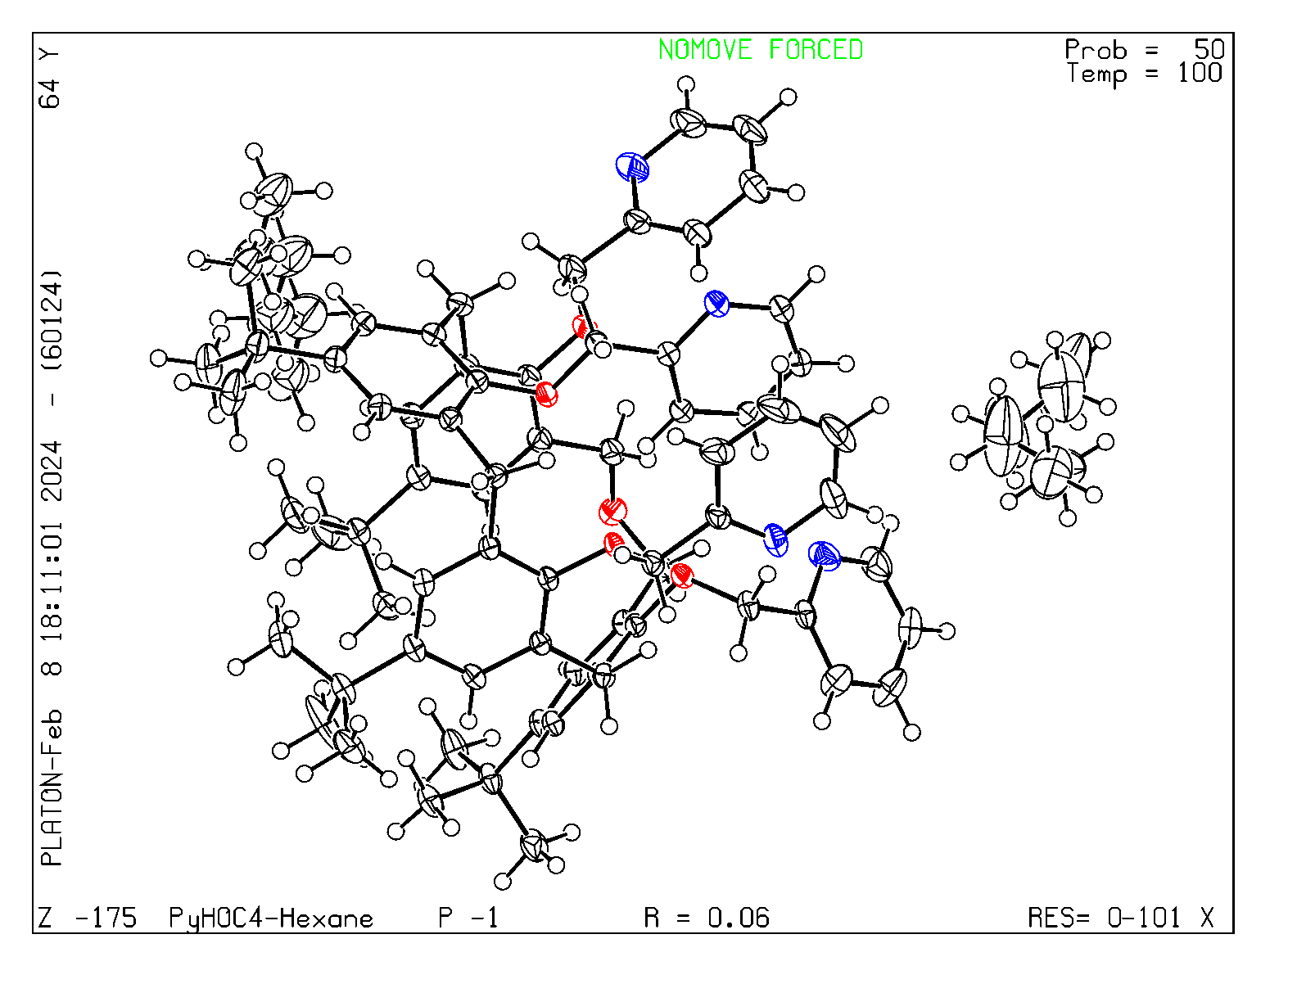
Figure S9. ORTEP drawing of the asymmetric unit for the PyHOC4-Hexane crystal form.

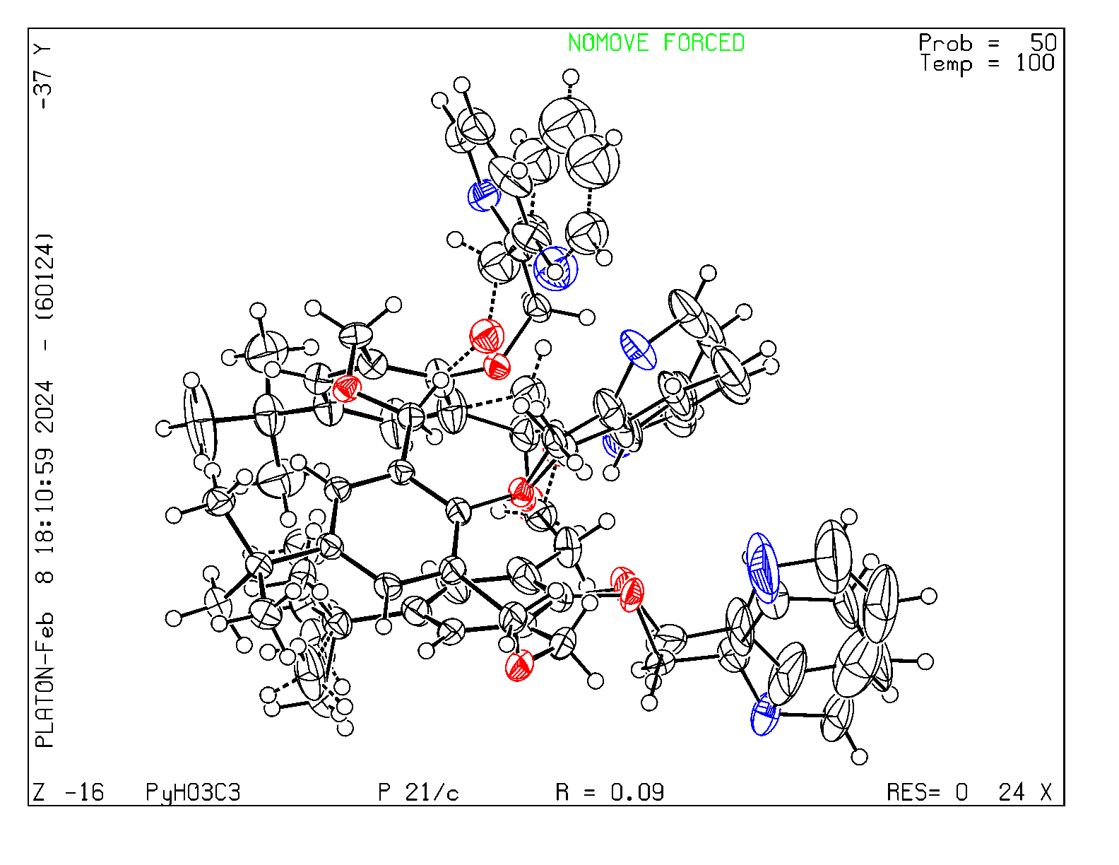
Figure S10. ORTEP drawing of the asymmetric unit for the PyHO3C3 crystal form.
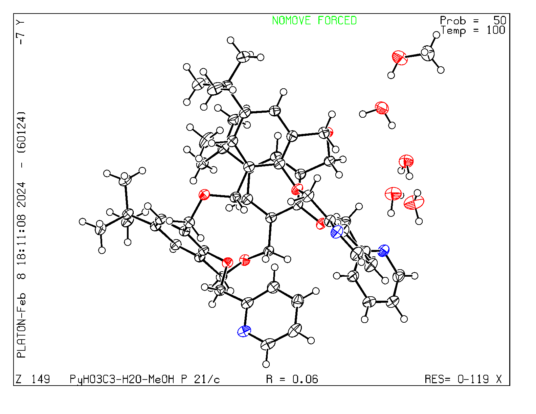
Figure S11. ORTEP drawing of the asymmetric unit for the PyHO3C3-H₂O-MeOH crystal form.

