Supplementary Information (8 pages):

- Five supplementary tables
- Four supplementary figures

Table S1. Oligonucleotide sequences (in the 5’ to 3’ direction) were employed for the amplification of genes encoding lipopeptides from the DNA of bacterial isolates.
Lipopeptides | Primers | Primer sequences | PCP length (bp) | Annealing T° | References
Bacillomycin | Bacc1F  Bacc1R | GAAGGACACGGCAGAGAGTC  CGCTGATGACTGTTCATGCT | 875 | 60 °C | [1]
Fengycin | Fend1F  Fend1R | TTTGGCAGCAGGAGAAGTT  GCTGTCCGTTCTGCTTTTTC | 964 | 62 °C | [1]
Iturin | Itup1F  Ituo2R | AGCTTAGGGAACAATTGTCATCGGGGCTTC  TCAGATAGGCCGCCATATCGGAATGATTCG | 2000 | 45 °C | [2]
Surfactin | P17  P18 | ATGAAGATTTACGGAATTTA  TTATAAAAGCTCTTCGTACG | 675 | 53 °C | [3]

Table S2. Diverse biochemical analyses were performed, encompassing both the aspect of revelation and the evaluation of activity indices. [References are shown at the end of SI].
Biochemical test | Media reference | Revelation  aspect | Activity  index  evaluation | Activity index evaluation reference
Cellulase | [4] | clear circular area around the bacteria colony | (Clear zone+ colony diameter (mm)/colony diameter (mm)) | [5]
Pectinase | [6] | clear circular area around the bacteria colony | (Clear zone+ colony diameter (mm)/colony diameter (mm)) | [5]
Amylase | [7] | clear circular area around the bacteria colony | (Clear zone+ colony diameter (mm)/colony diameter (mm)) | [8]
Protease | [4] | clear circular area around the bacteria colony | (Clear zone+ colony diameter (mm)/colony diameter (mm)) | [9]
Chitinase | [10] | clear circular area around the bacteria colony | (Clear zone+ colony diameter (mm)/colony diameter (mm)) | [5]
Phosphate solubilisation | [5] | clear circular area around the bacteria colony | (Clear zone+ colony diameter (mm)/colony diameter (mm)) | [11]
HCN | [12] | change of coloration from yellow to reddish-brown | (-) negative; light brown (+); brown (++) dark brown (+++) | [13]
AIA | [14] | change of coloration from yellow to red | (-) negative; light red (+); red (++) dark red (+++) | -

Table S3. Application of treatments with varying concentrations against C. beticola in the field experiment.
Treatments | Active ingredient | Concentration g/(l-kg) | Active ingredient/ha | Code
SCORE 250 EC (SYNGENTA) | Difenoconazole | 250 | 125 | DF
BGH 1-6 | Pantoea sp. | 1x10^8 CFU/ml | 4x10^12 CFU | BGH 1-6
BGH 2-2 | Serratia sp. | 1x10^8 CFU/ml | 4x10^12 CFU | BGH 2-2
BGH 1-3 | Serratia sp. | 1x10^8 CFU/ml | 4x10^12 CFU | BGH 1-3
BGH 2-7 | Bacillus sp. | 1x10^8 CFU/ml | 4x10^12 CFU | BGH 2-7
untreated control |  |  |  | UC

Table S4. The impact of bacterial inoculation on the growth of sugar beet plants in a greenhouse experiment.

Bacterial isolates | Root dry weightª (g) | Shoot dry weightª (g) | Root lengthª (mm) | shoot lengthª (mm) | Gain of root lenght (%) | Gain of shoot length^{b} (%) | Gain of Shoot dry weight^{b} (%) | Gain of root dry weight^{b} (%) | Total gain of root dry weight^{b} (%) | Root hair development ^{c}
BGH 1-5 | 1.09±0.04 | 1.70±0.02 | 44.13±1.79 | 22.28±0.30 | 72.70% | 389% | 78% | 107% | 86% | +
G1b | 1.22±0.02 | 1.49±0.03 | 31.13±1.26 | 18.74±0.65 | 45.30% | 245% | 56% | 131% | 81% | ++
BGH 2-1 | 1.06±0.072 | 1.62±0.10 | 38.12±4.93 | 21.81±0.80 | 69.10% | 322% | 70% | 101% | 79% | +
BGH 4-1 | 0.93±0.07 | 1.72±0.02 | 17.68±0.42 | 23.01±0.40 | 78.40% | 96% | 80.50% | 77% | 77% | ++
BGH 1-6 | 1.15±0.17 | 1.44±0.13 | 25.12±9.46 | 18.58±2.06 | 44.00% | 178% | 51% | 118% | 73% | +
BGH 2-3 | 1.11±0.02 | 1.36±0.05 | 47.43±1.23 | 16.83±0.45 | 30.50% | 425% | 43% | 111% | 65% | ++
G3f | 1.12±0.05 | 1.34±0.10 | 34.59±0.83 | 16.13±0.66 | 25.10% | 283% | 41% | 113% | 64% | +++
G2c | 1.12±0.06 | 1.22±0.30 | 26.48±0.95 | 15.29±2.55 | 18.50% | 193% | 29% | 114% | 57% | +++
G2b | 0.94±0.07 | 1.31±0.02 | 16.29±1.12 | 16.25±0.39 | 26.00% | 80% | 37% | 79% | 50% | ++++
BGH 2-2 | 0.89±0.07 | 1.26±0.10 | 18.01±0.85 | 15.9±0.74 | 23.30% | 99% | 33% | 70% | 44% | ++
BGH 1-3 | 0.82±0.06 | 1.26±0.05 | 14.23±0.23 | 16.0±0.43 | 24.00% | 58% | 32% | 56% | 39% | +
BGH 2-7 | 0.56±0.03 | 1.51±0.15 | 9.43±1.03 | 19.675±2 | 52.50% | 4% | 59% | 6% | 38% | +
G1d | 0.76±0.07 | 1.22±0.06 | 13.5±0.4 | 15.73±0.76 | 22.00% | 49% | 28% | 44% | 32% | ++++
G3d | 0.77±0.12 | 1.20±0.060 | 13.33±1.03 | 15.38±0.77 | 19.30% | 48% | 26% | 47% | 32% | ++
BGH 2-5 | 0.74±0.07 | 1.19±0.04 | 14.36±0.50 | 15.28±0.86 | 18.50% | 59% | 25% | 41% | 29% | ++
G1a | 0.50±0.04 | 1.28±0.07 | 8.52±0.47 | 16.60±0.27 | 28.70% | -6% | 34% | -4% | 19% | ++
G3c | 0.50±0.01 | 1.04±0.05 | 8.80±0.47 | 13.77±1.16 | 6.80% | -3% | 10% | -4% | 3% | ++++
TNT | 0.52±0.01 | 0.95±0.13 | 9.03±0.70 | 12.91±0.56 | 0% | 0% | 0% | 0% | 0% | +++
G4a | 0.61±0.02 | 0.87±0.18 | 11.45±0.47 | 12.60±0.26 | -2.30% | 27% | -8% | 16% | -1% | ++++
ª The values represent the mean of three independent assay replicates, expressed as the mean ± standard error, with units in grams (g) and millimeters (mm).
^{b} Percentages are derived by comparing inoculated versus non-inoculated samples.
^{c} The gradation of responses for the trait of root hair development, ranging from strong to weak, is denoted as (+ + ++), (+ + +), (+ +), and (+).
Figure S1.

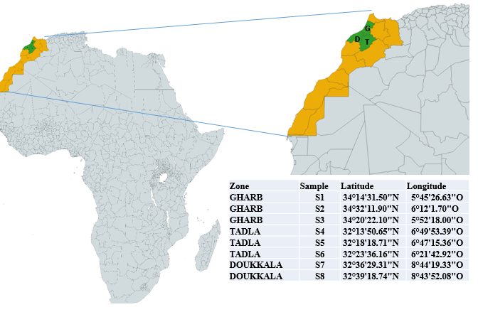
Figure S1. A map showing the 6 sites that have been sampled in Morocco in three regions: G, Gharb; D, Doukkala; and T, Tadla.

Figure S2.

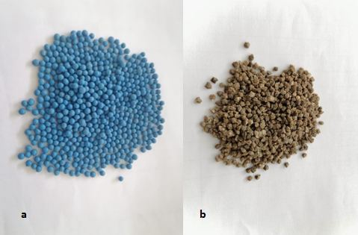

Figure S2. Panel a displays seeds of sugar beet with a coating, whereas Panel b illustrates seeds that have been washed to eliminate the coated reagents.

Figure S3.

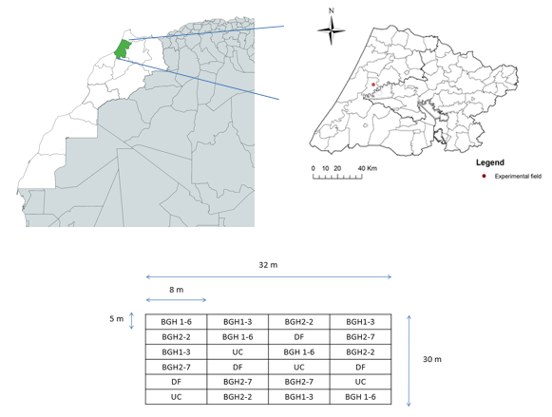
Figure S3. The field trial site's location and the experimental setup, including treatments, are shown. The four bacterial isolates (BGH1-6, Pantoea sp.; BGH 2-2, Serratia sp.; BGH 2-7, Bacillus sp.; and BGH 1-3, Serratia sp.), along with DF (Difenoconazole) and UC (untreated control), were employed. The experiment included four replicates. The dimensions of the plots are presented in meters.

Figure S4.
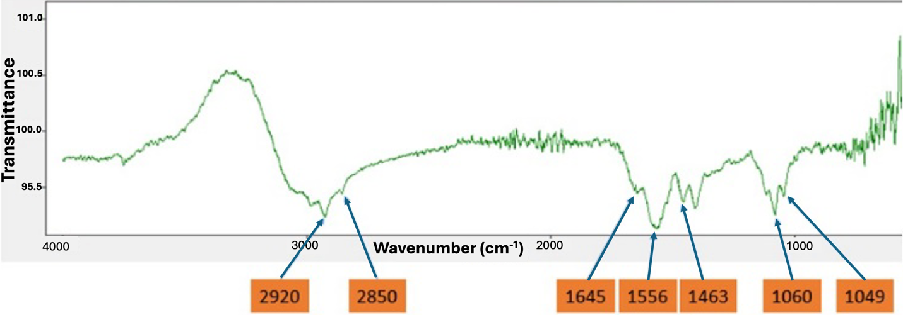

Figure S4. Fourier Transform Infrared (FTIR) Spectroscopy used to perform qualitative and quantitative analysis the bacterial isolate BGH2-2 supernatant.
Figure S5.
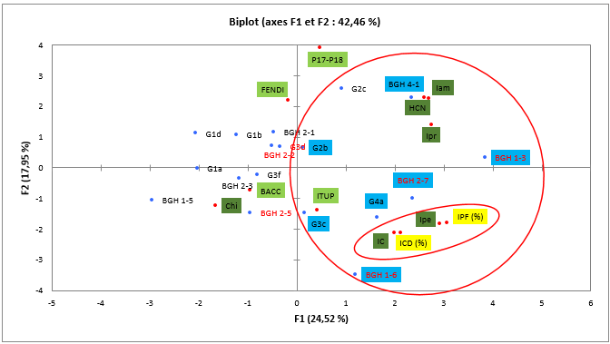

Figure S4. Principal components analysis was conducted for the simultaneous assessment of hydrolytic enzyme production, bacterial antagonism, and the presence of lipopeptide encoding genes (ipe: pectinase index; IC: cellulase index; Iam: amylase index; IPR: protease index; hcn: hydrogen cyanide production). Bacterial isolates highlighted in red exhibited a high inhibition rate in dual culture, while those with a blue background demonstrated a high indirect inhibition rate.

References used in Table S2

1. Ramarathnam, R.; Bo, S.; Chen, Y.; Fernando, W.G.D.; Xuewen, G.; De Kievit, T. Molecular and biochemical detection of fengycin-and bacillomycin D-producing Bacillus spp., antagonistic to fungal pathogens of canola and wheat. Canadian Journal of Microbiology 2007, 53, 901-911.
2. Dimkić, I.; Živković, S.; Berić, T.; Ivanović, Ž.; Gavrilović, V.; Stanković, S.; Fira, D. Characterization and evaluation of two Bacillus strains, SS-12.6 and SS-13.1, as potential agents for the control of phytopathogenic bacteria and fungi. Biological Control 2013, 65, 312-321.
3. Hsieh, F.C.; Li, M.C.; Lin, T.C.; Kao, S.S. Rapid detection and characterization of surfactin-producing Bacillus subtilis and closely related species based on PCR. Current Microbiology 2004, 49, 186-191, doi:10.1007/s00284-004-4314-7.
4. Syed-Ab-Rahman, S.F.; Carvalhais, L.C.; Chua, E.; Xiao, Y.; Wass, T.J.; Schenk, P.M. Identification of soil bacterial isolates suppressing different phytophthora spp. And promoting plant growth. Frontiers in Plant Science 2018, 871, doi:10.3389/fpls.2018.01502.
5. Ezrari, S.; Mhidra, O.; Radouane, N.; Tahiri, A.; Polizzi, G.; Lazraq, A.; Lahlali, R. Potential role of rhizobacteria isolated from citrus rhizosphere for biological control of citrus dry root rot. Plants 2021, 10, 1-26, doi:10.3390/plants10050872.
6. Etesami, H.; Alikhani, H.A.; Mirseyed Hosseini, H. Evaluation of halotolerant endophytic bacteria isolated from the halophyte suaeda for biological control of fungal rice pathogens. 2019.
7. Dinesh, R.; Anandaraj, M.; Kumar, A.; Bini, Y.K.; Subila, K.P.; Aravind, R. Isolation, characterization, and evaluation of multi-trait plant growth promoting rhizobacteria for their growth promoting and disease suppressing effects on ginger. Microbiological research 2015, 173, 34-43.
8. Jamilah, I.T.; Meryandini, A.; Rusmana, I.; Suwanto, A.; Mubarik, N.R. Activity of proteolytic and amylolytic enzymes from Bacillus spp. isolated from shrimp ponds. Microbiology Indonesia 2009, 3, 4-4.
9. Pertiwiningrum, A.; Anggraini, F.D.; Fitrianto, N.A. Isolation and identification of bacterial protease enzyme of leather waste. Journal of the Indonesian Tropical Animal Agriculture 2017, 42.
10. Hsu, S.C.; Lockwood, J.L. Powdered Chitin Agar as a Selective Medium for Enumeration of Actinomycetes in Water and Soil1. Applied Microbiology 1975, 29, 422-426, doi:10.1128/aem.29.3.422-426.1975.
11. Rodrigues, A.A.; Forzani, M.V.; Soares, R.d.S.; Sibov, S.T.; Vieira, J.D.G. Isolation and selection of plant growth-promoting bacteria associated with sugarcane. Pesquisa Agropecuária Tropical 2016, 46, 149-158.
12. Lahlali, R.; Aksissou, W.; Lyousfi, N.; Ezrari, S.; Blenzar, A.; Tahiri, A.; Ennahli, S.; Hrustić, J.; MacLean, D.; Amiri, S. Biocontrol activity and putative mechanism of Bacillus amyloliquefaciens (SF14 and SP10), Alcaligenes faecalis ACBC1, and Pantoea agglomerans ACBP1 against brown rot disease of fruit. Microbial Pathogenesis 2020, 139, 103914-103914, doi:10.1016/j.micpath.2019.103914.
13. Modi, K.; Patel, P.; Parmar, K. Isolation, screening and characterization of PGPR from rhizosphere of rice. International Journal of Pure & Applied Bioscience 2017, 5, 264-270.
14. Yuttavanichakul, W.; Lawongsa, P.; Wongkaew, S.; Teaumroong, N.; Boonkerd, N.; Nomura, N.; Tittabutr, P. Improvement of peanut rhizobial inoculant by incorporation of plant growth promoting rhizobacteria (PGPR) as biocontrol against the seed borne fungus, Aspergillus niger. Biological Control 2012, 63, 87-97.

