Appendix 1:
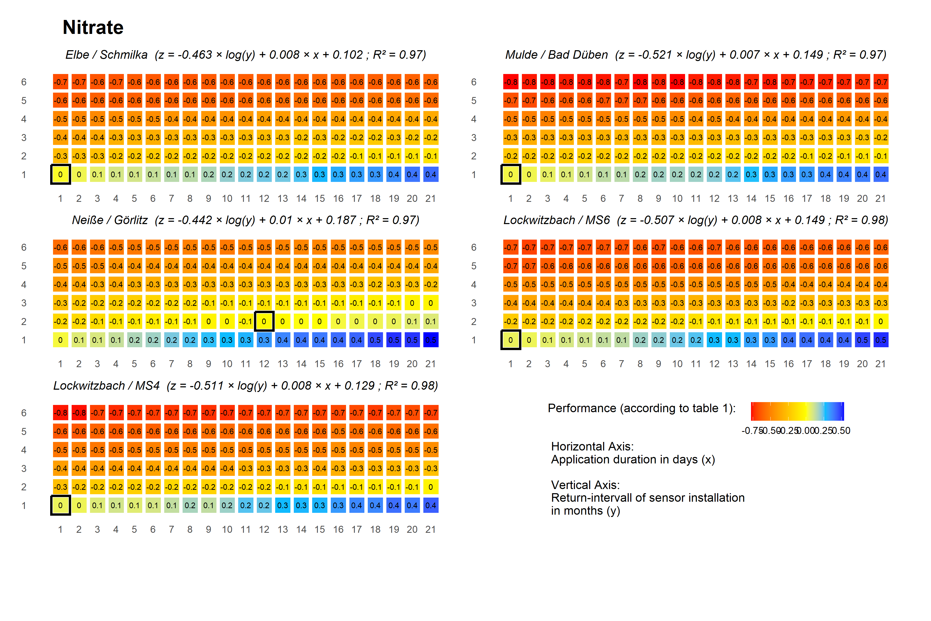
Figure 1: Performance between STOM and grab sampling at weekend and 9 am to 5 pm for nitrogen-nitrate
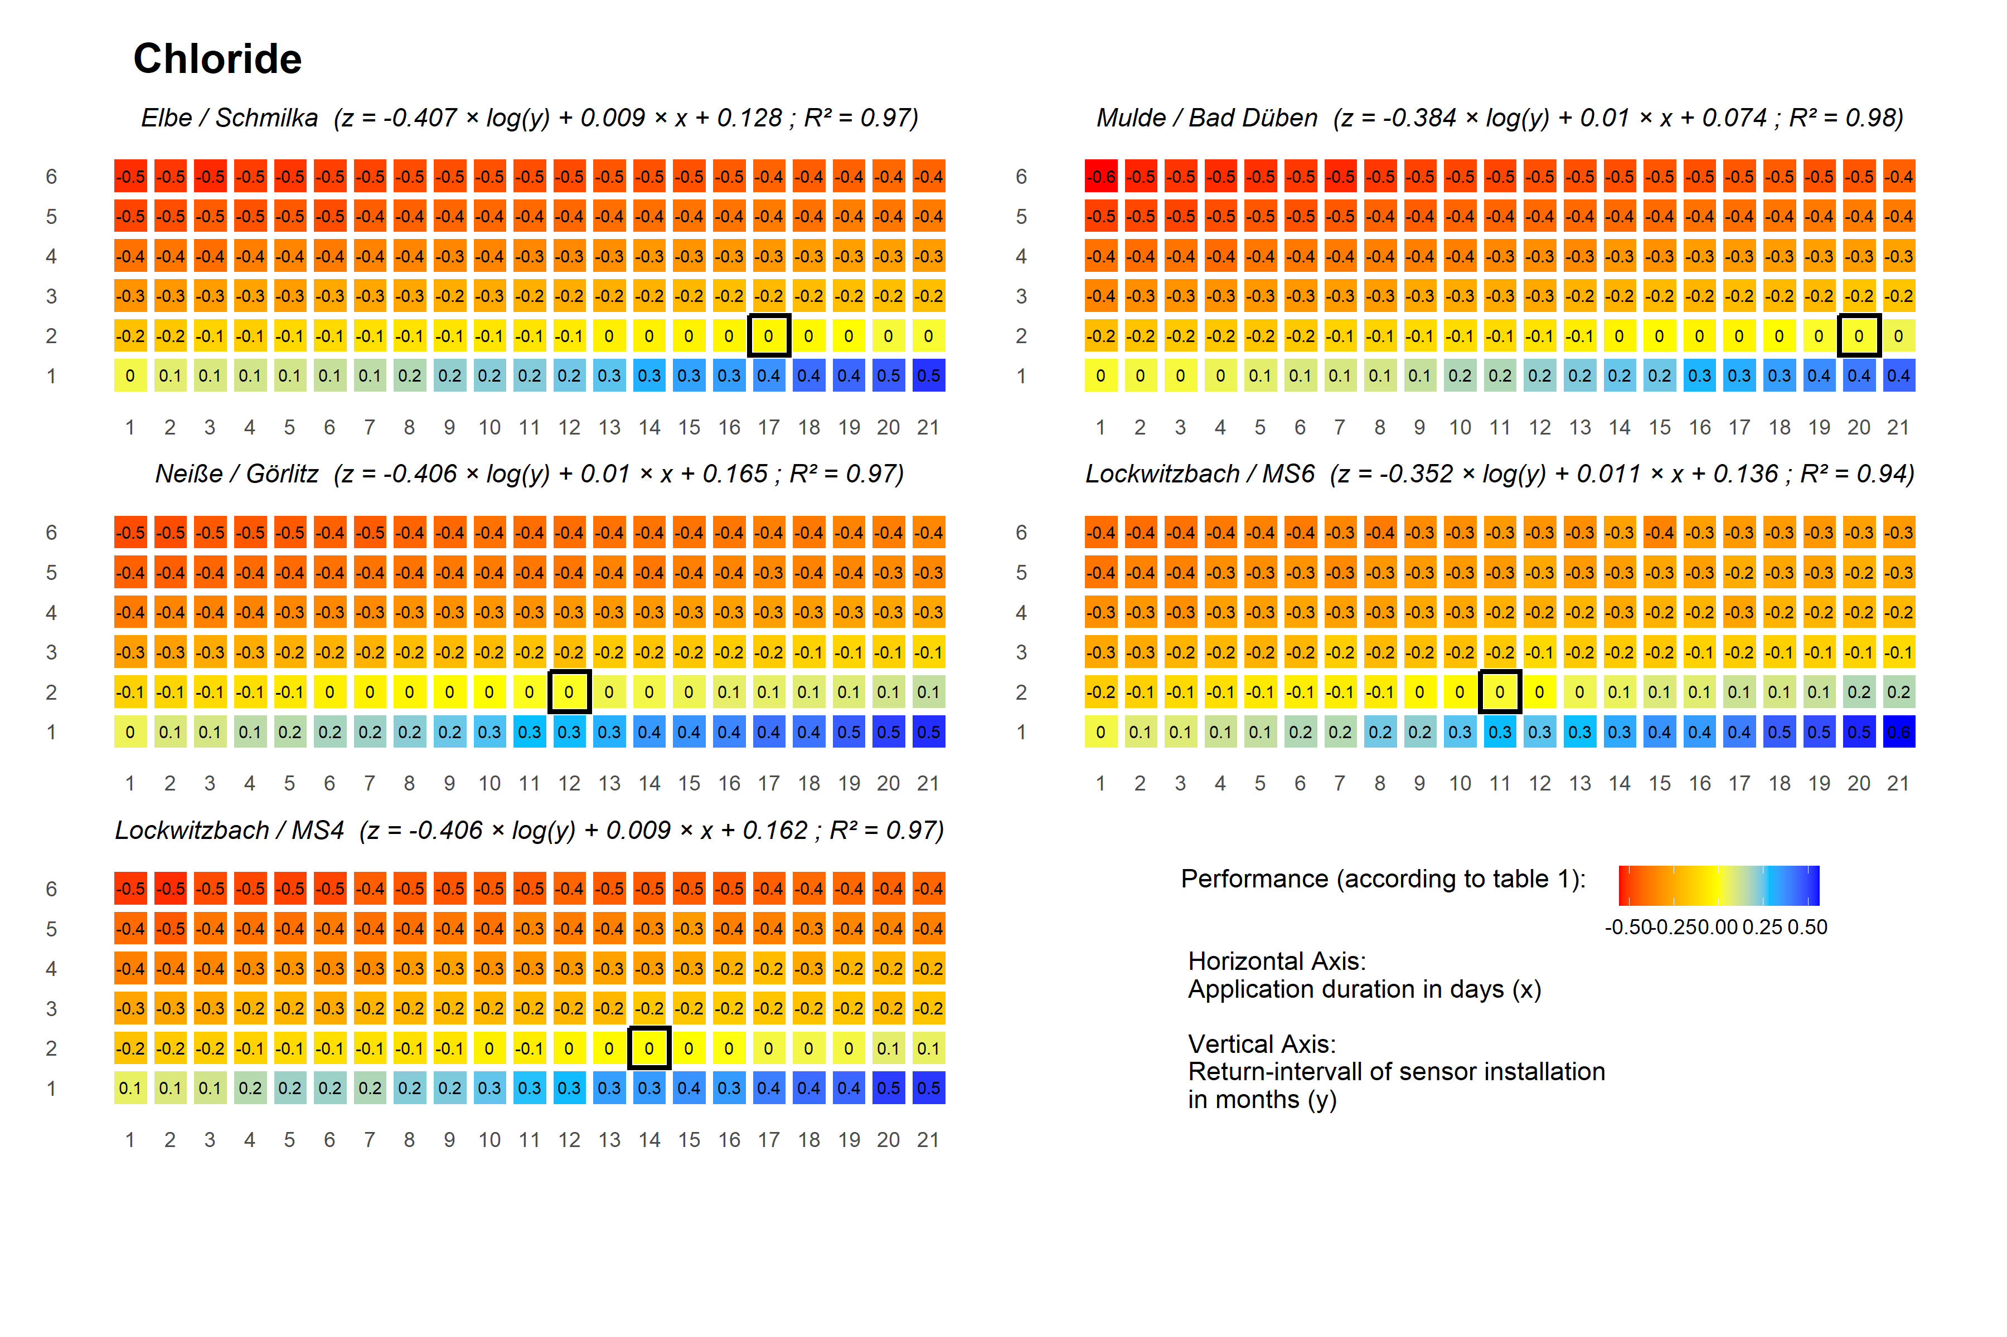 Figure 2: Performance between STOM and grab sampling at weekend and 9 am to 5 pm for cholride

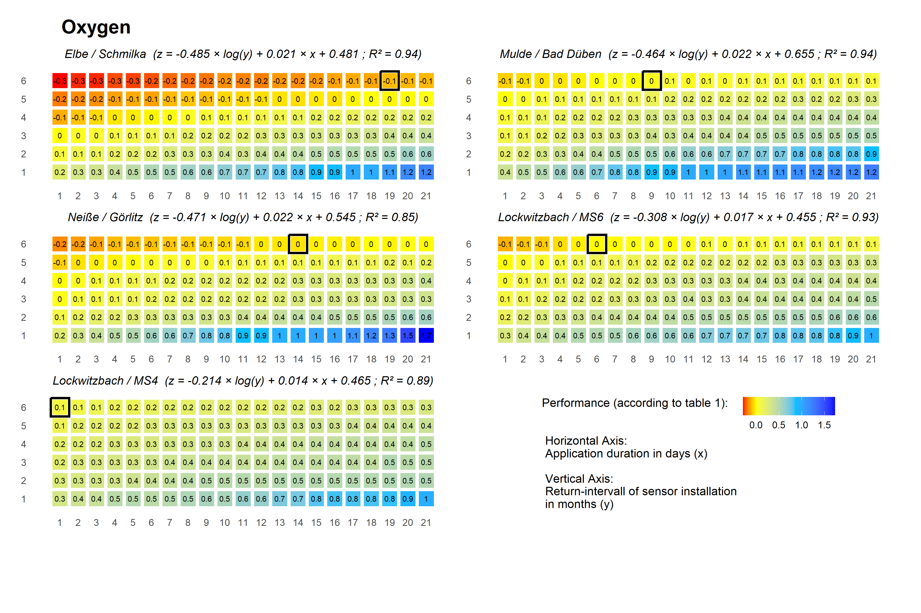
Figure 3: Performance between STOM and grab sampling at weekend and 9 am to 5 pm for dissolved oxygen

Grab sampling during the whole day (0-24h):
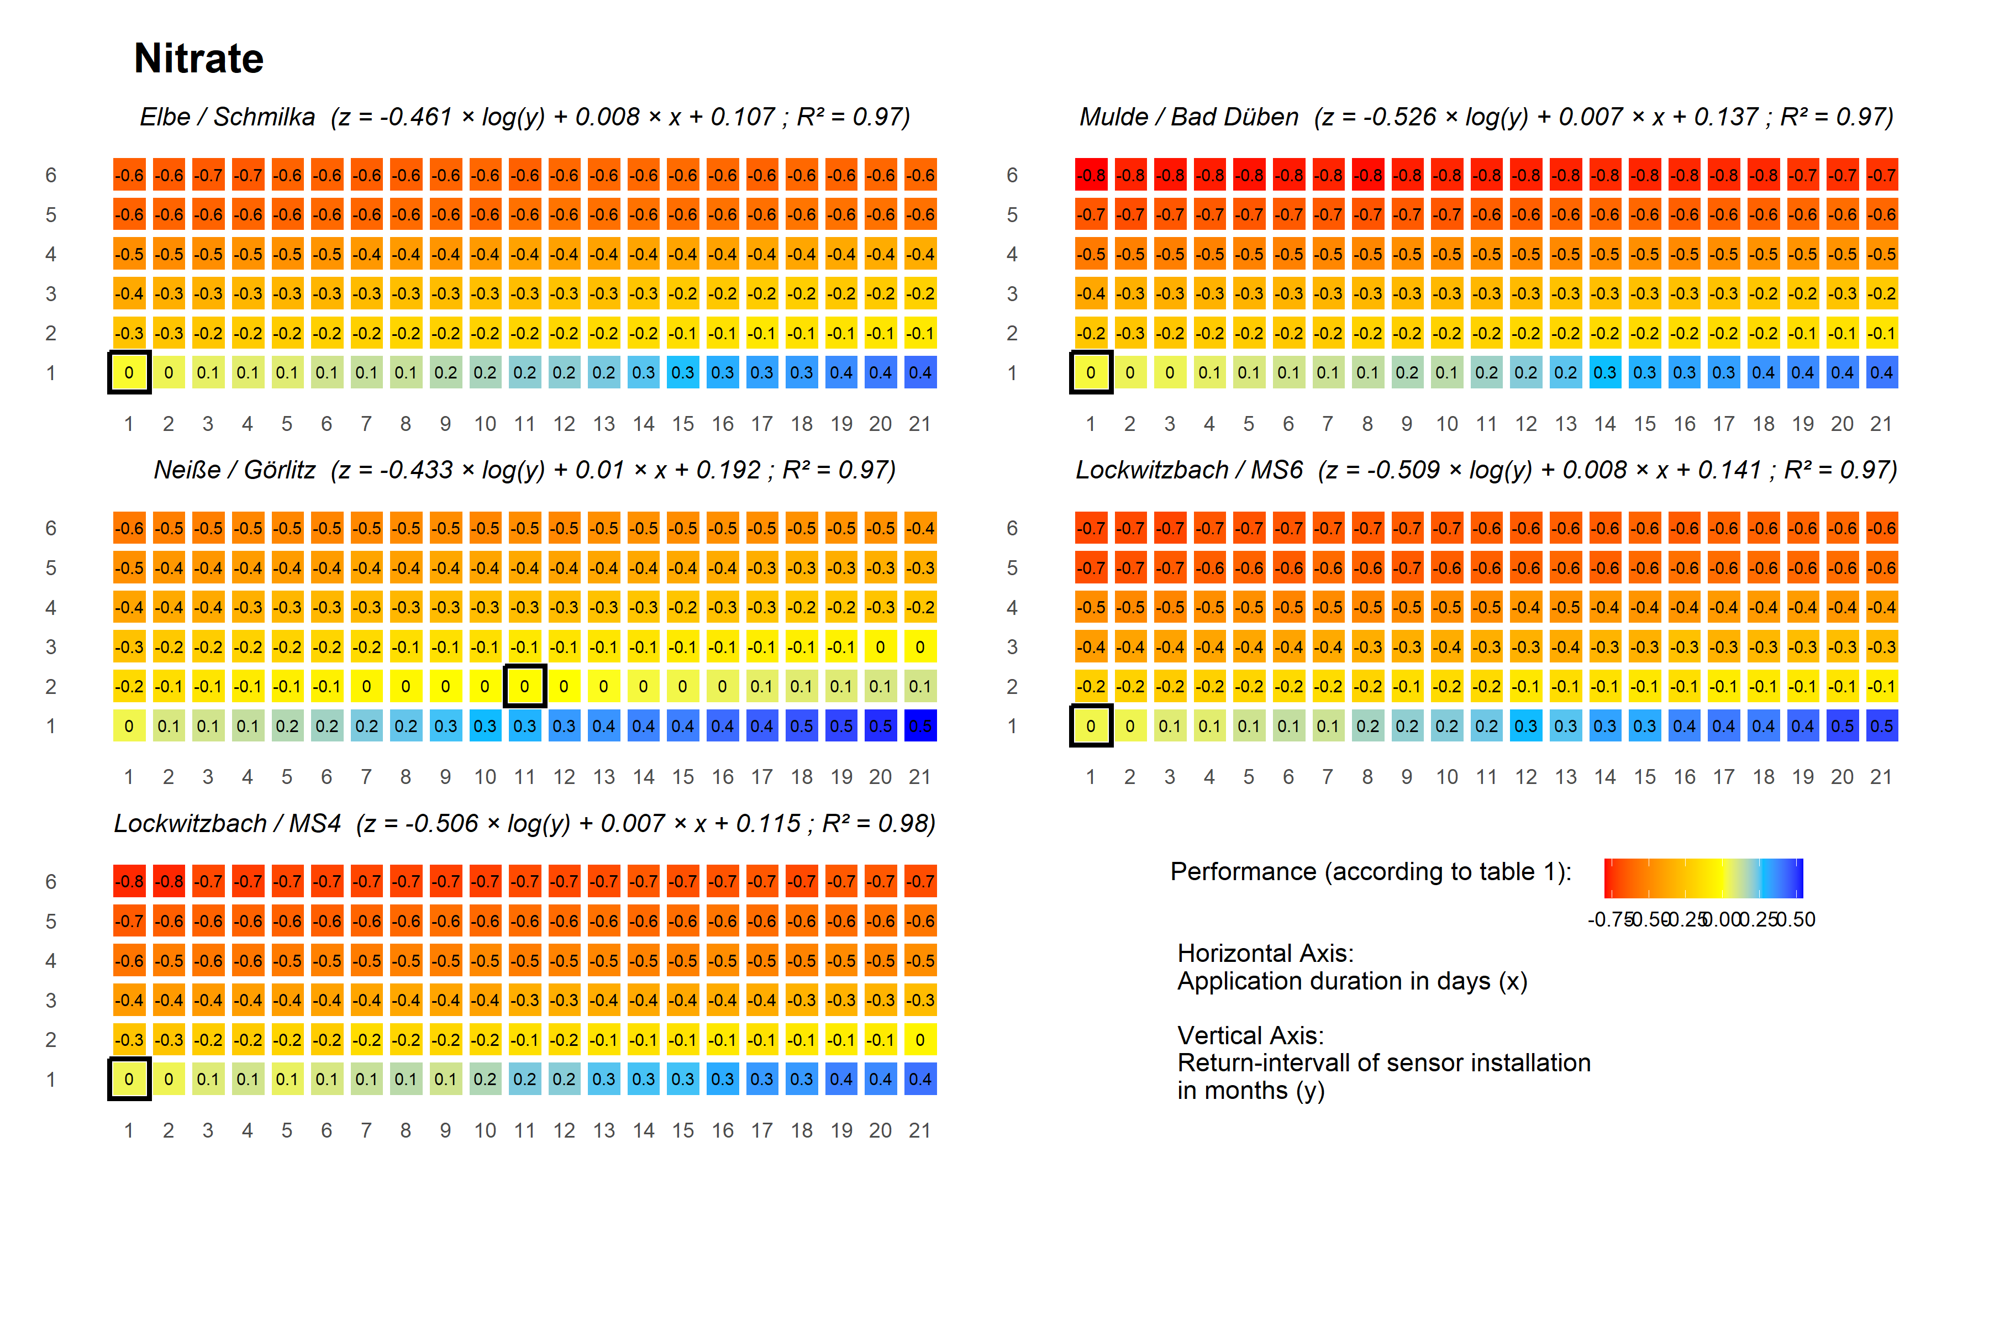
Figure 4: Performance between STOM and Grab sampling during the whole day (0-24h) for nitrate nitrogen

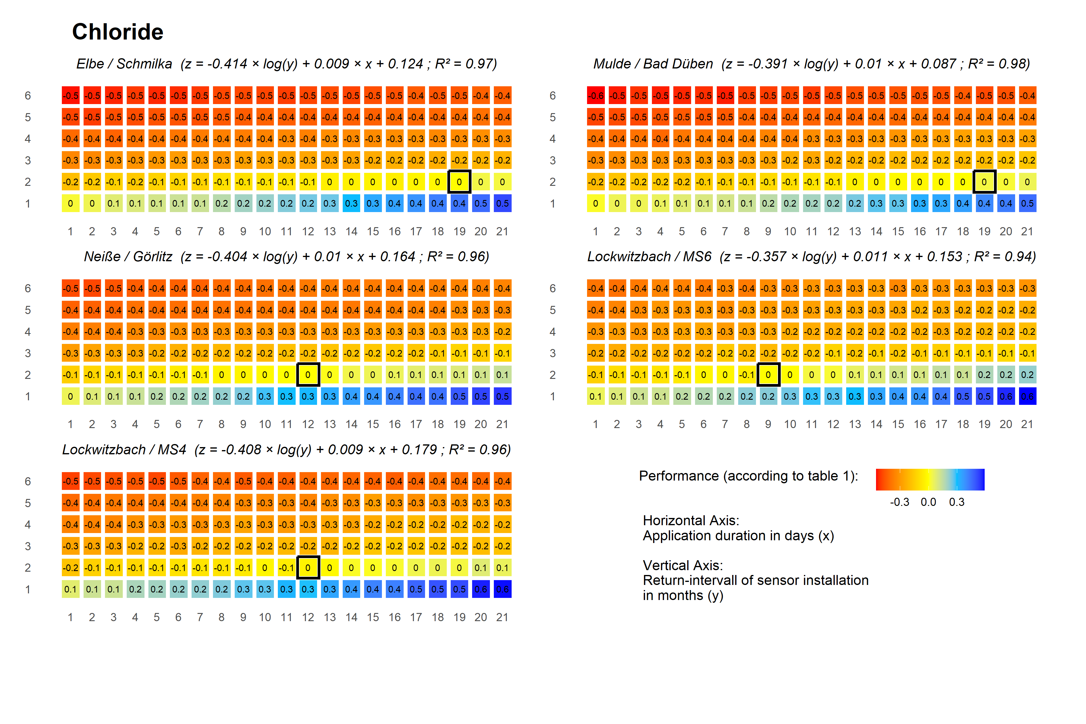
Figure 5: Performance between STOM and Grab sampling during the whole day (0-24h) for chloride

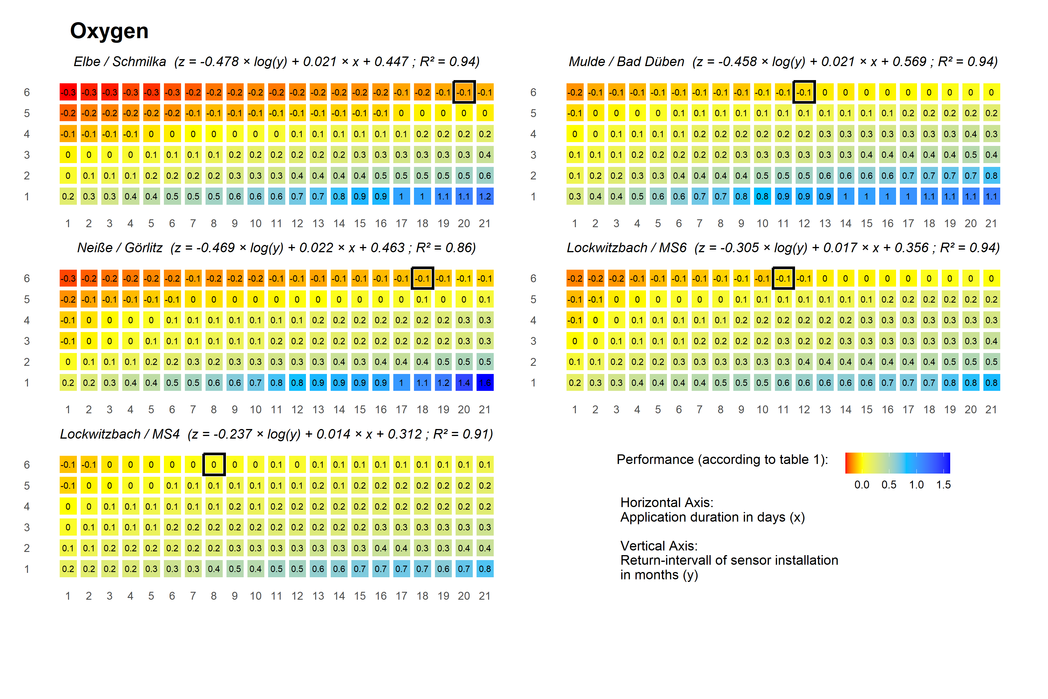
Figure 6: Performance between STOM and Grab sampling during the whole day (0-24h) for dissolved oxygen

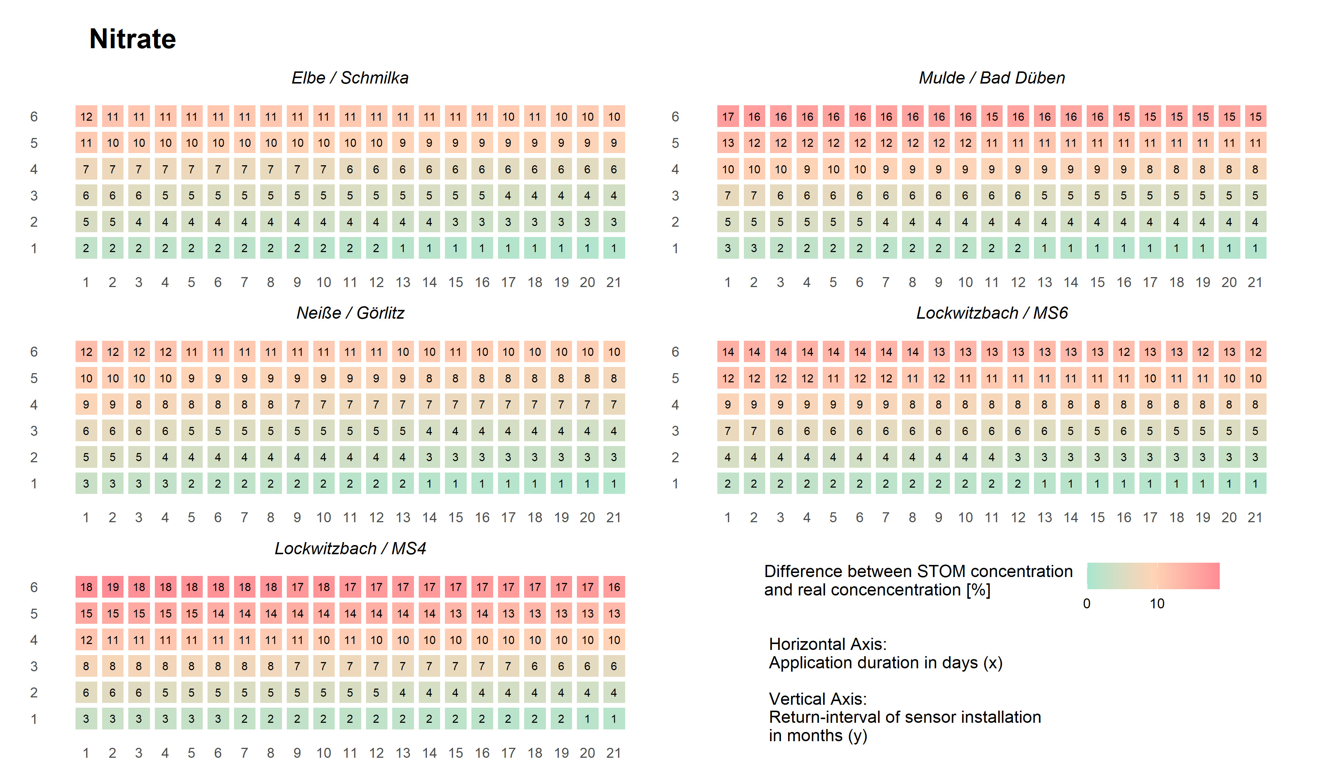
Figure 7: Difference between STOM concentration and real concentration for nitrogen-nitrate
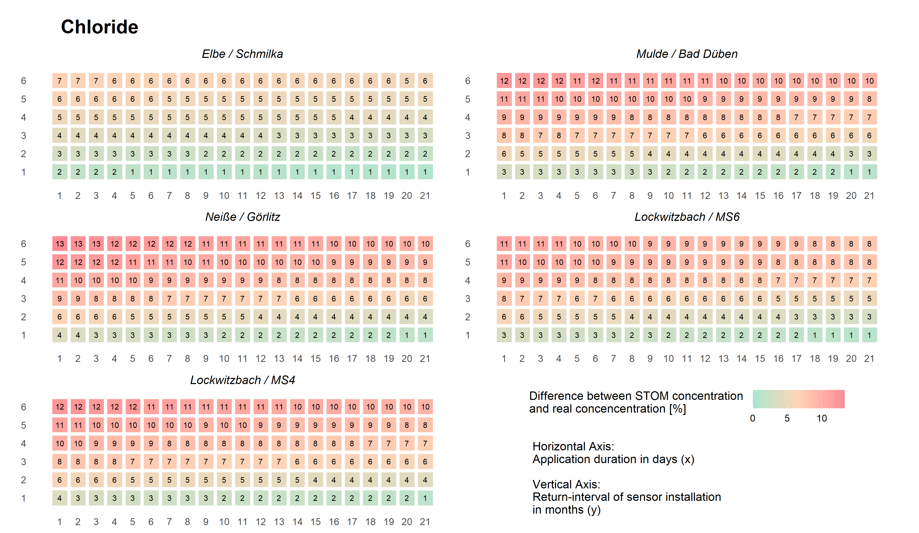
Figure 8: Difference between STOM concentration and real concentration for cholride

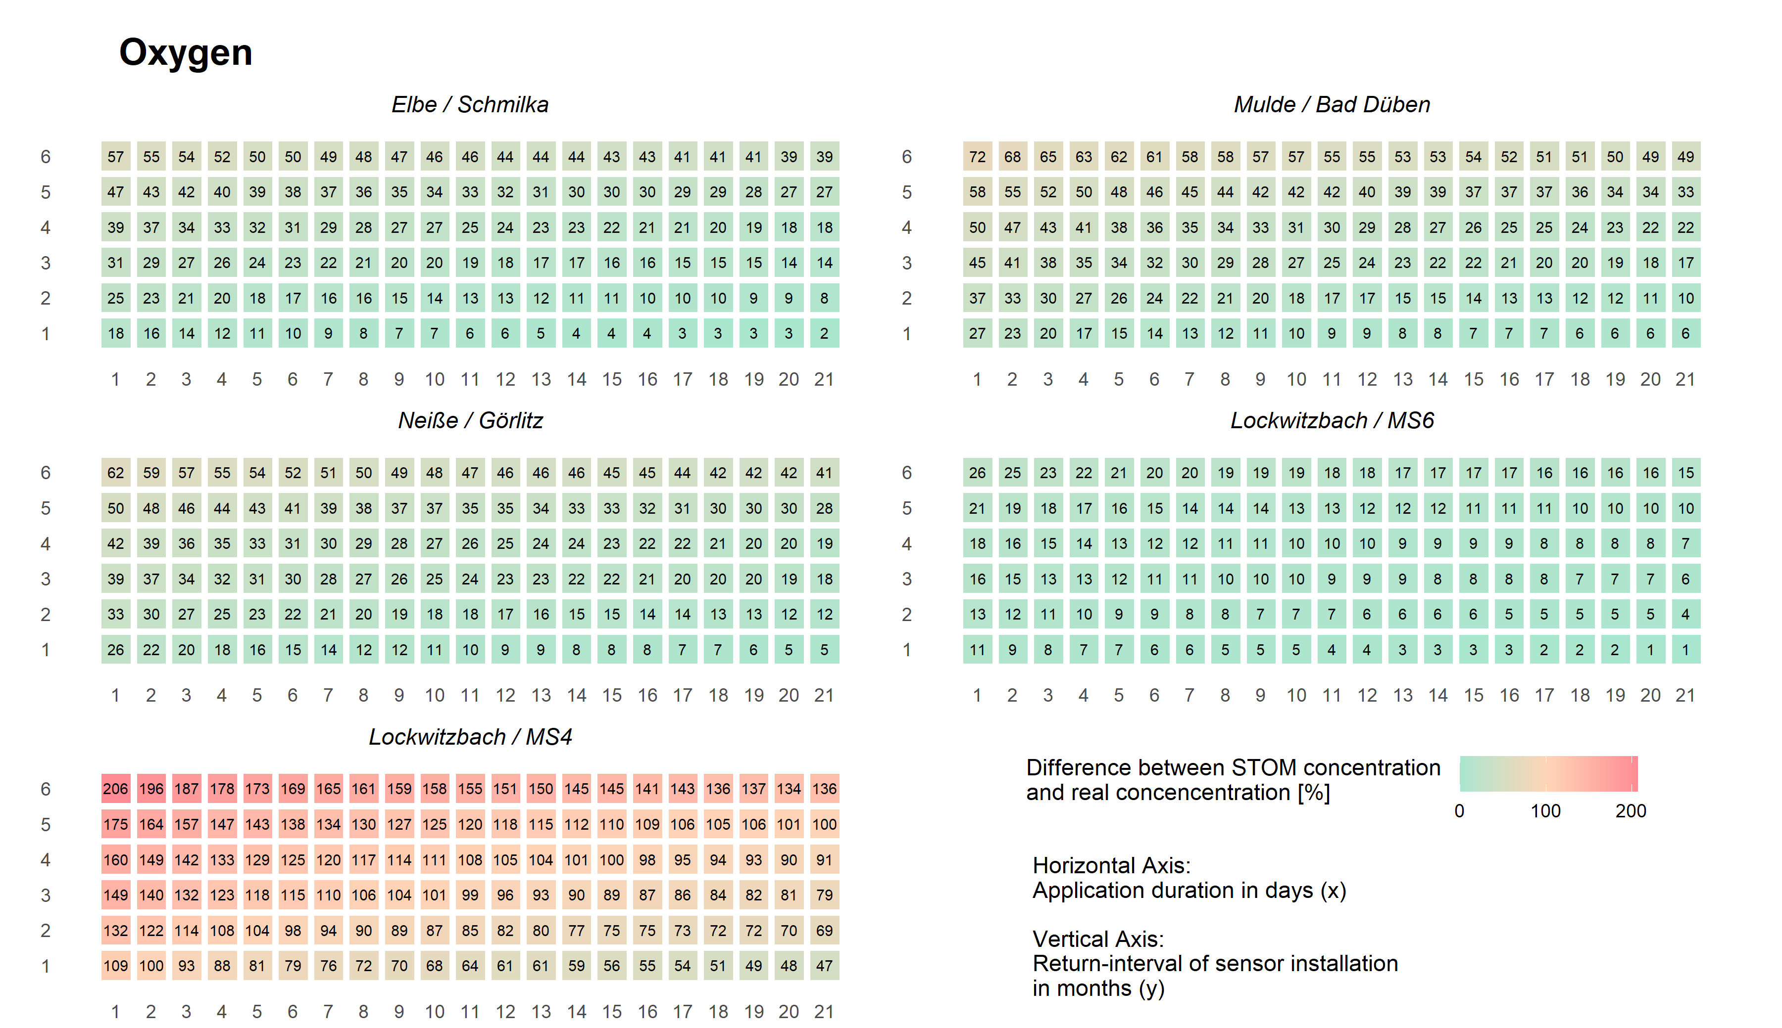
Figure 9: Difference between STOM concentration and real concentration for oxygen

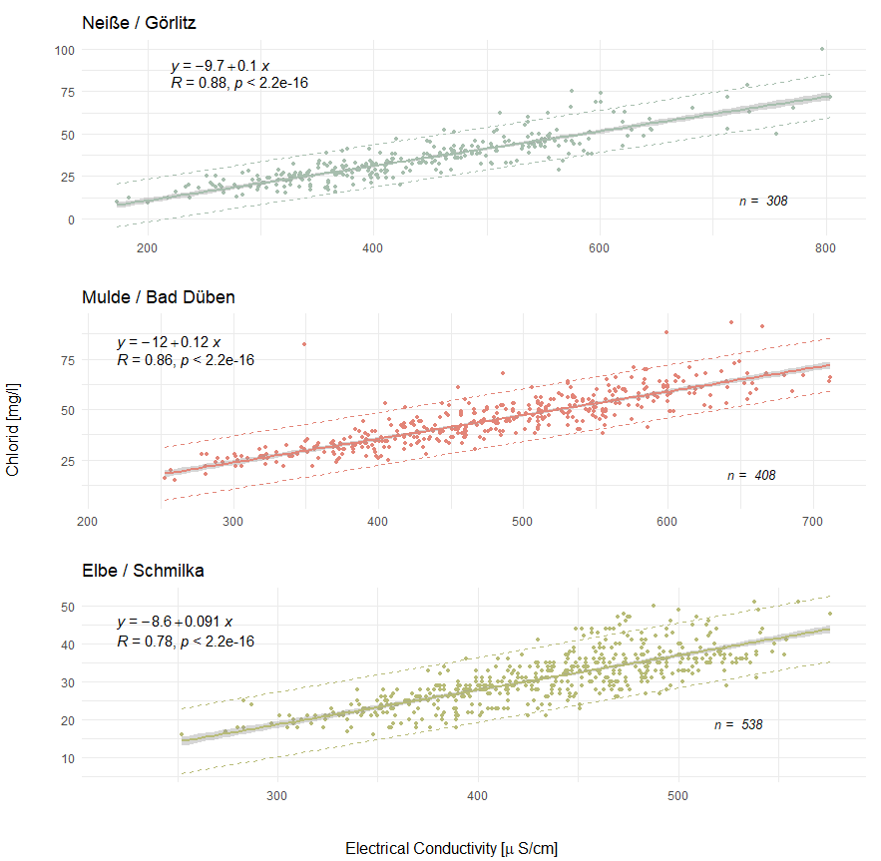
Figure 10:Linear relation between electrical conductivity and chloride concentration at Mule / Bad Düben, Lausitzer Neiße / Görlitz and Elbe / Schmilka. Shaded area: 95%-confidence interval, dashed lines: Prediction interval

Table 1: Result of 500 simulation runs of grab sampling according to OGewV rules with standard deviation. Sampling frequency were varied between once to every month to two times per year.
 | Grab sampling every month |  |  |  |  | Grab sampling every fourth month
 | Nitrate-Nitrogen [mg/l] | Chloride  [mg/l] |  |  | Dissolved Oxygen [mg/l] |  | Nitrate-Nitrogen [mg/l] |  | Chloride  [mg/l] |  | Dissolved Oxygen [mg/l]
Mulde / Bad Düben | 4.2 ± 0.1 | 41 ± 1.7 |  |  | 11.1 ± 0.3 |  | 4.2 ± 0.5 |  | 40.9 ± 4.7 |  | 11.1 ± 0.8
Elbe / Schmilka | 3.3 ± 0.1 | 30.2 ± 0.7 |  |  | 10.4 ± 0.3 |  | 3.3 ± 0.3 |  | 30.2 ± 2.1 |  | 10.4 ± 1
Neiße / Görlitz | 2.8 ± 0.1 | 35.3 ± 1.8 |  |  | 10.5 ± 0.2 |  | 2.7 ± 0.3 |  | 35.3 ± 4.8 |  | 10.5 ± 0.7
Lockwitzbach /MS6 | 7 ± 0.2 | 43 ± 2.2 |  |  | 11.2 ± 0.2 |  | 7 ± 0.8 |  | 42.9 ± 5.5 |  | 11.1 ± 0.7
Lockwitzbach /MS4 | 6.3 ± 0.3 | 41.9 ± 2.2 |  |  | 12.6 ± 0.5 |  | 6.4 ± 1 |  | 42 ± 5.9 |  | 12.5 ± 1.1
 | Grab sampling every second month |  |  |  |  | Grab sampling every fifth month
 | Nitrate-Nitrogen [mg/l] | Chloride  [mg/l] |  |  | Dissolved Oxygen [mg/l] |  | Nitrate-Nitrogen [mg/l] |  | Chloride  [mg/l] |  | Dissolved Oxygen [mg/l]
Mulde / Bad Düben | 4.2 ± 0.3 | 40.9 ± 2.9 |  |  | 11.1 ± 0.5 |  | 4.2 ± 0.6 |  | 40.9 ± 5.5 |  | 11 ± 1.1
Elbe / Schmilka | 3.3 ± 0.2 | 30.2 ± 1.2 |  |  | 10.4 ± 0.5 |  | 3.4 ± 0.4 |  | 30.3 ± 2.4 |  | 10.4 ± 1.2
Neiße / Görlitz | 2.8 ± 0.2 | 35.3 ± 2.9 |  |  | 10.5 ± 0.4 |  | 2.7 ± 0.3 |  | 35.5 ± 5.6 |  | 10.5 ± 0.9
Lockwitzbach /MS6 | 7 ± 0.4 | 43.1 ± 3.5 |  |  | 11.2 ± 0.4 |  | 7 ± 0.9 |  | 42.6 ± 6.9 |  | 11.1 ± 0.8
Lockwitzbach /MS4 | 6.3 ± 0.5 | 41.9 ± 3.7 |  |  | 12.6 ± 0.8 |  | 6.3 ± 1.1 |  | 41.5 ± 6.6 |  | 12.5 ± 1.4
 | Grab sampling every third month |  |  |  |  | Grab sampling every sixth month
 | Nitrate-Nitrogen [mg/l] |  | Chloride [mg/l] | Dissolved Oxygen [mg/l] |  | Nitrate-Nitrogen [mg/l] |  | Chloride [mg/l] |  | Dissolved Oxygen [mg/l]
Mulde / Bad Düben | 4.2 ± 0.4 | 41 ± 4 |  |  | 11.1 ± 0.7 |  | 4.2 ± 0.9 |  | 40.9 ± 6.4 |  | 11.1 ± 1.2
Elbe / Schmilka | 3.3 ± 0.2 | 30.2 ± 1.7 |  |  | 10.4 ± 0.7 |  | 3.3 ± 0.5 |  | 30.2 ± 2.6 |  | 10.4 ± 1.4
Neiße / Görlitz | 2.8 ± 0.2 | 35.3 ± 3.9 |  |  | 10.5 ± 0.6 |  | 2.7 ± 0.4 |  | 35.3 ± 6 |  | 10.5 ± 1.4
Lockwitzbach /MS6 | 7 ± 0.6 | 42.9 ± 4.5 |  |  | 11.1 ± 0.6 |  | 7 ± 1.2 |  | 42.8 ± 6.7 |  | 11.1 ± 1.1
Lockwitzbach /MS4 | 6.4 ± 0.7 | 41.8 ± 4.7 |  |  | 12.5 ± 1.1 |  | 6.4 ± 1.5 |  | 41.9 ± 7.9 |  | 12.5 ± 1.6

Table 2: Monitoring costs for STOM in Euro per year
 |  | Return interval in months
 |  | 1 | 2 | 3 | 4 | 5 | 6
Application duration in days | 1 | 8011 | 5077 | 4099 | 3610 | 3316 | 3121
 | 2 | 8011 | 5077 | 4099 | 3610 | 3316 | 3121
 | 3 | 8011 | 5077 | 4099 | 3610 | 3316 | 3121
 | 4 | 8011 | 5077 | 4099 | 3610 | 3316 | 3121
 | 5 | 8011 | 5077 | 4099 | 3610 | 3316 | 3121
 | 6 | 8011 | 5077 | 4099 | 3610 | 3316 | 3121
 | 7 | 8011 | 5077 | 4099 | 3610 | 3316 | 3121
 | 8 | 8011 | 5077 | 4099 | 3610 | 3316 | 3121
 | 9 | 10154 | 5077 | 4099 | 3610 | 3316 | 3121
 | 10 | 10154 | 5077 | 4099 | 3610 | 3316 | 3121
 | 11 | 10154 | 5077 | 4099 | 3610 | 3316 | 3121
 | 12 | 10154 | 5077 | 4099 | 3610 | 3316 | 3121
 | 13 | 10154 | 5077 | 4099 | 3610 | 3316 | 3121
 | 14 | 10154 | 5077 | 4099 | 3610 | 3316 | 3121
 | 15 | 12297 | 5077 | 4099 | 3610 | 3316 | 3121
 | 16 | 12297 | 5077 | 4099 | 3610 | 3316 | 3121
 | 17 | 12297 | 5077 | 4099 | 3610 | 3316 | 3121
 | 18 | 12297 | 5077 | 4099 | 3610 | 3316 | 3121
 | 19 | 12297 | 5077 | 4099 | 3610 | 3316 | 3121
 | 20 | 12297 | 5077 | 4099 | 3610 | 3316 | 3121
 | 21 | 14439 | 5077 | 4099 | 3610 | 3316 | 3121

