**Supplementary information**

Optimizing Flexible Microelectrode Designs for Enhanced Ef-ficacy in Electrical Stimulation Therapy

Lihong Qi 1, Ying Yu 2, Zeru Tao 3, Yongwei Jiang 1*, Mujie Liu 4, Kai Yao 4, and Yuheng Wang 4*

1 Ningbo Zhenhai People's Hospital Health Management Center;

2 AIE Institute, Guangzhou Development District;

3 Department of Otorhinolaryngology Head and Neck Surgery, Ningbo Urology and Nephrology Hospital;

4 Faculty of Electrical Engineering and Computer Science, Health Science Center, Ningbo University;

* Correspondence: nano.plasma.uv@gmail.com; Professor Yuheng Wang

Lihong Qi, Ying Yu, and Zeru Taoare Consistent contribution, co authored.

**Note S1. Electrical modelling of simplified multi-layer flexible microelectrodes -hydrogel-epidermis system (FHES)**

The charge migrates from the Ag-Cu coverings (ACCs) to hydrogel and then to the skin surface (epidermis). According to Ampere circuit rule and Gauss’s law in Maxwell’s equations, the current continuity equation can be deduced as follows:



Where  is the current density in the medium and  is the charge density.

In the domain with external charge input, Poisson equationis introduced to describe the relationship between potential distribution and external charge density. For example, external current and charge transportation exist in the metal wire lead-out.



Where  is electric potential,  the permittivity of the vacuum,  the relative permittivity of Ag (Because the dense copper layer is electroplated on the surface of the silver grid).

In other domains without external charge input, Poisson's equationcan be simplified as Laplace's equation.



Constitutive relationship between current density and electric fieldcan be described as



Where  is the conductivity of medium. Conductivity differs between skin, hydrogel and PET. The internal conductivity of hydrogel also shows differences due to the non-uniform doping components inside.

Electric field  is defined in terms of the applied voltage 



As for the boundary conditions, a constant voltage of 1 V is applied to the output of the ACCs’ lead. The lower bottom surface of the PET substrate is in contact with air, and the air conductivity tends to 0, so the interface is approximated as an insulating surface. The distal end of the skin is approximated as having no charge movement and a potential of 0, which is approximated as grounded.

With the above equation to and boundaries, we obtain the distribution of electric potential, electric field as well as resistive loss using finite element analysis of COMSOL.

**Note S2. Structural mechanics modelling of FMs**

Newton's second law of motion can be expressed as



Considering the steady-state equilibrium conditions and neglect the intermediate process, the equation can be simplified as



Where  is internal stress and  is external force per unit volume applied to the system.

Stress and strain can be expressed by 3x3 matrix



  Equation of strain compatibilityis introduced to describe the relationship between strain and displacement.



We assume that both materials forming the FMs and skin are linear elastic materials. Consequently, according to Hooke’s lawand connection between elastic moduluswe obtain that



Also, the initial condition of displacement and external force that applied are given in equation. The initial displacement and velocity of the electrode is 0. The entire lower surface of the electrode is subjected to an external force of magnitude along the z-axis upward. In addition, the long side of the electrode can be deformed and displaced, while the short side is fixed and the displacement is constant to zero.



With equations above and initial conditions given, we obtain the corresponding distribution of stress and displacement in steady state, which is effective to evaluate the flexibility of bioelectrode.

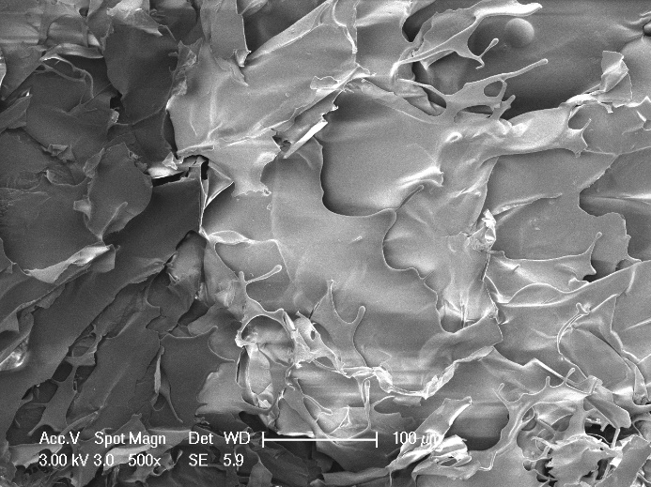

**Fig. S1.** Images of PPY@PDA/PANI (3/6) hydrogel under an electron microscope.



**Fig.S2.** (a)~(c) Normalized resistive loss distribution of the hexagonal, cross-shaped and serpentine FHES. (d)~(f) Corresponding partial longitudinal section distribution of the hexagonal, cross-shaped and serpentine FHES.



**Fig.S3.** (a)~(c) Normalized electric potential distribution of the hexagonal, cross-shaped and serpentine FHES. (d)~(f) Normalized electric field distribution of the hexagonal, cross-shaped and serpentine FHES.



**Fig.S4.** (a) Hydrogel showed a dispersed resistive loss distribution due to the random doping which also had an impact on the distribution in the epidermis. (b) Hydrogel also showed a dispersed electric field distribution. (c) The voltage distribution does not show an obviously dispersed distribution in hydrogel and epidermis, because the voltage is an integral of the potential and the discrete type is greatly reduced. Therefore, the voltage is minimally affected by non-uniform doping.