Table S1 Free amino acid content of straw mushroom enzymatic digest
Amino acids | Content（mg/ml）
 | Monoenzyme | Dual Enzyme | Trienzyme
Asp | 0.0862±0.01^{b} | 0.0856±0.02^{b} | 0.1091±0.01ª
Glu | 0.4301±0.02^{c} | 0.4412±0.01^{b} | 0.5425±0.03ª
Ser | 0.0310±0.01^{b} | 0.0290±0.02^{c} | 0.0422±0.01ª
His | 0.0467±0.01ª | 0.0412±0.01ª | 0.0550±0.01^{b}
Gly | 0.0503±0.01^{c} | 0.0547±0.01^{b} | 0.0604±0.01ª
Thr | 0.1695±0.01^{b} | 0.1567±0.01^{b} | 0.1871±0.01ª
Arg | 0.2386±0.02^{b} | 0.2113±0.01^{b} | 0.2574±0.01ª
Ala | 0.2208±0.01ª | 0.2124±0.01ª | 0.2590±0.01ª
Tyr | 0.1561±0.01^{b} | 0.1401±0.01^{c} | 0.1580±0.01ª
Cys | 0.0084±0.01ª | 0.0020±0.01^{b} | 0.0151±0.01ª
Val | 0.1494±0.01ª | 0.1373±0.01^{c} | 0.1624±0.01^{b}
Met | 0.0449±0.01ª | 0.0177±0.02^{b} | 0.0295±0.01^{b}
Phe | 0.2013±0.01ª | 0.1523±0.01^{b} | 0.1777±0.01ª
Ile | 0.1624±0.02ª | 0.1410±0.01ª | 0.1688±0.02ª
Leu | 0.2887±0.03ª | 0.1778±0.01^{b} | 0.2106±0.01ª
Lys | 0.2185±0.01^{b} | 0.1992±0.01^{b} | 0.2393±0.01ª
Pro | 0.0498±0.01^{b} | 0.0568±0.01^{b} | 0.0635±0.01ª
Total | 2.5526±0.02 ^{b} | 2.2563±0.06 ^{c} | 2.7377±0.05 ª
Note: Using a one-way ANOVA, the same letter of the marker indicates that there is no statistical difference between the amounts of free amino acids obtained using different enzymatic methods (p>0.05).

Table S2 Results of the peptide molecular weight distribution
Peptide molecular mass/Da | Mass fraction /%
 | Monoenzyme | Dual Enzyme | Trienzyme
<500 | 85.70±0.02^{c} | 86.33±0.03^{b} | 87.01±0.02ª
500-1000 | 8.77±0.02ª | 8.54±0.01^{b} | 8.69±0.02^{c}
1000-3000 | 4.33±0.01^{c} | 4.08±0.01^{b} | 3.31±0.02ª
>3000 | 1.19±0.01^{c} | 1.06±0.01^{b} | 0.99±0.02ª
Note: Using one-way ANOVA, the different letters of the markers indicate statistical differences in the content of peptides of different molecular weights obtained using different enzymatic digestion methods (p>0.05).

Table S3 The parameters of the power functions and the relationship between the natural logarithmic salt concentration and the natural logarithmic intensity of saltiness.
Control | A1 | A2 | A3
y=1.21483x+0.682 | y=1.0736x+1.06555 | y=0.9207x+1.47065 | y=1.04752x+1.15109
（R²=0.95546） | （R²=0.97125） | （R²=0.98241） | （R²=0.97629）

Table S4 The dose-response relationship of three synthetic peptides on saltiness intensity of 0.5g/L NaCl solution
VP10+0.5g/L NaCl |  | YN9+0.5g/L NaCl |  | DF8+0.5g/L NaCl
VP10  (mM) | saltiness intensity | YN9  (mM) | saltiness intensity | DF8  (mM) | saltiness intensity
0 | 1 | 0 | 1 | 0 | 1
0.2 | 2.0±0.1^{b} | 0.2 | 1.5±0.1ª | 0.2 | 7.5±0.3^{b}
0.4 | 4.5±0.1^{b} | 0.4 | 2.5±0.3ª | 0.4 | 8.0±0.4^{c}
0.8 | 6.5±0.3^{b} | 0.8 | 5.0±0.1ª | 0.8 | 8.5±0.6^{c}
1.6 | 7.8±0.4^{c} | 1.6 | 6.5±0.1ª | 1.6 | 7.0±0.4^{b}
3.2 | 8.0±0.2^{c} | 3.2 | 1.2±0.3ª | 3.2 | 2.5±0.5^{b}
Note: Using one-way ANOVA, the different letters of the markers indicate statistical differences in the content of peptides of different molecular weights obtained using different enzymatic digestion methods (p>0.05).

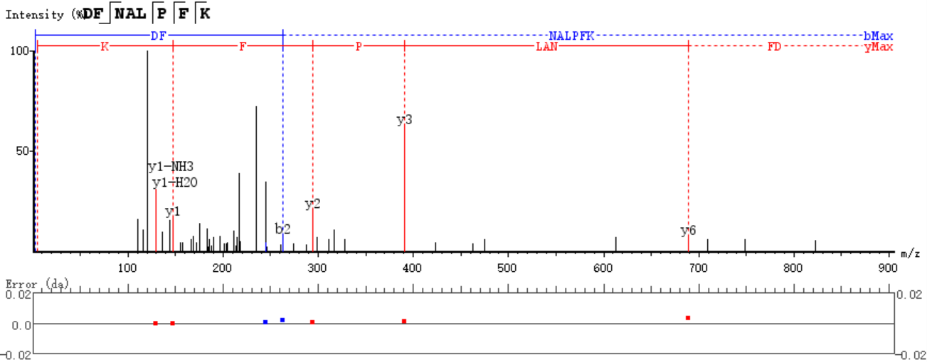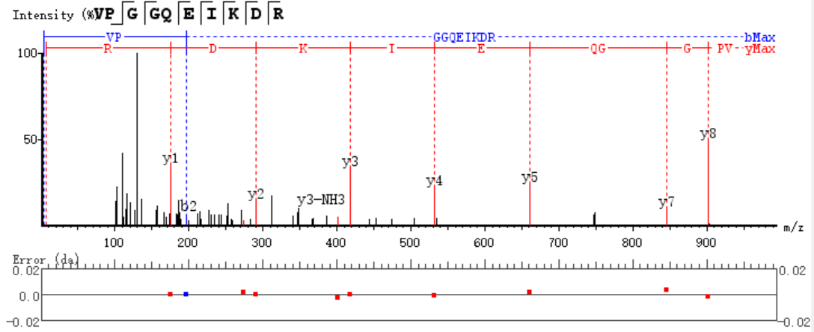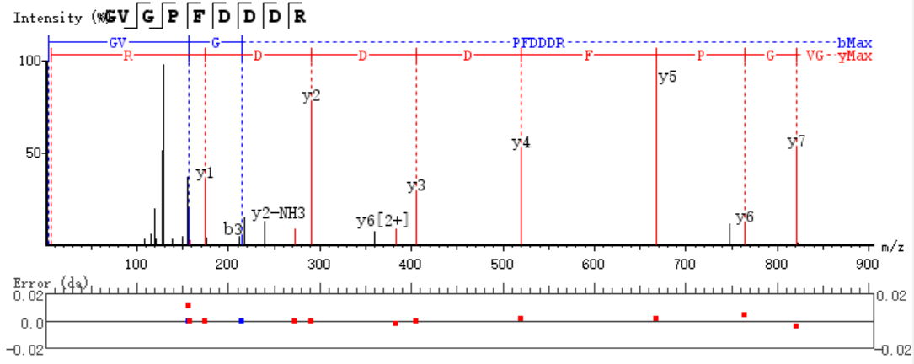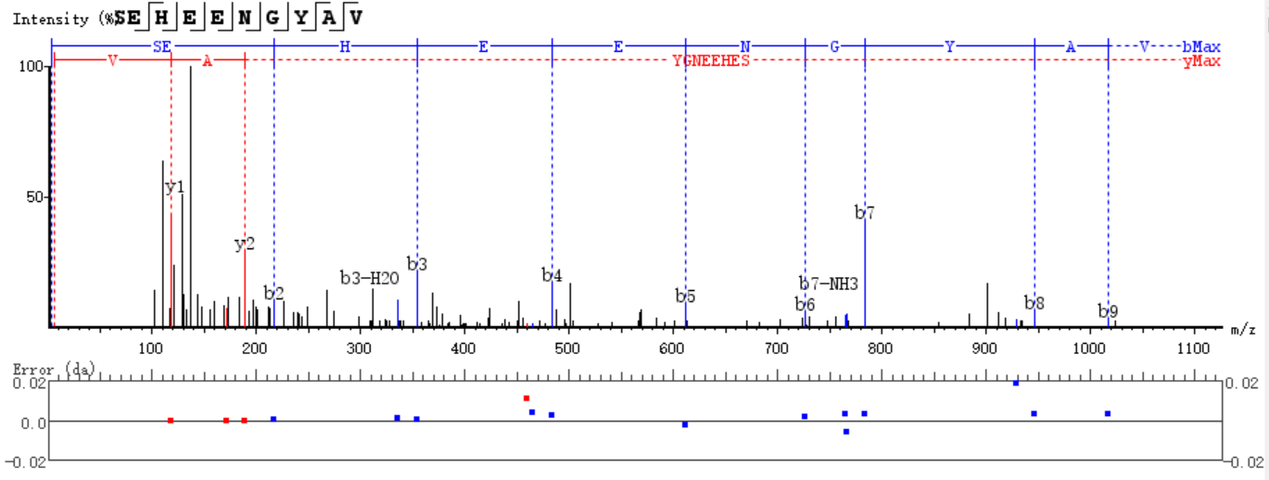
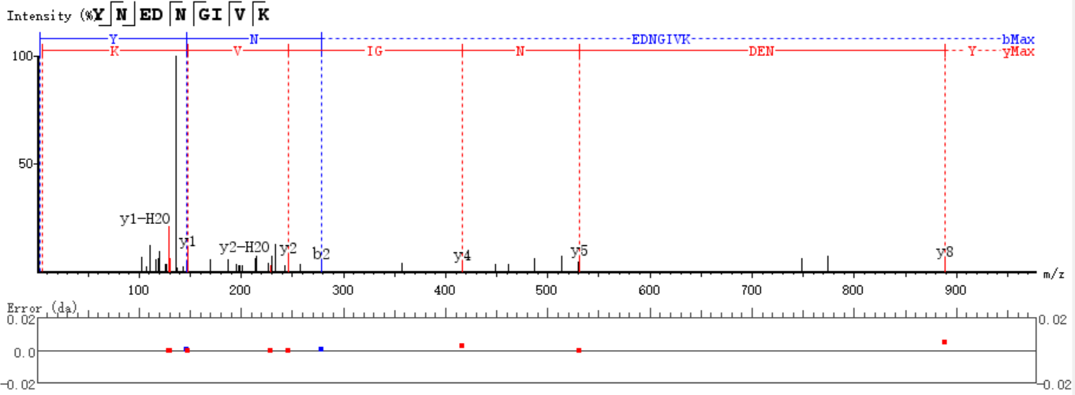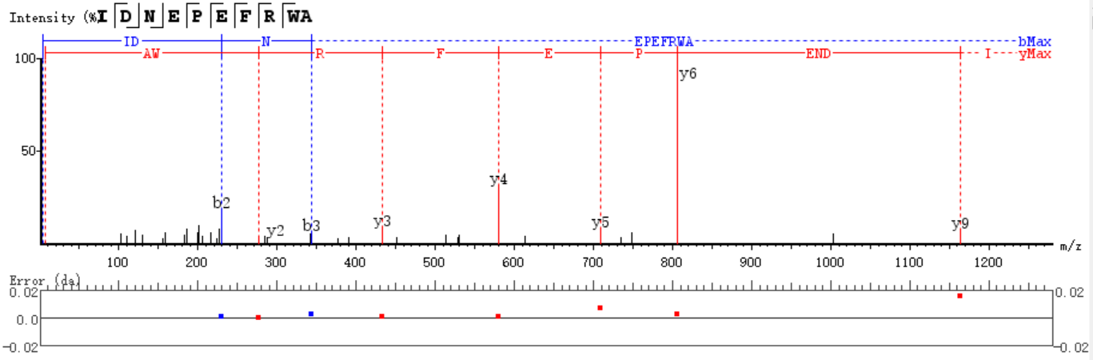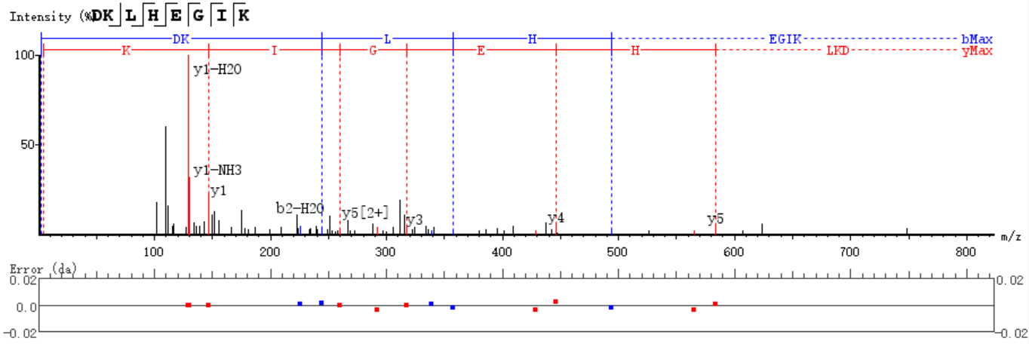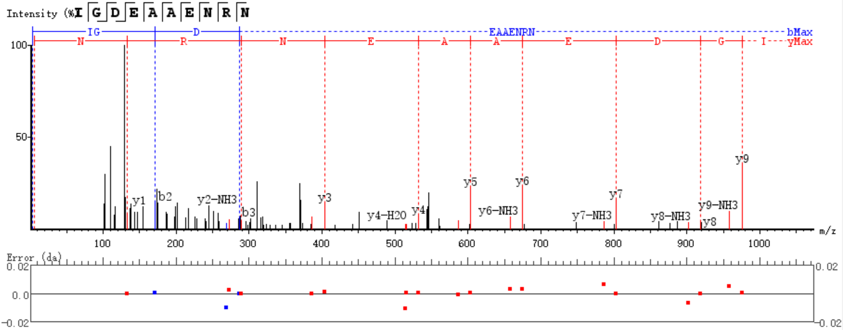Figure S1. MS/MS spectra of DFNALPFK (m/z 574.25, A), VPGGQEIKDR (m/z 366.87, B), GVGPFDDDR (m/z 489.22, C), SEHEENGYAV (m/z 567.75, D), YNEDNGIVK (m/z 526.26, E), IDNEPEFRWA (m/z 638.81, F), DKLHEGIK (m/z 313.85, G), and IGDEAAENRN (m/z 544.75, H). The y and b ions refer to fragment ions of each peptide.

