SUPPLEMENTARY MATERIALS
for article
Evaluation and modeling of PLA photodegradation under UV irradiation: Bio-based polyester photolysis mechanism
Sergei Lomakin, Yurii Mikheev, Sergey Usachеv, Svetlana Rogovina, Lubov Zhorina, Evgeniya Perepelitsina, Irina Levina, Olga Kuznetsova, Natalia Shilkina, Alexey Iordanskii and Alexander Berlin
The procedure of GPC (Gel Permeation Chromatography) peaks’ deconvolution was carried out by means of NETZSCH Peak Separation 2006.01 program employing the nonlinear regression method for asymmetric M_{w} peaks (Fraser-Suzuki algorithm) [36]. In calculation, the least squares (SLS) reduction was achieved using a hybrid procedure in which the LEVENBERG/MARQUARDT method was combined with step length optimization [J [38].
a | b
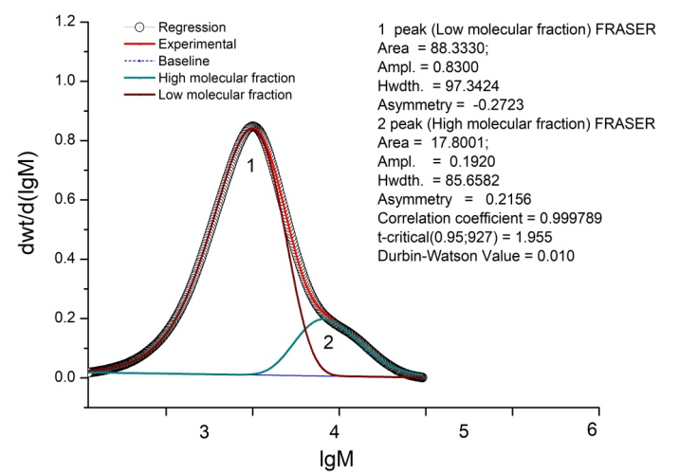 | 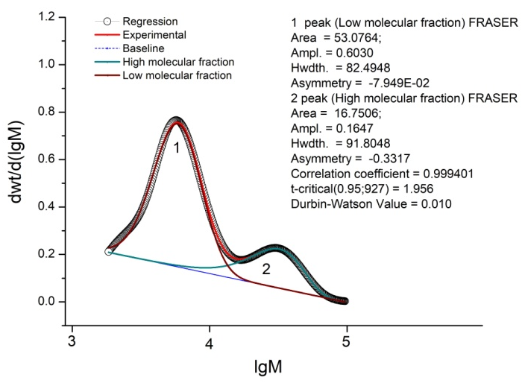
Figure S1. Deconvolution results of the ln(M_{w}) curves for PLA-24 (a) and PLA-144 (b).

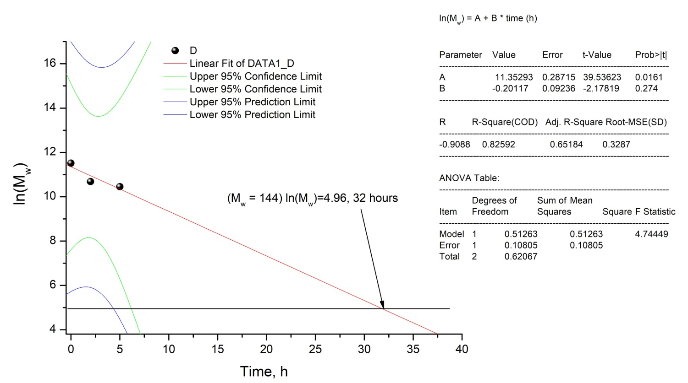
Figure S2. Kinetic analysis of PLA photodegradation.

NMR spectra of initial PLA and PLA after 144 hours of UV irradiation
Figure S3. ¹H NMR spectrum of neat PLA (500.18 MHz, CDCl₃). δ ,ppm: 1,60 (3H, CH₃); 5,19 (1H, CH); 4,38 (1H, CH).

Figure S4. ¹H NMR spectrum of PLA after 144 hours of UV irradiation (500.18 MHz, CDCl₃).
δ, ppm: 1.60 (3H, CH₃); 5.19 (1H, CH); 4.38 (1H, CH); 5.91, 6.21, 6.52 (CH₂=CH-).

500 MHz (H, H) COZY Spectrum of PLA after 144 hours of UV irradiation
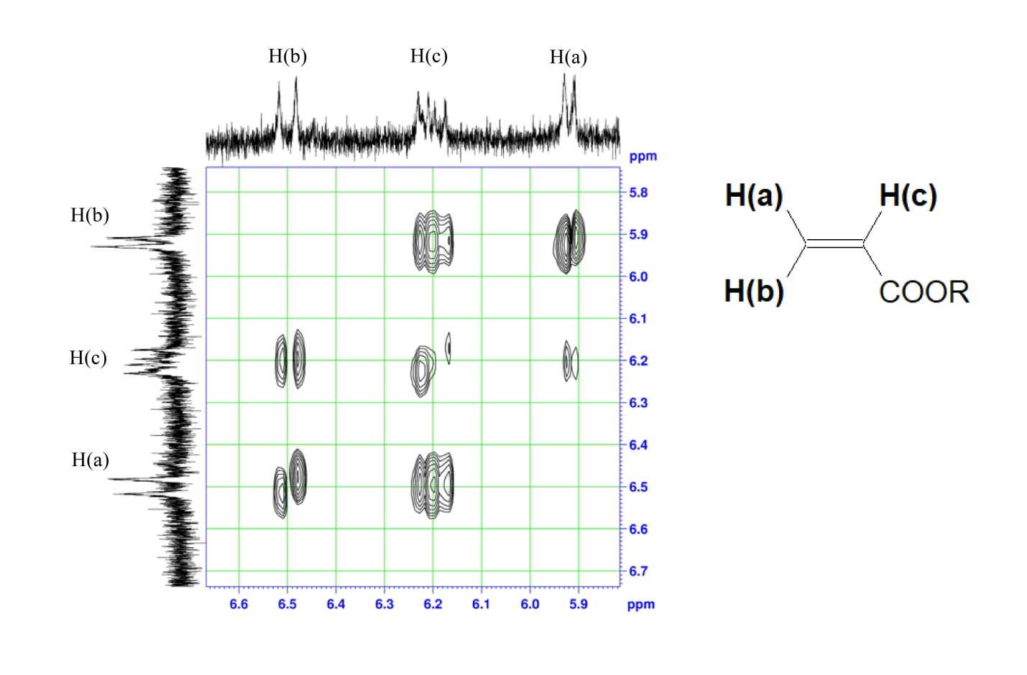
Figure S5. COZY (H, H) spectrum of PLA after 144 hours of UV irradiation. ²J_{H(a)H(b)}=1.5 Hz, ³J_{H(b)H(c)}=17,0 Hz and ³J_{H(a)H(c)} =10.0 Hz.

