Supporting Information

Impact of Copolymer Architecture on Demicellization and Cargo Release via Head-to-Tail Depolymerization of hydrophobic moieties.

Christos Gioldasis¹, Apostolos Gkamas¹ and Costas Vlahos^{1*}
¹ Chemistry Department, University of Ioannina, 45110 Ioannina, Greece

Table 1S. The number of encapsulated cargo molecules in micelles formed from mixtures containing 1000 linear or miktoarm copolymer chains with 2000 or 4000 cargo molecules C_{3.} The different interaction parameters between hydrophobic C-C and B-C beads correspond to T*=1.8,1.6, and 1.4. [Φ]=0.12.
 | Total C₃ | encapsulated C₃ | Ratio
A₃₀B₃₀, T*_{B} = 1.8  T*_{C} = 1.8, T*_{B-C} = 1.8 | 2000 | 816 | 0.408
A₃₀B₃₀, T*_{B} = 1.8  T* _{C} = 1.6, T* _{B-C} = 1.8 | 2000 | 841 | 0.421
A₃₀B₃₀, T*_{B} = 1.8  T* _{C} = 1.5, T* _{B-C} = 1.8 | 2000 | 860 | 0.430
A₃₀B₃₀, T*_{B} = 1.8  T* _{C} = 1.4, T* _{B-C} = 1.8 | 2000 | 863 | 0.432
A₃₀B₃₀, T*_{B} = 1.8  T* _{C} = 1.4, T* _{B-C} = 1.4 | 2000 | 1662 | 0.831
A₃₀(B₁₅)₂, T*_{B} = 1.8  T* _{C} = 1.4, T* _{B-C} = 1.4 | 2000 | 1651 | 0.826
A₃₀(B₁₀)₃, T*_{B} = 1.8  T* _{C} = 1.4, T* _{B-C} = 1.4 | 2000 | 1625 | 0.812
A₃₀B₃₀, T*_{B} = 1.8  T* _{C} = 1.4, T* _{B-C} = 1.4 | 4000 | 3284 | 0.821

Table 2S. The preferential aggregation number (N_{p}), the mean squared radius and gyration (<R_{g}²>), and the shape asymmetry parameter (κ²) of micelles formed by A₃₀B₃₀, A₃₀(B₁₅)₂ and A₃₀(B₁₀)₃ copolymers, and from their mixtures with 2000 C₃ cargo molecules.
 | N_{p} | <R_{g}²> | κ²
A₃₀B₃₀ | 44 | 115.5 ± 0.2 | 0.0162 ± 0.0009
A₃₀B₃₀ + C₃ | 51 | 126.8 ± 0.3 | 0.0126 ± 0.0006
A₃₀(B₁₅)₂ | 30 | 91.4 ± 0.2 | 0.031 ± 0.001
A₃₀(B₁₅)₂ + C₃ | 39 | 108.4 ± 0.2 | 0.025 ± 0.001
A₃₀(B₁₀)₃ | 23 | 82.1 ± 0.3 | 0.049 ± 0.002
A₃₀(B₁₀)₃ + C₃ | 31 | 97.9 ± 0.4 | 0.041 ± 0.002

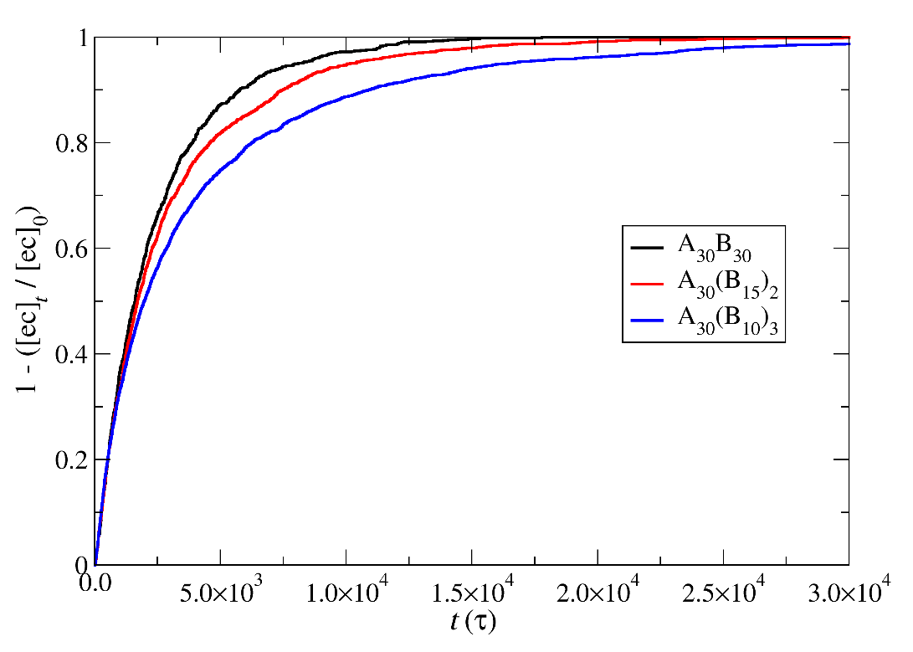
Figure 1S Depolymerization fraction of end cap beads of A₃₀B₃₀, A₃₀(B₁₅)₂, and A₃₀(B₁₀)₃ copolymers as a function of time for constant trigger molecules concentration. RP_{T}=10⁻², RP_{B}=10⁻³. [ec]₀ is the initial end cap beads concentration, [ec]_{t} is the end cap concentration.
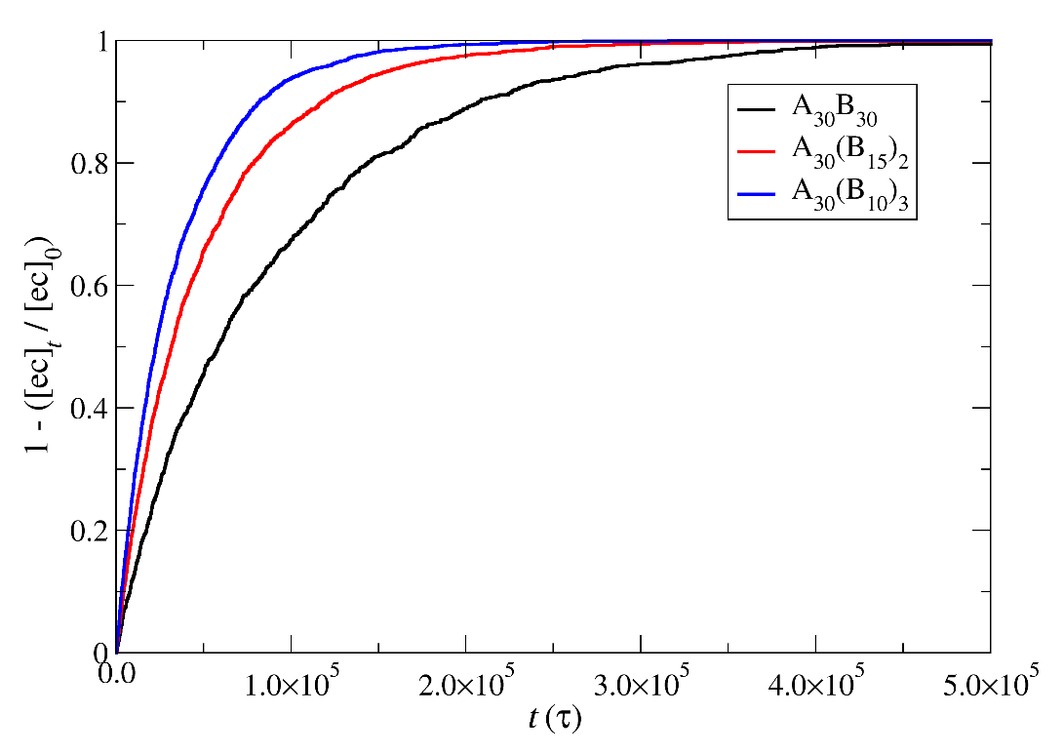
Figure 2S Depolymerization fraction of end cap (ec) beads of A₃₀B₃₀, A₃₀(B₁₅)₂, and A₃₀(B₁₀)₃ copolymers as a function of time for 10 times the stoichiometric trigger molecules concentration. RP_{T}=10⁻⁴, RP_{B}=10⁻³. [ec]₀ is the initial end cap beads concentration, [ec]_{t} is the end cap concentration.

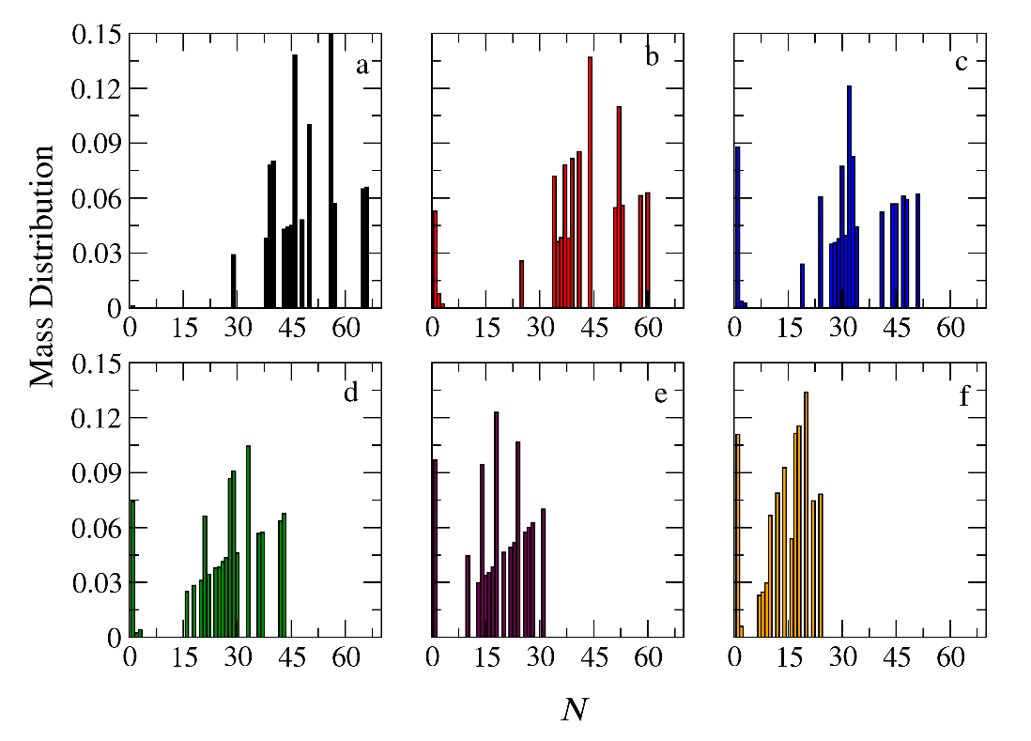
Figure 3S Mass distribution of micelles formed by linear A₃₀B₃₀ copolymers across various time points and depolymerization fractions of all hydrophobic beads: a) t=0, 0, b) t=9100τ, 0.17, c) t=13500τ, 0.32, d) t=18000τ, 0.44, e) t= 27000τ, 0.61, f) t= 36500τ, 0.74. The trigger molecule concentration is maintained constant in all cases. RP_{T}=RP_{B}=10⁻³.

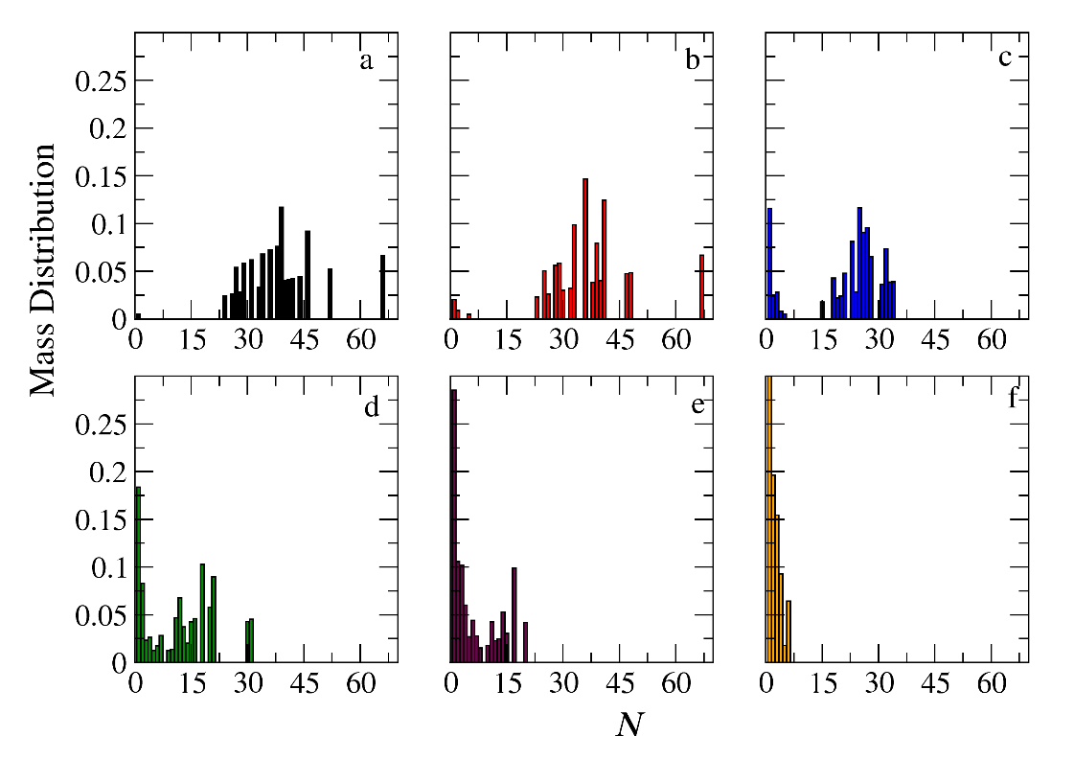
Figure 4S Mass distribution of micelles formed by miktoarm A₃₀(B₁₅)₂ copolymers across various time points and depolymerization fractions of all hydrophobic beads: a) t=0, 0, b) t=4500τ, 0.10, c) t=9000τ, 0.24, d) t=18000τ, 0.45, e) t= 27000τ, 0.59, f) t= 45000τ, 0.76. The trigger molecule concentration is maintained constant in all cases. RP_{T}= RP_{B}=10⁻³.
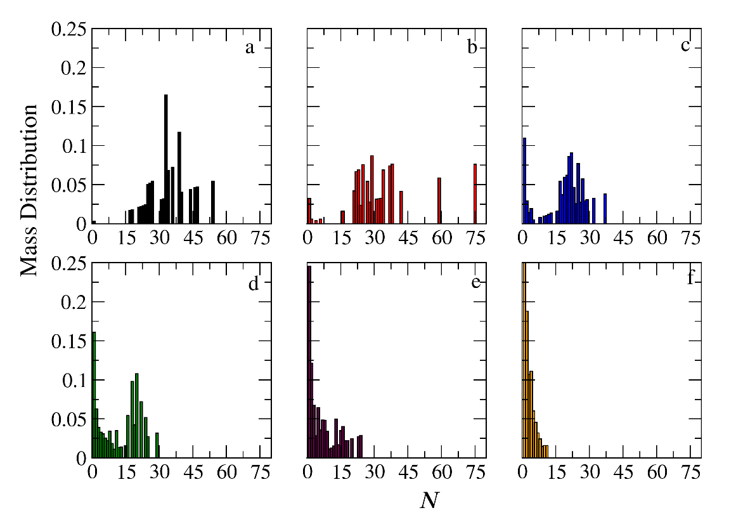
Figure 5S Mass distribution of micelles formed by miktoarm A₃₀(B₁₀)₃ copolymers across various time points and depolymerization fractions of all hydrophobic beads: a) t=0, 0, b) t=4500τ, 0.11, c) t=13500τ, 0.34, d) t=22500τ, 0.49, e) t= 36000τ, 0.63, f) t= 63000τ, 0.76. The trigger molecule concentration is maintained constant in all cases. RP_{T}=RP_{B}=10⁻³

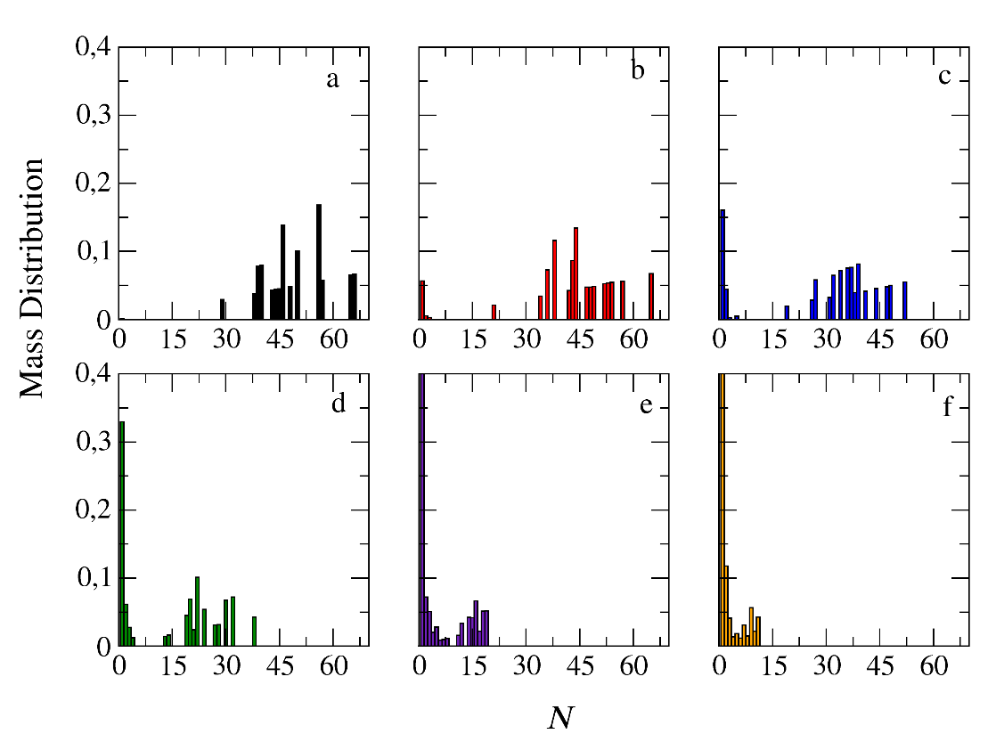
Figure 6S Mass distribution of micelles formed by linear A₃₀B₃₀ copolymers across various time points and depolymerization fractions of all hydrophobic beads: a) t=0, 0, b) t=4500τ, 0.27, c) t=6000τ, 0.41, d) t=7500τ, 0.55, e) t= 9000τ, 0.68, f) t= 10500τ, 0.80. The trigger molecule concentration is maintained constant in all cases. RP_{T}=10⁻² and RP_{B}=10⁻³.

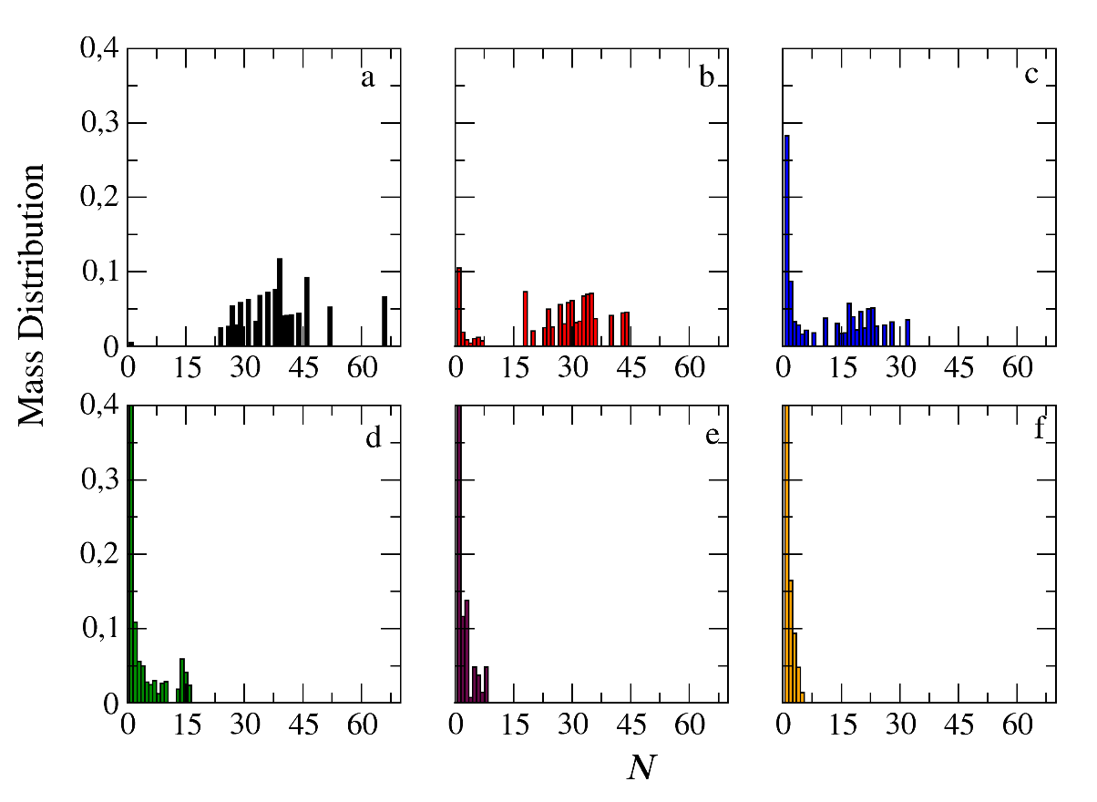
Figure 7S Mass distribution of micelles formed by miktoarm A₃₀(B₁₅)₂ copolymers across various time points and depolymerization fractions of all hydrophobic beads: a) t=0, 0, b) t=3000τ, 0.30, c) t=4000τ, 0.45, d) t=6000τ, 0.67, e) t= 7500τ, 0.78, f) t= 9000τ, 0.86. The trigger molecule concentration is maintained constant in all cases. RP_{T}=10⁻² and RP_{B}=10⁻³.

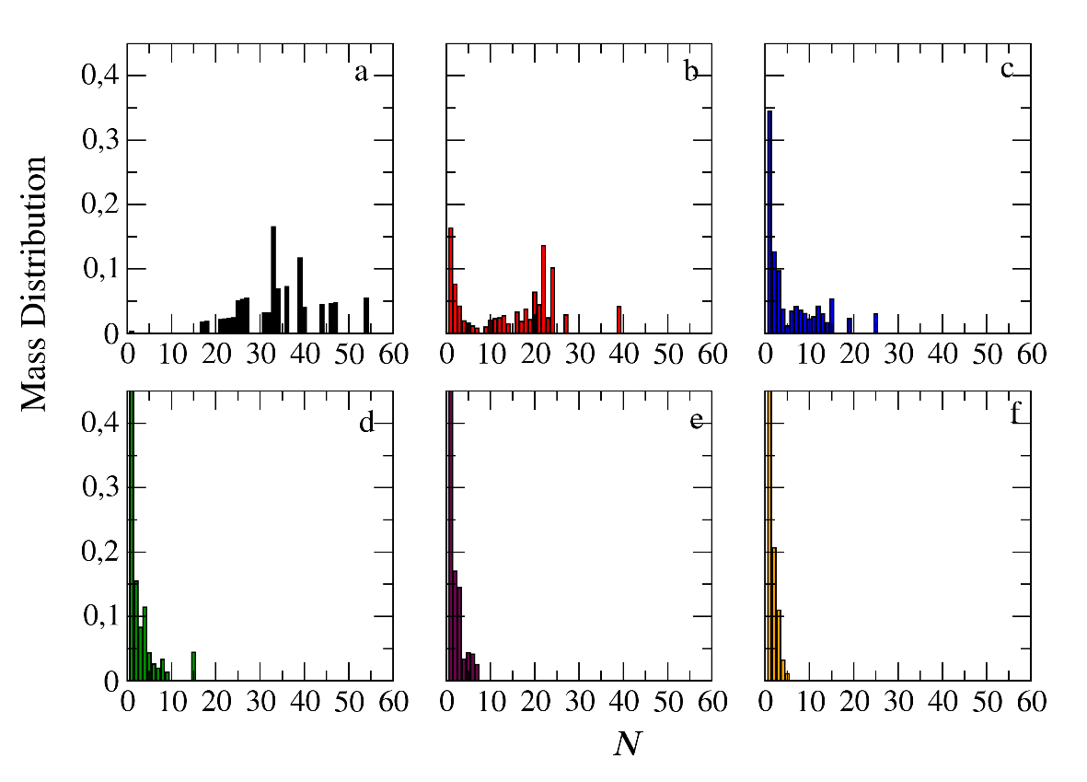
Figure 8S Mass distribution of micelles formed by miktoarm A₃₀(B₁₀)₃ copolymers across various time points and depolymerization fractions of all hydrophobic beads: a) t=0, 0, b) t=3000τ, 0.37, c) t=4500τ, 0.56, d) t=6000τ, 0.68, e) t= 7500τ, 0.74, f) t= 9000τ, 0.80. The trigger molecule concentration is maintained constant in all cases. RP_{T}=10⁻² and RP_{B}=10⁻³.

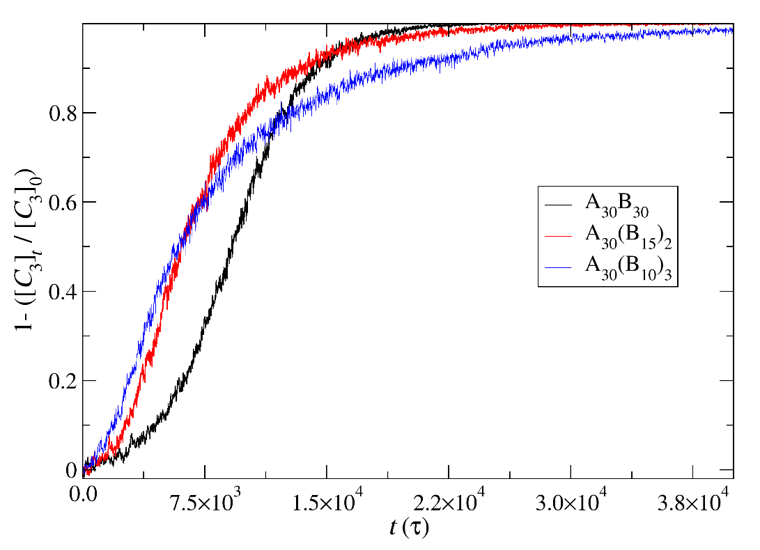a
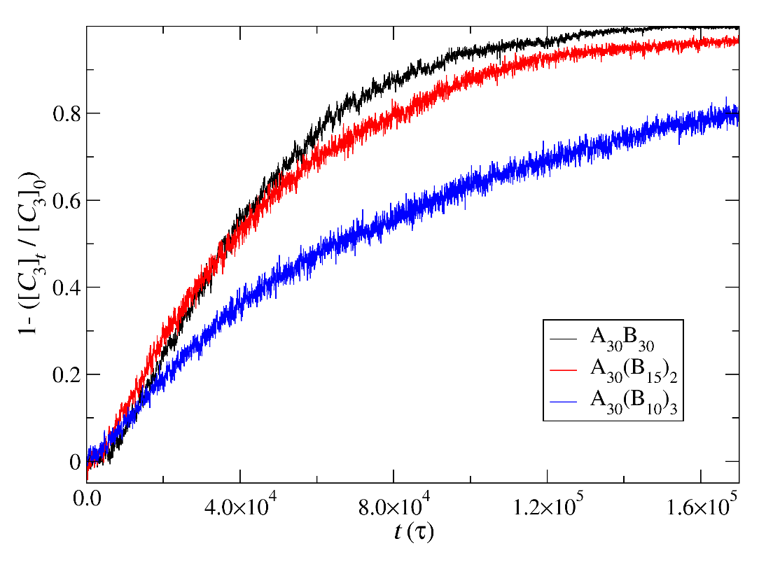b
Figure 9S Cargo molecules release fraction from A₃₀B₃₀, A₃₀(B₁₅)₂, and A₃₀(B₁₀)₃ copolymer mixtures plotted against time for constant trigger molecule concentration. a) RP_{T}=10⁻², RP_{B}=10⁻³ and b) RP_{T}=10⁻³ and RP_{B}=10⁻³. [C₃]₀ is the initial cargo molecules concentration, [C₃]_{t} is the cargo molecules concentration.
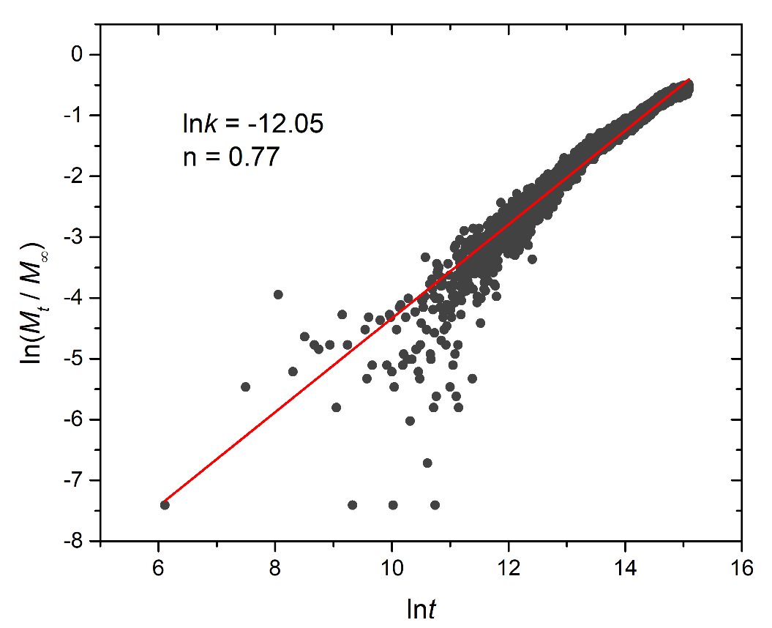a
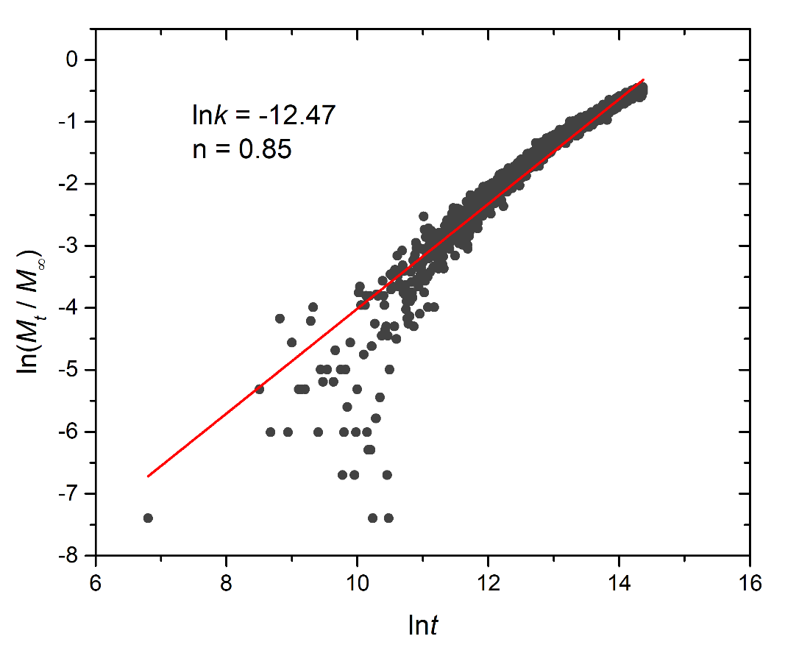b
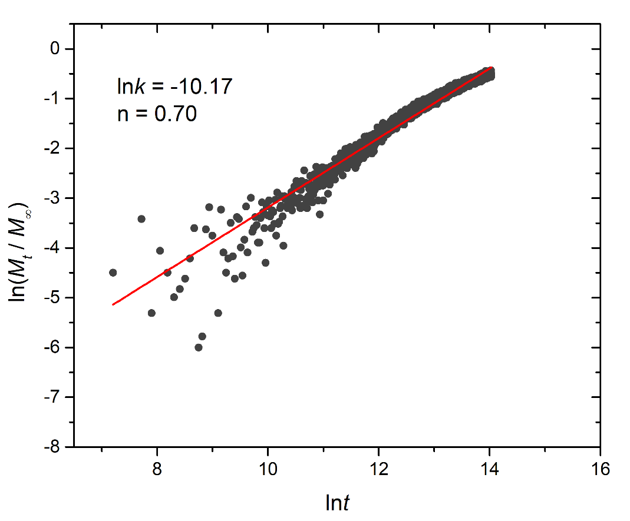c
Figure 10S Logarithmic plot depicting the fraction of released cargo molecules against time for a) linear A₃₀B₃₀, b) miktoarm A₃₀(B₁₅)₂, and c) miktoarm A₃₀(B₁₀)₃ copolymers. Fitting lines, k and n correspond to the Korsmeyer-Peppas equation. Trigger molecule concentration is maintained stoichiometric to end cap beads in all cases. RP_{T}=10⁻⁴ and RP_{B}=10⁻³.

