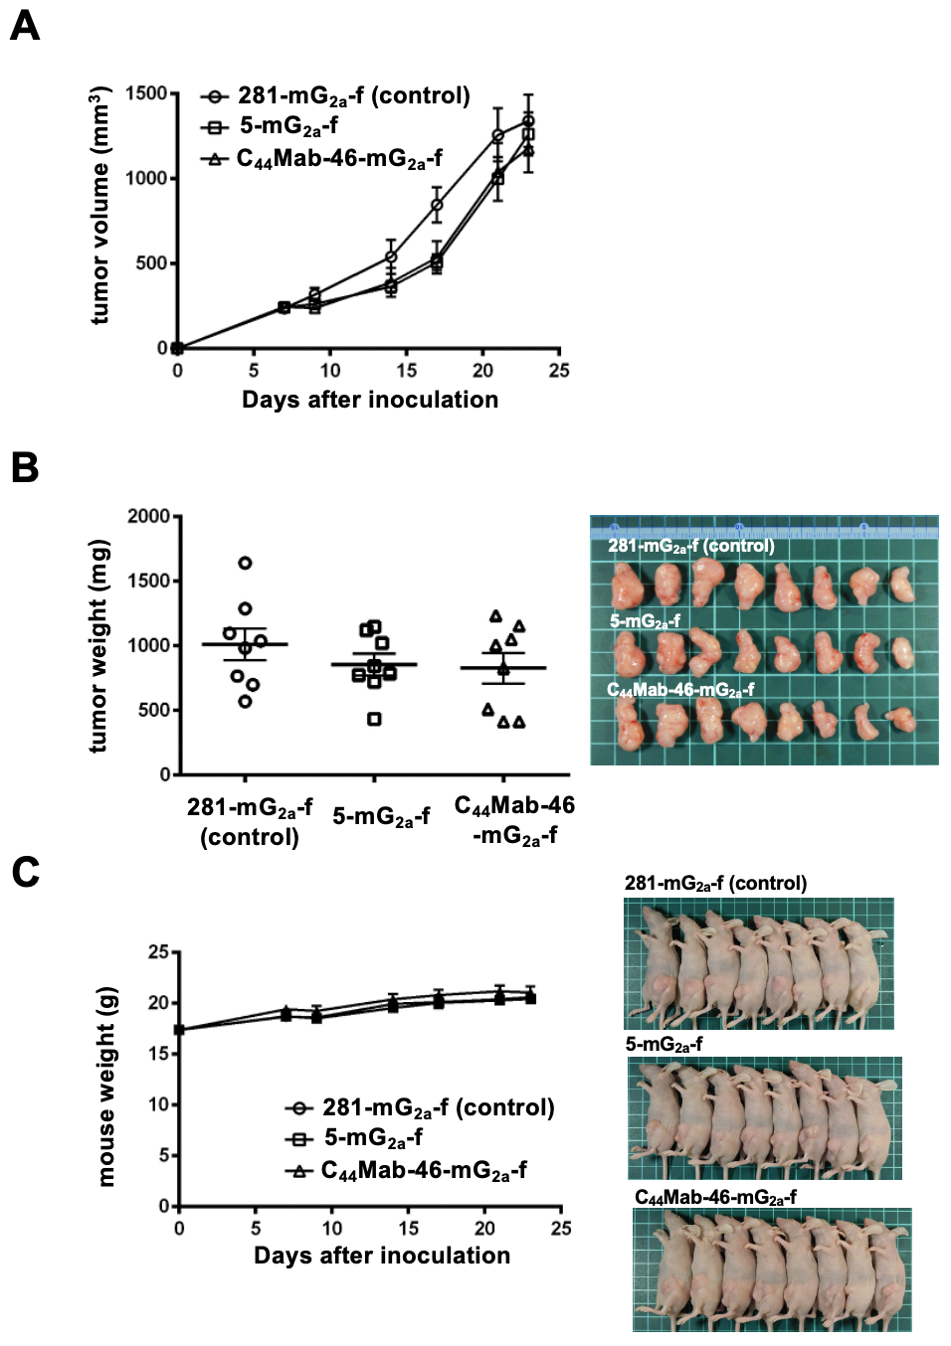
Supplementary figure 1. Antitumor activity of 5-mG_{2a}-f and C₄₄Mab-46-mG_{2a}-f against KYSE770 xenograft (low dosage). (A) Measurement of tumor volume in KYSE770 xenograft. KYSE770 cells (5 × 10⁶ cells) were injected into mice subcutaneously. On day 7, 100 μg of 5-mG_{2a}-f and C₄₄Mab-46-mG_{2a}-f or control mouse IgG_{2a} (281-mG_{2a}-f) were injected into mice intraperitoneally. On days 14 and 21, additional antibodies were injected. On days 7, 9, 14, 17, 21, and 23 following the inoculation, the tumor volume was measured. Values are presented as the mean ± SEM. There is no significant difference (ANOVA and Sidak’s multiple comparisons test). (B) The weight (left) and appearance (right) of the excised KYSE770 xenografts. The weight was measured on day 23. Values are presented as the mean ± SEM. There is no significant difference (Two-tailed unpaired t-test). (C) The body weight (left) and appearance (right) of control mouse IgG_{2a,} 5-mG_{2a}-f, and C₄₄Mab-46-mG_{2a}-f-treated mice.

