Supplementary Material
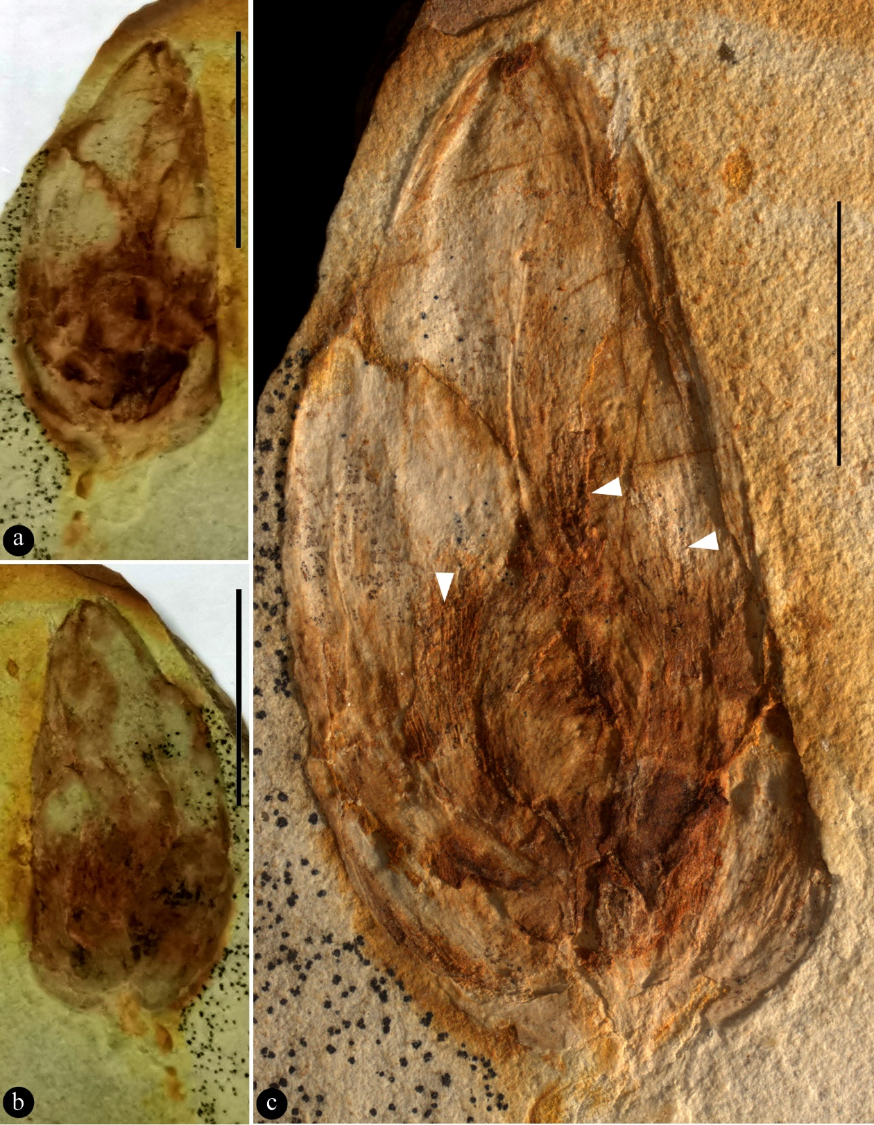
Figure S1. More information of Archaebuda cretaca sp. nov. a-b. Two facing parts of the same specimen. Scale bar = 10 mm. c. Enlargement showing details of the flower bud. Note variable textures distinguish one petal from another. Possible androecium is marked with white triangles. Scale bar = 5 mm.

