Bowman-Birk inhibitor mutants of soybean generated by CRISPR-Cas9 reveal drastic reductions in trypsin and chymotrypsin inhibitor activities
Won-Seok Kim ¹, Jason D. Gillman ², Sunhyung Kim³, Junqi Liu ⁴, Madhusudhana R. Janga⁵ , Robert M. Stupar⁶, Hari B. Krishnan ^{7*}

Supplementary Materials

Figure S1. Gene expression of BBi genes in soybean. Data is repurposed from Severin et al. [20] using data housed on https://soybase.org/soyseq/. This RNAseq data was obtained from plant P-C609-45-2-2, a BC5F5 plant which was heterozygous for a seed protein QTL introgression from a G. soja (PI468916) into a G. max (A81-356022).
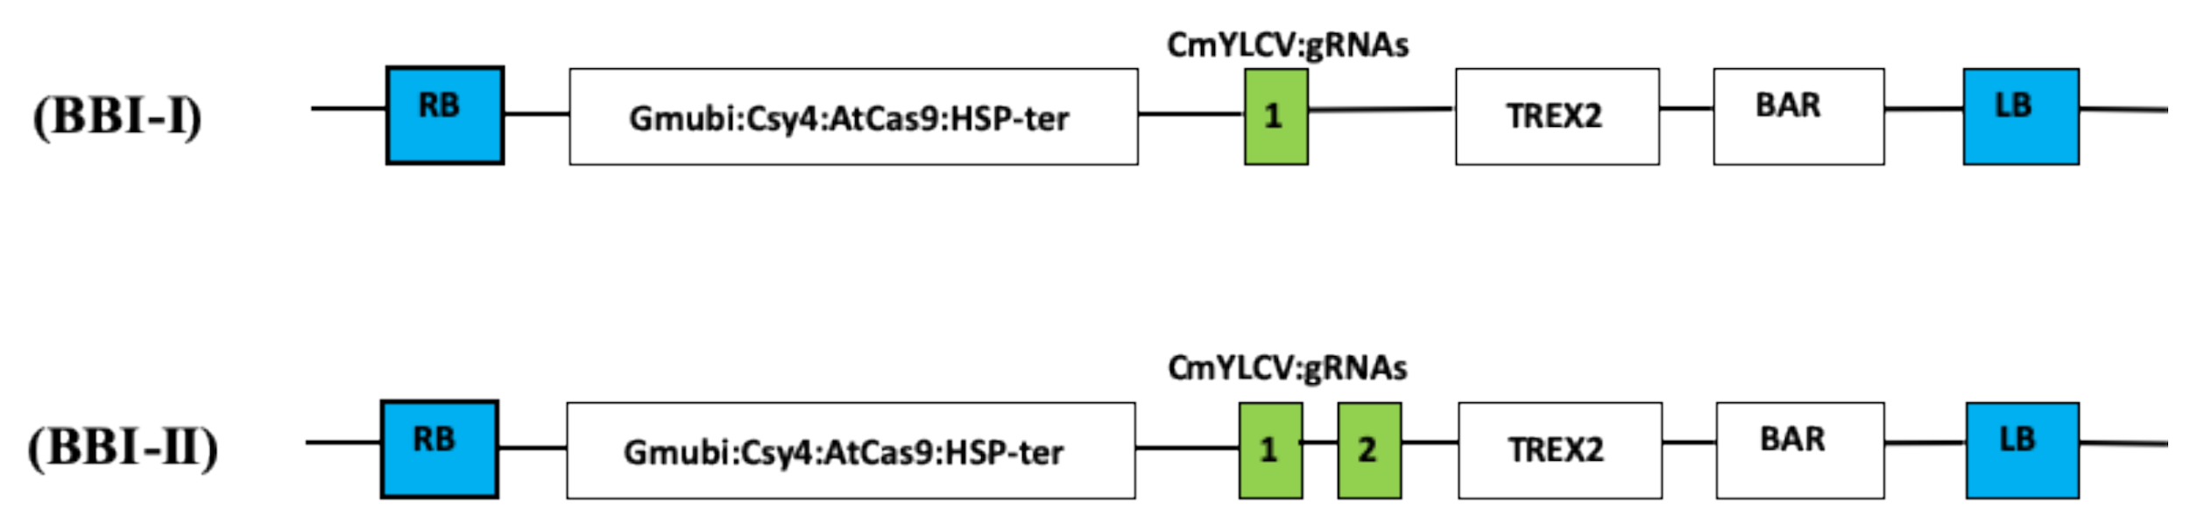
Figure S2. CRISPR-Cas9 cassettes targeting BBi genes. Events 5 was created using the BBi-II CRISPR-Cas9 construct and all other events were created through use of the BBi-I CRISPR-Cas9 construct.

Figure S3. Sequencing traces for Glyma.16g208900 and Glyma.14G117700.

Table S1. Primers used for sequencing analysis and RT-PCR
Gene | Purpose | Primer name | Primer Sequence 5'- to -3'
Glyma.16g208900 | PCR/sequencing | 16G208900_WGF1 | TAAATAACTCACTTCACGGGTTCT
Glyma.16g208900 | PCR/sequencing | 16G208900_WGR1 | TGAACACACAAGTCGCATGA
Glyma.14G117700 | PCR/sequencing | 14G117700_WGF1 | CAGTCATGATATCCTGCATGTGTG
Glyma.14G117700 | PCR/sequencing | 14G117700_WGR1 | CCCATTGGAGAGAGAGCTTACAT
Glyma.16g208900 | qRTPCR/sequencing | 09G158500_WGF1 | GAATTCGTGCCATTCAGCTTGCAAATC
Glyma.16g208900 | qRTPCR/sequencing | 09G158500_WGR1 | AACAAAGCATAAAGGGGGCTTTGTCCG
Glyma.14G117700 | qRTPCR/sequencing | 14F117700_WGF1 | GAATTCGTGCCATTCAGCTTGCAAATC
Glyma.16g208900 | qRTPCR/sequencing | 14F117700_WGR1 | ACAAAGCCTAAAGGGGGCTTTGCCCA
Glyma.16g208900 | qRTPCR/sequencing | 09G158600_WGF1 | AATTCATGTCACTCAGCTTGTGATCGC
Glyma.14G117700 | qRTPCR/sequencing | 09G158600_WGF1 | CCTAAAGGGCTTTGTTCATTTGAGAGAG
Glyma.16g208900 | qRTPCR/sequencing | 09G158700_WGF1 | AATTCATGTCACTCAGCTTGTGATCGC
Glyma.16g208900 | qRTPCR/sequencing | 09G158700_WGR1 | CCTAAAGGGCTTTGTTCATTTGAGAGAA
Glyma.14G117700 | qRTPCR/sequencing | 16G208900_WGF1 | AGCTTCTTCAAAAGTGATCAGTCATCAAGTTATG
Glyma.16g208900 | qRTPCR/sequencing | 16G208900_WGR1 | GGCTGTGAGCGTGTGCACATACAGCTC

