SUPPORTING INFORMATION
Sequestration Effect on the Open-Cyclic Switchable Property of Warfarin by Cyclodextrin: Ultrafast Dynamical Study

Naji Al-Dubaili and Na’il Saleh*

Chemistry Department, College of Science, United Arab Emirates University, P.O.Box 15551, Al-Ain, United Arab Emirates

Chart S1. The structures of selected β-cyclodextrins macrocycles in the present work that were not previously studied for their interactions with W.

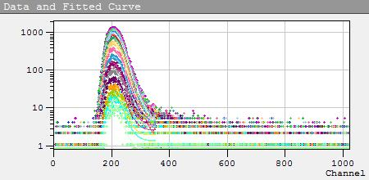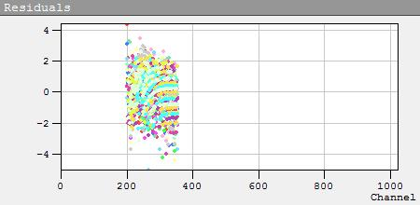
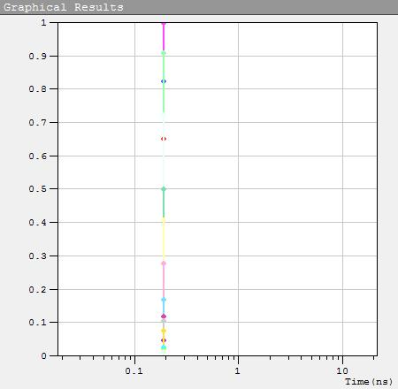
Figure S1. Collected emission decays measured over the emission spectrum of W at pH 3, excited at 320 nm (Figure 6A) from 330 to 490 nm every 10 nm with a dwell time of 50 s at each wavelength. Data at each wavelength were fitted to a mono-exponential model convoluted with IRF ~ 90 ps (as shown in the residuals), see Appendix I for fitting parameters.

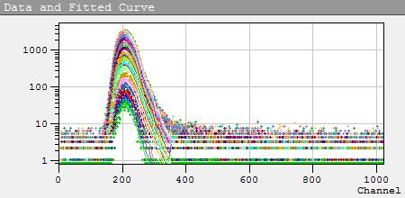
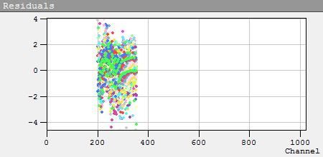
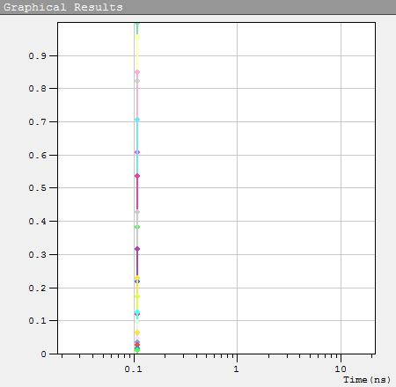
Figure S2. Collected emission decays measured over the emission spectrum of W at pH 9, excited at 320 nm (Figure 5) from 330 to 550 nm every 10 nm with a dwell time of 50 s at each wavelength. Data at each wavelength were fitted to a mono-exponential model convoluted with IRF ~ 90 ps (as shown in the residuals), see Appendix II for fitting parameters.
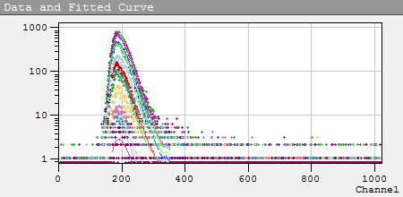
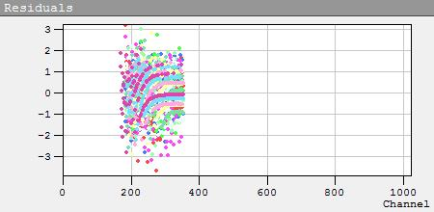
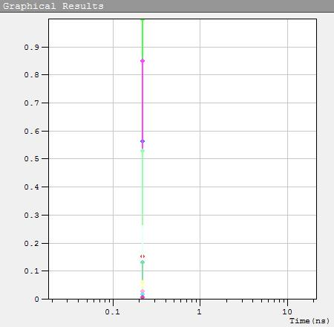
Figure S3. Collected emission decays measured over the emission spectrum of W at pH 3, excited at 280 nm (Figure 6B) from 310 to 510 nm every 20 nm with a dwell time of 50 s at each wavelength. Data at each wavelength were fitted to a mono-exponential model convoluted with IRF ~90 ps (as shown in the residuals, see Appendix III for fitting parameters.

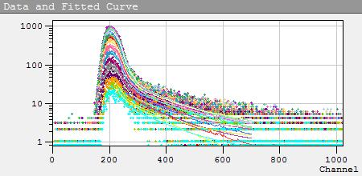

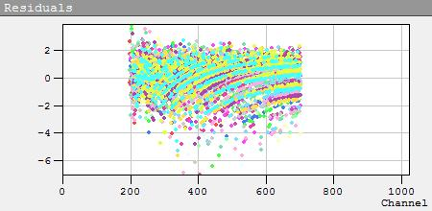
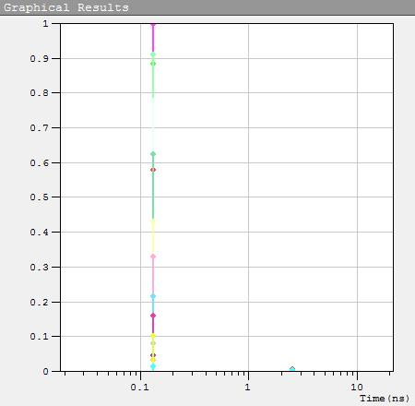
Figure S4. Collected emission decays measured over the emission spectrum of W-Me-β-CD at pH 3, excited at 320 nm (Figure 6A) from 330 to 480 nm every 10 nm with a dwell time of 50 s at each wavelength. Data at each wavelength were fitted to a bi-exponential model convoluted with IRF ~ 90 ps (as shown in the residuals), assuming 2 excited states that decay mono-exponentially in parallel (Figure 8A),¹¹ see Appendix IV for fitting parameters.

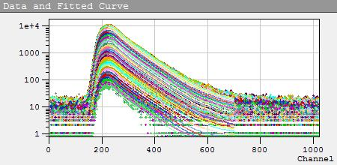
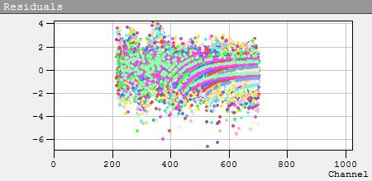
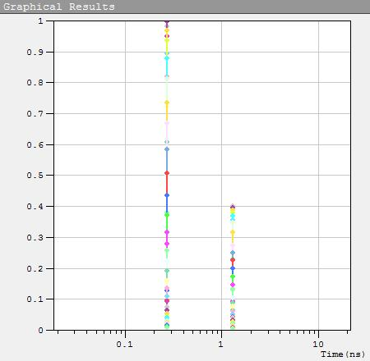
Figure S5. Collected emission decays measured over the emission spectrum of W-Me-β-CD at pH 9, excited at 320 nm (Figure 5) from 330 to 550 nm every 5 nm with a dwell time of 50 s at each wavelength. Data at each wavelength were fitted to a bi-exponential model convoluted with IRF~ 90 ps (as shown in the residuals), assuming 2 excited states that decay bi-exponentially in parallel (Figure 8B),¹¹ see Appendix V.

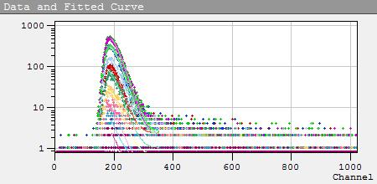
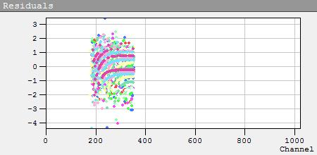
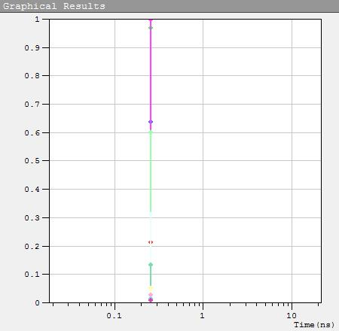
Figure S6. Collected emission decays measured over the emission spectrum of W-Me-β-CD at pH 3, excited at 280 nm (Figure 6B) from 310 to 510 nm every 20 nm with a dwell time of 50 s at each wavelength. Data at each wavelength were fitted to a mono-exponential model convoluted with IRF ~ 90 ps (as shown in the residuals), see Appendix VI.

Figure S7. UV–Visible absorption titration of W (25 μM) with Ac-β-CD at pH 3 (A), and pH 9 (B); the inset shows the corresponding titration curve and the 1:1 binding fit (solid line) with K = (5.5 ± 78) M^{‒1}. The very large error in binding affinity reflects very weak binding.
Figure S8. UV–visible absorption spectra at different pH values of W in water and inside HE-β-CD, Ac-β-CD, and Me-β-CD hosts. The sigmoidal fitting error for each extracted pK_{a} at 280 (CYCLIC) and 320 nm (OPEN) are shown in the insets.

Figure S9. Fluorescence spectra of W (25 µM) at pH 3 and 9 with λ_{ex} = 320 nm and λ_{ex} = 280 nm as labeled by a distinct color. While no change in peak position, spectra of neutral W excited at 280 nm (dark yellow) and 320 nm (dark green) are different.

Figure S10. Fluorescence spectra of W (25 µM) at pH 3 upon the addition of Me-β-CD up to 250 µM (10 equiv.) with λ_{ex} = 320 nm (A); λ_{ex} = 280 nm (B), no significant changes in spectra were observed.

APPENDIX I

Global Analysis Data of W (pH 3; 320 nm)

File: Em1=330.00nm
❖ Global Analysis (Reconvolution)
Fitting range | : [198; 350] channels
Global χ² | : 1.330
χ² | : 1.373

 | B _{i} |  | f _{i} | τ _{i} (ns)
1 | 0.1193 |  | 100.00 | 0.182 | linked

Shift | : -0.0623 ns
Decay Background | : 1.7676
IRF Background | : 0.6000

File: Em1=340.00nm
❖ Global Analysis (Reconvolution)
Fitting range | : [198; 350] channels
Global χ² | : 1.330
χ² | : 1.317

 | B _{i} |  | f _{i} | τ _{i} (ns)
1 | 0.1511 |  | 100.00 | 0.182 | linked

Shift | : -0.0843 ns
Decay Background | : 2.6230
IRF Background | : 0.6000

File: Em1=350.00nm
❖ Global Analysis (Reconvolution)
Fitting range | : [203; 350] channels
Global χ² | : 1.330
χ² | : 1.502

 | B _{i} |  | f _{i} | τ _{i} (ns)
1 | 0.1835 |  | 100.00 | 0.182 | linked

Shift | : -0.0662 ns
Decay Background | : 3.3868
IRF Background | : 0.6000

File: Em1=360.00nm
❖ Global Analysis (Reconvolution)
Fitting range | : [205; 350] channels
Global χ² | : 1.330
χ² | : 1.284

 | B _{i} |  | f _{i} | τ _{i} (ns)
1 | 0.1830 |  | 100.00 | 0.182 | linked

Shift | : -0.0390 ns
Decay Background | : 5.2076
IRF Background | : 0.6000

File: Em1=370.00nm
❖ Global Analysis (Reconvolution)
Fitting range | : [199; 350] channels
Global χ² | : 1.330
χ² | : 1.108

 | B _{i} |  | f _{i} | τ _{i} (ns)
1 | 0.1667 |  | 100.00 | 0.182 | linked

Shift | : -0.0609 ns
Decay Background | : 5.1108
IRF Background | : 0.6000

File: Em1=380.00nm
❖ Global Analysis (Reconvolution)
Fitting range | : [206; 350] channels
Global χ² | : 1.330
χ² | : 1.399

 | B _{i} |  | f _{i} | τ _{i} (ns)
1 | 0.1327 |  | 100.00 | 0.182 | linked

Shift | : -0.0579 ns
Decay Background | : 4.8014
IRF Background | : 0.6000

File: Em1=390.00nm
❖ Global Analysis (Reconvolution)
Fitting range | : [204; 350] channels
Global χ² | : 1.330
χ² | : 1.121

 | B _{i} |  | f _{i} | τ _{i} (ns)
1 | 0.0915 |  | 100.00 | 0.182 | linked

Shift | : -0.0348 ns
Decay Background | : 5.0537
IRF Background | : 0.6000

File: Em1=400.00nm

❖ Global Analysis (Reconvolution)
Fitting range | : [199; 350] channels
Global χ² | : 1.330
χ² | : 1.309

 | B _{i} |  | f _{i} | τ _{i} (ns)
1 | 0.0742 |  | 100.00 | 0.182 | linked

Shift | : -0.0820 ns
Decay Background | : 4.7219
IRF Background | : 0.6000

File: Em1=410.00nm
❖ Global Analysis (Reconvolution)
Fitting range | : [203; 350] channels
Global χ² | : 1.330
χ² | : 1.611

 | B _{i} |  | f _{i} | τ _{i} (ns)
1 | 0.0505 |  | 100.00 | 0.182 | linked

Shift | : -0.0890 ns
Decay Background | : 5.1625
IRF Background | : 0.6000

File: Em1=420.00nm
❖ Global Analysis (Reconvolution)
Fitting range | : [198; 350] channels
Global χ² | : 1.330
χ² | : 1.370

 | B _{i} |  | f _{i} | τ _{i} (ns)
1 | 0.0305 |  | 100.00 | 0.182 | linked

Shift | : -0.0587 ns
Decay Background | : 4.5170
IRF Background | : 0.6000

File: Em1=430.00nm
❖ Global Analysis (Reconvolution)
Fitting range | : [199; 350] channels
Global χ² | : 1.330
χ² | : 1.577

 | B _{i} |  | f _{i} | τ _{i} (ns)
1 | 0.0214 |  | 100.00 | 0.182 | linked

Shift | : -0.1367 ns
Decay Background | : 3.5061
IRF Background | : 0.6000

File: Em1=440.00nm
❖ Global Analysis (Reconvolution)
Fitting range | : [207; 350] channels
Global χ² | : 1.330
χ² | : 1.943

 | B _{i} |  | f _{i} | τ _{i} (ns)
1 | 0.0187 |  | 100.00 | 0.182 | linked

Shift | : -0.2734 ns
Decay Background | : 3.2706
IRF Background | : 0.6000

File: Em1=450.00nm
❖ Global Analysis (Reconvolution)
Fitting range | : [210; 350] channels
Global χ² | : 1.330
χ² | : 1.086

 | B _{i} |  | f _{i} | τ _{i} (ns)
1 | 0.0079 |  | 100.00 | 0.182 | linked

Shift | : -0.0781 ns
Decay Background | : 2.6210
IRF Background | : 0.6000

File: Em1=460.00nm
❖ Global Analysis (Reconvolution)
Fitting range | : [210; 350] channels
Global χ² | : 1.330
χ² | : 1.479

 | B _{i} |  | f _{i} | τ _{i} (ns)
1 | 0.0136 |  | 100.00 | 0.182 | linked

Shift | : -0.5469 ns
Decay Background | : 1.9734
IRF Background | : 0.6000

File: Em1=470.00nm
❖ Global Analysis (Reconvolution)
Fitting range | : [201; 350] channels
Global χ² | : 1.330
χ² | : 1.158

 | B _{i} |  | f _{i} | τ _{i} (ns)
1 | 0.0032 |  | 100.00 | 0.182 | linked

Shift | : -0.0977 ns
Decay Background | : 1.3457
IRF Background | : 0.6000

File: Em1=480.00nm
Fitting range | : [227; 350] channels
Global χ² | : 1.330
χ² | : 0.955

 | B _{i} |  | f _{i} | τ _{i} (ns)
1 | 0.0041 |  | 100.00 | 0.182 | linked

Shift | : -0.2148 ns
Decay Background | : 1.3984
IRF Background | : 0.6000

File: Em1=490.00nm
❖ Global Analysis (Reconvolution)
Fitting range | : [202; 350] channels
Global χ² | : 1.330
χ² | : 0.968

 | B _{i} |  | f _{i} | τ _{i} (ns)
1 | 0.0018 |  | 100.00 | 0.182 | linked

Shift | : -0.2736 ns
Decay Background | : 0.7885
IRF Background | : 0.6000

APPENDIX II

Global Analysis Data of W (pH 9; 320 nm)

File: Em1=330.00nm
❖ Global Analysis (Reconvolution)
Fitting range | : [198; 350] channels
Global χ² | : 1.436
χ² | : 1.248

 | B _{i} |  | f _{i} | τ _{i} (ns)
1 | 0.0992 |  | 100.00 | 0.104 | linked

Shift | : -0.0028 ns
Decay Background | : 0.5518
IRF Background | : 0.6000

File: Em1=340.00nm
❖ Global Analysis (Reconvolution)
Fitting range | : [198; 350] channels
Global χ² | : 1.436
χ² | : 1.447

 | B _{i} |  | f _{i} | τ _{i} (ns)
1 | 0.1835 |  | 100.00 | 0.104 | linked

Shift | : -0.0064 ns
Decay Background | : 1.1423
IRF Background | : 0.6000

File: Em1=350.00nm
❖ Global Analysis (Reconvolution)
Fitting range | : [201; 350] channels
Global χ² | : 1.436
χ² | : 1.553

 | B _{i} |  | f _{i} | τ _{i} (ns)
1 | 0.3226 |  | 100.00 | 0.104 | linked

Shift | : 0.0332 ns
Decay Background | : 3.0877
IRF Background | : 0.6000

File: Em1=360.00nm
❖ Global Analysis (Reconvolution)
Fitting range | : [204; 350] channels
Global χ² | : 1.436
χ² | : 1.601

 | B _{i} |  | f _{i} | τ _{i} (ns)
1 | 0.5130 |  | 100.00 | 0.104 | linked

Shift | : 0.0276 ns
Decay Background | : 3.2082
IRF Background | : 0.6000

File: Em1=370.00nm
❖ Global Analysis (Reconvolution)
Fitting range | : [201; 350] channels
Global χ² | : 1.436
χ² | : 2.018

 | B _{i} |  | f _{i} | τ _{i} (ns)
1 | 0.6966 |  | 100.00 | 0.104 | linked

Shift | : 0.0253 ns
Decay Background | : 4.3292
IRF Background | : 0.6000

File: Em1=380.00nm

❖ Global Analysis (Reconvolution)
Fitting range | : [203; 350] channels
Global χ² | : 1.436
χ² | : 1.667

 | B _{i} |  | f _{i} | τ _{i} (ns)
1 | 0.8048 |  | 100.00 | 0.104 | linked

Shift | : 0.0334 ns
Decay Background | : 4.5986
IRF Background | : 0.6000

File: Em1=390.00nm
❖ Global Analysis (Reconvolution)
Fitting range | : [202; 350] channels
Global χ² | : 1.436
χ² | : 1.906

 | B _{i} |  | f _{i} | τ _{i} (ns)
1 | 0.8458 |  | 100.00 | 0.104 | linked

Shift | : 0.0291 ns
Decay Background | : 4.6974
IRF Background | : 0.6000

File: Em1=400.00nm
❖ Global Analysis (Reconvolution)
Fitting range | : [202; 350] channels
Global χ² | : 1.436
χ² | : 1.812

 | B _{i} |  | f _{i} | τ _{i} (ns)
1 | 0.8080 |  | 100.00 | 0.104 | linked

Shift | : 0.0336 ns
Decay Background | : 4.4687
IRF Background | : 0.6000

File: Em1=410.00nm
❖ Global Analysis (Reconvolution)
Fitting range | : [203; 350] channels
Global χ² | : 1.436
χ² | : 2.044

 | B _{i} |  | f _{i} | τ _{i} (ns)
1 | 0.7190 |  | 100.00 | 0.104 | linked

Shift | : 0.0345 ns
Decay Background | : 3.7058
IRF Background | : 0.6000

File: Em1=420.00nm
❖ Global Analysis (Reconvolution)
Fitting range | : [204; 350] channels
Global χ² | : 1.436
χ² | : 2.066

 | B _{i} |  | f _{i} | τ _{i} (ns)
1 | 0.5974 |  | 100.00 | 0.104 | linked

Shift | : 0.0492 ns
Decay Background | : 2.7790
IRF Background | : 0.6000

File: Em1=430.00nm
❖ Global Analysis (Reconvolution)
Fitting range | : [205; 350] channels
Global χ² | : 1.436
χ² | : 2.049

 | B _{i} |  | f _{i} | τ _{i} (ns)
1 | 0.4522 |  | 100.00 | 0.104 | linked

Shift | : 0.0781 ns
Decay Background | : 2.6920
IRF Background | : 0.6000

File: Em1=440.00nm
❖ Global Analysis (Reconvolution)
Fitting range | : [199; 350] channels
Global χ² | : 1.436
χ² | : 1.753

 | B _{i} |  | f _{i} | τ _{i} (ns)
1 | 0.3605 |  | 100.00 | 0.104 | linked

Shift | : 0.0530 ns
Decay Background | : 2.1747
IRF Background | : 0.6000

File: Em1=450.00nm
❖ Global Analysis (Reconvolution)
Fitting range | : [204; 350] channels
Global χ² | : 1.436
χ² | : 1.301

 | B _{i} |  | f _{i} | τ _{i} (ns)
1 | 0.2664 |  | 100.00 | 0.104 | linked

Shift | : 0.0479 ns
Decay Background | : 1.4656
IRF Background | : 0.6000

File: Em1=460.00nm
❖ Global Analysis (Reconvolution)
Fitting range | : [203; 350] channels
Global χ² | : 1.436
χ² | : 1.305

 | B _{i} |  | f _{i} | τ _{i} (ns)
1 | 0.1934 |  | 100.00 | 0.104 | linked

Shift | : 0.0499 ns
Decay Background | : 0.9652
IRF Background | : 0.6000

File: Em1=470.00nm
❖ Global Analysis (Reconvolution)
Fitting range | : [200; 350] channels
Global χ² | : 1.436
χ² | : 1.139

 | B _{i} |  | f _{i} | τ _{i} (ns)
1 | 0.1461 |  | 100.00 | 0.104 | linked

Shift | : 0.0306 ns
Decay Background | : 0.7773
IRF Background | : 0.6000

File: Em1=480.00nm

❖ Global Analysis (Reconvolution)
Fitting range | : [202; 350] channels
Global χ² | : 1.436
χ² | : 1.251

 | B _{i} |  | f _{i} | τ _{i} (ns)
1 | 0.1048 |  | 100.00 | 0.104 | linked

Shift | : 0.0420 ns
Decay Background | : 0.6611
IRF Background | : 0.6000

File: Em1=490.00nm
❖ Global Analysis (Reconvolution)
Fitting range | : [207; 350] channels
Global χ² | : 1.436
χ² | : 1.041

 | B _{i} |  | f _{i} | τ _{i} (ns)
1 | 0.0796 |  | 100.00 | 0.104 | linked

Shift | : 0.0195 ns
Decay Background | : 0.5155
IRF Background | : 0.6000

File: Em1=500.00nm
❖ Global Analysis (Reconvolution)
Fitting range | : [207; 350] channels
Global χ² | : 1.436
χ² | : 0.994

 | B _{i} |  | f _{i} | τ _{i} (ns)
1 | 0.0534 |  | 100.00 | 0.104 | linked

Shift | : 0.0276 ns
Decay Background | : 0.4548
IRF Background | : 0.6000

File: Em1=510.00nm
❖ Global Analysis (Reconvolution)
Fitting range | : [203; 350] channels
Global χ² | : 1.436
χ² | : 0.872

 | B _{i} |  | f _{i} | τ _{i} (ns)
1 | 0.0366 |  | 100.00 | 0.104 | linked

Shift | : 0.0195 ns
Decay Background | : 0.3143
IRF Background | : 0.6000

File: Em1=520.00nm
❖ Global Analysis (Reconvolution)
Fitting range | : [206; 350] channels
Global χ² | : 1.436
χ² | : 1.267

 | B _{i} |  | f _{i} | τ _{i} (ns)
1 | 0.0290 |  | 100.00 | 0.104 | linked

Shift | : -0.0585 ns
Decay Background | : 0.1086
IRF Background | : 0.6000

File: Em1=530.00nm
❖ Global Analysis (Reconvolution)
Fitting range | : [204; 350] channels
Global χ² | : 1.436
χ² | : 0.951

 | B _{i} |  | f _{i} | τ _{i} (ns)
1 | 0.0204 |  | 100.00 | 0.104 | linked

Shift | : -0.1172 ns
Decay Background | : 0.1034
IRF Background | : 0.6000

File: Em1=540.00nm
❖ Global Analysis (Reconvolution)
Fitting range | : [199; 350] channels
Global χ² | : 1.436
χ² | : 0.988

 | B _{i} |  | f _{i} | τ _{i} (ns)
1 | 0.0132 |  | 100.00 | 0.104 | linked

Shift | : -0.1172 ns
Decay Background | : 0.0268
IRF Background | : 0.6000

File: Em1=550.00nm
❖ Global Analysis (Reconvolution)
Fitting range | : [201; 350] channels
Global χ² | : 1.436
χ² | : 0.751

 | B _{i} |  | f _{i} | τ _{i} (ns)
1 | 0.0089 |  | 100.00 | 0.104 | linked

Shift | : -0.0918 ns
Decay Background | : 0.0312
IRF Background | : 0.6000

APPENDIX III

Global Analysis Data of W (pH 3; 280 nm)

File: Em1=310.00nm
❖ Global Analysis (Reconvolution)
Fitting range | : [182; 350] channels
Global χ² | : 0.934
χ² | : 1.185

 | B _{i} |  | f _{i} | τ _{i} (ns)
1 | 0.0161 |  | 100.00 | 0.210 | linked

Shift | : -0.1562 ns
Decay Background | : 0.6212
IRF Background | : 0.3000

File: Em1=330.00nm
❖ Global Analysis (Reconvolution)
Fitting range | : [178; 350] channels
Global χ² | : 0.934
χ² | : 0.935

 | B _{i} |  | f _{i} | τ _{i} (ns)
1 | 0.0597 |  | 100.00 | 0.210 | linked

Shift | : -0.1969 ns
Decay Background | : 0.7525
IRF Background | : 0.3000

File: Em1=350.00nm
❖ Global Analysis (Reconvolution)
Fitting range | : [186; 350] channels
Global χ² | : 0.934
χ² | : 1.057

 | B _{i} |  | f _{i} | τ _{i} (ns)
1 | 0.1064 |  | 100.00 | 0.210 | linked

Shift | : -0.1953 ns
Decay Background | : 1.3562
IRF Background | : 0.3000

File: Em1=370.00nm
❖ Global Analysis (Reconvolution)
Fitting range | : [182; 350] channels
Global χ² | : 0.934
χ² | : 1.427

 | B _{i} |  | f _{i} | τ _{i} (ns)
1 | 0.0905 |  | 100.00 | 0.210 | linked

Shift | : -0.1325 ns
Decay Background | : 1.6502
IRF Background | : 0.3000

File: Em1=390.00nm
❖ Global Analysis (Reconvolution)
Fitting range | : [180; 350] channels
Global χ² | : 0.934
χ² | : 0.949

 | B _{i} |  | f _{i} | τ _{i} (ns)
1 | 0.0563 |  | 100.00 | 0.210 | linked

Shift | : -0.1777 ns
Decay Background | : 1.0776
IRF Background | : 0.3000

File: Em1=410.00nm
❖ Global Analysis (Reconvolution)
Fitting range | : [184; 350] channels
Global χ² | : 0.934
χ² | : 1.151

 | B _{i} |  | f _{i} | τ _{i} (ns)
1 | 0.0271 |  | 100.00 | 0.210 | linked

Shift | : -0.1758 ns
Decay Background | : 1.1854
IRF Background | : 0.3000

File: Em1=430.00nm
❖ Global Analysis (Reconvolution)
Fitting range | : [180; 350] channels
Global χ² | : 0.934
χ² | : 0.963

 | B _{i} |  | f _{i} | τ _{i} (ns)
1 | 0.0137 |  | 100.00 | 0.210 | linked

Shift | : -0.2871 ns
Decay Background | : 0.8345
IRF Background | : 0.3000

File: Em1=450.00nm
❖ Global Analysis (Reconvolution)
Fitting range | : [188; 350] channels
Global χ² | : 0.934
χ² | : 0.842

 | B _{i} |  | f _{i} | τ _{i} (ns)
1 | 0.0060 |  | 100.00 | 0.210 | linked

Shift | : -0.3125 ns
Decay Background | : 0.5586
IRF Background | : 0.3000

File: Em1=470.00nm
❖ Global Analysis (Reconvolution)
Fitting range | : [187; 350] channels
Global χ² | : 0.934
χ² | : 0.765

 | B _{i} |  | f _{i} | τ _{i} (ns)
1 | 0.0026 |  | 100.00 | 0.210 | linked

Shift | : -0.4883 ns
Decay Background | : 0.5237
IRF Background | : 0.3000

File: Em1=490.00nm
❖ Global Analysis (Reconvolution)
Fitting range | : [185; 350] channels
Global χ² | : 0.934
χ² | : 0.503

 | B _{i} |  | f _{i} | τ _{i} (ns)
1 | 0.0016 |  | 100.00 | 0.210 | linked

Shift | : -0.4687 ns
Decay Background | : 0.2748
IRF Background | : 0.3000

File: Em1=510.00nm
❖ Global Analysis (Reconvolution)
Fitting range | : [166; 350] channels
Global χ² | : 0.934
χ² | : 0.524

 | B _{i} |  | f _{i} | τ _{i} (ns)
1 | 0.0004 |  | 100.00 | 0.210 | linked

Shift | : -0.0504 ns
Decay Background | : 0.0985
IRF Background | : 0.3000

APPENDIX IV

Global Analysis Data of W-Me-β-CD (pH 3; 320 nm)

File: Em1=330.00nm
❖ Global Analysis (Reconvolution)
Fitting range | : [194; 700] channels
Global χ² | : 1.302
χ² | : 1.081

 | B _{i} |  | f _{i} | τ _{i} (ns)
1 | 0.1037 |  | 92.15 | 0.127 | linked
2 | 0.0005 |  | 7.8472 | 2.433 | linked

Shift | : -0.0757 ns
Decay Background | : 0.4957
IRF Background | : 0.6000

File: Em1=340.00nm
❖ Global Analysis (Reconvolution)
Fitting range | : [198; 700] channels
Global χ² | : 1.302
χ² | : 1.130

 | B _{i} |  | f _{i} | τ _{i} (ns)
1 | 0.1393 |  | 91.95 | 0.127 | linked
2 | 0.0006 |  | 8.0530 | 2.433 | linked

Shift | : -0.0730 ns
Decay Background | : 1.1128
IRF Background | : 0.6000

File: Em1=350.00nm
❖ Global Analysis (Reconvolution)
Fitting range | : [200; 700] channels
Global χ² | : 1.302
χ² | : 1.408

 | B _{i} |  | f _{i} | τ _{i} (ns)
1 | 0.1586 |  | 91.31 | 0.127 | linked
2 | 0.0008 |  | 8.6939 | 2.433 | linked

Shift | : -0.0112 ns
Decay Background | : 1.8160
IRF Background | : 0.6000

File: Em1=360.00nm
❖ Global Analysis (Reconvolution)
Fitting range | : [198; 700] channels
Global χ² | : 1.302
χ² | : 1.418

 | B _{i} |  | f _{i} | τ _{i} (ns)
1 | 0.1792 |  | 89.69 | 0.127 | linked
2 | 0.0011 |  | 10.31 | 2.433 | linked

Shift | : -0.0514 ns
Decay Background | : 2.0862
IRF Background | : 0.6000

File: Em1=370.00nm
❖ Global Analysis (Reconvolution)
Fitting range | : [200; 700] channels
Global χ² | : 1.302
χ² | : 1.274

 | B _{i} |  | f _{i} | τ _{i} (ns)
1 | 0.1632 |  | 88.40 | 0.127 | linked
2 | 0.0011 |  | 11.60 | 2.433 | linked

Shift | : -0.0391 ns
Decay Background | : 2.7184
IRF Background | : 0.6000

File: Em1=380.00nm
❖ Global Analysis (Reconvolution)
Fitting range | : [201; 700] channels
Global χ² | : 1.302
χ² | : 1.341

 | B _{i} |  | f _{i} | τ _{i} (ns)
1 | 0.1392 |  | 85.91 | 0.127 | linked
2 | 0.0012 |  | 14.09 | 2.433 | linked

Shift | : -0.0510 ns
Decay Background | : 2.2448
IRF Background | : 0.6000

File: Em1=390.00nm
❖ Global Analysis (Reconvolution)
Fitting range | : [196; 700] channels
Global χ² | : 1.302
χ² | : 1.419

 | B _{i} |  | f _{i} | τ _{i} (ns)
1 | 0.1120 |  | 83.21 | 0.127 | linked
2 | 0.0012 |  | 16.79 | 2.433 | linked

Shift | : -0.0977 ns
Decay Background | : 2.3790
IRF Background | : 0.6000

File: Em1=400.00nm
❖ Global Analysis (Reconvolution)
Fitting range | : [202; 700] channels
Global χ² | : 1.302
χ² | : 1.278

 | B _{i} |  | f _{i} | τ _{i} (ns)
1 | 0.0769 |  | 80.35 | 0.127 | linked
2 | 0.0010 |  | 19.65 | 2.433 | linked

Shift | : -0.0427 ns
Decay Background | : 3.1892
IRF Background | : 0.6000

File: Em1=410.00nm
❖ Global Analysis (Reconvolution)
Fitting range | : [200; 700] channels
Global χ² | : 1.302
χ² | : 1.624

 | B _{i} |  | f _{i} | τ _{i} (ns)
1 | 0.0587 |  | 77.32 | 0.127 | linked
2 | 0.0009 |  | 22.68 | 2.433 | linked

Shift | : -0.1172 ns
Decay Background | : 2.6179
IRF Background | : 0.6000

File: Em1=420.00nm
❖ Global Analysis (Reconvolution)
Fitting range | : [203; 700] channels
Global χ² | : 1.302
χ² | : 1.381

 | B _{i} |  | f _{i} | τ _{i} (ns)
1 | 0.0382 |  | 72.45 | 0.127 | linked
2 | 0.0008 |  | 27.55 | 2.433 | linked

Shift | : -0.0781 ns
Decay Background | : 2.4877
IRF Background | : 0.6000

File: Em1=430.00nm
❖ Global Analysis (Reconvolution)
Fitting range | : [208; 700] channels
Global χ² | : 1.302
χ² | : 1.387

 | B _{i} |  | f _{i} | τ _{i} (ns)
1 | 0.0281 |  | 67.55 | 0.127 | linked
2 | 0.0007 |  | 32.45 | 2.433 | linked

Shift | : -0.1953 ns
Decay Background | : 1.6332
IRF Background | : 0.6000

File: Em1=440.00nm
❖ Global Analysis (Reconvolution)
Fitting range | : [204; 700] channels
Global χ² | : 1.302
χ² | : 1.370

 | B _{i} |  | f _{i} | τ _{i} (ns)
1 | 0.0138 |  | 60.46 | 0.127 | linked
2 | 0.0005 |  | 39.54 | 2.433 | linked

Shift | : -7e-6 ns
Decay Background | : 1.9908
IRF Background | : 0.6000

File: Em1=450.00nm
❖ Global Analysis (Reconvolution)
Fitting range | : [204; 700] channels
Global χ² | : 1.302
χ² | : 1.142

 | B _{i} |  | f _{i} | τ _{i} (ns)
1 | 0.0079 |  | 48.22 | 0.127 | linked
2 | 0.0004 |  | 51.78 | 2.433 | linked

Shift | : 0.0459 ns
Decay Background | : 0.8921
IRF Background | : 0.6000

File: Em1=460.00nm
❖ Global Analysis (Reconvolution)
Fitting range | : [207; 700] channels
Global χ² | : 1.302
χ² | : 1.258

 | B _{i} |  | f _{i} | τ _{i} (ns)
1 | 0.0057 |  | 47.92 | 0.127 | linked
2 | 0.0003 |  | 52.08 | 2.433 | linked

Shift | : -5e-6 ns
Decay Background | : 1.2734
IRF Background | : 0.6000

File: Em1=470.00nm
❖ Global Analysis (Reconvolution)
Fitting range | : [219; 700] channels
Global χ² | : 1.302
χ² | : 1.246

 | B _{i} |  | f _{i} | τ _{i} (ns)
1 | 0.0179 |  | 68.44 | 0.127 | linked
2 | 0.0004 |  | 31.56 | 2.433 | linked

Shift | : -0.6250 ns
Decay Background | : 0.1238
IRF Background | : 0.6000

File: Em1=480.00nm
❖ Global Analysis (Reconvolution)
Fitting range | : [206; 700] channels
Global χ² | : 1.302
χ² | : 1.062

 | B _{i} |  | f _{i} | τ _{i} (ns)
1 | 0.0022 |  | 31.99 | 0.127 | linked
2 | 0.0002 |  | 68.01 | 2.433 | linked

Shift | : -0.0195 ns
Decay Background | : 0.5745
IRF Background | : 0.6000

APPENDIX V

Global Analysis Data of W-Me-β-CD (pH 9; 320 nm)

File: Em1=330.00nm

❖ Global Analysis (Reconvolution)
Fitting range | : [218; 700] channels
Global χ² | : 1.253
χ² | : 1.215

 | B _{i} |  | f _{i} | τ _{i} (ns)
1 | 0.0524 |  | 41.84 | 0.259 | linked
2 | 0.0151 |  | 58.16 | 1.248 | linked

Shift | : -0.0071 ns
Decay Background | : 1.4812
IRF Background | : 0.6000

File: Em1=335.00nm
❖ Global Analysis (Reconvolution)
Fitting range | : [217; 700] channels
Global χ² | : 1.253
χ² | : 1.311

 | B _{i} |  | f _{i} | τ _{i} (ns)
1 | 0.0705 |  | 39.78 | 0.259 | linked
2 | 0.0222 |  | 60.22 | 1.248 | linked

Shift | : 0.0781 ns
Decay Background | : 1.7349
IRF Background | : 0.6000

File: Em1=340.00nm
❖ Global Analysis (Reconvolution)
Fitting range | : [221; 700] channels
Global χ² | : 1.253
χ² | : 1.341

 | B _{i} |  | f _{i} | τ _{i} (ns)
1 | 0.1063 |  | 38.57 | 0.259 | linked
2 | 0.0352 |  | 61.43 | 1.248 | linked

Shift | : 0.0693 ns
Decay Background | : 2.0643
IRF Background | : 0.6000

File: Em1=345.00nm
❖ Global Analysis (Reconvolution)
Fitting range | : [218; 700] channels
Global χ² | : 1.253
χ² | : 1.187

 | B _{i} |  | f _{i} | τ _{i} (ns)
1 | 0.1558 |  | 38.86 | 0.259 | linked
2 | 0.0510 |  | 61.14 | 1.248 | linked

Shift | : 0.1477 ns
Decay Background | : 4.2210
IRF Background | : 0.6000

File: Em1=350.00nm
❖ Global Analysis (Reconvolution)
Fitting range | : [221; 700] channels
Global χ² | : 1.253
χ² | : 1.231

 | B _{i} |  | f _{i} | τ _{i} (ns)
1 | 0.2122 |  | 37.53 | 0.259 | linked
2 | 0.0734 |  | 62.47 | 1.248 | linked

Shift | : 0.1527 ns
Decay Background | : 5.0772
IRF Background | : 0.6000

File: Em1=355.00nm
❖ Global Analysis (Reconvolution)
Fitting range | : [216; 700] channels
Global χ² | : 1.253
χ² | : 1.496

 | B _{i} |  | f _{i} | τ _{i} (ns)
1 | 0.2801 |  | 36.23 | 0.259 | linked
2 | 0.1025 |  | 63.77 | 1.248 | linked

Shift | : 0.1117 ns
Decay Background | : 6.9354
IRF Background | : 0.6000

File: Em1=360.00nm
❖ Global Analysis (Reconvolution)
Fitting range | : [218; 700] channels
Global χ² | : 1.253
χ² | : 1.281

 | B _{i} |  | f _{i} | τ _{i} (ns)
1 | 0.3405 |  | 35.73 | 0.259 | linked
2 | 0.1273 |  | 64.27 | 1.248 | linked

Shift | : 0.1313 ns
Decay Background | : 8.7025
IRF Background | : 0.6000

File: Em1=365.00nm
❖ Global Analysis (Reconvolution)
Fitting range | : [218; 700] channels
Global χ² | : 1.253
χ² | : 1.466

 | B _{i} |  | f _{i} | τ _{i} (ns)
1 | 0.4045 |  | 35.49 | 0.259 | linked
2 | 0.1528 |  | 64.51 | 1.248 | linked

Shift | : 0.1396 ns
Decay Background | : 9.7300
IRF Background | : 0.6000

File: Em1=370.00nm
❖ Global Analysis (Reconvolution)
Fitting range | : [218; 700] channels
Global χ² | : 1.253
χ² | : 1.378

 | B _{i} |  | f _{i} | τ _{i} (ns)
1 | 0.4601 |  | 35.08 | 0.259 | linked
2 | 0.1770 |  | 64.92 | 1.248 | linked

Shift | : 0.1486 ns
Decay Background | : 11.44
IRF Background | : 0.6000

File: Em1=375.00nm

❖ Global Analysis (Reconvolution)
Fitting range | : [217; 700] channels
Global χ² | : 1.253
χ² | : 1.585

 | B _{i} |  | f _{i} | τ _{i} (ns)
1 | 0.5019 |  | 34.41 | 0.259 | linked
2 | 0.1988 |  | 65.59 | 1.248 | linked

Shift | : 0.1444 ns
Decay Background | : 12.98
IRF Background | : 0.6000

File: Em1=380.00nm
❖ Global Analysis (Reconvolution)
Fitting range | : [216; 700] channels
Global χ² | : 1.253
χ² | : 1.532

 | B _{i} |  | f _{i} | τ _{i} (ns)
1 | 0.5336 |  | 33.83 | 0.259 | linked
2 | 0.2168 |  | 66.17 | 1.248 | linked

Shift | : 0.1332 ns
Decay Background | : 13.65
IRF Background | : 0.6000

File: Em1=385.00nm
❖ Global Analysis (Reconvolution)
Fitting range | : [221; 700] channels
Global χ² | : 1.253
χ² | : 1.455

 | B _{i} |  | f _{i} | τ _{i} (ns)
1 | 0.5510 |  | 33.82 | 0.259 | linked
2 | 0.2241 |  | 66.18 | 1.248 | linked

Shift | : 0.1514 ns
Decay Background | : 14.16
IRF Background | : 0.6000

File: Em1=390.00nm
❖ Global Analysis (Reconvolution)
Fitting range | : [220; 700] channels
Global χ² | : 1.253
χ² | : 1.532

 | B _{i} |  | f _{i} | τ _{i} (ns)
1 | 0.5608 |  | 34.54 | 0.259 | linked
2 | 0.2209 |  | 65.46 | 1.248 | linked

Shift | : 0.1744 ns
Decay Background | : 15.06
IRF Background | : 0.6000

File: Em1=395.00nm
❖ Global Analysis (Reconvolution)
Fitting range | : [222; 700] channels
Global χ² | : 1.253
χ² | : 1.612

 | B _{i} |  | f _{i} | τ _{i} (ns)
1 | 0.5432 |  | 34.19 | 0.259 | linked
2 | 0.2173 |  | 65.81 | 1.248 | linked

Shift | : 0.1929 ns
Decay Background | : 15.69
IRF Background | : 0.6000

File: Em1=400.00nm
❖ Global Analysis (Reconvolution)
Fitting range | : [223; 700] channels
Global χ² | : 1.253
χ² | : 1.668

 | B _{i} |  | f _{i} | τ _{i} (ns)
1 | 0.5264 |  | 34.02 | 0.259 | linked
2 | 0.2121 |  | 65.98 | 1.248 | linked

Shift | : 0.1842 ns
Decay Background | : 14.83
IRF Background | : 0.6000

File: Em1=405.00nm
❖ Global Analysis (Reconvolution)
Fitting range | : [221; 700] channels
Global χ² | : 1.253
χ² | : 1.434

 | B _{i} |  | f _{i} | τ _{i} (ns)
1 | 0.4933 |  | 33.13 | 0.259 | linked
2 | 0.2069 |  | 66.87 | 1.248 | linked

Shift | : 0.1658 ns
Decay Background | : 14.43
IRF Background | : 0.6000

File: Em1=410.00nm
❖ Global Analysis (Reconvolution)
Fitting range | : [222; 700] channels
Global χ² | : 1.253
χ² | : 1.380

 | B _{i} |  | f _{i} | τ _{i} (ns)
1 | 0.4553 |  | 32.71 | 0.259 | linked
2 | 0.1947 |  | 67.29 | 1.248 | linked

Shift | : 0.1585 ns
Decay Background | : 13.98
IRF Background | : 0.6000

File: Em1=415.00nm
❖ Global Analysis (Reconvolution)
Fitting range | : [220; 700] channels
Global χ² | : 1.253
χ² | : 1.511

 | B _{i} |  | f _{i} | τ _{i} (ns)
1 | 0.4129 |  | 32.68 | 0.259 | linked
2 | 0.1768 |  | 67.32 | 1.248 | linked

Shift | : 0.1779 ns
Decay Background | : 12.56
IRF Background | : 0.6000

File: Em1=420.00nm
❖ Global Analysis (Reconvolution)
Fitting range | : [224; 700] channels
Global χ² | : 1.253
χ² | : 1.498

 | B _{i} |  | f _{i} | τ _{i} (ns)
1 | 0.3752 |  | 33.82 | 0.259 | linked
2 | 0.1526 |  | 66.18 | 1.248 | linked

Shift | : 0.2195 ns
Decay Background | : 12.78
IRF Background | : 0.6000

File: Em1=425.00nm
❖ Global Analysis (Reconvolution)
Fitting range | : [226; 700] channels
Global χ² | : 1.253
χ² | : 1.397

 | B _{i} |  | f _{i} | τ _{i} (ns)
1 | 0.3279 |  | 32.92 | 0.259 | linked
2 | 0.1389 |  | 67.08 | 1.248 | linked

Shift | : 0.1953 ns
Decay Background | : 11.28
IRF Background | : 0.6000

File: Em1=430.00nm
❖ Global Analysis (Reconvolution)
Fitting range | : [223; 700] channels
Global χ² | : 1.253
χ² | : 1.237

 | B _{i} |  | f _{i} | τ _{i} (ns)
1 | 0.2836 |  | 31.93 | 0.259 | linked
2 | 0.1257 |  | 68.07 | 1.248 | linked

Shift | : 0.1733 ns
Decay Background | : 10.30
IRF Background | : 0.6000

File: Em1=435.00nm
❖ Global Analysis (Reconvolution)
Fitting range | : [217; 700] channels
Global χ² | : 1.253
χ² | : 1.181

 | B _{i} |  | f _{i} | τ _{i} (ns)
1 | 0.2434 |  | 31.18 | 0.259 | linked
2 | 0.1117 |  | 68.82 | 1.248 | linked

Shift | : 0.1482 ns
Decay Background | : 8.7256
IRF Background | : 0.6000

File: Em1=440.00nm
❖ Global Analysis (Reconvolution)
Fitting range | : [220; 700] channels
Global χ² | : 1.253
χ² | : 1.037

 | B _{i} |  | f _{i} | τ _{i} (ns)
1 | 0.2075 |  | 31.08 | 0.259 | linked
2 | 0.0957 |  | 68.92 | 1.248 | linked

Shift | : 0.1525 ns
Decay Background | : 8.1860
IRF Background | : 0.6000

File: Em1=445.00nm
❖ Global Analysis (Reconvolution)
Fitting range | : [221; 700] channels
Global χ² | : 1.253
χ² | : 1.289

 | B _{i} |  | f _{i} | τ _{i} (ns)
1 | 0.1769 |  | 31.27 | 0.259 | linked
2 | 0.0808 |  | 68.73 | 1.248 | linked

Shift | : 0.1634 ns
Decay Background | : 7.4017
IRF Background | : 0.6000

File: Em1=450.00nm
❖ Global Analysis (Reconvolution)
Fitting range | : [216; 700] channels
Global χ² | : 1.253
χ² | : 1.363

 | B _{i} |  | f _{i} | τ _{i} (ns)
1 | 0.1432 |  | 28.97 | 0.259 | linked
2 | 0.0730 |  | 71.03 | 1.248 | linked

Shift | : 0.0997 ns
Decay Background | : 6.2817
IRF Background | : 0.6000

File: Em1=455.00nm
❖ Global Analysis (Reconvolution)
Fitting range | : [219; 700] channels
Global χ² | : 1.253
χ² | : 1.175

 | B _{i} |  | f _{i} | τ _{i} (ns)
1 | 0.1249 |  | 31.40 | 0.259 | linked
2 | 0.0567 |  | 68.60 | 1.248 | linked

Shift | : 0.1771 ns
Decay Background | : 4.9216
IRF Background | : 0.6000

File: Em1=460.00nm
❖ Global Analysis (Reconvolution)
Fitting range | : [217; 700] channels
Global χ² | : 1.253
χ² | : 1.175

 | B _{i} |  | f _{i} | τ _{i} (ns)
1 | 0.1067 |  | 31.15 | 0.259 | linked
2 | 0.0490 |  | 68.85 | 1.248 | linked

Shift | : 0.1482 ns
Decay Background | : 4.3856
IRF Background | : 0.6000

File: Em1=465.00nm
❖ Global Analysis (Reconvolution)
Fitting range | : [225; 700] channels
Global χ² | : 1.253
χ² | : 1.142

 | B _{i} |  | f _{i} | τ _{i} (ns)
1 | 0.0880 |  | 30.09 | 0.259 | linked
2 | 0.0425 |  | 69.91 | 1.248 | linked

Shift | : 0.1172 ns
Decay Background | : 3.2145
IRF Background | : 0.6000

File: Em1=470.00nm
❖ Global Analysis (Reconvolution)
Fitting range | : [224; 700] channels
Global χ² | : 1.253
χ² | : 1.442

 | B _{i} |  | f _{i} | τ _{i} (ns)
1 | 0.0746 |  | 31.85 | 0.259 | linked
2 | 0.0332 |  | 68.15 | 1.248 | linked

Shift | : 0.1897 ns
Decay Background | : 3.4595
IRF Background | : 0.6000

File: Em1=475.00nm
❖ Global Analysis (Reconvolution)
Fitting range | : [229; 700] channels
Global χ² | : 1.253
χ² | : 1.072

 | B _{i} |  | f _{i} | τ _{i} (ns)
1 | 0.0606 |  | 31.22 | 0.259 | linked
2 | 0.0278 |  | 68.78 | 1.248 | linked

Shift | : 0.1952 ns
Decay Background | : 3.2892
IRF Background | : 0.6000

File: Em1=480.00nm
❖ Global Analysis (Reconvolution)
Fitting range | : [226; 700] channels
Global χ² | : 1.253
χ² | : 1.242

 | B _{i} |  | f _{i} | τ _{i} (ns)
1 | 0.0512 |  | 31.71 | 0.259 | linked
2 | 0.0229 |  | 68.29 | 1.248 | linked

Shift | : 0.2066 ns
Decay Background | : 2.3549
IRF Background | : 0.6000

File: Em1=485.00nm
❖ Global Analysis (Reconvolution)
Fitting range | : [223; 700] channels
Global χ² | : 1.253
χ² | : 1.200

 | B _{i} |  | f _{i} | τ _{i} (ns)
1 | 0.0409 |  | 28.09 | 0.259 | linked
2 | 0.0218 |  | 71.91 | 1.248 | linked

Shift | : 0.0804 ns
Decay Background | : 2.3291
IRF Background | : 0.6000

File: Em1=490.00nm
❖ Global Analysis (Reconvolution)
Fitting range | : [212; 700] channels
Global χ² | : 1.253
χ² | : 1.314

 | B _{i} |  | f _{i} | τ _{i} (ns)
1 | 0.0357 |  | 29.66 | 0.259 | linked
2 | 0.0176 |  | 70.34 | 1.248 | linked

Shift | : 0.0956 ns
Decay Background | : 2.0109
IRF Background | : 0.6000

File: Em1=495.00nm
❖ Global Analysis (Reconvolution)
Fitting range | : [227; 700] channels
Global χ² | : 1.253
χ² | : 1.130

 | B _{i} |  | f _{i} | τ _{i} (ns)
1 | 0.0298 |  | 30.73 | 0.259 | linked
2 | 0.0140 |  | 69.27 | 1.248 | linked

Shift | : 0.1367 ns
Decay Background | : 1.7137
IRF Background | : 0.6000

File: Em1=500.00nm
❖ Global Analysis (Reconvolution)
Fitting range | : [218; 700] channels
Global χ² | : 1.253
χ² | : 1.068

 | B _{i} |  | f _{i} | τ _{i} (ns)
1 | 0.0229 |  | 28.46 | 0.259 | linked
2 | 0.0119 |  | 71.54 | 1.248 | linked

Shift | : 0.1115 ns
Decay Background | : 1.3398
IRF Background | : 0.6000

File: Em1=505.00nm
❖ Global Analysis (Reconvolution)
Fitting range | : [215; 700] channels
Global χ² | : 1.253
χ² | : 1.106

 | B _{i} |  | f _{i} | τ _{i} (ns)
1 | 0.0210 |  | 32.54 | 0.259 | linked
2 | 0.0091 |  | 67.46 | 1.248 | linked

Shift | : 0.1656 ns
Decay Background | : 1.0679
IRF Background | : 0.6000

File: Em1=510.00nm
❖ Global Analysis (Reconvolution)
Fitting range | : [221; 700] channels
Global χ² | : 1.253
χ² | : 1.121

 | B _{i} |  | f _{i} | τ _{i} (ns)
1 | 0.0154 |  | 29.12 | 0.259 | linked
2 | 0.0078 |  | 70.88 | 1.248 | linked

Shift | : 0.1367 ns
Decay Background | : 1.3310
IRF Background | : 0.6000

File: Em1=515.00nm
❖ Global Analysis (Reconvolution)
Fitting range | : [228; 700] channels
Global χ² | : 1.253
χ² | : 1.079

 | B _{i} |  | f _{i} | τ _{i} (ns)
1 | 0.0131 |  | 30.77 | 0.259 | linked
2 | 0.0061 |  | 69.23 | 1.248 | linked

Shift | : 0.1454 ns
Decay Background | : 0.7937
IRF Background | : 0.6000

File: Em1=520.00nm
❖ Global Analysis (Reconvolution)
Fitting range | : [221; 700] channels
Global χ² | : 1.253
χ² | : 1.008

 | B _{i} |  | f _{i} | τ _{i} (ns)
1 | 0.0104 |  | 28.63 | 0.259 | linked
2 | 0.0054 |  | 71.37 | 1.248 | linked

Shift | : 0.0298 ns
Decay Background | : 0.8950
IRF Background | : 0.6000

File: Em1=525.00nm
❖ Global Analysis (Reconvolution)
Fitting range | : [215; 700] channels
Global χ² | : 1.253
χ² | : 0.979

 | B _{i} |  | f _{i} | τ _{i} (ns)
1 | 0.0080 |  | 28.51 | 0.259 | linked
2 | 0.0041 |  | 71.49 | 1.248 | linked

Shift | : 0.0675 ns
Decay Background | : 0.6009
IRF Background | : 0.6000

File: Em1=530.00nm
❖ Global Analysis (Reconvolution)
Fitting range | : [211; 700] channels
Global χ² | : 1.253
χ² | : 1.048

 | B _{i} |  | f _{i} | τ _{i} (ns)
1 | 0.0052 |  | 22.01 | 0.259 | linked
2 | 0.0039 |  | 77.99 | 1.248 | linked

Shift | : -0.0679 ns
Decay Background | : 0.3592
IRF Background | : 0.6000

File: Em1=535.00nm
❖ Global Analysis (Reconvolution)
Fitting range | : [224; 700] channels
Global χ² | : 1.253
χ² | : 0.924

 | B _{i} |  | f _{i} | τ _{i} (ns)
1 | 0.0067 |  | 32.04 | 0.259 | linked
2 | 0.0030 |  | 67.96 | 1.248 | linked

Shift | : -0.0719 ns
Decay Background | : 0.3084
IRF Background | : 0.6000

File: Em1=540.00nm
❖ Global Analysis (Reconvolution)
Fitting range | : [216; 700] channels
Global χ² | : 1.253
χ² | : 0.803

 | B _{i} |  | f _{i} | τ _{i} (ns)
1 | 0.0046 |  | 32.57 | 0.259 | linked
2 | 0.0020 |  | 67.43 | 1.248 | linked

Shift | : 0.0888 ns
Decay Background | : 0.2895
IRF Background | : 0.6000

File: Em1=545.00nm
❖ Global Analysis (Reconvolution)
Fitting range | : [227; 700] channels
Global χ² | : 1.253
χ² | : 0.878

 | B _{i} |  | f _{i} | τ _{i} (ns)
1 | 0.0037 |  | 29.54 | 0.259 | linked
2 | 0.0018 |  | 70.46 | 1.248 | linked

Shift | : -0.0247 ns
Decay Background | : 0.4206
IRF Background | : 0.6000

File: Em1=550.00nm
❖ Global Analysis (Reconvolution)
Fitting range | : [228; 700] channels
Global χ² | : 1.253
χ² | : 0.847

 | B _{i} |  | f _{i} | τ _{i} (ns)
1 | 0.0039 |  | 31.83 | 0.259 | linked
2 | 0.0017 |  | 68.17 | 1.248 | linked

Shift | : -0.2150 ns
Decay Background | : 0.2680
IRF Background | : 0.6000

APPENDIX VI

Global Analysis Data of W-Me-β-CD (pH 3; 280 nm)

File: Em1=310.00nm
❖ Global Analysis (Reconvolution)
Fitting range | : [184; 350] channels
Global χ² | : 0.959
χ² | : 1.118

 | B _{i} |  | f _{i} | τ _{i} (ns)
1 | 0.0128 |  | 100.00 | 0.245 | linked

Shift | : -0.3125 ns
Decay Background | : 2.4569
IRF Background | : 0.3000

File: Em1=330.00nm
❖ Global Analysis (Reconvolution)
Fitting range | : [184; 350] channels
Global χ² | : 0.959
χ² | : 1.222

 | B _{i} |  | f _{i} | τ _{i} (ns)
1 | 0.0386 |  | 100.00 | 0.245 | linked

Shift | : -0.2734 ns
Decay Background | : 2.8583
IRF Background | : 0.3000

File: Em1=350.00nm
❖ Global Analysis (Reconvolution)
Fitting range | : [184; 350] channels
Global χ² | : 0.959
χ² | : 1.121

 | B _{i} |  | f _{i} | τ _{i} (ns)
1 | 0.0586 |  | 100.00 | 0.245 | linked

Shift | : -0.1808 ns
Decay Background | : 2.4454
IRF Background | : 0.3000

File: Em1=370.00nm
❖ Global Analysis (Reconvolution)
Fitting range | : [182; 350] channels
Global χ² | : 0.959
χ² | : 1.300

 | B _{i} |  | f _{i} | τ _{i} (ns)
1 | 0.0605 |  | 100.00 | 0.245 | linked

Shift | : -0.2498 ns
Decay Background | : 2.0239
IRF Background | : 0.3000

File: Em1=390.00nm
❖ Global Analysis (Reconvolution)
Fitting range | : [183; 350] channels
Global χ² | : 0.959
χ² | : 1.262

 | B _{i} |  | f _{i} | τ _{i} (ns)
1 | 0.0363 |  | 100.00 | 0.245 | linked

Shift | : -0.2144 ns
Decay Background | : 2.2432
IRF Background | : 0.3000

File: Em1=410.00nm
❖ Global Analysis (Reconvolution)
Fitting range | : [189; 350] channels
Global χ² | : 0.959
χ² | : 0.951

 | B _{i} |  | f _{i} | τ _{i} (ns)
1 | 0.0188 |  | 100.00 | 0.245 | linked

Shift | : -0.2539 ns
Decay Background | : 1.4608
IRF Background | : 0.3000

File: Em1=430.00nm
❖ Global Analysis (Reconvolution)
Fitting range | : [183; 350] channels
Global χ² | : 0.959
χ² | : 0.968

 | B _{i} |  | f _{i} | τ _{i} (ns)
1 | 0.0080 |  | 100.00 | 0.245 | linked

Shift | : -0.2532 ns
Decay Background | : 1.0641
IRF Background | : 0.3000

File: Em1=450.00nm
❖ Global Analysis (Reconvolution)
Fitting range | : [175; 350] channels
Global χ² | : 0.959
χ² | : 0.689

 | B _{i} |  | f _{i} | τ _{i} (ns)
1 | 0.0030 |  | 100.00 | 0.245 | linked

Shift | : -0.2539 ns
Decay Background | : 0.7463
IRF Background | : 0.3000

File: Em1=470.00nm
❖ Global Analysis (Reconvolution)
Fitting range | : [191; 350] channels
Global χ² | : 0.959
χ² | : 0.850

 | B _{i} |  | f _{i} | τ _{i} (ns)
1 | 0.0015 |  | 100.00 | 0.245 | linked

Shift | : -0.3907 ns
Decay Background | : 0.4401
IRF Background | : 0.3000

File: Em1=490.00nm
❖ Global Analysis (Reconvolution)
Fitting range | : [180; 350] channels
Global χ² | : 0.959
χ² | : 0.673

 | B _{i} |  | f _{i} | τ _{i} (ns)
1 | 0.0007 |  | 100.00 | 0.245 | linked

Shift | : -0.4688 ns
Decay Background | : 0.5554
IRF Background | : 0.3000

File: Em1=510.00nm
❖ Global Analysis (Reconvolution)
Fitting range | : [187; 350] channels
Global χ² | : 0.959
χ² | : 0.398

 | B _{i} |  | f _{i} | τ _{i} (ns)
1 | 0.0003 |  | 100.00 | 0.245 | linked

Shift | : -0.4297 ns
Decay Background | : 0.2456
IRF Background | : 0.3000

