SUPPORTING INFROMATION

Table of Contents

Figure S1. ¹H NMR spectra of LA, ODA and Gal-ODA. The important peaks were pointed out.
Figure S2. Optic photographs of MNLC dispersion.
Figure S3. In vitro cytotoxicity of MNLC against LO2, HepG2 and RAW264.7 cells.
Tabel S1. Particle diameter and zeta potential of Gal-NLC-SPIO, NLC-SPIO and Gal-NLC-SPIO/PEG nanoparticles.

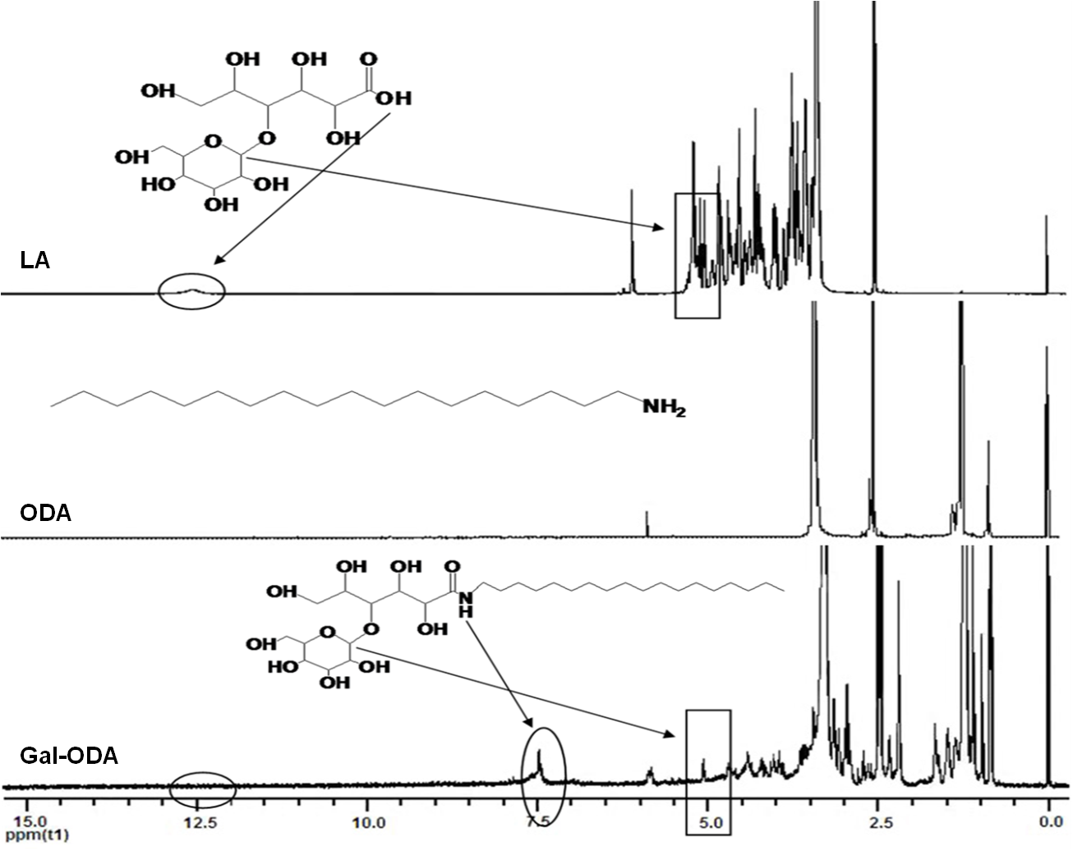
Figure S1. ¹H NMR spectra of LA, ODA and Gal-ODA. The important peaks were pointed out.

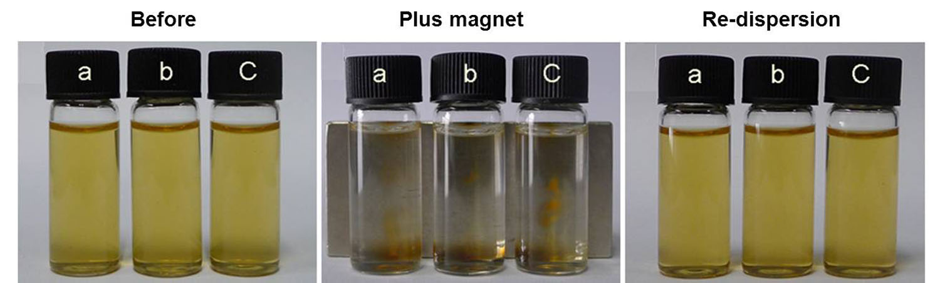
Figure S2. Optic photographs of MNLC dispersion（left）, MNLC dispersion after standing in external magnetic field overnight（middle）and MNLC re-dispersion after the external magnetic field was removed（right）. a: NLC-SPIO, b: Gal-NLC-SPIO, c: Gal-NLC-SPIO/PEG.

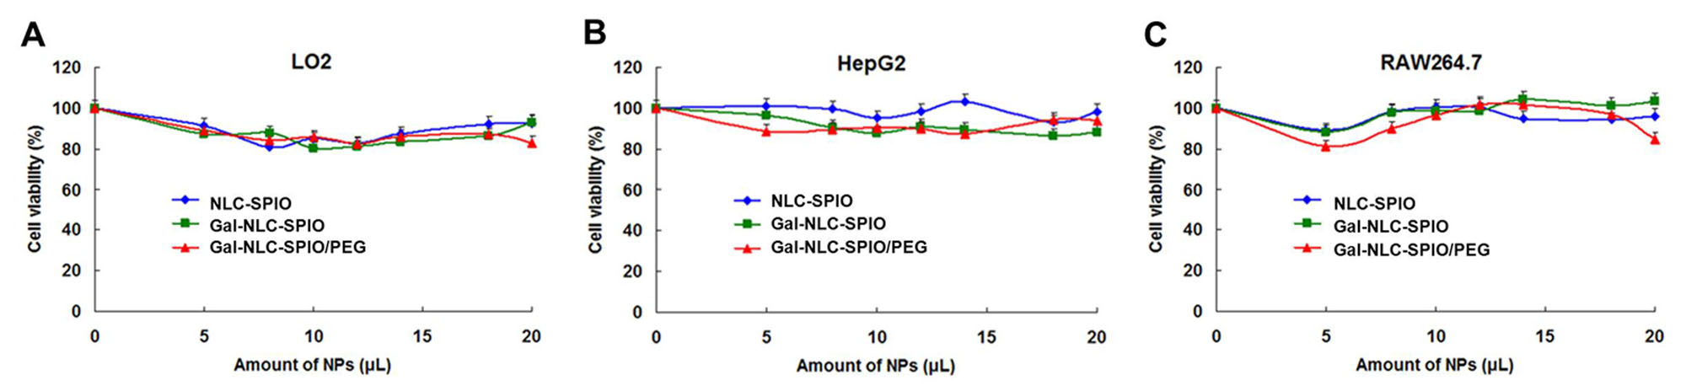
Figure S3. In vitro cytotoxicity of MNLC against LO2 (A), HepG2 (B) and RAW264.7 (C) cells. Data represent the mean ± standard deviation (n=3). The Gal-MNLC prepared consisted of 100 µg/ml Fe₃O₄.

Table S1. Particle diameter and zeta potential of Gal-NLC-SPIO, NLC-SPIO and Gal-NLC-SPIO/PEG nanoparticles. Data represent the mean standard deviation (n=3). PI: polydispersity index of the nanoparticle size.
