Fig. S1 XRD patterns of the prepared TiO₂ nanotubes (a)20s-Cu,N-TNT; (b)40s-Cu,N-TNT; (c)60s-Cu,N-TNT; (d)80s-Cu,N-TNT; (e)100s-Cu,N-TNT
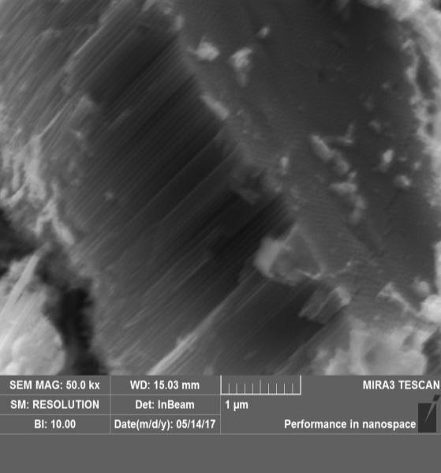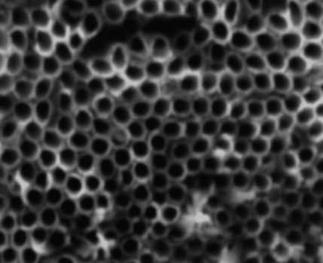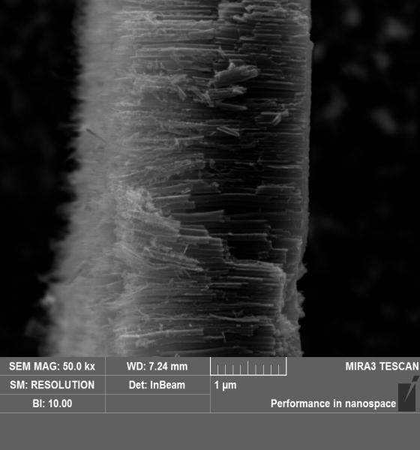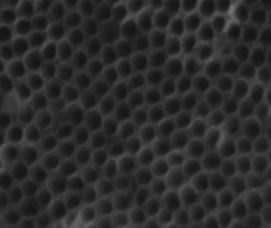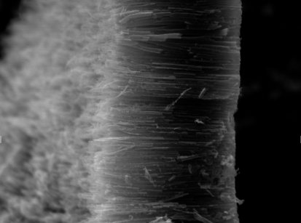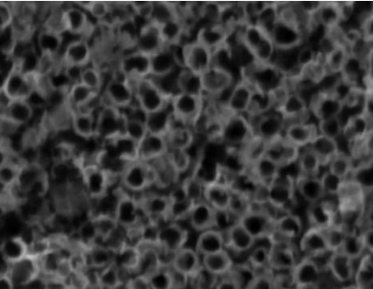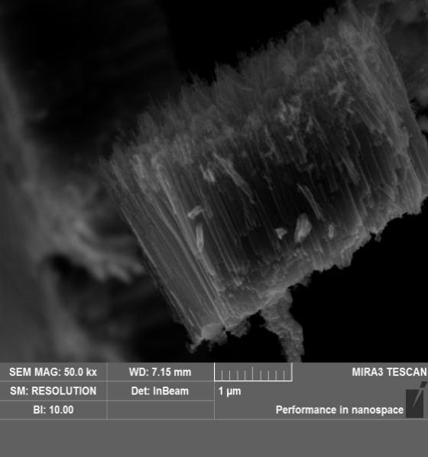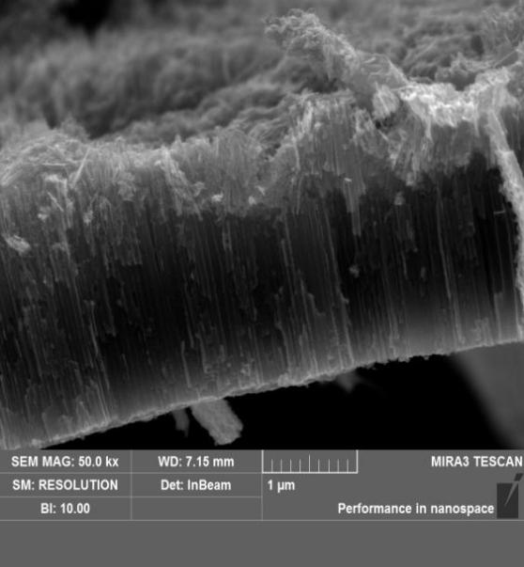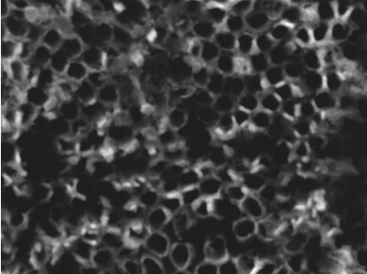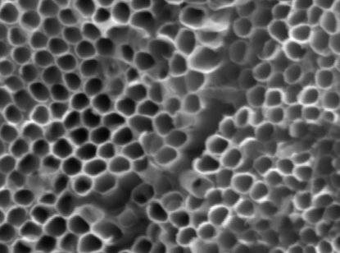
(f)
500nm

(a)
200nm

(b)
500nm

(c)
200nm

(d)
500nm

(i)
200nm

(j)
500nm

(h)
500nm

(g)
200nm

200nm

(e)
Fig. S2 SEM images of the TiO₂ nanotubes arrays, (a) and (b) 20s-Cu-TNT; (c) and (d) 40s-Cu-TNT; (e) and (f) 60s-Cu-TNT; (g) and (h) 80s-Cu-TNT; (i) and (j) 100s-Cu-TNT
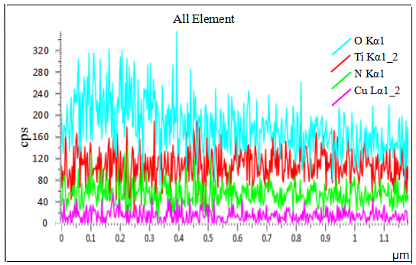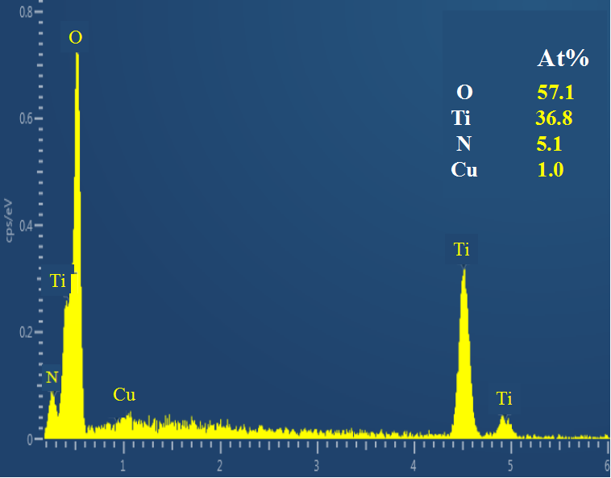
Fig. S3. EDS pattern of the 60s-Cu,N-TNT

