# Supporting Information

# Mechanochemical Induced Structure Transformations in Lithium Titanates: A Detailed PXRD and 6Li MAS NMR Study

**Dennis Becker, Robert Haberkorn and Guido Kickelbick\***

Saarland University, Inorganic Solid State Chemistry, Campus, Building C 41, 66123 Saarbrücken, Germany

**\***Correspondence: guido.kickelbick@uni-saarland.de; Tel.: +49-681-302-70651

## Formation of α-Li2TiO3 from LiOH and TiO2



**Figure SI1**: Rietveld refinement of the milling product from LiOH and anatase (ZrO2 tools, 600 rpm, 6h). Li2TiO3 in SG *Fmm* with *a*= 4.1555(2) Å, *V* = 71.76(1) Å3, number of reflections = 8 and *RBragg* = 0.99%. Refinement parameters: number of independent parameters = 46, *Rwp* =5.41%, *Rexp* =3.30%, *GOF* = 1.64.



**Figure SI2**: Rietveld refinement of the milling product from LiOH and rutile (WC tools, 600 rpm, 6h) after handling in the glovebox. Measurement was conducted with an air tight dome sample holder (responsible for the background signal). The small percentage of crystalline TiO2 is due to a small unreacted residue between milling vial and lid.

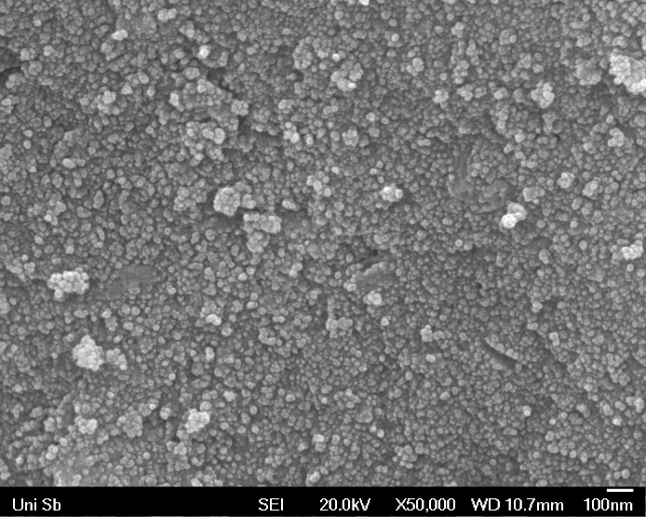

**Figure SI3**: SEM photograph of the milling product from LiOH and rutile in WC tools at 600 rpm and 6h.

**Table SI1**: Refined structure parameters of α-Li2TiO3 produced by milling of LiOH and rutile in WC tools at 600 rpm for 6 h. *Biso* was constrained at the same value for all atoms in the refinement. Global refinement parameters: number of independent parameters = 40, *Rwp* =3.44%, *Rexp* =2.60%, *GOF* = 1.32. *WP*= Wyckoff position, *sof* = site occupancy factor.

|  |  |  |  |  |  |  |  |
| --- | --- | --- | --- | --- | --- | --- | --- |
| SG | |  | *Fm $\overline{3}$ m* | |  |  |  |
| RBragg | |  | 1.17% | |  |  |  |
| No. of reflections | |  | 8 | |  |  |  |
| Wt% Rietveld | |  | 68.3(4) | |  |  |  |
| Cell Mass | |  | 150.6(5) | |  |  |  |
| Cell Volume [Å3] | |  | 71.93(1) | |  |  |  |
| Lattice Parameter [Å] | | | 4.1588(2) | |  |  |  |
| Crystallite Size Lvol-IB [nm] | | | 15.7(4) | |  |  |  |
| Strain *e*0 | |  | 0.18742 | |  |  |  |
| Lin. Abs. Coeff. [cm-1] | | | 358(4) | |  |  |  |
| Crystal Density [g/cm3] | | | 3.48(1) | |  |  |  |
| Site | *WP* | *x* | *y* | *z* | Atom | *sof* | *Biso* |
| Li1 | 4*a* | 0 | 0 | 0 | Li+ | 0.46(2) | 1.34(2) |
|  | 4*a* |  |  |  | Ti4+ | 0.39(6) | 1.34(2) |
| O1 | 4*b* | 1/2 | 1/2 | 1/2 | O2- | 1 | 1.34(2) |

## Thermogravimetric analysis



**Figure SI4**: TGA and calculated DTA curve of Li2TiO3 from milling of LiOH and rutile in WC tools at 600 rpm for 6 h. Intermediate drying in N2 atmosphere at 100 °C leads to mass loss of 3%.



**Figure SI5**: Temperature dependent IR signals from coupling of TGA gas flow to IR detector. Colors indicate intensity of the signals.

## Thermal transformation of α-Li2TiO3 to β-Li2TiO3



**Figure SI6**: Rietveld refinement of the milling product from LiOH and rutile (WC tools, 600 rpm, 6h) after heating to 200 °C for 1 h. Li2TiO3 in SG *Fmm* with *a*= 4.1435(1) Å, *V* = 71.14(1) Å3, number of reflections = 8 and *RBragg* = 1.50%. Refinement parameters: number of independent parameters = 48, *Rwp* =3.08%, *Rexp* =2.63%, *GOF* = 1.17.

## Transformation of β-Li2TiO3 and spinel Li4Ti5O12 to α-Li2TiO3



**Figure SI7**: Rietveld refinement of β-Li2TiO3 after ball milling with WC tools for 6 h at 600 rpm. Li2TiO3 in SG *Fmm* with *a*= 4.1463(2) Å, *V* = 71.28(1) Å3, number of reflections = 8 and *RBragg* = 0.60%. Refinement parameters: number of independent parameters = 31, *Rwp* =3.60%, *Rexp* =2.85%, *GOF* = 1.26.

## 6Li SPE MAS NMR of Li4Ti5O12



**Figure SI8**: 6Li SPE MAS NMR spectra of a) spinel Li4Ti5O12, b) after *hebm* for 1 h. The spectra were referenced against solid LiCl and fitted with two independent Voigt functions with R2 > 0.99.