Supplementary information

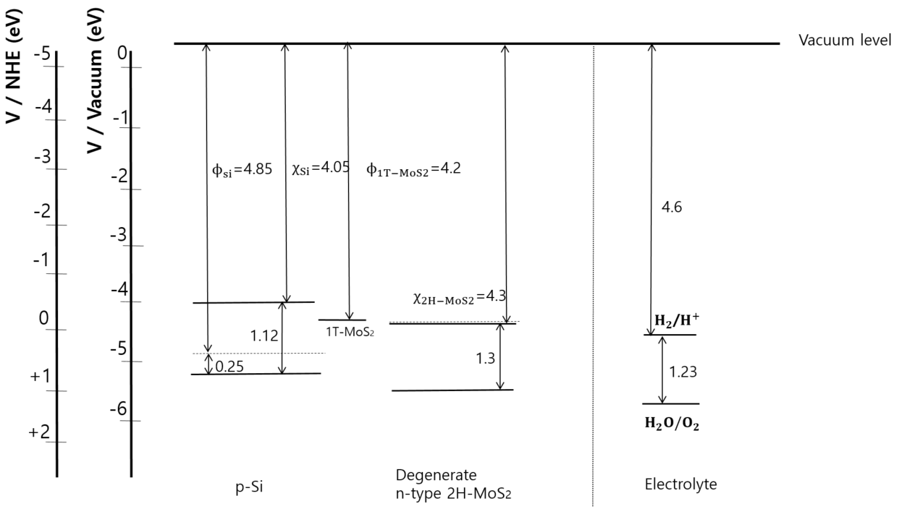

Figure S1. Schematic energy level diagram of the band alignment at p-Si/MoS₂ interface in terms of vacuum level and normal hydrogen electrode level in electrolyte of pH = 0.3. The p-Si doping level is ~1.6$×{10}^{15}$cm⁻³.

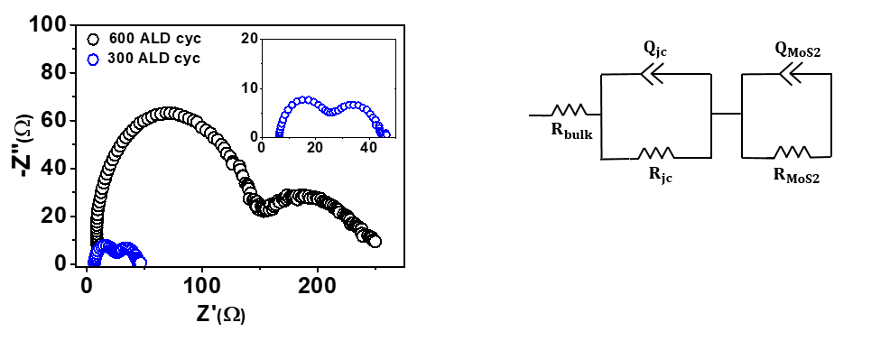
Figure S2. (a) Nyquist plot of 700–ALD-cycles and 300-ALD-cycles on p-Si photocathode under 1sun illumination at 0 bias. (b) Equivalent circuit corresponding to the EIS measurement. R_{bulk} is bulk resistance of the silicon, Q_{jc} is constant phase element (CPE) of p-Si/MoS₂ junction along with junction resistance R_{jc}, CPE of MoS₂/electrolyte interface is denoted as QMoS₂ and the resistance of R_{Mos2.}

Table S1. Measured charge transfer resistances.
Condition | R_{bulk} (Ωcm²)  Back contact/p-Si | R_{jc} (Ωcm²)  p-Si/SiOx/MoS₂ | R_{MoS2} (Ωcm²)  MoS₂/electrolyte
Dark (500) | 5.94 | 702.5 | 9517
600 | 5.514 | 77.98 | 157.4
500 | 4.974 | 27.38 | 22.38
300 | 4.642 | 22.26 | 16.95
100 | 4.108 | 83.11 | 77.1

List of symbols with values and Units

$N_{a}$ Acceptor density 1.6 x${10}^{15}{cm}^{-3}$
$N_{d}$ Donor density ${10}^{19} {cm}^{-3}$
$n_{i_Si}$ Intrinsic carrier density of p-silicon ${10}^{10}{ cm}^{-3}$
$n_{i_MoS_{2}}$ Intrinsic carrier density of MoS₂ ${10}^{13}{ cm}^{-3}$
$n_{0}$ Electron concentration in p-Si at dark equilibrium 66,000 ${cm}^{-3}$
$p_{0}$ Hole concentration in n-MoS₂ at dark equilibrium ${10}^{13}{ cm}^{-3}$
$n_{s}^{0}$ Surface electron concentration across the cm⁻³
electrode/electrolyte interface at light
$n_{s}$ Surface electron concentration across the cm⁻³
Electrode/electrolyte interface at dark equilibrium
W Depletion width cm
$χ_{p}$ Electron negativity of p-Si eV
$χ_{n}$ Electron negativity of MoS2 eV
$x_{p}$ Interface to p-Si depletion width cm
$x_{n}$ Interface to n-MoS2 depletion width cm
$L_{n}$ Minority carrier diffusion length in p-Si cm
$L_{p}$ Minority carrier diffusion length in MoS2 cm
$N_{c}$ Density of states in the conduction band ${cm}^{-3}$
$N_{v}$ Density of states in the valence band ${cm}^{-3}$
k Boltzmann’s constant 1.38$×{10}^{-23}{JK}^{-1}$
q Charge of an electron 1.6$×{10}^{-19}$C
$ε_{r}$ Relative permittivity F$m^{-1}$
$ε_{0}$ Vacuum permittivity F$m^{-1}$
$V_{ph}$ Photovoltage V
$V_{on}$ On-Set voltage V
$V_{bi}$ Built-in potential V
$V_{fb}$ Flatband potential V
$V_{A}$ Applied voltage V
$V_{0}$ The maximum restriction of photovoltage V
V_{o} band bending of silicon V
$ϕ_{B}$ Barrier height eV
$ϕ_{w}$ Work function eV
J_{ph} Saturated photocurrent density mA·cm⁻²
J_{sc} Photocurrent density at 0 V vs RHE mA·cm⁻²
T Temperature T
C Capacitance F${cm}^{-2}$
$R_{s}$ Series resistance $Ω$cm²
$F_{p}$ Quasi-Fermi level in p-Si eV
$F_{n}$ Quasi-Fermi level in n-MoS₂ eV
$g_{op}$ Optical generation rate ${cm}^{-3}s^{-1}$

