Genome based meta-QTL analysis of grain weight in tetraploid wheat identifies rare alleles of GRF4 associated with larger grains
Raz Avni, Leah Oren, Gai Shabtai, Siwar Assili, Curtis Pozniak, Iago Hale, Roi Ben-David, Zvi Peleg, Assaf Distelfeld

Supplementary Materials
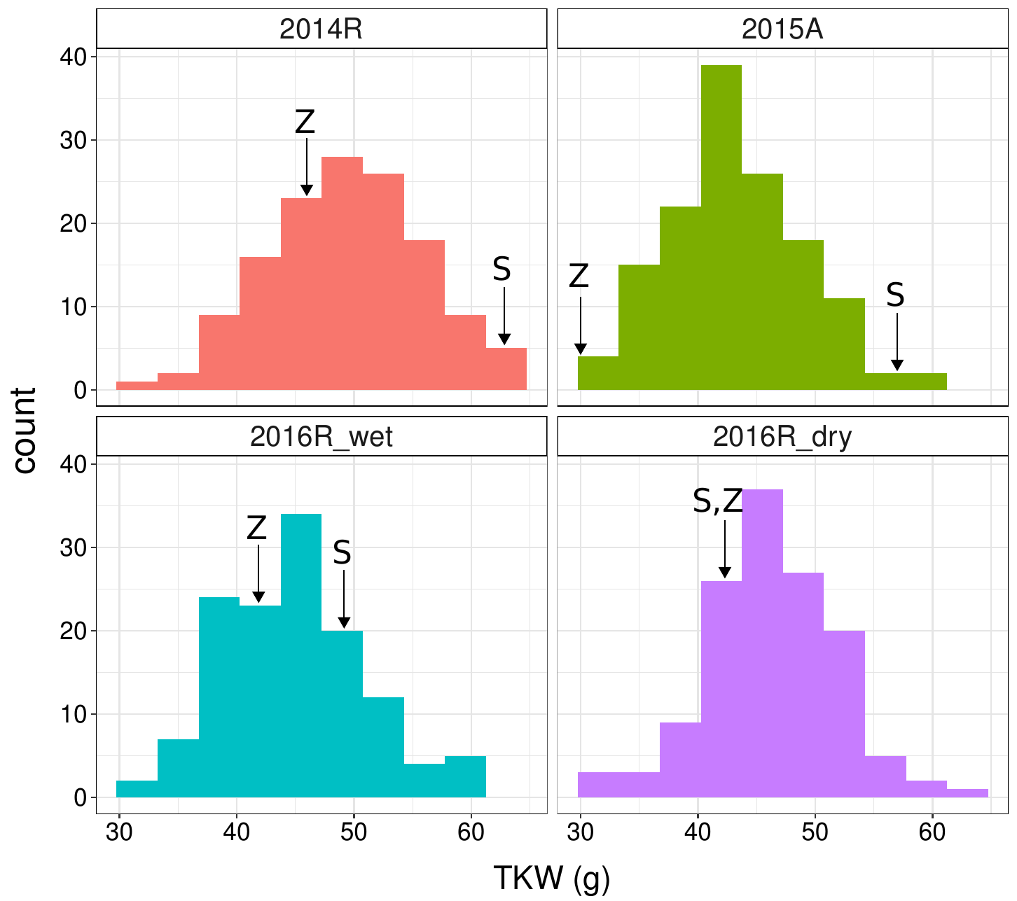
Figure S1. Distributions of thousand-kernel weight (TKW) on the Svevo × Zavitan population across four environments (2014R, 2015A, 2016R_wet and 2016R_dry). Arrows point to the mean value for the two parents Svevo (S) and Zavitan (Z).
Table S1. QTL parameters for TKW in four environments (see Table 1.)
Chromosome | Environment | LOD | P-value | PEVª | Subst.effect^{b} | Genetic Marker | Start on Zavitan | End on Zavitan
1A | 2015A | 3.006 | 0.00093 | 0.059 | 2.731 | IWA2056 | 31274191 | 31274391
1A | 2016R_ WET | 4.877 | 0.01429 | 0.069 | 2.76 | IWA8551 | 23748366 | 23748266
1B | 2015A | 10.85 | 0.01429 | 0.209 | -5.147 | IWB20542 | 373810959 | 373810859
2A | 2014R | 3.682 | 0.00093 | 0.068 | -2.949 | IWB50818 | 608897808 | 608897908
2A | 2016R_ WET | 5.322 | 0.02703 | 0.051 | -3.09 | IWB2683/IWB44472 | 643855130 | 643855230
2B | 2016R_ WET | 4.284 | 0.00187 | 0.057 | 2.684 | IWB46299 | 729462816 | 729462877
3A | 2014R | 5.622 | 0.00093 | 0.111 | 3.757 | IWB53527/IWB52086 | 416199186 | 416199259
3A | 2016R_ WET | 7.795 | 0.01429 | 0.101 | 4.363 | IWB16112 | 492095032 | 492094831
3B | 2015A | 5.471 | 0.01429 | 0.085 | 3.291 | IWB7540 | 787686011 | 787686111
4B | 2014R | 9.331 | 0.01429 | 0.06 | 2.756 | IWB72369/IWB72367 | 494965971 | 494966071
4B | 2015A | 3.719 | 0.00093 | 0.131 | 4.081 | IWB72369/IWB72367 | 494965971 | 494966071
4B | 2016R_ WET | 7.896 | 0.01429 | 0.179 | 5.799 | IWB72369/IWB72367 | 494965971 | 494966071
5A | 2014R | 5.052 | 0.01429 | 0.093 | 4.183 | IWB42031/IWB25205 | 622359795 | 622359895
5A | 2015A | 5.608 | 0.01429 | 0.095 | 3.462 | IWB686 | 611738001 | 611738101
5B | 2016R_ WET | 4.565 | 0.0028 | 0.056 | 2.678 | IWB33375 | 383073895 | 383073979
6A | 2014R | 3.784 | 0.01429 | 0.083 | -3.033 | IWB31050 | 480981917 | 500982017
6A | 2016R_DRY | 3.47 | 0.00093 | 0.053 | -2.602 | IWB31050 | 520981917 | 500982017
6A | 2016R_ WET | 4.431 | 0.01429 | 0.055 | -3.225 | IWB31050 | 531470572 | 531470672
6B | 2015A | 4.063 | 0.01429 | 0.061 | 2.77 | IWB72854 | 130241883 | 130241983
6B | 2016R_ WET | 4.411 | 0.00093 | 0.053 | 2.606 | IWB19912 | 95059978 | 95060046
7A | 2016R_DRY | 3.5 | 0.01429 | 0.082 | -3.028 | IWA7741 | 579644500 | 579644700
7A | 2016R_ WET | 3.97 | 0.00093 | 0.049 | -2.492 | IWA6562 | 641817495 | 641817695

ª Proportion of explained variance of the trait.
^{b} The adaptive effect of an allele calculated as one-half of the mean difference between homozygotes with and without the allele.

Table S2. Mean TKW of parental lines and segregating populations in the 9 independent studies used for the meta-QTL analysis.
Study | Population | Mean TKW (g) of the wild/emmer  parent | Mean TKW (g) of the durum/emmer parent | Mean TKW (g) of the population | Type of cross
Elouafi and Nachit 2004 | BC₁F₈ RIL | 28.6 | 32.1 | 29.9 | DW × WEW
Peleg et al. 2011 | RIL | 42 | 46 | 42 | DW × WEW
Peng et al. 2003 | F₃ | 10 | 30 | - | DW × WEW
Thanh et al. 2013 | F₂ | 19 | 52 (emmer) | - | DEW × WEW
Faris et al. 2014 | RIL | 28.84 (emmer) | 55.12 | 40.84 | DW × DEW
Russo et al. 2014 | RIL | 58, 45.5 (emmer) | 74, 54.5 | 58.9, 56.9 | DW × DEW
Golan et al. 2015 | RIL | 42 | 49.7 | - | DW × WEW
Tzarfati et al 2014 | RIL | 48, 45 | 56, 51 | - | DW × WEW
Avni et al. 2018 | RIL | 45.8, 29.7 | 61.8, 56.5 | 49.6, 43.1 | DW × WEW

Table S3. Significance of 6A TKW QTL between Svevo and Zavitan alleles in the RIL population. RILs were grouped by their parental allele at the peak QTL marker – IWB31050, significance was determined using a t-test. The table shows mean ± standard error.
 | Svevo Allele | Zavitan Allele | pv
2016R-WL | 45.5±0.7 | 47.4±0.6 | 0.035
2016R- WET | 43.8±0.7 | 46.3±0.8 | 0.014
2014R | 48.1±0.8 | 51.4±0.9 | 0.005

Table S4. Genotypes used for allelic diversity study with molecular marker for the presence of GRF4-Az and GRF4-Ag
Label | Location | Accession | Species | Improvement status | GRF4_allele
WE-1 | Central Israel | PI 471021 | dicoccoides | wild | -
WE-2 | Northern Israel | PI 538673 | dicoccoides | wild | -
WE-4 | Central Israel | PI 471038 | dicoccoides | wild | -
WE-6 | Qazerin, Syria | PI 466946 | dicoccoides | wild | -
WE-7 | Northern Israel | Qazerin (UH 5) | dicoccoides | wild | -
WE-8 | Northern Israel | PI 466957 | dicoccoides | wild | -
WE-9 | Northern Israel | Nesher (UH 27) | dicoccoides | wild | -
WE-10 | Central Israel | PI 471060 | dicoccoides | wild | GRF4-Az
WE-11 | Northern Israel | Zavitan | dicoccoides | wild | GRF4-Az
WE-12 | Northern, Israel | PI 467008 | dicoccoides | wild | GRF4-Az
WE-14 | Central Israel | PI 470962 | dicoccoides | wild | -
WE-15 | Central Israel | PI 466950 | dicoccoides | wild | -
WE-16 | Central Lebanon | PI 428132 | dicoccoides | wild | -
WE-17 | Central Lebanon | PI 352322 | dicoccoides | wild | -
WE-18 | Northern Israel | Mt. Hermon (UH 1) | dicoccoides | wild | -
WE-19 | Central Israel | Mt. Gerizim (UH 17) | dicoccoides | wild | -
WE-20 | Halab, Syria | PI 487264 | dicoccoides | wild | -
WE-21 | Iraq | Iraq (UH 41) | dicoccoides | wild | -
WE-22 | Central Lebanon | PI 428129 | dicoccoides | wild | -
WE-23 | Central Turkey | PI 428066 | dicoccoides | wild | -
WE-24 | Diyarbakir, Turkey | PI 428084 | dicoccoides | wild | -
WE-25 | Karacadag, Turkey | PI 538666 | dicoccoides | wild | -
WE-26 | Diyarbakir, Turkey | PI 428054 | dicoccoides | wild | -
WE-29 | Diyarbakir, Turkey | PI 538642 | dicoccoides | wild | -
WE-30 | Diyarbakir, Turkey | PI 428072 | dicoccoides | wild | -
WE-31 | Central Turkey | PI 428070 | dicoccoides | wild | -
WE-32 | Diyarbakir, Turkey | PI 428036 | dicoccoides | wild | -
WE-33 | Diyarbakir, Turkey | PI 428025 | dicoccoides | wild | -
WE-34 | Diyarbakir, Turkey | PI 538631 | dicoccoides | wild | -
G18-16 | Gitit, Israel |  | dicoccoides | wild | GRF4-Ag
DE-1 | Oman | PI 532302 | dicoccum | domesticated | -
DE-2 | India | PI 322232 | dicoccum | domesticated | -
DE-3 | Central Turkey | PI 319868 | dicoccum | domesticated | -
DE-4 | Central Turkey | PI 319869 | dicoccum | domesticated | -
DE-5 | Central Israel | PI 352347 | dicoccum | domesticated | -
DE-6 | Southern Turkey | PI 355454 | dicoccum | domesticated | -
DE-7 | Central Israel | PI 355496 | dicoccum | domesticated | -
DE-8 | Central Israel | PI 352357 | dicoccum | domesticated | -
DE-10 | Central Israel | PI 352367 | dicoccum | domesticated | -
DE-11 | Southern Turkey | PI 352352 | dicoccum | domesticated | -
DE-12 | Central Turkey | PI 182743 | dicoccum | domesticated | -
DE-14 | Italy | PI 352361 | dicoccum | domesticated | -
DE-15 | Spain | PI 191091 | dicoccum | domesticated | -
DE-16 | Spain | PI 276007 | dicoccum | domesticated | -
DE-17 | Central Turkey | PI 606325 | dicoccum | domesticated | -
DE-18 | Central Turkey | PI 352329 | dicoccum | domesticated | -
DE-19 | Ukraine | PI 94741 | dicoccum | domesticated | -
DE-20 | Slovenia | PI 377658 | dicoccum | domesticated | -
DE-21 | Croatia | PI 264964 | dicoccum | domesticated | -
DE-22 | Bosnia and Herzegovnia | PI 434995 | dicoccum | domesticated | -
DE-23 | Iran | PI 254158 | dicoccum | domesticated | -
DE-24 | Iran | PI 254169 | dicoccum | domesticated | -
DE-26 | Central Turkey | PI 470739 | dicoccum | domesticated | -
DE-27 | Central Turkey | PI 470738 | dicoccum | domesticated | -
DE-28 | Armenia | PI 94661 | dicoccum | domesticated | -
DE-29 | Central Turkey | PI 470737 | dicoccum | domesticated | -
DE-30 | Georgia | PI 326312 | dicoccum | domesticated | -
DDW | Italy | Svevo | Durum | domesticated | -

