Supporting Information

Synthesis and Antiviral Activity of Novel Myricetin Derivatives Containing a Ferulic Acid Amide Scaffolds
Xu Tang^{1,†}, Cheng Zhang^{1,†}, Mei Chen¹, Yining Xue², Tingting Liu¹, Wei Xue^{1,*}
¹ State Key Laboratory Breeding Base of Green Pesticide and Agricultural Bioengineering, Key Laboratory of Green Pesticide and Agriculture Bioengineering, Ministry of Education, Gui zhou University, Huaxi District, Guiyang 550025, P. R. China.
² College of Chemistry, Chemical Engineering and Environment, Minnan Normal University, Zhang zhou, 363000, P. R. China.
E-Mails: tx1173182020@163.com (X. T.); zhangcheng6954@163.com (C. Z.); 18208697744 @163.com (M. C.); iotaix@163.com(Y. X); ltt15642332007@163.com (T. L).
† These authors contributed equally to this work.
*Corresponding author: Wei Xue; e-mail: wxue@gzu.edu.cn (W. X.); Tel/Fax: 0086-851-88292090

Content
The physical properties of compounds 4a-4v 3
Characterization of intermediate compounds 2a-2j 4
Characterization of title compounds 4a-4v 15
¹H NMR, ¹³C NMR, ¹⁹F NMR and HRMS spectrum of the title compounds 4a-4v 25

The physical properties of compounds 4a-4v
Table 1 The physical properties of compounds 4a-4v
Compounds | R₂ | n | Appearance | Yield /% | m.p./ºC
4a | 4-CH₃ | 3 | Gray solid | 215.4-215.5 | 58.6
4b | 4-OCH₃ | 3 | Gray solid | 190.3-190.5 | 39.1
4c | 4-CH₃ | 4 | Gray solid | 100.1-101.9 | 51.4
4d | 4-OCH₃ | 4 | Gray solid | 108.6-109.8 | 63.6
4e | 3-Cl | 3 | Yellow solid | 187.2-187.5 | 49.6
4f | 3-Cl | 4 | Gray solid | 104.1-104.9 | 55.5
4g | 4-Cl | 4 | Gray solid | 103.3-104.8 | 62.0
4h | H | 4 | Yellow solid | 116.4-116.7 | 60.3
4i | H | 3 | Yellow solid | 242.5-242.9 | 49.7
4j | 3,4-di-CH₃ | 3 | Gray solid | 202.5-202.9 | 83.9
4k | 3,4-di-CH₃ | 4 | Gray solid | 107.3-108.1 | 48.3
4l | 3,4-di-OCH₃ | 3 | Green solid | 118.0-118.7 | 65.33
4m | 3,4-di-OCH₃ | 4 | Green solid | 95.3-96.1 | 59.6
4n | 4-Br | 3 | Gray solid | 208.4-209.6 | 67.9
4o | 4-Br | 4 | Gray solid | 180.3-181.6 | 58.2
4p | 3,4-di-Cl | 3 | Yellow solid | 118.6-119.3 | 65.5
4q | 3,4-di-Cl | 4 | Gray solid | 102.3-103.4 | 51.7
4r | 4-Cl | 5 | Gray solid | 112.3-112.9 | 58.2
4s | 3-Cl | 5 | Gray solid | 153.5-154.1 | 62.8
4t | 4-OCH₃ | 5 | Gray solid | 123.6-124.7 | 64.7
4u | 2-F | 3 | Gray solid | 117.6-118.3 | 54.8
4v | 2-F | 4 | Gray solid | 162.3-163.6 | 66.7

Characterization of intermediate compounds 2a-2j
(E)-3-(4-hydroxy-3-methoxyphenyl)-N-(4-methylphenyl)acrylamide (2a): Yellow solid, yield : 62.14 %, m.p. 137.7 – 138.3, ¹H NMR (500 MHz, DMSO) δ 10.07 (s, 1H, OH), 9.60 (s, 1H, NH), 7.63 (d, J = 8.4 Hz, 2H, Ph-2H), 7.51 (d, J = 15.6 Hz, 1H, CO-C=CH), 7.22 (t, J = 5.0 Hz, 1H, CO-CH=), 7.17 (d, J = 8.3 Hz, 2H, Ph-2H), 7.10 (dt, J = 5.9, 2.9 Hz, 1H, Ph-H), 6.86 (t, J = 7.7 Hz, 1H, Ph-H), 6.67 (d, J = 15.6 Hz, 1H, Ph-H), 3.87 (s, 3H, OCH₃), 2.29 (d, J = 11.3 Hz, 3H, CH₃).
Figure S1. ¹H NMR spectrum of intermediate 2a
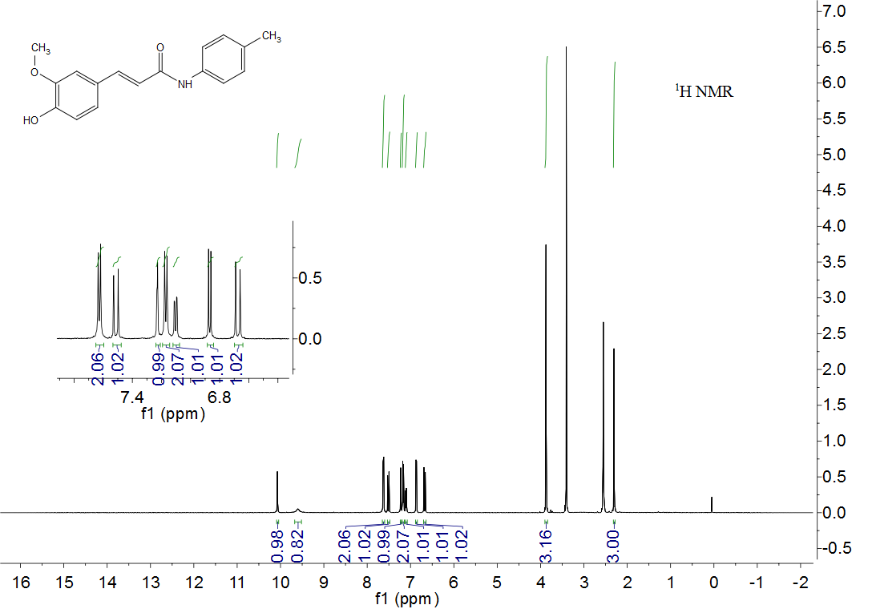

(E)-3-(4-hydroxy-3-methoxyphenyl)-N-(4-methoxyphenyl)acrylamide (2b): Gray solid, yield : 57.23 %, m.p. 163.1 – 163.7, ¹H NMR (500 MHz, DMSO) δ 10.01 – 9.83 (m, 1H, OH), 9.46 (s, 1H, NH), 7.60 – 7.54 (m, 2H, Ph-2H), 7.42 (d, J = 15.6 Hz, 1H, CO-CH=CH), 7.14 (d, J = 1.6 Hz, 1H, Ph-H), 7.01 (dt, J = 11.8, 5.9 Hz, 1H, CO-CH=), 6.89 – 6.84 (m, 2H, Ph-2H), 6.79 (d, J = 8.1 Hz, 1H, Ph-H), 6.57 (d, J = 15.6 Hz, 1H, Ph-H), 3.79 (s, 3H, OCH₃), 3.68 (d, J = 10.1 Hz, 3H, OCH₃).
Figure S2. ¹H NMR spectrum of intermediate 2b
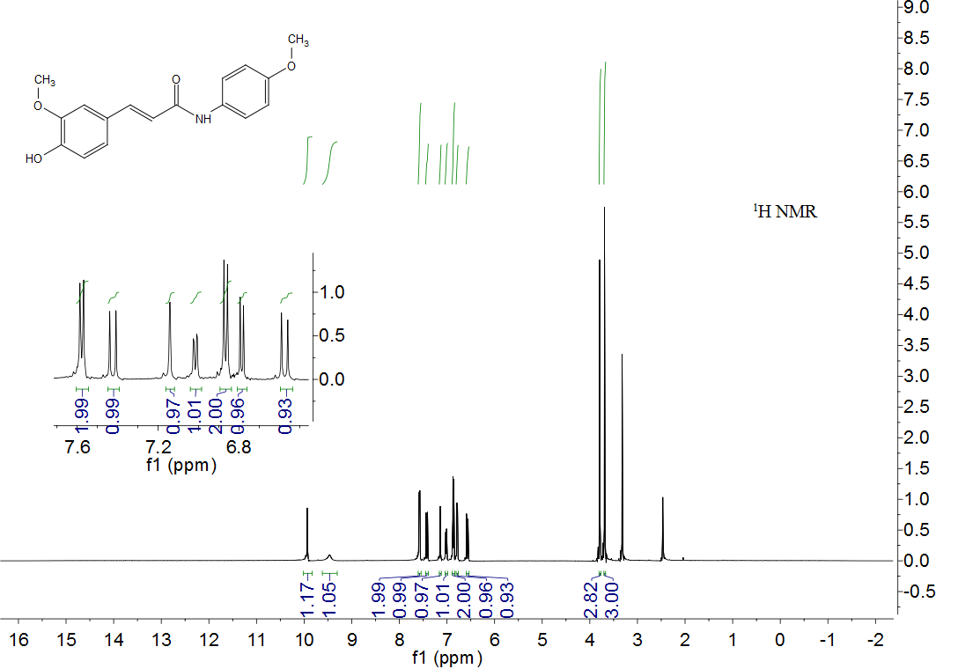

(E)-3-(4-hydroxy-3-methoxyphenyl)-N-(3-chlorophenyl)acrylamide (2c) : Yellow solid, yield : 60.63 %, m.p. 172.3 – 173.2, ¹H NMR (500 MHz, DMSO) δ 10.29 (s, 1H, OH), 9.59 (s, 1H, NH), 7.94 (t, J = 2.0 Hz, 1H, Ph-H), 7.53 – 7.47 (m, 2H, Ph-2H), 7.35 (t, J = 8.1 Hz, 1H, CO-CH=CH), 7.19 (d, J = 1.9 Hz, 1H, CO-CH=), 7.12 – 7.05 (m, 2H, Ph-2H), 6.82 (d, J = 8.1 Hz, 1H, Ph-H), 6.60 (d, J = 15.6 Hz, 1H, Ph-2H), 3.82 (s, 3H, OCH₃).

Figure S3. ¹H NMR spectrum of intermediate 2c

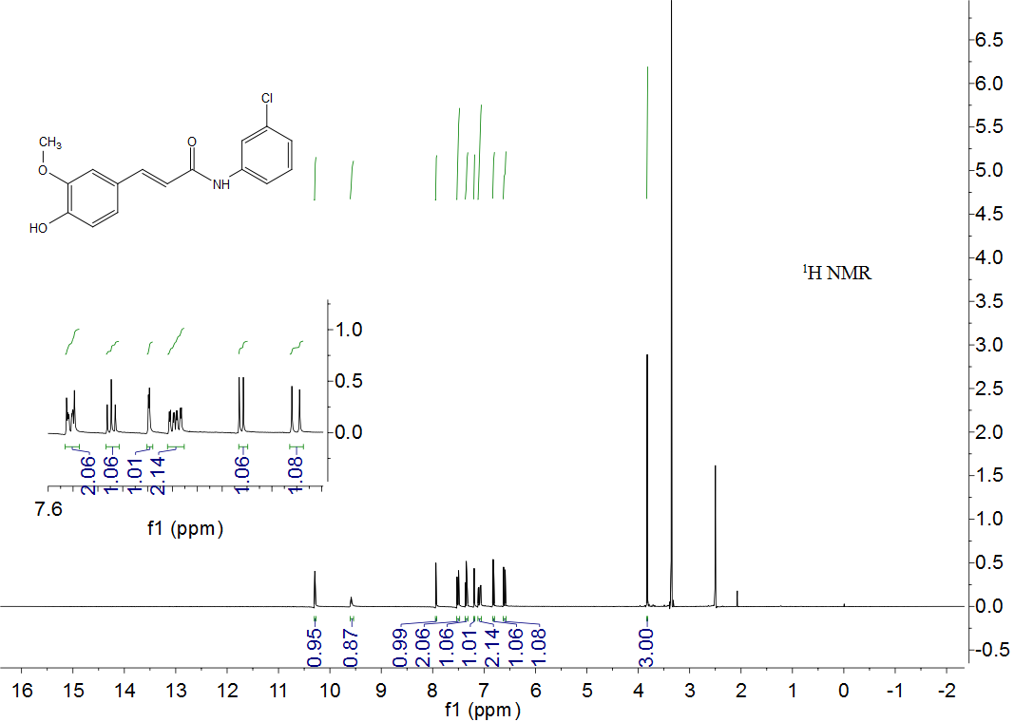

(E)-3-(4-hydroxy-3-methoxyphenyl)-N-(4-chlorophenyl)acrylamide (2d) : Gray solid, yield : 56.92 %, m.p. 234.7 – 235.2, ¹H NMR (500 MHz, DMSO) δ 10.24 (s, 1H, OH), 9.57 (s, 1H, NH), 7.75 – 7.68 (m, 2H, Ph-2H), 7.50 (d, J = 15.4 Hz, 1H, CO-CH=CH), 7.40 – 7.34 (m, 2H, Ph-2H), 7.19 (s, 1H, Ph-H), 7.06 (t, J = 11.3 Hz, 1H, CO-CH=), 6.82 (dd, J = 8.1, 1.0 Hz, 1H, Ph-H), 6.64 – 6.57 (m, 1H, Ph-H), 3.81 (t, J = 7.8 Hz, 3H, OCH₃).

Figure S4. ¹H NMR spectrum of intermediate 2d
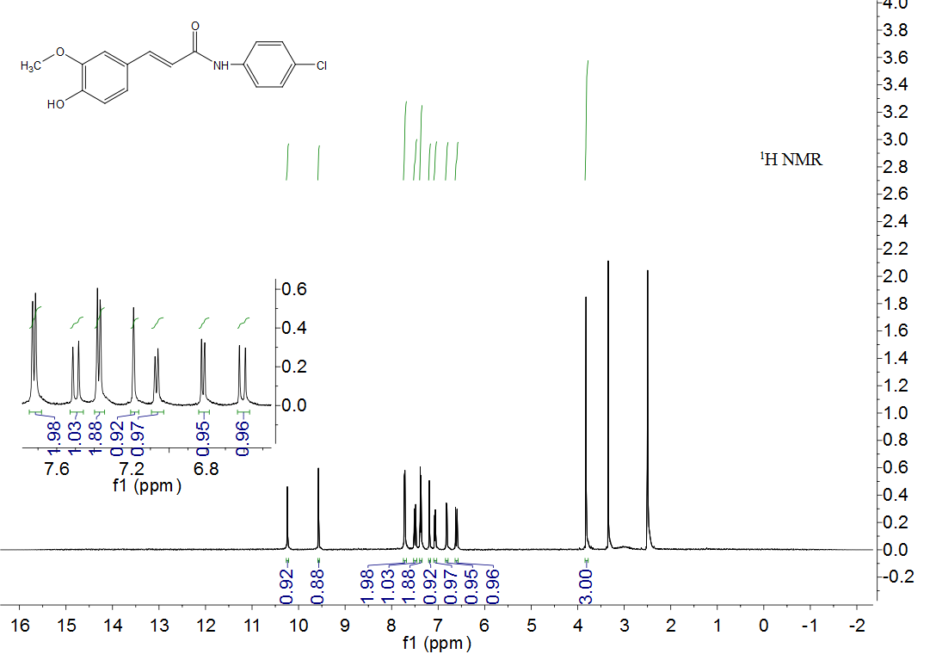

(E)-3-(4-hydroxy-3-methoxyphenyl)-N-phenylacrylamide (2e) : Yellow solid, yield : 63.74 %, m.p. 120.3 – 121.1, ¹H NMR (500 MHz, DMSO) δ 10.13 (s, 1H, OH), 9.58 (s, 1H, NH), 7.74 – 7.70 (m, 2H, Ph-2H), 7.52 (d, J = 15.6 Hz, 1H, CO-CH=CH), 7.34 (dd, J = 16.1, 8.0 Hz, 2H, Ph-2H), 7.22 (d, J = 1.8 Hz, 1H, CO-CH=), 7.11 – 7.04 (m, 2H, Ph-2H), 6.85 (dd, J = 11.1, 6.1 Hz, 1H, Ph-H), 6.67 (d, J = 15.6 Hz, 1H, Ph-H), 3.86 (s, 3H, OCH₃).

Figure S5. ¹H NMR spectrum of intermediate 2e

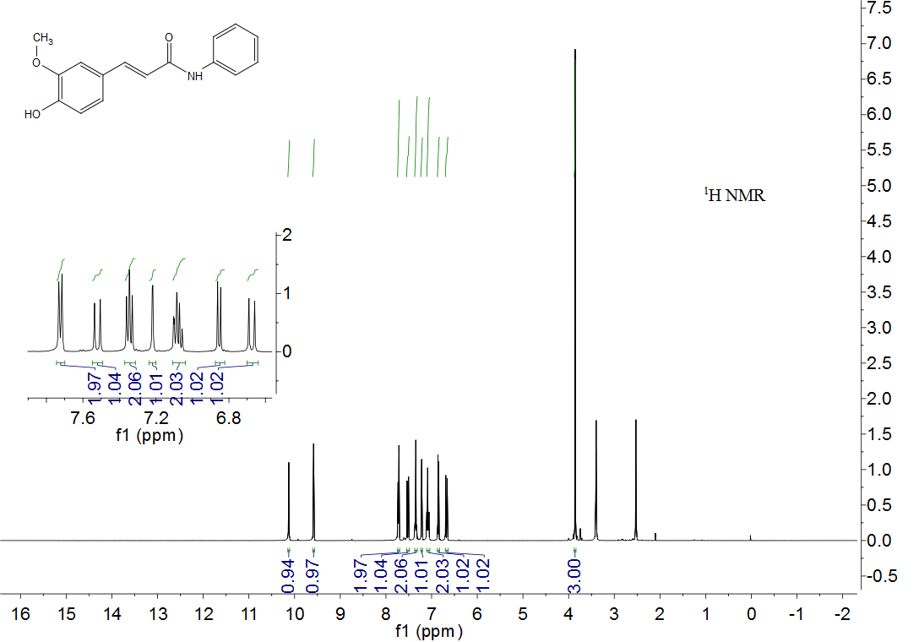

(E)-3-(4-hydroxy-3-methoxyphenyl)-N-(3,4-dimethylphenyl)acrylamide (2f) : Gray solid, yield : 67.38 %, m.p. 182.4 – 183.6, ¹HNMR (500 MHz, DMSO) δ 9.90 (s, 1H), 9.49 (s, 1H), 7.40 (ddd, J = 10.2, 7.5, 3.6 Hz, 3H), 7.13 (d, J = 1.9 Hz, 1H), 7.04 – 7.00 (m, 2H), 6.80 – 6.76 (m, 1H), 6.59 (dd, J = 16.0, 5.4 Hz, 1H), 3.79 (s, 3H), 2.16 (s, 3H), 2.13 (s, 3H).

Figure S6. ¹H NMR spectrum of intermediate 2f

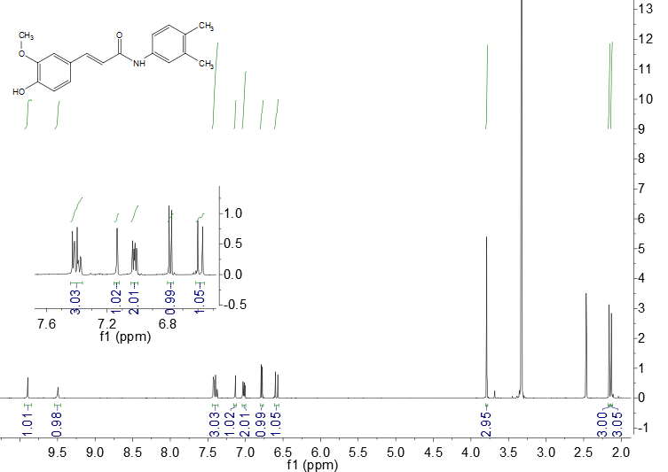

(E)-3-(4-hydroxy-3-methoxyphenyl)-N-(3,4-dimethoxyphenyl)acrylamide (2g) : Purple solid, yield : 72.85 %, m.p. 91.2 – 91.7, ¹H NMR (500 MHz, DMSO) δ 9.96 (s, 1H, OH), 9.52 (s, 1H, NH), 7.43 (dd, J = 15.2, 9.0 Hz, 2H, Ph-2H), 7.21 – 7.15 (m, 2H, Ph-2H), 7.04 (dd, J = 8.2, 1.9 Hz, 1H, CO-CH=CH), 6.90 (d, J = 8.8 Hz, 1H, Ph-H), 6.83 – 6.80 (m, 1H, CO-CH=), 6.60 (d, J = 15.6 Hz, 1H, Ph-H), 3.82 (s, 3H, OCH3), 3.74 (s, 3H, OCH3), 3.72 (s, 3H, OCH3).

Figure S7. ¹H NMR spectrum of intermediate 2g

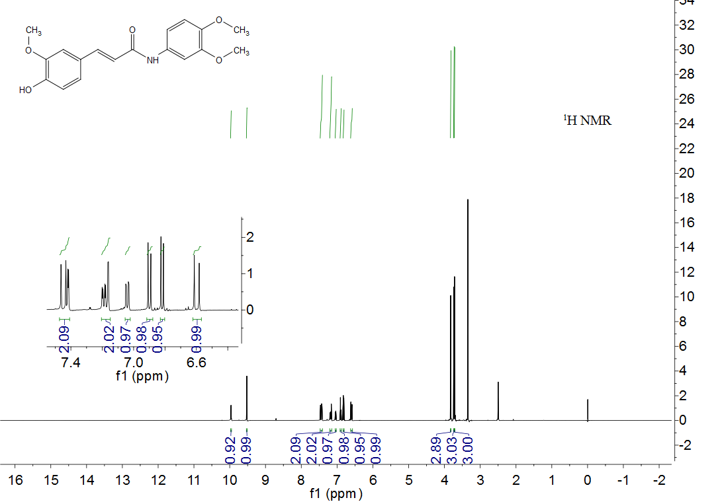

(E)-3-(4-hydroxy-3-methoxyphenyl)-N-(4-bromophenyl)acrylamide (2h) : Gray solid, yield : 54.73 %, m.p. 205.3 – 206.7, ¹H NMR (500 MHz, CDCl₃) δ 10.24 (s, 1H, OH), 9.57 (s, 1H, NH), 7.69 – 7.63 (m, 2H, Ph-2H), 7.52 – 7.46 (m, 3H, Ph-3H), 7.19 (d, J = 1.9 Hz, 1H, CO-CH=CH), 7.07 (dd, J = 8.2, 1.9 Hz, 1H, CO-CH=), 6.84 – 6.79 (m, 1H, Ph-H), 6.61 (d, J = 15.6 Hz, 1H, Ph-H), 3.82 (s, 3H, OCH₃).

Figure S8. ¹H NMR spectrum of intermediate 2h

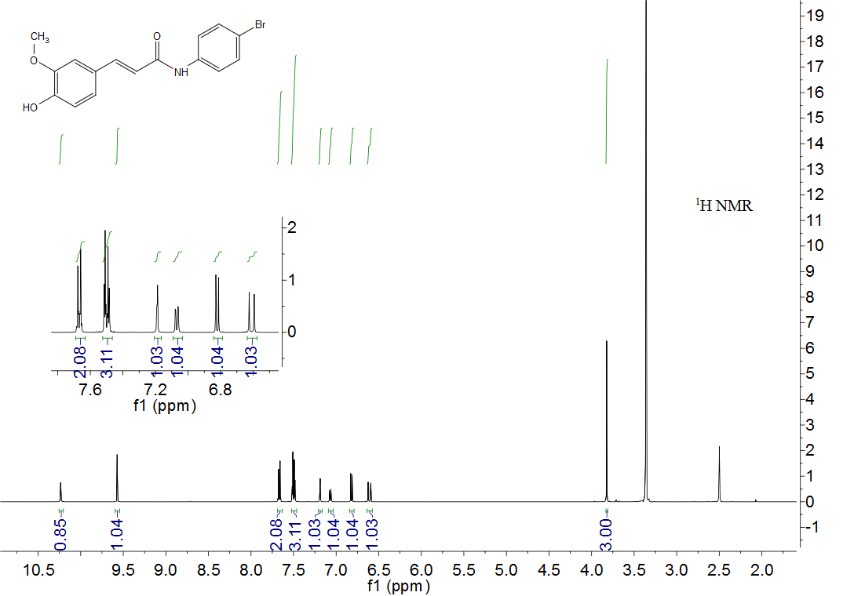

(E)-3-(4-hydroxy-3-methoxyphenyl)-N-(3,4-dichlorophenyl)acrylamide (2i) : Yellow solid, yield : 54.33 %, m.p. 224.4 – 224.9, ¹H NMR (500 MHz, DMSO) δ 10.40 (s, 1H, OH), 9.59 (s, 1H, NH), 8.11 (d, J = 2.1 Hz, 1H, Ph-H), 7.59 – 7.55 (m, 2H, Ph-2H), 7.52 (d, J = 15.6 Hz, 1H, CO-CH=CH), 7.20 (d, J = 1.9 Hz, 1H, Ph-H), 7.07 (dt, J = 6.8, 3.4 Hz, 1H, CO-CH=), 6.82 (t, J = 7.6 Hz, 1H, Ph-H), 6.58 (d, J = 15.6 Hz, 1H, Ph-H), 3.82 (s, 3H, OCH₃).

Figure S9. ¹H NMR spectrum of intermediate 2i

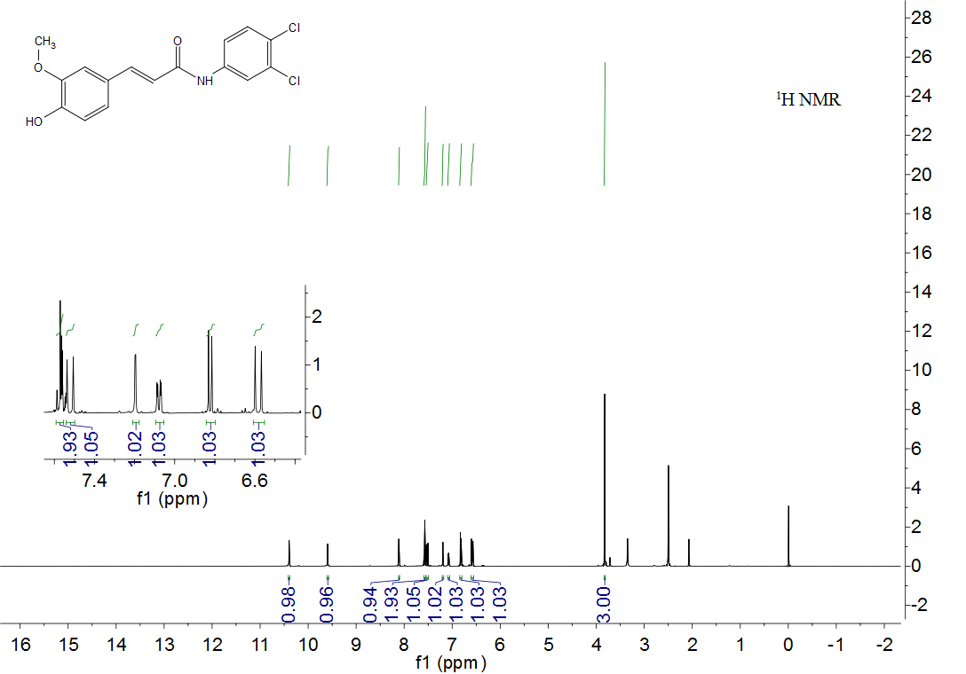

(E)-3-(4-hydroxy-3-methoxyphenyl)-N-(2-fluorophenyl)acrylamide (2j), Yellow solid, yield : 73.34 %, m.p. 190.2 - 190. ¹H NMR (400 MHz, DMSO) δ 9.78 (s, 1H), 9.54 (s, 1H), 8.12 (td, J = 8.0, 1.6 Hz, 1H), 7.50 (d, J = 15.6 Hz, 1H), 7.27 (ddd, J = 11.2, 7.9, 1.6 Hz, 1H), 7.22 – 7.11 (m, 3H), 7.07 (dd, J = 8.2, 1.7 Hz, 1H), 6.89 (d, J = 15.6 Hz, 1H), 6.83 (d, J = 8.1 Hz, 1H), 3.83 (s, 3H), ¹⁹F NMR (376 MHz, DMSO) δ -125.57 (s).

Figure S10. ¹H NMR spectrum of intermediate 2j

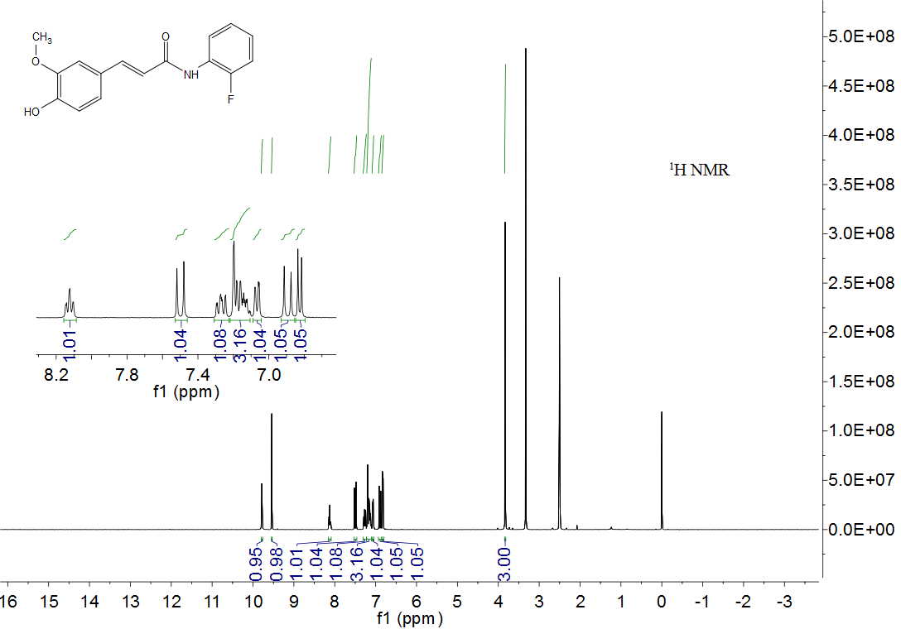

Figure S11. ¹⁹F NMR spectrum of intermediate 2j

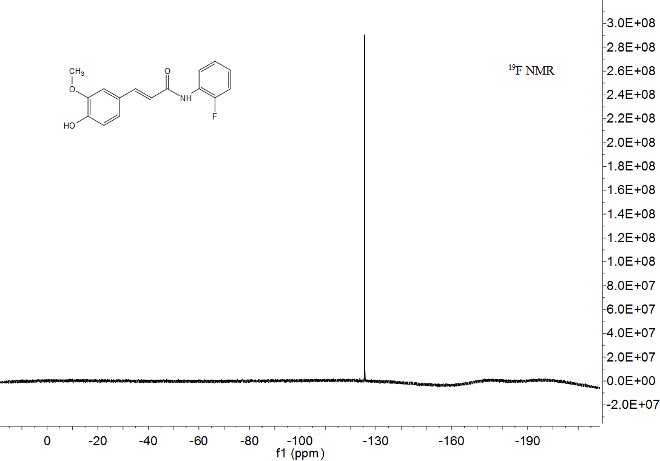

Characterization of title compounds 4a-4v
(E)-3-(4-(3-((5,7-dimethoxy-4-oxo-2-(3,4,5-trimethoxyphenyl)-4H-chromen-3-yl)oxy)propoxy)-3-methoxyphenyl)-N-(p-tolyl)acrylamide (4a) : gray solid, m.p. 215.4-215.5, yield : 58.68 %, ¹H NMR (400 MHz, CDCl₃) δ 8.01 (s, 1H, NH), 7.63 (t, J = 11.8 Hz, 1H, Ph-H), 7.57 (d, J = 7.1 Hz, 2H, Ph-2H), 7.32 (s, 2H, Ph-2H), 7.13 (d, J = 8.2 Hz, 2H, Ph-2H), 7.00 (d, J = 8.3 Hz, 1H, CO-CH=CH), 6.95 (s, 1H, Ph-H), 6.74 (d, J = 8.3 Hz, 1H, Ph-H), 6.51 (d, J = 2.1 Hz, 1H, Ph-H), 6.47 (s, 1H, CO-CH=), 6.36 (d, J = 2.2 Hz, 1H, Ph-H), 4.23 (t, J = 5.9 Hz, 2H, CH₂), 4.18 (t, J = 6.7 Hz, 2H, CH₂), 3.94 (s, 3H, OCH₃), 3.92 (d, J = 3.4 Hz, 6H, 2×OCH₃), 3.88 (s, 6H, 2×OCH₃), 3.77 (s, 3H, OCH₃), 2.31 (d, J = 9.9 Hz, 3H, CH₃), 2.25 (dd, J = 12.6, 6.3 Hz, 2H, CH₂), ¹³C NMR (101 MHz, CDCl₃) δ 174.07, 164.12, 163.82, 160.99, 158.83, 153.02, 152.77, 150.00, 149.22, 141.68, 140.56, 140.00, 129.51, 127.77, 125.94, 121.78, 119.88, 112.61, 110.41, 109.35, 105.91, 95.89, 92.49, 69.26, 66.00, 61.01, 56.38, 56.30, 55.86, 55.77, 30.13, 20.91, HRMS calcd for C₄₀H₄₁NO₁₁[M+H]⁺: 712.2753, found 712.2752.
(E)-3-(4-(3-((5,7-dimethoxy-4-oxo-2-(3,4,5-trimethoxyphenyl)-4H-chromen-3-yl)oxy)propoxy)-3-methoxyphenyl)-N-(4-methoxyphenyl)acrylamide (4b) : gray solid, m.p. 190.3- 190.5, yield : 39.19 %, ¹H NMR (400 MHz, CDCl₃) δ 8.20 (s, 1H, Ph-H), 7.67 (d, J = 5.0 Hz, 1H, Ph-H), 7.66 – 7.61 (m, 2H, Ph-2H), 7.35 (s, 2H, Ph-2H), 7.01 (d, J = 8.3 Hz, 1H, CO-CH=CH), 6.96 (s, 1H, Ph-H), 6.89 (d, J = 8.8 Hz, 2H, Ph-2H), 6.76 (d, J = 8.3 Hz, 1H, CO-CH=), 6.56 – 6.48 (m, 2H, Ph-2H), 6.38 (d, J = 2.0 Hz, 1H, Ph-H), 4.25 (t, J = 5.9 Hz, 2H, CH₂), 4.19 (t, J = 6.6 Hz, 2H, CH₂), 3.97 – 3.92 (m, 9H, 3×OCH₃), 3.90 (s, 6H, 2×OCH₃), 3.81 (s, 3H, OCH₃), 3.77 (s, 3H, OCH₃), 2.34 – 2.20 (m, 2H, CH₂), ¹³C NMR (101 MHz, CDCl₃) δ 174.07, 164.36, 164.13, 160.97, 158.83, 156.20, 153.02, 152.79, 149.94, 149.20, 141.40, 140.56, 140.00, 131.82, 127.83, 125.93, 121.68, 121.52, 119.15, 114.14, 112.61, 110.44, 109.33, 105.90, 95.90, 92.50, 77.39, 77.07, 76.76, 69.27, 65.99, 61.01, 56.36, 56.30, 55.86, 55.75, 55.48, 30.14, HRMS calcd for C₄₀H₄₁NO₁₂[M+H]⁺: 728.2701, found 712.2691.
(E)-3-(4-(4-((5,7-dimethoxy-4-oxo-2-(3,4,5-trimethoxyphenyl)-4H-chromen-3-yl)oxy)butoxy)-3-methoxyphenyl)-N-(p-tolyl)acrylamide (4c) : gray solid, m. p.100.1-101.9, yield : 51.49 %, ¹H NMR (400 MHz, DMSO) δ 10.05 (s, 1H, NH), 7.59 (d, J = 8.4 Hz, 2H, Ph-2H), 7.50 (d, J = 15.5 Hz, 1H, CO-CH=CH), 7.40 (s, 2H, Ph-2H), 7.20 (d, J = 1.8 Hz, 1H, Ph-H), 7.14 (dd, J = 8.5, 3.7 Hz, 2H, Ph-2H), 7.12 (s, 1H, CO-CH=), 6.98 (d, J = 8.4 Hz, 1H, Ph-H), 6.85 (d, J = 2.2 Hz, 1H, Ph-H), 6.68 (d, J = 15.6 Hz, 1H, Ph-H), 6.50 (d, J = 2.3 Hz, 1H, Ph-H), 4.05 – 3.96 (m, 4H, 2×CH2), 3.90 (s, 3H, OCH₃), 3.87 (s, 6H, 2×OCH₃), 3.85 (s, 3H, OCH₃), 3.81 (s, 3H, OCH₃), 3.75 (s, 3H, OCH₃), 2.26 (s, 3H, CH₃), 1.84 (s, 4H, 2×CH₂), 13C NMR (126 MHz, DMSO) δ 172.74, 164.29, 164.17, 160.80, 158.70, 153.23, 152.11, 150.16, 149.56, 140.54, 140.45, 139.88, 137.49, 132.60, 129.70, 127.97, 126.15, 122.21, 120.40, 119.58, 113.18, 110.59, 108.97, 106.16, 93.62, 71.77, 68.26, 60.71, 56.61, 56.56, 55.89, 26.84, 25.91, 21.02, HRMS calcd for C₄₁H₄₃NO₁₁[M+H]⁺: 726.2908, found 712.2904.
(E)-3-(4-(4-((5,7-dimethoxy-4-oxo-2-(3,4,5-trimethoxyphenyl)-4H-chromen-3-yl)oxy)butoxy)-3-methoxyphenyl)-N-(4-methoxyphenyl)acrylamide (4d) : gray solid, m. p.108.6- 109.8, yield : 63.54 %, ¹H NMR (400 MHz, DMSO) δ 10.01 (s, 1H, NH), 7.62 (d, J = 9.1 Hz, 2H, Ph-2H), 7.52 – 7.45 (m, 1H, CO-CH=CH), 7.40 (s, 2H, Ph-2H), 7.21 – 7.18 (m, 1H, Ph-H), 7.14 (dd, J = 8.4, 1.7 Hz, 1H, CO-CH=), 6.98 (d, J = 8.4 Hz, 1H, Ph-H), 6.93 – 6.87 (m, 2H, Ph-2H), 6.84 (t, J = 4.0 Hz, 1H, Ph-H), 6.67 (d, J = 15.6 Hz, 1H, Ph-H), 6.50 (d, J = 2.3 Hz, 1H, Ph-H), 4.01 (dd, J = 6.0, 3.2 Hz, 4H, 2×CH₂), 3.90 (s, 3H, OCH₃), 3.87 (s, 6H, 2×OCH₃), 3.84 (d, J = 3.1 Hz, 3H, OCH₃), 3.80 (s, 3H, OCH₃), 3.74 (d, J = 5.6 Hz, 6H, 2×OCH₃), 1.84 (s, 4H, 2×CH₂), ¹³C NMR (101 MHz, DMSO) δ 172.68, 164.23, 163.86, 160.75, 158.64, 155.62, 153.17, 152.05, 150.06, 149.51, 140.39, 140.22, 139.84, 133.13, 127.97, 126.09, 122.09, 120.97, 120.40, 114.38, 113.16, 110.53, 108.92, 106.12, 96.39, 93.57, 71.72, 68.21, 60.65, 56.51, 55.84, 55.62, 26.78, 25.85, HRMS calcd for C₄₁H₄₃NO₁₂[M+H]⁺: 742.2858, found 712.2840.
(E)-N-(3-chlorophenyl)-3-(3-(3-((5,7-dimethoxy-4-oxo-2-(3,4,5-trimethoxyphenyl)-4H-chromen-3-yl)oxy)propoxy)-4-methoxyphenyl)acrylamide (4e) : yellow solid, m.p. 187.2- 187.5, yield : 49.65 %, ¹H NMR (400 MHz, DMSO) δ 10.34 (s, 1H, NH), 7.97 (t, J = 2.0 Hz, 1H, Ph-H), 7.59 – 7.51 (m, 2H, Ph-2H), 7.40 – 7.34 (m, 3H, Ph-3H), 7.21 (t, J = 5.4 Hz, 1H, CO-CH=CH), 7.19 – 7.10 (m, 2H, Ph-2H), 6.90 (d, J = 8.4 Hz, 1H, CO-CH=), 6.84 (d, J = 2.2 Hz, 1H, Ph-H), 6.68 (d, J = 15.6 Hz, 1H, Ph-H), 6.50 (d, J = 2.3 Hz, 1H, Ph-H), 4.16 – 4.12 (m, 2H, CH₂), 4.09 (t, J = 6.4 Hz, 2H, CH₂), 3.91 (s, 3H, OCH₃), 3.86 (d, J = 1.7 Hz, 9H, 3×OCH₃), 3.80 (s, 3H, OCH₃), 3.75 (s, 3H, OCH₃), 2.13 (p, J = 6.2 Hz, 2H, CH₂), ¹³C NMR (101 MHz, DMSO) δ 172.66, 164.61, 164.23, 160.74, 158.64, 153.17, 152.07, 150.15, 149.50, 141.36, 140.37, 139.85, 133.58, 130.95, 127.85, 126.01, 123.31, 122.29, 119.81, 118.99, 117.95, 113.08, 110.72, 108.90, 106.18, 96.38, 93.55, 69.25, 65.71, 60.64, 56.54, 56.48, 55.85, 49.07, 30.11, HRMS calcd for C₃₉H₃₈ClNO₁₁[M+H]⁺: 732.2206, found 732.2187.
(E)-N-(3-chlorophenyl)-3-(4-(4-((5,7-dimethoxy-4-oxo-2-(3,4,5-trimethoxyphenyl)-4H-chromen-3-yl)oxy)butoxy)-3-methoxyphenyl)acrylamide (4f) : gray solid, m. p.104.1- 104.9, yield : 55.55 %, ¹H NMR (400 MHz, DMSO) δ 10.33 (s, 1H, NH), 7.95 (t, J = 2.0 Hz, 1H, Ph-H), 7.54 (ddd, J = 6.7, 5.8, 4.2 Hz, 2H, Ph-2H), 7.40 (s, 2H, Ph-2H), 7.36 (t, J = 8.1 Hz, 1H, CO-CH=CH), 7.22 (d, J = 1.8 Hz, 1H, CO-CH=), 7.19 – 7.09 (m, 2H, Ph-2H), 6.99 (d, J = 8.4 Hz, 1H, Ph-H), 6.84 (d, J = 2.2 Hz, 1H, Ph-H), 6.67 (d, J = 15.6 Hz, 1H, Ph-H), 6.49 (d, J = 2.3 Hz, 1H, Ph-H), 4.06 – 3.96 (m, 4H, 2×CH₂), 3.90 (s, 3H, OCH₃), 3.87 (d, J = 5.8 Hz, 6H, 2×OCH₃), 3.85 (s, 3H, OCH₃), 3.82 (s, 3H, OCH₃), 3.75 (s, 3H, OCH₃), 1.84 (s, 4H, 2×CH₂), ¹³C NMR (101 MHz, DMSO) δ 172.67, 164.63, 164.21, 160.74, 158.63, 153.17, 152.02, 150.32, 149.52, 141.43, 141.37, 140.39, 139.85, 133.58, 130.95, 127.68, 126.09, 123.30, 122.42, 119.71, 118.98, 117.94, 113.12, 110.62, 108.92, 106.12, 96.37, 93.55, 71.70, 68.22, 60.64, 56.53, 56.50, 55.86, 26.78, 25.85, HRMS calcd for C₄₀H₄₀ClNO₁₁[M+H]⁺: 746.2362, found 746.2345. (E)-N-(4-chlorophenyl)-3-(4-(4-((5,7-dimethoxy-4-oxo-2-(3,4,5-trimethoxyphenyl)-4H-chromen-3-yl)oxy)butoxy)-3-methoxyphenyl)acrylamide (4g) : gray solid, m. p.103.3-104.8, yield : 62.00 %, ¹H NMR (500 MHz, DMSO) δ 10.29 (s, 1H, NH), 7.74 (d, J = 7.7 Hz, 2H, Ph-2H), 7.54 (d, J = 15.5 Hz, 1H, Ph-H), 7.41 (d, J = 1.2 Hz, 3H, Ph-3H), 7.39 (s, 1H, CO-CH=CH), 7.23 – 7.15 (m, 2H, Ph-2H), 7.00 (d, J = 7.9 Hz, 1H, CO-CH=), 6.87 (s, 1H, Ph-H), 6.68 (d, J = 15.6 Hz, 1H, Ph-H), 6.51 (s, 1H, Ph-H), 4.05 – 3.98 (m, 4H, 2×CH₂), 3.91 (d, J = 1.0 Hz, 3H, OCH₃), 3.87 (d, J = 1.1 Hz, 6H, 2×OCH₃), 3.86 (s, 3H, OCH₃), 3.81 (s, 3H, OCH₃), 3.75 (d, J = 1.3 Hz, 3H, OCH₃), 1.84 (s, 4H, 2×CH₂), ¹³C NMR (101 MHz, DMSO) δ 172.68, 164.43, 164.24, 160.75, 158.65, 153.18, 152.06, 150.25, 149.51, 141.16, 140.39, 139.83, 138.88, 129.17, 127.74, 127.14, 126.09, 122.35, 121.06, 119.86, 113.13, 110.59, 108.91, 106.12, 96.41, 93.58, 71.72, 68.21, 60.66, 56.52, 55.85, 26.77, 25.84, HRMS calcd for C₄₀H₄₀ClNO₁₁[M+H]⁺: 746.2362, found 746.2351.
(E)-3-(4-(4-((5,7-dimethoxy-4-oxo-2-(3,4,5-trimethoxyphenyl)-4H-chromen-3-yl)oxy)butoxy)-3-methoxyphenyl)-N-phenylacrylamide (4h) : yellow solid, m.p.116.4-116.7, yield : 60.30 %, ¹H NMR (400 MHz, DMSO) δ 10.13 (s, 1H, NH), 7.71 (d, J = 7.6 Hz, 2H, Ph-2H), 7.53 (d, J = 15.6 Hz, 1H, CO-CH=CH), 7.41 (s, 2H, Ph-2H), 7.36 – 7.30 (m, 2H, Ph-2H), 7.22 (d, J = 1.8 Hz, 1H, CO-CH=), 7.16 (dd, J = 8.4, 1.8 Hz, 1H, Ph-H), 7.06 (t, J = 7.4 Hz, 1H, Ph-H), 6.99 (d, J = 8.4 Hz, 1H, Ph-H), 6.86 (d, J = 2.2 Hz, 1H, Ph-H), 6.71 (d, J = 15.6 Hz, 1H, Ph-H), 6.51 (d, J = 2.2 Hz, 1H, Ph-H), 4.07 – 3.96 (m, 4H, 2×CH₂), 3.91 (s, 3H, OCH₃), 3.87 (d, J = 7.5 Hz, 9H, 3×OCH₃), 3.82 (s, 3H, OCH₃), 3.75 (s, 3H, OCH₃), 1.85 (s, 4H, 2×CH₂), ¹³C NMR (101 MHz, DMSO) δ 172.68, 164.32, 164.24, 160.76, 158.65, 153.18, 152.07, 150.17, 149.53, 140.76, 140.39, 139.92, 139.88, 129.25, 127.88, 126.09, 123.63, 122.23, 120.25, 119.56, 113.19, 110.61, 108.93, 106.16, 96.40, 93.59, 71.74, 68.24, 60.66, 56.53, 55.87, 26.78, 25.85, HRMS calcd for C₄₀H₄₁NO₁₁[M+H]⁺: 712.2752, found 712.2743.
(E)-3-(4-(3-((5,7-dimethoxy-4-oxo-2-(3,4,5-trimethoxyphenyl)-4H-chromen-3-yl)oxy)propoxy)-3-methoxyphenyl)-N-phenylacrylamide (4i) : yellow solid, m.p. 242.5-242.9, yield : 49.79 %, ¹H NMR (400 MHz, CDCl₃) δ 7.99 (d, J = 22.6 Hz, 1H, Ph-H), 7.70 – 7.62 (m, 3H, Ph-3H), 7.36 – 7.29 (m, 4H, Ph-4H)), 7.10 (t, J = 7.4 Hz, 1H, CO-CH=CH)), 7.01 (d, J = 8.3 Hz, 1H, CO-CH=), 6.95 (s, 1H, Ph-H), 6.75 (d, J = 8.3 Hz, 1H, Ph-H), 6.54 – 6.43 (m, 2H, Ph-2H), 6.35 (t, J = 4.8 Hz, 1H, Ph-H), 4.23 (t, J = 5.9 Hz, 2H, CH₂), 4.17 (t, J = 6.6 Hz, 2H, CH₂), 3.93 (s, 3H, OCH₃), 3.92 (s, 3H, OCH₃), 3.90 (s, 3H, OCH₃), 3.88 (s, 6H, 2×OCH₃), 3.77 (s, 3H, OCH₃), 2.25 (p, J = 6.2 Hz, 2H, CH₂), ¹³C NMR (101 MHz, CDCl₃) δ 174.09, 164.19, 161.09, 158.90, 153.11, 152.81, 150.20, 149.38, 142.05, 140.64, 140.17, 138.56, 129.07, 127.80, 126.01, 124.17, 121.91, 119.98, 112.80, 110.60, 109.45, 106.08, 95.95, 92.58, 69.33, 66.12, 61.05, 56.43, 56.39, 55.89, 30.22, HRMS calcd for C₃₉H₃₉NO₁₁[M+H]⁺: 696.2439, found 696.2459.
(E)-3-(4-(3-((5,7-dimethoxy-4-oxo-2-(3,4,5-trimethoxyphenyl)-4H-chromen-3-yl)oxy)propoxy)-3-methoxyphenyl)-N-(3,4-dimethylphenyl)acrylamide (4j) : gray solid, m. p. 202.5-202.9, yield : 83.97 %, ¹H NMR (400 MHz, DMSO) δ 9.99 (s, 1H, NH), 7.50 (d, J = 15.4 Hz, 2H, Ph-2H), 7.47 – 7.42 (m, 1H, Ph-H), 7.38 (s, 2H, Ph-2H), 7.20 (d, J = 1.9 Hz, 1H, Ph-H), 7.14 (dd, J = 8.4, 1.8 Hz, 1H, CO-CH=CH), 7.09 (d, J = 8.3 Hz, 1H, Ph-H), 6.89 (d, J = 8.4 Hz, 1H, Ph-H), 6.86 (d, J = 2.2 Hz, 1H, Ph-H), 6.70 (d, J = 15.6 Hz, 1H, CO-CH=), 6.53 (d, J = 2.3 Hz, 1H, Ph-H), 4.11 (dt, J = 19.7, 6.4 Hz, 4H, 2×CH₂), 3.92 (s, 3H, OCH₃), 3.89 – 3.84 (m, 9H, 3×OCH₃), 3.80 (s, 3H, OCH₃), 3.75 (s, 3H, OCH₃), 2.21 (d, J = 11.8 Hz, 6H, 2×CH₃), 2.12 (dd, J = 12.5, 6.3 Hz, 2H, CH₂), ¹³C NMR (101 MHz, CDCl₃) δ 174.07, 164.11, 160.97, 158.82, 153.02, 152.76, 149.94, 149.18, 141.54, 140.56, 139.94, 137.18, 129.97, 127.80, 125.95, 121.77, 121.20, 117.36, 112.54, 110.33, 109.33, 105.85, 95.89, 92.47, 77.40, 77.08, 76.77, 69.25, 65.98, 61.02, 56.39, 56.29, 55.87, 55.74, 30.13, 19.96, 19.24, HRMS calcd for C₄₁H₄₃NO₁₁[M+H]⁺:726.2908, found 726.2902.
(E)-3-(4-(4-((5,7-dimethoxy-4-oxo-2-(3,4,5-trimethoxyphenyl)-4H-chromen-3-yl)oxy)butoxy)-3-methoxyphenyl)-N-(3,4-dimethylphenyl)acrylamide (4k) : gray solid, m. p. 107.3.-108.1, yield : 48.39 %, ¹H NMR (400 MHz, DMSO) δ 9.97 (s, 1H, NH), 7.49 (d, J = 15.6 Hz, 2H, Ph-2H), 7.43 (dd, J = 7.7, 5.9 Hz, 1H, CO-CH=CH), 7.41 (s, 2H, Ph-2H), 7.20 (d, J = 1.8 Hz, 1H, Ph-H), 7.14 (dd, J = 8.4, 1.7 Hz, 1H, Ph-H), 7.08 (d, J = 8.3 Hz, 1H, CO-CH=), 6.99 (d, J = 8.4 Hz, 1H, Ph-H), 6.85 (d, J = 2.0 Hz, 1H, Ph-H), 6.69 (d, J = 15.6 Hz, 1H, Ph-H), 6.50 (d, J = 2.1 Hz, 1H, Ph-H), 4.03 (t, J = 9.7 Hz, 4H, 2×CH₂), 3.91 (s, 3H, OCH₃), 3.88 (s, 6H, 2×OCH₃), 3.85 (d, J = 7.1 Hz, 3H, OCH₃), 3.82 (s, 3H, OCH₃), 3.76 (d, J = 4.7 Hz, 3H, OCH₃), 2.21 (s, 3H, CH₃), 2.18 (s, 3H, CH₃), 1.85 (s, 4H, 2×CH₂), ¹³C NMR (101 MHz, DMSO) δ 172.68, 164.22, 164.05, 160.75, 158.63, 153.17, 152.03, 150.09, 149.52, 140.39, 140.35, 139.86, 137.68, 136.77, 131.37, 130.08, 127.96, 126.09, 122.09, 120.74, 120.47, 117.10, 113.17, 110.60, 108.92, 106.13, 96.38, 93.56, 71.72, 68.22, 60.65, 56.54, 56.51, 55.85, 26.79, 25.86, 20.16, 19.28, 0.56, HRMS calcd for C₄₂H₄₅NO₁₁[M+H]⁺:740.3065, found 740.3060.
(E)-3-(4-(3-((5,7-dimethoxy-4-oxo-2-(3,4,5-trimethoxyphenyl)-4H-chromen-3-yl)oxy)propoxy)-3-methoxyphenyl)-N-(3,4-dimethoxyphenyl)acrylamide (4l) : green solid, m. p. 118.0.-118.7, yield : 65.33 %, ¹H NMR (400 MHz, DMSO) δ 10.03 (s, 1H, NH), 7.47 (dd, J = 21.3, 8.8 Hz, 2H, Ph-2H), 7.36 (d, J = 14.3 Hz, 2H, Ph-2H), 7.26 – 7.16 (m, 2H, Ph-2H), 7.13 (d, J = 8.3 Hz, 1H, CO-CH=CH), 6.97 – 6.77 (m, 3H, Ph-2H, CO-CH=), 6.68 (d, J = 15.6 Hz, 1H, Ph-H), 6.51 (d, J = 2.1 Hz, 1H, Ph-H), 4.11 (dt, J = 19.2, 6.1 Hz, 4H, 2×CH₂), 3.91 (d, J = 7.0 Hz, 3H, OCH₃), 3.85 (t, J = 7.1 Hz, 9H, 3×OCH₃), 3.81 (s, 3H, OCH₃), 3.79 – 3.70 (m, 9H, 3×OCH₃), 2.12 (dd, J = 12.5, 6.3 Hz, 2H, CH₂), ¹³C NMR (101 MHz, DMSO) δ 172.67, 164.24, 163.90, 160.76, 158.65, 153.17, 152.09, 149.92, 149.52, 149.02, 145.29, 140.37, 140.21, 139.88, 133.57, 128.13, 126.01, 121.99, 120.52, 113.17, 112.61, 111.48, 110.65, 108.91, 106.21, 104.69, 96.39, 93.57, 69.28, 65.73, 60.65, 56.50, 56.19, 55.85, 55.80, 30.12, HRMS calcd for C₄₁H₄₃NO₁₃[M+H]⁺:756.2650, found 756.2675.
(E)-3-(4-(4-((5,7-dimethoxy-4-oxo-2-(3,4,5-trimethoxyphenyl)-4H-chromen-3-yl)oxy)butoxy)-3-methoxyphenyl)-N-(3,4-dimethoxyphenyl)acrylamide (4m) : green solid, m. p. 95.3-96.1, yield : 59.67 %, ¹H NMR (400 MHz, DMSO) δ 10.01 (s, 1H, NH), 7.49 (d, J = 15.5 Hz, 1H, CO-CH=CH), 7.43 (t, J = 3.9 Hz, 1H, Ph-H), 7.41 (s, 2H, Ph-2H), 7.24 – 7.18 (m, 2H, Ph-2H), 7.14 (dd, J = 8.4, 1.7 Hz, 1H, CO-CH=), 6.99 (d, J = 8.4 Hz, 1H, Ph-H), 6.92 (d, J = 8.9 Hz, 1H, Ph-H), 6.85 (d, J = 2.2 Hz, 1H, Ph-H), 6.67 (d, J = 15.6 Hz, 1H, Ph-H), 6.50 (d, J = 2.2 Hz, 1H, Ph-H), 4.02 (dd, J = 6.0, 3.1 Hz, 4H, 2×CH₂), 3.91 (s, 3H, OCH₃), 3.88 (s, 6H, 2×OCH₃), 3.86 (s, 3H, OCH₃), 3.82 (s, 3H, OCH₃), 3.76 (s, 6H, 2×OCH₃), 3.74 (s, 3H), 1.85 (s, 4H, 2×CH₂), ¹³C NMR (101 MHz, DMSO) δ 172.68, 164.22, 163.91, 160.75, 158.64, 153.17, 152.04, 150.09, 149.53, 149.01, 145.27, 140.39, 140.24, 139.85, 133.58, 127.96, 126.09, 122.11, 120.43, 113.18, 112.59, 111.45, 110.54, 108.92, 106.14, 104.67, 96.38, 93.57, 71.72, 68.23, 60.65, 56.54, 56.51, 56.18, 55.85, 55.79, 26.78, 25.85, HRMS calcd for C₄₂H₄₅NO₁₃[M+H]⁺:772.2963, found 772.2972.
(E)-N-(4-bromophenyl)-3-(4-(3-((5,7-dimethoxy-4-oxo-2-(3,4,5-trimethoxyphenyl)-4H-chromen-3-yl)oxy)propoxy)-3-methoxyphenyl)acrylamide (4n) : gray solid, m. p. 208.4- 209.6, yield : 67.92 %,¹H NMR (400 MHz, CDCl₃) δ 7.61 (dd, J = 19.4, 12.0 Hz, 3H, Ph-3H), 7.42 (d, J = 8.7 Hz, 2H, Ph-2H), 7.32 (s, 2H, Ph-2H), 7.03 – 6.88 (m, 2H, Ph-2H), 6.73 (d, J = 8.3 Hz, 1H, CO-CH=CH), 6.50 (d, J = 2.2 Hz, 1H, Ph-H), 6.46 (d, J = 15.5 Hz, 1H, CO-CH=), 6.35 (d, J = 2.1 Hz, 1H, Ph-H), 4.19 (dt, J = 13.2, 6.2 Hz, 4H, 2×CH₂), 3.92 (t, J = 5.5 Hz, 9H, 3×OCH₃), 3.87 (s, 6H, 2×OCH₃), 3.75 (s, 3H, OCH₃), 2.33 – 2.17 (m, 2H, CH₂), ¹³C NMR (101 MHz, CDCl₃) δ 174.08, 164.51, 164.18, 160.99, 158.85, 153.06, 152.85, 150.21, 149.30, 142.30, 140.56, 140.14, 137.73, 131.92, 127.63, 125.91, 121.82, 121.39, 116.53, 112.71, 110.63, 109.35, 106.02, 95.93, 92.55, 69.29, 66.03, 60.99, 56.33, 55.84, 55.80, 30.16, HRMS calcd for C₃₉H₃₈BrNO₁₁[M+H]⁺:776.1701, found 776.1682.
(E)-N-(4-bromophenyl)-3-(4-(4-((5,7-dimethoxy-4-oxo-2-(3,4,5-trimethoxyphenyl)-4H-chromen-3-yl)oxy)butoxy)-3-methoxyphenyl)acrylamide (4o) : yellow solid, m. p. 180.3- 181.6, yield : 58.25 %, ¹H NMR (400 MHz, DMSO) δ 10.30 (s, 1H, NH), 7.72 (d, J = 8.9 Hz, 2H, Ph-2H), 7.56 (t, J = 7.7 Hz, 2H, Ph-2H), 7.53 (s, 1H, CO-CH=CH), 7.43 (s, 2H , Ph-2H), 7.22 (dd, J = 19.9, 5.0 Hz, 2H, Ph-2H), 7.02 (d, J = 8.3 Hz, 1H, CO-CH=), 6.88 (t, J = 2.1 Hz, 1H, Ph-H), 6.71 (d, J = 15.6 Hz, 1H, Ph-H), 6.53 (d, J = 1.9 Hz, 1H, Ph-H), 4.08 – 4.01 (m, 4H, 2×CH₂), 3.94 (s, 3H, OCH₃), 3.90 (s, 6H, 2×OCH₃), 3.88 (s, 3H, OCH₃), 3.84 (s, 3H, OCH₃), 3.78 (s, 3H, OCH₃), 1.87 (s, 4H, 2× CH₂), ¹³C NMR (101 MHz, DMSO) δ 172.68, 164.46, 164.23, 160.75, 158.64, 153.17, 152.04, 150.27, 149.52, 141.19, 140.39, 139.86, 139.28, 132.06, 127.75, 126.09, 122.34, 121.46, 119.87, 115.18, 113.15, 110.63, 108.92, 106.14, 96.39, 93.57, 71.72, 68.23, 60.65, 56.51, 55.86, 26.78, 25.84, HRMS calcd for C₄₀H₄₀BrNO₁₁ [M+H]⁺:790.1857, found 790.1853.
(E)-N-(3,4-dichlorophenyl)-3-(4-(3-((5,7-dimethoxy-4-oxo-2-(3,4,5-trimethoxyphenyl)-4H-chromen-3-yl)oxy)propoxy)-3-methoxyphenyl)acrylamide (4p) : yellow solid, m. p. 118.6-119.3, yield : 65.55 %, ¹H NMR (400 MHz, DMSO) δ 10.45 (s, 1H, NH), 8.13 (d, J = 1.9 Hz, 1H, Ph-H), 7.60 – 7.57 (m, 2H, Ph-2H), 7.57 – 7.53 (m, 1H, CO-CH=CH), 7.37 (d, J = 2.7 Hz, 2H, Ph-H), 7.23 – 7.13 (m, 2H, Ph-2H), 6.87 (dd, J = 18.4, 5.3 Hz, 2H, Ph-2H), 6.65 (d, J = 15.6 Hz, 1H, CO-CH=), 6.51 (d, J = 2.2 Hz, 1H, Ph-H), 4.16 – 4.03 (m, 4H, 2×CH₂), 3.91 (s, 3H, OCH₃), 3.88 – 3.83 (m, 9H, 3×OCH₃), 3.79 (s, 3H, OCH₃), 3.74 (d, J = 2.5 Hz, 3H, OCH₃), 2.18 – 2.05 (m, 2H, CH₂), ¹³C NMR (101 MHz, DMSO) δ 172.66, 164.70, 164.25, 160.76, 158.66, 153.18, 152.11, 150.23, 149.51, 141.70, 140.37, 140.00, 139.87, 131.48, 131.21, 126.01, 125.00, 122.37, 120.69, 119.53, 113.11, 110.78, 108.91, 106.21, 96.42, 93.59, 69.27, 65.72, 60.65, 56.50, 55.87, 30.10, HRMS calcd for C₃₉H₃₇Cl₂NO₁₁[M+H]⁺:766.1816, found 766.1801.
(E)-N-(3,4-dichlorophenyl)-3-(4-(4-((5,7-dimethoxy-4-oxo-2-(3,4,5-trimethoxyphenyl)-4H-chromen-3-yl)oxy)butoxy)-3-methoxyphenyl)acrylamide (4q) : grey solid, m. p. 102.3-103.4, yield : 51.70 %, ¹H NMR (400 MHz, DMSO) δ 10.42 (s, 1H, NH), 8.13 (s, 1H, Ph-H), 7.59 (s, 2H, Ph-2H), 7.55 (s, 1H, CO-CH=CH), 7.41 (s, 2H, Ph-2H), 7.24 – 7.14 (m, 2H, Ph-2H), 7.00 (d, J = 8.4 Hz, 1H, CO-CH=), 6.84 (d, J = 2.2 Hz, 1H, Ph-H), 6.65 (d, J = 15.6 Hz, 1H, Ph-H), 6.50 (d, J = 2.2 Hz, 1H, Ph-H), 4.06 – 3.99 (m, 4H, 2×CH₂), 3.92 (s, 3H, OCH₃), 3.88 (s, 6H, 2×OCH₃), 3.86 (s, 3H, OCH₃), 3.82 (s, 3H, OCH₃), 3.77 (s, 3H, OCH₃), 1.85 (s, 4H, 2×CH₂), ¹³C NMR (101 MHz, DMSO) δ 172.68, 164.71, 164.22, 160.77, 158.63, 153.18, 152.02, 150.43, 149.57, 141.71, 140.39, 140.00, 139.94, 131.48, 131.15, 127.65, 126.09, 125.00, 122.47, 120.71, 119.61, 119.47, 113.21, 110.78, 108.95, 106.22, 96.37, 93.58, 71.73, 68.29, 60.65, 56.54, 56.49, 55.91, 26.79, 25.86, HRMS calcd for C₄₀H₃₉Cl₂NO₁₁ [M+H]⁺:780.1972, found 780.1976.
(E)-N-(4-chlorophenyl)-3-(4-((5-((5,7-dimethoxy-4-oxo-2-(3,4,5-trimethoxyphenyl)-4H-chromen-3-yl)oxy)pentyl)oxy)-3-methoxyphenyl)acrylamide (4r) : grey solid, m. p. 112.3-112.9, yield : 58.23 %, ¹H NMR (400 MHz, DMSO) δ 10.28 (s, 1H, NH), 7.75 (d, J = 8.6 Hz, 2H, Ph-2H), 7.55 (d, J = 15.6 Hz, 1H, Ph-H), 7.41 (s, 3H, Ph-3H), 7.39 (s, 1H, CO-CH=CH), 7.23 (s, 1H, Ph-H), 7.18 (d, J = 8.5 Hz, 1H, Ph-H), 7.00 (d, J = 8.3 Hz, 1H, Ph-H), 6.85 (s, 1H, Ph-H), 6.69 (d, J = 15.6 Hz, 1H, CO-CH=), 6.51 (s, 1H, Ph-H), 3.98 (t, J = 6.2 Hz, 4H, 2×CH₂), 3.92 (s, 3H, OCH₃), 3.87 (d, J = 6.0 Hz, 9H, 3×OCH₃), 3.83 (s, 3H, OCH₃), 3.76 (s, 3H, OCH₃), 1.75 (dd, J = 13.6, 6.7 Hz, 4H, 2×CH₂), 1.59 – 1.48 (m, 2H, CH₂), ¹³C NMR (101 MHz, DMSO) δ 172.68, 164.44, 164.21, 160.76, 158.63, 153.15, 152.01, 150.32, 149.52, 141.15, 140.46, 139.86, 138.88, 129.15, 127.75, 127.14, 126.12, 122.37, 121.07, 119.88, 113.12, 110.61, 108.94, 106.20, 96.38, 93.56, 71.94, 68.54, 60.65, 56.52, 55.88, 29.86, 28.83, 22.66, HRMS calcd for C₄₁H₄₂ClNO₁₁[M+H]⁺:760.2519, found 760.2507.
(E)-N-(3-chlorophenyl)-3-(4-((5-((5,7-dimethoxy-4-oxo-2-(3,4,5-trimethoxyphenyl)-4H-chromen-3-yl)oxy)pentyl)oxy)-3-methoxyphenyl)acrylamide (4s) : grey solid, m. p. 153.5 -154.1, yield : 62.87 %, ¹H NMR (400 MHz, DMSO) δ 10.31 (s, 1H, NH), 7.95 (d, J = 1.5 Hz, 1H, Ph-H), 7.53 (dd, J = 11.1, 8.8 Hz, 2H, Ph-2H), 7.39 (d, J = 1.8 Hz, 2H, Ph-H), 7.34 (dd, J = 8.1, 1.6 Hz, 1H, Ph-H), 7.21 (s, 1H, Ph-H), 7.17 (d, J = 8.2 Hz, 1H, CO-CH=CH), 7.11 (d, J = 7.9 Hz, 1H, Ph-H), 6.99 (d, J = 7.1 Hz, 1H, Ph-H), 6.83 (s, 1H, Ph-H), 6.67 (d, J = 15.6 Hz, 1H, CO-CH=), 6.49 (s, 1H, Ph-H), 3.96 (t, J = 5.6 Hz, 4H, 2×CH₂), 3.90 (d, J = 1.5 Hz, 3H, OCH₃), 3.88 – 3.83 (m, 9H, 3×OCH₃), 3.81 (d, J = 1.5 Hz, 3H, OCH₃), 3.75 (d, J = 1.9 Hz, 3H, OCH₃), 1.73 (d, J = 6.3 Hz, 4H, 2×CH₂), 1.52 (d, J = 6.8 Hz, 2H, CH₂), ¹³C NMR (101 MHz, DMSO) δ 172.69, 164.63, 164.20, 160.76, 158.63, 153.15, 152.00, 150.39, 149.53, 141.43, 141.37, 140.46, 139.87, 133.58, 130.94, 127.68, 126.12, 123.30, 122.45, 119.72, 118.99, 117.95, 113.12, 110.64, 108.95, 106.21, 96.37, 93.56, 71.94, 68.55, 60.65, 56.53, 56.49, 55.89, 40.61, 40.40, 40.19, 39.98, 39.77, 39.57, 39.36, 29.86, 28.83, 22.66, HRMS calcd for C₄₁H₄₂ClNO₁₁ [M+H]⁺:760.2519, found 760.2507.
(E)-3-(4-((5-((5,7-dimethoxy-4-oxo-2-(3,4,5-trimethoxyphenyl)-4H-chromen-3-yl)oxy)pentyl)oxy)-3-methoxyphenyl)-N-(4-methoxyphenyl)acrylamide (4t) : grey solid, m. p. 123.6-124.7, yield : 64.75 %, ¹H NMR (400 MHz, DMSO) δ 9.99 (s, 1H, NH), 7.61 (d, J = 9.0 Hz, 2H, Ph-2H), 7.48 (d, J = 15.6 Hz, 1H, CO-CH=CH), 7.38 (s, 2H, Ph-2H), 7.19 (d, J = 1.6 Hz, 1H, Ph-H), 7.14 (dd, J = 8.3, 1.6 Hz, 1H, Ph-H), 6.97 (d, J = 8.4 Hz, 1H, Ph-H), 6.90 (d, J = 9.1 Hz, 2H, Ph-2H), 6.83 (d, J = 2.2 Hz, 1H, Ph-H), 6.66 (d, J = 15.6 Hz, 1H, CO-CH=), 6.48 (d, J = 2.2 Hz, 1H, Ph-H), 3.95 (dt, J = 12.4, 6.2 Hz, 4H, 2×CH₂), 3.89 (s, 3H, OCH₃), 3.87 – 3.82 (m, 9H, 3×OCH₃), 3.80 (s, 3H, OCH₃), 3.73 (d, J = 5.1 Hz, 6H, 2×OCH₃), 1.73 (dq, J = 12.8, 6.3 Hz, 4H, 2×CH₂), 1.56 – 1.46 (m, 2H, CH₂), ¹³C NMR (101 MHz, DMSO) δ 172.69, 164.21, 163.87, 160.76, 158.63, 155.63, 153.15, 152.01, 150.13, 149.52, 140.46, 140.22, 139.86, 133.13, 127.97, 126.12, 122.12, 120.99, 120.41, 114.39, 113.15, 110.55, 108.94, 106.20, 96.37, 93.56, 71.94, 68.54, 60.65, 56.52, 56.50, 55.87, 55.62, 29.86, 28.84, 22.66, HRMS calcd for C₄₂H₄₅NO₁₂[M+H]⁺:756.3014, found 756.2999.
(E)-3-(4-(3-((5,7-dimethoxy-4-oxo-2-(3,4,5-trimethoxyphenyl)-4H-chromen-3-yl)oxy)propoxy)-3-methoxyphenyl)-N-(2-fluorophenyl)acrylamide (4u) : grey solid, m. p. 117.6- 118.3, yield : 54.83 %, ¹H NMR (400 MHz, DMSO) δ 9.85 (s, 1H, NH), 8.18 – 8.10 (m, 1H, Ph-H), 7.54 (d, J = 15.6 Hz, 1H, CO-CH=CH), 7.37 (s, 2H, Ph-2H), 7.29 (ddd, J = 11.1, 7.9, 1.6 Hz, 1H, Ph-2H), 7.20 (dd, J = 5.5, 1.6 Hz, 2H, Ph-2H), 7.19 – 7.11 (m, 3H, Ph-3H), 6.97 (d, J = 15.6 Hz, 1H, Ph-H), 6.89 (d, J = 8.4 Hz, 1H, Ph-H), 6.85 (d, J = 2.2 Hz, 1H, CO-CH=), 6.51 (d, J = 2.2 Hz, 1H, Ph-H), 4.10 (dt, J = 17.9, 6.2 Hz, 4H, 2×CH₂), 3.91 (s, 3H, OCH₃), 3.86 (d, J = 3.9 Hz, 9H, 3×OCH₃), 3.80 (s, 3H, OCH₃), 3.74 (s, 3H, OCH₃), 2.12 (p, J = 6.1 Hz, 2H, CH₂), ¹³C NMR (101 MHz, DMSO) δ 172.66, 164.69, 164.25, 160.76, 158.66, 153.18, 152.11, 150.08, 149.49, 141.25, 140.37, 139.87, 128.04, 126.02, 124.88, 123.89, 122.23, 119.92, 115.96, 115.77, 113.12, 110.71, 108.91, 106.21, 96.42, 93.58, 69.28, 65.71, 60.65, 56.58, 56.50, 55.84, 30.11, ¹⁹F NMR (376 MHz, DMSO) δ -125.55 (s), HRMS calcd for C₃₉H₃₈FNO₁₁[M+H]⁺:716.2501, found 716.2494.
(E)-3-(4-(4-((5,7-dimethoxy-4-oxo-2-(3,4,5-trimethoxyphenyl)-4H-chromen-3-yl)oxy)butoxy)-3-methoxyphenyl)-N-(2-fluorophenyl)acrylamide (4v): grey solid, m. p. 162.3- 163.6, yield : 66.77 %,¹H NMR (400 MHz, DMSO) δ 9.86 (s, 1H, NH), 8.19 – 8.12 (m, 1H, Ph-H), 7.55 (d, J = 15.6 Hz, 1H, CO-CH=CH), 7.42 (s, 2H, Ph-2H), 7.33 – 7.25 (m, 1H, Ph-H), 7.25 – 7.13 (m, 4H, Ph-4H), 6.99 (t, J = 11.5 Hz, 2H, Ph-2H), 6.86 (d, J = 2.2 Hz, 1H, CO-CH=), 6.51 (d, J = 2.2 Hz, 1H, Ph-H), 4.07 – 3.98 (m, 4H, 2×CH₂), 3.92 (s, 3H, OCH₃), 3.89 (s, 6H, 2×OCH₃), 3.87 (s, 3H, OCH₃), 3.83 (s, 3H, OCH₃), 3.76 (s, 3H, OCH₃), 1.86 (s, 4H, 2×CH₂), ¹³C NMR (101 MHz, DMSO) δ 172.68, 164.71, 164.23, 160.74, 158.64, 154.84, 153.17, 152.42, 152.05, 150.24, 149.49, 141.29, 140.39, 139.84, 127.86, 127.13, 127.01, 126.09, 124.84, 123.85, 122.35, 119.82, 115.95, 115.76, 113.12, 110.59, 108.91, 106.12, 96.39, 93.56, 71.71, 68.21, 60.65, 56.54, 56.51, 55.82, 49.07, 26.78, 25.84, ¹⁹F NMR (376 MHz, DMSO) δ -125.58 (s), HRMS calcd for C₄₀H₄₀FNO₁₁[M+H]⁺: 730.2658, found 730.2653.

¹H NMR, ¹³C NMR, ¹⁹F NMR and HRMS spectrum of the title compounds4a-4v

Figure S12. ¹H NMR spectrum of compound 4a
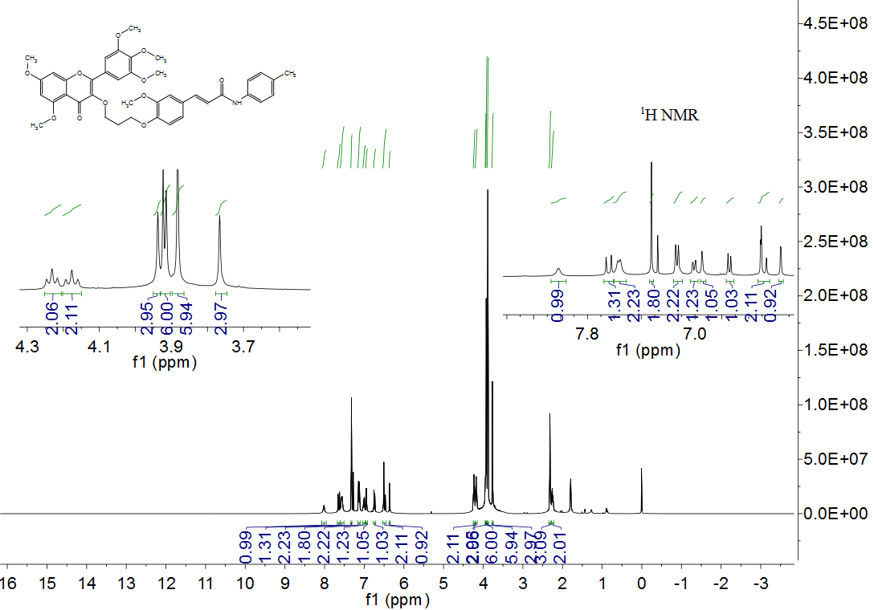

Figure S13. ¹³C NMR spectrum of compound 4a
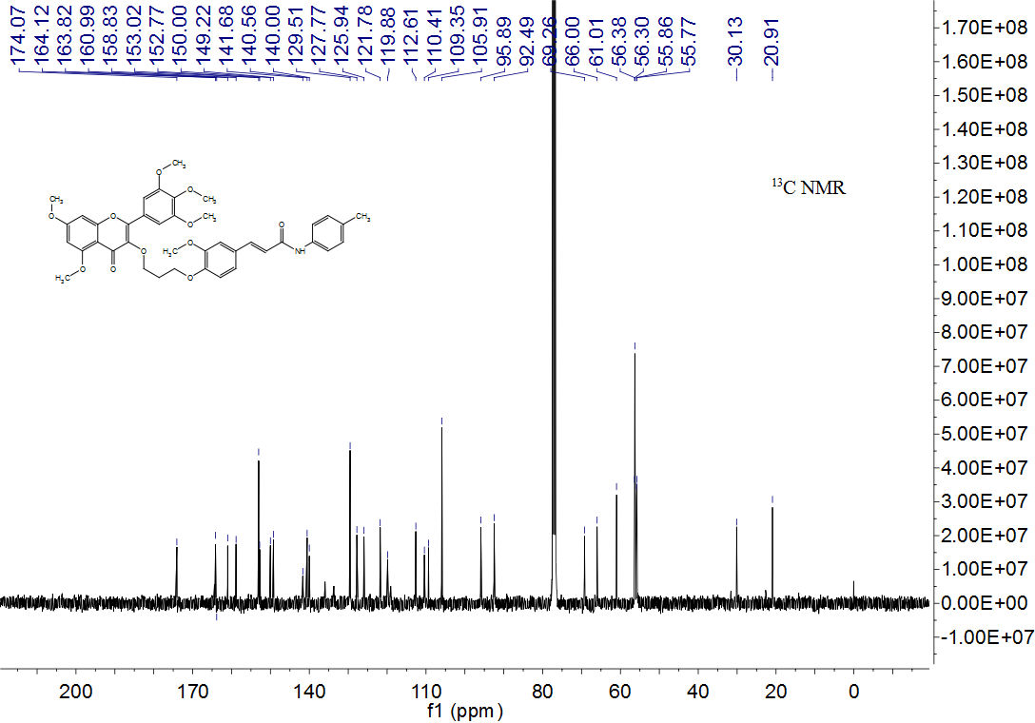

Figure S14. HRMS spectrum of compound 4a

Figure S15. ¹H NMR spectrum of compound 4b
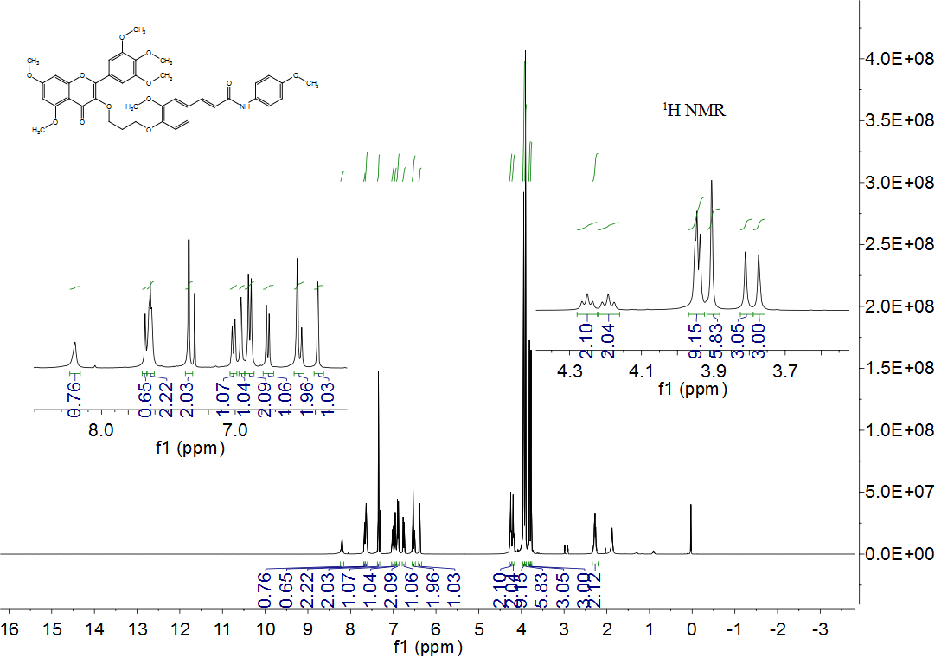

Figure S16. ¹³C NMR spectrum of compound 4b
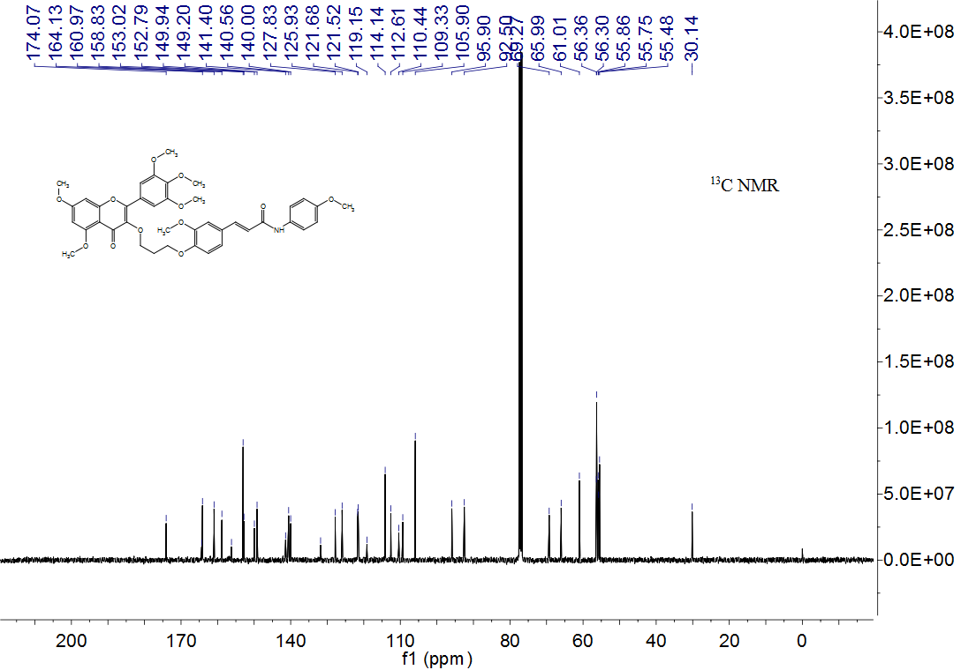

Figure S17. HRMS spectrum of compound 4b

Figure S18. ¹H NMR spectrum of compound 4c
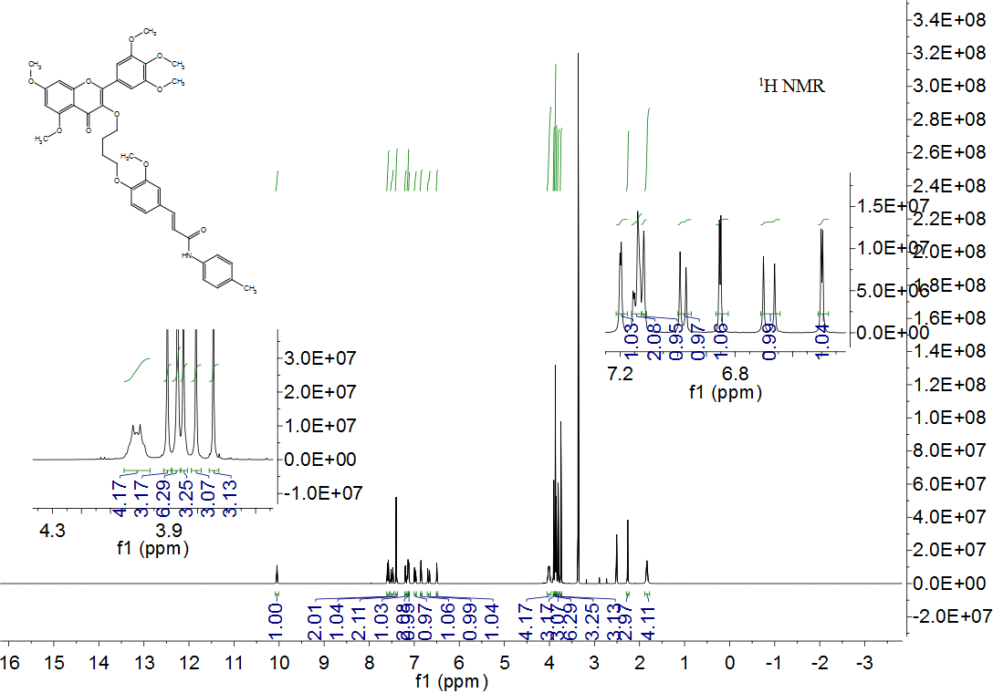
Figure S19. ¹³C NMR spectrum of compound 4c
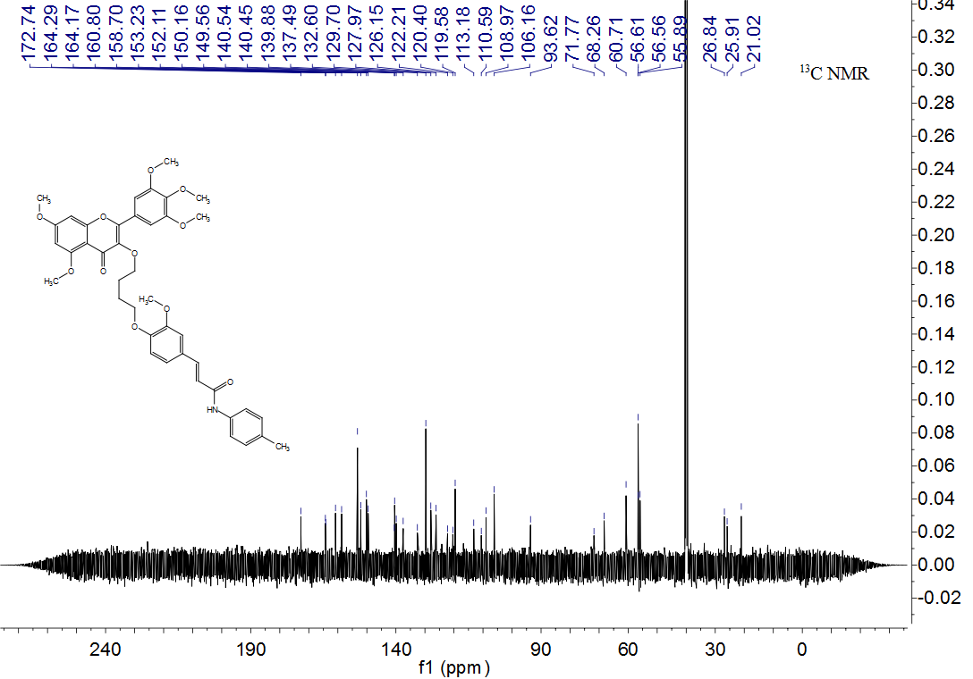
Figure S20. MS spectrum of compound 4c

Figure S21. ¹H spectrum of compound 4d
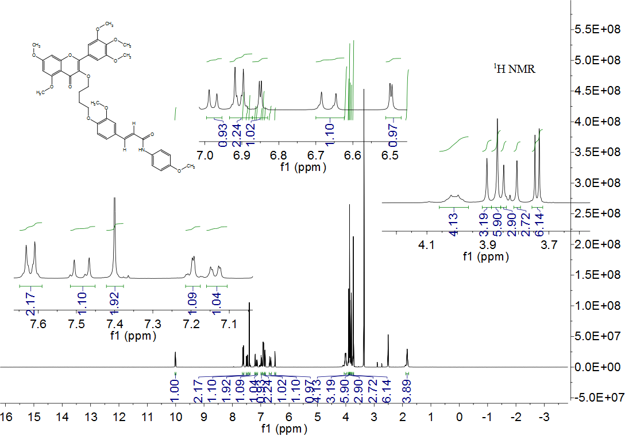

Figure S22. ¹³C NMR spectrum of compound 4d
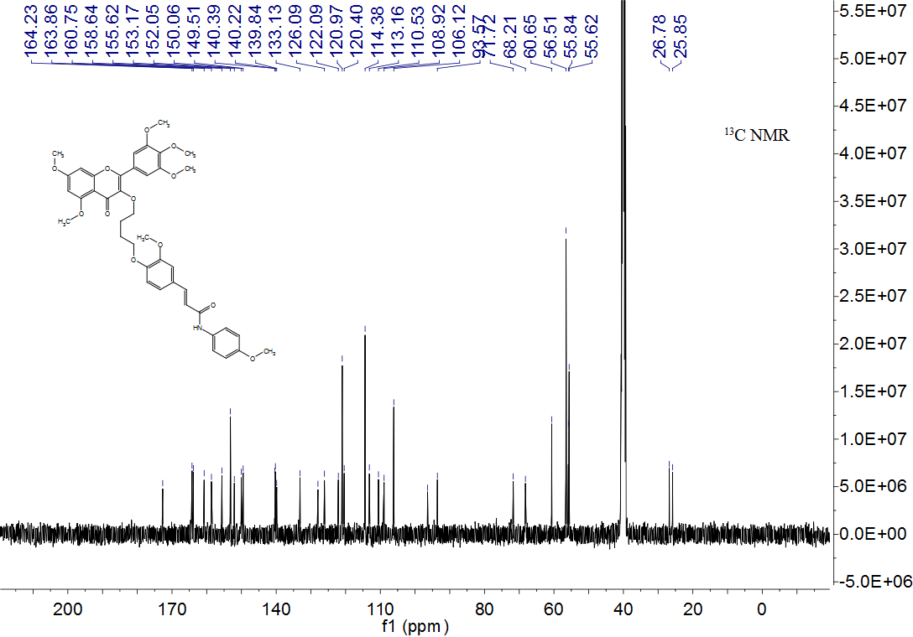

Figure S23. HRMS spectrum of compound 4d

Figure S24. ¹HNMR spectrum of compound 4e
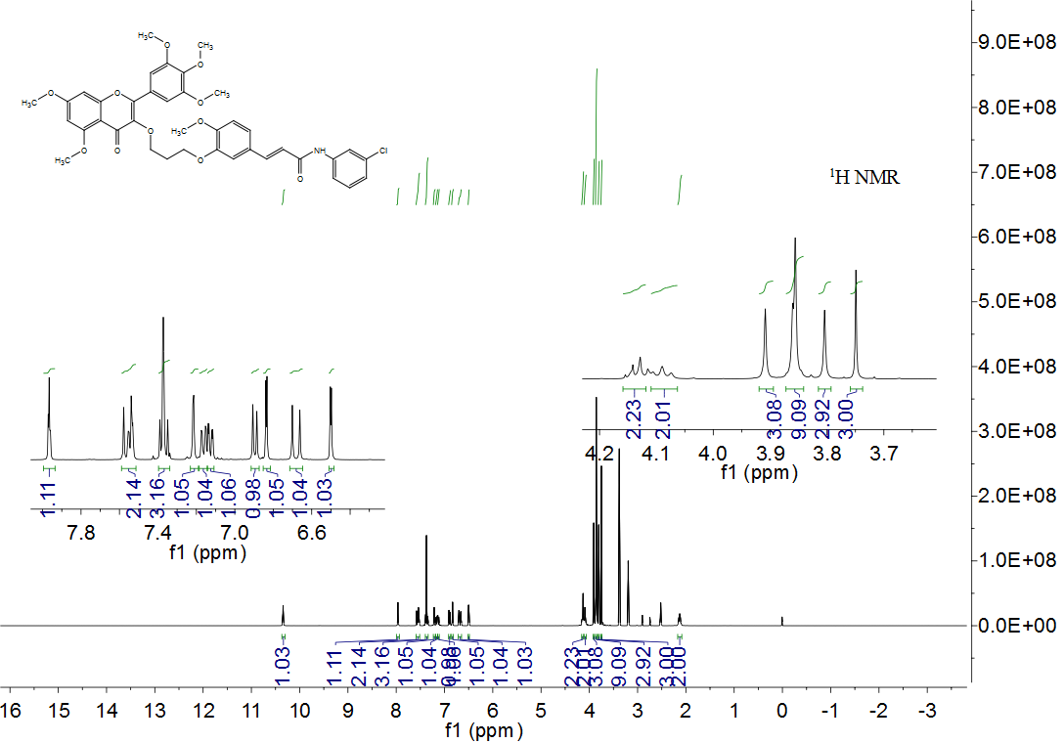

Figure S25.¹³C NMR spectrum of compound 4e

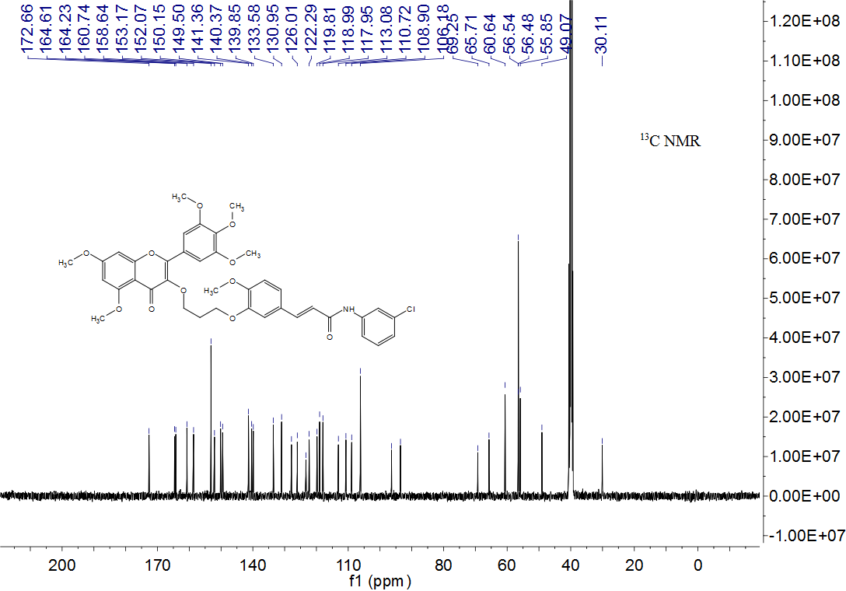

Figure S26. HRMS spectrum of compound 4e

Figure S27. ¹H NMR spectrum of compound 4f
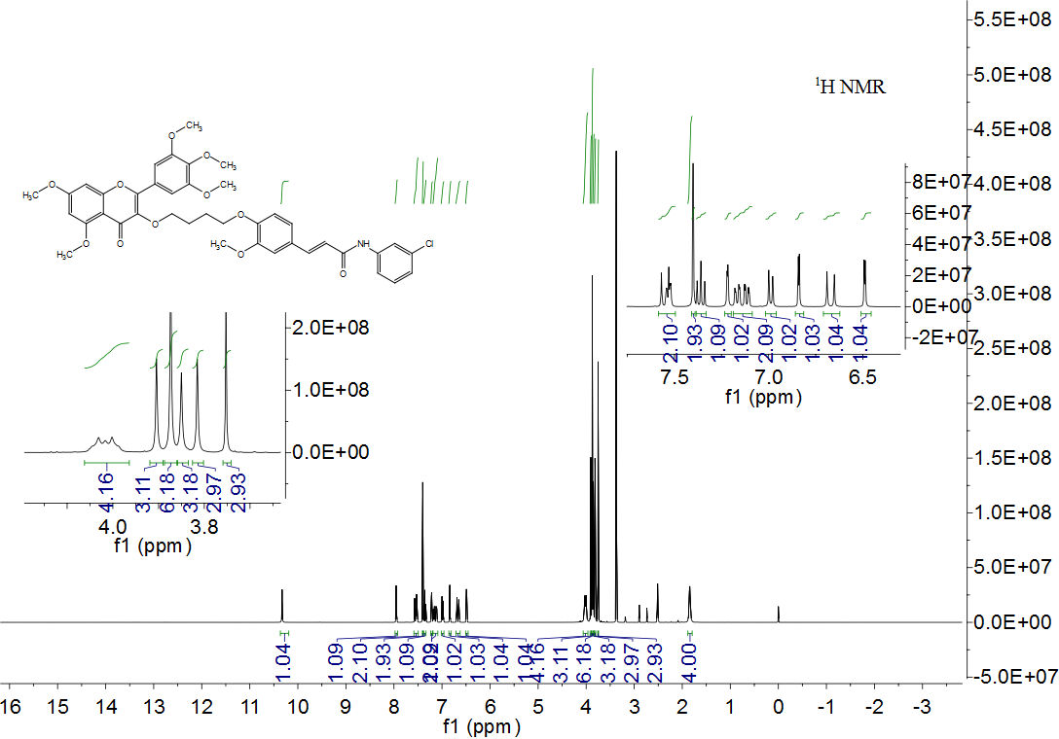

Figure S28. ¹³C NMR spectrum of compound 4f
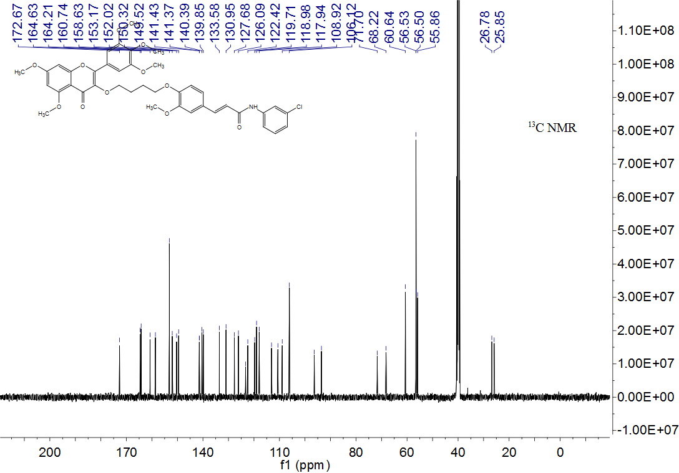

Figure S29.HRMS spectrum of compound 4f

Figure S30 ¹H NMR spectrum of compound 4g
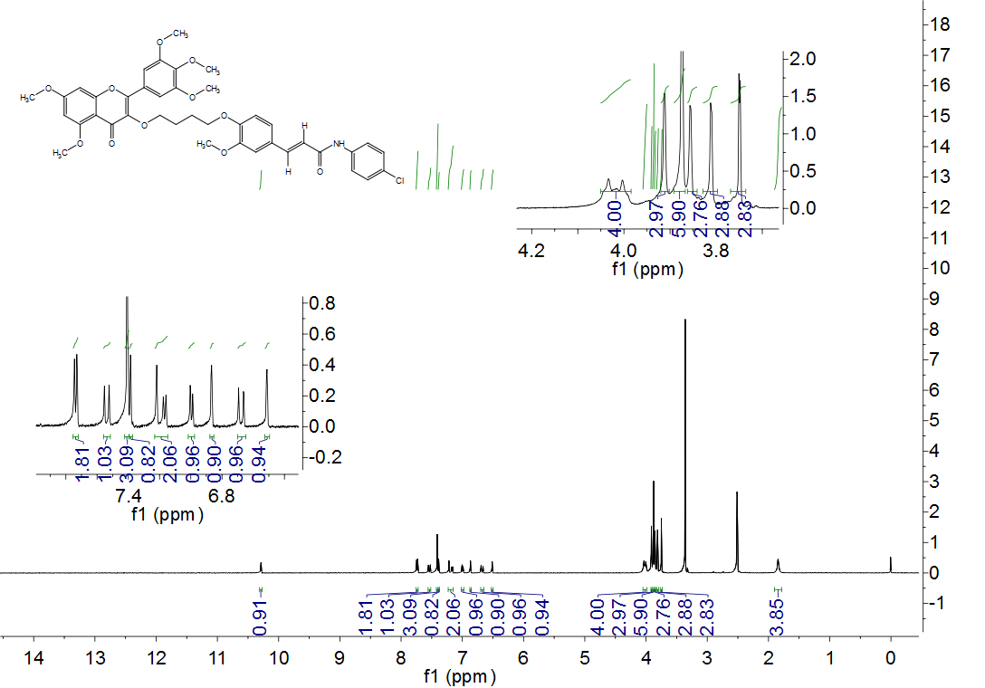

Figure S31.¹³C NMR spectrum of compound 4g
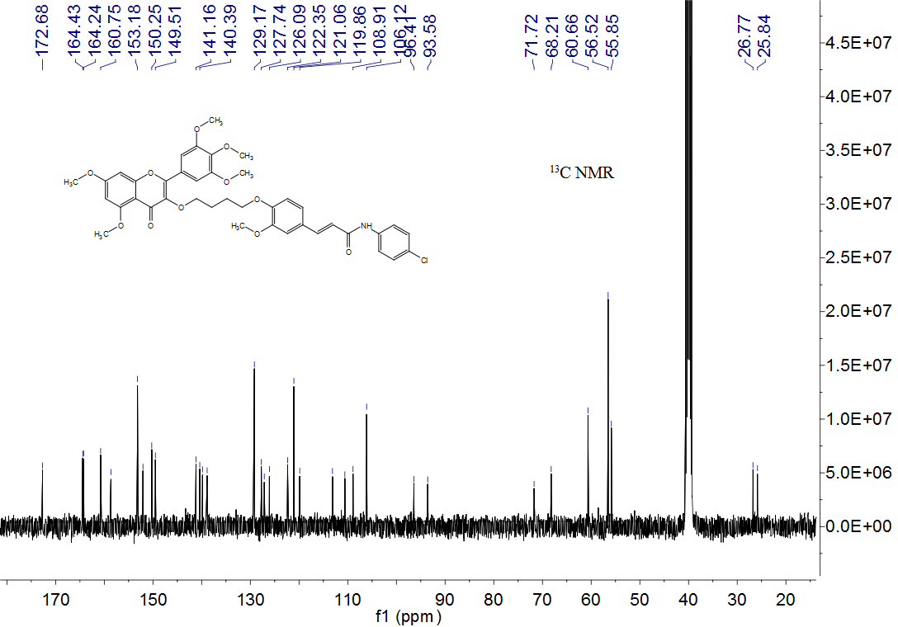

Figure S32.HRMS spectrum of compound 4g

Figure S33. ¹H NMR spectrum of compound 4h
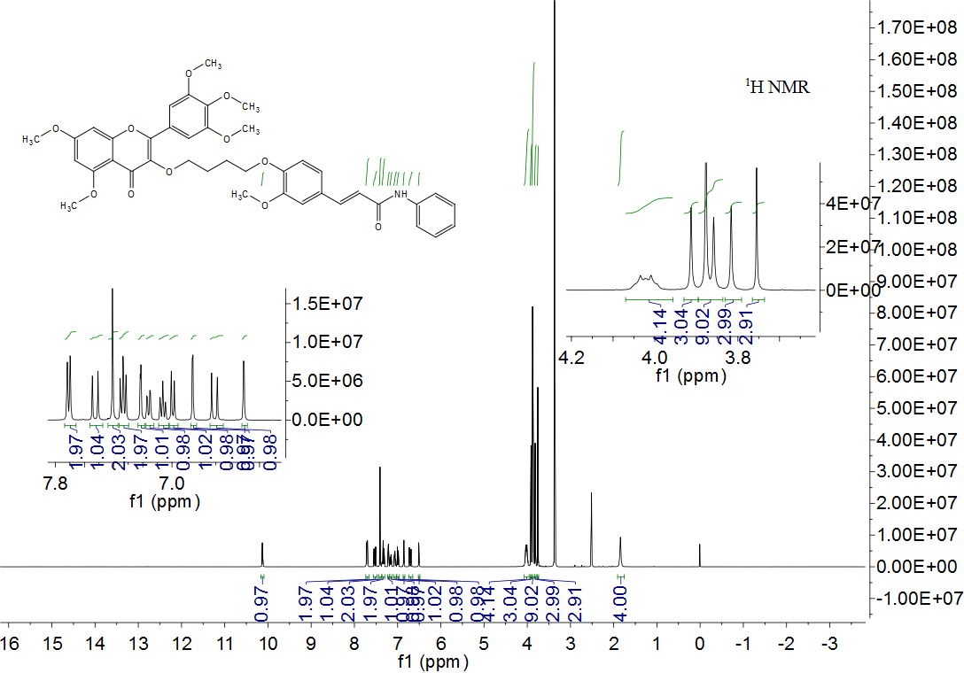
Figure S34. ¹³C NMR spectrum of compound 4h
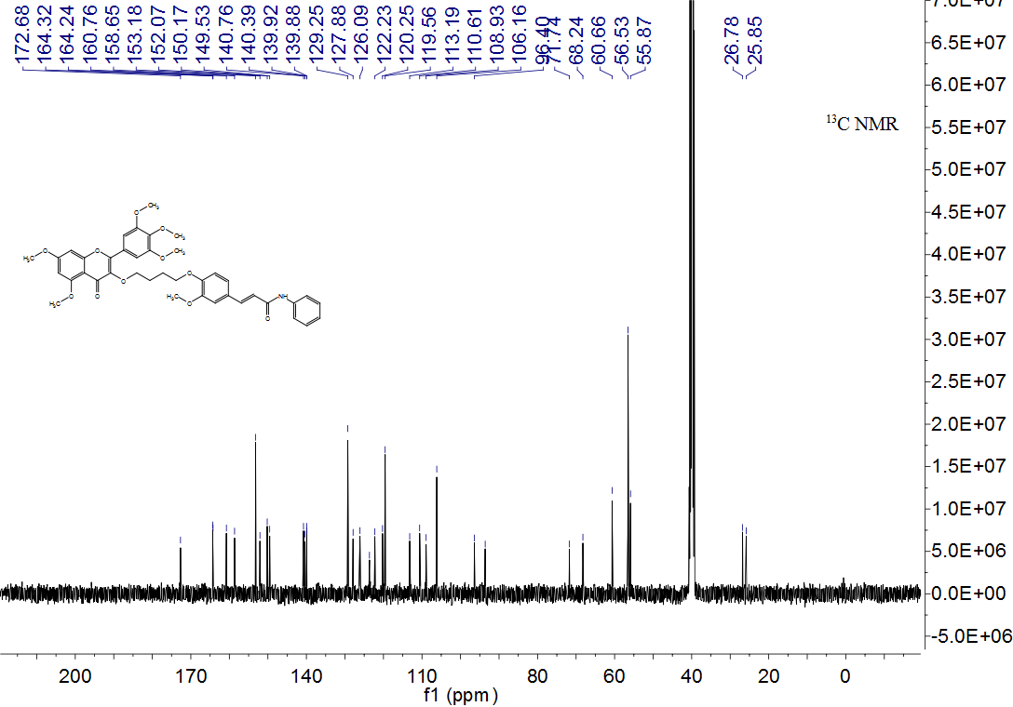

Figure S35. HRMS spectrum of compound 4h

Figure S36.¹H NMR spectrum of compound 4i
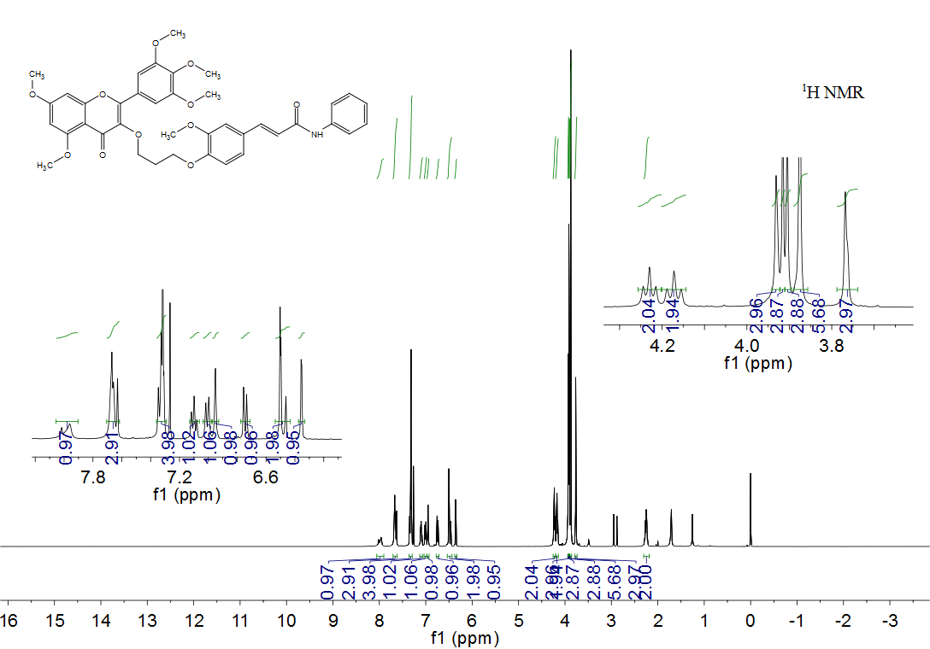

Figure S37.¹³C NMR spectrum of compound 4i
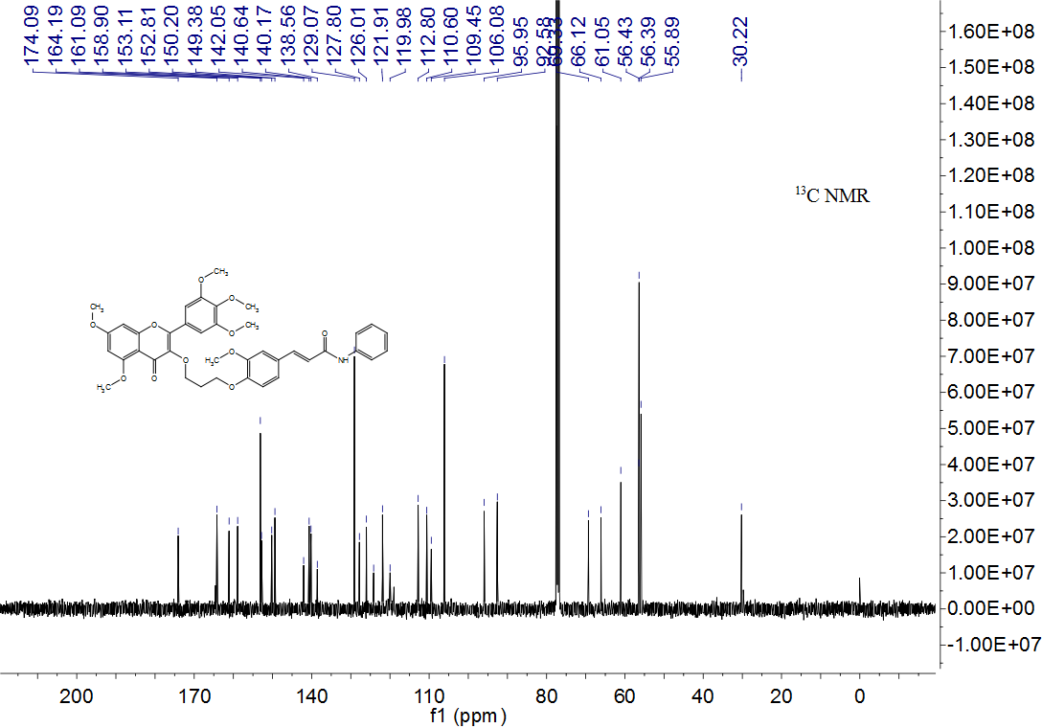

Figure S38. HRMS spectrum of compound 4i

Figure S39. ¹H NMR spectrum of compound 4j
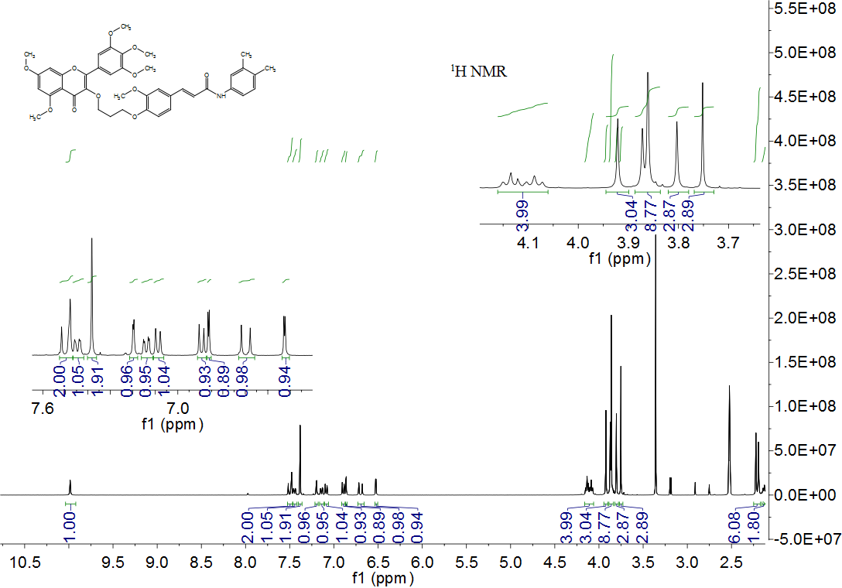

Figure S40. ¹³C NMR spectrum of compound 4j
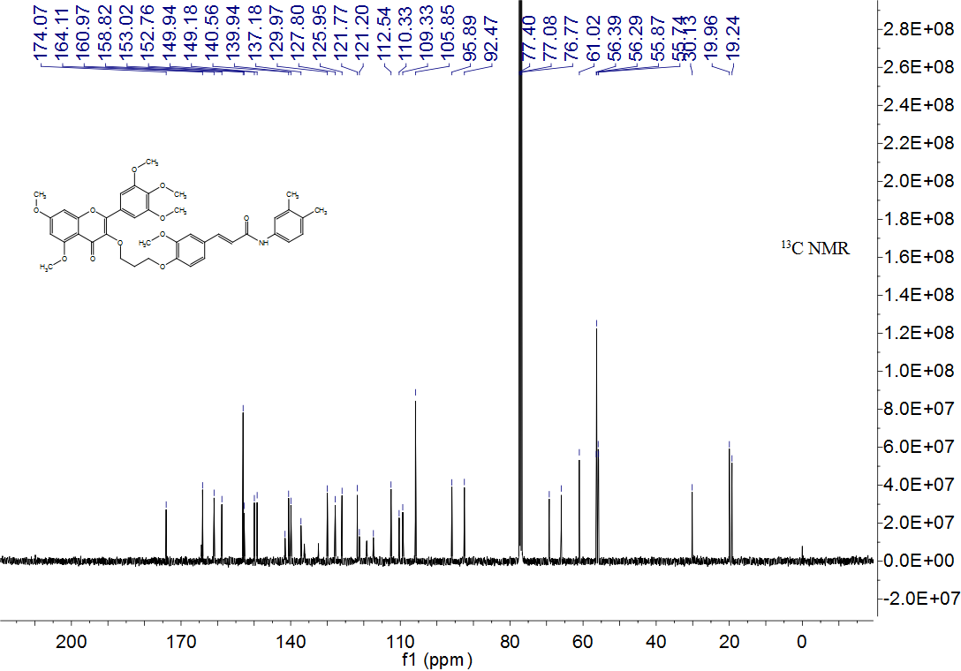

Figure S41. HRMS spectrum of compound 4j
Figure S42. ¹H NMR spectrum of compound 4k
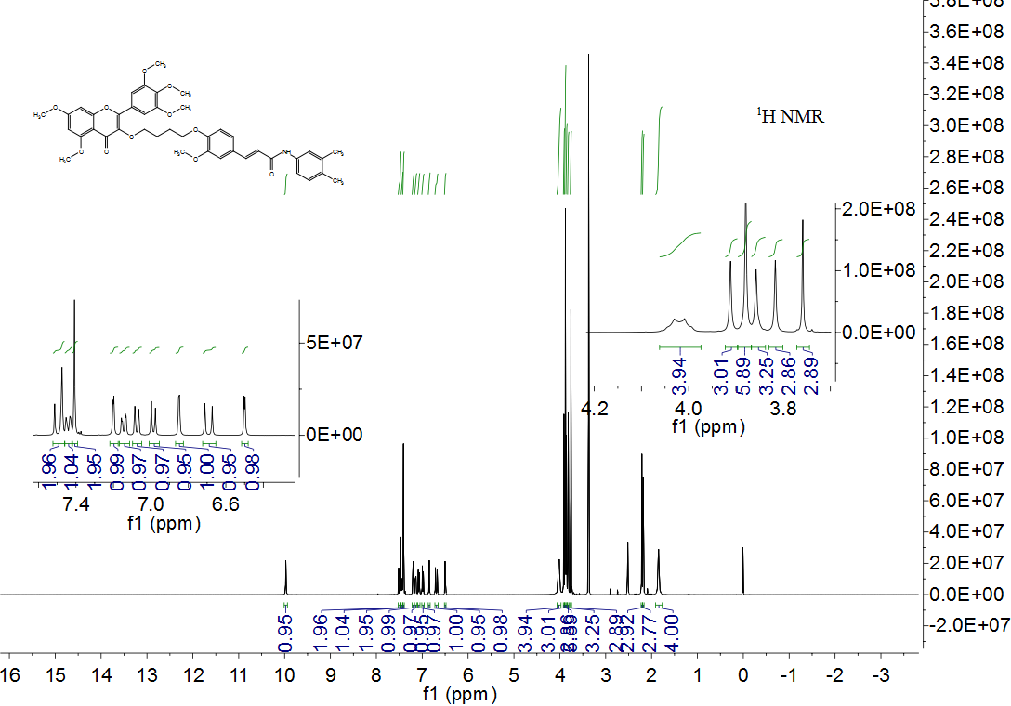

Figure S43. ¹³C NMR spectrum of compound 4k
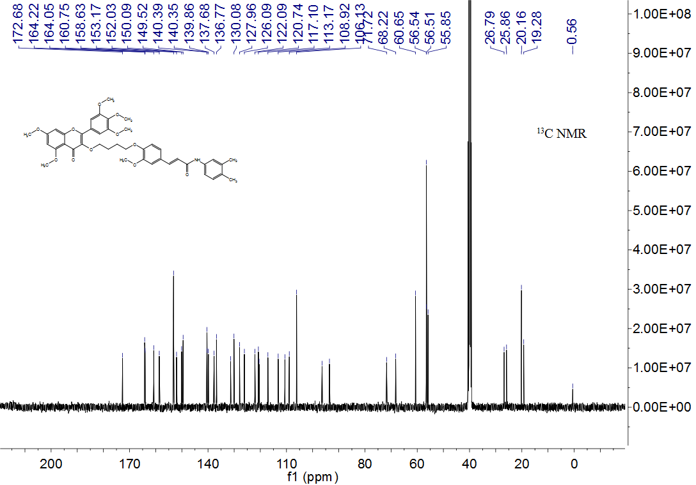

Figure S44. HRMS spectrum of compound 4k

Figure S45. ¹H NMR spectrum of compound 4l
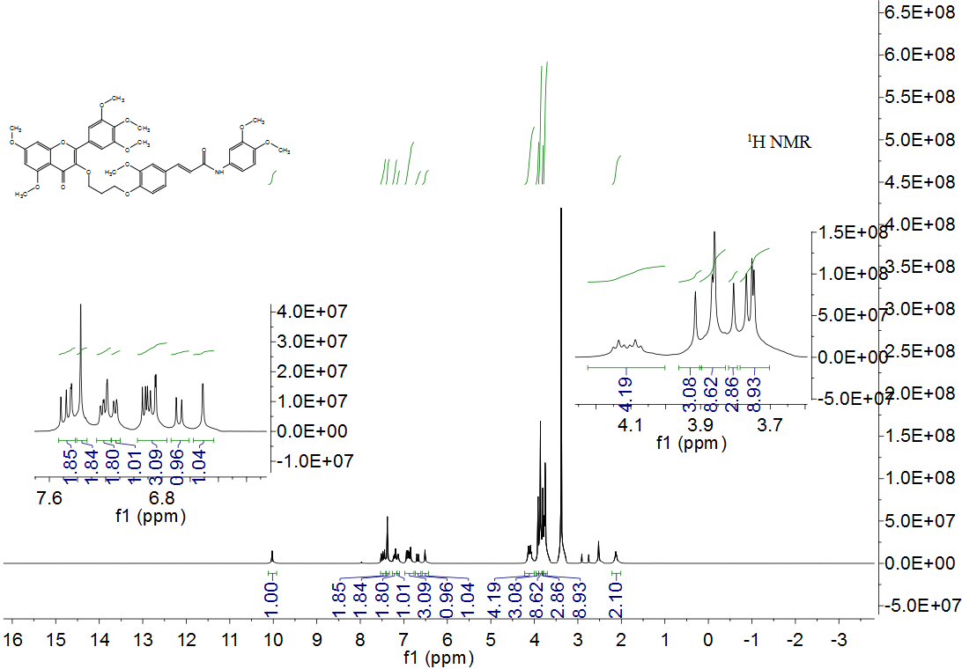

Figure S46. ¹³C NMR spectrum of compound 4l
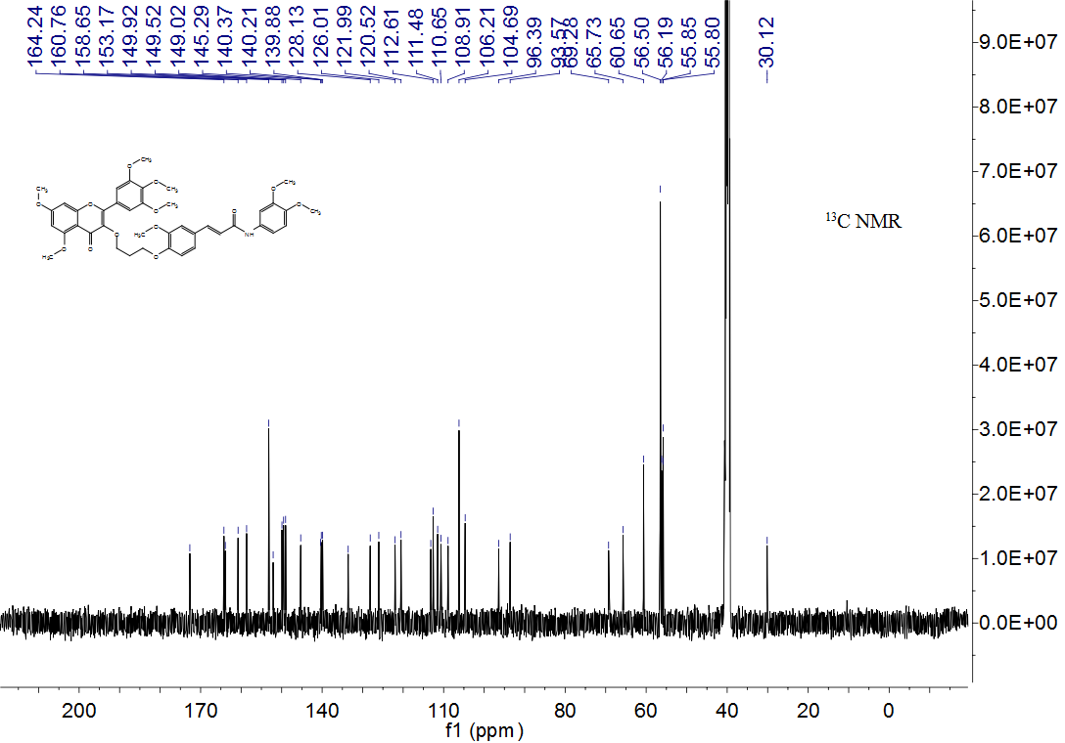

Figure S47. HRMS spectrum of compound 4l
Figure S48. ¹H NMR spectrum of compound 4m
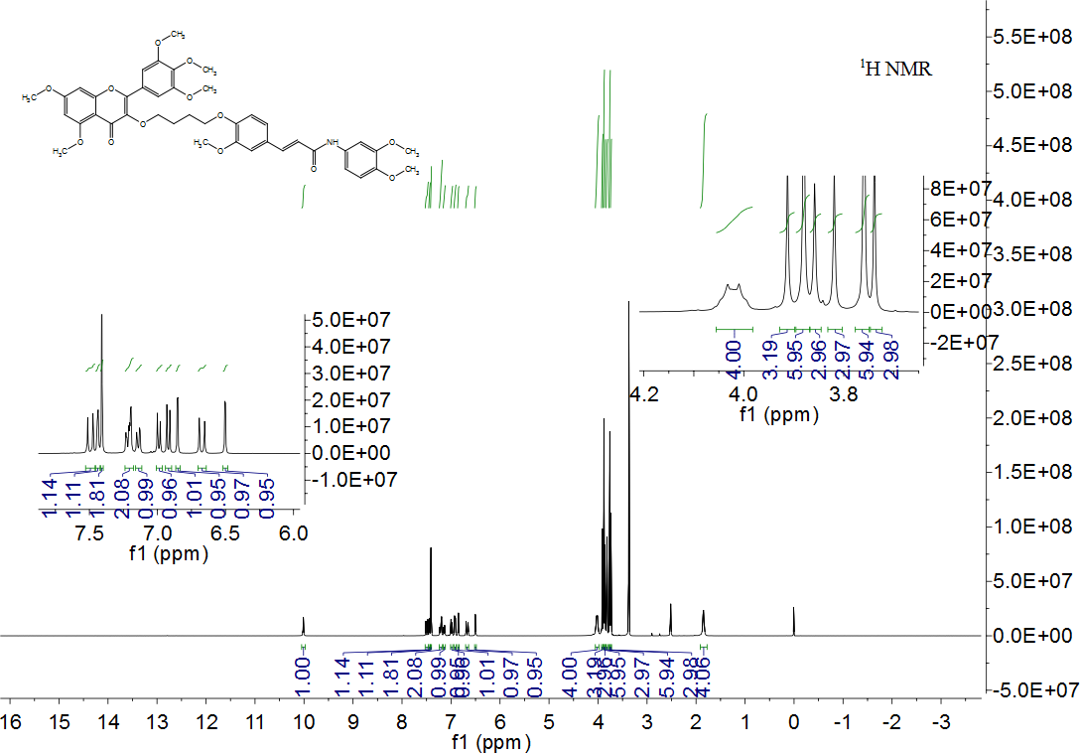

Figure S49. ¹³C NMR spectrum of compound 4m
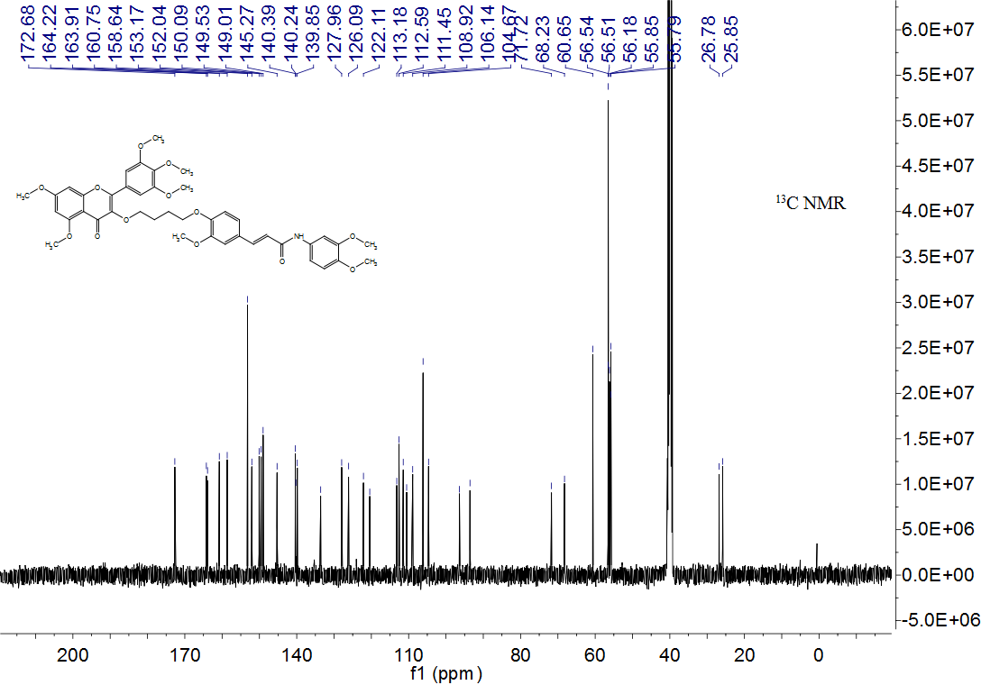

Figure S50. HRMS spectrum of compound 4m

Figure S51. ¹H NMR spectrum of compound 4n
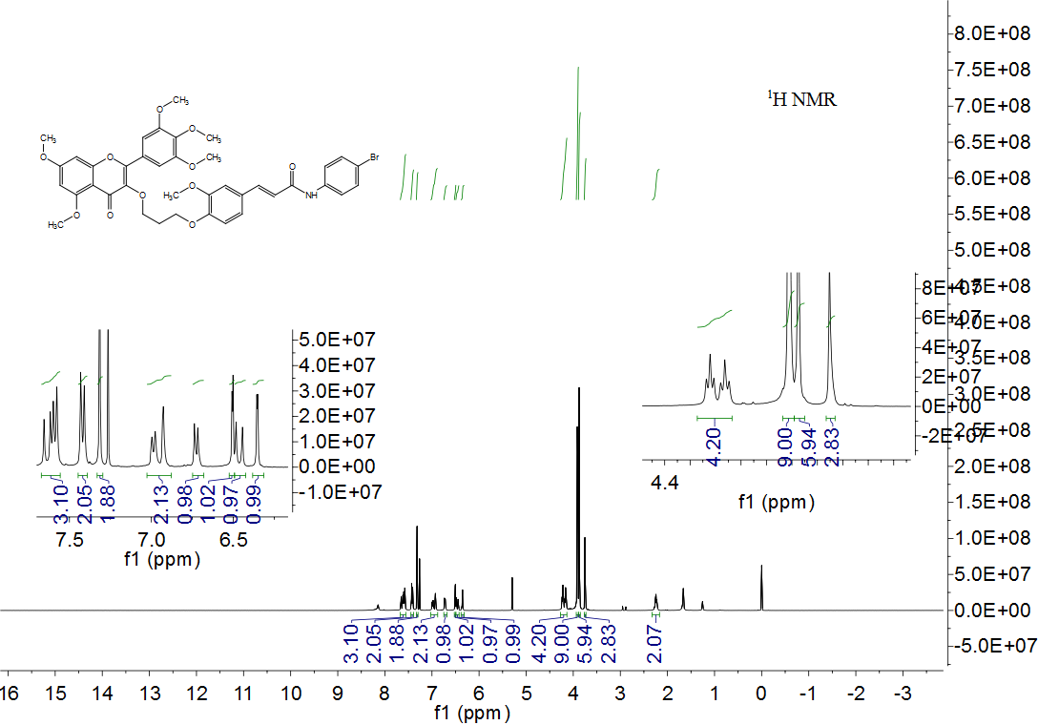

Figure S52. ¹³C NMR spectrum of compound 4n
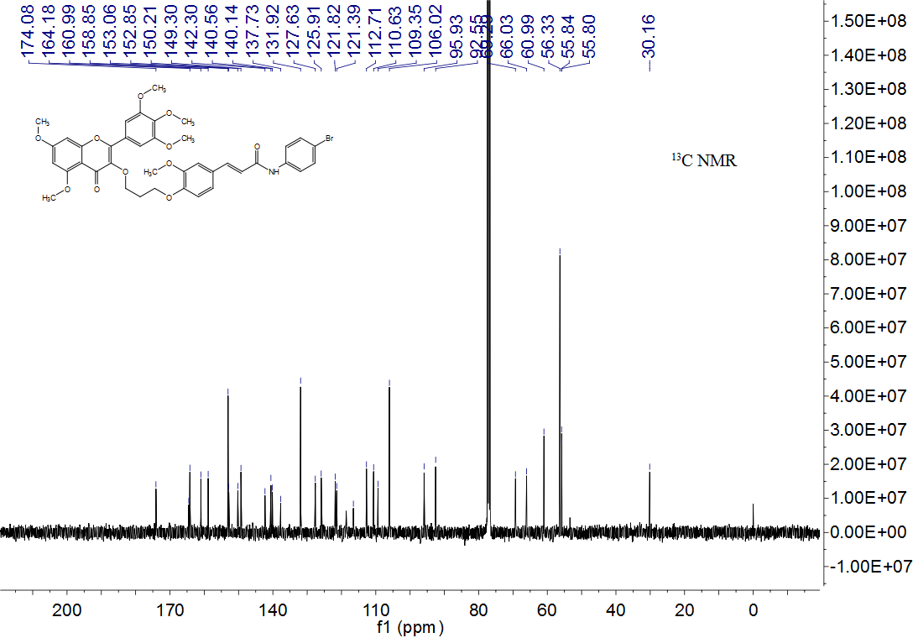

Figure S53. HRMS spectrum of compound 4n

Figure S54. ¹H NMR spectrum of compound 4o
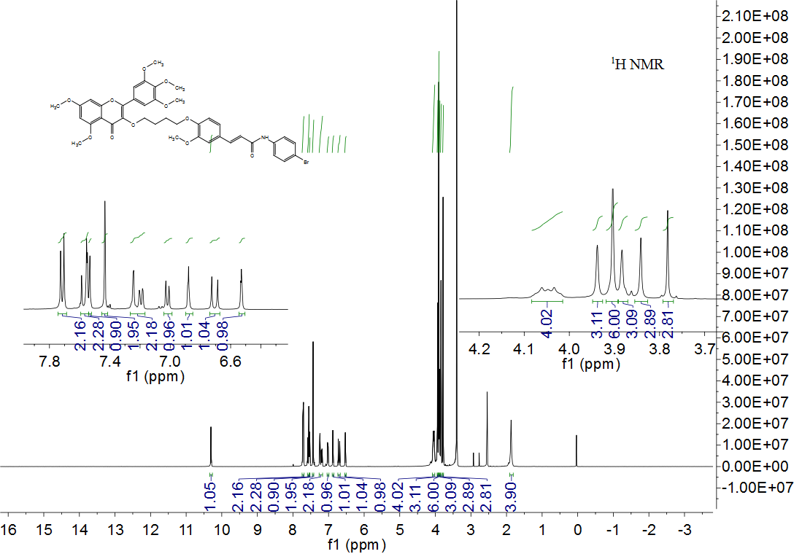

Figure S55. ¹³C NMR spectrum of compound 4o
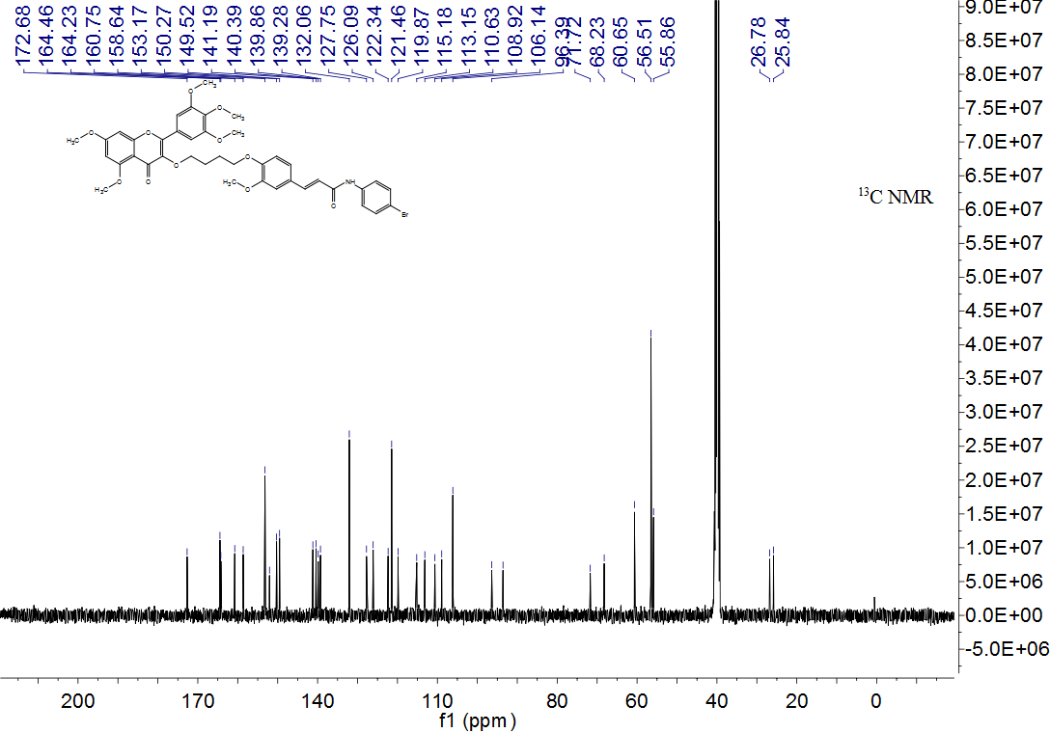

Figure S56. HRMS spectrum of compound 4o

Figure S57. ¹H NMR spectrum of compound 4p
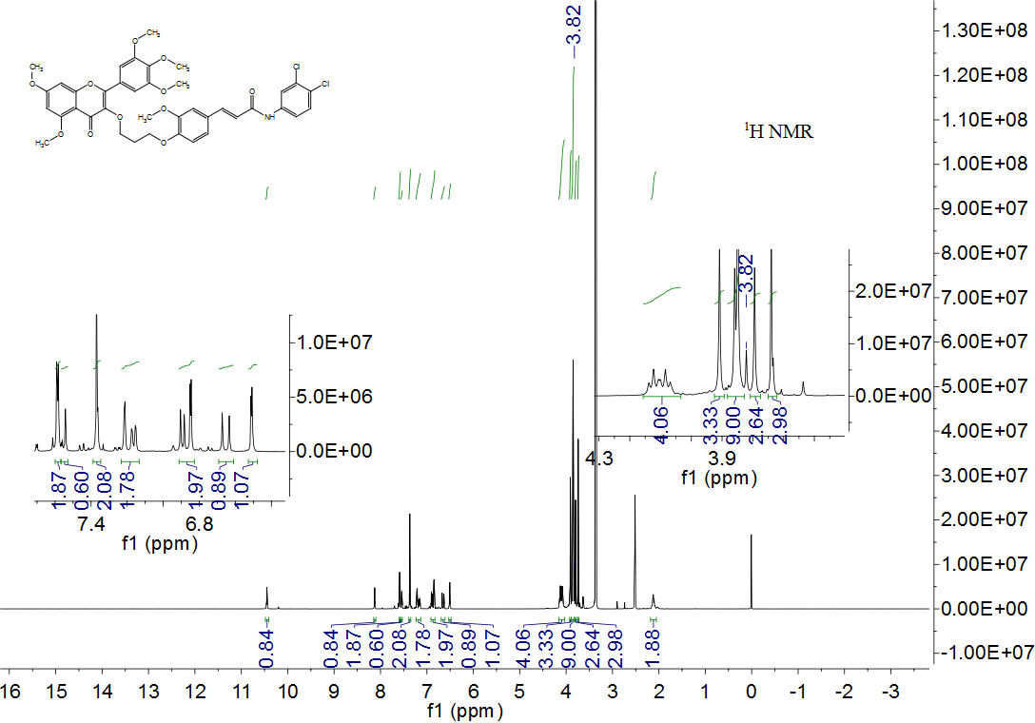

Figure S58. ¹³C NMR spectrum of compound 4p
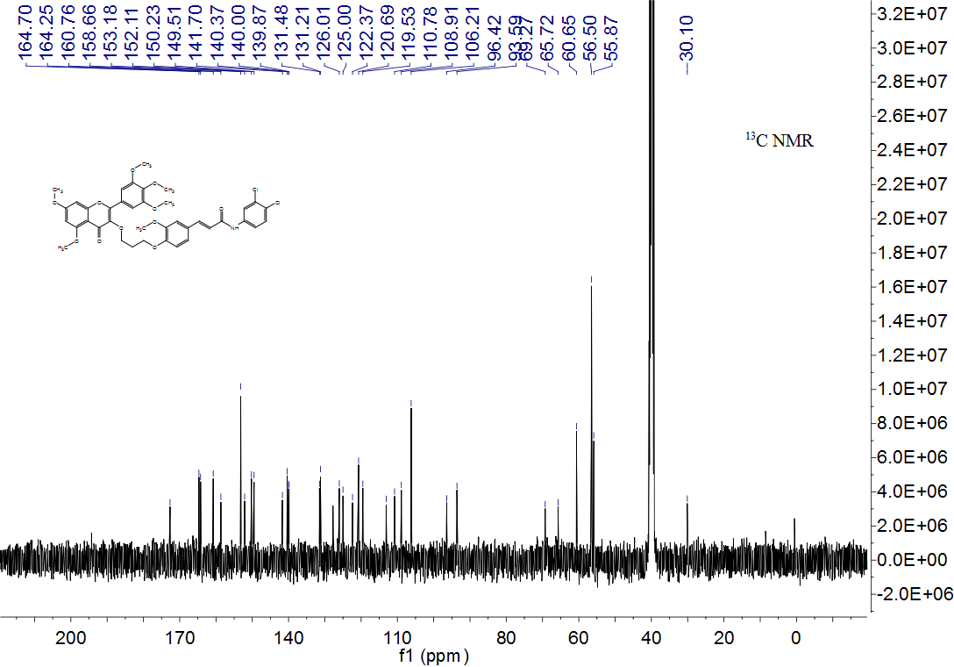

Figure S59. HRMS spectrum of compound 4p

Figure S60. ¹H NMR spectrum of compound 4q
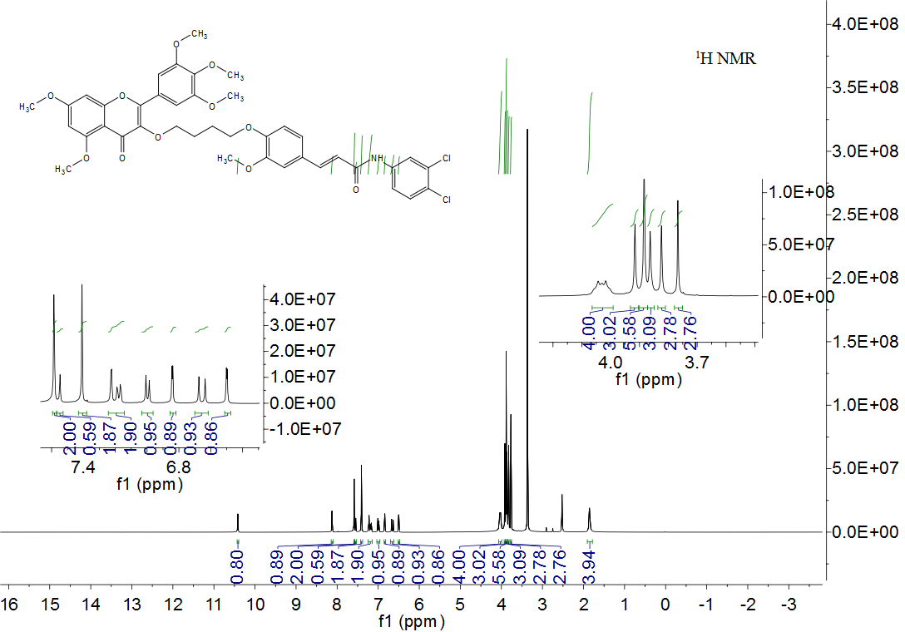

Figure S61. ¹³C NMR spectrum of compound 4q
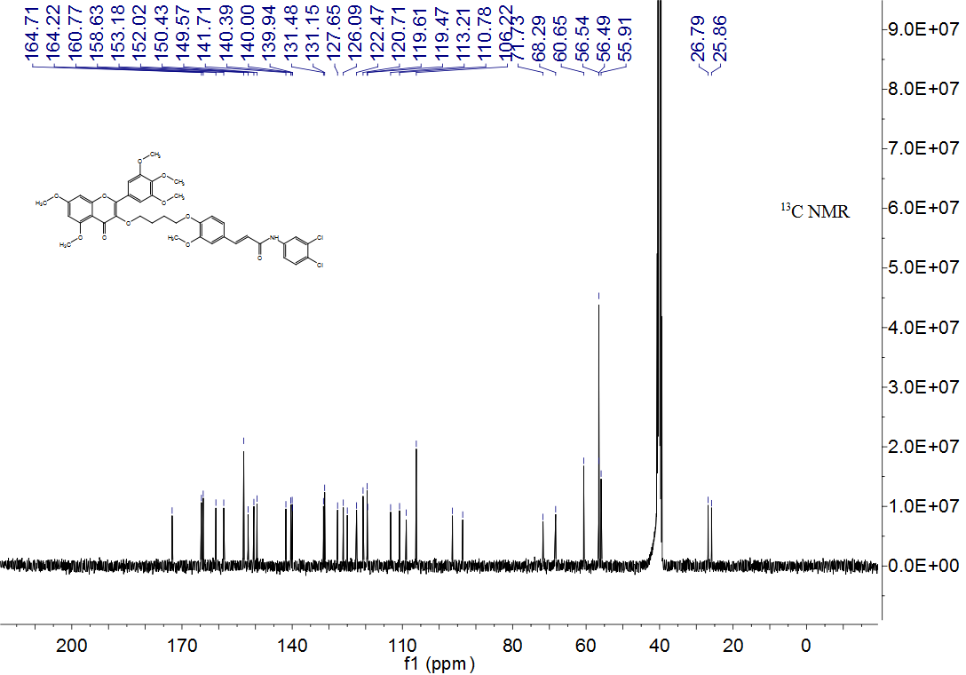

Figure S62. HRMS spectrum of compound 4q

Figure S63. ¹H NMR spectrum of compound 4r
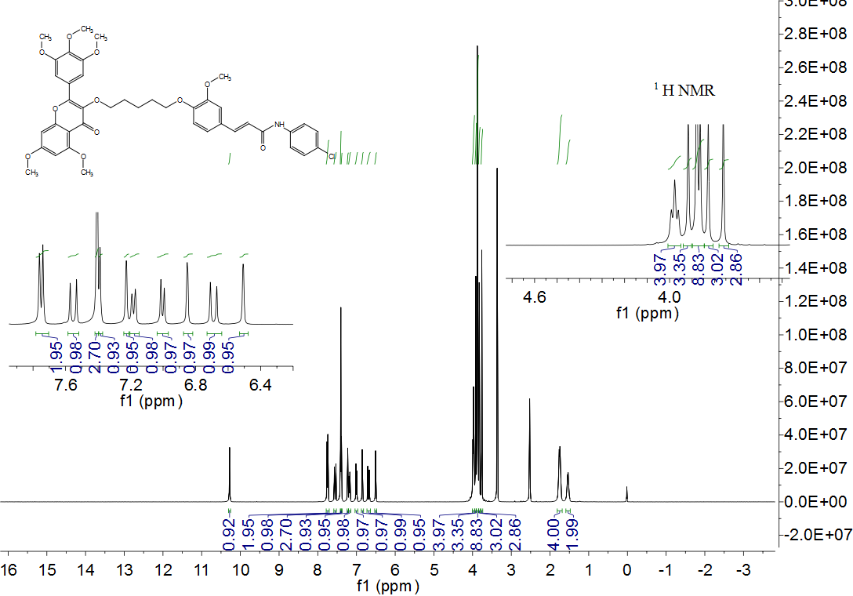
Figure S64. ¹³C NMR spectrum of compound 4r
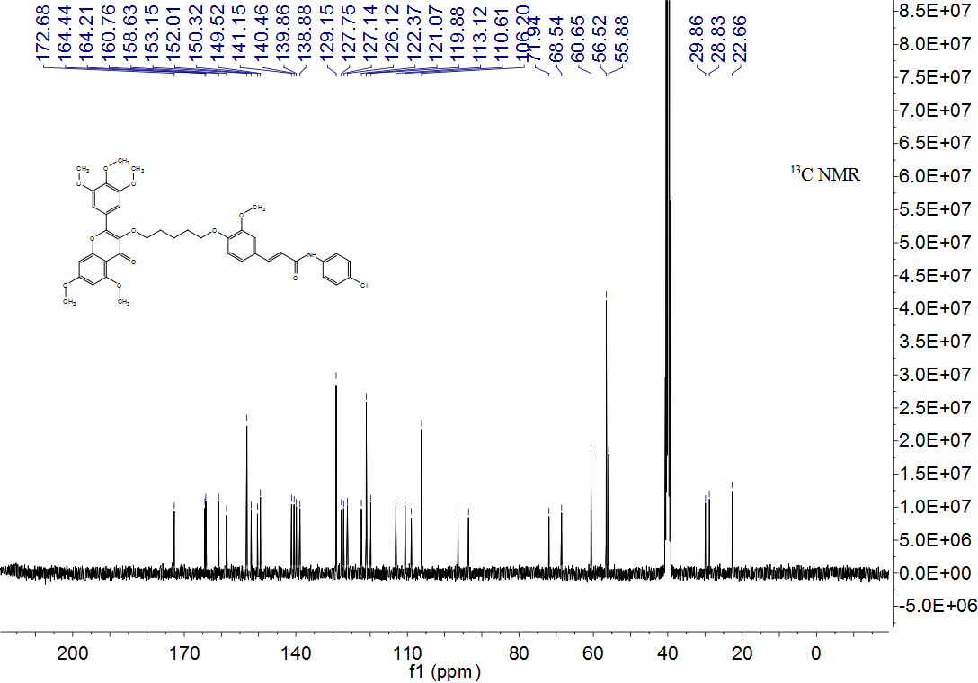

Figure S65. HRMS spectrum of compound 4r
Figure S66. ¹H NMR spectrum of compound 4s
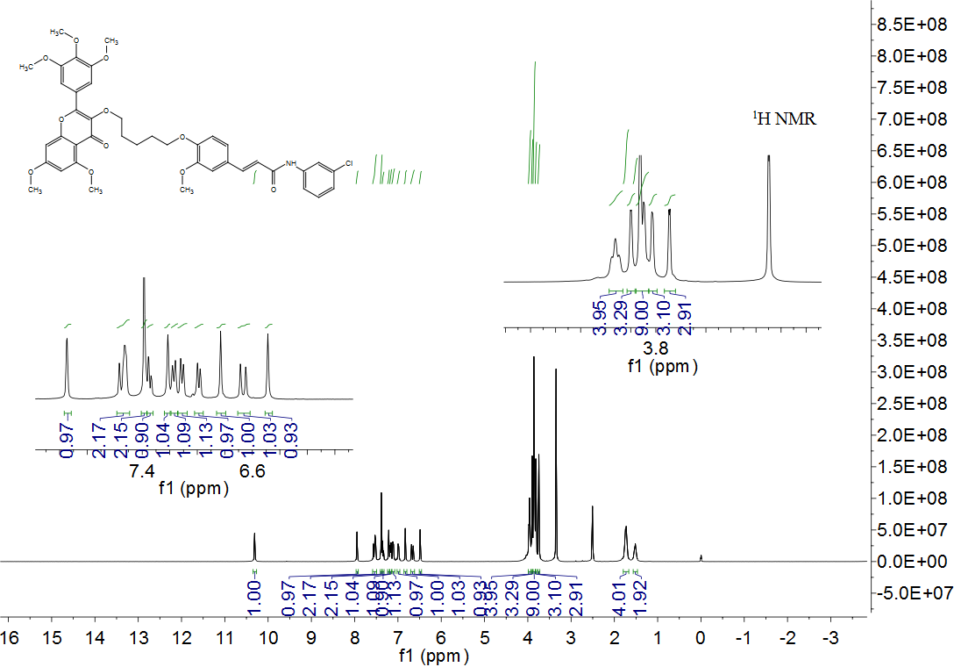

Figure S67. ¹³C NMR spectrum of compound 4s
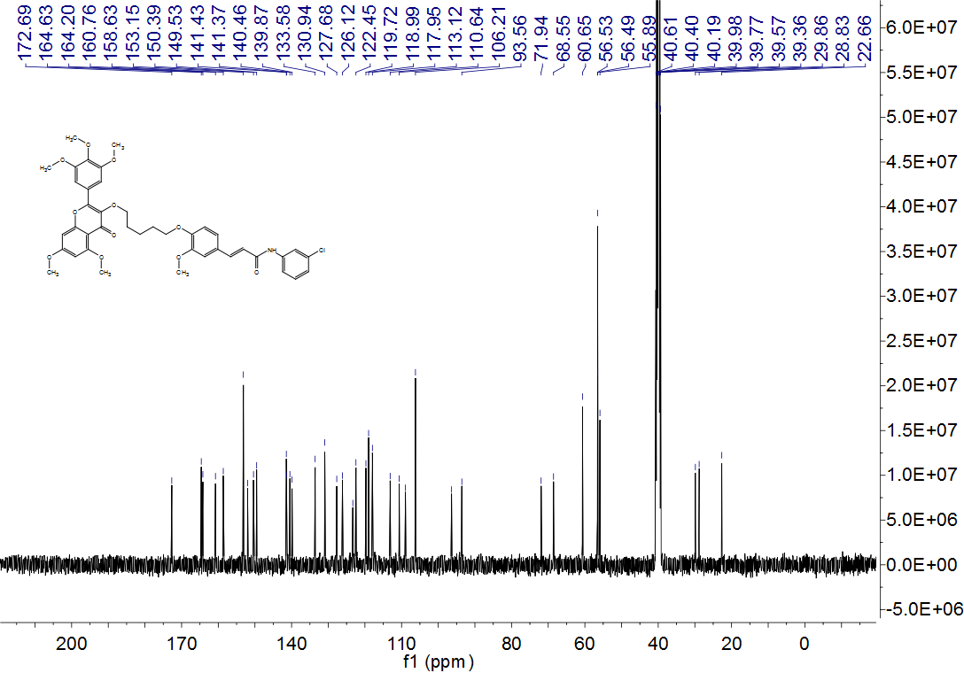

Figure S68. HRMS spectrum of compound 4s

Figure S69. ¹H NMR spectrum of compound 4t
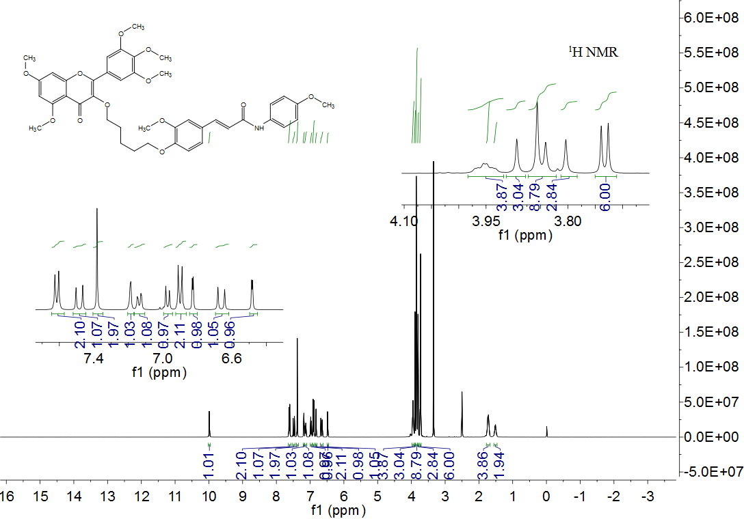

Figure S70. ¹³C NMR spectrum of compound 4t
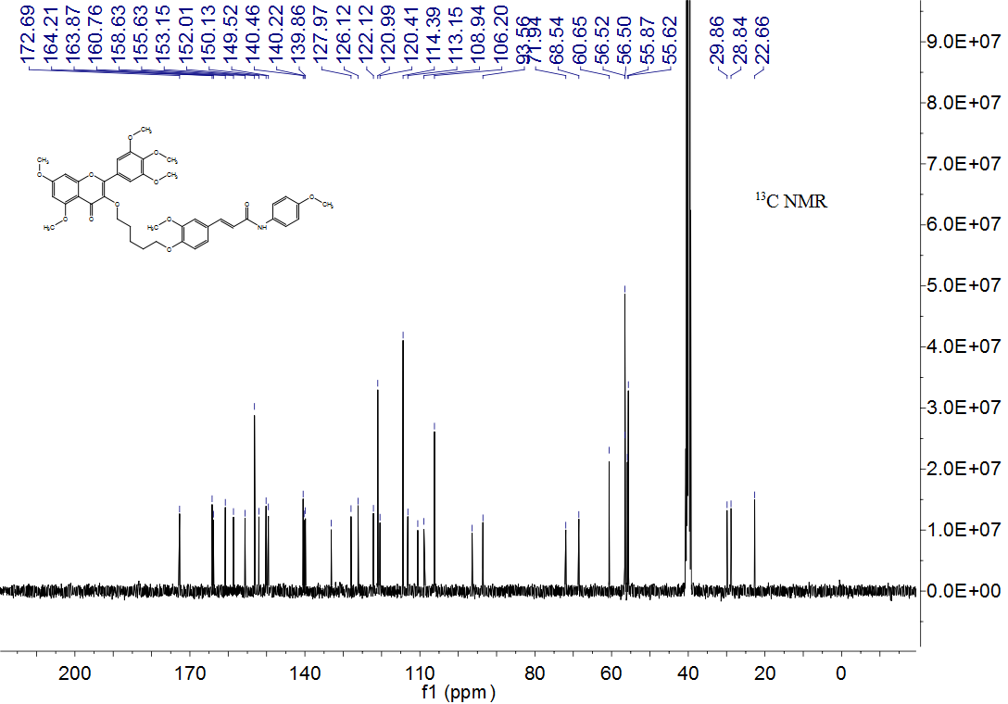

Figure S71. HRMS spectrum of compound 4t
Figure S72. ¹H NMR spectrum of compound 4u
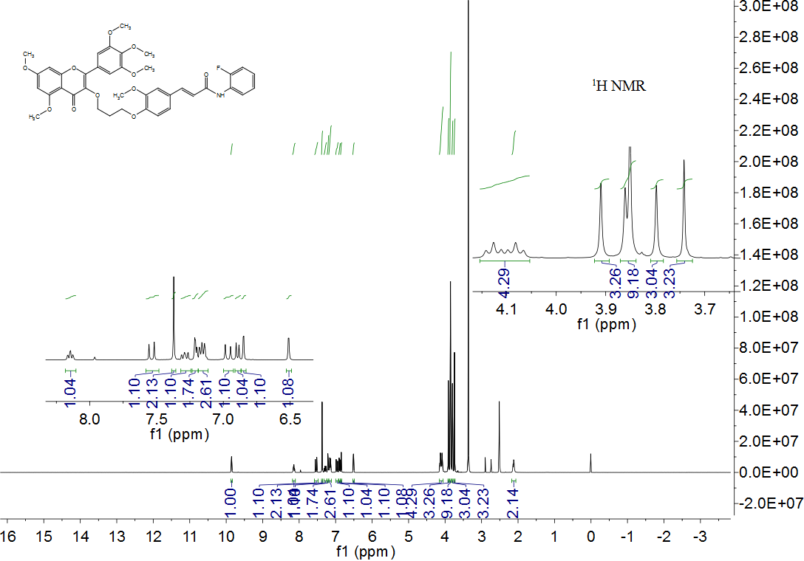

Figure S73. ¹³C NMR spectrum of compound 4u
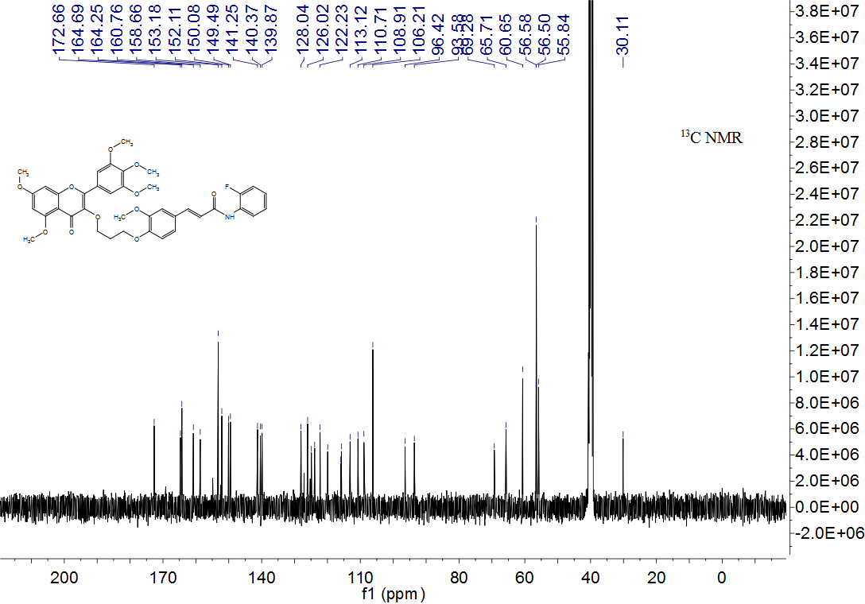

Figure S74. ¹⁹F NMR spectrum of compound 4u
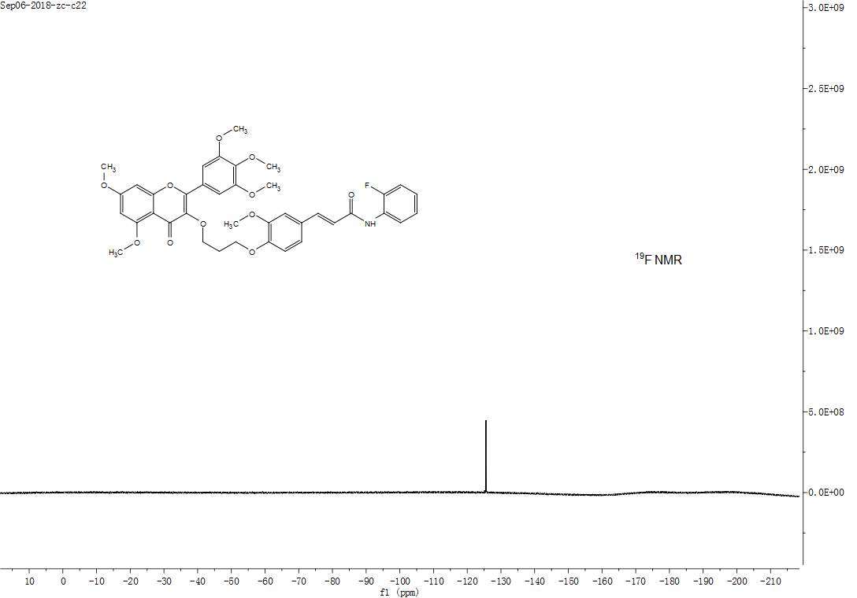

Figure S75. HRMS spectrum of compound 4u
Figure S76. ¹H NMR spectrum of compound 4v
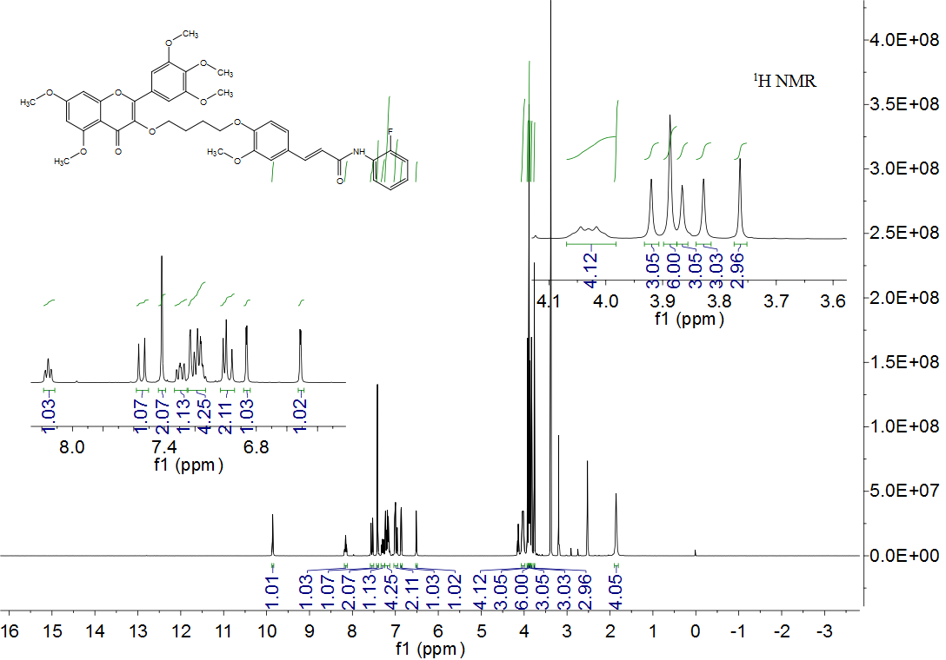

Figure S77. ¹³C NMR spectrum of compound 4v
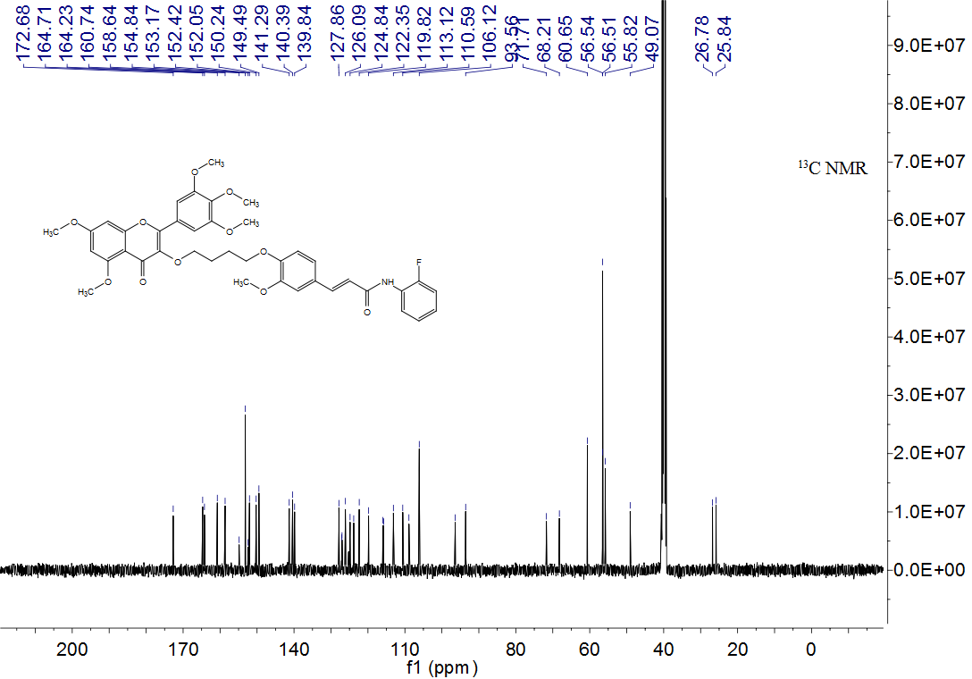

Figure S78. ¹⁹F NMR spectrum of compound 4v
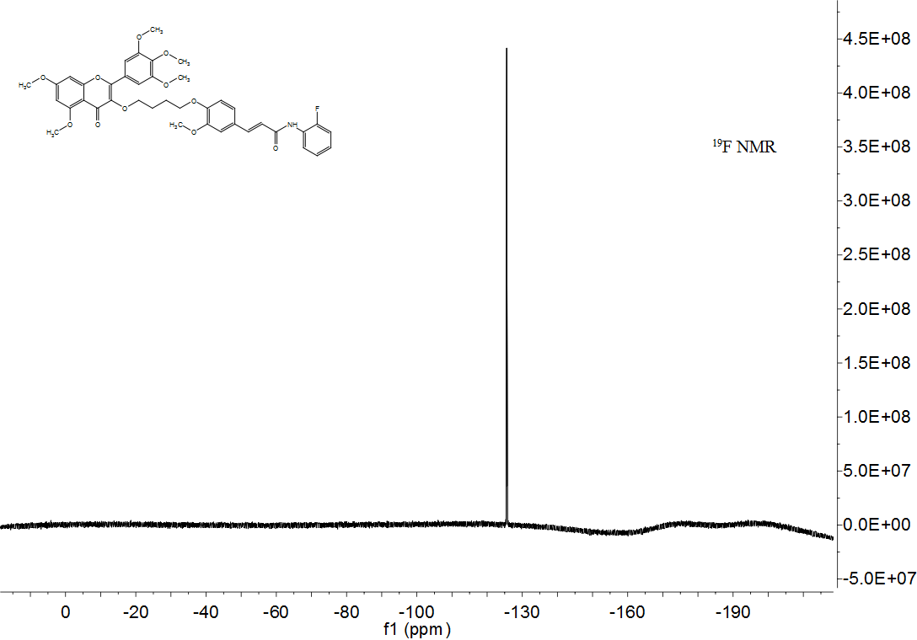

Figure S79. HRMS spectrum of compound 4v

