The n-10 fatty acids family in the lipidome of human prostatic adenocarcinoma cell membranes and extracellular vesicles

Carla Ferreri1,*, Chryssostomos Chatgilialoglu1, Sandra Buratta2, Lorena Urbanelli2, Eva Costanzi2, Carla Emiliani2, and Anna Sansone1

1 Istituto per la Sintesi Organica e la Fotoreattività, Consiglio Nazionale delle Ricerche, ISOF, Area della Ricerca, Via P. Gobetti 101, 40129 Bologna (Italy); chrys@isof.cnr.it; anna.sansone@isof.cnr.it (A.S.)

2 Department of Chemistry, Biology and Biotechnology, University of Perugia, Via del Giochetto, 06122 Perugia (Italy); sandra.buratta@unipg.it; lorena.urbanelli@unipg.it; eva.costanzi@studenti.unipg.it; carla.emiliani@unipg.it

* Correspondence: carla.ferreri@isof.cnr.it (C.F.); Tel.: +39-051-6398289

Table S1. Main lipid classes detected in PC3 and LNCaP cell membranes and their corresponding EVs expressed in µg/mL and reported as mean ± SEM. In the brackets are reported results expressed as percentage of the sum of all identified lipids (*EVs *vs* corresponding cells, p<0.05).

|  |  |  |  |  |  |
| --- | --- | --- | --- | --- | --- |
| Lipids§ | PC3 cells (*n*=8) µg/mL | | PC3-EVs (*n*=8) µg/mL | LNCaP cells (*n*=8)  µg/mL | LNCaP-EVs (*n*=8)  µg/mL |
| CHO | 30.37±8.35 *(6.5+0.7%)* | 18.63±3.26  *(12.7+3.2%*)* | | 32.5±3.5  *(5.8+0.4%)* | 22.41±6.29  *(15.5+1.5%*)* |
| SM | 48.58±8.35 *(10.3+1.6%)* | 29.94±17.52  *(10.1+12.2%)* | | 62.40±10.73  *(11.3+2.0%)* | 19.8±8.69  *(11.6+2.8%)* |
| PE | 161.11±32.11 *(34.8+3.3%)* | 23.92±7.23  *(16.6+4.3%*)* | | 203.36±36.00  *(36.5+4.2%)* | 51±34.55  *(26.5+10.0%*)* |
| PS | 23.42±4.18 *(5.2+1.3%)* | 38.65±11.03  *(26.1+5.6%*)* | | 28.79±3.29  *(5.2+0.5%)* | 29.22±5.35  *(18.2+5.1%*)* |
| PC | 204.27±36.56 *(43.2+5.5%)* | 37.05±14.21  *(25.5+8.6%*)* | | 230.61±8.14  *(41,1+2.7%)* | 48.5±10.35  *(30.2+7.3%*)* |

§ Abbreviations: CHO= cholesterol; SM=sphingomyelins; PE=phosphatidyl ethanolamine; PS=phosphatidyl serine; PC=phosphatidyl choline. Lipid classes are identified by the standard references as described in Materials and Methods.

Table S2. Membrane phospholipid fatty acids of PC3 cells, PC3-EVs, LNCaP cells and LNCaP-EVs expressed in μg/mL. These data were used for the values in Tables 1 and 2 expressed as % relative quantitative (% rel. quant.)

|  |  |  |  |  |
| --- | --- | --- | --- | --- |
| FAME1 | PC3 cells  (*n*=8) | PC3-EVs  (*n*=8) | LNCaP cells  (*n*=8) | LNCaP-EVs  (*n*=8) |
| C14:0 | 12.15±1.26 | 5.04±1.30 | 11.36±0.68 | 6.97±0.38 |
| C16:0 | 123.18±4.53 | 38.82±1.46 | 110.76±3.53 | 47.01±1.40 |
| 6*trans*-C16:1 | 1.35±0.15 | 0.11±0.03 | 1.83±0.08 | 0.63±0.04 |
| 6*cis-C*16:1 n-10 | 27.53±1.33 | 7.02±1.78 | 25.65±1.01 | 10.74±0.43 |
| 9 *cis*-C16:1 n-7 | | 8.75±0.65 | 1.31±0.35 | 6.44±0.19 | 2.10±0.11 |
| C18:0 | | 40.51±1.87 | 14.48±1.00 | 37.77±0.86 | 20.21±0.83 |
| 9*trans*-C18:1 | | 0.35±0.04 | 0.21±0.05 | 0.36±0.07 | 0.30±0.05 |
| 8*cis*-C18:1 n-10 | | 22.31±2.87 | 3.32±0.77 | 14.97±0.39 | 5.73±0.41 |
| 9*cis*-C18:1 n-9 | | 72.26±2.47 | 36.00±5.27 | 61.30±1.30 | 20.36±0.91 |
| 11*cis*-C18:1 n-7 | | 14.61±1.15 | 1.42±0.13 | 12.80±0.17 | 2.05±0.29 |
| 5*cis*,8*cis*-C18:2 n-10 | | 1.74±0.11 | 0.30±0.05 | 1.71±0.14 | 0.82±0.09 |
| mono-trans C18:2 n-6 | | 1.02±0.18 | 0.17±0.03 | 0.80±0.08 | 0.27±0.08 |
| C18:2 n-6 | | 9.21±0.68 | 3.98±0.61 | 6.49±0.33 | 3.86±0.27 |
| C20:3 n-6 | | 6.02±0.62 | 0.57±0.09 | 5.67±0.58 | 1.30±0.20 |
| C20:4 n-6 | | 10.66±0.89 | 0.85±0.20 | 13.15±0.41 | 2.71±0.18 |
| mono-trans C20:4 | | 0.36±0.03 | 0.05±0.02 | 0.37±0.15 | 0.10±0.03 |
| C20:5 n-3 | | 1.75±0.21 | 0.33±0.05 | 1.24±0.23 | 0.71±0.12 |
| C22:5 n-3 | | 6.58±0.70 | 0.63±0.16 | 5.06±0.52 | 1.87±0.27 |
| C22:6 n-3 | | 11.07±0.70 | 1.97±0.31 | 11.51±0.71 | 4.26±0.34 |
| SFA | | 175.84±4.53 | 58.34±2.52 | 159.89±4.35 | 74.19±1.19 |
| MUFA | | 145.45±4.63 | 49.06±3.02 | 121.16±2.20 | 40.97±0.86 |
| PUFA | | 47.02±1.57 | 8.63±1.20 | 44.83±1.62 | 15.53±0.69 |
| n-6 | | 25.89±1.36 | 5.40±0.73 | 25.31±1.01 | 7.86±0.34 |
| n-3 | | 19.39±0.56 | 2.93±0.46 | 17.81±1.36 | 6.85±0.47 |
| n-6/ n-3 | | 1.34±0.07 | 1.97±0.17 | 1.52±0.19 | 1.18±0.08 |
| n-10 | | 51.58±3.82 | 10.64±2.52 | 42.34±1.22 | 17.29±0.81 |
| Total *trans* | | 3.08±0.27 | 0.56±0.10 | 3.35±0.17 | 1.30±0.12 |

1 identified by standard references and quantified as described in Materials and Methods. Values are obtained in µg/mL considering the GC peak areas recognized and calibrated with standard references (corresponding to >98% of the total peaks of the chromatogram). Values are expressed in µg/mL ± Standard Error of the Mean (s.e.m) from the analyses of n=8 cell samples of each type.

*C:\Users\AnnaAdmin\Desktop\perugia\gc pc3.ai.tif*

Figure S1. Representative GC chromatogram of fatty acid methyl esters obtained from PC3 membrane phospholipids. In the boxes the enlargement of the areas containing C16 MUFA (green box) and 8*cis*-C18:1, 5*cis*,8*cis*-C18:2 (purple box).

C:\Users\AnnaAdmin\Desktop\perugia\gc lncap cell and EXO  e EXOPC3.ai.tif

Figure S2. Representative examples of FAME analyses coming from phospholipids of A, (LNCaP cells), B (LNCaP-EVs) and C (PC3-EVs).

*C:\Users\AnnaAdmin\Desktop\perugia\perugia DMDS.ai.tif*

Figure S3. Representative GC/MS analyses of FAME mixture obtained from membrane phospholipids of the A, (PC3) and B (LNCaP) after DMSD derivatization following the protocol described in Materials and Methods; GC/MS traces focus on the chromatographic region containing the FAME DMDS adducts of: 6*cis*-C16:1, 9*cis*-C16:1 , *cis*8-C18:1, *cis*9-C18:1 and *cis*5,*cis*8-C18:2; in the bottom, the box contains details of the diagnostic fragmentations of the DMDS adducts, and the color codes indicate these fragments and their detection in the samples.

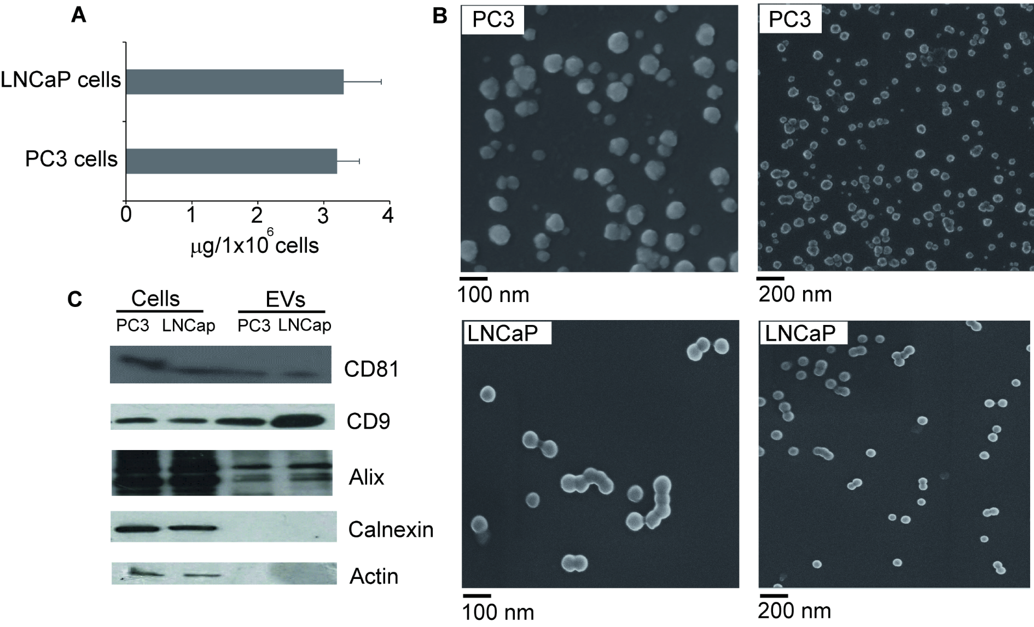

Figure S4. Characterization of EVs released by PC3 and LNCaP cells. EVs were isolated from cell culture

media of PC3 or LNCaP cells by differential centrifugation (see Materials and Methods). A)

Recovered EVs quantified as µg proteins/106 cells (mean+S.D., n=8). B) Scanning electron micrographs of

EVs. See Materials and Methods for experimental details. C) Cell lysates and EV preparations were

separated by SDS-PAGE, electrotransferred and probed with the indicated positive and negative EV

markers. See Materials and Methods for experimental details.

Table S3. Primers used for qRT-PCR.

