A Hint on the COVID-19 Risk: Population Disparities in Gene Expression of Three Receptors of SARS-CoV

Guoshuai Cai†, Xiang Cui*, Xia Zhu*, Jun Zhou*
Department of Environmental Health Sciences, Arnold School of Public Health, University of South Carolina, Columbia, SC 29208

†Address correspondence to:
Guoshuai Cai
Department of Environmental Health Sciences
Arnold School of Public Health
University of South Carolina
915 Greene Street
Discovery 517
Columbia, SC 29204
GCAI@mailbox.sc.edu
Phone: 803-777-4120

*authors contributed equally to this manuscript

A
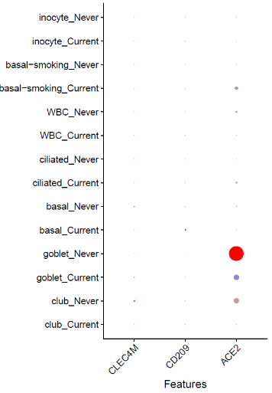
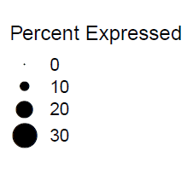
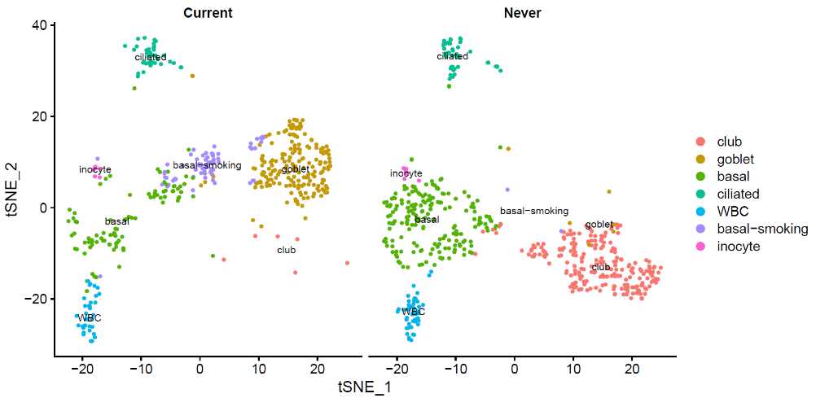
C
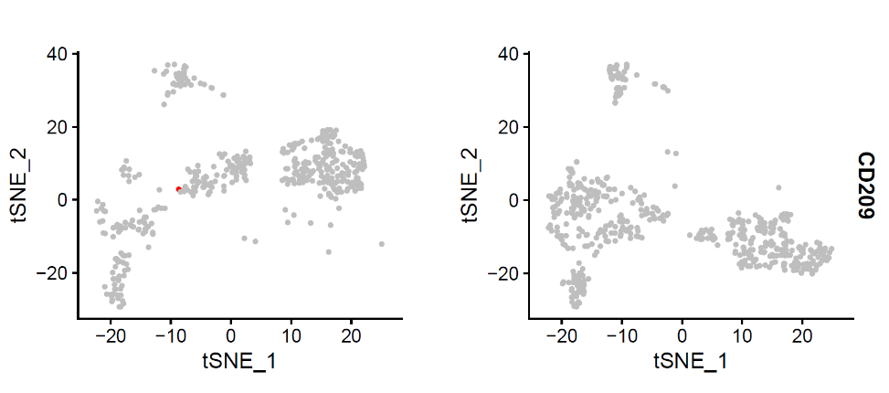
B

Figure S1. Single-cell transcriptomics of bronchial epithelium cells.
A shows tSNE plots of single-cell transcriptome profiles from never smokers and current smokers. B shows identified cell types. C shows detection rates of markers in each cell cluster. D and E show ACE2 gene expression in cells of current smokers and never smokers, separately.

tcga
GSE40419
GSE10072
GSE19804

Figure S2. Correlation of genes ACE2, CLEC4M and CD209, in four datasets.
Lower panel shows pairwise scatter plots of data mean of each gene expression across samples. Upper panel shows their corresponding Pearson correlation coefficients.

