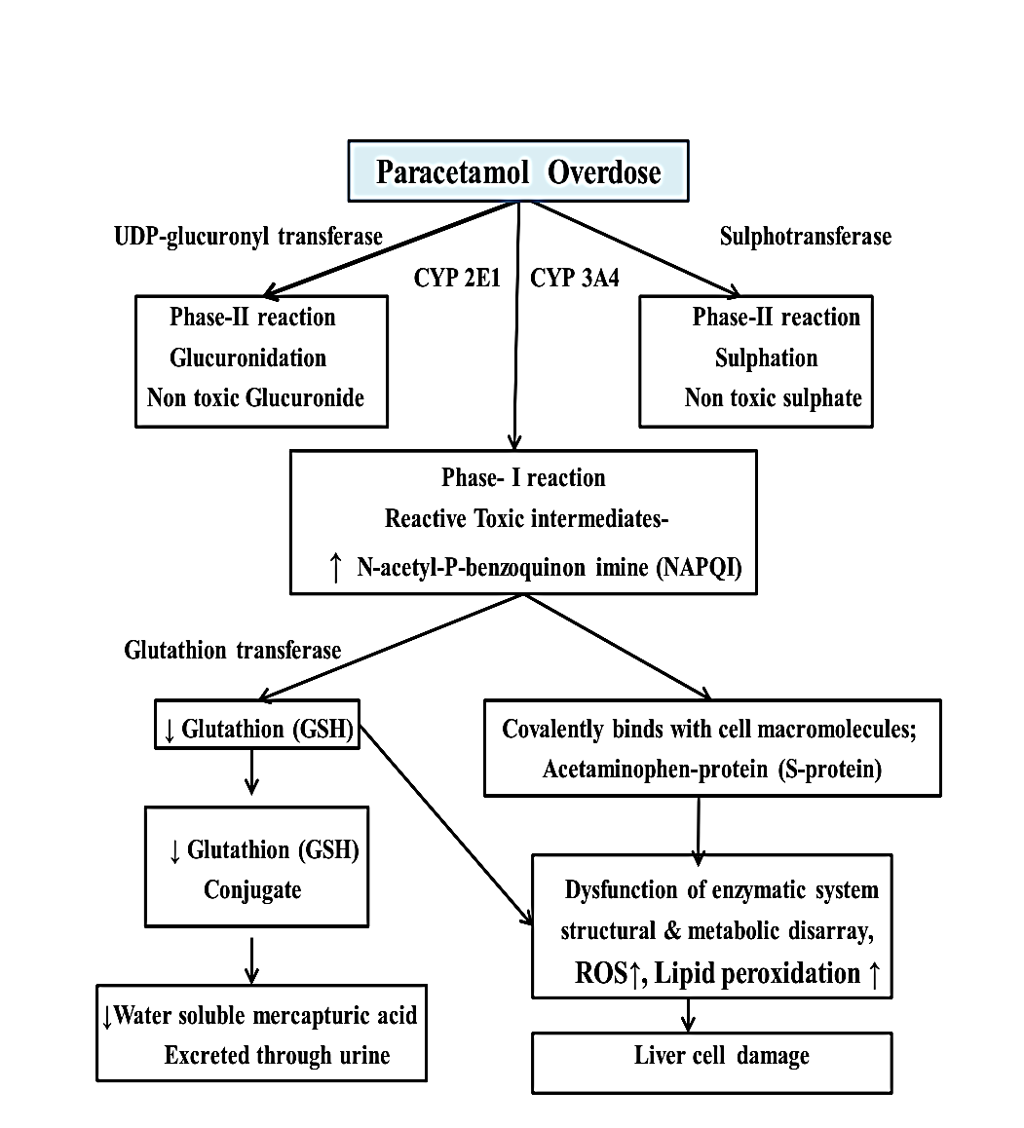

Figure S1: Possible mechanism of paracetamol induced hepatotoxicity

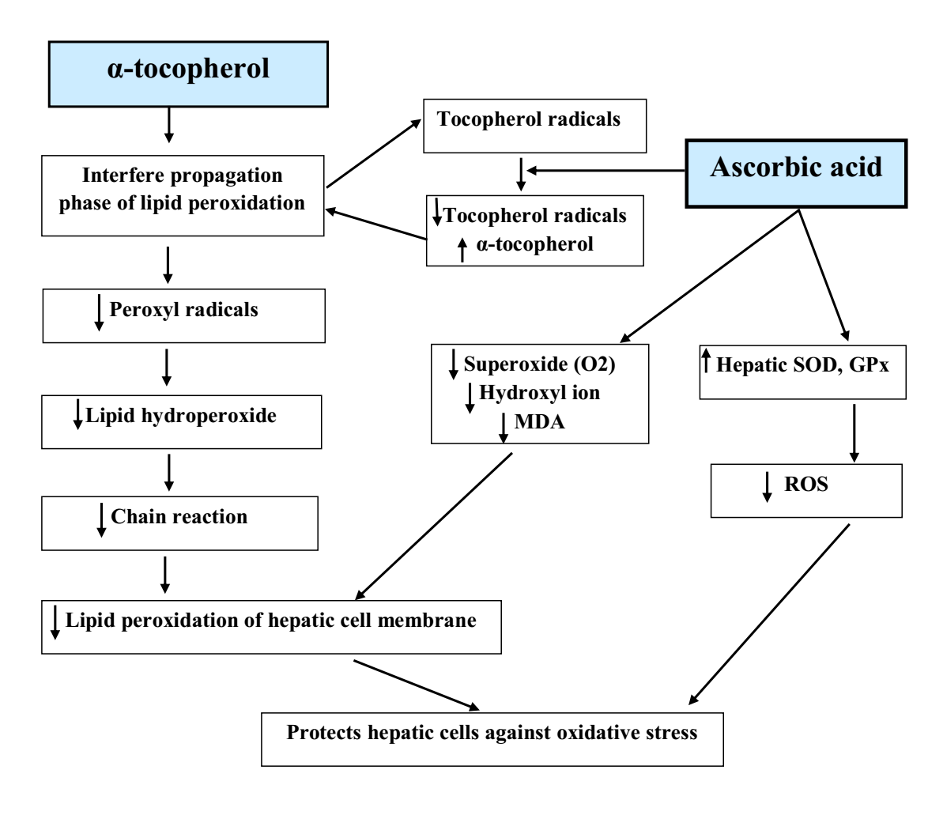
Figure S2: Possible mechanism of antioxidant effect of α-tocopherol & ascorbic acid

