Supplementary Information

Hydrogen Peroxide Detection by Super-Porous Hybrid CuO/Pt NP Platform: Improved Sensitivity and Selectivity

Rakesh Kulkarni, Sundar Kunwar, Rutuja Mandavkar, Jae−Hun Jeong* and Jihoon Lee**

Department of Electronic Engineering, College of Electronics and Information, Kwangwoon University, Nowon-gu Seoul 01897, South Korea
E-mail: myloveofjh@gmail.com*, jihoonlee@kw.ac.kr**

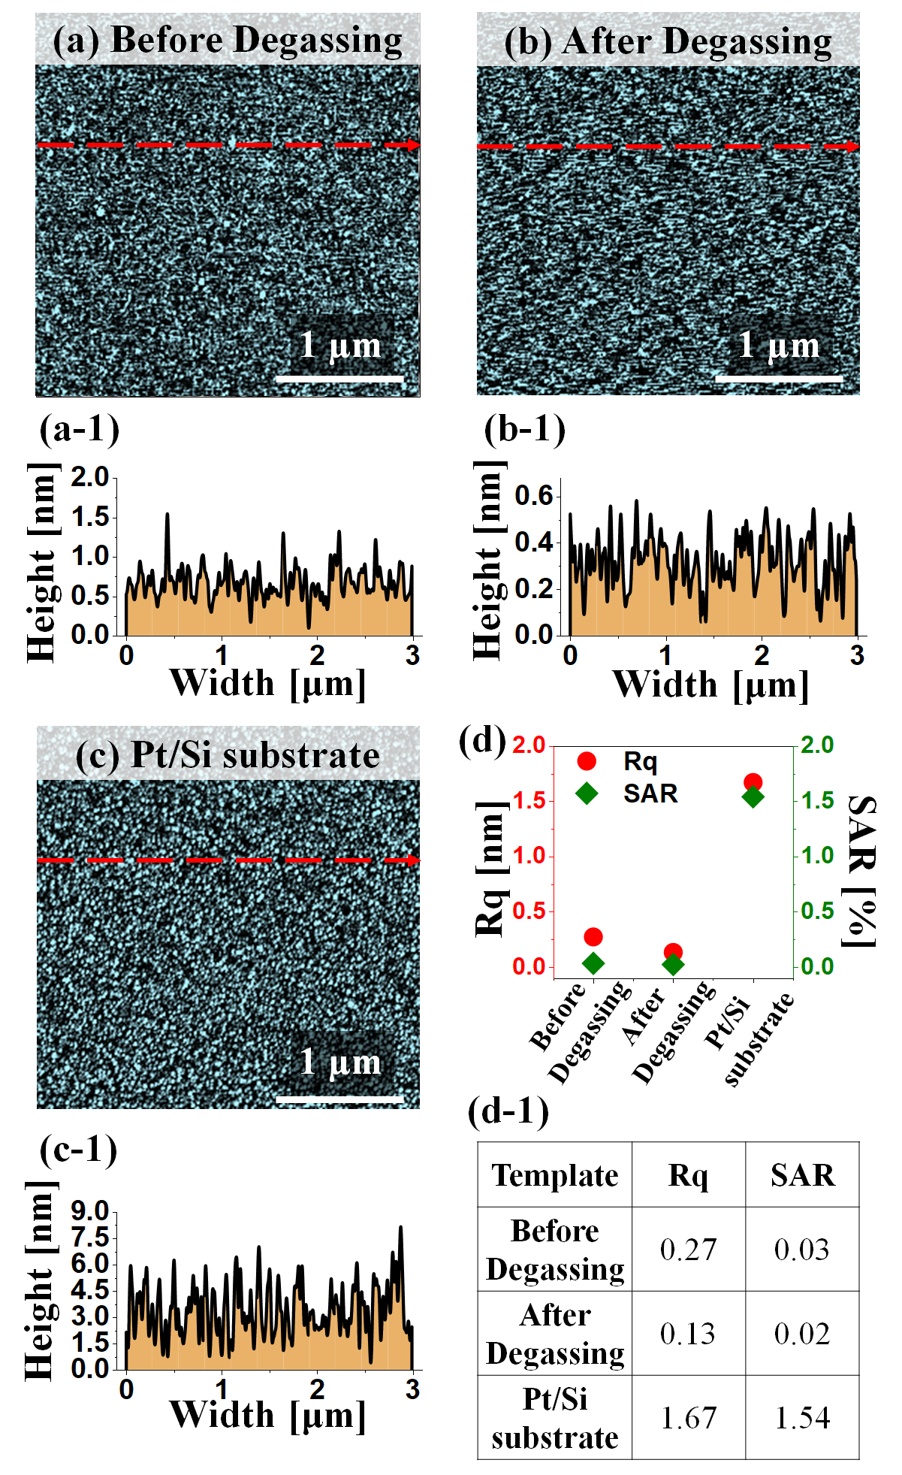
Figure S1. (a) - (c) Atomic force microscope (AFM) image of Si substrate before degassing, after degassing and after 50 nm Pt layer deposition and annealing at 425 ºC for 30 min. (a-1) – (c-1) Cross-sectional line profiles from the corresponding AFM images. (d) Summary of RMS roughness (Rq) and surface area ratio (SAR) under different conditions. (d-1) Rq and SAR summary table.
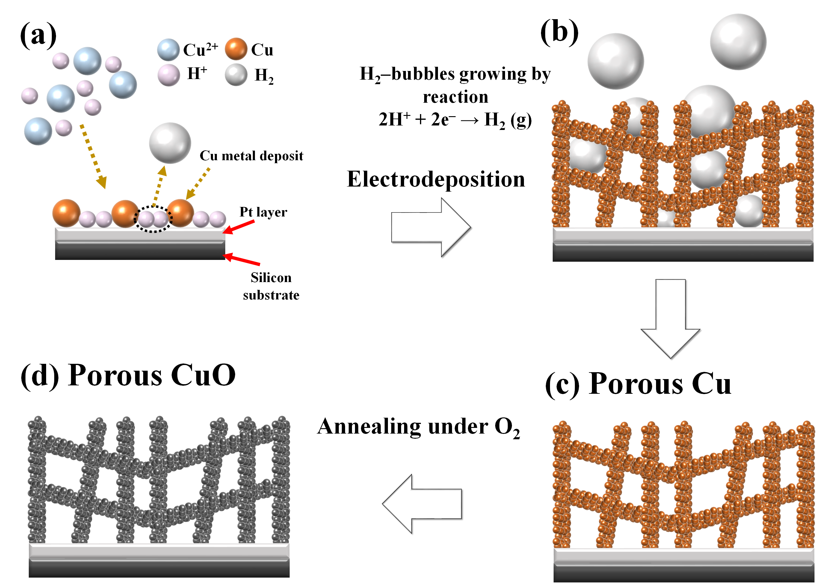
Figure S2. (a) – (d) Schematics of porous CuO fabrication procedure on Pt/Si. As shown in (a), the deposition of Cu ions and the evolution of hydrogen bubbles occurs simultaneously on the surface during electrochemical deposition. (b) As the H₂ bubble generation continues, metal ions grow in between the gas bubbles. These H₂ bubbles can create dynamic templates for the growth of Cu nanostructures. (c) Pores in the range of micron size are generated by the growth of Cu around the bubbles, resulting in the highly porous metallic layer. The agitation action of the bubbles affects the hydrodynamic conditions near the electrode surface and greatly affects the subsequent nanostructure. (d) Various nanostructures such as dendrites, small pores to large pores can be created along with the control of deposition conditions such as current density and deposition time. Due to the large overpotential used, a co-reduction process occurs in which the metal ions in the electrolyte are reduced simultaneously with H ⁺, i.e., the processes in which equations 1 and 2 occur simultaneously.

2H⁺_{(aq)} + 2e⁻ → H₂ (1)
Cu²⁺_{(aq)} + 2e⁻ → Cu_{(s)} (2)
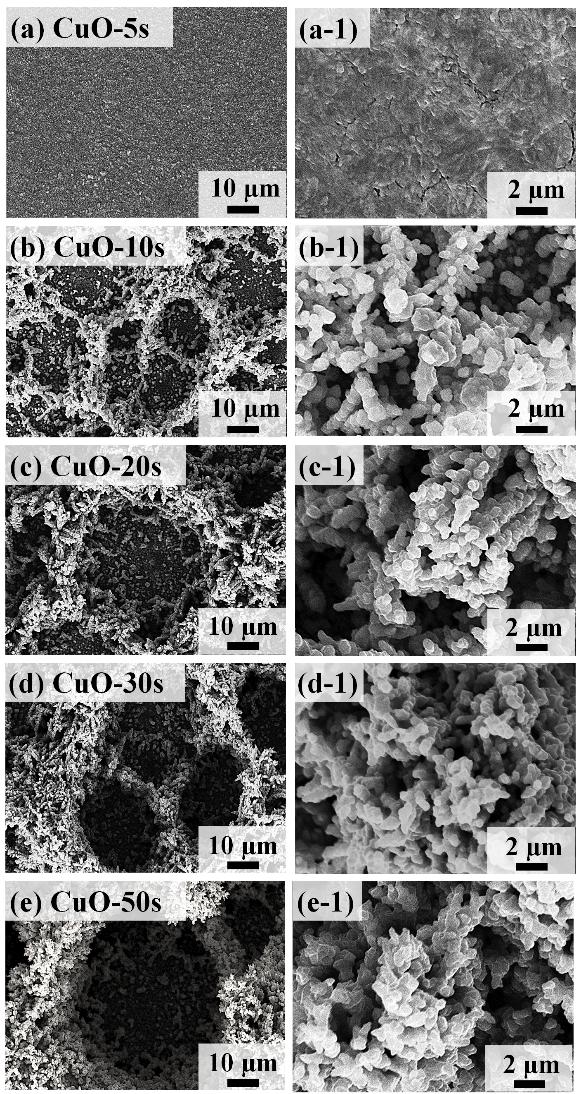
Figure S3. (a) – (e) Large scale SEM images of porous CuO samples by the electrochemical deposition time variation at 2 A/cm² cathodic current density. (a-1) – (e-1) High magnification SEM images of the porous CuO.
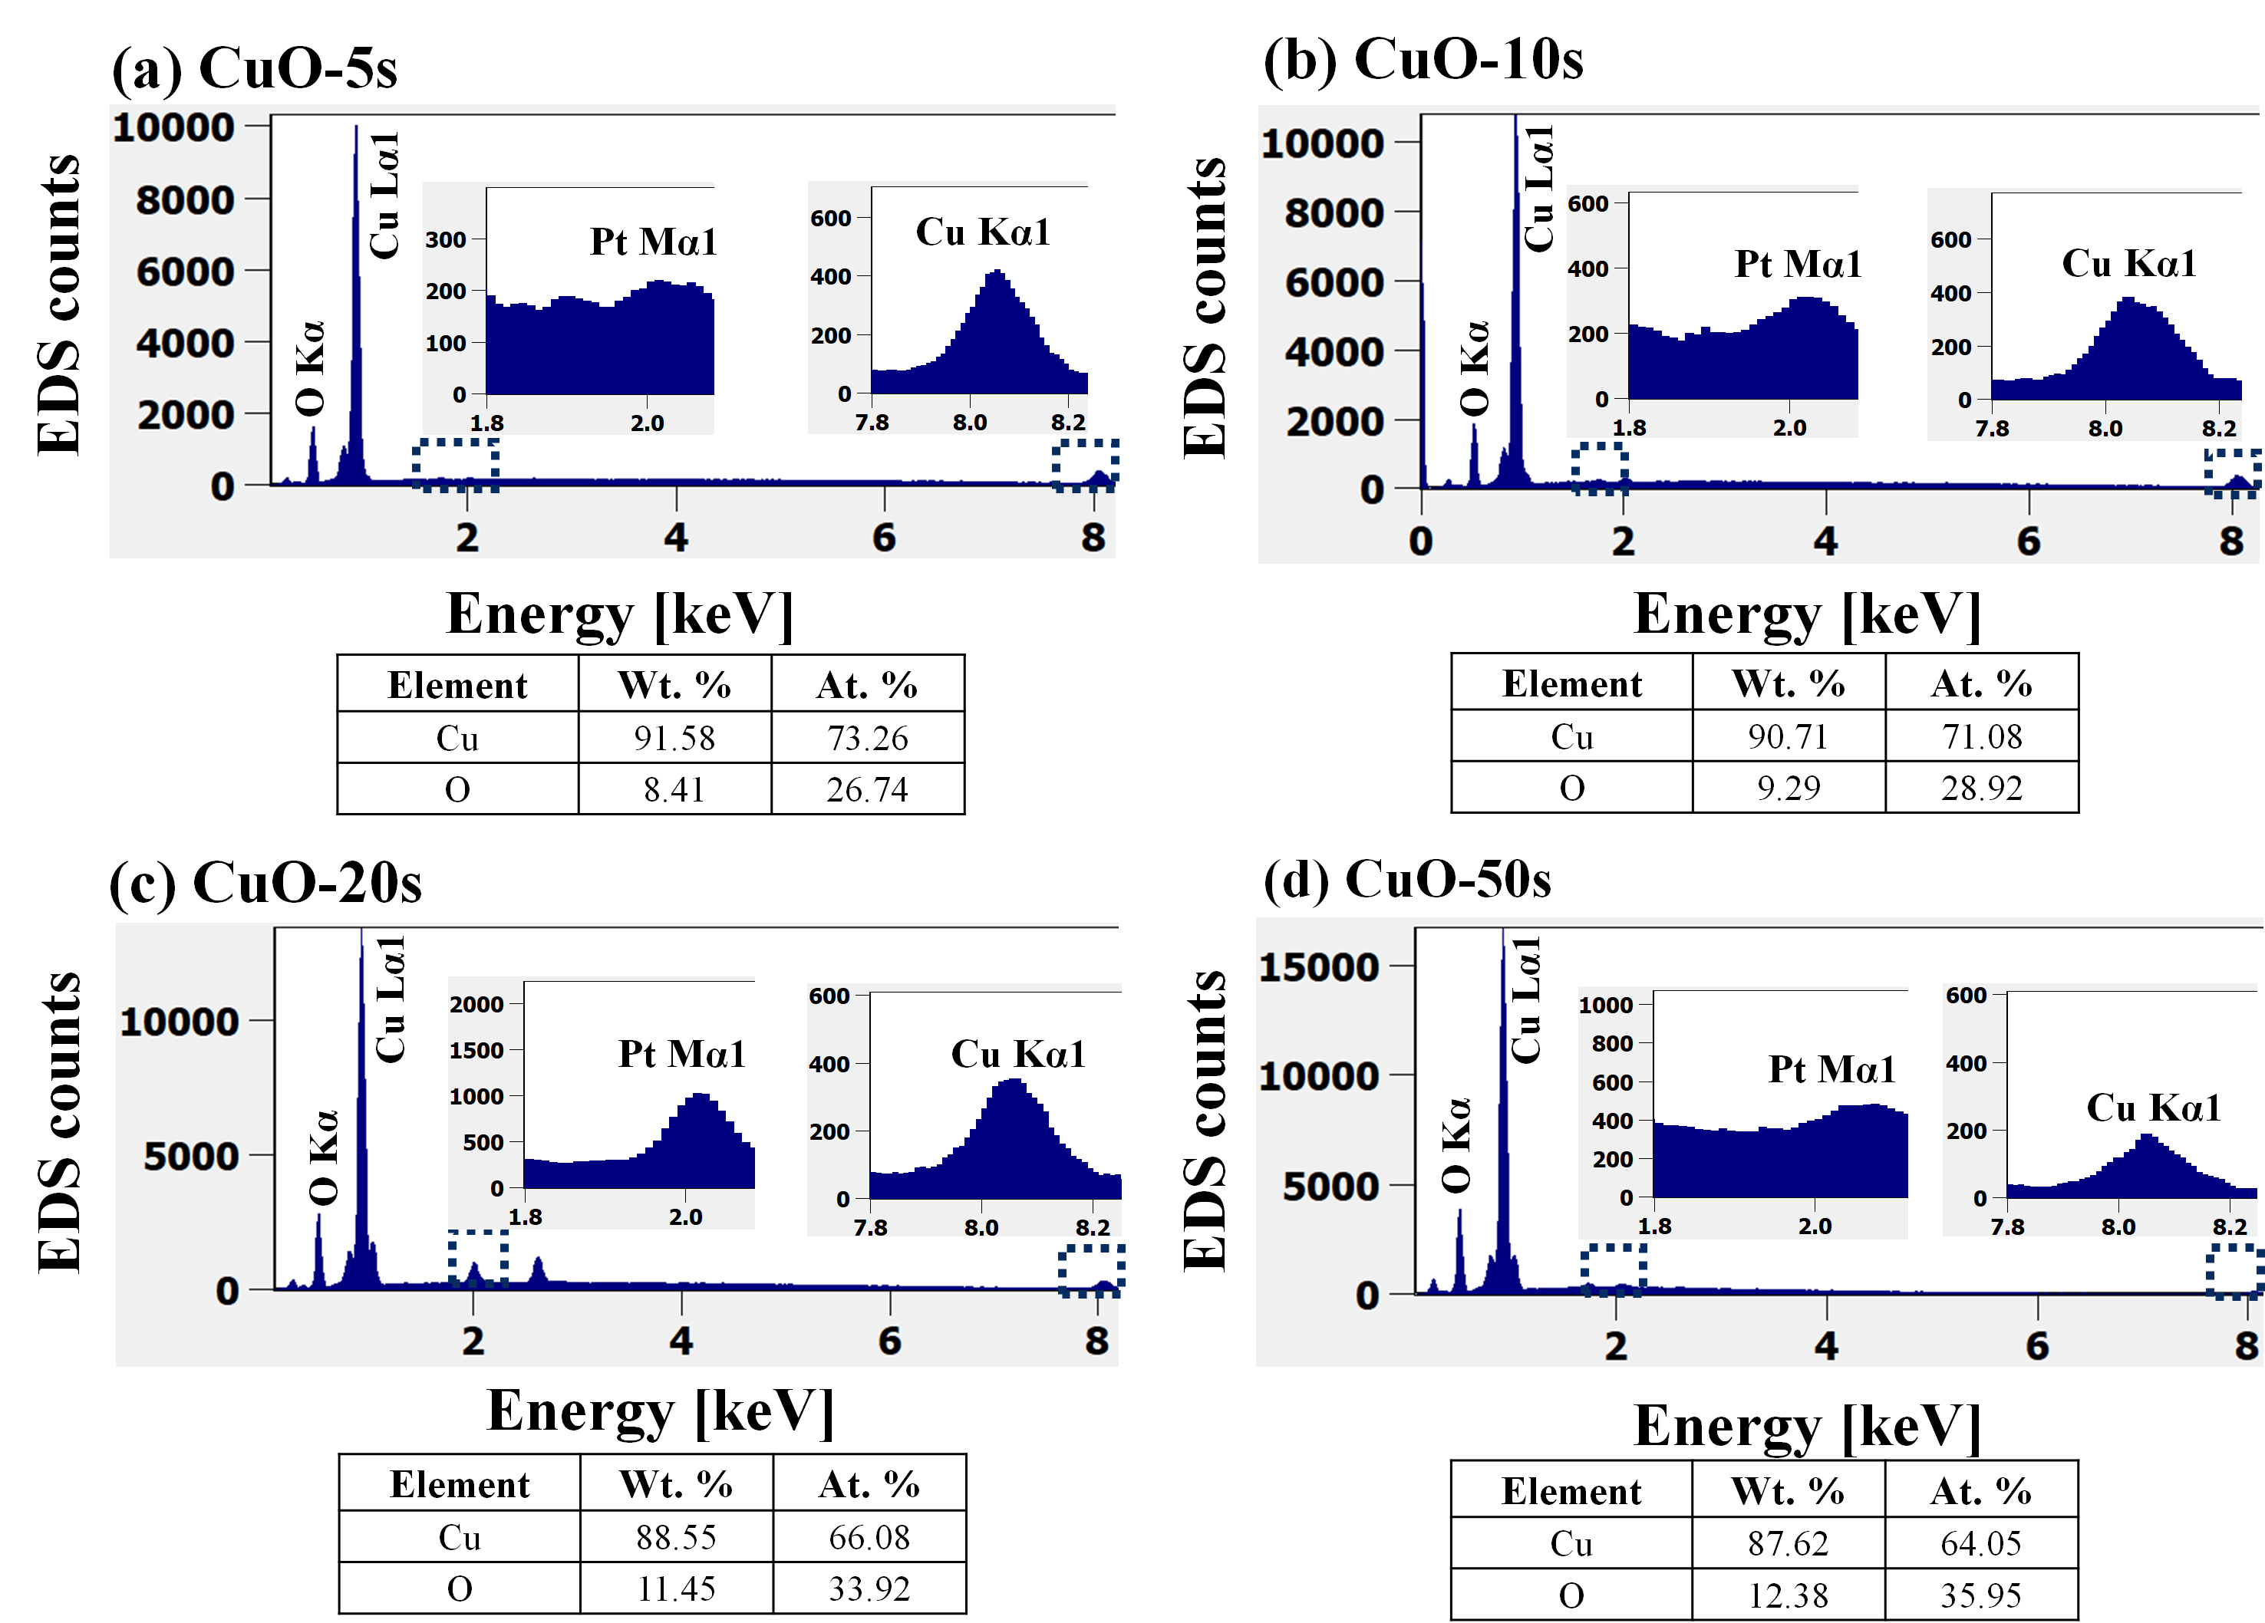
Figure S4. EDS spectra of porous CuO based on the variation of deposition time (a) CuO-5s, (b) CuO-10s, (c) CuO-20s, and (d) CuO-50 s. Insets show the enlarged Pt Mα1 and Cu Kα1 peaks in each sample. The elemental composition of Cu and O is summarized in corresponding tables.

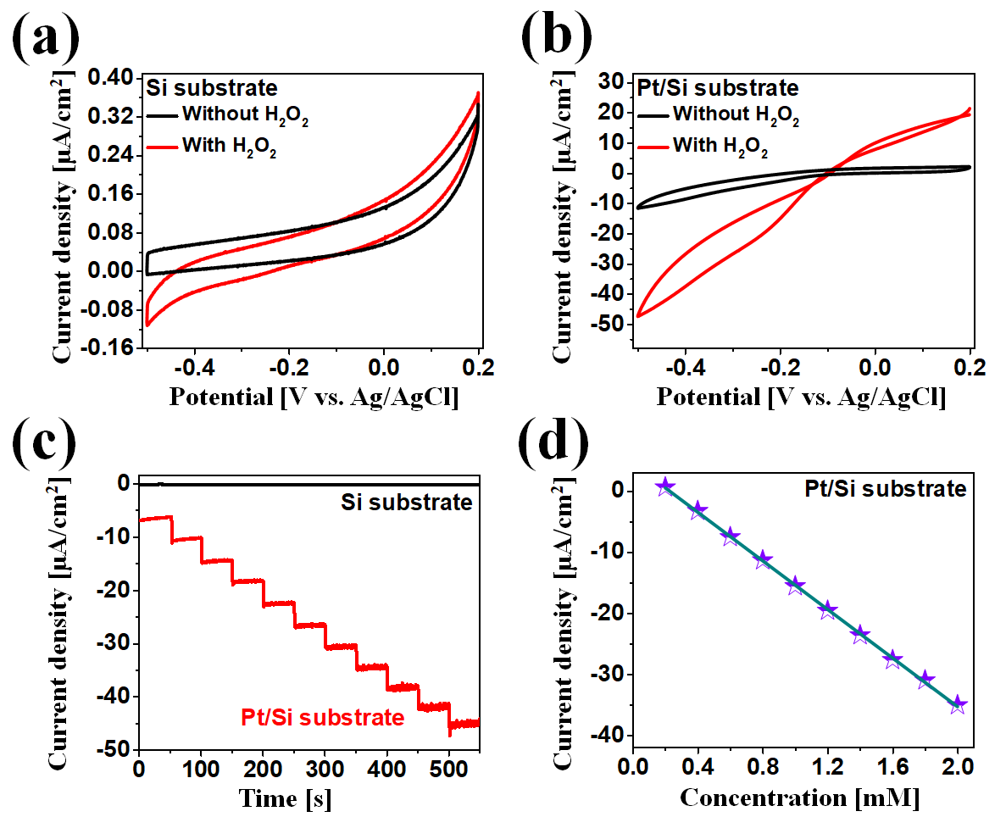
Figure S5. (a) – (b) CV responses of Si substrate and Pt/Si substrate with and with the addition of the H₂O₂ in 0.1 mM PBS (pH 7.4) at a scan rate of 50 mV/s. (c) Amperometric response of Si substrate and Pt/Si substrate and (d) linear calibration curve of current versus concentration of H₂O₂ with Pt/Si substrate.
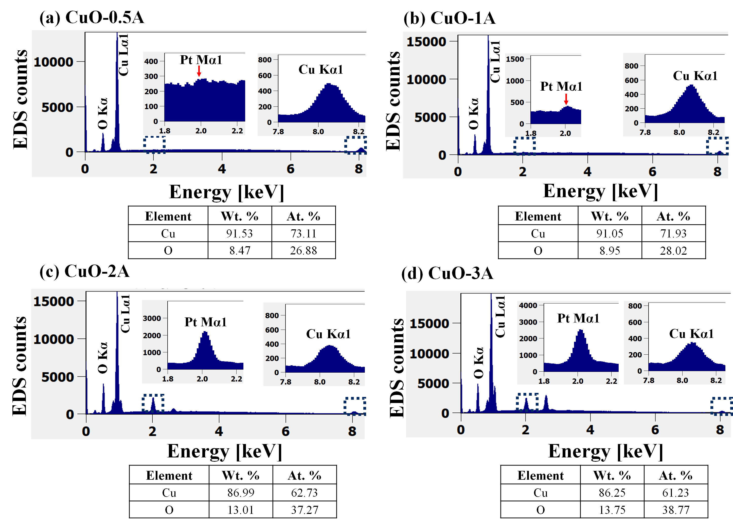
Figure S6. (a) – (d) EDS spectra of CuO samples at different deposition current density CuO-0.5A - CuO-3A. Insets show the enlarged Pt Mα1 and Cu Kα1 peaks. The elemental composition of Cu and O is summarized in corresponding tables.
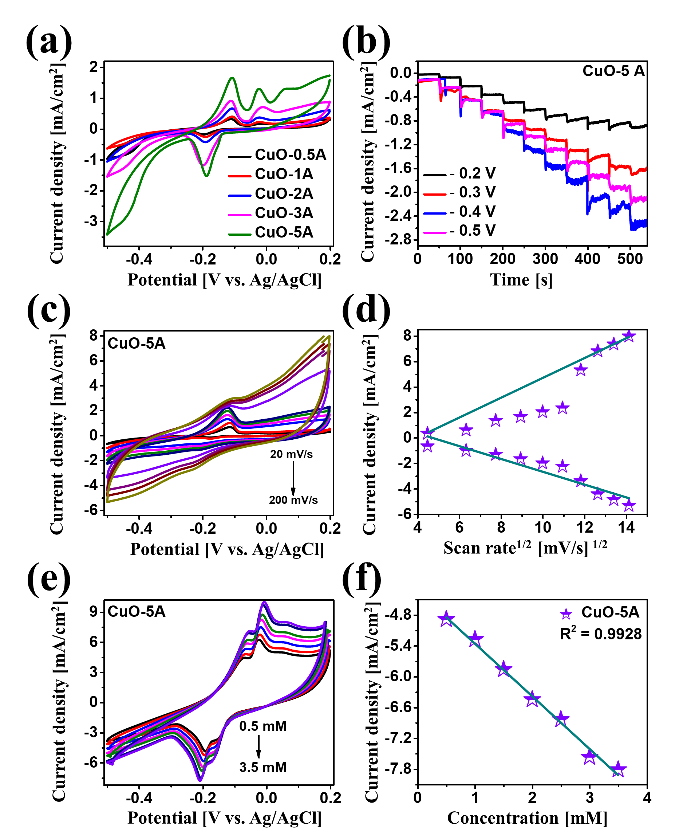
Figure S7. (a) Cyclic voltammetry (CV) response of various CuO samples in 0.1 M PBS (pH 7.4) containing 0.4 mM H₂O₂ at a scan rate of 50 mV/s. (b) Amperometric response of CuO-5A sample with dropwise addition of 0.1 mM H₂O₂ at different applied potential. (c) CVs response of the CuO-5A sample at different scan rates from 20 to 200 mV/s in 0.1 M PBS (pH 7.4) containing 0.1 mM H₂O₂. (d) Plot of oxidation and reduction peak current with respect to square root of scan rate in (c). (e) CV of CuO-5A sample in 0.1 M PBS (pH- 7.4) containing different concentrations of H₂O₂ ranging from 0.5 to 3.5 mM at the scan rate of 50 mV/s. (f) Relation between peak current and H₂O₂ concentration.

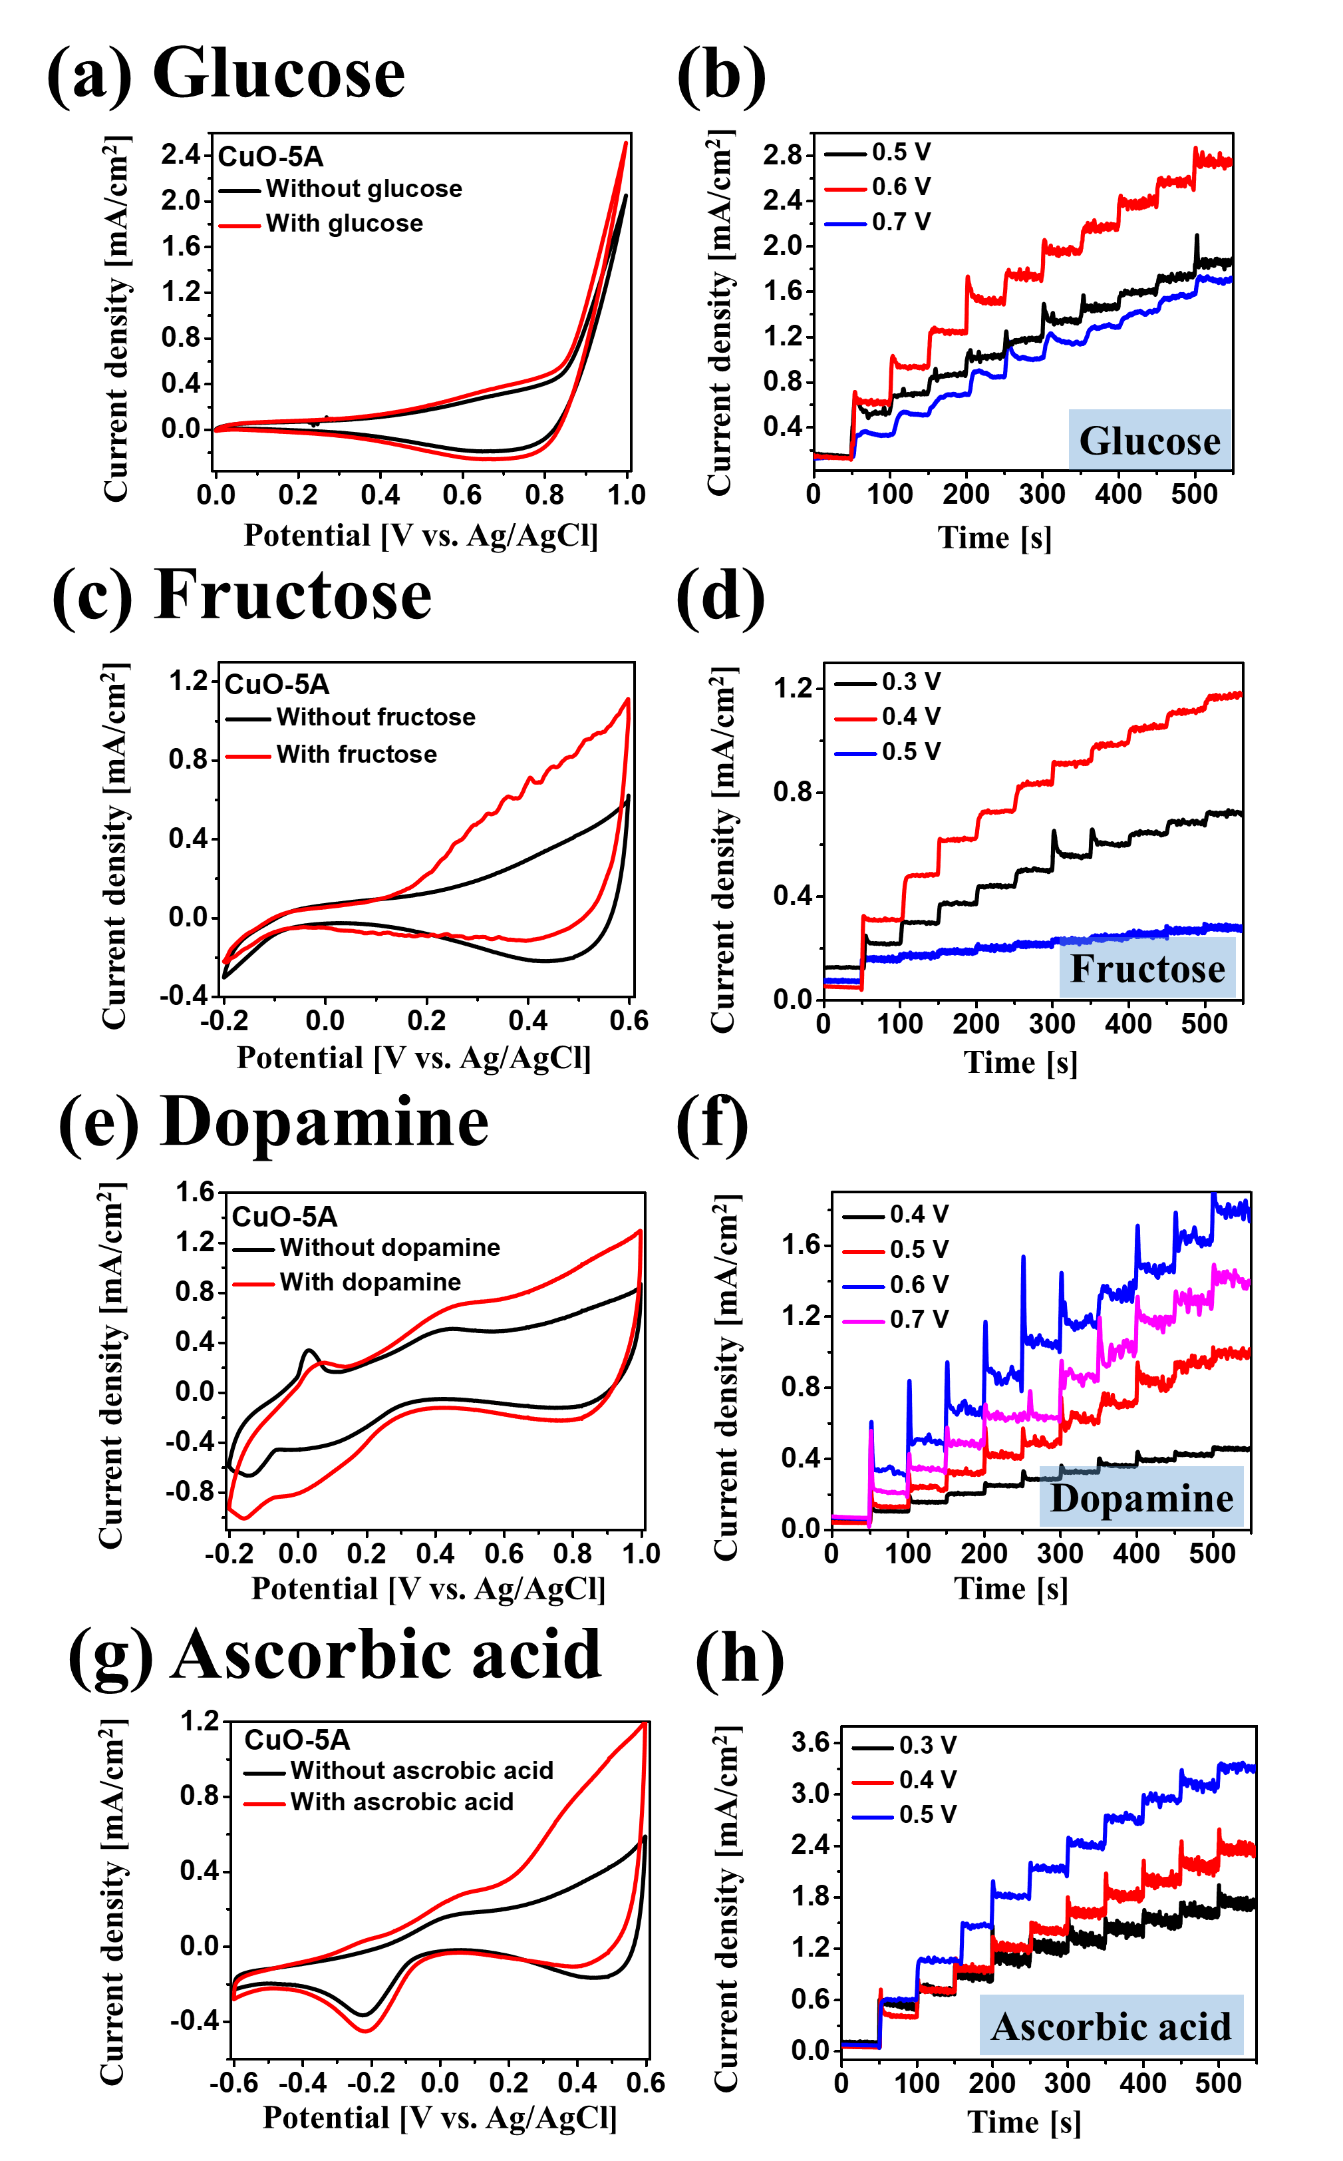
Figure S8. (a) – (g) CV response of CuO-5A with and without the addition of 0.1 mM organic molecules such as glucose, fructose, and ascorbic acid in 0.1 M NaOH and, dopamine in 0.1 M PBS at a scan rate of 50 mV/s. (b) – (d) Amperometric current response of corresponding organic molecules at different applied potentials.

