Supplementary Information
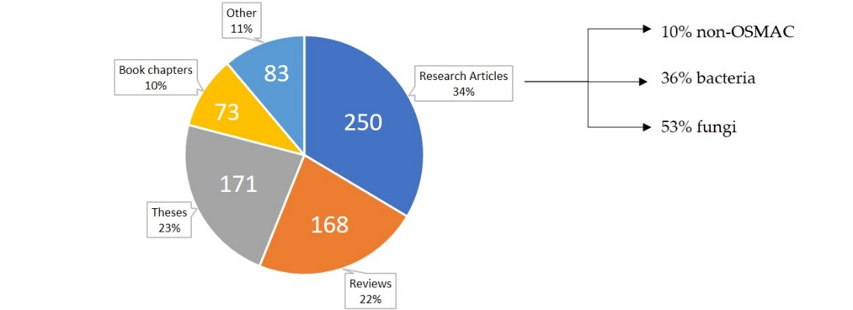
Figure S1. Distribution of Google Scholar-based literature survey results for the keywords “bacteria OSMAC” from 2002-2019. Despite the keyword “bacteria”, many research paper hits deal with fungi. Molecular biology research and analytics publications have been categorized as non-OSMAC.

Table S1. NCBI Accession numbers of candidate strains examined with antiSMASH.
Strain | NCBI Accession # | Strain | NCBI Accession #
Bacillus cereus NC4701 | AP007209 | Myxococcus xanthus DK 1622 | CP000113
Bacillus thuringiensis Bc60 | CP015150 | Corallococcus coralloides DSM2259 | NC_017030
Bacillus subtilis TOA-JPC | NZ_CP011882 | Myxococcus stipitatus DSM14675 | CP004025
Bacillus subtilis PS832 | NZ_CP010053 | Pyxidicoccus fallax HKI727 | Obtained from Prof. Nett’s group of Technical Biology, TU Dortmund University
Bacillus atrophaeus UCMB5137 | CP011802 | Streptomyces nodosus ATCC14899 | CP009313
Bacillus amyloliquefaciens DSM7 | NC_014551 | Rhodococcus erythropolis BG43 | CP011295
Pseudomonas putida JBC17 | CP029693 | Rhodococcus pyridinivorans SB3094 | NC_023150
Escherichia coli CFT-073 | AE014075 | Rhodococcus jostii DSM44719 | NZ_FNTL01000004
Pseudomonas fluorescens LBUM223 | NZ_CP011117 | Streptomyces laurentii ATCC31255 | AP017424
Pseudomonas protegens Pf-5 | NC_04129 | Rhodococcus aetherivorans IcdP1 | NZ_CP011341
Streptomyces rapamycinicus NRRL5491 | CP006567 | Streptomyces avermitilis DSM46492 | NZ_KQ948581
Sorangium cellulosum So ce56 | AM746676 | Streptomyces griseochromogenes DSM40499 | NZ_CP016279
Paenibacillus polymyxa strain J | NZ_CP015423 | Actinosynnema mirum DSM43827 | NC_013093
Saccharopolyspora erythraea NRRL2338 | NC_009142 | Streptomyces bingchenggensis BCW-1 | NC_016582
Pseudomonas aeruginosa AR0110 | CP029745 | Pseudomonas aeruginosa PB350 | CP025055
Streptomyces violaceusniger Tu 4113 | CP002994 | Rhodococcus opacus B4 | NC_012522
Rhodococcus erythropolis R138 | NZ_CP007255 | Kribbella flavida DSM 17836 | NC_013729
Bacillus amyloliquefaciens FZB42 | NC_009725 | Pseudomonas fluorescens str. PCL1751 | NZ_CP010896
Pseudomonas fluorescens str. FW300-N2C3 | NZ_CP012831 | Bacillus coagulans | CP025437
Melittangium boletus DSM 14713 | CP022163 | S. aurantiaca DW4/3-1 | CP002271
Archangium gephyra DSM 2261 | CP011509 | S. amylolyticus DSM 53668 | NZ_CP011125
Chondromyces crocatus Cm c5 | CP012159

Table S2. List of chemicals, chemical formulae, and supplier. Chemicals were used in the purest form available.
Chemical | Chemical formula | Supplier | Chemical | Chemical formula | Supplier
BactoPeptone | - | Beckto Dickinson | magnesium sulfate heptahydrate | MgSO₄ x 7 H₂O | Carl Roth
meat extract | - | Fluka | dipotassium-phosphate | K₂HPO₄ | Carl Roth
raffinose D(+) pentahydrate | C₁₈H₃₂O₁₆ x 5 H₂O | Sigma Aldrich | calcium chloride dihydrate | CaCl₂ x 2 H₂O | Carl Roth
sucrose D(+) | C₁₂H₂₂O₁₁ | Carl Roth | vitamin B12 | C₆₃H₈₈CoN₁₄O₁₄P | Carl Roth
galactose D(+) | C₆H₁₂O₆ | Carl Roth | EDTA | C₁₀H₁₆N₂O₈ | Carl Roth
soluble starch | (C₆H₁₀O₅)n | Carl Roth | iron (II) sulfate heptahydrate | FeSO₄ x 7 H₂O | Carl Roth
BactoCasitone | - | Beckto Dickinson | zinc sulfate heptahydrate | ZnSO₄ x 7 H₂O | AppliChem
boric Acid | H₃BO₃ | Carl Roth | manganese (II) cloride tetrahydrate | MnCl₂ x 4 H₂O | Carl Roth
cobalt (II) chloride hexahydrate | CoCl₂ x 6 H₂O | Carl Roth | copper (II) chloride dihydrate | CuCl₂ x 2 H₂O | Carl Roth
nickel (II) chloride dihydrate | NiCl₂ x 6 H₂O | Alfa Aesar | sodium molybdate dihydrate | MoNa₂O₄ x 2 H₂O | Carl Roth
peptone from soybean | - | Carl Roth | D (+) glucose | C₆H₁₂O₆ | Carl Roth
sodium chloride | NaCl | Carl Roth | Bacto yeast extract | - | Beckto Dickinson
malt extract | - | Carl Roth | HEPES | C₈H₁₈N₂O₄S | Carl Roth
tryptone | - | Carl Roth | L-glutamic acid | C₅H₉NO₄ | AppliChem
potassium chloride | KCl | Carl Roth | sodium nitrate | NaNO₃ | Carl Roth
potassium dihydrogen phosphate | KH₂PO₄ | Carl Roth | thiamine-HCl | C₁₂H₁₇ClN₄OS x HCl | Carl Roth
L-phenyl-alanine | C₉H₁₁NO₂ | Carl Roth | L-proline | C₅H₉NO₂ | Carl Roth
manganese (II) sulfate hydrate | MnSO₄ x H₂O | Carl Roth | disodium hydrogen phosphate | Na₂HPO₄ x 2 H₂O | AppliChem
copper (II) sulfate pentahydrate | CuSO₄ x 5 H₂O | Carl Roth | ammonium chloride | NH₄Cl | Carl Roth
ethyl acetate | C₄H₈O₂ | VWR | methanol | CH₄O | Carl Roth
acetonitrile | C₂H₃N | Carl Roth | dimethyl sulfoxide | C₂H₆OS | Fisher Scientific
ethanol | C₂H₆O | Merck | toluene | C₇H₈ | Fisher Scientific
surfactin | C₅₃H₉₃N₇O₁₃  C₅₂H₈₉N₇O₁₃ | Santa Cruz Biotechno-logy | myxochelin A | C₂₀H₂₄N₂O₇ | Biomol
cyclo-(tyr-pro) | C₁₄H₁₆N₂O₃ | Carbo-synth Limited | nocardamin | C₂₇H₄₈N₆O₉ | Biomol
desferrioxa-mine B | C₂₅H₄₈N₆O₈ | Sigma

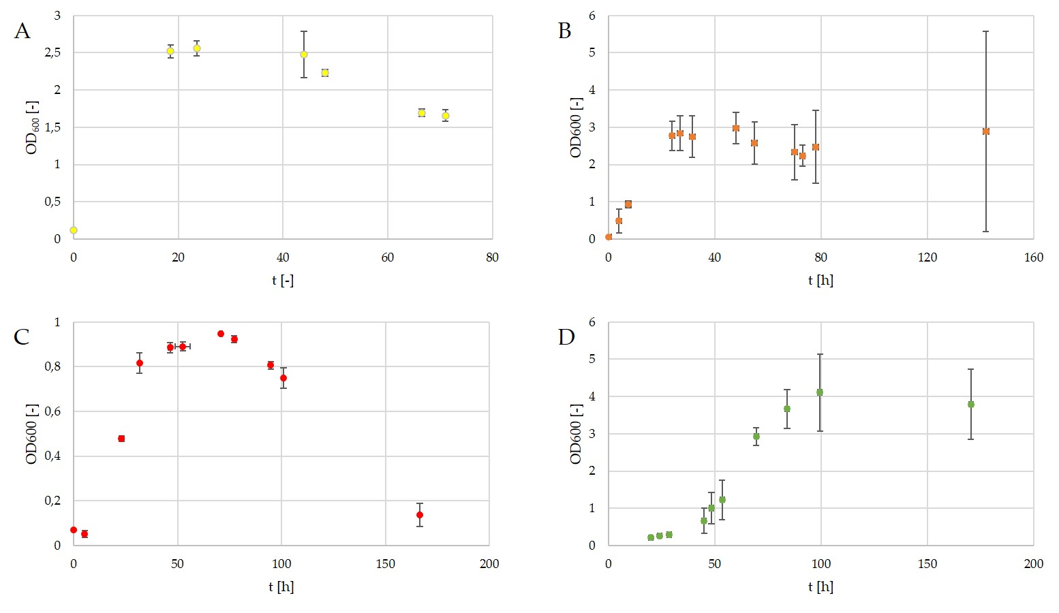
Figure S2. Growth curves of selected bacterial under control group conditions. A-B. amyloliquefaciens on NB medium at 30°C, B- C. corallloides on SP medium at 30°C, C- P. fallax on MD1 medium at 30°C, D- R. jostii on TSB medium at 28°C.
Table S3. Composition of CY/H medium
. Solutions A and B are to be autoclaved separately. 1 mL of each solution B and C will be added to solution A. Final pH = 7.4.[1]
components | amount [g∙L⁻¹]
solution A
Bacto® Casitone | 1.5
yeast extract | 1.5
starch | 4.0
soy flour | 1.0
D-(+)-Glucose | 1.0
CaCl₂ x 2 H₂O | 1.0
MgSO4 x 7 H₂O | 0.5
HEPES | 11.9
solution B
EDTA-iron | 0.8 g
distilled water | 100.0 ml
solution C
Vitamin B₁₂ | 0.05 g
distilled water | 100.0 ml

Table S4. Composition of LB medium. Final pH = 7.0.
Components | amount [g∙L⁻¹]
tryptone | 10.0
yeast extract | 5.0
NaCl | 10.0

Table S5. Composition of MD1+G medium. Final pH = 7.4.
Components | amount [g∙L⁻¹]
MD1 recipe
D-(+)-Glucose | 2.2

Table S6. Composition of Landy medium. Final pH = 7.0.[2]
Components | amount [g∙L⁻¹]
D-(+)-Glucose | 20.0
L-glutamic acid | 5.0
L-phenylalanine | 2.0
MgSO₄ x 7 H₂O | 0.5
KCl | 0.5
KH₂PO₄ | 1.0
1% FeSO₄ | 15 µL/L
1% MnSO₄ | 500 µL/L
1% CuSO₄ | 16 µL/L

Table S7. Composition of Glucose Minerals Salts (GMS) medium. Final pH = 7.0. (No longer available at DSMZ.)
Components | amount [g∙L⁻¹]
NaNO₃ | 2.0
K₂HPO₄ | 0.5
MgSO₄ x 7 H₂O | 0.2
MnSO₄ x 5 H₂O | 0.02
FeSO₄ x 7 H₂O | 0.02
CaCl₂ x 7 H₂O | 0.02
D-(+)-Glucose | 5.0

Table S8. Composition of M9 medium and 1% PO₄³⁻ M9 medium. Final pH = 7.4.[3]
components | amount [mL]
1 M MgSO₄ | 1.0
0.1 M CaCl₂ | 1.0
1 M thiamine-HCl x 2 H₂O | 1.0
D-(+)-glucose | 2.01 g
L-proline | 20.0 mg
distilled water | 900.0
salt solution | 100.0
salt solution for M9 medium
Na₂HPO₄ | 6.0 g
KH₂PO₄ | 3.0 g
NH₄Cl | 1.0 g
NaCl | 0.5 g
distilled water | 100.0
salt solution for M9 medium 1% PO₄³⁻
Na₂HPO₄ | 0.06 g
KH₂PO₄ | 0.03 g
NH₄Cl | 0.01 g
NaCl | 0.005 g
distilled water | 100.0

Table S9. Settings for vendor format raw data conversion with msConvert according to GNPS website instructions.[4]
Parameter | Setting
output format | mzXML
binary encoding precision | 32 bit
write idex | (check)
TPP compatibility | (check)
use zlib compresion | uncheck
Filters | Peak Picking with algorithm = vendor and MS Level 1-

Table S10. Steps for raw data preparation with MZmine 2.35.
Input | Step | Settings | Output
raw data, mzXML-format | Peak Detection -> Mass Detection | MS level: 1  Mass Detector: Centroid  Noise level: 1.0E4 | mass list
mass list | Peak Detection -> Chromatogram Builder | MS level: 1  Min time span: 0.01 min  Min height: 3.0E4  m/z tolerance: 0.0 m/z or 20 ppm | peak lists, suffix:  chromatograms

Table S11. Steps for peak list processing with MZmine 2.35 with t_{R} = retention time.
Input | Step | Settings | Output
peak lists, suffix:  chromatograms | Peak Detection -> Chromatogram Deconvolution | Algorithm: Baseline cut-off | peak lists, suffix:  chromatograms deconvoluted
peak lists, suffix:  chromatograms deconvoluted | Isotopes -> Isotopic peaks grouper | m/z tolerance: 0.0 m/z or 20 ppm  t_{R} tolerance: 0.1 min  Maximum charge: 3  Representative isotope: lowest m/z | peak lists, suffix:  chromatograms deconvoluted deisotoped
peak lists, suffix:  chromatograms deconvoluted deisotoped | Alignment -> Join Aligner | m/z tolerance: 0.0 m/z or 20 ppm  Weight for m/z: 75  t_{R} tolerance: 0.1 min  Weight for t_{R} : 25 | aligned peak list
aligned peak list | Filtering -> Peak list rows filter | Minimum peaks in a row: 2  remove rows that match all criteria | aligned peak list, suffix:  filtered
aligned peak list, suffix:  filtered | Filtering -> Peak list rows filter | t_{R} : 1.0-11.0 min  keep rows that match all criteria | aligned peak list, suffix:  filtered filtered

Table S12. Numbers of BGCs of different natural product classes present on the genomes of selected strains. Some BGCs were not clearly identified and were labeled as two classes by antiSMASH. Those BGCs have been counted twice. Therefore, the total number of BGCs does not necessarily equal the sum of listed gene clusters. PKS = polyketides, NRPs = non-ribosomal peptides, PKs-NRPs = PKs-NRPs-hybrid.
Natural product class | # BGCs on DSM7 genome | # of BGCs on DSM2259 genome | # of BGCs on HKI727 genome | # of BGCs on DSM44719 genome | # BGCs on DSM40499 genome
PKs | 2 | 3 | 7 | 2 | 7
NRPs | 3 | 4 | 8 | 11 | 3
PKs-NRPs | 2 | 8 | 9 | 0 | 8
Terpenes | 2 | 4 | 1 | 2 | 8
Lantipeptides | 4 | 5 | 0 | 0 | 6
Bacteriocins | 0 | 5 | 5 | 2 | 7
Other | 1 | 5 | 3 | 3 | 14
Total | 11 | 34 | 33 | 18 | 49
Orphan clusters | 5 | 22 | 11 | 5 | 11

Table S13. Color code used for natural product classes in genome maps.
Color | Natural Product Class
 | Non-ribosomal peptide (NRPS)
 | Siderophore
 | Lantipeptide
 | Bacteriocin
 | Polyketides (PKS)
 | Terpenes
 | PKS-NRPS-hybrids
 | Ectoine
 | Other group
 | lassopeptide

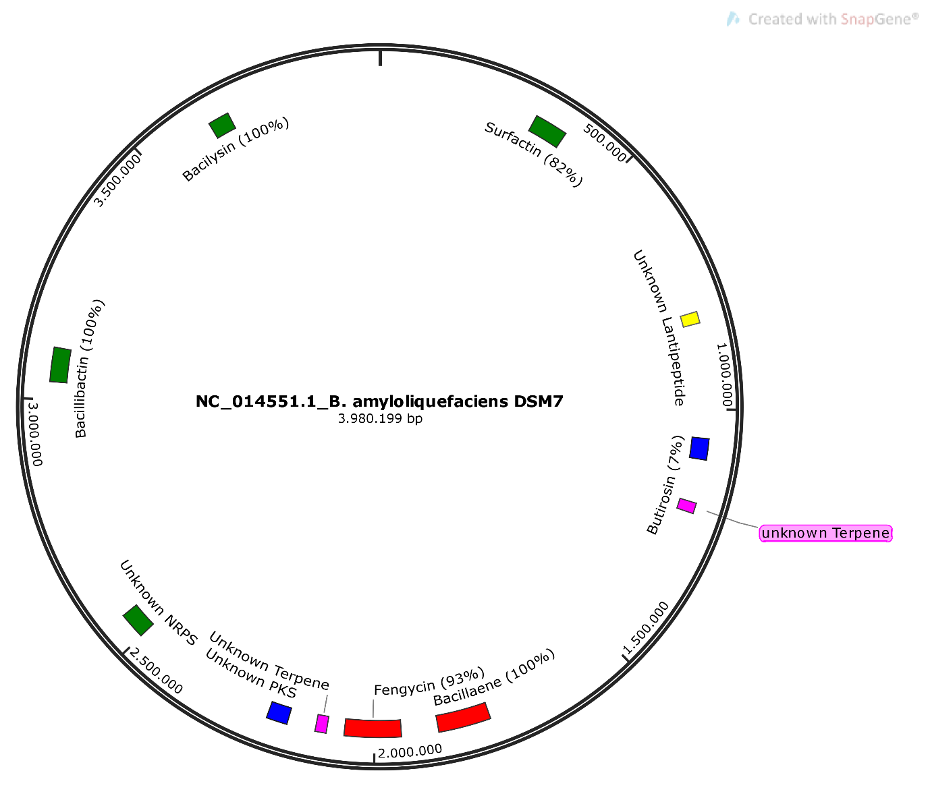
Figure S3. antiSMASH predictions for Bacillus amyloliquefaciens DSM7.
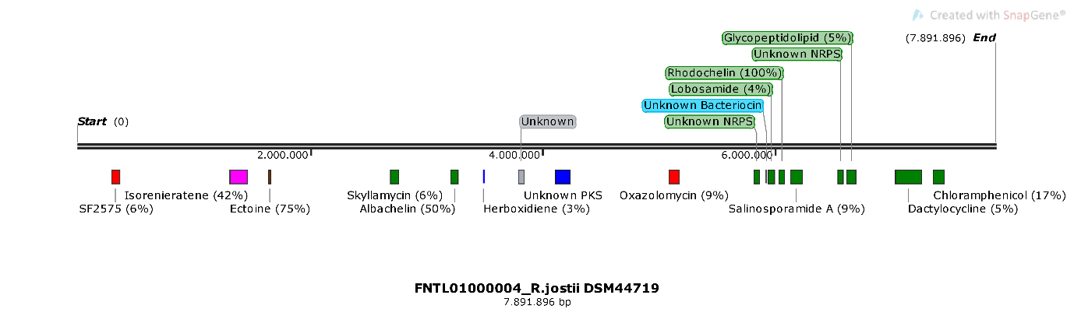
Figure S4. antiSMASH predictions for Rhodococcus jostii DSM44719.
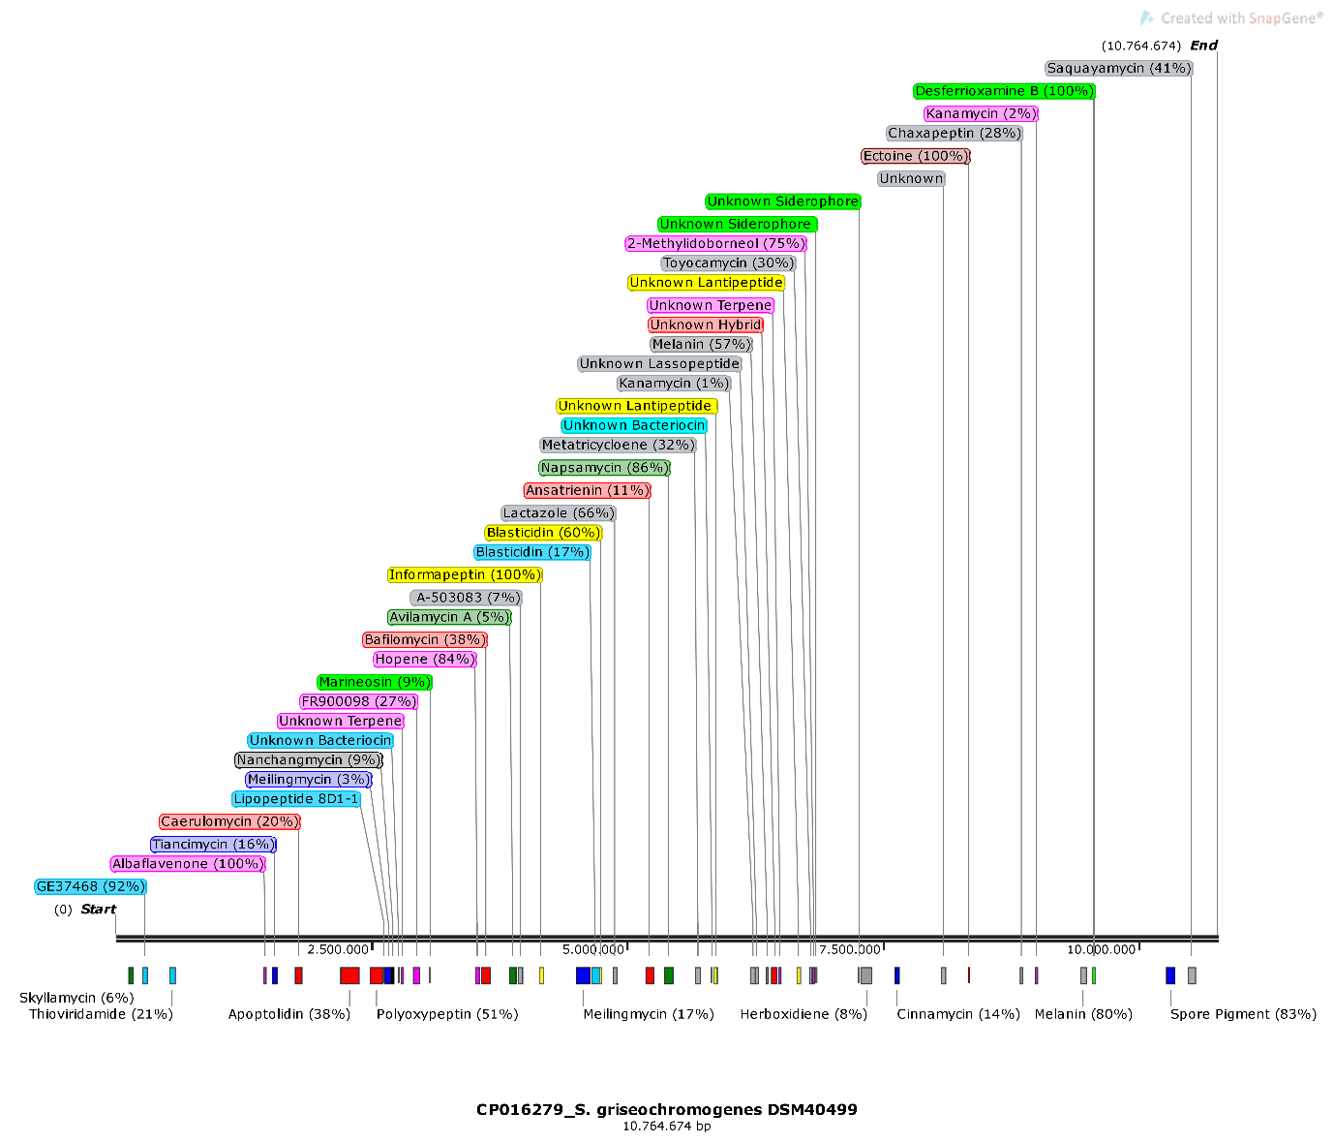
Figure S5. antiSMASH predictions for Streptomyces griseochromogenes DSM40499.
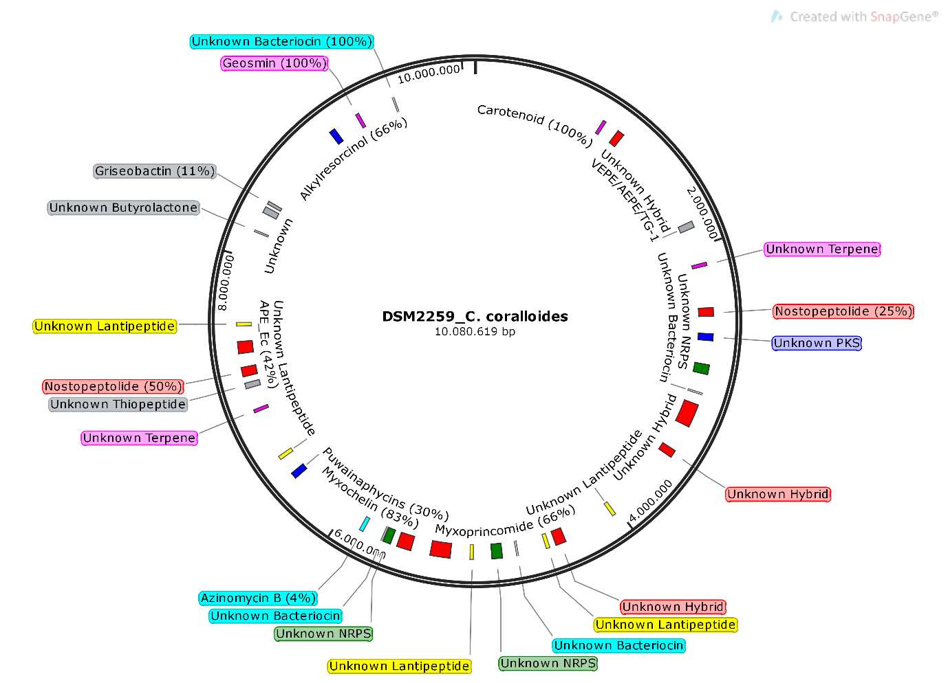
Figure S6. antiSMASH predictions for Corallococcus coralloides DSM2259.
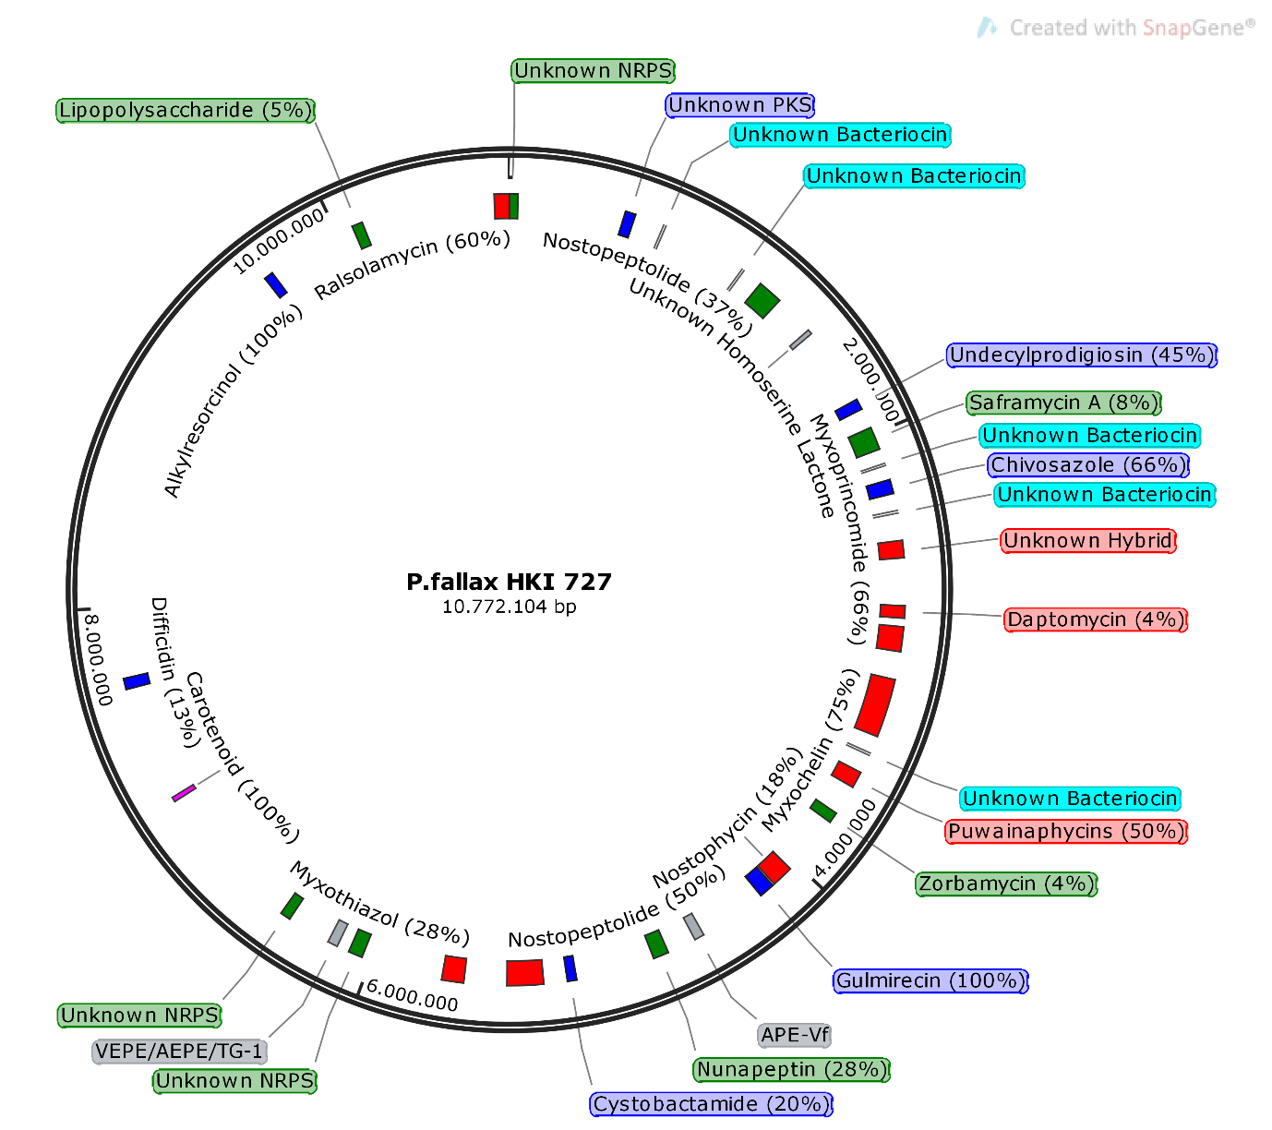
Figure S7. antiSMASH predictions for Pyxidicoccus fallax HKI727.
Table S14. Overview of compounds and corresponding producing conditions from selected strains. Bold print indicates that the compounds were not detected in control group samples.
Strain | Detected compound  (% similarity) | Producing conditions
B. amyloliquefaciens DSM 7 | surfactin (82%) | 40°C, GMS medium, Fe³⁺-limited GMS medium (GMS FeX), 3% EtOH, 3% Tol, addition of sterile-filtered supernatant of P. fallax
 | bacillibactin (100%) | Fe³⁺-limited GMS medium (GMS FeX),
 | putative bacillaene (100%) | control, LB medium, 40°C, Fe³⁺-limited GMS medium (GMS FeX), 3% EtOH, 3% Tol, addition of sterile-filtered supernatant of P. fallax
P. fallax HKI727 | myxochelin A (75%) | NB medium, SP medium, M9 medium, M9 medium with 1% PO₄³⁻, 25°C, 35°C, 0.5%/1%/3% DMSO, 0.5%/1% EtOH, addition of C. coralloides or S. griseochromogenes pellet.
 | nostophycin (18%) | GMS medium, Fe³⁺-limited GMS medium (GMS FeX), Mg²⁺-limited GMS medium (GMS MgX), 6% EtOH, 6% Tol
S. griseochromogenes DSM 40499 | desferrioxamine B (100%) | all tested conditions BUT: TSB medium, GMS medium, Mg²⁺-limited GMS medium (GMS MgX), 6% ACN, addition of Tol, 8% EtOH
 | putative albaflavenone (100%) | oxygen limitation, SP medium, GMS medium, Fe³⁺-limited GMS medium (GMS FeX), Mg²⁺-limited GMS medium (GMS MgX)

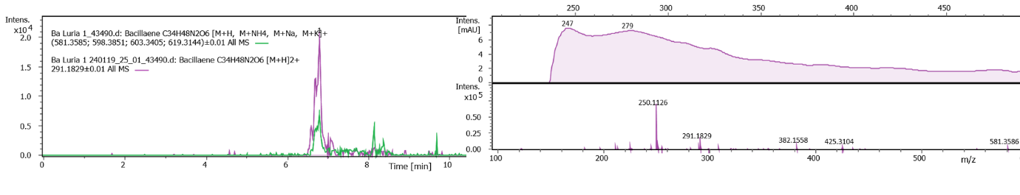
Figure S8: Extracted Ion Chromatograms (EICs) of singly and double charged of putative bacillaene from B. amyloliquefaciens cultures grown on LB medium and corresponding MS-spectrum. The UV spectrum is shown above the MS spectrum. Δppm = 0.7.
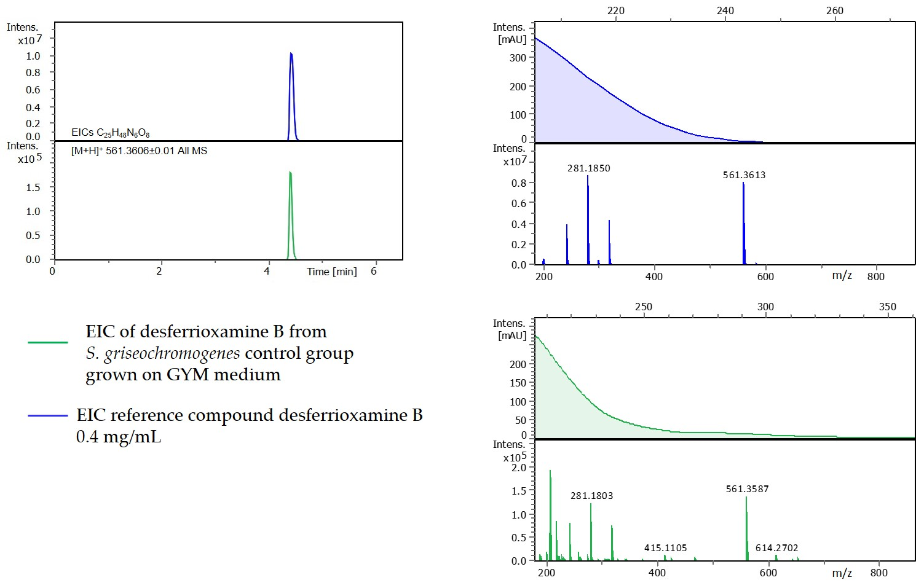
Figure S9. Comparison of chromatograms (EICs) and MS-spectra of desferrioxamine B reference compound (blue) and EIC of S. griseochromogenes control group sample (green). The UV spectrum is shown above the MS spectrum. Δppm = 4.6.

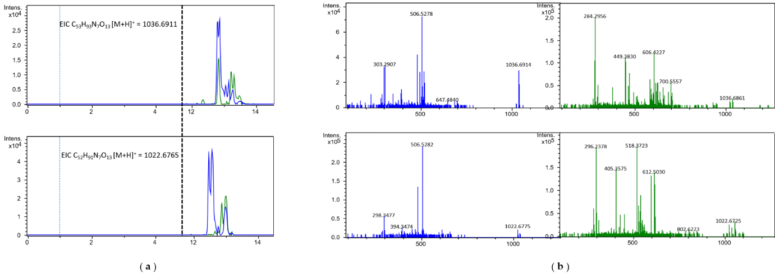
Figure S10. ( a ) Comparison of chromatograms of surfactin reference compund (contains C14- and C15-variant) (blue) and Extracted Ion Chromatograms (EICs) from sample B. amyloliquefaciens grown at 40°C (green). ( b ) Comparison of MS-spectra of surfactin reference compound and sample B. amyloliquefaciens grown at 40°C. Δppm = 4.9 for C14, Δppm = 2.2 for C15.
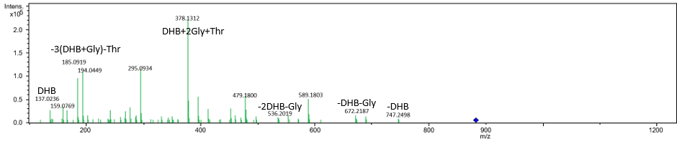
Figure S11. Experimental fragmentation pattern of bacillibactin with 45eV in accordance to [32]. Blue diamond marks the precursor molecule with m/z = 883.2424. Δppm = 1.4.
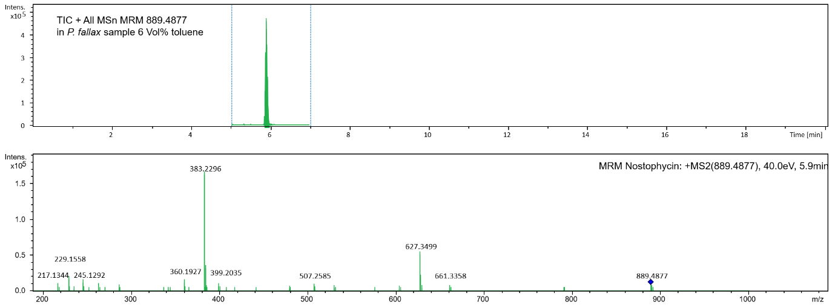
Figure S12. Total Ion Chromatogram (TIC) and fragmentation pattern of putative nostophycin in sample P. fallax 6 Vol% toluene. CE = 40eV. Δppm = 7.0.
Table S15. m/z of fragments generated through MS2 experiment of sample P. fallax 6 Vol% toluene and corresponding intensities used for in silico fragmentation of PubChem entry #101945102 for verification of nostophycin.
m/z_{fragment} | Intensity [%]
383.2296 | 100
627.3499 | 31.15
229.1558 | 10.26
360.1927 | 7.2
245.1292 | 7.2
263.1394 | 4.1
399.2035 | 4.0
217.1344 | 3.9
507.2585 | 3.5
286.1776 | 2.5
661.3358 | 2.0

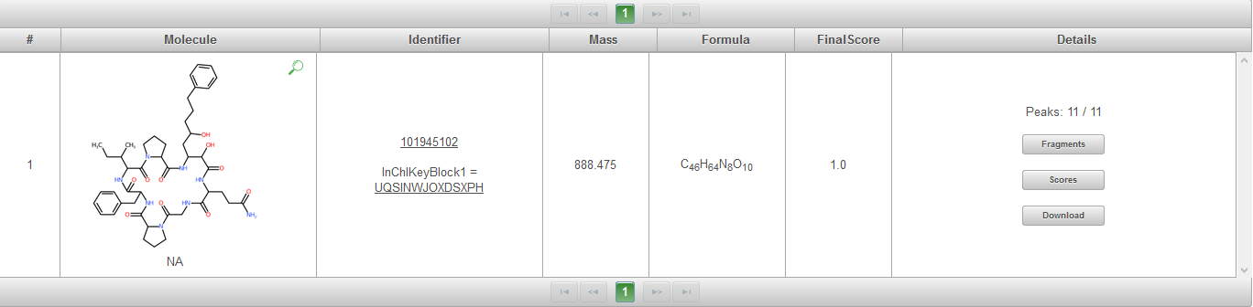
Figure S13. MetFrag results of in silico fragmentation of PubChem entry #101945102 compared with experimental MS2 spectrum of putative nostophycin. (Figure S12,Table S15)
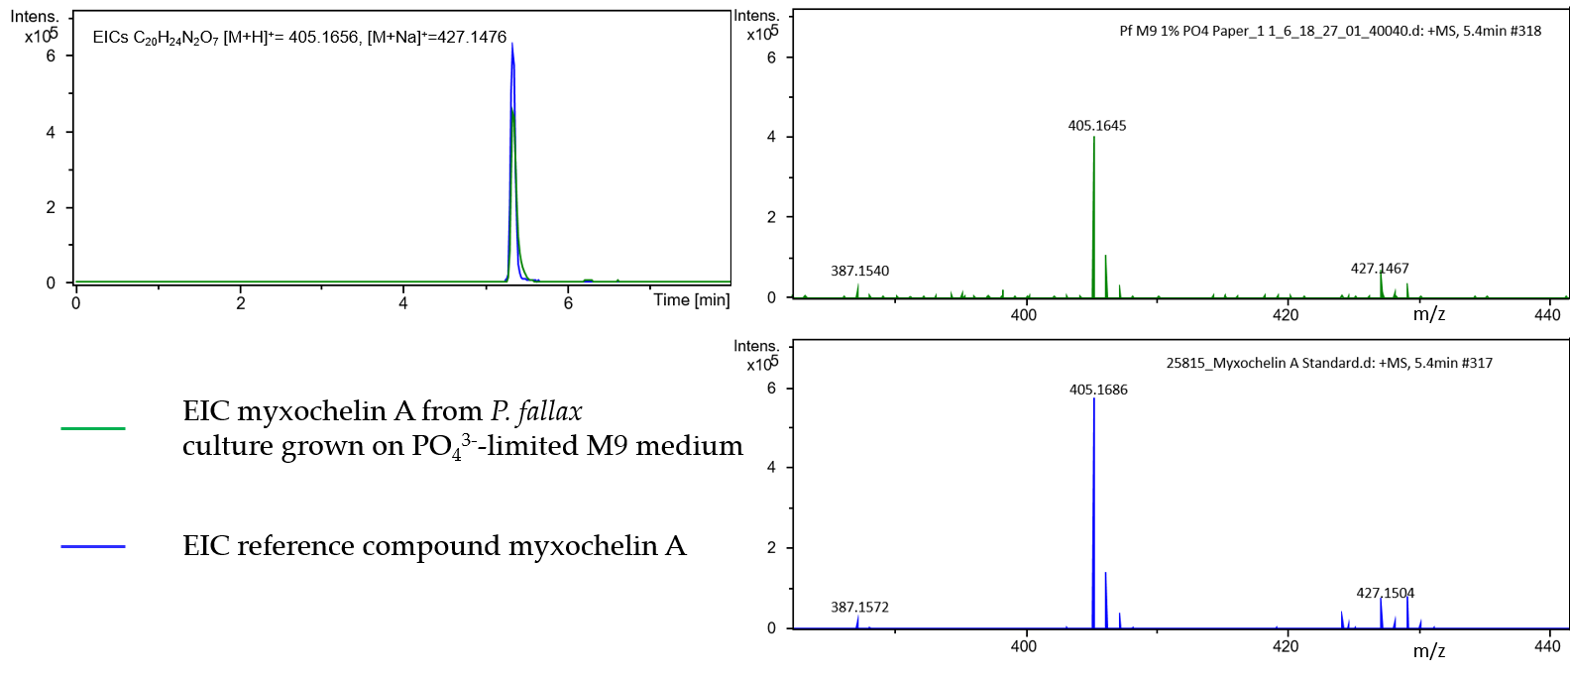
Figure S14. Comparison of chromatograms and MS-spectra of myxochelin A reference compound (blue) and EIC of sample P. fallax M9 1% PO₄³⁻ (green). Δppm = 10.1.

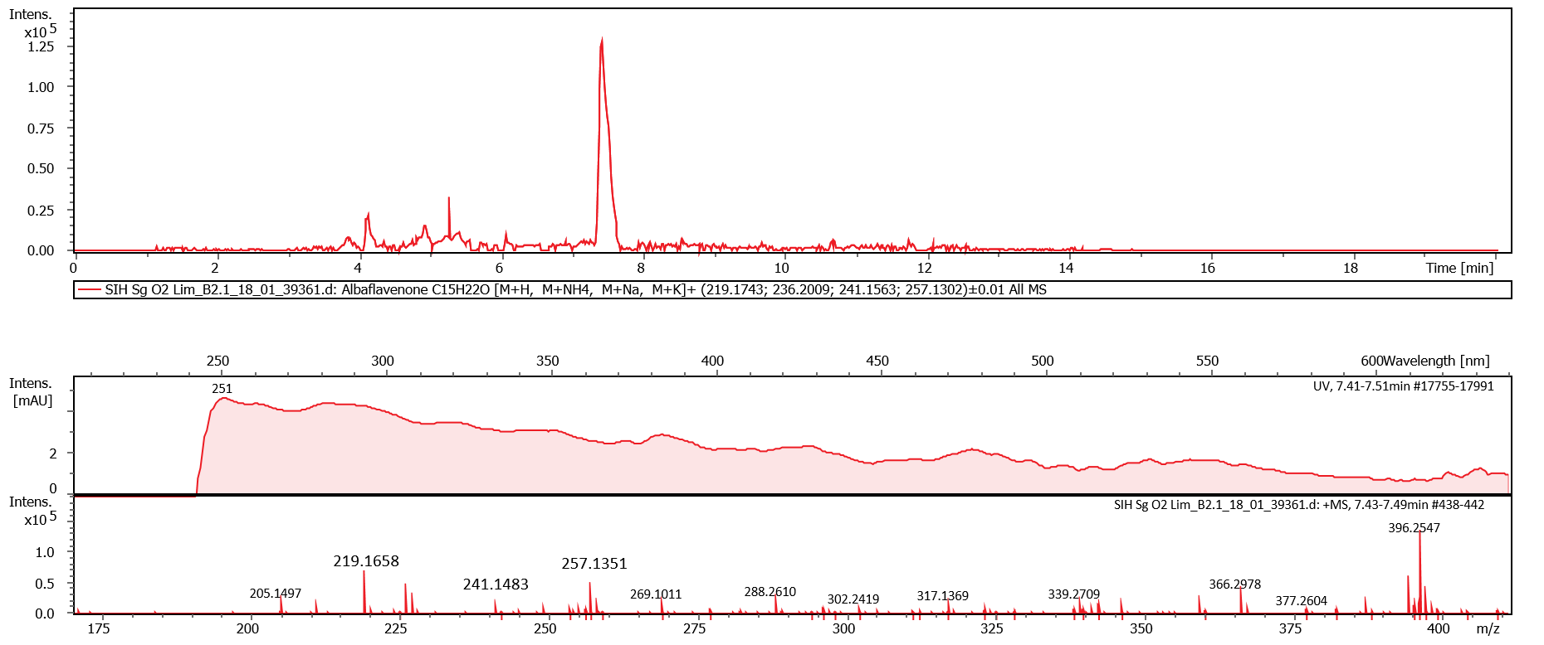
Figure S15. Extracted Ion Chromatogram and corresponding MS-spectrum of putative albaflavenone from oxygen limitation sample of S. griseochromogenes culture. The UV spectrum is shown above the MS spectrum. Δppm = 38.8.

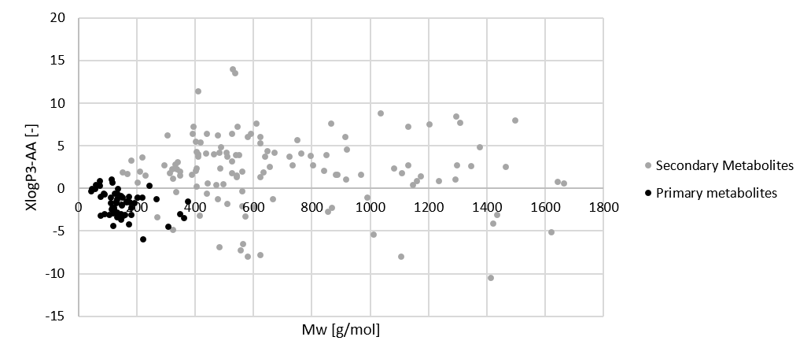
Figure S16. Comparison of physicochemical data of bacterial primary and secondary metabolites taken from PubChem.
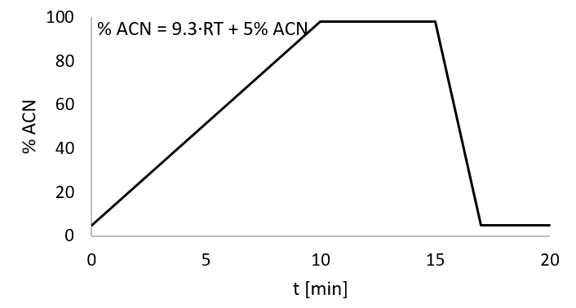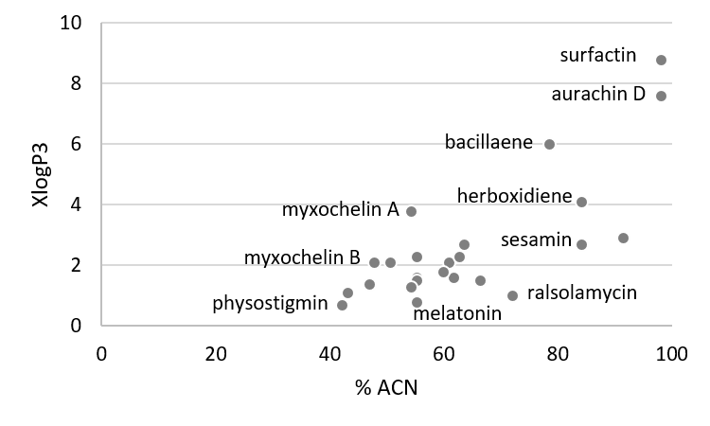
Figure S17. Visualization of employed HPLC method and correlation of logP values and ACN percentage at t_{R}.

Table S16. List of new mass features detected in extracts from B. amyloliquefaciens DSM7 including mass feature ID, m/z_{measured}, retention time (t_{R}), number of activating conditions and activating conditions.
ID | m/z_{measured}  [-] | t_{R} [min] | # of  a.c. | activating conditions (a.c.)
Ba1 | 304.3004 | 8.51 | 1 | Landy Medium
Ba2 | 332.3315 | 9.22 | 1 | Landy Medium
Ba3 | 261.1232 | 4.5 | 4 | GMS MgX, 40°C, LB Medium, Landy Medium
Ba4 | 338.1392 | 7.92 | 4 | Landy Medium
Ba5 | 227.1389 | 3.92 | 3 | GMS FeX, LB Medium, Landy Medium
Ba6 | 458.1596/  436.172 | 5.9 | 1 | Landy Medium
Ba7 | 277.1194 | 4.78 | 1 | Landy Medium
Ba8 | 1057.57 | 7.21 | 1 | LB Medium
Ba9 | 1071.5832 | 7.57 | 1 | LB Medium
Ba10 | 1085.6 | 7.89 | 1 | LB Medium
Ba11 | 250.1126 | 6.67 | 4 | 3% EtOH, 3% Tol, 40°C, LB Medium
Ba12 | 360.1934 | 4.45 | 1 | LB Medium
Ba13 | 382.1563 | 6.64 | 2 | GMS, LB Medium
Ba14 | 316.2487 | 7.7 | 2 | + Sg sup sf, + Pf sup auto
Ba18 | 418.2748 | 6.44 | 1 | SP Medium
Ba19 | 346.2602 | 7.35 | 3 | 3% ACN, 25°C, + Sg sup sf
Ba20 | 510.3197 | 8.78 | 1 | 25°C
Ba21 | 233.1316 | 6.1 | 1 | 25°C
Ba22 | 363.1955 | 6.1 | 1 | 25°C
Ba23 | 228.223 | 10.33 | 1 | 40°C
Ba24 | 243.0854 | 6.13 | 1 | 40°C
Ba25 | 211.1408 | 6.13 | 1 | 40°C
Ba27 | 227.1728 | 5.79 | 3 | 3% EtOH, 3% Tol, 40°C
Ba28 | 311.1368 | 5.21 | 1 | 40°C
Ba29 | 225.041 | 6.69 | 1 | 40°C
Ba30 | 213.1574 | 5.3 | 2 | 3% EtOH, 40°C
Ba31 | 453.2702 | 4.09 | 1 | 40°C
Ba32 | 227.1529 | 5.41 | 1 | GMS
Ba35 | 398.2633/  382.2858 | 10.27 | 3 | GMS MgX, GMS FeX, GMS
Ba36 | 495.2603 | 9.81 | 5 | 3% EtOH, 3% Tol, GMS MgX, GMS FeX, GMS
Ba38 | 370.2349 | 5.97 | 2 | GMS FeX, GMS
Ba39 | 537.1458 | 4.77 | 2 | GMS FeX, GMS
Ba41 | 412.2427/  426.2224 | 7.16 | 1 | GMS
Ba42 | 480.2127 | 7.41 | 1 | GMS
Ba43 | 433.2961 | 10.43 | 5 | 3% EtOH, 3% Tol, GMS MgX, GMS FeX, GMS
Ba44 | 390.1644 | 7.43 | 1 | GMS
Ba46 | 298.2746 | 9.94 | 1 | GMS
Ba48 | 296.2594 | 9.49 | 1 | GMS
Ba52 | 623.3655 | 8.36 | 1 | GMS
Ba53 | 328.1826 | 9.81 | 2 | GMS FeX, GMS
Ba54 | 263.2369 | 9.05 | 1 | GMS
Ba55 | 317.2691 | 8.36 | 1 | GMS
Ba56 | 607.1897 | 5.21 | 1 | GMS FeX
Ba57 | 265.1273 | 3.74 | 1 | GMS FeX
Ba58 | 883.2646 | 6.07 | 1 | GMS FeX
Ba60 | 708.2496 | 4.85 | 1 | GMS FeX
Ba61 | 218.1372 | 4.51 | 1 | GMS FeX
Ba62 | 384.2504 | 6.4 | 1 | GMS FeX
Ba63 | 901.275 | 5.85 | 1 | GMS FeX
Ba64 | 225.1371 | 10.96 | 1 | GMS FeX
Ba65 | 287.1968 | 5.43 | 1 | M9 1% PO₄³⁻
Ba68 | 341.1802 | 8.8 | 2 | M9 Medium, + Cc Pellet
Ba69 | 359.1908 | 7.14 | 1 | M9 Medium
Ba70 | 401.2043 | 8.1 | 1 | M9 Medium
Ba71 | 354.4145 | 9.85 | 1 | M9 Medium
Ba72 | 325.2259 | 6.91 | 1 | 3% EtOH
Ba73 | 240.1379 | 8.8 | 2 | 3% EtOH, 3% Tol
Ba74 | 269.2005 | 5.88 | 2 | 3% EtOH, 3% Tol
Ba75 | 343.2944 | 7.19 | 2 | 3% EtOH, 3% Tol
Ba77 | 250.118 | 9.36 | 2 | 3% EtOH, 3% Tol
Ba78 | 284.1386 | 6.02 | 2 | 3% EtOH, 3% Tol
Ba79 | 249.2057 | 8.48 | 2 | 3% EtOH, 3% Tol
Ba80 | 285.1047 | 6.25 | 2 | 3% EtOH, 3% Tol
Ba81 | 234.0579 | 8.31 | 2 | 3% EtOH, 3% Tol
Ba82 | 252.1074 | 9.47 | 1 | 3% EtOH
Ba85 | 296.2571 | 10.18 | 1 | 3% EtOH
Ba86 | 292.1067 | 5.88 | 2 | 3% EtOH, 3% Tol
Ba87 | 987.1246 | 8.33 | 1 | 3% EtOH
Ba88 | 328.2837 | 6.77 | 2 | 3% EtOH, 3% Tol
Ba89 | 443.2566 | 4.99 | 2 | + Sg sup sf, + Sg sup auto
Ba90 | 625.3203 | 4.21 | 1 | + Sg sup sf
Ba91 | 243.1407 | 4.19 | 1 | + Sg sup sf
Ba92 | 654.2732 | 4.31 | 1 | + Sg sup sf
Ba93 | 401.2462 | 5.07 | 1 | + Sg sup sf
Ba94 | 496.1674 | 4.04 | 1 | + Sg sup sf
Ba95 | 565.1014 | 10.79 | 5 | + Rj sup sf, + Cc sup sf, + Pf sup auto, + Pf Pellet
Ba96 | 553.3055 | 4.5 | 1 | + Rj sup sf
Ba97 | 396.9055 | 6.32 | 2 | + Rj sup sf, + Pf Pellet
Ba98 | 252.0972 | 10.79 | 2 | + Rj sup sf, + Pf Pellet
Ba99 | 279.1207 | 5.44 | 1 | + Rj sup sf
Ba100 | 727.5254 | 8.53 | 1 | + Rj sup sf
Ba101 | 256.2317 | 5.91 | 1 | + Cc sup sf
Ba102 | 274.2421 | 5.91 | 1 | + Cc sup sf
Ba103 | 268.1930 | 5.54 | 1 | + Cc sup sf
Ba104 | 743.411 | 7.3 | 1 | + Cc sup sf
Ba105 | 370.198 | 7.23 | 2 | + Cc sup sf, + Pf sup auto
Ba106 | 254.1079 | 4.76 | 1 | + Rj sup auto
Ba107 | 440.2823 | 8.46 | 1 | + Pf sup auto
Ba108 | 553.3378 | 4.36 | 1 | + Pf sup auto
Ba109 | 385.2492 | 4.28 | 1 | + Pf sup auto
Ba110 | 439.1387 | 9.25 | 1 | + Pf sup auto
Ba111 | 424.134 | 9.3 | 1 | 3% DMSO
Ba112 | 279.0808 | 5.04 | 1 | 3% DMSO
Ba113 | 257.1294 | 7.62 | 1 | 3% ACN
Ba114 | 226.1469 | 8.95 | 1 | 3% ACN
Ba115 | 376.1669 | 8.71 | 1 | 3% ACN
Ba116 | 415.2023 | 9.28 | 1 | 3% ACN
Ba117 | 297.1603 | 8.32 | 1 | 3% ACN
Ba118 | 399.2079 | 8.95 | 1 | 3% ACN
Ba119 | 269.1392 | 8.19 | 1 | 3% ACN
Ba120 | 301.1651 | 8.19 | 1 | 3% ACN
Ba121 | 273.1487 | 9.37 | 1 | 3% ACN
Ba122 | 283.1449 | 8.42 | 1 | 3% ACN
Ba123 | 222.1129 | 5.49 | 1 | 3% ACN
Ba124 | 230.0814 | 5.29 | 1 | 3% ACN
Ba125 | 241.1227 | 9.37 | 1 | 3% ACN
Ba126 | 529.2658 | 6.37 | 1 | 3% ACN
Ba127 | 310.1668 | 5.9 | 1 | 3% ACN
Ba128 | 260.1863 | 7.21 | 1 | 3% ACN
Ba129 | 360.275 | 7.51 | 1 | 3% ACN
Ba130 | 255.1499 | 7.95 | 2 | 3% ACN, + Cc Pellet
Ba131 | 305.1752 | 9.37 | 1 | 3% ACN
Ba132 | 274.202 | 7.5 | 1 | 3% ACN
Ba133 | 310.1408 | 6.1 | 1 | 3% ACN
Ba134 | 340.1774 | 6.15 | 1 | 3% ACN
Ba135 | 233.1257 | 8.24 | 1 | 3% ACN
Ba136 | 463.286 | 7.9 | 1 | 3% ACN
Ba137 | 421.2402 | 7.9 | 1 | 3% ACN
Ba138 | 403.2243 | 8.78 | 1 | 3% ACN
Ba139 | 243.135 | 3.81 | 1 | 3% ACN
Ba140 | 236.1285 | 5.95 | 1 | 3% ACN
Ba141 | 357.1615 | 8.56 | 1 | 3% ACN
Ba142 | 269.2034 | 5.74 | 1 | + Cc Pellet
Ba143 | 279.106 | 9.16 | 1 | + Cc Pellet
Ba144 | 250.1234 | 8.15 | 1 | + Cc Pellet
Ba145 | 445.2617 | 8.96 | 1 | + Cc Pellet

Table S17. List of new mass features detected in extracts from C. coralloides DSM2259 including mass feature ID, m/z_{measured}, retention time (t_{R}), number of activating conditions and activating conditions.
ID | m/z_{measured}  [-] | t_{R} [min] | # of  a.c. | activating conditions (a.c.)
Cc1 | 360.3602 | 9.4 | 1 | M9 1% PO₄³⁻
Cc6 | 385.1893 | 9.2 | 1 | + Sg sup auto
Cc8 | 793.3483 | 8.06 | 1 | MD1 medium
Cc11 | 707.3117 | 7.7 | 1 | MD1 medium
Cc12 | 332.3299 | 8.7 | 3 | 0,5% Tol, M9 medium, M9 1% PO₄³⁻
Cc18 | 284.2593 | 7.7 | 1 | MD1+G medium
Cc21 | 304.2975 | 8.0 | 5 | M9 1% PO₄³⁻, M9 medium, + Rj sup sf, + Pf sup sf, + Ba sup sf
Cc22 | 357.1579 | 10.2 | 2 | 0,5% Tol, GMS FeX
Cc27 | 349.2323 | 6.5 | 1 | + Ba P
Cc29 | 361.265 | 7.23 | 1 | + Ba sup sf
Cc42 | 601.3558 | 4.68 | 3 | + Sg sup sf, + Ba sup sf, + Rj sup sf
Cc49 | 343.2947 | 6.97 | 1 | 3% EtOH
Cc50 | 371.3278 | 7.82 | 1 | 3% EtOH
Cc58 | 348.322 | 6.79 | 1 | + Pf sup sf
Cc59 | 342.3742 | 7.46 | 2 | + Ba sup sf, + Pf sup sf
Cc63 | 587.3396 | 4.49 | 4 | + Rj sup auto, + Pf sup auto, + Ba sup auto, + Ba sup sf
Cc84 | 347.1532 | 6.18 | 1 | + Ba sup sf
Cc90 | 393.2525 | 3.13 | 1 | + Rj sup auto
Cc102 | 243.0859 | 5.48 | 1 | 40°C
Cc104 | 268.0811 | 5.26 | 1 | 40°C
Cc105 | 231.1141 | 5.95 | 1 | 40°C
Cc146 | 443.2531 | 4.6 | 1 | + Sg sup auto
Cc147 | 487.199 | 5.98 | 1 | + Sg sup auto
Cc148 | 399.172 | 9.3 | 1 | + Sg sup auto
Cc149 | 435.2194 | 6.52 | 1 | + Sg sup auto
Cc154 | 521.2413 | 3.01 | 1 | + Ba sup auto
Cc155 | 387.2056 | 5.51 | 1 | + Pf sup auto
Cc167 | 254.1018 | 5.14 | 1 | 40°C
Cc181 | 242.2838 | 7.82 | 2 | GMS FeX, GMS MgX
Cc183 | 214.2525 | 7.13 | 3 | GMS, GMS FeX, GMS MgX
Cc186 | 371.1742 | 5.59 | 1 | GMS FeX
Cc187 | 359.1737 | 5.83 | 1 | GMS FeX
Cc189 | 375.1688 | 6.22 | 1 | GMS FeX
Cc190 | 284.1579 | 6.45 | 1 | + Pf sup sf
Cc193 | 359.1737 | 8.33 | 1 | GMS FeX
Cc210 | 566.2988 | 9.64 | 1 | GMS FeX
Cc243 | 380.2758 | 6.67 | 1 | M9 FeX
Cc244 | 330.2638 | 5.81 | 1 | M9 FeX
Cc249 | 340.2847 | 6.67 | 3 | M9 FeX, + Rj sup sf, + Pf sup sf
Cc250 | 293.2003 | 6.64 | 1 | M9 FeX
Cc274 | 585.3623 | 4.82 | 1 | O2-Lim
Cc275 | 373.1203 | 7.18 | 1 | O2-Lim
Cc276 | 337.1464 | 10.57 | 1 | O2-Lim

Table S18. List of new mass features detected in extracts from P. fallax HKI727 including mass feature ID, m/z_{measured}, retention time (t_{R}), number of activating conditions and activating conditions.
ID | m/z_{measured}  [-] | t_{R} [min] | # of  a.c. | activating conditions (a.c.)
Pf2 | 312.2872 | 7.92 | 1 | NB medium
Pf12 | 441.1847 | 1.19 | 1 | NB medium
Pf17 | 300.324 | 8.78 | 1 | NB medium
Pf22 | 276.1065 | 1.12 | 1 | NB medium
Pf24 | 330.2622 | 8.66 | 1 | SP medium
Pf27 | 521.2367 | 2.74 | 1 | TSB medium
Pf31 | 247.1279 | 1.8 | 1 | 1% DMSO @35°C
Pf43 | 313.2007 | 6.17 | 1 | 1% EtOH @25°C
Pf48 | 314.3031 | 7.99 | 2 | + Ba Pellet, NB medium
Pf54 | 353.2053 | 5.49 | 1 | SP medium
Pf55 | 433.1931 | 6.18 | 2 | SP medium, + Cc sup auto
Pf56 | 356.1453 | 1.85 | 1 | 1% DMSO @35°C
Pf57 | 340.3579 | 8.43 | 1 | TSB medium
Pf60 | 325.1764 | 4.89 | 2 | SP medium, + Cc sup sf
Pf61 | 342.3715 | 8.36 | 1 | 1% Tol
Pf62 | 312.3621 | 8.95 | 2 | 1% DMSO @35°C, SP medium
Pf63 | 272.1582 | 4.46 | 8 | 1% DMSO @35°C, 0,5% DMSO, SP medium, + Cc sup sf, + Ba sup sf, + Cc Pellet, + Ba Pellet, 35°C
Pf69 | 298.3445 | 8.63 | 5 | 1% DMSO @35°C, 1% Tol, 0,5% Tol @ 25°C, TSB medium, SP medium
Pf77 | 255.1692 | 4.72 | 1 | TSB medium
Pf92 | 358.1384 | 4.24 | 3 | 1% DMSO @35°C, 3% EtOH, 25°C
Pf93 | 316.182 | 3.74 | 1 | 25°C
Pf95 | 383.2239 | 4.06 | 1 | 25°C
Pf96 | 343.1938 | 2.27 | 2 | 1% DMSO @35°C, 25°C
Pf97 | 295.1247 | 3.33 | 1 | 25°C
Pf98 | 250.9953 | 7.87 | 2 | 35°C, 25°C
Pf99 | 316.243 | 9.29 | 1 | 25°C
Pf103 | 451.1426 | 3.72 | 5 | 1% DMSO @35°C, 3% DMSO, 0,5% DMSO, 3% EtOH, 1% EtOH @25°C
Pf104 | 619.2468 | 4.82 | 2 | 0,5% DMSO, 1% EtOH @25°C
Pf105 | 375.1246 | 4.83 | 1 | 0,5% DMSO
Pf106 | 387.1464 | 4.55 | 7 | 1% DMSO @35°C, 3% DMSO, 0,5% DMSO, 3% EtOH, 1% EtOH @25°C, 1% Tol, 0,5% Tol @ 25°C
Pf108 | 716.4562 | 5.14 | 7 | 1% DMSO @35°C, 3% DMSO, 0,5% DMSO, 3% EtOH, 1% EtOH @25°C, 1% Tol, 0,5% Tol @ 25°C
Pf109 | 315.2194 | 6.3 | 6 | 0,5% DMSO, + Cc sup sf, + Ba sup sf, + Ba sup auto, + Cc Pellet, + Ba Pellet
Pf110 | 575.5 | 8.14 | 9 | 1% DMSO @35°C, 3% DMSO, 0,5% DMSO, 3% EtOH, 1% EtOH @25°C, 0,5% EtOH @ 35°C, 3% Tol @ 35°C, 1% Tol, 0,5% Tol @ 25°C
Pf111 | 705.4926 | 8.14 | 9 | 1% DMSO @35°C, 3% DMSO, 0,5% DMSO, 3% EtOH, 1% EtOH @25°C, 0,5% EtOH @ 35°C, 3% Tol @ 35°C, 1% Tol, 0,5% Tol @ 25°C
Pf112 | 900.6918 | 8.14 | 9 | 1% DMSO @35°C, 3% DMSO, 0,5% DMSO, 3% EtOH, 1% EtOH @25°C, 0,5% EtOH @ 35°C, 3% Tol @ 35°C, 1% Tol, 0,5% Tol @ 25°C
Pf114 | 272.2238 | 9.64 | 9 | 1% DMSO @35°C, 3% DMSO, 0,5% DMSO, 3% EtOH, 1% EtOH @25°C, 0,5% EtOH @ 35°C, 3% Tol @ 35°C, 1% Tol, 0,5% Tol @ 25°C
Pf115 | 406.106 | 1.,76 | 1 | 0,5% DMSO
Pf120 | 586.1848 | 3.91 | 5 | 1% DMSO @35°C, 3% DMSO, 3% EtOH, 1% EtOH @25°C, 0,5% Tol @ 25°C
Pf122 | 351.1488 | 3.38 | 3 | 3% EtOH, 0,5% Tol @ 25°C
Pf123 | 723.2384 | 3.91 | 5 | 1% DMSO @35°C, 3% DMSO, 3% EtOH, 1% EtOH @25°C, 0,5% Tol @ 25°C
Pf124 | 243.1353 | 3.97 | 1 | 1% DMSO @35°C
Pf125 | 1015.4444 | 4.82 | 6 | 1% DMSO @35°C, 3% DMSO, 3% EtOH, 1% EtOH @25°C, 1% Tol, 0,5% Tol @ 25°C
Pf129 | 532.2226 | 10.71 | 3 | 3% DMSO, 3% EtOH, 1% EtOH @25°C
Pf131 | 321.1285 | 5.27 | 1 | 3% DMSO
Pf132 | 292.1819 | 5.46 | 2 | 3% DMSO, 1% EtOH @25°C
Pf134 | 421.2044 | 10.42 | 1 | 3% DMSO
Pf144 | 332.176 | 10.3 | 1 | 3% EtOH
Pf159 | 270.1444 | 5.07 | 3 | 3% DMSO, 3% EtOH, 1% EtOH @25°C
Pf160 | 421.1298 | 4.63 | 1 | 1% EtOH @25°C
Pf161 | 505.2129 | 5.38 | 1 | 3% EtOH
Pf163 | 270.1459 | 5.02 | 3 | 3% EtOH, 1% Tol, 0,5% Tol @ 25°C
Pf164 | 383.2291 | 3.72 | 1 | 3% EtOH
Pf165 | 523.2568 | 4.82 | 2 | 3% EtOH, 0,5% Tol @ 25°C
Pf167 | 1258.5694 | 4.8 | 1 | 0,5% Tol @ 25°C
Pf169 | 1187.9476 | 8.14 | 3 | 3% DMSO, 3% EtOH, 1% EtOH @25°C
Pf171 | 342.1983 | 6.27 | 3 | 3% DMSO, GMS FeX, M9 1% PO₄³⁻
Pf175 | 354.2189 | 6.37 | 1 | 1% EtOH @25°C
Pf176 | 415.2124 | 8.11 | 1 | 3% EtOH
Pf178 | 356.1772 | 6.85 | 1 | 3% EtOH
Pf184 | 274.0961 | 9.22 | 1 | 3% DMSO
Pf185 | 245.1278 | 9.31 | 3 | 3% DMSO, 3% EtOH, 1% EtOH @25°C
Pf186 | 799.178 | 9.36 | 2 | 3% EtOH, 1% EtOH @25°C
Pf192 | 229.1219 | 2.22 | 1 | 1% DMSO @35°C
Pf201 | 243.1963 | 8.07 | 1 | 3% EtOH
Pf202 | 244.2295 | 8.33 | 2 | 1% DMSO @35°C, 3% EtOH
Pf204 | 456.264 | 10.74 | 1 | 3% EtOH
Pf205 | 299.2589 | 10.47 | 1 | 3% EtOH
Pf208 | 357.1772 | 10.28 | 1 | 3% EtOH
Pf213 | 393.2579 | 4.48 | 2 | 3% EtOH, 0,5% Tol @ 25°C
Pf214 | 475.2567 | 4.09 | 1 | 3% EtOH
Pf217 | 314.2695 | 8.38 | 1 | 3% EtOH
Pf218 | 378.2036 | 3.45 | 1 | 3% EtOH
Pf220 | 225.149 | 8.93 | 1 | 3% EtOH
Pf221 | 328.2241 | 3.99 | 1 | 3% EtOH
Pf222 | 298.2747 | 9.68 | 1 | 3% EtOH
Pf223 | 320.1758 | 5.95 | 1 | 3% EtOH
Pf224 | 338.2677 | 7.87 | 1 | 3% EtOH
Pf228 | 342.2395 | 4.36 | 1 | 3% EtOH
Pf231 | 943.6278 | 5.37 | 1 | 3% EtOH
Pf232 | 440.2512 | 3.54 | 1 | 3% EtOH
Pf240 | 467.2943 | 4.43 | 1 | 0,5% Tol @ 25°C
Pf245 | 583.4444 | 10.42 | 2 | 1% DMSO @35°C, 0,5% Tol @ 25°C
Pf258 | 330.2033 | 1.98 | 1 | 1% DMSO @35°C
Pf259 | 333.1697 | 6.18 | 1 | 1% EtOH @25°C
Pf260 | 334.2294 | 7.01 | 1 | 1% EtOH @25°C
Pf261 | 242.0869 | 3.15 | 1 | 1% EtOH @25°C
Pf279 | 254.1054 | 5.09 | 1 | + Cc sup auto
Pf280 | 327.2079 | 5.41 | 1 | + Cc sup auto
Pf282 | 314.3063 | 8.07 | 3 | + Sg sup sf, + Ba sup sf, + Sg sup auto
Pf285 | 300.2911 | 7.82 | 1 | + Sg sup auto
Pf286 | 316.3225 | 8.31 | 4 | + Sg sup sf, + Ba sup sf, + Sg sup auto, + Ba Pellet
Pf287 | 316.3225 | 6.94 | 1 | + Sg sup auto
Pf290 | 290.1301 | 8.76 | 2 | + Sg sup auto, + Rj sup auto
Pf292 | 235.1094 | 1.33 | 1 | + Rj sup auto
Pf293 | 381.1715 | 9.42 | 1 | + Rj sup auto
Pf294 | 274.1636 | 10.33 | 3 | + Sg sup sf, + Cc sup sf, + Ba sup sf
Pf295 | 269.2061 | 5.75 | 1 | + Sg sup sf
Pf297 | 358.206 | 8.78 | 3 | + Sg sup sf, + Cc sup sf, + Ba sup sf
Pf298 | 243.1388 | 3.87 | 1 | + Sg sup sf
Pf300 | 445.2646 | 8.95 | 3 | + Sg sup sf, + Cc sup sf, + Ba sup sf
Pf301 | 387.1976 | 5.98 | 6 | + Sg sup sf, + Cc sup sf, + Ba sup sf, + Sg Pellet, + Cc Pellet, + Ba Pellet
Pf304 | 231.0816 | 4.46 | 2 | + Sg sup sf, + Cc sup sf
Pf307 | 298.1009 | 1.83 | 1 | + Sg sup sf
Pf308 | 418.2292 | 8.07 | 1 | + Sg sup sf
Pf309 | 255.1543 | 7.67 | 2 | + Sg sup sf, + Ba sup sf
Pf310 | 365.348 | 6.36 | 1 | + Ba sup sf
Pf311 | 263.1417 | 5.01 | 4 | + Cc sup sf, + Ba sup sf, + Cc Pellet, + Ba Pellet
Pf314 | 279.188 | 6.43 | 1 | + Cc sup sf
Pf315 | 296.1378 | 1.86 | 1 | + Cc sup sf
Pf316 | 496.1834 | 7.82 | 2 | GMS FeX, M9 1% PO₄³⁻
Pf317 | 331.2029 | 5.53 | 1 | GMS FeX
Pf318 | 351.1692 | 5.61 | 1 | GMS FeX
Pf319 | 339.1856 | 6.67 | 1 | GMS MgX
Pf321 | 470.2255 | 5.83 | 1 | M9 medium
Pf322 | 427.0937 | 5.26 | 1 | M9 medium
Pf323 | 289.0578 | 4.87 | 2 | M9 1% PO₄³⁻, M9 medium
Pf324 | 348.2185 | 6.0 | 1 | M9 medium
Pf325 | 459.0651 | 5.54 | 1 | M9 medium
Pf326 | 311.1916 | 5.8 | 1 | M9 medium
Pf327 | 659.139 | 3.67 | 1 | M9 medium
Pf328 | 486.2024 | 6.18 | 2 | M9 1% PO₄³⁻, M9 medium
Pf329 | 491.1096 | 4.09 | 1 | M9 medium
Pf330 | 691.1106 | 4.11 | 1 | M9 medium
Pf331 | 509.1023 | 4.43 | 1 | M9 medium
Pf332 | 428.2193 | 7.69 | 1 | M9 1% PO₄³⁻
Pf333 | 395.1362 | 6.39 | 1 | M9 1% PO₄³⁻
Pf334 | 435.1762 | 5.8 | 1 | M9 1% PO₄³⁻
Pf335 | 390.1625 | 7.35 | 1 | M9 1% PO₄³⁻
Pf336 | 405.1645 | 5.38 | 1 | M9 1% PO₄³⁻
Pf337 | 360.2178 | 6.1 | 1 | M9 1% PO₄³⁻
Pf338 | 227.1541 | 8.38 | 1 | M9 1% PO₄³⁻
Pf339 | 206.1022 | 4.97 | 1 | M9 1% PO₄³⁻
Pf340 | 448.2318 | 4.95 | 1 | M9 1% PO₄³⁻
Pf342 | 394.3477 | 8.38 | 1 | M9 1% PO₄³⁻
Pf343 | 398.1851 | 8.04 | 1 | M9 1% PO₄³⁻
Pf344 | 226.1465 | 6.0 | 1 | M9 1% PO₄³⁻
Pf345 | 336.0843 | 4.92 | 1 | M9 1% PO₄³⁻
Pf347 | 230.2108 | 6.2 | 1 | M9 1% PO₄³⁻
Pf348 | 387.1569 | 6.73 | 1 | M9 1% PO₄³⁻
Pf350 | 313.2025 | 6.42 | 1 | + Ba sup auto
Pf351 | 309.1455 | 5.63 | 1 | + Ba sup auto

Table S19. List of new mass features detected in extracts from R. jostii DSM44719 including mass feature ID, m/z_{measured}, retention time (t_{R}), number of activating conditions and activating conditions.
ID | m/z_{measured}  [-] | t_{R} [min] | # of  a.c. | activating conditions (a.c.)
Rj1 | 271.1523 | 6.72 | 4 | + Sg sup auto, + Cc sup auto, + Sg Pellet, + Cc Pellet
Rj4 | 480.2788 | 4.26 | 1 | + Sg Pellet
Rj6 | 331.0206 | 5.04 | 1 | + Sg Pellet
Rj9 | 217.1016 | 4.75 | 4 | LB Medium, + Pf sup auto, + Ba sup auto, + Cc Pellet
Rj10 | 220.1203 | 4.83 | 1 | + Ba sup auto
Rj11 | 254.1763 | 6.37 | 3 | O₂-Lim., + Cc sup auto, + Cc Pellet
Rj13 | 250.1136 | 6.37 | 4 | O₂-Lim., + Pf sup auto, + Ba sup auto, + Cc Pellet
Rj15 | 287.2589 | 9.57 | 1 | GMS MgX
Rj16 | 269.2126 | 8.88 | 2 | GMS, Landy Medium
Rj18 | 271.2283 | 9.34 | 1 | Landy Medium
Rj20 | 257.2124 | 8.63 | 2 | GMS, Landy Medium
Rj22 | 255.2332 | 8.76 | 3 | GMS MgX, GMS, Landy Medium
Rj24 | 213.1855 | 7.18 | 4 | GMS MgX, GMS FeX, GMS, Landy Medium
Rj26 | 227.2015 | 7.72 | 4 | GMS MgX, GMS FeX, GMS, Landy Medium
Rj31 | 203.1395 | 3.84 | 1 | + Pf sup auto
Rj45 | 296.138 | 1.92 | 1 | + Pf Pellet
Rj47 | 319.2868 | 10,17 | 2 | + Pf Pellet, 23°C
Rj65 | 243.1308 | 3.91 | 1 | + Sg sup auto
Rj88 | 261.1225 | 4.08 | 1 | NB Medium
Rj89 | 453.2682 | 3.79 | 1 | NB Medium
Rj90 | 292.1063 | 5.71 | 1 | NB Medium
Rj91 | 521.2382 | 4.03 | 1 | NB Medium
Rj92 | 300.1362 | 3.96 | 1 | NB Medium
Rj93 | 275.0838 | 4.28 | 1 | NB Medium
Rj94 | 297.1359 | 4.94 | 1 | NB Medium
Rj95 | 240.0687 | 6.17 | 1 | O₂-Lim.
Rj98 | 237.2205 | 10.33 | 1 | 23°C
Rj120 | 285.1345 | 1.87 | 1 | O₂-Lim.
Rj141 | 435.3022 | 8.1 | 1 | M9 FeX
Rj142 | 414.2576 | 8.63 | 1 | M9 1% PO₄³⁻
Rj144 | 307.2184 | 7.01 | 1 | M9 FeX
Rj146 | 354.2854 | 8.58 | 1 | M9 1% PO₄³⁻
Rj165 | 230.2121 | 6.23 | 1 | M9 FeX, M9 1% PO₄³⁻
Rj166 | 216.1963 | 5.75 | 1 | M9 FeX
Rj185 | 240.233 | 7.16 | 1 | Landy Medium
Rj214 | 342.235 | 4.53 | 1 | 0,5% EtOH
Rj215 | 328.218 | 4.26 | 1 | 0,5% EtOH
Rj217 | 318.1992 | 3.84 | 1 | 0,5% EtOH
Rj239 | 430.1826 | 10.4 | 1 | Landy Medium
Rj240 | 250.1454 | 4.1 | 1 | Landy Medium
Rj241 | 228.1038 | 8.07 | 1 | Landy Medium
Rj242 | 303.2547 | 7.92 | 3 | GMS MgX, GMS FeX, Landy Medium
Rj243 | 271.2279 | 7.45 | 2 | GMS MgX, Landy Medium
Rj245 | 354.1506 | 10.18 | 1 | Landy Medium
Rj246 | 456.1609 | 6.81 | 1 | Landy Medium
Rj247 | 370.1819 | 9.25 | 1 | Landy Medium
Rj248 | 393.1829 | 5.83 | 1 | Landy Medium
Rj249 | 264.1609 | 4.94 | 1 | Landy Medium
Rj250 | 475.1665 | 8.87 | 1 | Landy Medium
Rj251 | 306.1502 | 8.88 | 1 | Landy Medium
Rj252 | 287.2237 | 8.04 | 2 | GMS FeX, Landy Medium
Rj253 | 267.1954 | 7.81 | 4 | GMS MgX, GMS FeX, GMS, Landy Medium
Rj254 | 503.1978 | 9.09 | 1 | Landy Medium
Rj255 | 254.2478 | 7.87 | 2 | GMS FeX, Landy Medium
Rj256 | 463.2859 | 7.89 | 2 | GMS FeX, GMS
Rj257 | 271.1878 | 7.33 | 3 | GMS MgX, GMS FeX, GMS
Rj258 | 533.4829 | 10.81 | 2 | GMS FeX, GMS
Rj259 | 239.1619 | 6.84 | 2 | GMS FeX, GMS
Rj260 | 321.1475 | 4.46 | 2 | GMS FeX, GMS
Rj261 | 281.2092 | 8.34 | 3 | GMS MgX, GMS FeX, GMS
Rj262 | 293.2093 | 8.43 | 2 | GMS FeX, GMS
Rj263 | 270.2415 | 7.53 | 2 | GMS FeX, GMS
Rj264 | 263.158 | 10.49 | 2 | GMS FeX, GMS
Rj265 | 241.265 | 8.34 | 1 | GMS
Rj266 | 325.235 | 7.94 | 1 | GMS
Rj267 | 245.0939 | 5.22 | 2 | GMS FeX, GMS
Rj269 | 253.1411 | 5.48 | 2 | GMS FeX, GMS
Rj270 | 235.2048 | 7.53 | 2 | GMS FeX, GMS
Rj271 | 284.2574 | 7.99 | 2 | GMS FeX, GMS
Rj272 | 253.2166 | 8.43 | 3 | GMS MgX, GMS FeX, GMS
Rj273 | 267.1574 | 5.81 | 2 | GMS FeX, GMS
Rj275 | 307.2246 | 8.92 | 1 | GMS
Rj276 | 229.143 | 5.81 | 1 | GMS
Rj277 | 275.2206 | 7.03 | 2 | GMS FeX, GMS
Rj278 | 456.31 | 10.54 | 1 | GMS
Rj279 | 393.2475 | 3.27 | 2 | GMS FeX, GMS
Rj280 | 244.2266 | 6.96 | 2 | GMS FeX, GMS
Rj281 | 311.2192 | 7.48 | 2 | GMS MgX, GMS
Rj282 | 247.19 | 6.15 | 2 | GMS FeX, GMS
Rj284 | 482.3627 | 8.88 | 1 | GMS
Rj285 | 257.2117 | 6.47 | 1 | GMS FeX
Rj286 | 265.1777 | 7.33 | 1 | GMS FeX
Rj287 | 257.2111 | 7.03 | 1 | GMS FeX
Rj288 | 241.2165 | 8.33 | 2 | GMS MgX, GMS FeX
Rj289 | 226.2165 | 6.96 | 1 | GMS FeX
Rj290 | 428.2183 | 8.06 | 1 | GMS FeX
Rj291 | 279.1933 | 7.85 | 1 | GMS FeX
Rj292 | 479.1797 | 10.59 | 1 | GMS FeX
Rj293 | 295.1878 | 7.55 | 1 | GMS FeX
Rj294 | 274.2367 | 6.29 | 1 | GMS FeX
Rj295 | 319.2428 | 6.71 | 1 | GMS FeX
Rj296 | 256.227 | 7.74 | 1 | GMS FeX
Rj297 | 301.2369 | 7.04 | 1 | GMS FeX
Rj298 | 272.258 | 7.89 | 1 | GMS FeX
Rj299 | 275.2275 | 8.02 | 1 | GMS FeX
Rj300 | 307.1883 | 7.26 | 1 | GMS FeX
Rj301 | 275.2212 | 6.47 | 1 | GMS FeX
Rj302 | 259.1918 | 7.06 | 1 | GMS FeX
Rj303 | 245.0419 | 4.31 | 1 | GMS FeX
Rj304 | 243.1948 | 6.05 | 1 | GMS FeX
Rj305 | 256.2543 | 5.61 | 1 | GMS FeX
Rj306 | 511.2551 | 6.37 | 1 | GMS FeX
Rj307 | 325.2851 | 6.89 | 1 | GMS FeX
Rj308 | 243.1951 | 6.57 | 1 | GMS FeX
Rj309 | 233.1723 | 5.75 | 1 | GMS FeX
Rj310 | 269.211 | 7.18 | 1 | GMS FeX
Rj311 | 255.1949 | 8.26 | 1 | GMS FeX
Rj312 | 291.1935 | 8.11 | 1 | GMS FeX
Rj313 | 210.0218 | 4.19 | 1 | GMS FeX
Rj314 | 375.1819 | 8.09 | 1 | + Sg sup sf
Rj315 | 243.1338 | 4.06 | 1 | + Sg sup sf
Rj316 | 443.2487 | 4.9 | 1 | + Sg sup sf
Rj317 | 227.1387 | 3.76 | 1 | + Sg sup sf
Rj318 | 507.2416 | 4.06 | 1 | + Sg sup sf
Rj319 | 255.2306 | 9.84 | 1 | + Sg sup sf
Rj320 | 385.1935 | 9.22 | 1 | GMS MgX
Rj321 | 363.1419 | 7.06 | 1 | GMS MgX
Rj322 | 277.1001 | 5.27 | 1 | GMS MgX
Rj323 | 226.1489 | 8.93 | 1 | GMS MgX
Rj324 | 348.1733 | 6.56 | 1 | GMS MgX
Rj325 | 326.1915 | 6.59 | 1 | GMS MgX
Rj326 | 329.1726 | 4.82 | 1 | GMS MgX
Rj327 | 399.2094 | 8.93 | 1 | GMS MgX
Rj328 | 281.0945 | 6.1 | 1 | GMS MgX
Rj329 | 398.1896 | 8.26 | 1 | GMS MgX
Rj330 | 381.183 | 7.96 | 1 | GMS MgX
Rj331 | 262.11 | 5.33 | 1 | GMS MgX
Rj332 | 243.1518 | 8.28 | 1 | GMS MgX
Rj333 | 227.203 | 8.12 | 1 | GMS MgX
Rj334 | 258.11541 | 5.87 | 1 | GMS MgX
Rj336 | 298.2339 | 7.33 | 1 | GMS MgX
Rj337 | 415.2042 | 9.25 | 1 | GMS MgX
Rj338 | 255.0788 | 5.92 | 1 | GMS MgX
Rj339 | 400.2045 | 6.79 | 1 | GMS MgX
Rj340 | 259.229 | 8.63 | 1 | GMS MgX
Rj341 | 334.2575 | 5.55 | 1 | GMS MgX
Rj342 | 222.115 | 568 | 1 | GMS MgX
Rj343 | 224.1293 | 6.35 | 1 | GMS MgX

Table S20. List of new mass features detected in extracts from S. griseochromogenes DSM40499 including mass feature ID, m/z_{measured}, retention time (t_{R}), number of activating conditions and activating conditions.
ID | m/z  _{measured}  [-] | t_{R} [min] | # of  a.c. | activating conditions (a.c.)
Sg1 | 252.1864 | 4.06 | 1 | TSB Medium
Sg3 | 236.1812 | 5.09 | 1 | TSB Medium
Sg4 | 231.0645 | 7.04 | 1 | TSB Medium
Sg9 | 998.5606 | 7.99 | 3 | 3% DMSO, 1% DMSO, CYH-Medium
Sg11 | 639.3028 | 5.09 | 1 | CYH-Medium
Sg12 | 423.2058 | 8.36 | 1 | CYH-Medium
Sg13 | 444.1734 | 3.84 | 1 | CYH-Medium
Sg14 | 393.1806 | 6.56 | 1 | Landy Medium
Sg16 | 425.1706 | 6.03 | 1 | Landy Medium
Sg18 | 333.1586 | 6.56 | 1 | Landy Medium
Sg19 | 393.1806 | 5.93 | 1 | Landy Medium
Sg21 | 266.1162 | 6.4 | 1 | Landy Medium
Sg23 | 305.2212 | 6.37 | 1 | Landy Medium
Sg30 | 307.1419 | 6.88 | 1 | Landy Medium
Sg38 | 259.1777 | 8.78 | 1 | 40°C
Sg39 | 208.0583 | 4.43 | 2 | 1% DMSO, 40°C
Sg42 | 209.042 | 5.34 | 1 | 40°C
Sg43 | 351.1784 | 6.44 | 1 | 40°C
Sg44 | 234.121 | 3.84 | 1 | 40°C
Sg45 | 414.1396 | 4.53 | 1 | 40°C
Sg47 | 447.0908 | 5.19 | 2 | 1% DMSO, 40°C
Sg53 | 365.1722 | 7.31 | 1 | 40°C
Sg54 | 235.1047 | 4.7 | 1 | 40°C
Sg68 | 325.2347 | 5.73 | 3 | 3% EtOH, 1% EtOH, SP-Medium
Sg71 | 269.066 | 4.83 | 1 | 3% EtOH
Sg72 | 297.0606 | 5.73 | 1 | 3% EtOH
Sg73 | 410.1465 | 7.07 | 1 | 3% EtOH
Sg74 | 532.2989 | 7.19 | 2 | 3% EtOH, 3% ACN
Sg77 | 301.217 | 5.95 | 2 | 3% EtOH, O2-Lim.
Sg84 | 359.1568 | 6.6 | 3 | GMS FeX, GMS Medium, O2-Lim.
Sg85 | 386.3099 | 6.3 | 1 | O2-Lim.
Sg87 | 420.2615 | 4.99 | 1 | O2-Lim.
Sg89 | 379.184 | 5.02 | 1 | GMS Medium
Sg90 | 362.2402 | 4.85 | 1 | GMS Medium
Sg91 | 325.2652 | 5.04 | 1 | GMS Medium
Sg92 | 378.1779 | 5.04 | 1 | GMS Medium
Sg94 | 339.2226 | 10.12 | 1 | GMS Medium
Sg96 | 337.2226 | 10.12 | 1 | GMS FeX
Sg97 | 336.1746 | 4.75 | 1 | GMS FeX
Sg101 | 290.2841 | 7.87 | 1 | GMS FeX
Sg103 | 256.1512 | 8.53 | 1 | GMS FeX
Sg104 | 312.37 | 8.64 | 1 | GMS FeX
Sg106 | 418.3013 | 10.12 | 1 | GMS FeX
Sg107 | 369.2497 | 10.12 | 1 | GMS FeX
Sg109 | 353.219 | 9.69 | 1 | GMS FeX
Sg115 | 379.2431 | 6.49 | 2 | M9 FeX, M9 1% PO₄³⁻
Sg117 | 587.3468 | 4.53 | 1 | M9 FeX
Sg118 | 295.1597 | 4.89 | 2 | M9 FeX, M9 Medium Cyclo-(Phe-Phe)
Sg119 | 583.3485 | 4.36 | 1 | M9 FeX
Sg120 | 823.4818 | 5.46 | 1 | M9 FeX
Sg121 | 243.1311 | 4.26 | 1 | SP-Medium
Sg130 | 585.3593 | 4.94 | 2 | 3% DMSO, 1% DMSO
Sg134 | 342.3789 | 8.44 | 1 | M9 1% PO₄³⁻
Sg135 | 430.1457 | 7.0 | 1 | M9 FeX
Sg143 | 340.3619 | 8.17 | 1 | M9 1% PO₄³⁻
Sg145 | 257.109 | 5.61 | 1 | 0,5% ACN
Sg146 | 208.0661 | 4.04 | 1 | M9 1% PO₄³⁻
Sg147 | 348.2248 | 6.05 | 1 | M9 1% PO₄³⁻
Sg148 | 428.2258 | 7.68 | 1 | M9 1% PO₄³⁻
Sg149 | 317.1929 | 6.48 | 1 | M9 1% PO₄³⁻
Sg150 | 395.1427 | 6.39 | 1 | M9 1% PO₄³⁻
Sg151 | 327.1753 | 6.39 | 1 | M9 1% PO₄³⁻
Sg152 | 515.4181 | 9.61 | 1 | M9 1% PO₄³⁻
Sg153 | 259.1877 | 8.32 | 1 | M9 1% PO₄³⁻
Sg154 | 390.1706 | 7.36 | 1 | M9 1% PO₄³⁻
Sg155 | 345.225 | 8.27 | 1 | M9 1% PO₄³⁻
Sg156 | 217.1394 | 6.26 | 1 | M9 1% PO₄³⁻
Sg157 | 289.0644 | 4.94 | 1 | M9 1% PO₄³⁻
Sg158 | 269.1721 | 9.0 | 1 | M9 1% PO₄³⁻
Sg159 | 226.1524 | 6.05 | 1 | M9 1% PO₄³⁻
Sg160 | 388.1754 | 5.78 | 1 | M9 1% PO₄³⁻
Sg161 | 415.1217 | 4.04 | 1 | M9 1% PO₄³⁻
Sg163 | 275.1451 | 4.33 | 1 | M9 1% PO₄³⁻
Sg164 | 415.1316 | 4.33 | 1 | M9 1% PO₄³⁻
Sg165 | 303.1781 | 6.63 | 1 | M9 1% PO₄³⁻
Sg167 | 386.1801 | 6.71 | 1 | M9 1% PO₄³⁻
Sg168 | 499.2702 | 6.51 | 1 | M9 1% PO₄³⁻
Sg172 | 464.2239 | 6.12 | 1 | M9 1% PO₄³⁻
Sg175 | 269.1178 | 5.24 | 1 | M9 1% PO₄³⁻
Sg176 | 386.1798 | 6.75 | 1 | M9 1% PO₄³⁻
Sg181 | 331.2088 | 7.78 | 1 | M9 1% PO₄³⁻
Sg184 | 415.1232 | 4.11 | 1 | M9 1% PO₄³⁻
Sg185 | 311.1457 | 4.84 | 1 | M9 1% PO₄³⁻ Cyclo-(Phe-Tyr)
Sg187 | 573.3914 | 5.53 | 1 | M9 1% PO₄³⁻
Sg198 | 573.3304 | 4.45 | 1 | M9 FeX
Sg199 | 599.345 | 4.87 | 2 | M9 FeX, + Pf sup auto
Sg201 | 393.2592 | 7.15 | 1 | M9 FeX
Sg203 | 421.2689 | 7.8 | 1 | M9 FeX
Sg206 | 471.2689 | 10.3 | 1 | M9 FeX
Sg207 | 276.0933 | 5.11 | 1 | M9 FeX
Sg214 | 363.2865 | 8.56 | 1 | M9 FeX
Sg217 | 328.1495 | 7.65 | 1 | GMS MgX
Sg220 | 220.1151 | 1.26 | 1 | 1% DMSO
Sg221 | 458.3749 | 10.03 | 1 | 1% DMSO
Sg222 | 532.2887 | 7.59 | 1 | 1% DMSO
Sg224 | 225.1171 | 5.22 | 1 | 1% DMSO
Sg227 | 584.3468 | 4.94 | 1 | 1% DMSO
Sg228 | 273.177 | 5.34 | 1 | 1% DMSO
Sg242 | 320.252 | 9.96 | 1 | 3% DMSO
Sg251 | 243.1386 | 3.86 | 2 | 0,5% ACN, + Rj sup sf
Sg252 | 836.6292 | 10.13 | 2 | + Ba Pellet
Sg253 | 354.3058 | 9.86 | 1 | 0,5% ACN
Sg255 | 266.1126 | 4.78 | 3 | 0,5% ACN, + Rj sup sf, + Ba sup sf
Sg257 | 457.4401 | 7.04 | 1 | + Ba Pellet
Sg258 | 431.4251 | 6.86 | 1 | + Ba Pellet
Sg264 | 425.2848 | 5.26 | 1 | 3% ACN
Sg272 | 240.2293 | 7.57 | 1 | 3% Tol
Sg273 | 230.2091 | 6.59 | 1 | 3% Tol
Sg274 | 244.2246 | 7.08 | 1 | 3% Tol
Sg275 | 272.2555 | 8.34 | 1 | 3% Tol
Sg276 | 267.2289 | 9.09 | 1 | 3% Tol
Sg277 | 216.1934 | 6.1 | 1 | 3% Tol
Sg278 | 255.2291 | 9.0 | 1 | 3% Tol
Sg279 | 270.2399 | 6.79 | 1 | 3% Tol
Sg280 | 264.2292 | 6.44 | 1 | 3% Tol
Sg285 | 284.2557 | 8.16 | 1 | 3% Tol
Sg286 | 270.2403 | 6.22 | 1 | 3% Tol
Sg287 | 264.2299 | 7.74 | 1 | 3% Tol
Sg288 | 228.1931 | 5.53 | 1 | 3% Tol
Sg290 | 271.2241 | 8.8 | 1 | 3% Tol
Sg291 | 284.2196 | 7.04 | 1 | 3% Tol
Sg293 | 266.2409/ 282.2395 | 6.5 | 1 | 3% Tol
Sg294 | 253.2133 | 8.53 | 1 | 3% Tol
Sg296 | 301.2348 | 8.33 | 1 | 3% Tol
Sg297 | 300.2499 | 6.69 | 1 | 3% Tol
Sg299 | 284.2197 | 6.3 | 1 | 3% Tol
Sg302 | 252.2294 | 7.69 | 1 | 3% Tol
Sg308 | 271.2352 | 6.72 | 1 | 3% Tol
Sg309 | 266.2092 | 7.84 | 1 | 3% Tol
Sg310 | 254.2449 | 8.06 | 1 | 3% Tol
Sg312 | 300.2512 | 7.38 | 1 | 3% Tol
Sg335 | 1030.578 | 7.15 | 1 | + Pf Pellet
Sg336 | 279.138 | 3.28 | 6 | + Pf sup auto, + Cc sup auto, + Rj Pellet, + Pf Pellet, + Ba Pellet, + Cc Pellet
Sg337 | 219.1166 | 4.04 | 2 | + Rj Pellet, + Pf Pellet
Sg340 | 1040.741 | 9.93 | 1 | + Ba Pellet
Sg341 | 597.3904 | 5.6 | 3 | + Rj Pellet, + Ba Pellet, + Cc Pellet
Sg342 | 414.2611 | 8.31 | 1 | + Ba Pellet
Sg345 | 252.1871 | 3.73 | 2 | + Ba sup sf, + Rj Pellet
Sg346 | 401.343 | 3.73 | 1 | + Rj Pellet
Sg352 | 434,.3177 | 5.12 | 1 | + Rj sup sf
Sg353 | 420.3018 | 4.78 | 1 | + Rj sup sf
Sg354 | 290.1655 | 4.78 | 1 | + Rj sup sf
Sg357 | 763.4162 | 4.63 | 1 | + Cc sup sf
Sg358 | 545.3635 | 4.2 | 1 | + Ba sup auto
Sg359 | 487.3471 | 6.78 | 1 | + Ba sup auto
Sg363 | 205.0963 | 3.18 | 1 | + Pf sup auto
Sg364 | 615.3323 | 5.77 | 1 | + Pf sup auto
Sg366 | 229.0996 | 3.86 | 1 | + Rj sup auto
Sg367 | 258.132 | 5.82 | 1 | + Rj sup auto
Sg368 | 201.1228 | 2.25 | 1 | + Rj sup auto

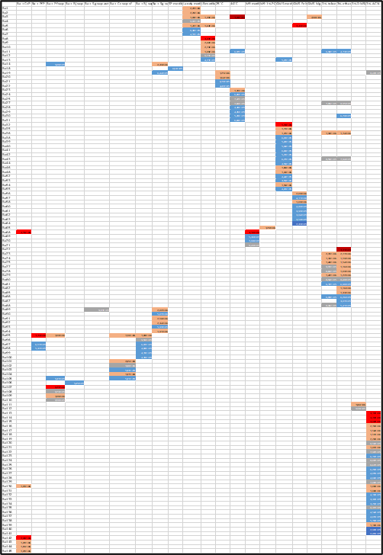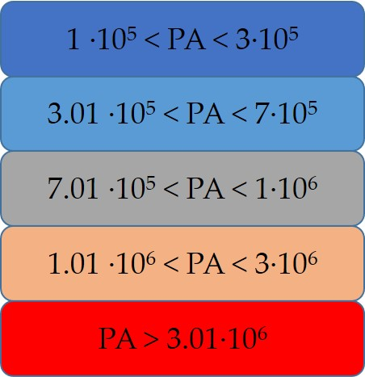
Figure S18. Heat map for new mass features of B. amyloliquefaciens DSM7 and utilized color code. PA = peak area. Rows = mass features, columns = producing conditions. Conditions which did not provoke any new mass features are not shown in the heat map. See separate excel file for detailed heat map.
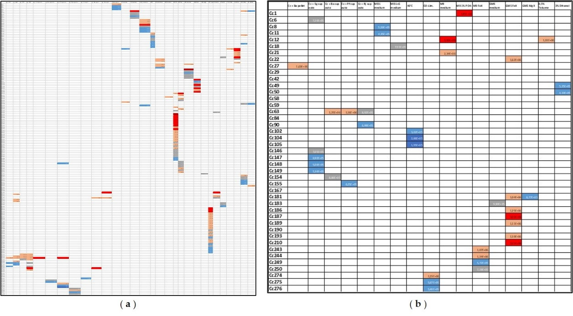
Figure 19. ( a ) Heat map of S. griseochromogenes DSM40499; ( b ) Heat map of C. coralloides DSM2259. Rows = mass features, columns = producing conditions. Conditions which did not provoke any new mass features are not shown in the heat map. See separate excel file for detailed heat map.

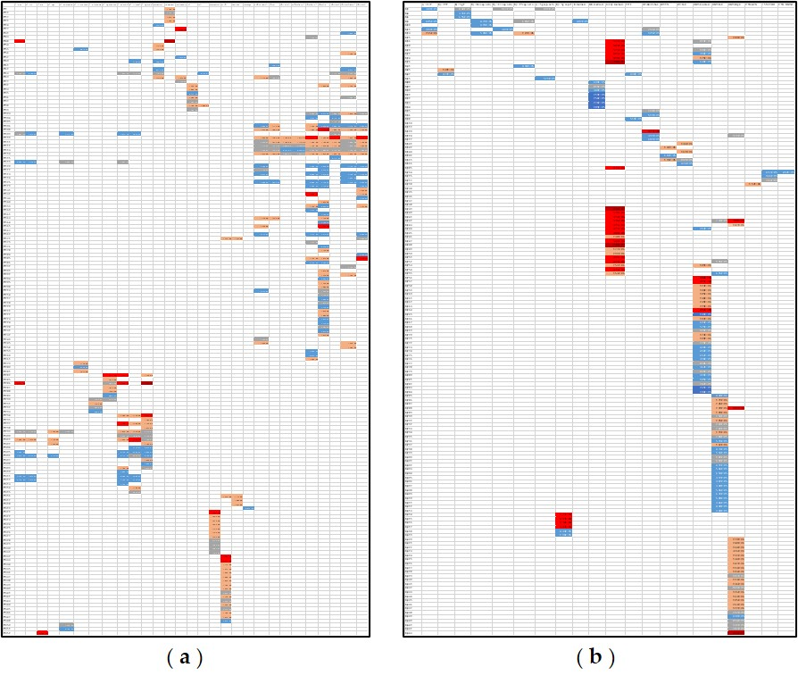
Figure 20. ( a ) Heat map of P. fallax HKI727; ( b ) Heat map of R. jostii DSM44719. Rows = mass features, columns = producing conditions. Conditions which did not provoke any new mass features are not shown in the heat map. See separate excel file for detailed heat map.

Table S21. Overview of new mass features, proposed compounds, and corresponding producing conditions from selected strains.
ID | Proposed compound | producing conditions
Ba3 | cyclo(Tyr-Pro) | Landy medium, LB medium, 40°C, Mg²⁺-limited GMS medium (GMS MgX)
Ba8 | iturin A-4 | LB medium
Ba9 | iturin A-6 | LB medium
Ba10 | iturin A-8 | LB medium
Ba58 | bacillibactin | Fe3⁺-limited GMS medium (GMS FeX)
Cc42 | nocardamin | addition of sterile-filtered supernatant of B. amyloliquefaciens, R. jostii and S. griseochromogenes (separately)
Pf336 | myxochelin A | M9 medium with 1% PO₄³⁻
Sg117 | desmethyl enyl nocardamin | Fe3⁺-limited GMS medium (GMS FeX)
Sg130 | desferrioxamine B + Al | addition of 1% and 3% DMSO

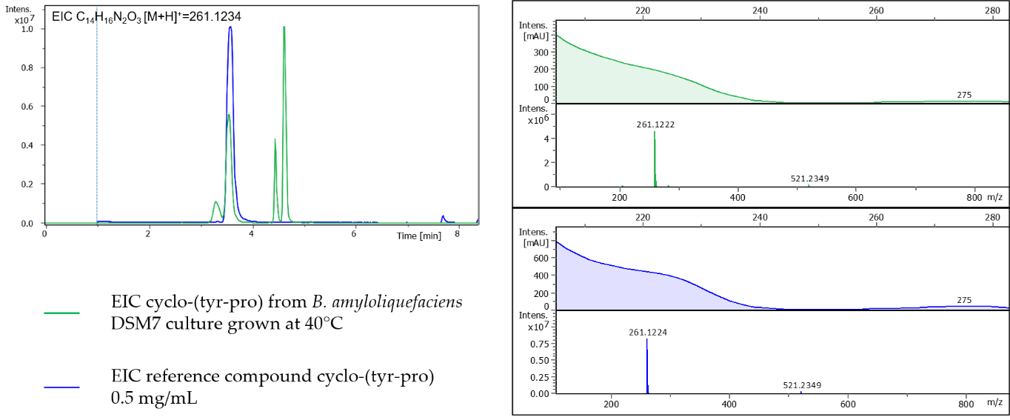
Figure S21. Comparison of Extracted Ion Chromatograms (EICs) and MS spectra of cyclo-(tyr-pro) reference compound (blue) and cyclo-(tyr-pro) in B. amyloliquefaciens sample grown at 40°C (green). The UV spectrum is shown above the MS spectrum. Δppm = 0.7.

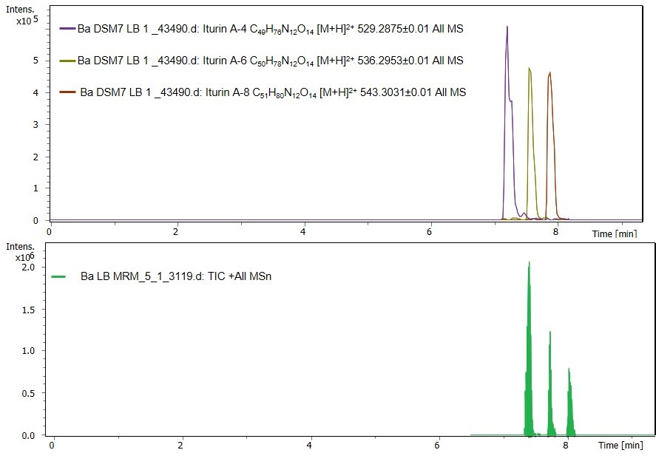
Figure S22. Extracted Ion Chromatograms of putative iturins A4, A-6 and A-8 from B. amyloliquefaciens sample grown on LB medium and Total Ion Chromatogram of MS2-experiment from the same sample.
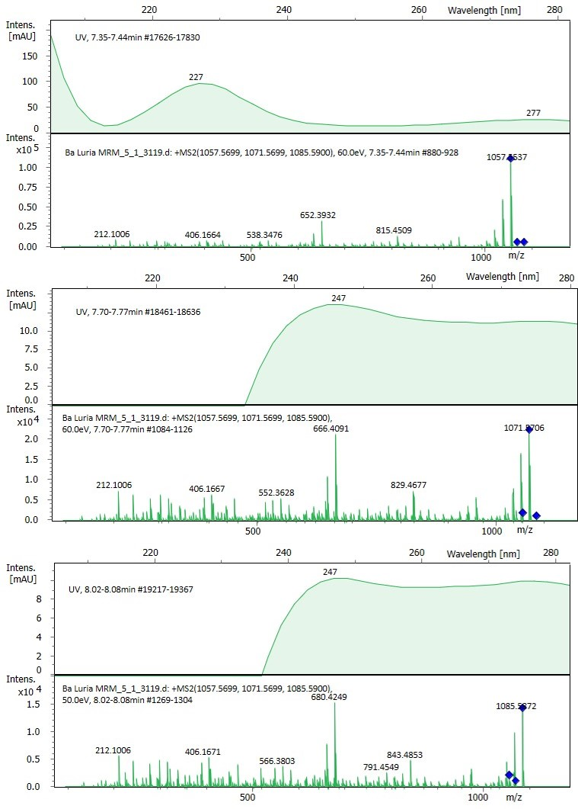
Figure S23. MS2-spectra of putative iturin A-4, A-6 and A-8 masses in B. amyloliquefaciens sample grown on LB medium. The UV spectrum is shown above the MS spectrum. Δppm = 12.8 for Iturin A-4, Δppm = 11.5 for Iturin A-6, Δppm = 10.5 for Iturin A-8.
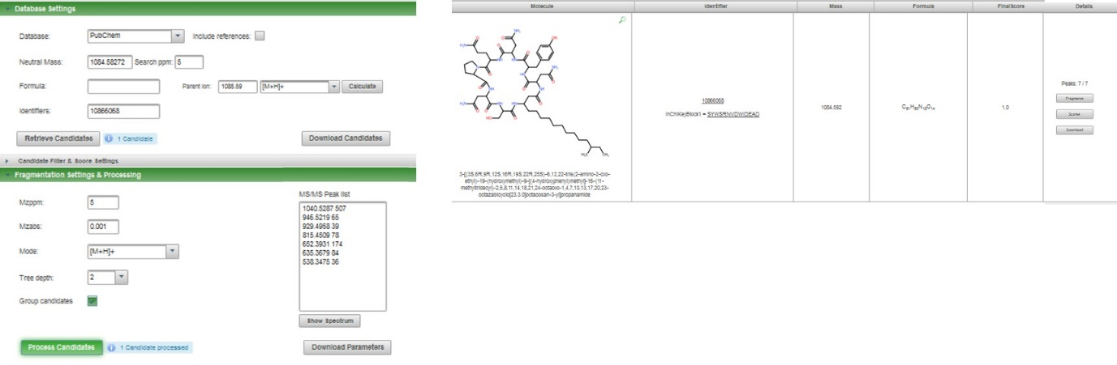
Figure S24. MetFrag settings used for the verification of MS2-fragments of putative iturin A-8 with corresponding PubChem entry #10866068
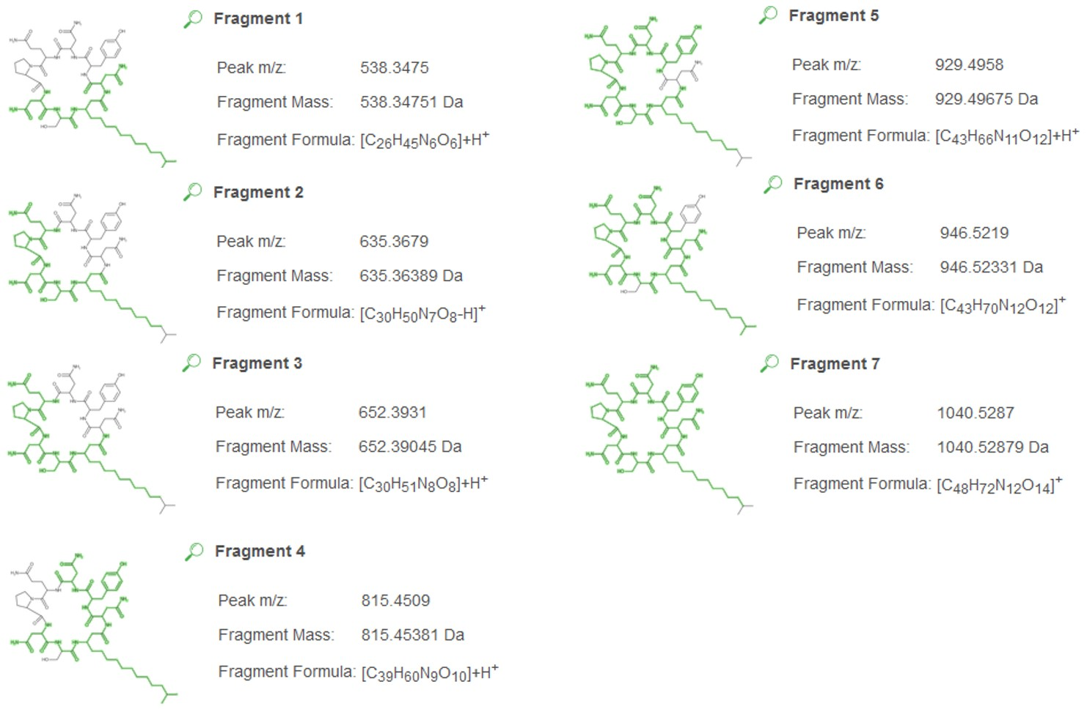
Figure S25. MetFrag explanations of fragments obtained through MS2-analysis of mass 1085.59 (putative iturin A-8) in B. amyloliquefaciens DSM7 sample grown on LB medium.
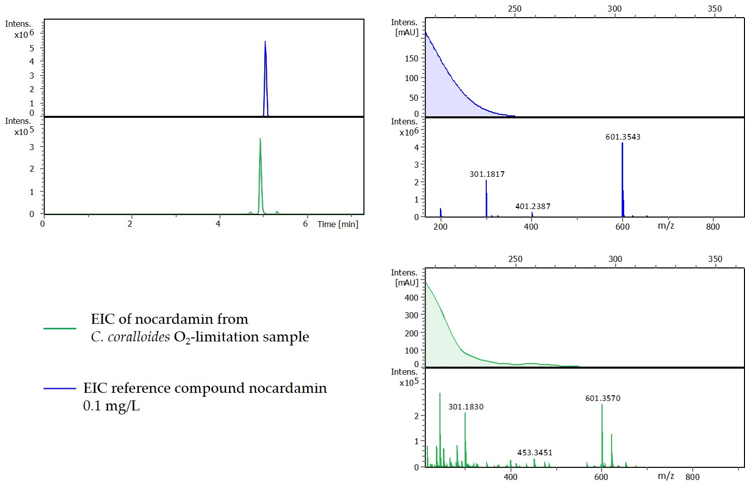
Figure S26. Comparison of Extracted Ion Chromatograms (EICs) and MS spectra of nocardamin reference compound (blue) and nocardamin in C.coralloides sample grown under O₂-limitation (green). The UV spectrum is shown above the MS spectrum. Δppm = 4.4.

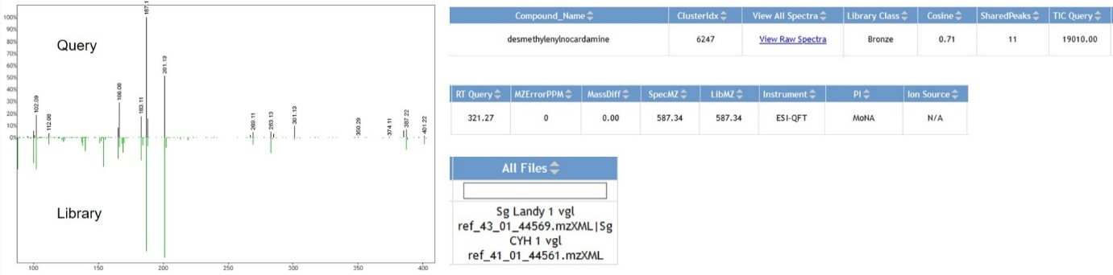
Figure 27. Results of GNPS search of desmethyl enyl nocardamin MS2-spectrum (mirror match and overview). Δppm = 0.
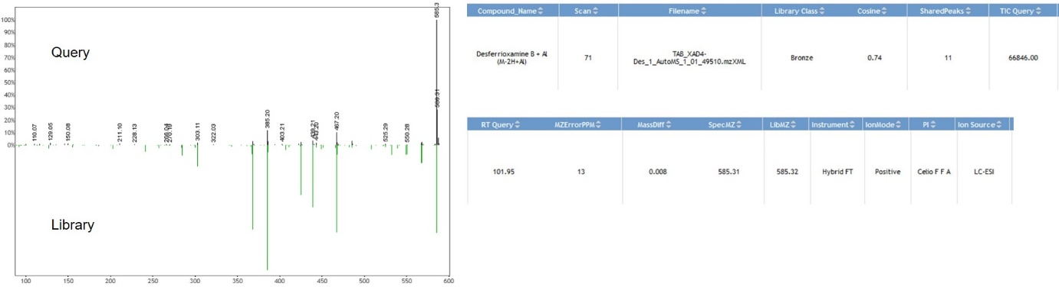
Figure S28. Results of GNPS search of desferrioxamine B + Al MS2-spectrum (mirror match and overview). Δppm = 13.
Table S22. Summary of fragmentation patterns and collision energies (CE) of compounds identified among the new mass features.
Compound and Collision Energy | Fragmentation pattern
cyclo(Tyr-Pro)  CE = 35 eV | 107.05 1000  136.08 501  98.06 217  113.07 154  154.07 246  188.11 24
iturin A-4  CE = 60 eV | 1040.53 517  1023.51 301  1006.48 159  946.52 398  929.49 254  912.47 162  895.45 100  846.46 165  815.45 387  798.43 216  781.41 158  763.42 177  746.40 130  718.40 161  701.38 156  684.36 108  652.39 1000  635.37 611  538.35 256  406.17 154  299.13 311  212.10 314
bacillibactin  CE = 45 eV | 137.02 99  159.08 132  166.05 89  185.09 395  194.04 468  242.11 102  277.08 119  295.09 490  378.13 1000  396.14 237  414.15 104  453.16 117  479.18 235  589.18 219  672.22 51  690.23 44
nocardamin  CE = 33 eV | 201.1 1000  183.11 230  168.08 170  102.09 170  100.03 170  283.13 70  301.13 40  401.24 110
desmethylenyl-nocardamin  CE = 28 eV | 102.09 190  112.06 40  166.08 290  183.11 180  187.1 1000  201.13 501  269.11 40  283.13 50  301.13 100  387.22 70  401.22 10
desferrioxamine B + Al  CE = 37.6 eV | 585.31 1000 parent ion  485.21 32  467.20 100  439.21 33  385.19 116  368.17 29  303.11 16

Table S23. Summary of detected compounds and level of confidence for their identification according to [5].
Compound | Level of Confidence
surfactin | 1
myxochelin A | 1
desferrioxamine B | 1
cyclo(Tyr-Pro) | 1
nocardamin | 1
bacillibactin | 2
nostophycin | 2
bacillaene | 3
albaflavenone | 3
iturin | 3

[1] DSMZ GmbH, “CY/H Medium Composition,” available at https://www.dsmz.de/microorganisms/medium/pdf/DSMZ_Medium1542.pdf, 2012.
[2] P. Thonart, E. Akpa, B. Wathelet, R. Fuchs, M. Paquot, P. Jacques, H. Budzikiewicz, Appl. Biochem. Biotechnol. 2003, 91–93 (1–9), 551–562. DOI: 10.1385/abab:91-93:1-9:551.
[3] DSMZ GmbH, “M9 Medium Composition,” available at https://www.dsmz.de/microorganisms/medium/pdf/DSMZ_Medium1542.pdf, 2007.
[4] M. Wang, “GNPS Documentation: Mass Spectrometry File Conversion,” available at https://ccms-ucsd.github.io/GNPSDocumentation/fileconversion/#conversion-with-msconvert, n.d.
[5] A. C. Schrimpe-Rutledge, S. G. Codreanu, S. D. Sherrod, J. A. McLean, J. Am. Soc. Mass Spectrom. 2016, 27 (12), 1897–1905. DOI: 10.1007/s13361-016-1469-y.

