Supplementary Information (two Appendices, four Tables, two Figures) for:

**Microplastic Contamination of Three Commonly Consumed Seafood Species from Taiwan: a Pilot Study**

Jennifer Yee-Shian Chen 1, Yao-Chang Lee 2,3, Bruno A. Walther 4,*

1 *Graduate Institute of Medical Sciences, Taipei Medical University, 250 Wu-Hsing St., Taipei 110, Taiwan*

2 *National Synchrotron Radiation Research Center, Life Science group, Hsinchu 30076, Taiwan*

3 *Department of Optics and Photonics, National Central University, Chung-Li 32001, Taiwan*

4 *Alfred-Wegener-Institut Helmholtz-Zentrum für Polar- und Meeresforschung, Am Handelshafen 12, D-27570 Bremerhaven, Germany*

* Correspondence: bawalther2009@gmail.com

**Appendix S1.** Detailed methodology of our protocol to dissolve animal tissues and filter the solution (adopted from protocol 1b as described in Dehaut et al. [1]).

Approximate times are given which are the work hours spent by one laboratory assistant on all tasks for one sample batch (e.g., 10 clams or 10 shrimp).

**1. Purchase (~0.5 hours)**

Step 1. Buy seafood sample and document with photo and unique label number, including date, place of purchase, brand name, etc. Immediately wrap sample into aluminium foil so that it is not contaminated, e.g., by plastic bag. Place sample into freezer.

**2. Dissolution and filtering (~5 hours)**

Step 2. Make 20 liters of filtered water with the help of the vacuum pump and paper filter and keep it in a large storage container. Use only filtered water for everything which mixes the sample with water.

For all laboratory work, we produced particle-free water as follows [2, 3]. Whenever needed, we filtered several liters of tab water through a 5μm pore size filter paper made by Advantec. The filtering system consisted of a vacuum pump connected via a rubber tube to a collecting flask. The filter paper was held in place between the funnel and the collecting flask by a filter holder and a clamp. The vacuum pump sucked the tab water within less than one minute through the filter paper. The filtered water was stored in a clean tank and was exclusively used for all further laboratory work. Before the next steps, all equipment parts were first cleaned twice with filtered water, after which the tops of the funnel and all flasks were covered with aluminium caps [2, 3]. The caps were only removed when needed.

Step 3. Use filtered water to make 10% potassium hydroxide (KOH) solution. This solution is made by mixing 90% of water with 10% KOH by weight. The solution is made by slowly adding water to KOH while monitoring the heat production carefully. The solution is then thoroughly stirred with a stir bar. The KOH solution is kept in a safe container.

Step 4. Defrost seafood while keeping it wrapped in aluminium foil to avoid contamination through the air. Wear gloves, facemask and clean room laboratory suit (specifically designed not to shed fibers) for all experimental procedures.

Step 5. Label each plastic vial and each corresponding Petri dish for keeping the filter paper (see Step 10) with the unique label number. Include three Petri dishes for blank samples.

Step 6. Place one seafood item (e.g., the meat of one individual clam or shrimp) into each plastic vial, then fill up 50-70% of the vial with the KOH solution. Try to keep possible contamination from air to a minimum during this step by working quickly and closing vial with its screw top immediately.

Step 7. Place vial into 50º C water bath.

Step 8. Check every 24 hours if sample has completely dissolved. If not, add additional KOH solution to sample. Usually, samples are completely dissolved between 24 and 48 hours.

Step 9. Rinse filter holder thoroughly with filtered water to clean it before sample is filtered. Keep filter top covered with aluminium cap as much as possible. Lift cap and pour KOH solution (with dissolved animal tissue but with undissolved particles, including microplastic particles) through the paper filter, rinse again with filtered water so that residues on the filter above the filter paper are moved onto the filter paper. The solution is sucked through the filter paper by a vacuum pump.

Place aluminium cap back onto the filter. Repeat the same procedure with three blank samples, but use filtered water instead.

Step 10. Fix filter paper onto flat and labelled plastic disk which is then placed into a labelled Petri dish. Seal Petri dish with sticky tape.

**3. Scanning for potential microplastic particles (~10 hours)**

Step 11. Scan filter paper visually under microscope and mark places on filter paper with potential microplastic particles.

**4. Checking potential microplastic particles with spectroscopy (~5 hours)**

Step 12. Use Fourier transform infrared (ATR-FTIR) spectroscopy or Raman spectroscopy to measure spectra of all potential microplastic particles to distinguish microplastic particles from non-plastic particles (see Methods for details).

**Appendix S2.** Details of our validation trials using seeded samples to test the method detailed in Appendix 1.

For these validation trials, we used the methods as explained in detail in Appendix 1, but not with whole animal seafood samples (see main text), but using samples seeded with (1) only microplastic particles and (2) microplastic particles and clean seafood tissue.

To produce microplastics, we obtained samples of clean polyethylene (PE), polyethylene terephthalate (PET), polypropylene (PP), and polystyrene (PS) from commercial products who clearly state the plastic polymer of which they are made of (e.g., PET bottles). We then cut very small pieces using strong scissors and selected those pieces which measured 1- 5 mm. In December 2016, we also purchased fish, shrimp and mussel samples from markets as described in the Methods, and then cut small pieces of tissue from each animal, assuming that pure muscle tissue should be free of microplastics.

We then ran 10 samples seeded only with 10 microplastic particles each (blank samples; Table 2); furthermore, we ran 10 samples for three seafood types seeded with 5 small tissue samples and 10 microplastic particles each (fish, shrimp, and mussel samples; Table 2). After each tissue had completely dissolved (Table 2), we used the filtering procedure as described in Appendix 1 to extract the seeded microplastics. We recovered 99-100% of the seeded microplastics (Table S2).

**Table S1.** Information adopted from Table 1 in Chen and Chen [4] which is based on the Taiwanese Dietary Habit and Food Balance Sheet. Chen and Chen [4] used this list of seafood taxa (specifically, shellfish and cephalopods) to determine the mercury levels within seafood commonly consumed in Taiwan.

|  |  |
| --- | --- |
| Common name | Scientific name |
| Asian/Corbicula clam | *Corbicula fluminea* |
| Asian hard clam | *Meretrix lusoria* |
| Pacific oyster | *Crassostrea gigas* |
| Giant tiger prawn | *Penaeus monodon* |
| Spear shrimp | *Parapenaeus* spp. |
| Loligo squid | *Loliginidae* spp. |
| Cuttlefish | *Sepiidae* spp. |
| Whiteleg shrimp | *Litopenaeus vannamei* |
| Bigfin reef squid | *Sepioteuthis lessoniana* |
| Flower crab | *Portunus armatus* (formerly *pelagicus*) |
| Mud crab | *Scylla serrata* |
| Three-spot swimming crab | *Portunus sanguinolentus* |

**Table S2.** Dissolution times for three types of seafood tissues dissolved with 10% potassium hydroxide (KOH) solution at 50 ºC (see Methods and Appendix 1 for details), and number and percentage of microplastic particles recovered.

|  |  |  |  |
| --- | --- | --- | --- |
| Sample type | Sample size | Dissolution time (hours) | Added plastics recovered |
| Blank | 10 | - | 100 (100%) |
| Fish | 10 | 72 | 100 (100%) |
| Shrimp | 10 | 24 | 99 (99%) |
| Mussel | 10 | 24 | 100 (100%) |

**Table S3.** Polymer types of microplastics found in six batches of Taiwanese seafood (Table 1). For a table of polymer type abbreviations, see, e.g., Wypych [5]. Note that diene refers to a covalent compound which contains two double bonds, and that, according to Kutz [6], PP+PE-PP is a thermoplastic elastomer which is a physical mixture of different polymers.

|  |  |
| --- | --- |
| Polymer type | Abbreviation |
| polyamide | PA |
| polyethylene | PE |
| polyethylene low-density | PE-LD |
| polyethylene terephthalate | PET |
| polymethacrylate (= polymethylmethacrylate) | PMMA |
| polypropylene | PP |
| poly(ethyl acrylate) | PEA |
| poly(ethylene:propylene:diene) | PE-PP |
| polypropylene+poly(ethylene:propylene) | PP+PE-PP |

**Table S4.** The data on polymer type, shape, colour, and size for each of the 100 microplastic particles detected during our study (sorted according to species, then polymer type, shape, and colour).

|  |  |  |  |
| --- | --- | --- | --- |
| Polymer type | Shape | Colour | Size (μm) |
| *Hard clam* |  |  |  |
| poly(ethyl acrylate) (PEA) | fragment | green |  |
| poly(ethyl acrylate) (PEA) | fragment | green |  |
| poly(ethyl acrylate) (PEA) | fragment | green |  |
| poly(ethyl acrylate) (PEA) | fragment | green |  |
| polyamide (PA) | fragment | blue | 100 |
| polyamide (PA) | fragment | transparent |  |
| polyethylene low-density (PE-LD) | fragment | black |  |
| polyethylene terephthalate (PET) | fiber | black | 500 |
| polyethylene terephthalate (PET) | fiber | yellow | 800 |
| polyethylene terephthalate (PET) | fragment | brown |  |
| polyethylene terephthalate (PET) | fragment | dark blue | 400 |
| polyethylene terephthalate (PET) | fragment | transparent | 400 |
| polyethylene terephthalate (PET) | fragment | white | 100 |
| polymethacrylate (PMMA) | fragment | green |  |
| polymethacrylate (PMMA) | fragment | green |  |
| polypropylene (PP) | fragment | blue | 100 |
| polypropylene (PP) | fragment | blue | 20 |
| polypropylene (PP) | fragment | blue | 160 |
| polypropylene (PP) | fragment | blue | 40 |
| polypropylene (PP) | fragment | blue | 100 |
| polypropylene (PP) | fragment | blue | 100 |
| polypropylene (PP) | fragment | blue | 50 |
| polypropylene (PP) | fragment | blue | 240 |
| polypropylene (PP) | fragment | blue | 120 |
| polypropylene (PP) | fragment | blue | 50 |
| polypropylene (PP) | fragment | blue | 160 |
| polypropylene (PP) | fragment | blue | 100 |
| polypropylene (PP) | fragment | blue | 40 |
| polypropylene (PP) | fragment | blue | 120 |
| polypropylene (PP) | fragment | blue | 60 |
| polypropylene (PP) | fragment | blue | 80 |
| polypropylene (PP) | fragment | blue | 80 |
| polypropylene (PP) | fragment | blue | 50 |
| polypropylene (PP) | fragment | blue | 40 |
| polypropylene (PP) | fragment | blue | 400 |
| polypropylene (PP) | fragment | blue | 60 |
| polypropylene (PP) | fragment | blue | 350 |
| polypropylene (PP) | fragment | blue | 50 |
| polypropylene (PP) | fragment | blue | 100 |
| polypropylene (PP) | fragment | blue | 60 |
| polypropylene (PP) | fragment | blue | 50 |
| polypropylene (PP) | fragment | green | 60 |
| polypropylene (PP) | fragment | green | 50 |
| polypropylene (PP) | fragment | green | 100 |
| polypropylene (PP) | fragment | green |  |
| polypropylene (PP) | fragment | green |  |
| polypropylene (PP) | fragment | green | 500 |
| polypropylene (PP) | fragment | green | 70 |
| polypropylene (PP) | fragment | green | 50 |
| polypropylene (PP) | fragment | green | 160 |
| polypropylene (PP) | fragment | green | 100 |
| polypropylene (PP) | fragment | green |  |
| polypropylene (PP) | fragment | green | 50 |
| polypropylene (PP) | fragment | green | 150 |
| polypropylene (PP) | fragment | green | 50 |
| polypropylene (PP) | fragment | green | 800 |
| polypropylene (PP) | fragment | green | 50 |
| polypropylene (PP) | fragment | green | 350 |
| polypropylene (PP) | fragment | green | 160 |
| polypropylene (PP) | fragment | green | 100 |
| polypropylene (PP) | fragment | green |  |
| polypropylene (PP) | fragment | green |  |
| polypropylene (PP) | fragment | green | 60 |
| polypropylene (PP) | fragment | green | 80 |
| polypropylene (PP) | fragment | green | 80 |
| polypropylene+poly(ethylene:propylene) (PP+PE-PP) | fiber | blue |  |
| polypropylene+poly(ethylene:propylene) (PP+PE-PP) | fragment | black |  |
| polypropylene+poly(ethylene:propylene) (PP+PE-PP) | fragment | white |  |
| *Loligo squid* |  |  |  |
| poly(ethyl acrylate) (PEA) | fragment | blue |  |
| poly(ethylene:propylene:diene) (PE-PP) | fragment | blue |  |
| poly(ethylene:propylene:diene) (PE-PP) | fragment | translucent |  |
| poly(ethylene:propylene:diene) (PE-PP) | fragment | white |  |
| polyethylene (PE) | sphere | translucent |  |
| polyethylene terephthalate (PET) | fiber | grey |  |
| polypropylene (PP) | fragment | white |  |
| *Oyster* |  |  |  |
| poly(ethyl acrylate) (PEA) | fragment | black |  |
| poly(ethyl acrylate) (PEA) | fragment | blue |  |
| poly(ethylene:propylene:diene) (PE-PP) | fragment | black | 500 |
| poly(ethylene:propylene:diene) (PE-PP) | fragment | black | 600 |
| poly(ethylene:propylene:diene) (PE-PP) | fragment | blue |  |
| poly(ethylene:propylene:diene) (PE-PP) | fragment | blue |  |
| poly(ethylene:propylene:diene) (PE-PP) | fragment | brown | 600 |
| poly(ethylene:propylene:diene) (PE-PP) | fragment | green |  |
| poly(ethylene:propylene:diene) (PE-PP) | fragment | white | 80 |
| poly(ethylene:propylene:diene) (PE-PP) | fragment | white | 100 |
| poly(ethylene:propylene:diene) (PE-PP) | fragment | white | 50 |
| polyamide (PA) | fragment | grey | 250 |
| polyamide (PA) | fragment | grey | 600 |
| polyamide (PA) | fragment | grey | 250 |
| polyamide (PA) | fragment | translucent | 250 |
| polyamide (PA) | fragment | translucent | 250 |
| polyethylene (PE) | fragment | blue | 100 |
| polyethylene low-density (PE-LD) | fragment | black | 250 |
| polyethylene low-density (PE-LD) | fragment | black | 400 |
| polyethylene terephthalate (PET) | fiber | black |  |
| polyethylene terephthalate (PET) | fiber | grey |  |
| polyethylene terephthalate (PET) | fiber | grey |  |
| polyethylene terephthalate (PET) | fiber | transparent |  |
| polypropylene (PP) | fragment | white |  |
| polypropylene (PP) | fragment | white |  |

**Figure S1.** Production quantity in metric tons of 12 taxa of seafood in Taiwan for 2016 (source: Fisheries Agency, Council of Agriculture, Executive Yuan, Taiwan).



**References**

1. Dehaut, A.; Cassone, A.-L.; Frère, L.; Hermabessiere, L.; Himber, C.; Rinnert, E.; Rivière, G.; Lambert, C.; Soudant, P.; Huvet, A. et al. Microplastics in seafood: Benchmark protocol for their extraction and characterization. *Environ. Pollut.* **2016**, *215*, 223-233.

2. Yang, D.; Shi, H.; Li, L.; Li, J.; Jabeen, K.; Kolandhasamy, P. Microplastic pollution in table salts from China. *Environ. Sci. Technol.* **2015**, *49*, 13622-13627.

3. Karami, A.; Golieskardi, A.; Keong Choo, C.; Larat, V.; Galloway, T.S.; Salamatinia, B. The presence of microplastics in commercial salts from different countries. *Sci. Rep.* **2017**, *7*, 46173.

4. Chen, Y.C.; Chen, M.H. Mercury levels of seafood commonly consumed in Taiwan. *J. Food Drug Anal.* **2006**, *14*, 373-378.

5. Wypych, G. *Handbook of polymers, 2nd edition*. ChemTec Publishing: Toronto, Canada, 2016.

6. Kutz, M. (ed.) *Applied Plastics Engineering Handbook: Processing and Materials*. Elsevier: 2011.

**Figure S2.** Examples of spectra generated with FTIR spectroscopy for each of the nine polymer types which we identified among the 100 microplastic particles (Table 2).

polyamide (PA)



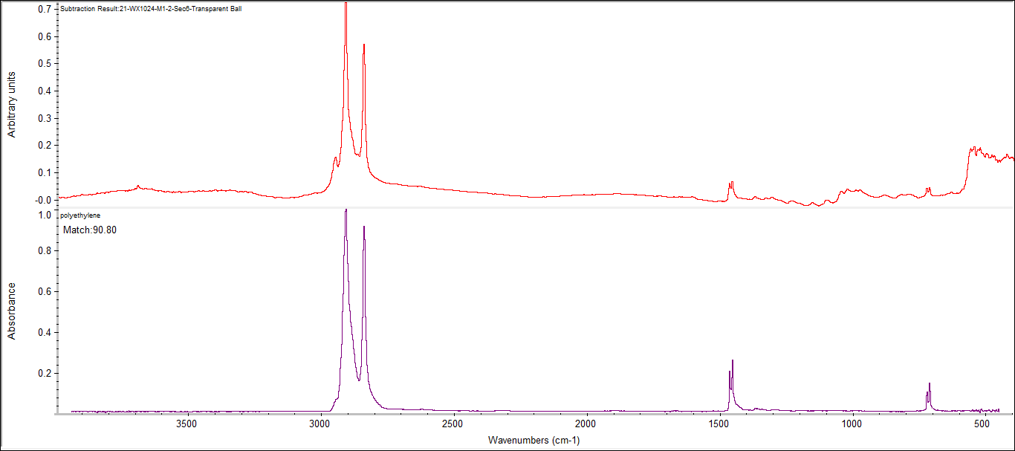polyethylene (PE)polyethylene low-density (PE-LD)

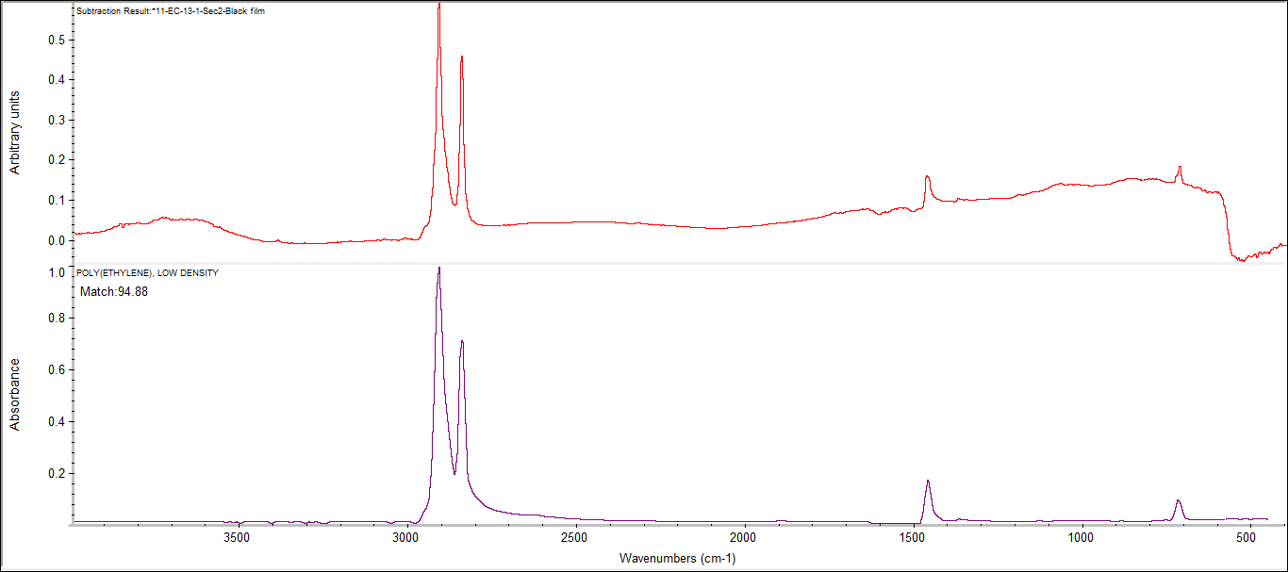

polyethylene terephthalate (PET)

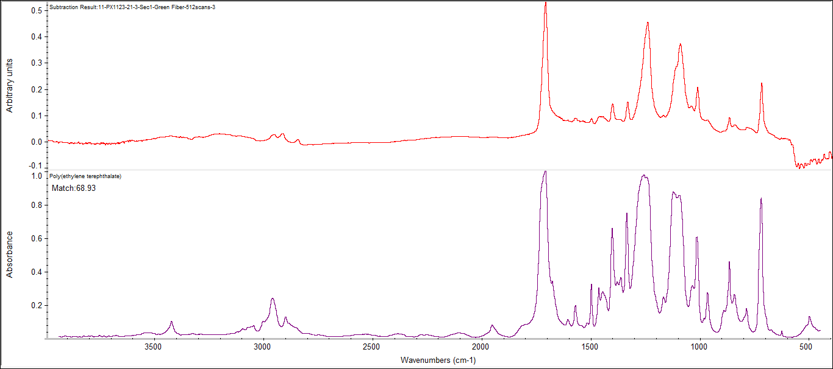

polymethacrylate (PMMA)

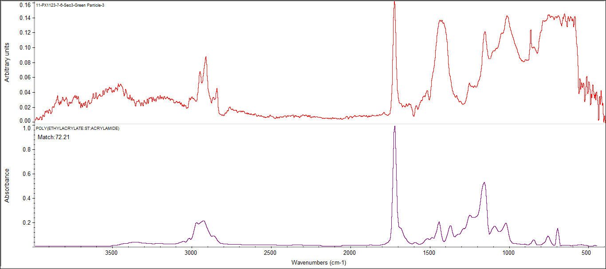

polypropylene (PP)

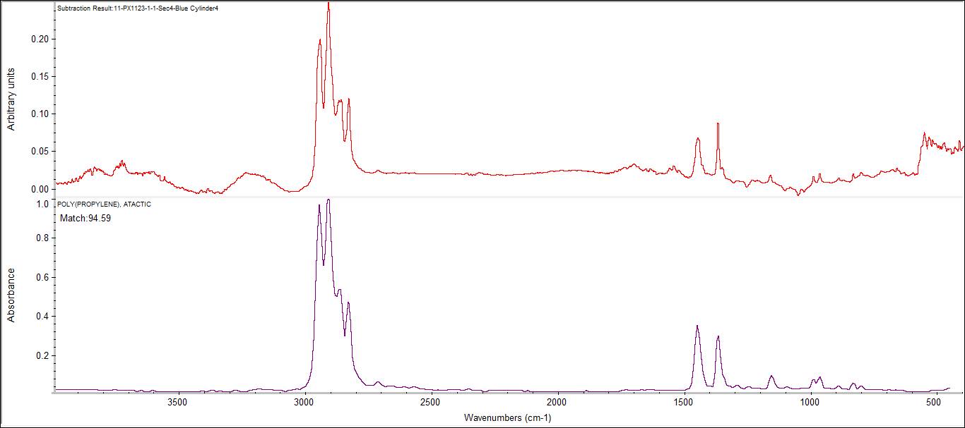

poly(ethyl acrylate) (PEA)

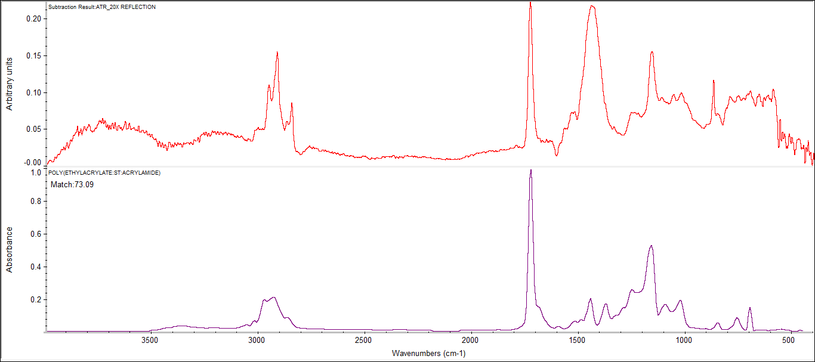

poly(ethylene:propylene:diene) (PE-PP)

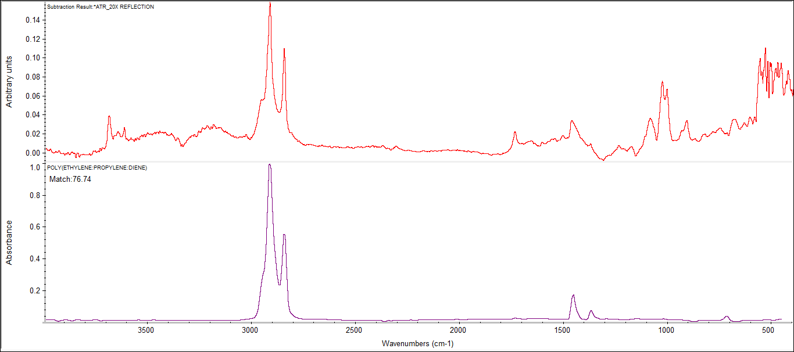

polypropylene+poly(ethylene:propylene) (PP+PE-PP)

